  - Project Environmental Management Plan Template
  - To be used in conjunction with Tender Criteria Questions and Weighting spreadsheet
A resource developed by Buy Circular Council Champions in collaboration with Sustainability Victoria

Authorised and published by
Sustainability Victoria
Level 12, 321 Exhibition Street
Melbourne Victoria 3000 Australia
Project Environmental Management Plan Template
© Sustainability Victoria 2025
December 2025
Accessibility
This document is available in PDF and Word format on the internet at sustainability.vic.gov.au
While reasonable efforts have been made to ensure that the contents of this publication
are factually correct, Sustainability Victoria gives no warranty regarding its accuracy, completeness, currency or suitability for any particular purpose and to the extent permitted by law, does not accept any liability for loss or damages incurred as a result of reliance placed upon the content of this publication.
This publication is provided on the basis that all persons accessing it undertake responsibility for assessing the relevance and accuracy of its content.
This report should be attributed to Sustainability Victoria.
This report is licensed under a Creative Commons Attribution 4.0 International licence.
In essence, you are free to copy, distribute and adapt the work, as long as you attribute the work and abide by the other licence terms. Go to http://creativecommons.org/licenses/by/4.0/ to view a copy of this licence.

Sustainability Victoria acknowledges Aboriginal and Torres Strait Islander people as the Traditional Custodians of the land and acknowledges and pays respect to their Elders, past and present.

Project Waste Management and Circular Economy Plan Template

A resource developed by Buy Circular Council Champions and Sustainability Victoria

Table of Contents
Introduction 3
Environmental Impact Assessment 4
Introduction to Environmental Impact Assessment 4
Environmental Impact Assessment Guidelines 4
Identify Hazards 5
Assess Risk 6
Implement Controls 6
Check Controls 7
Environmental Impact Assessment 8
Environmental Impact Assessment – Risk Register 9

Introduction
Council supports environmental stewardship in all its operations. This includes the operations and actions of all consultants and contractors working for Council. Environmental stewardship involves taking all reasonable steps to protect the environment from harm caused directly or indirectly by the actions of a business or individual.
The Environmental Protection Act 2017 (EP Act) applies to all businesses located in Victoria, including Council and its consultants and contractors. At the centre of the EP Act is general environmental duty, which requires anyone engaging in an activity that may give rise to risks of harm to human health or the environment from pollution or waste, must minimise those risks so far as reasonably practicable (EPA publication 1856).
This Environmental Management Plan is designed to help contractors identify and manage their environmental risk in order to fulfil their legal obligations, as well as identify any areas they can make improvements to their project methodology to achieve greater outcomes for humans and the environment than what is legislated. This can be done by filling out an Environmental Impact Assessment. This tool allows the identification of all environmental hazards posed by the execution of a project, assessment of the risks they pose to the environment as well as the creation of control measures designed to reduce or eliminate these risks. In this context the hazards to be identified and the controls to be put in place are not limited to those required by law and will demonstrate the commitment of a contractor to environmental protection.
As the reduction in environmental harm is a shared goal between Council and its contractors, the process of creating this EMP should be one of collaboration with the whole project team. Council is committed to fully supporting this process, and as such, has supplied this template to assist in the creation of a draft project specific EMP to be submitted as part of the tender package.

Environmental Impact Assessment

Introduction to Environmental Impact Assessment
The Environmental Impact Assessment (EIA) that forms part of this plan is structured as per Environmental Protection Authority Victoria (EPA Victoria) guidelines. It uses two main tools:
- Risk Matrix; and
- Risk Register.
The Risk Matrix can be used when filling out the Risk Register, to assign each identified hazard the appropriate level of severity and likelihood, both before a control is created for that hazard and after.
An inherent risk, that is the level of risk presented by a hazard before any control is put in place, is assigned based on all available information and the collective experience of the project team.
A control is a description of the mitigation measures that will be put in place to manage a hazard. This description can have as much detail as needed but does not replace a site instruction, procedure manual or memo required to adequately communicate the control to the project team.
Being able to assign a residual risk before the control is applied in practice is difficult and cannot be done with absolute accuracy at the time the EIA is written. Assigning a residual risk rating should be done after assessing all available knowledge and making an educated estimate. Controls may need to be adjusted during the project depending on their effectiveness, to ensure risk is reduced or eliminated to the greatest extent possible. Residual risk ratings may be revisited during the project to evaluate this accuracy against actual outcomes, to improve collective knowledge for future EIAs.
The EIA is only used in this context to address environmental risks. All other risks should be dealt with outside of this framework.

Environmental Impact Assessment Guidelines
EPA Victoria outlines a four-step method for identifying and controlling environmental risk:
- Identify hazards – what hazards are present that might cause harm
- Assess risk – what is the level or severity of risk, based on likelihood and consequence
- Implement controls – What measures are suitable and available to business to eliminate or reduce a risk
- Check controls – Review controls to ensure they are effective
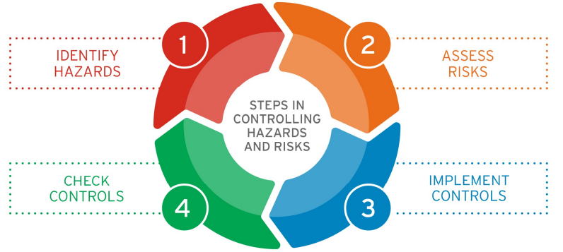Source: EPA Victoria (2018) 1695.1 Assessing and controlling risk: A guide for business, Source: 1695 1.pdf.

Identify Hazards
A wide range of activities undertaken on behalf of Council may present a hazard to the environment. These may be related to:
- Noise and vibration
- Erosion, sediment and dust
- Contaminated land and groundwater
- Chemicals
- Waste
All potential hazards to the environment should be identified prior to commencing the activity being assessed. All hazards identified must be entered into the Risk Register at the end of this document.
It may be difficult to identify hazards before the work site has been established, however the project team may be able to use certain methodology to assist in this part of the assessment, including:
- meet with stakeholders, design and construction team
- conduct a site visit
- reviewing any available design documentation, including land survey and safety in design reports
- identifying receptors near the work site that could be harmed, e.g. waterways, parks and houses
- identifying pathways that pollution could use to reach receptors, such as wind, site drainage, overland flow and groundwater
There are also resources available to assist the identification of hazards. Refer to Table 2, taken from Assessing and controlling risk: A guide for business (EPA Victoria, Publication 1695.1 August 2018), for a list of potential hazards. Note, this list is not exhaustive and the particular activity being assessed may present a hazard not in this table.

Assess Risk
The hazards identified in the previous step must be assessed to determine how they could lead to harm, their likelihood and severity to come up with an inherent risk rating. This assessment will also include the identification of potential controls that will need to be put in place to reduce this inherent risk. A residual risk rating can then be given, which assumes the controls will be put in place.
This risk assessment can be completed in the table at the end of this document.

Implement Controls
EPA Victoria prioritises risk controls from the highest level of effectiveness to the lowest, shown in Figure 3 below:
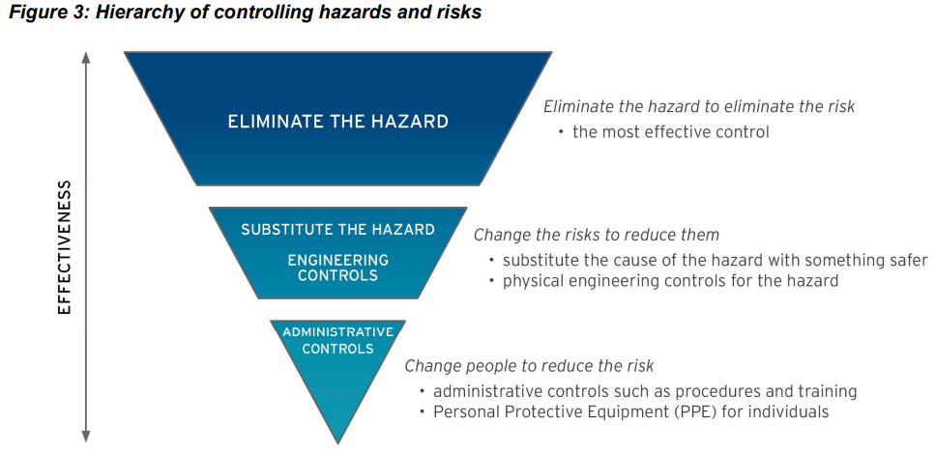

Source: EPA Victoria (2018) 1695.1 Assessing and controlling risk: A guide for business, Source: 1695 1.pdf.
- Elimination - the most effective control
- Substitute the cause of the hazard with a safer alternative takes priority over implementing controls
- Engineering controls are physical controls for a hazard. E.g. bunding
- Administrative controls include training, procedures and policies, supervision or shift design that lessen the threat of a hazard or help people be aware of the hazard
- Personal Protective Equipment (PPE) and spill kits should be used in the presence of any substance that presents a risk to the environment or individuals
EPA Victoria advocates for the use of the precautionary principle, if it is hard to determine the likelihood or consequence of a hazard. If there are controls available that can be easily implemented, then they should be applied anyway.
Controls are separated by EPA Victoria into preventative (controls that prevent harmful events from occurring) and mitigating (controls that limit the consequence or damage from a harmful event). For further definition of these two categories, refer to EPA Victoria, Publication 1695.1 August 2018.

Check Controls
EPA Victoria identifies common methods used to check the effectiveness of controls are:
- regular site inspections and audits
- consulting with employees, contractors, occupants and landlords
- inspecting, testing and maintenance of risk control systems
- using available information, such as manufacturer/supplier instructions
- analysing records and data, such as incident and near miss reports.
If these checks are made on a regular basis then failures in controls can be identified as well as opportunities for improvement.
Several things need to be put in place to maintain controls and ensure they stay effective:
- review hazards and risk assessments regularly as these can change over time
- regularly review, test and maintain all engineering controls
- allocate responsibility and accountability for risks and their controls
- regular consultation with employees and other stakeholders such as insurance providers and emergency service representatives
- clear and effective communication about hazards and risk controls to all who may be affected by them
- regular training, including refresher training for administrative controls.

Environmental Impact Assessment
Likelihood |  | Severity Level
Likelihood |  | Low | Minor | Moderate | Major | Severe
Likelihood |  | Negligible impact and/or contained to work site | Short to medium term impact requiring remediation action and/or contained to local area | Medium term reversible impact to local area requiring remediation | Uncontrolled, long term but reversible impact to localized area resulting in regulatory breach | Long term impact and/or large affected area. Actions could be subject to prosecution
Likelihood | Rare | Low | Low | Low | Medium | Medium
Likelihood | Unlikely | Low | Low | Medium | Medium | High
Likelihood | Possible | Low | Medium | Medium | High | High
Likelihood | Likely | Medium | Medium | High | High | Extreme
Likelihood | Almost Certain | Medium | High | High | Extreme | Extreme

Likelihood can be rated as:
- certain: expected to happen regularly under normal circumstances
- very likely: expected to happen at some time
- likely: may happen at some time
- unlikely: not likely to happen in normal circumstances
- rare: could happen but probably never will.

Environmental Impact Assessment – Risk Register

Hazard | Impact | Inherent Risk | Control | Residual Risk
e.g. Contaminated runoff from site | Contamination of stormwater, waterways and downstream environments | High | Bunding in place to contain runoff on site | Medium

