|  |  |
| --- | --- |
| Waste and recycling in VictoriaStrategic summary report 2019–20 |  |
| Report by: Sustainability Victoria  November 2021 |  |

|  |
| --- |
| Authorised and published by  Sustainability Victoria Level 28, Urban Workshop 50 Lonsdale Street Melbourne  Victoria 3000 Australia  Waste and recycling in Victoria – Strategic summary report, 2019–20  © Sustainability Victoria 2021  November 2021  **Accessibility**  This document is available in PDF and Word format on the internet at [sustainability.vic.gov.au](https://www.sustainability.vic.gov.au/)  While reasonable efforts have been made to ensure that the contents of this publication are factually correct, Sustainability Victoria gives no warranty regarding its accuracy, completeness, currency or suitability for any particular purpose and to the extent permitted by law, does not accept any liability for loss or damages incurred as a result of reliance placed upon the content of this publication.  This publication is provided on the basis that all persons accessing it undertake responsibility for assessing the relevance and accuracy of its content.  This report should be attributed to Sustainability Victoria.  This report is licensed under a Creative Commons Attribution 4.0 International licence.  In essence, you are free to copy, distribute and adapt the work, as long as you attribute the work and abide by the other licence terms.  Go to <http://creativecommons.org/licenses/by/4.0/> to view a copy of this licence.    Data graphics were designed and developed with Little Sketches as part of an SV funded data storytelling residency |
| Sustainability Victoria acknowledges Aboriginal and Torres Strait Islander people as the Traditional Custodians of the land and acknowledges and pays respect to their Elders, past and present. | |

Contents

Minister’s foreword 4

Waste management in Victoria, 2019–20 5

1 Introduction 7

2 Hazardous wastes 8

3 The Victorian sector is building resilience to local disruptions and change 10

3.1 SKM site closures and material storage 10

3.2 Waste management during COVID-19 pandemic 11

3.3 Policy changes impact material flows 12

4 Global shifts in manufacturing supply chains are changing the sector in Victoria 14

4.1 Material flow changes in local and export reprocessing 14

4.2 Commodity values in export markets 15

4.3 New reprocessing capacity to keep materials local 16

4.4 Innovation creating new local markets 17

4.5 Victorian Recycling Infrastructure Plan 17

5 SV is tracking Victoria’s performance towards a circular economy and against *Recycling Victoria*’s targets 18

5.1 Measuring Victoria’s progress towards a circular economy 18

5.2 Performance against *Recycling Victoria*’s waste targets 18

6 Methods of collecting waste and resource recovery data in Victoria are improving 21

6.1 Method – Victorian Recycling Industry Annual Survey (VRIAS) 21

6.2 Method – Victorian Local Government Annual Waste Services Survey (VLGAWS) 22

6.3 What is the Victorian Government doing to improve our data? 23

7 References 24

8 Glossary 26

Minister’s foreword

**Managing Victoria’s waste**

The Waste and Recycling in Victoria Strategic summary report shows how our waste in 2019–20 was managed, recovered, and reprocessed to produce recycled materials and products.

The Victorian Government has invested more than $515 million to deliver the biggest reform and transformation of the waste and recycling system in our state’s history. This includes $380 million to deliver Recycling Victoria, which outlines four key targets that we remain on track to meet. These targets include:

* Diverting 80% of our waste from landfill by 2030
* Cutting total waste generation by 15% per capita by 2030
* Halving the volume of organics going to landfill between 2020 and 2030, and
* Ensuring every Victorian household has access to food and garden organic waste recycling services or local composting by 2030.

Recycling Victoria is transforming our recycling sector, reducing waste, creating jobs and setting Victoria up for a more sustainable future.

Already Recycling Victoria initiatives are enabling more local material recovery and processing in Victoria. Within the year, a record amount of materials were diverted from landfill and processed locally. A total of 11.05 million tonnes was recovered, and the state was able to reprocess 91 per cent of these resources locally. By reprocessing these materials at home, we are able to grow the local industry, create jobs and drive innovation and new technologies while reducing our reliance on export markets.

With Victorian residents at home more often during 2019-20 period, local councils collected more kerbside garbage, recyclables, and organics than ever before - 2.4 million tonnes. This includes 0.57 million tonnes of organics. Collecting this record amount of organics was possible thanks to a doubling of Victorian households provided with a kerbside food and garden organic waste collection service in the 2019-20 period (from 13% to 26%), or provided access to a council managed drop-off service.

Collecting organics separately from other waste can help us to reduce greenhouse gas emissions, convert more of them to compost and allows us to use them as an alternative energy source.

We are continuing to support local councils in their roll-out of new bin systems, with more than a third of Victorian local governments now employing a 3-bin system to better dispose of waste. We’re on track to make sure all Victorian households will have access to a 4-bin system by 2030 where every household will have access to a glass bin collection service and a food and garden organics collection service.

We continue to roll out plans as part of Recycling Victoria, engaging in new efforts to reuse, repair and recycle – paving the way for increased investments in recycling projects and new jobs.

Read more: [vic.gov.au/transforming-recycling-victoria](http://intranet/Docs/PolicyGov/Gov/MO/MBR045767%20Annual%20Waste%20Data%20Reports%202019-2020/vic.gov.au/transforming-recycling-victoria)

**The Hon. Lily D’Ambrosio MP**

**MP Minister for Energy, Environment and Climate Change**

**Minister for Solar Homes**

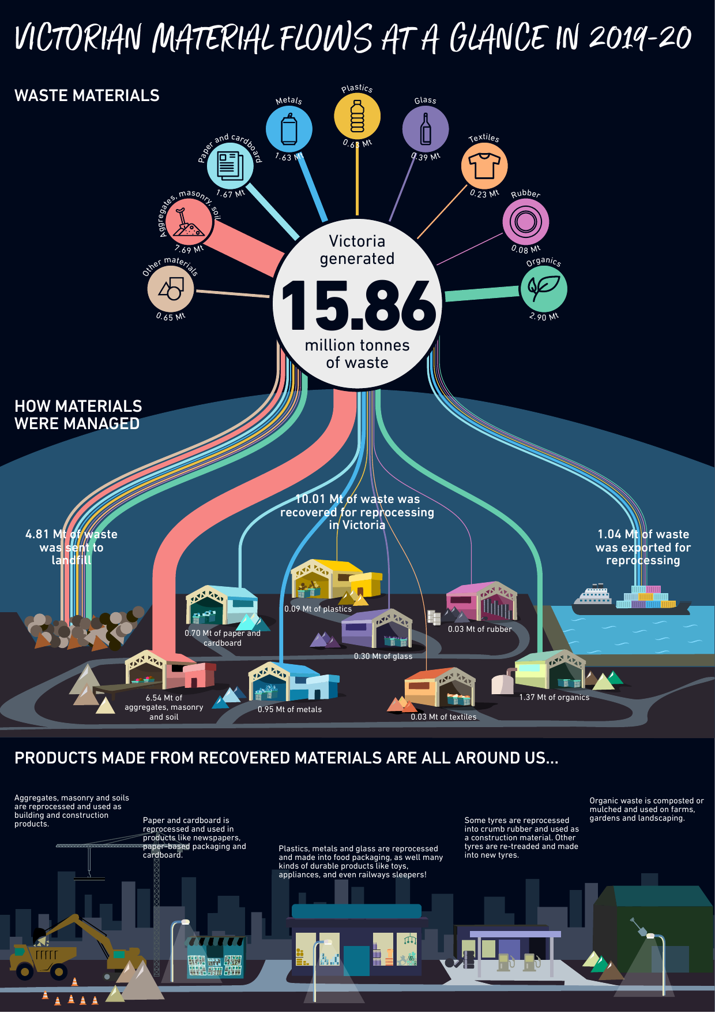Waste management in Victoria, 2019–20

# An infographic giving a snapshot of high level findings for local government services this year. These points are detailed later within the report content. Kerbside waste in Victoria, 2019–20

1. Introduction

This *Waste and Recycling in Victoria – Strategic Summary Report 2019–20* (SSR)is a *strategic* report exploring the key insights of the *Waste and Recycling in Victoria – Recycling Industry Waste Report 2019–20* (RIWR) and the *Waste and Recycling in Victoria – Local Government* *Waste Services Report 2019–20* (LGWSR) in relation to broader sector insights from a range of sources in order to provide a more comprehensive view of waste management in Victoria. These sources include:

* Environment Protection Authority (EPA) Victoria data on quantities of:
  + waste sent to landfill
  + prescribed industrial waste (PIW), largely translated as ‘reportable priority waste’ from 1 July 2021 and includes wastes with hazarduous properties recorded via waste transport certificates
* Australian Bureau of Statistics (ABS) commodity export data
* Australian Plastics Recycling Survey data on plastics consumption and recovery
* *Recovered Resources Market Bulletin* information on resource recovery markets
* government action plans, policies and programs
* general articles and papers on sector development.

This is the first time that Sustainability Victoria (SV) has released this strategic summary report alongside these annual reports. The strategic summary report has been written to deliver further insightful and accessible information that goes beyond the survey data and delves into key developments in the waste and resource recovery sector for 2019–20. This includes a chapter on the management of PIW (also known as hazardous waste) as well as a chapter on measurements against the four key targets in the Victorian Government’s [*Recycling Victoria: A New Economy*](https://www.vic.gov.au/sites/default/files/2020-02/Recycling%20Victoria%20A%20new%20economy.pdf) policy released in 2020. For data and detailed specific information for either the LGWSR or the RIWR please refer to the individual reports as well as the data in the *Waste and Recycling in Victoria – Recycling Industry Waste Workbook 2019–20* and the *Waste and Recycling in Victoria – Local Government Waste Services Workbook 2019–20*. The workbooks provide public access to the underlying data and include historically available figures. All reports and workbooks are available on the SV website ([sustainability.vic.gov.au](https://www.sustainability.vic.gov.au/research-data-and-insights/waste-data/waste-annual-reports-and-data)).



1. Hazardous wastes

Hazardous wastes, a subset of reportable priority wastes where the most stringent duties apply, come from commercial, industrial, construction, demolition and remediation activities and have intrinsic characteristics that if not managed correctly could pose a significant risk to public health, our communities and the environment. These wastes were previously regulated under the Environment Protection (Industrial Waste Resource) Regulations 2009 as PIW. From 1 July 2021, the Environment Protection Regulations 2021 came into effect. Under these regulations, PIW will now be regulated as reportable priority wastes.

The main source of data on hazardous wastes in Victoria comes from the Victorian EPA waste tracking system. Each leg of a journey that a waste takes from a generating facility requires a waste transport certificate (WTC), for example from a producer to a treatment facility or from one management facility to another. Wastes that have generated a WTC are termed as arisings, as they have ‘arisen’ into the system to be managed by infrastructure. This is distinct from waste generation, as the management pathway for a waste stream may involve several different treatments or management steps, each with their own distinct WTC. Therefore hazarduous waste materials may be counted multiple times through WTCs.

An improved digital waste tracking system was developed by EPA Victoria and came into effect under the *Environment Protection Act 2017* (EP Act) on 1 July 2021.

In 2019–20, noting the potential for and efforts to avoid any double counting given the generation of WTC at all management steps, approximately 1.72 million tonnes of hazardous waste arisings were managed in Victoria (SV, 2020). This consisted of over 30 different types of hazardous wastes. As shown in Figure 1, seven waste types made up 89.8% of arisings. Additional information on the associated waste codes and descriptions of these waste types is provided in Table 1. For a full list of waste types see [EPA Victoria publication 1967.2](https://www.epa.vic.gov.au/about-epa/publications/1967-2).

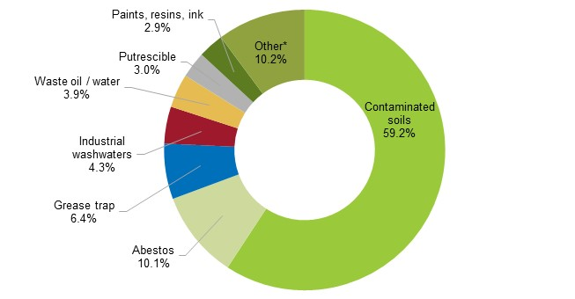Figure : Hazarduous waste arisings in Victoria, 2019–20

* Other includes wastes such as clinical and pharmaceutical wastes, non-toxic salts, mercury and zinc compounds

Table : Hazardous waste types, codes and descriptions

|  |  |  |
| --- | --- | --- |
| Waste type | Waste code | Waste description |
| Contaminated soils | N codes | Cat A, B & C contaminated soils |
| Abestos | N220 | Abestos-containing material |
| Grease trap | K110 (K120) | Grease trap wastes |
| Industrial washwaters | L codes | Industrial and vehicle washwaters |
| Waste oil / water | J120 | Waste oil / water mixtures |
| Putrescible | Other K | Putrescible / organic waste |
| Paints, resins, inks | F codes | Paints, resins, inks, organics sludge |
| Other | Remaining waste codes | Clinical and pharmaceutical wastes, non-toxic salts, mercury and zinc compounds |

Strict controls regulate the movement and management of hazardous wastes to ensure the protection of public health and the environment. These controls dictate how hazardous wastes can be transported, the treatment required to enable reuse and what they can be reused for, and for many wastes, the treatment required before they can be disposed of to landfill.

Of the roughly 1.72 million tonnes of arisings managed in Victoria, approximately 0.19 million tonnes (11.2 per cent) was recovered, 0.09 million tonnes (5.5 per cent) exported interstate for management and 1.43 million tonnes (83.3 per cent) safely disposed of in Victoria after treatment (Figure 2).

Figure : Management and fate of hazardous waste arisings in Victoria, 2019–20

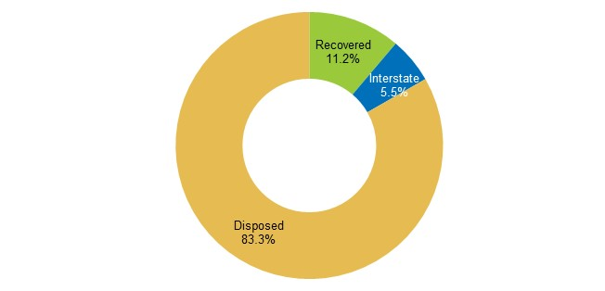



1. The Victorian sector is building resilience to local disruptions and change

In 2019–20, the waste and resource recovery sector experienced several disruptions impacting on material flow and quantities recovered. In October 2019, major material recovery facility operator SKM (a kerbside recycling sorter) went into liquidation, immediately impacting the ability for 35 of Victoria’s 79 councils to sort their kerbside recyclable collections. In March 2020, the sector had to adapt to changed operational requirements and consumer disposal patterns associated with the Victorian Government’s response to the COVID-19 pandemic. Despite 2019–20 being burdened with many unusual situations, Victoria has managed to recover more material for reprocessing than any previous period.

* 1. SKM site closures and material storage

In early 2019, EPA Victoria issued SKM with notices to stop accepting recyclable waste materials at its Laverton North and Coolaroo sites. EPA Victoria issued these notices in response to SKM’s large stockpiles of combustible recyclable material at these sites. In October 2019, SKM was placed into liquidation (McMillan and Vedelago, 2019) and closed permanently. As a result, 35 of the 79 Victorian local governments that had sorting contracts with SKM sent recyclables directly to landfill until December 2019, impacting up to 3 months of this 2019–20 reference period. From October 2019 onwards the facilities previously owned and operated by SKM were purchased by Cleanaway Waste Management (Inside Waste, 2019) and were re-operational by December 2019. The widespread practice of councils sending kerbside collected recyclables directly to landfill ended from January 2020 onwards.

The impact of these actions is apparent from data submitted by councils to the SV Victorian Local Government Annual Waste Services Survey. There was a significant increase in the cost of providing a kerbside recyclables collection service for 2019–20. This year, the cost increased considerably (for the second year in a row) to more than $147 million, $26 million more (21.8 per cent) than the previous period. Concerningly, the cost to councils to provide a recyclable collection service is now slightly more than the cost to provide a garbage collection service. The cost per tonne of recyclables collected was also $48 per tonne higher for SKM-affected councils ($282 per tonne) compared with councils not affected by the SKM closure ($234 per tonne).

Furthermore, at the beginning of 2019–20 there was an estimated 280,000 tonnes of kerbside recyclables in storage (including glass), mostly in metropolitan Melbourne, accumulated through 2018 and early 2019 as a result of SKM sorting facility shutdowns due to non-compliance with EPA Victoria site operating conditions and SKM’s eventual closure. Prior to and during this period, there was a sustained practice of sending unsorted and single stream recyclable material to storage with the intent that it would be sorted or sold and reprocessed at a later date. However, by the end of 2019–20 all of this stored material is now reported to have been removed (Sustainability Victoria, 2020). Figure 3 highlights the change in storage material volumes over 2019–20, with most of the stored material sent to:

* landfill, due to material degredation in storage making it unrecoverable
* reprocessing, particularly glass reprocessing, which saw an increase of 54.5 per cent from 2018–19 to 301,000 tonnes. This can be attributed to increases of glass reprocessing into aggregate material for construction.

Figure : Estimated total recyclable material storage change in Victoria, 2019–20

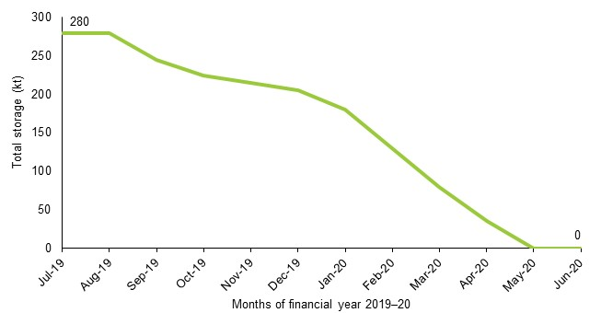

* 1. Waste management during the COVID-19 pandemic

At the beginning of 2020 the coronavirus pandemic became a global issue. In March 2020 the sector had to adapt to changes associated with the Victorian Government’s response to COVID-19. As with many other national and state jurisdictions, the Victorian Government implemented COVID-19 restrictions in an attempt to protect human health. These measures resulted in a shift of consumer waste and recycling disposal behaviours as well as changed operational requirements for collectors and reprocessors. The movements of many Victorians were restricted under stay-at-home orders and so individuals were unable to attend places of work, high-density commercial areas (e.g. shopping centres) or hospitality venues in large numbers.

Figure 4: Proportion of MSW and C&I recovered, 2019–20 vs 5-year average (2014–19)

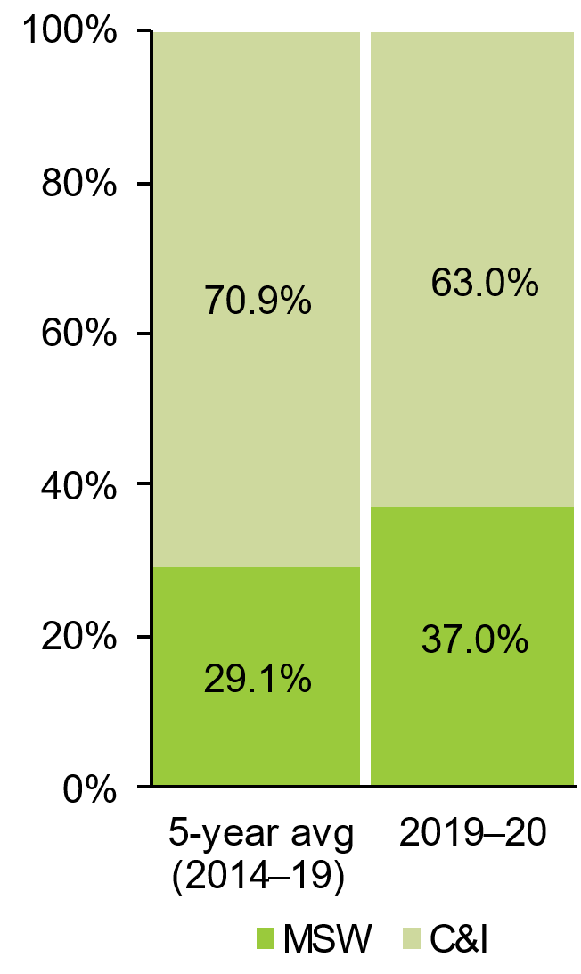

The impact of these lockdowns appears to have slightly offset the expected impact of SKM closures (where associated recyclables went to landfill) on the total tonnes of recyclables collected in kerbside services, which increased by 1.3 per cent compared with 2018–19. The impact of these lockdowns is also evident in the increased organics tonnes collected from kerbside, which increased by 28.7 per cent and set a new record high for Victoria, and the amount of garbage collected from households, where consumption shifted from the commercial and industrial (C&I) sector and into the municipal solid waste (MSW) sector.

The potential impact on sector operations can be seen through the following observations:

* Figure shows that, of the total tonnes of MSW and C&I recovered for reprocessing, the proportion from MSW in 2019–20 was 7.9 percentage points more than the average from the last 5 years
* Table 2 shows the increases in tonnages and costs associated with kerbside collection in 2019–20 compared with 2018–19.

This change in waste and recycling patterns required adaptation from the waste and resource recovery sector.

Table : Kerbside collection (tonnes collected and sorted, annual service cost and cost per tonne) in Victoria, 2018–19 and 2019–20

|  |  |  |  |
| --- | --- | --- | --- |
|  | 2018–19 | 2019–20 | Change |
| Annual service cost | $488,205,008 | $556,423,406 | 14.0% |
| Tonnes collected | 2,189,248 | 2,365,992 | 8.1% |
| Tonnes sorted | 949,341 | 1,065,008 | 12.2% |
| Cost per tonne | $223 | $235 | 5.5% |

In relation to hazardous waste, the impact of COVID-19 pandemic required the continued management of clinical waste. Clinical waste is waste associated with testing, monitoring of treatment of patients suspected or suspected of having a communicable disease, like coronavirus (COVID-19). This waste includes personal protective equipment (PPE) and cytotoxic waste (e.g. needles, swabs, gloves) which are generally safely disposed of through incineration. Compared with 2018–19, there was only a slight increase of 2.1 per cent (0.3 kt) of clinical waste managed. It is thought the anticipated rise in PPE gear due to the pandemic was offset by the limitations of other clinical treatments and procedures.

* 1. Policy changes impact material flows

Recycling Victoria: A New Economy

Recycling Victoria is the Victorian Government’s circular economy policy and action plan, released in early 2020 by the Department Environment, Land, Water and Planning (DELWP). An ambitious policy and framework to transition Victoria’s waste management to a functioning circular economy by 2030, it sets out targets and programs to be delivered against that will fundamentally reduce waste, boost jobs and transform the waste and recycling sector in Victoria.

This policy comes with a Victorian Government investment of more that $300 million to support industry, innovation and the Victorian community in this transformation.

As well as factors associated with SKM and COVID-19, the industry is also adapting to changes associated with state and national policy. A number of policy settings will impact on the flow of material recovered for reprocessing through the Victorian sector. Some examples of these include:

* Under the *Recycling Victoria* policy, the programs most to relevant to changing material flows within the sector are:
  + the Victorian [container deposit scheme](https://www.vic.gov.au/container-deposit-scheme) (CDS), which will incentivise better recycling by offering a cash reward for the return of beverage cans, cartons and bottles
  + kerbside recycling systems reform, which will standardise household waste and recycling services across the 79 local governments by 2030. All households will have access to a collection service, including a glass bin collection service by 2027 and a food and garden organics collection service by 2030.
  + Household bin content standardisation which will set the materials accepted in each bin at the household level for the entire state. This will allow consistent communication and education campaigns and reduce confusion amongst residents between different councils.
* The *National Waste Policy Action Plan 2019*, which sets targets and actions to implement the 2018 National Waste Policy – for example target 6 (which was adopted by *Recycling Victoria* and is tracked in Section 5.2 of this report) to halve the volume of organic waste sent to landfill by 2030 (Department of Environment and Energy, 2019). The plan guides investment and national efforts to 2030 and beyond, reflected in the *Recycling Victoria* policy, and aims to address impediments to a circular economy in Australia. Some of the actions most relevant to changing material flow within the sector are:
  + The waste export bans, as agreed by the Council of Australian Governments (COAG) and released in March 2020, fulfils an action to ban the export of plastic, paper, glass and tyre wastes (COAG, 2020). The COAG export bans set out timelines for each material, with bans for all materials to be in effect by 1 July 2024.
  + The Australian Packaging Covenant Organisation *Action Plan for Problematic and Unnecessary Single-Use Plastic Packaging* to phase out problematic materials (Australian Packaging Covenant Organisation, 2020). It sets out to eliminate nine priority materials[1] by providing a practical framework and a range of resources to help businesses and supply chains identify opportunities to eliminate, redesign, replace or innovate on new packaging solutions and in doing so help drive progress to the target of phasing out these problematic and unnecessary plastics by 2025.

While the above examples are not comprehensive it is evident that a range of policy actions and targets at the national and state level will change the quality and quantity of material flows through the Victorian waste management sector. The sector has demonstrated resilience to dynamic changes and will face further challenges over the next decade.

1. Global shifts in manufacturing supply chains are changing the sector in Victoria
   1. Material flow changes in local and export reprocessing

The 2018–19 financial year saw a national and global shift in how recyclable commodities were utilised and traded. This shift continued into 2019–20, with many countries which Victoria and other Australian jurisdictions traded recyclable commodities with instituting restrictions or bans (China most notably, but also India, Indonesia, Malaysia, Taiwan, Thailand and Vietnam). In addition to these foreign country import bans, the COAG announced in 2020 that four waste materials, namely unprocessed glass (from January 2021), mixed resin / polymer plastics (from July 2021) and single resin / polymer plastics (from July 2022), whole tyres (from December 2021), and mixed paper and cardboard (from July 2024), would be banned from export from Australia (COAG, 2020).

Despite Victoria having a historical reliance on export markets for secondary reprocessing and manufacturing, especially for materials from kerbside recycling bins (plastics, paper and cardboard), Victoria has demonstrated an overall decline in the quantities of exported materials over 2019–20, and an increase in the quantities of locally reprocessed material. These trends point to a sector that is shifting away from export markets and towards local markets for reprocessing. Table 3 presents the material volume changes between local and export reprocessing in 2019–20 compared with 2018–19 as well as the quantities that will be impacted by COAG material export bans.

Table : Material volume changes in local and export reprocessing in Victoria, 2019–20 (percentage change from 2018–19)

| Material | Recovered for reprocessing | Locally reprocessed | Exported for reprocessing | Estimated amount impacted by export ban |
| --- | --- | --- | --- | --- |
| Aggregates, masonry and soil | 6,538,700 | 6,538,700 | 0 | Not applicable |
| up 3.5% | up 3.5% | No change |
| Glass | 300,700 | 296,800 | 3,900 | 3,900  (1 Jan 21) |
| up 54.5% | up 64.6% | down 72.8% |
| Metals | 1,482,400 | 953,800 | 528,600 | Not applicable |
| up 0.5% | down 3.4% | up 8.6% |
| Organics | 1,383,500 | 1,370,200 | 13,300 | Not applicable |
| up 5.1% | up 5.2% | down 2.6% |
| Paper / cardboard | 1,114,800 | 699,200 | 415,700 | 137,800  (1 Jul 21) |
| down 10.8% | down 8.7% | down 14.1% |
| Plastics | 140,100 | 87,600 | 52,500 | 54,000  (unsort: 1 Jul 21)  (unproc: 1 Jul 22) |
| down 1.7% | up 44.5% | down 35.9% |
| Rubber | 62,600 | 32,600 | 30,100 | 14,300  (1 Dec 21) |
| down 13.0% | up 8.4% | down 28.3% |

Numbers in table have been rounded and may not add up within the table or to other figures reported elsewhere in this document. The term ‘unsort’ refers to the ban on unsorted plastics and the term ‘unproc’ to the ban on unprocessed plastics.

1.04 million tonnes of material was exported from Victoria for reprocessing, which is approximately 9.4 per cent of the total material recovered for reprocessing from Victorian sources. Figure 4 shows the top 10 export destintions in 2019–20. These countries accounted for 94.6 per cent of all materials exported from Victoria. The country receiving the highest proportion of recovered materials from Victoria was Bangladesh, followed by Indonesia and China, suggesting local sorters and reprocessors have been able to meet strict import requirements related to contamination levels in materials exported to these countries.

Figure : Major export destinations for recovered material from Victoria, 2019–20

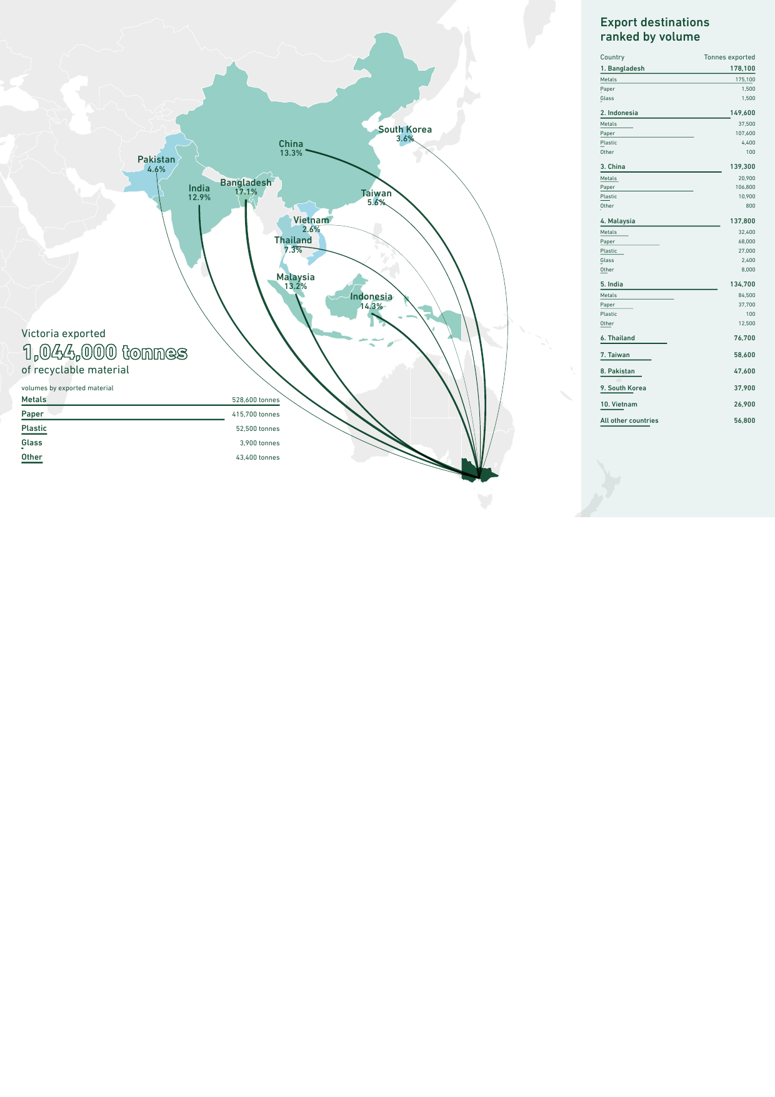

* 1. Commodity values in export markets

Material commodity value plays an important role in ensuring material collected for recycling is converted into new products. The following trends are reported for key recyclable materials for 2019–20:

* For plastics, the value of recovered material is linked to the value for the same virgin products for each plastics type. As reported by the *Recovered Resources Market Bulletin* (July 2020), “The low prices for oil and gas, along with massive new virgin resin manufacturing capacity internationally across the 2017–22 period, are resulting in downwards trending virgin resin prices, that are already at the lowest prices in many years.” This coupled with the low demand for material recovery facility (MRF) grade plastics, which tend to be lower quality, as well as reported export prices declining means there is little value for some reprocessed plastics. In 2019–20 the prices of polyethylene terephthalate (PET), high-density polyethylene (HDPE) and mixed plastics declined by 31.6 per cent, 32.6 per cent and 33.8 per cent respectively.
* For recovered paper and cardboard, there has been a sharp reduction in demand and prices in export markets, and a weak market generally, as global virgin pulp price is “lower than at any time in the last decade” (*Recovered Resources Market Bulletin*, July 2020). This alongside a global pandemic that interrupted operations of “paper and board producers and meant that materials such as old corrugated cartons ceased to be ordered” (*Recovered Resources Market Bulletin*, July 2020) only served to exacerbate paper and cardboard supply chains and prices. In 2019–20, the price of old corrugated cartons declined by 46.4 per cent.
* Metals have experienced a general downwards trend in market commodity value, however, it is not considered problematic material as global demand remains relatively consistent and that is “primarily due to the lack of barriers in using MRF-sourced metal packaging into many steel and aluminium market outlets” (*Recovered Resources Market Bulletin*, July 2020). In 2019–20 the prices of steel and aluminium declined by 29.6 per cent and 15.1 per cent respectively.

Table 4 illustrates the decline in value of plastics, metals, and paper and cardboard between July 2019 and June 2020.

Table : Reported commodity values in July 2019 compared with June 2020

|  |  |  |  |
| --- | --- | --- | --- |
| Material | July 2019 | June 2020 | % change |
| Old corrugated cartons | $196 | $105 | –46.4% |
| Steel | $135 | $95 | –29.6% |
| High-density polyethylene (HDPE) | $500 | $337 | –32.6% |
| Mixed unsorted polymers | $65 | $43 | –33.8% |
| Polyethylene terephthalate (PET) | $380 | $260 | –31.6% |
| Aluminium | $1,100 | $934 | –15.1% |

Source data: Recovered Resources Market Bulletin

* 1. New reprocessing capacity to keep materials local

In response to the waste export ban, the Australian Government announced the Recycling Modernisation Fund, an initiative “to invest over $190 million into expanding Australia’s capacity to sort, process and remanufacture” (Sustainability Victoria, June 2021a) those materials subject to exports bans such as paper and cardboard, plastics and glass.

The Recycling Modernisation Fund is being delivered alongside funding from the Victorian Government’s *Recycling Victoria* policy as the Recycling Victoria Infrastructure Fund (RVIF). To date, $32.1 million has been awarded to eight infrastructure projects to assist businesses in improving the quality of materials recovered during sorting, the capacity to process more materials, and the capability to remanufacture these materials into recycled products.

To date, “the projects funded will create 76 new ongoing full-time jobs and process almost 320,000 tonnes of glass, paper and plastic waste each year – more than doubling Victoria’s domestic glass recycling and boosting domestic plastics recycling by almost 40 per cent” (Sustainability Victoria, June 2021b). The investment and installation of advanced paper recycling technologies in Coolaroo, Melbourne, where a “$37 million investment in a drum pulping system, which eliminates contaminates like plastics from the waste paper stream, will work to transform Victoria’s recycling and remanufacturing landscape and keep more discarded paper out of local landfills” (Waste Management Review, April 2021) is one such project. This project in particular will target materials that have historically been exported.

The RVIF, with contributions from the Victorian and Australian governments, will continue to improve the ability of the local market to process materials in Victoria, removing our reliance on export markets.

* 1. Innovation creating new local markets

Over 2019–20, the [Research, Development and Demonstration program](https://www.sustainability.vic.gov.au/grants-funding-and-investment/funded-projects/recycling-and-reducing-waste/research-development-and-demonstration-grants) (RD&D) at SV invested $1.6 million and leveraged a further $8 million of investment. Funding has supported partnerships between industry and research institutions to develop and test innovative new ways to reuse waste materials. One such partnership between the University of Melbourne and its project partners the North West Program Alliance, Hanson and Department of Transport constructed a demonstration site in March 2020 at the completed level crossing removal project at Reservoir Station. [The site trialled two concrete mixes](https://www.sustainability.vic.gov.au/news/news-articles/breaking-glass-and-breaking-traditions-innovation-in-the-construction-industry) that included both washed and unwashed glass. The trial concluded that when unwashed glass fines are used as a replacement for sand (10% by mass), the mass of contaminants is within the limits for fine aggregate according to Australian Standards. University of Melbourne presented its research findings to Department of Transport, who are in the review process to update Section 703 – General concrete paving, to enable the inclusion of unwashed glass.

A partnership led by Integrated Recycling and Monash Institute of Railway Technology and supported by SV over nearly 4 years through the aforementioned RD&D fund led to the installation of ground-breaking recycled plastic railway sleepers at Richmond train station as part of maintenance work by Metro Trains Melbourne in June 2019. These “sleepers require far less maintenance and have a lifespan of up to 50 years – three times longer than traditional timber sleepers. At the end of their lifetime the sleepers will be recycled into new sleepers, fulfilling the promise of a truly circular economy” (Sustainability Victoria, 2019).This trial led to Metro Trains providing full type approval for Integrated Recycling’s composite sleepers as a replacement for low-profile concrete sleepers and the direct replacement of timber.

* 1. Victorian Recycling Infrastructure Plan

SV’s statutory roles are established under the *Sustainability Victoria Act 2005* and the *Environment Protection Act* 1970 and 2017. This includes the preparation of the *Statewide Waste and Resource Recovery Infrastructure Plan* (SWRRIP).

There have been significant changes in the operating environment since the publication of the 2018 SWRRIP. These include changes to policy settings internationally resulting in significant changes in market value of recycled commodities, announcement of the introduction of export bans of some materials, introduction of a new *Environment Protection Act 2017* (EP Act) (implemented in July 2021), publication of a national waste policy, and Victorian Government commitment to purchase recycled materials.

*Recycling Victoria* requires that the *Victorian Recycling Infrastructure Plan* (VRIP) (the new name of the SWRRIP) be developed, and that it should include planning for hazardous waste infrastructure, planning for waste-to-energy facilities, improved statewide risk and contingency planning, and alignment of land use planning systems with infrastructure planning.

1. SV is tracking Victoria’s performance towards a circular economy and against *Recycling Victoria*’s targets
   1. Measuring Victoria’s progress towards a circular economy

Key Commitment 11 of *Recycling Victoria* commits the Victorian Government to “establish a framework for monitoring progress towards the circular economy, including the identification of indicators and metrics.” New circular economy metrics will measure increases in materials productivity and decreases in environmental impacts achieved through these reforms.

Circular economy indicators and metrics have been designed and are used by a range of countries and states, mainly in Europe and North America, to track progress towards circularity. As such, there is a set of common characteristics that help to define how indicators and metrics are classified. In an Organisation for Economic Co-operation and Development (OECD) 2020 report titled *The OECD Inventory of Circular Economy Indicators*, metrics and indicators were grouped into:

* five main theme categories: environment, governance, economic and business, infrastructure and technology, and jobs
* eleven sector categories: waste; resources and materials; repair, reuse and share; built environment; energy; food; water; public administration; air; other; and non-sector specific
* three measurement scale categories: macro (indicators applicable at national / state level); meso (indicators applicable at industry / sector level); and micro (indicators applicable at business, government department, city, or municipality level).

SV has undertaken a circular economy metrics and indicators identification project in order to understand the:

* scope of requirements for measuring circular economy metrics in Victorian Government – What does the Victorian Government want to achieve by monitoring the circular economy? What questions do we want to answer?
* level and breadth of circular economy metrics used in other jurisdictions locally, nationally and globally – What level of reporting is used in other jurisdictions?
* types and availability of data required for measuring circular economy metrics – What do we already know?

The output from the project has provided SV with recommendations for measuring circular economy metrics in Victoria. From this work SV will also produce a circular economy metrics measurement report.

* 1. Performance against *Recycling Victoria*’s waste targets

*Recycling Victoria* established four targets to measure the state’s performance on waste management:

* Divert 80% of waste from landfill by 2030, with an interim target of 72% by 2025.
* Cut total waste generation by 15% per capita by 2030.
* Halve the volume of organics going to landfill between 2020 and 2030, with an interim target of a 20% reduction by 2025.
* Ensure every Victorian household has access to food and garden organic waste recycling services or local composting by 2030.

Figure : Tracking performance against Recycling Victoria targets

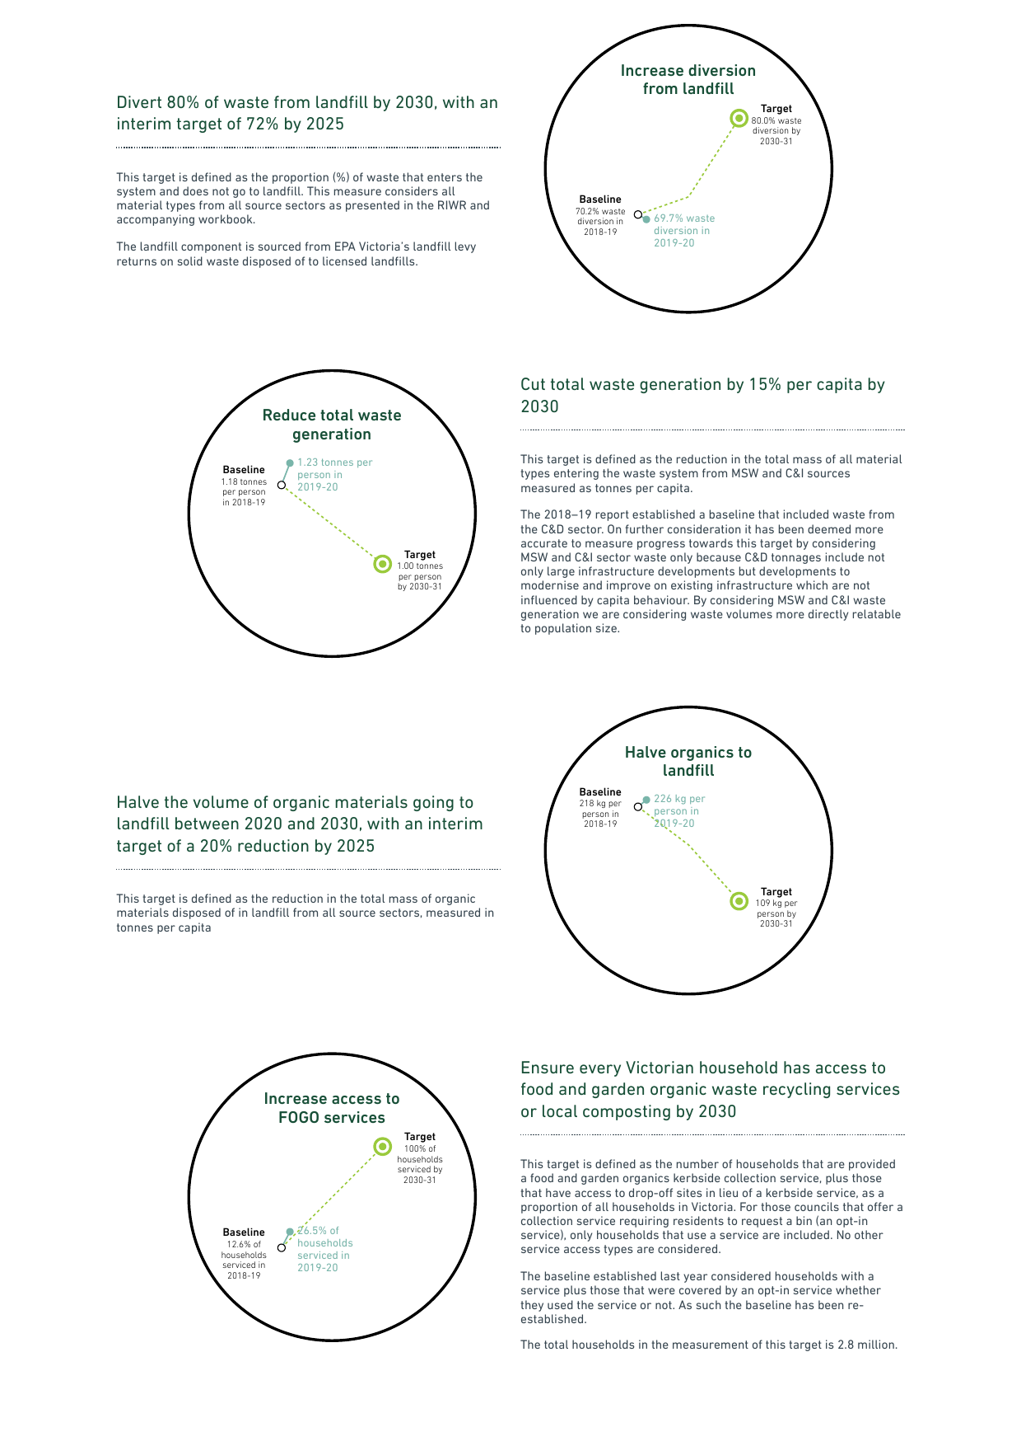

Compared with the 2018–19 baseline there has been a slight change in the percentage of waste diverted from landfill in 2019–20, with 69.7 per cent of waste recovered. It is expected that, as *Recycling Victoria* programs begin to roll out into the industry and community, the diversion rate will increase.



Compared with the 2018–19 baseline there was a 5 per cent increase in total waste generated per capita to 1.24 tonnes per person in 2019–20 (waste generation from the MSW and C&I sectors only). This is likely to be due to increases in organics and municipal construction material associated with increased garden and home renovation projects during COVID-19 restrictions in Victoria.

If looking at all waste generated (including construction and demolition (C&D) waste) there was a 1.9 per cent increase in the total waste generated per capita to 2.4 tonnes per person compared with a baseline of 2.3 tonnes per capita.

The baseline measurement for this target was based on an estimated composition of waste to landfill capture in 2018–19. No new landfill waste composition data was available for 2019–20 and so progress against this target could not be measured for the period. Sustainability Victoria is developing a method to measure progress against this target more frequently. It is expected that the widespread rollout of food and garden organic collection services to Victorian households (as part of *Recycling Victoria* kerbside reform) due to gradually take place across local governments from 2021 will show positive gains towards this target.

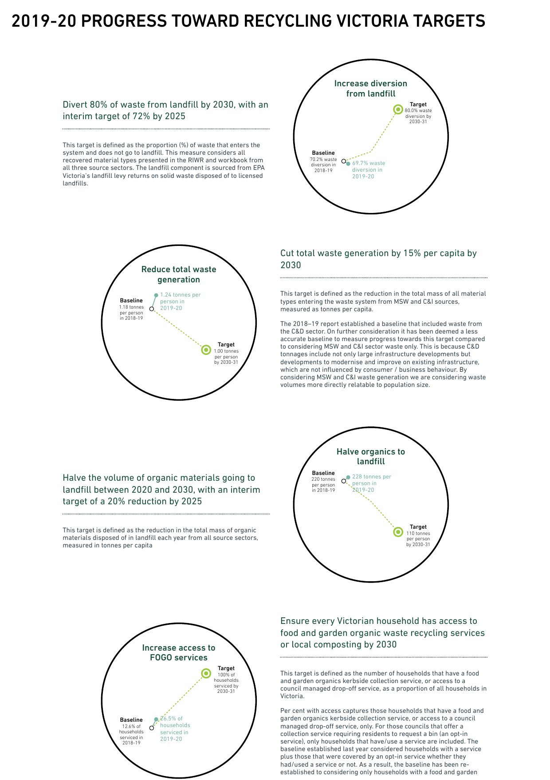

Measurement method in development



Compared with the 2018–19 baseline there has been a 13.9 percentage point increase in the proportion of Victorian households that have a kerbside food and garden organic waste collection service or access to a council managed drop-off service, from 12.6 to 26.5 per cent in 2019–20. This is due to councils rolling out more food and garden organic waste collection services to residents. The proportion of households with this service type is expected to increase due to commitments in *Recycling Victoria* which states, “Mandatory rollout food and garden organics recovery services to households that don’t already have access will commence in 2026–27, with all Victorians to have access to a bin or service by 2030” (DELWP, 2020). With the mandating of these, it is expected that we will achieve this target by 2030 and in doing so “significantly reduce greenhouse gas emissions associated with disposing of organic waste in landfill.”

1. Methods of collecting waste and resource recovery data in Victoria are improving

The Victorian Recycling Industry and Victorian Local Government surveys and reports have occurred annually since 2005–06 and 2001–02 respectively. They provide the Victorian Government with a good understanding of waste management over a 12-month period in relation to local government kerbside waste and the tonnages of waste managed by the resource recovery sector.

While the data collected through these surveys is an invaluable source of insights into waste collected, managed, recovered and reprocessed within Victoria – representing the official statistics that inform much of industry and government decision-making and programs – it is well recognised that there is some way to go to improve how and what information is captured. Here we present the current methodologies used by each survey and the vision towards expanding Victoria’s waste data system as committed by *Recycling Victoria*.

* 1. Method – Victorian Recycling Industry Annual Survey (VRIAS)

## What data does the survey collect?

The VRIAS targets the collection of data on the amount of material recovered for reprocessing by material type and source sector from companies processing Victorian waste. Reprocessing recovered materials, typically an industrial process, results in a material or product that can be productively used. Energy recovery is the process by which embodied energy is captured for use. It is a form of resource recovery, but it is not reprocessing. To avoid double counting, this survey only focuses on materials recovered for reprocessing and no other stages of the resource recovery life cycle, such as collecting, sorting and manufacturing. Additionally the survey does not target materials that have been collected and baled only (unless they are exported) or materials that have been stockpiled. It also does not include materials that have been resold in their original state for reuse, such as clothing sold through second-hand or charity stores.

## How does the survey collect data?

The VRIAS is voluntary and performed annually at the end of the financial year. The VRIAS 2019–20 was conducted between November 2020 and June 2021. It sought data from 99 Victorian waste reprocessing businesses (excluding plastics reprocessors) via a voluntary online survey. The response rate, describing those that submitted a response or chose to opt out of this year’s survey, was 85 per cent, a decrease of 1 percentage point compared with 2018–19. The survey participation rate was 66 per cent as 19 businesses requested to opt out of completing the survey. Only 15 businesses out of 99 contacted did not respond. Please refer to Appendix A of the VRIAS technical report for further details.

Victorian plastic reprocessor data was obtained from the 2019–20 Australian Plastics Recycling Survey prepared by Envisage Works. This survey aims to capture plastic consumption and recycling from surveying a combination of sources including resin producers, resin importers, plastic reprocessors and plastic exporters.

## How are data validated and reported?

The information is self-reported by the organisation before being validated by SV. Validation is done by comparing responses to previous years’ data, by consulting with individual organisations and by adjusting figures for double counts captured in the reported transfer of materials between Victorian reprocessors.

The data are reported in aggregated form, which reduces the impact of statistical anomalies on the findings. The findings are therefore more representative of trends in recovered quantities and these are reported at an overall level as well as groupings by sector and by material type.

Given the manual, voluntary and consultative nature of the survey data collected, it is not surprising that the data may be liable to variability from year to year or errors (for example, material flows subjected to unaccounted double counts or tonnages misappropriated to sector or materials). The best efforts have been made by both respondents and SV to mitigate these and to report representative trends and insights. As such, SV is confident that the findings of these reports represent a good understanding of waste management and recovery in Victoria.

* 1. Method – Victorian Local Government Annual Waste Services Survey (VLGAWS)

## What data does the survey collect?

The VLGAWS collects information from each local government across a range of waste services – household garbage collection and disposal, household recyclables collection and sorting, household organics collection and processing, public litter bin and litter trap collection and disposal, litter clean-up services, street sweeping, hard waste collection services, and landfill and resource recovery centre / transfer station operations.

The data, level of detail and accuracy of data available varies per council. For example, 57 per cent of local governments were able to provide a detailed material composition for all recyclables and contamination rate from either a bin audit or MRF reported audit. All local governments were able to provide data on total tonnages for garbage, recyclables and organics, which represents the key data points for reporting.

## How does the survey collect data?

The VLGAWS is performed annually at the end of the financial year. The VLGAWS 2019–20 was conducted between November 2020 and June 2021. It sought data from all 79 municipalities in Victoria via a voluntary online survey. All 79 local governments participated in the survey to some degree, representing an overall response rate of 100 per cent.

## How is data validated and reported?

The information is self-reported by the local government before being validated by SV. Validation is done using a hierarchical validation structure. First, an internal local government approval process takes place. Two local government representatives participate in the survey, with one respondent and another reviewer confirming submitted data. Second, SV performs validation by calculating and comparing key metrics for each council and comparing responses to previous years’ data for any historical anomalies and by consulting with local governments and Waste and Resource Recovery Groups.

The data are presented in aggregated form, which reduces the impact of statistical anomalies on the findings. The findings are therefore more representative of costs, yields and trends in collection quantities. In various parts of the report, the data are grouped by service provision category, metro and non-metro classification, Waste and Resource Recovery Group region, collection system type and collection frequency.

* 1. What is the Victorian Government doing to improve our data?

Similar to the many goals being committed to, not just in Victoria but in Australia and the rest of the world, targets are being set to monitor and evaluate our progress towards a more sustainable and circular economy. In Victoria these targets are set out in the *Recycling Victoria* policy.

While both of these surveys capture vital components of the waste management life cycle and are used for decision-making and to measure Victoria’s progress towards these targets, it does not capture data at a high enough quality, detail, frequency or completeness to provide entire transparency and accountability for what happens to our waste. “Data are the lifeblood of decision-making and the raw material for accountability. Without high-quality data providing the right information on the right things at the right time; designing, monitoring and evaluating effective policies becomes almost impossible” (United Nations (IEAG) Independent Expert Advisory Group on a Data Revolution for Sustainable Development, 2014). In order to address these issues the *Recycling Victoria* policy established Key Commitment 11: Expand Victoria’s Waste Data Systems (DELWP, 2020). The aim of Key Commitment 11 as stated in the policy is to “help businesses and government better manage waste and make better investment decisions. It will also help the government track Victoria’s progress towards a circular economy.”

Through *Recycling Victoria*, the Victorian Government is investing $7 million to modernise our waste data system to improve decision-making and policy development and provide more transparency about what happens to our waste.

This commitment comes following the Victorian Auditor-General’s Office report of 2019 documenting the inadequacies of current data collection systems and methodologies across Victoria and their ability to accurately monitor and intervene in the waste sector (Victorian Auditor-General’s Office, 2019). The report made strong recommendations to strengthen industry regulation by drafting a new Act that will mandate waste as an essential service; to establish a waste authority whose purpose would be to oversee the performance of the waste and recycling sector; and to generally improve the accuracy, completeness, consistency, timeliness and reliability of data collected.

Already efforts are being made to better understand and transform our collection and use of waste data. Products such as the SV *Recovered Resources* *Market Bulletin*, which detail the latest developments for industry and government around on and off-shore markets for recovered waste, or “the development of national standards and specifications” as set out in the *National Waste Policy Action Plan 2019*, aim to establish consistency to facilitate increased sharing of information across states and so improve performance. Developments to improve tracking of materials such as the introduction of a digital waste tracking system by EPA Victoria which came into effect under the *Environment Protection Act 2017* (EP Act) on 1 July 2021.

While these efforts continue and the sector has a way to go, what we do have is a consistent data set, collecting the same information since the early 2000s and stored securely, allowing us to view general trends over time. While it does not adhere to all the data principles of timeliness and completeness, it does speak to consistency and conformity. The gaps in these reports, described in more detail in Appendix B of the RIWR and the LGWSR, give a good understanding of the similarities, differences and limitations to the insights gained with these reports.

We can only work within what we know now, and we look forward to working with the waste and resource recovery sector to establish a more granular, holistic and timely data system that will improve the evidence base and provide a more detailed understanding of the nature, volumes and destination of waste, for industry, government and the public.

1. References

Australian Packaging Covenant Organisation (2020) [*Action Plan for Problematic and Unnecessary Single-Use Plastic Packaging*](https://apco.org.au/news/20Y4a00000000PaEAI), accessed 23 July 2021.

COAG (2020) [*Phasing Out Exports of Waste Plastic, Paper, Glass and Tyres*](https://www.coag.gov.au/sites/default/files/communique/phasing-out-waste-exports-response-strategy.pdf), accessed 23 July 2021.

Department of Environment and Energy (2019) [*National Waste Policy Action Plan 2019*](https://www.environment.gov.au/protection/waste/publications/national-waste-policy-action-plan)*,* accessed 23 July 2021.

Department of Environment, Land, Water and Planning (DELWP) (2020) [*Recycling Victoria: A New Economy*](https://www.vic.gov.au/transforming-recycling-victoria), accessed 25 June 2021.

Inside Waste (October, 2019), ‘[Cleanaway acquires SKM facilities for 66 million](https://www.insidewaste.com.au/index.php/2019/10/10/cleanaway-acquires-skm-facilities-for-66million/)’, Inside Waste, accessed 23 July 2021.

McMillan and Vedelago (October, 2019), ‘[Recycling firm SKM Industries goes into liquidation, sale expected](https://www.theage.com.au/national/victoria/recycling-firm-skm-industries-goes-into-liquidation-sale-expected-20191005-p52xwc.html)’, *The Age*, accessed 30June 2021.

Organisation for Economic Co-operation and Development (OECD) (2020) [*The OECD Inventory of Circular Economy Indicators*](https://www.oecd.org/cfe/cities/InventoryCircularEconomyIndicators.pdf), accessed 23 July 2021.

Sustainability Victoria (2019, 2020) [*Recovered Resources Market Bulletin*](https://www.sustainability.vic.gov.au/research-data-and-insights/waste-data/recovered-resources-market-bulletin), various dates, accessed 6 June 2021.

Sustainability Victoria (2020), Hazardous Waste Infrastructure Profile, (Commercial-in-confidence, Unpublished).

Sustainability Victoria (June, 2019), ‘[Railway sleepers made from recycled plastic installed at Richmond Train Station](https://www.sustainability.vic.gov.au/news/news-articles/railway-sleepers-made-from-recycled-plastic-installed-at-richmond-train-station)’, accessed 23 July 2021.

Sustainability Victoria (2021a) [*Waste and Recycling in Victoria – Recycling Industry Waste Report 2019–20*](https://www.sustainability.vic.gov.au/research-data-and-insights/waste-data/waste-annual-reports-and-data).

Sustainability Victoria (2021b) [*Waste and Recycling in Victoria – Recycling Industry Waste Workbook 2019–20*](https://www.sustainability.vic.gov.au/research-data-and-insights/waste-data/waste-annual-reports-and-data).

Sustainability Victoria (2021c) [*Waste and Recycling in Victoria – Local Government Waste Services Report 2019–20*](https://www.sustainability.vic.gov.au/research-data-and-insights/waste-data/waste-annual-reports-and-data).

Sustainability Victoria (2021d) [*Waste and Recycling in Victoria – Local Government Waste Services Workbook 2019–20*](https://www.sustainability.vic.gov.au/research-data-and-insights/waste-data/waste-annual-reports-and-data).

Sustainability Victoria (June, 2021a) ‘[Recycling Victoria Infrastructure Fund](https://www.sustainability.vic.gov.au/grants-funding-and-investment/funded-projects/recycling-and-reducing-waste/recycling-victoria-infrastructure-fund)’, accessed 25 June 2021.

Sustainability Victoria (June, 2021b) ‘[Recycling Victoria Infrastructure Fund – Materials (paper and cardboard, plastic, glass) grants](https://www.sustainability.vic.gov.au/grants-funding-and-investment/funded-projects/recycling-and-reducing-waste/recycling-victoria-infrastructure-fund/recycling-victoria-infrastructure-fund-materials-paper-and-cardboard-plastic-glass-grants)’, accessed 25 June 2021.

United Nations (IEAG) Independent Expert Advisory Group on a Data Revolution for Sustainable Development. (November 2014). [*A World That Counts: Mobilising the Data Revolution for Sustainable Development*](https://www.undatarevolution.org/report/), accessed 27 May 2021.

Victorian Auditor-General’s Office (2019) [*Recovering and Reprocessing Resources from Waste*](https://www.audit.vic.gov.au/report/recovering-and-reprocessing-resources-waste?section=)*,* accessed 23 July 2021.

Waste Management Review (April, 2021) ‘[Visy to install advanced paper recycling technology through RMF](https://wastemanagementreview.com.au/visy-to-install-advanced-paper-recycling-technology-through-rmf/)’, Waste Management Review, accessed 23 July 2021.

1. Glossary



|  |  |  |
| --- | --- | --- |
| Term | Acronym(s)  (if applicable) | Description |
| Arisings |  | Hazardous waste is said to ‘arise’ when it causes demand for processing, storage, treatment or disposal infrastructure.  Hazardous waste arisings are the appearance of waste in a waste tracking system (typically measured in tonnes). This is distinct from waste generation, as hazardous waste sometimes arises more than once in Victoria’s current waste tracking system. For example, a hazardous waste consignment may be recorded as moving from a waste generator to a treatment facility and later, treatment outputs could be recorded separately, as moving to a disposal facility. |
| Australian Bureau of Statistics | ABS | An independent statutory agency of the Australian Government responsible for statistical collection and analysis. |
| Commercial & industrial waste | C&I | Solid materials and waste generated from trade, commercial and industrial activities, including the government sector. It includes waste from offices, manufacturing, factories, schools, universities, state and government operations, and small to medium enterprises, e.g. food organics. |
| Construction & demolition waste | C&D | Solid materials and waste generated from residential and commercial construction and demolition activities, e.g. bricks and concrete. |
| Container deposit scheme | CDS | A government scheme to incentivise more and better recycling by offering a cash reward for the return of drink cans, bottles and cartons. |
| Coronavirus disease 2019 | COVID, COVID-19 | Coronavirus, also known as COVID-19, is the contagious respiratory disease that began in 2019 and has resulted in an ongoing global pandemic. |
| Council of Australian Governments | COAG | An intergovernmental forum in Australia whose role is to manage matters of national significance or matters that need coordinated action by all Australian governments. |
| Department of Environment, Land, Water and Planning | DELWP | Victorian Government department providing policy planning, preparation of legislative amendments, leadership coordination and oversight of the environment portfolio. |
| Diversion rate |  | The diversion rate is measured as the amount of waste recovered (not landfilled) of waste that enters the waste management system. It considers all recovered material types presented in the RIWR across all sectors. The landfill component is sourced from EPA Victoria’s landfill levy returns on solid waste disposed of to licensed landfills.  These reports also present two other diversion rates; the Kerbside diversion rate presented in the LGWSR and the MSW diversion rate presented in the RIWR.  These diversion rates are not directly comparable and as such, please refer to Appendix B of both the LGWSR or the RIWR for further information. |
| Environment Protection Authority | EPA | EPA Victoria’s role is to be an effective environmental regulator and an influential authority on environmental impacts. |
| Expanded polystyrene | EPS | See Polystyrene below. |
| Hazardous waste |  | All waste streams currently regulated as prescribed industrial waste in Victoria under the *Environment Protection Act 1970*. Upon commencement of the new *Environment Protection Act 2017* (EP Act) (proposed for 1 July 2021), hazardous waste is the subset of reportable priority wastes where the most stringent duties apply, as stipulated in section 142 and section 143 of the new Act. |
| High-density polyethylene | HDPE, PE-HD | A member of the polyethylene family of plastics, typically referred to as HDPE, used to make products such as milk bottles, pipes and shopping bags. HDPE may be coloured or opaque. |
| Kerbside collection |  | Materials and waste collected by local councils, including garbage, commingled recyclables and garden organics, but excluding hard waste. |
| Kerbside diversion rate |  | The diversion rate as calculated in the LGWSR. A calculation that indicates the amount of kerbside waste diverted from landfills. The kerbside diversion rate is calculated by dividing the tonnes of recyclables and organics collected (less contaminants) by the tonnes of recyclables, organics and garbage collected from the kerbside system (i.e. excludes transfer station and drop-off materials). It is not comparable to the MSW diversion rate as calculated in the RIWR, for further details on this please refer the RIWR or the LGWSR, Appendix B: Comparison of survey data. |
| Landfill |  | A waste disposal site used for the controlled deposit of solid waste onto or into land. |
| Material recovery facility | MRF | A centre for the receipt, sorting and transfer of materials recovered from the waste stream before transporting to another facility for recovery and management. At the MRF, materials may undergo mechanical treatment for sorting by characteristics such as weight, size, magnetism and optical density and may include cleaning and compression. Materials may be received as mixed streams such as commingled recyclables from households and businesses or single streams such as metals. |
| Municipal solid waste | MSW | Solid waste managed predominantly from domestic premises (residual and hard waste) and council activities such as street sweeping, litter collection and street tree lopping. Municipal waste also includes waste dropped off at transfer stations and construction waste from residential owner / occupier renovations. |
| MSW diversion rate |  | The diversion rate of the municipal sector as calculated in the RIWR. A calculation that indicates the amount of municipal waste diverted from landfills. It considers a subset of RIWR materials, namely excludes aggregates, masonry and soil, textiles and rubber, to best fit materials generated from kerbside in the LGWSR.  Please refer to Appendix B: Comparison of survey data for details on the similarities and differences between these in either the RIR or the LGWSR. |
| Organics |  | Any combination of food materials discarded from households or industry and / or organics dervied from garden sources.  Food organics may include food processing waste, out-of-date or off-specification food, meat, fruit and vegetable scraps. Excludes liquid waste. Garden organics may include grass clippings, tree prunings, etc. |
| Organisation for Economic Co-operation and Development | OECD | An intergovernmental economic organisation founded in 1961 to stimulate economic progress and world trade. It provides a platform for member countries to compare policy experiences, seek answers to common problems, identify good practices and coordinate domestic and international policies. |
| Packaging |  | Material used for the containment, protection, marketing or handling of product. Includes primary, secondary and tertiary / freight packaging in both consumer and industrial packaging applications. |
| Pathway |  | Combines the various steps in the route between waste generation and fate, potentially including transfer, storage and / or treatment of hazarduous waste. |
| Polyethylene terephthalate | PET | A member of the polyethylene family of plastics, typically referred to as PET, used to make products such as soft drink bottles, film packaging and fabrics. |
| Polystyrene or expanded polystyrene | PS, PS-E, ESP | A member of the styrene family of plastics, typically referred to as PS. PS can be either a solid or foamed and is used to make protective packaging like packing peanuts as well as yoghurt containers and disposable cutlery. |
| Polyvinyl chloride | PVC | A member of the polyvinyl family of plastics, typically referred to as PVC. PVC can be made into either a rigid form, used to make products such as construction pipe, bottles and bank cards, or into a soft form used to make products such as electrical cabling insulation, imitation leather and vinyl records. |
| Prescribed industrial waste | PIW | Wastes generated from commercial or industrial sources that are potentially hazardous to humans or the environment. |
| Priority waste |  | Priority waste is any waste, including municipal waste and industrial waste, that is prescribed to be priority waste for the purposes of:   * eliminating or reducing risks of harm to human health or the environment posed by the waste * ensuring the priority waste is managed in accordance with the *Environment Protection Act 2017* (EP Act) * facilitating waste reduction, resource recovery and resource efficiency. |
| Recovered |  | Materials recovered and diverted from landfill for reprocessing or use. |
| Recycle / Recycling |  | To convert waste into a reusable material. In common practice, the term is used to cover a wide range of activities, including collecting, sorting, reprocessing and reuse. |
| *Recycling Victoria* | RV | *Recycling Victoria* (short for *Recycling Victoria: A New Economy*)– a policy or framework of the Victorian Government to transition the state to a circular economy. |
| Recycling Victoria Infrastructure Fund | RVIF | A government fund that provides assistance to businesses to develop infrastructure that improves the quality of materials recovered and increase the capacity and capability of Victoria’s resource recovery sector. |
| Reportable priority waste |  | A subset of priority waste that carries the highest levels of controls / duties under the amended *Environment Protection Act 2017* (EP Act). These wastes are often hazardous by nature and pose the greatest level of risk to human health and the environment.[2] |
| Reprocess |  | To put a material that has been used through an industrial process to change it so it can be used again. |
| Reprocessor / Reprocessing facility |  | Facility that uses an industrial process to change the physical structure and properties of materials so they can be used again. This can include facilities that dismantle products, such as tyres, e-waste and mattresses and waste-to-energy facilities that use materials to generate energy. |
| Research, Development and Demonstration program | RD&D | A government program that provides grants for partnerships between businesses, local government and research institutes that are researching and developing new products made from recycled materials such as glass, plastic, organics, electronic waste, concrete, brick and rubber. |
| Solid waste |  | Non-hazardous, non-prescribed, solid waste ranging from municipal garbage to industrial waste. |
| *Statewide Waste and Resource Recovery Infrastructure Plan* | SWRRIP | A 30-year roadmap to improve Victoria’s waste and recycling infrastructure by working with business and government to create an integrated waste and recycling system that maximises the opportunities to reprocess and use recycled materials, reduce the need for raw materials and send less waste to landfill. |
| Stockpiling |  | Storing of excess recovered / reprocessed materials. |
| Sustainability Victoria | SV | Statutory authority established in October 2005 under the *Sustainability Victoria Act 2005* with the key objective of facilitating and promoting environmental sustainability in the use of resources. SV works across the areas of energy, waste and water with communities, industries and government, applying the best ideas and encouraging action to enable change in environmental practices. |
| Treatment |  | Treatment of waste is the removal, reduction or immobilisation of a hazardous characteristic to enable the waste to be reused, recycled, sent to an energy-from-waste facility or disposed. |
| Victorian Local Government Annual Waste Services Survey | VLGAWS | A survey carried out by SV that collects information on the waste and tonnages manged by local government waste services. |
| Victorian Recycling Industry Annual Survey | VRIAS | A survey carried out by SV that collects information on the tonnages of waste managed by the resource recovery sector. |
| *Victorian Recycling Infrastructure Plan* | VRIP | Now known as the *Statewide Waste and Resource Recovery Infrastructure Plan* (see above). |
| Waste |  | Any discarded, rejected, unwanted, surplus or abandoned matter, including where intended for recycling, reprocessing, recovery, purification or sale. Anything that is no longer valued by its owner for use or sale and which is, or will be, discarded. In this document, the term ‘solid waste’ refers to non-hazardous, non-prescribed, solid waste materials ranging from municipal garbage to industrial waste. |
| *Waste and Recycling in Victoria – Local Government Waste Services Report* | LGWSR | A technical report containing the complete data analysis of waste management and recycling services by Victorian local governments. |
| *Waste and Recycling in Victoria – Recycling Industry Waste Report* | RIWR | A technical report containing the complete data analysis of waste management and recovery by the Victorian recycling industry. |
| *Waste and Recycling in Victoria – Strategic Summary Report* | SSR | A summary report containing highlights from this technical report and the accompanying LGWSR and a broader discussion of the state of waste in Victoria. |
| Waste arisings |  | The volumes of waste (measured in tonnes) that have generated a WTC and therefore arisen into the tracking system to be managed by infrastructure. |
| Waste code |  | A three-digit code used to describe wastes. |
| Waste management |  | Management is a broad term that encompasses both waste fates (ultimate destination for a waste) and waste pathways (potentially multiple steps between a waste’s generation and fate). |
| Waste transport certificate | WTC | Certificates that allow the tracking of hazardous waste movements from waste producer to receiving facility as prescribed by the EPA. |

1. Lightweight plastic shopping bags, fragmentable plastics, expanded polystyrene (EPS) packaging for food and beverage service and retail fresh produce, EPS loose fill packaging, moulded EPS packaging for white / brown goods and electronics, rigid polyvinyl chloride (PVC) packaging, rigid polystyrene (PS) packaging, opaque polyethylene terephthalate (PET) bottles and rigid plastic packaging with carbon black
2. ‘[Reportable priority waste](https://www.epa.vic.gov.au/for-business/new-laws-and-your-business/manage-waste/reportable-priority-waste#:~:text=Reportable%20priority%20waste%20is%20generally%20hazardous%20by%20nature.,of%20risk%20to%20human%20health%20and%20the%20environment.)’, Environment Protection Authority Victoria, accessed 22 July 2021.