|  |  |
| --- | --- |
| Waste and recycling in Victoria Recycling industry waste report  2019–20 |  |
| Report by: Sustainability Victoria  November 2021 |  |

|  |  |
| --- | --- |
| Authorised and published by  Sustainability Victoria Level 28, Urban Workshop 50 Lonsdale Street Melbourne  Victoria 3000 Australia  Waste and recycling in Victoria – Recycling industry  waste report, 2019–20  © Sustainability Victoria 2021  November 2021  **Accessibility**  This document is available in PDF and Word format on the internet at [sustainability.vic.gov.au](https://www.sustainability.vic.gov.au/)  While reasonable efforts have been made to ensure that the contents of this publication are factually correct, Sustainability Victoria gives no warranty regarding its accuracy, completeness, currency or suitability for any particular purpose and to the extent permitted by law, does not accept any liability for loss or damages incurred as a result of reliance placed upon the content of this publication.  This publication is provided on the basis that all persons accessing it undertake responsibility for assessing the relevance and accuracy of its content.  This report should be attributed to Sustainability Victoria.  This report is licensed under a Creative Commons Attribution 4.0 International licence.  In essence, you are free to copy, distribute and adapt the work, as long as you attribute the work and abide by the other licence terms.  Go to <http://creativecommons.org/licenses/by/4.0/> to view a copy of this licence.    Data graphics were designed and developed with Little Sketches as part of an SV funded data storytelling residency |  |
| Sustainability Victoria acknowledges Aboriginal and Torres Strait Islander people as the Traditional Custodians of the land and acknowledges and pays respect to their Elders, past and present. | |

Contents

Key waste flows in Victoria, 2019–20 4

Victorian waste management trends to 2019–20 5

1 Overview 6

1.1 Introduction 6

2 Key points 8

2.1 Our waste, our responsibility 8

2.2 Strengthening sector resilience 8

2.3 Sector opportunities in *Recycling Victoria* policy targets 9

3 Material-specific recovery data 10

3.1 Aggregates, masonry and soil 10

3.2 Glass 12

3.3 Metals 13

3.4 Organics 15

3.5 Paper and cardboard 18

3.6 Plastics 19

3.7 Other materials – rubber and textiles 23

4 Material exported for recovery 24

4.1 Annual trends in waste exports 24

4.2 Export composition in 2019–20 25

4.3 Export destinations and import restrictions 26

4.4 Monthly trends in kerbside recycling material exports 27

5 Waste managed in Victoria 29

5.1 Overall waste disposal and recovery 29

5.2 Overall sector disposal and recovery 31

5.3 Overall material disposal and recovery 33

6 Glossary 36

7 Appendix A: Comparison of survey data 40

8 Appendix B: Data method 42

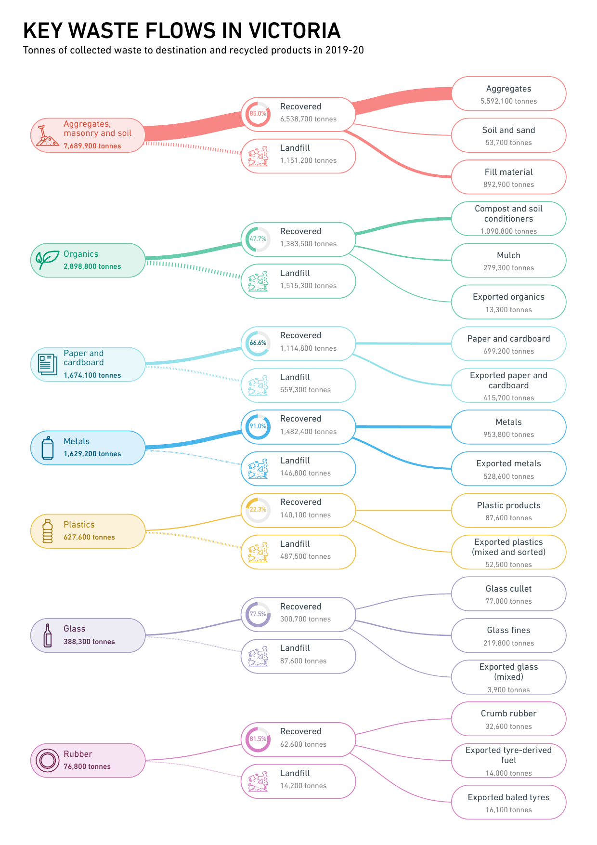

# Key waste flows in Victoria, 2019–20

# An infographic presenting the trends of waste recovery and exporting over time at an overall level and per material. These points are detailed later within the report content. Victorian waste management trends to 2019–20



1. Overview

* 1. Introduction

Every year, the Victorian Government surveys reprocessing organisations across the state to better understand the amount of waste recovered for recycling purposes in Victoria.

This *Waste and Recycling in Victoria – Recycling Industry Waste Report 2019–20* (RIWR)presents the results from a survey of resource recovery activities in 2019–20. The findings in this report are based on the data outlined in the *Waste and Recycling in Victoria – Recycling Industry Waste Workbook 2019–20,* which is available to download from the Sustainability Victoria (SV) website ([sustainability.vic.gov.au](http://www.sustainability.vic.gov.au/)).

This report and the workbook are released concurrently with the *Waste and Recycling in Victoria – Local Government Waste Services Report 2019–20* (LGWSR),which summarises the management of kerbside collected waste in Victoria, the *Waste and Recycling in Victoria – Local Government Waste Services Workbook* containing the data, and the *Waste and Recycling in Victoria – Strategic Summary Report* (SSR),which positions key insights from both reports into context, relating trends to events such as industry changes and government actions. For a comparison of the differences between the LGWSR and this report, please refer to Comparison of survey data.

All of these publications are available on the SV website ([sustainability.vic.gov.au](http://www.sustainability.vic.gov.au/)), which provides public access to the underlying data and includes historically available figures.

These publications and the data collected in the surveys contribute to our understanding of ongoing reform in the sector and allows Victoria to monitor progress towards some of the targets set out in [*Recycling Victoria: A New Economy*](https://www.vic.gov.au/sites/default/files/2020-02/Recycling%20Victoria%20A%20new%20economy.pdf)*,* the Victorian Government’s circular economy policy and action plan, released in early 2020 by the Department of Environment, Land, Water and Planning (DELWP). This is an ambitious decade-long policy and framework to transition Victoria’s waste management to a functioning circular economy by 2030. These targets are outlined below and reported on in the SSR:

* to divert 80 per cent of waste from landfill by 2030
* to cut total waste generation by 15 per cent per capita
* to halve the volume of organic material going to landfill between 2020 and 2030
* to ensure every Victorian household has access to food and garden organic (FOGO) waste recycling services or local composting by 2030.

This RIWR report is divided into five chapters including:

* this introductory chapter
* a chapter with brief discussions on key insights from the report
* a chapter on materials recovered for reprocessing by material type
* a chapter on material exports
* a chapter on the overall trends of disposal and recovery, source sectors and composition of waste materials.

This RIWR presents the results from the survey of resource recovery activities in 2019–20. Resource recovery covers a wide range of activities, including collecting waste, sorting waste, reprocessing waste, manufacturing new products and producing energy from waste. The RIWR provides a detailed summary of:

* the quantities of materials recovered via reprocessing of waste in Victoria. These materials include aggregates, masonry and soil; glass; metals; organics; paper and cardboard; plastics; rubber; and textiles
* the quantities and types of materials sourced from three sectors. These sectors are municipal solid waste (households and council activities, also known as municipal or MSW), commercial and industrial operations (C&I), and construction and demolition sites (C&D).

This RIWR includes data estimates and trends for materials exported overseas from Victoria for reprocessing and waste sent for landfill disposal in Victoria. These additional insights are provided to give a comprehensive view of waste management in Victoria[1] and is done by including data from the following sources:

* Environment Protection Authority (EPA) Victoria data on quantities sent to landfill
* Australian Bureau of Statistics (ABS) commodity export data
* Australian Plastics Recycling Survey data on plastics consumption and recovery.

In the context of this survey and report, it is not reasonable to report numbers to the last available digit as it may give a false impression about the precision of the data. For this reason, rounding of large numbers and long decimals has been performed at the latest stage of analysis and in doing so numbers presented throughout this report may not add up exactly to the totals provided and percentages may not exactly reflect the absolute figures. Rounding makes the publication more readable and avoids spurious accuracy.

1. Key points

To better understand our waste streams, data are only useful if they can be used to set benchmarks, understand trends and determine if goals are being achieved. Likewise, data are less useful if looked at in isolation, without understanding the circumstances and variables that affect the numbers. SV has made a particular effort in bringing more depth and understanding to the survey data by highlighting key points of interest about the data and explaining the trends and achievements against the targets set out in the Victorian Government *Recycling Victoria* policy. Key points relating to this RIWR are discussed below. These key points are explored in more detail in the SSR.

* 1. Our waste, our responsibility

Chapter 4 presents evidence that over the last 5 years Victoria continues a positive trend for increased local reprocessing of recovered materials and decreased export of material for recovery. Compared with 2018–19, there was a 3.8 per cent increase in the amount of recovered material remaining in Victoria for reprocessing and a 7.0 per cent decrease in the amount of recovered material exported for reprocessing. Material exports of plastics were down 35.9 per cent to 52.5 kt kilo tonnes (kt) and glass exports were down 72.8 per cent from 14.4 kt to 3.9 kt.

This trend, as well as indicating a reduction in export market availability, demonstrates the shift by government and industry to encourage the onshore management of our own waste through actions and initiatives such as the Council of Australian Governments (COAG) export ban to phase out waste exports, federal and state investments into programs and funding to boost onshore manufacturing and innovation pertaining to these materials, and the *Recycling Victoria* policy outlining key targets to measure and drive our shift to a circular economy.

* 1. Strengthening sector resilience

A noteworthy increase in the recovery of glass material is highlighted in Section 3.2, where a 54.5 per cent increase was observed compared with 2018–19. This increase is likely to be predominately sourced from long-term glass material stockpiles. Future volumes and quality of locally recovered glass for reprocessing are expected to increase with the introduction of a fourth bin for household glass collections as well as a container deposit scheme (CDS) in Victoria from 2023. Announcements associated with new glass beneficiation capacity and the existing capacity of the recycling network show that Victoria is well placed to handle increased volumes.

The impact of import bans in other countries and the resulting stockpiling of recyclables is evident, with reports of the forced landfilling of recyclables given the absence of alternative recycling pathways throughout 2019–20 ([*Recovered Resources Market Bulletin*](https://www.sustainability.vic.gov.au/research-data-and-insights/waste-data/recovered-resources-market-bulletin), December 2019). However, as evident here with glass, we see the potential of industry to rise to a challenge in a complex and highly interdependent waste and resource recovery management sector.

* 1. Sector opportunities in *Recycling Victoria* policy targets

C&D remains the source sector with the highest diversion rate at 86.2 per cent, followed by C&I at 58.8 per cent and MSW at 48.0 per cent. Given the stable and continuing high diversion rate of the C&D sector, the C&I and MSW sectors present the largest opportunities for taking steps towards the targets outlined in the *Recycling Victoria* policy. One of the *Recycling Victoria* policy targets is to divert 80 per cent of waste from landfill by 2030. Currently we are diverting 69.7 per cent.

In 2019–20, MSW demonstrated a noteworthy change in diversion rate, with an increase of 4.7 percentage points to 1.65 million tonnes (Mt) compared with 1.28 Mt in 2018–19. Future actions, such as the rollout of the CDS from 2023 and the reform of the kerbside recycling system from 2021, supported by education and public awareness campaigns around recycling and other practices such as reusing, repairing, and sharing products, aim to move us closer to the 80 per cent diversion target.

1. Material-specific recovery data

The following sections present data on the tonnages recovered per material for reprocessing, either locally or abroad. Information on the quantities and material types locally reprocessed and exported are presented in Chapter 4.

* 1. Aggregates, masonry and soil

» Aggregate, masonry and soil material recovered for reprocessing increased by 3.5 per cent to 6.54 Mt since 2018–19.

» Ninety-seven per cent of the total aggregate, masonry and soil material recovered for reprocessing was sourced from the C&D sector.

In 2019–20, the amount of aggregate, masonry and soil recovered for reprocessing in Victoria was 6.54 Mt, an increase of 3.5 per cent from 2018–19. This is a smaller increase than previously observed in 2017–18 and 2018–19 but demonstrates a continuing upward trend in the recovery of aggregates, masonry and soil.

Since 2010–11, there has been a 55.9 per cent increase in the total amount of aggregate, masonry and soil recovered for reprocessing. Figure 1 shows the trend over the last 10 years. This increase has been due to continued land clearing associated with new housing developments and infrastructure developments such as rail and roadworks.

Figure 1: Aggregates, masonry and soil waste recovered for reprocessing (kt) in Victoria, 2010–11 to 2019–20

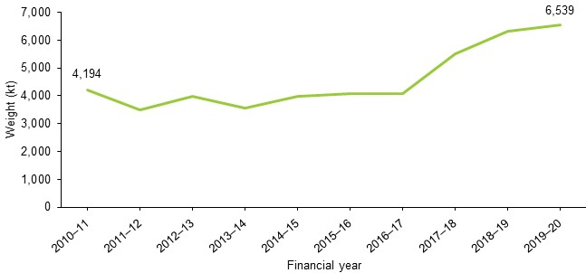

Concrete, bricks, clean fill (including rock and excavation stone) and rubble contributed to 91.7 per cent of all aggregate, masonry and soil waste types recovered. Figure 2 shows the breakdown with 48.7 per cent concrete at 3.18 Mt, 19.8 per cent bricks at 1.29 Mt, 13.7 per cent clean fill at 0.89 Mt and 9.6 per cent rubble at 0.63 Mt. Aggregate, bitumen, asphalt and plaster contributed to the remaining 8.3 per cent.

Figure 2: Material type composition of aggregate, masonry and soil wastes recovered for reprocessing in Victoria, 2019–20

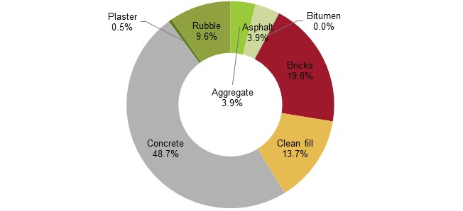

Figure 3 shows the weight (in kilotonnes) of waste recovered for reprocessing by source sector and by material type. The materials were sourced primarily from the C&D sector, which accounted for 96.8 per cent of the total aggregate, masonry and soil materials recovered for reprocessing. This is a consistent trend observed over the last 10 years.

While MSW and C&I account for only 1.5 per cent and 1.8 per cent respectively of the recovered aggregate, masonry and soil for reprocessing, MSW increased by 91.6 per cent to 0.10 Mt and C&I increased by 111.8 per cent to 0.11 Mt.

Figure 3: Aggregate, masonry and soil material type composition by source sector in Victoria, 2019–20

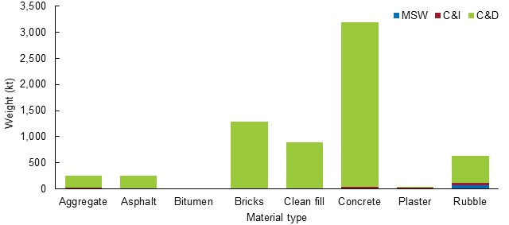

Figure 4 presents the material type composition of waste recovered for reprocessing by source sector in 2019–20. The figure shows:

* rubble was the main material recovered from the MSW source sector at 71.0 per cent (0.07 Mt)
* rubble and plaster were the main materials recovered from the C&I source sector, at 42.4 per cent (0.05 Mt) and 27.9 per cent (0.03 Mt) respectively
* concrete, bricks and clean fill were the main materials recovered from the C&D source sector at 49.7 per cent (3.14 Mt), 20.4 per cent (1.29 Mt) and 14.1 per cent (0.89 Mt) respectively.

Figure 4: Material type composition of aggregate, masonry and soil wastes recovered for reprocessing by source sector in Victoria, 2019–20

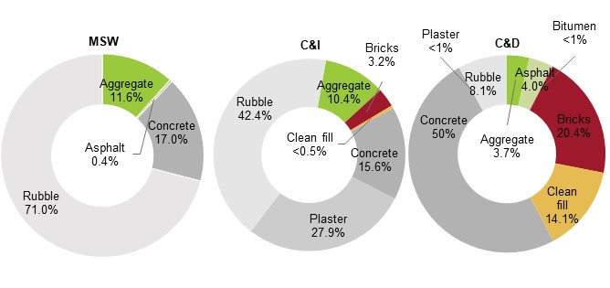

* 1. Glass

» Glass material recovered for reprocessing increased by 54.5 per cent to 300.7 kt since 2018–19. This is likely to be due to material sourced from long-term glass stockpiles.

» 95.6 per cent of the total glass material recovered for reprocessing was sourced from MSW.

In 2019–20, 300.7 kt of glass was recovered for reprocessing in Victoria, a 54.5 per cent increase from 2018–19 (194.7 kt).

Over the last 10 years, the amount of glass that has been reprocessed has varied considerably, as illustrated in Figure 5. The reduction in quantities witnessed between 2014–15 and 2016–17 is likely to signify glass material entering storage following material recovery facility (MRF) sorting and then the rise in 2017–18 due to material coming out of storage. Similarly, the fall and rise witnessed from 2018–19 to 2019–20 is thought to largely be associated with stockpiling of unsorted kerbside recyclable materials by former MRF operator SKM in 2018–19 followed by industry addressing some of this unsorted material and reprocessing stockpiled glass in 2019–20.

Figure 5: Glass waste recovered for reprocessing (kt) in Victoria, 2010–11 to 2019–20

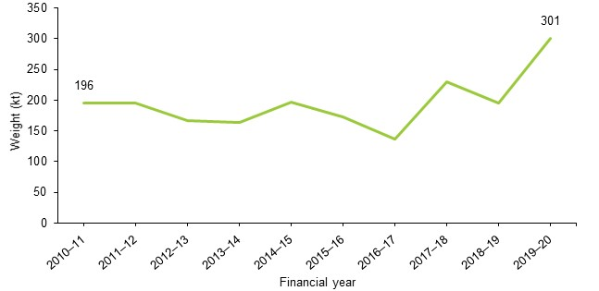

Glass recovered for reprocessing has increased by 54.5 per cent since 2010–11. Since this considers an anomalous amount of glass reprocessing coming from the aforementioned stockpiles, it is likely that this degree of increased reprocessing is somewhat distorted. If considering a smoothed distribution of these reported tonnages, in other words, if redistributing these values across the time frame of the abnormal stockpiles, it is more likely that the typical increased glass reprocessing compared with 2010–11 is in the range of 5 to 15 per cent. Taking either view, smoothed or unsmoothed, there has been a continued rise in reprocessed glass due to growing domestic demand and reuse of glass for road construction and asphalt production.

MSW remains the primary sector from which glass material is recovered. In 2019–20, 95.6 per cent of total glass came from MSW as illustrated by Figure 6, and most of this was container glass. Around 4.1 per cent came from the C&I sector and 0.3 per cent came from the C&D sector, and this was mostly mixed glass.

Figure 6: Sector composition of glass material recovered for reprocessing (by weight) in Victoria, 2019–20

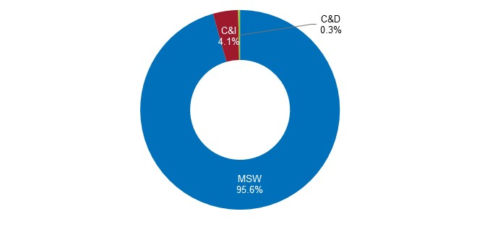

* 1. Metals

» Metals material recovered for reprocessing has remained steady with a 0.5 per cent increase to 1.48 Mt since 2018–19.

» Sixty-five point six per cent of the total metals material recovered for reprocessing was sourced from C&I.

» Ferrous metal was the main material recovered from all sectors, accounting for 86.9 per cent of MSW (301.7 kt), 63.2 per cent of C&I (615.1 kt) and 87.9 per cent of C&D (142.8 kt).

Over the last decade, metals have remained relatively steady in terms of tonnages recovered for reprocessing in Victoria (see Figure 7). In 2019–20, 1.48 Mt of metal was recovered, a 0.5 per cent increase from 2018–19. Since 2010–11 there has been a slight increase from 1.39 Mt to 1.48 Mt an increase of 6.6 per cent.

Figure 7: Metal wastes recovered for reprocessing (kt) in Victoria, 2010–11 to 2019–20

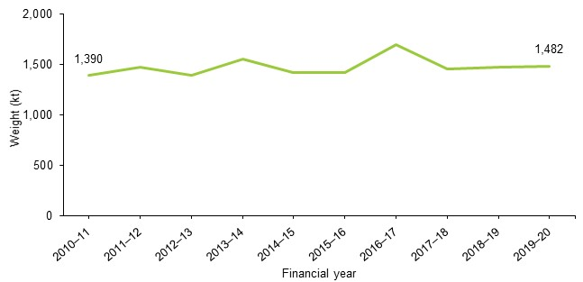

In 2019–20, 65.6 per cent of metal recovered for reprocessing was sourced from the C&I sector, 23.4 per cent from MSW and 11.0 per cent from C&D, as illustrated in Figure 8. Over the last 10 years, the C&I sector has been the predominant source of metal recovered for reprocessing.

Figure 8: Sector composition of metal materials recovered for reprocessing (by weight) in Victoria, 2019–20

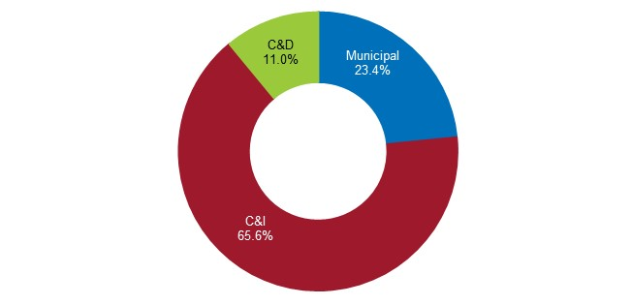

Figure 9 presents the material type composition of metal waste recovered for reprocessing by source sector in 2019–20. The figure shows:

* ferrous metal was the main material recovered from all sectors, accounting for 86.9 per cent of MSW (301.7 kt), 63.2 per cent of C&I (615.1 kt) and 87.9 per cent of C&D (142.8 kt)
* mixed metal was predominately sourced from the C&I sector, accounting for 24.8 per cent of C&I (241.7 kt)
* nonferrous metal was recovered from all sectors, accounting for 11 per cent of MSW (38.0 kt), 11.9 per cent of C&I (116.0 kt) and 11.9 per cent of C&D (19.3 kt).

Without considering source sector, ferrous metals made up 71.5 per cent (1,059.6 kt) of the total amount of metal recovered for reprocessing, mixed metal 16.8 per cent (249.4 kt) and nonferrous 11.7 per cent (173.3 kt).

Figure 9: Material type composition of metal wastes recovered for reprocessing by source sector in Victoria, 2019–20

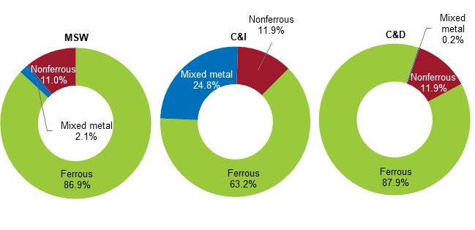

* 1. Organics

» Organic materials recovered for reprocessing increased by 5.1 per cent to 1.38 Mt since 2018–19.

» The MSW sector recovered 26.5 per cent more organic materials compared with   
2018–19.

» Increased availability of kerbside organic collections, rainfall and home gardening during the global COVID-19 pandemic are thought to be the drivers in this increased recovery of MSW.

In 2019–20, 1.38 Mt of organics was recovered for reprocessing in Victoria, a 5.1 per cent increase from 2018–19 (1.32 Mt). Overall, there has been a steady increase over the last 10 years in the tonnes of organics recovered for reprocessing, culminating in a 58.9 per cent increase since 2010–11. Figure 10 presents this trend over time.

Figure 10: Organic wastes recovered for reprocessing (kt) in Victoria, 2010–11 to 2019–20

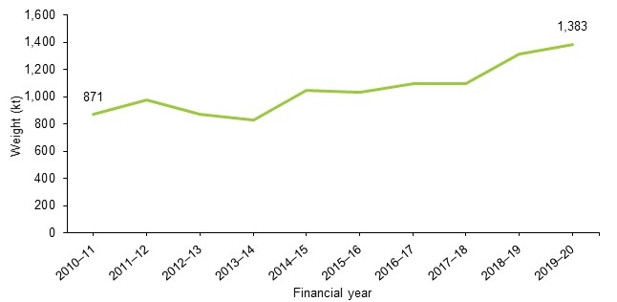

The increase since 2018–19 was due to the quantities recovered from the MSW sector, which increased by 26.5 per cent from 510.2 kt to 645.4 kt. This is likely to be the result of expanded organic waste collection services, increased biomass produced[2] in a wetter year and increased home gardening during the COVID-19 pandemic across Victoria. The C&I sector and C&D sector experienced decreases in the quantities of organic material recovered since 2018–19 by 4 and 28.9 per cent respectively. The C&I sector decreased from 660.6 kt to 634.5 kt and the C&D sector from 145.6 kt to 103.6 kt. For the first time since 2015–16, MSW has comparable quantities recovered for reprocessing to those from C&I. Figure 11 provides a comparison of the sector proportions between 2018–19 and 2019–20, where the proportion from MSW in 2019–20 was 7.9 percentage points more than in 2018–19.

Figure 11: Sector composition of organic material recovered for reprocessing (by weight) in Victoria, 2018–19 and 2019–20

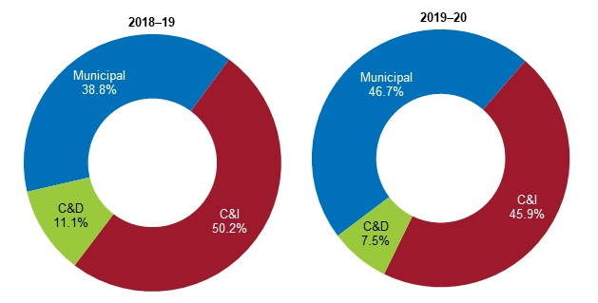

Garden organics, other organics (which includes mixed organics, non-hazardous sludges and some forestry and agricultural residuals), timber and mixed food and garden organics (FOGO) contributed to 92.0 per cent of all organic waste types recovered. Figure 12 shows the breakdown, with 38.6 per cent garden organics at 534.2 kt, 24.4 per cent other organics at 338.1 kt, 14.6 per cent timber at 202.2 kt and 14.3 per cent FOGO at 197.7 kt. Food organics and mulch contribute to the remaining 8.0 per cent at 69.9 and 41.4 kt respectively.

Figure 12: Material type composition of organic waste recovered for reprocessing in Victoria, 2019–20

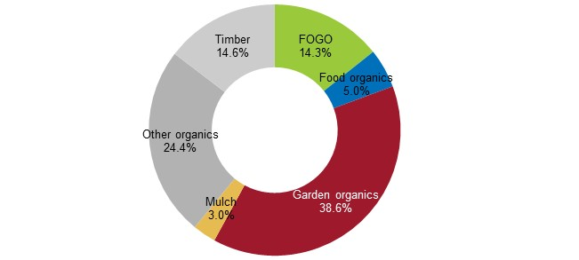

Figure 13 shows the source sectors of recovered organics for reprocessing:

* Garden organics were primarily sourced from MSW, contributing to 80.9 per cent of garden organics recovered.
* Other organics were primarily sourced from C&I, contributing to 91.0 per cent of other organics recovered.
* Food organics were primarily sourced from C&I, contributing to 86.9 per cent of food organics recovered.
* Mixed FOGO were primarily sourced from MSW, contributing to 78.4 per cent of mixed FOGO recovered.
* Timber was primarily sourced from C&D, contributing to 48.0 per cent of timber recovered.
* Mulch was only sourced from C&I.

Figure 13: Organic material type composition by source sector in Victoria, 2019–20

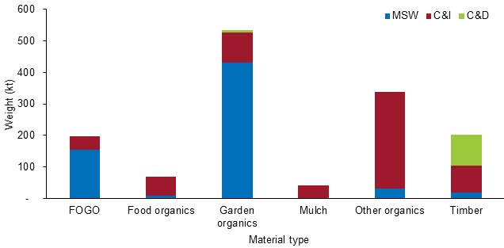

Figure 14 presents the material type composition of waste recovered for reprocessing by source sector in 2019–20. The figure shows:

* garden organics made up 67.0 per cent and FOGO 24.0 per cent of the material recovered for reprocessing from MSW
* other organics made up 48.5 per cent of the material recovered for reprocessing from C&I, followed by garden organics at 15.0 per cent and timber at 13.7 per cent
* timber made up 93.7 per cent of the total organics recovered from the C&D sector, most of this coming from building demolition works, with the remaining 6.3 per cent coming from garden organics.

Figure 14: Material type composition of organic wastes recovered for reprocessing by source sector in Victoria, 2019–20

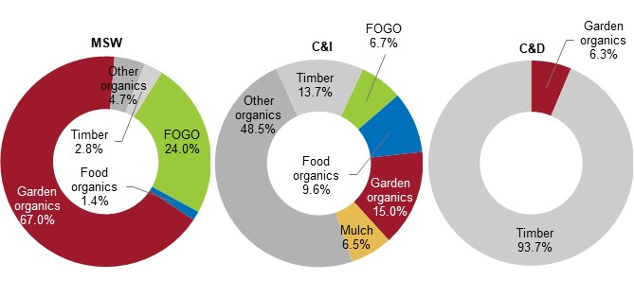

* 1. Paper and cardboard

» Paper and cardboard material recovered for reprocessing decreased by 10.8 per cent to 1.11 Mt since 2018–19.

» Of the 1.11 Mt, 63.9 per cent (0.71 Mt) was paper and 36.1 per cent was cardboard (0.40 Mt).

» C&I contributed 81.7 per cent of paper and cardboard recovered for reprocessing.

» MSW contributed 18.3 per cent of paper and cardboard recovered for reprocessing and consisted of mainly paper.

» Recovered cardboard was mainly sourced from C&I.

In 2019–20, 1.11 Mt of paper and cardboard was recovered for reprocessing in Victoria, a 10.8 per cent decrease from 2018–19 (1.25 Mt). This continues last year’s observed decrease, making a cumulative 24.7 per cent decrease since 2017–18 (1.48 Mt). This reduction in paper recovery is a symptom of the weak market value of recycled and virgin paper products as well as fragmented and interrupted markets. These market trends are discussed in more detail in theSSR.

Figure 15 charts the downwards trend for recovered paper and cardboard, which has decreased by 8.1 per cent since 2010–11.

Figure 15: Paper and cardboard wastes recovered for reprocessing (kt) in Victoria, 2010–11 to 2019–20

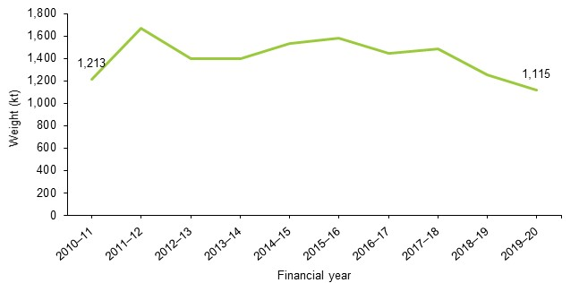

Of the paper and cardboard recovered for reprocessing in 2019–20, 63.9 per cent (712.5 kt) was paper and 36.1 per cent was cardboard (402.3 kt).

Figure 16 illustrates the composition of these material types (paper, cardboard) in relation to the source sectors that they came from in 2019–20. The figure shows:

* paper was primarily recovered from C&I, accounting for 55.9 per cent of the total paper recovered
* paper was the primary material recovered from MSW
* cardboard was primarily recovered from C&I
* the amount of paper and cardboard recovered from the C&D sector was negligible.

Figure 16: Paper and cardboard material type composition by source sector in Victoria, 2019–20

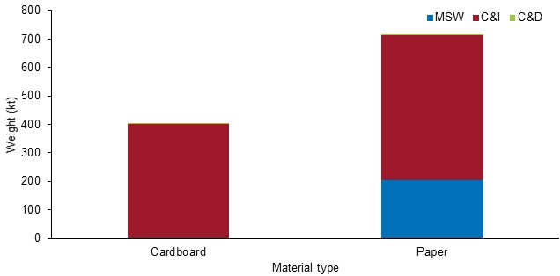

* 1. Plastics

» Plastic materials recovered for reprocessing decreased by 1.7 per cent to 140.1 kt since 2018–19.

» The C&I and MSW sectors contributed 97.7 per cent of the plastic materials recovered for reprocessing.

» PE-HD, PP, PET and PE-LD / LLD contributed to 75.1 per cent of all plastic types recovered.

In 2019–20, 140.1 kt of plastics was recovered for reprocessing in Victoria, a 1.7 per cent decrease from 2018–19 (142.5 kt). Figure 17 presents the trend of plastics recovered for reprocessing over the last 10 years. The trend has remained relatively stable, ranging between 130.7 kt (2016–17) and 160.5 kt (2014–15) in any given year.

Compared with the 146.2 kt recovered in 2010–11, there has been a 4.2 per cent reduction over the 10-year period.

Figure 17: Plastic wastes recovered for reprocessing (kt) in Victoria, 2010–11 to 2019–20

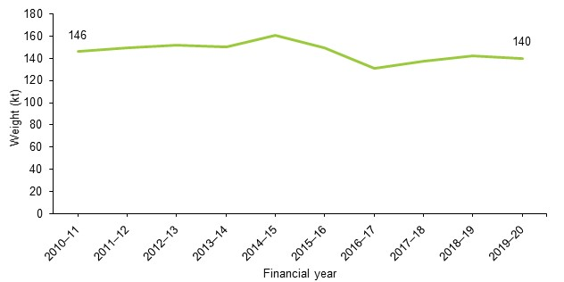

In 2019–20, the total amount of plastics recovered for reprocessing comprised of four key material types consisting of:

* PE-HD (high-density polyethylene, Plastic Identification Code (PIC) 1) used in beverage and home care product packaging, toys, pipe systems and grocery bags
* PP (polypropylene, PIC 5) used in plastic bottle caps, margarine containers, prescription bottles, car parts and protective packaging for medical equipment
* PET (polyethylene terephthalate, PIC 1) used in food, beverage and home care product packaging
* PE-LD / LLD (low-density polyethylene, PIC 4) used in plastic bags, plastic films and plastic containers.

Other plastic materials recovered were PS / PS-E (polystyrene and expanded polystyrene, PIC 6) and PVC (polyvinyl chloride, PIC 3), the material often using in plumbing applications.

PE-HD, PP, PET and PE-LD / LLD contributed to 75.1 per cent of all plastic types recovered. Figure 18 shows the breakdown with 20 per cent PE-HD at 28.5 kt, 19.0 per cent PP at 27.2 kt, 18.0 per cent PET at 25.7 kt and 17 per cent PE-LD / LLD at 23.9 kt. PS / PS–E, Unknown polymers (plastics unidentified by code), PVC and All (a group containing all PIC 7 polymers such as nylon, acrylic, bioplastic and others) made up the remaining 24.9 per cent.

Figure 18: Material composition of plastics recovered for reprocessing in Victoria, 2019–20

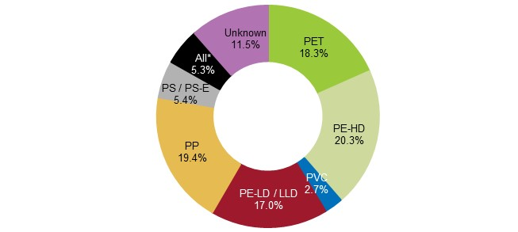

* All refers to the grouping of all PIC 7 polymers such as nylon, acrylic, bioplastic and others.

The C&I and MSW sectors remain the main contributors to the tonnages of plastic recovered for recycling, contributing 47.0 per cent and 51.0 per cent respectively. Figure 19 illustrates the plastic material types recovered for reprocessing by source sector. It shows that:

* PE-HD was primarily sourced from MSW, accounting for 75.8 per cent of all PE-HD recovered
* PP was primarily sourced from MSW and C&I, accounting for 46.7 and 51.8 per cent of all PP recovered
* PET was primarily sourced from MSW, accounting for 67.3 per cent of all PET recovered
* PE-LD / LLD was primarily sourced from C&I, accounting for 75.7 per cent of all PE-LD / LLD recovered
* PS / PS-E was primarily sourced from MSW, accounting for 52.6 per cent of all PS / PS-E recovered
* PVC was primarily sourced from C&I, accounting for 50.0 per cent of all PVC recovered.

Figure 19: Plastic material type composition by source sector in Victoria, 2019–20

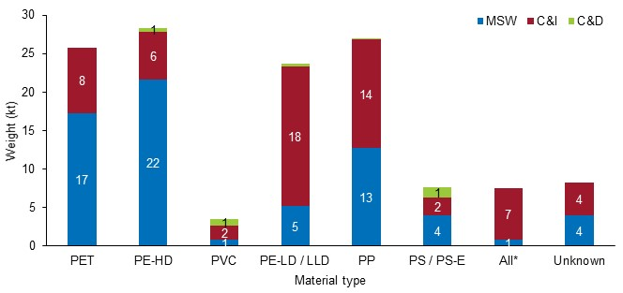

* All refers to the grouping of all PIC 7 polymers such as nylon, acrylic, bioplastic and others.

Figure 20 presents the material type composition of plastic waste recovered for reprocessing by source sector in 2019–20. The figure shows:

* the main materials recovered from MSW were PE-HD (32.5 per cent), PET (26.1 per cent) and PP (19.1 per cent), accounting for 77.7 per cent (51.6 kt) of all plastic materials recovered from MSW (66.4 kt)
* the main materials recovered from C&I were PE-LD / LLD (29.2 per cent), PP (22.8 per cent) and PET (13.6 per cent), accounting for 65.6 per cent (40.6 kt) of all plastic materials recovered from C&I (61.9 kt)
* the main materials recovered from C&D were PS / PS-E (41.9 per cent), PVC (25.8 per cent), PE-HD (16.1 per cent) and PE-LD / LLD (12.9 per cent), accounting for almost all, 96.8 per cent, of all plastic materials recovered from C&D (3.1 kt).

Figure 20: Material type composition of plastics recovered for reprocessing by source sector in Victoria, 2019–20

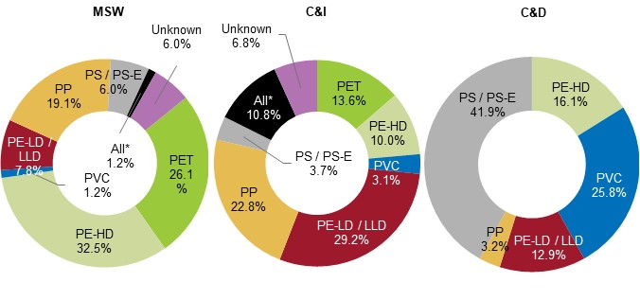

* All refers to the grouping of all PIC 7 polymers such as nylon, acrylic, bioplastic and others.

* 1. Other materials – rubber and textiles

Other materials comprise of rubber and textiles. This is 0.9 per cent of the total recovered materials in 2019–20. This year, 62.6 kt of rubber and 32.0 kt of textiles were recovered for reprocessing. Figure 21 shows the trend of rubber and textile material recovered over the last 10 years. For rubber, there was a 13.0 per cent decrease from 2018–19 (72.0 kt); this continues a downwards trend following a spike in reprocessing quantities in 2017–18 due to tyre stockpile clean-up activities. As such, the observed decrease in recovery may be closer to the quantity of tyres generated for reprocessing.

For textiles, there was a large increase in recovered tonnes compared with the 0.6 kt reported in 2018–19. This is due to more industry engagement and a higher response rate from textile reprocessors. Due to its anomalous nature, it is difficult to comment on the trend for textile recovery. The industry is certainly more engaged and hints towards a strengthening area of material recovery.

Figure 21: Rubber and textile waste recovered for reprocessing (kt) in Victoria, 2010–11 to 2019–20

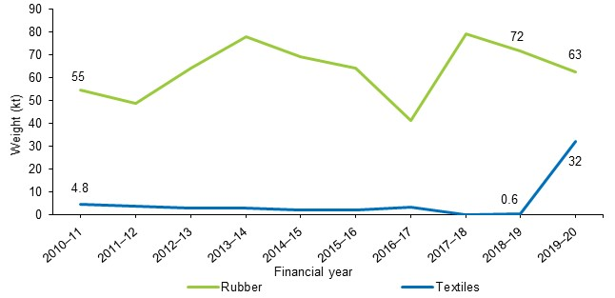

1. Material exported for recovery

» Victoria’s resources were predominantly reprocessed locally, with 90.6 per cent of all recyclables processed within the state.

» The quantity of materials exported for reprocessing overseas decreased by 7.0 per cent compared with 2018–19 to 1.04 Mt, as exporters were unable to find overseas markets for recyclable materials.

» The top 10 receiving countries of Victorian waste exports accounted for 94.6 per cent of all material exported. Bangladesh (17.1 per cent), Indonesia (14.3 per cent), China (13.3 per cent), Malaysia (13.2 per cent) and India (12.9 per cent) accepted the most by weight.

» Paper and cardboard made up the largest component of kerbside recyclables that were exported for reprocessing, peaking at 15.4 kt in February 2020. Exports of plastics and metals were steady across the year and exports of glass varied month-to-month in 2019–20.

* 1. Annual trends in waste exports

In 2019–20, Victoria’s resources were mostly reprocessed locally. Figure 22 shows the tonnes of materials remaining in Victoria and exported overseas or interstate since 2005–06. In 2019–20, 90.6 per cent or around 10.01 Mt of recovered material remained in Victoria to be reprocessed by local plants. This is an increase of 3.8 per cent compared with the 9.64 Mt that remained for local reprocessing in 2018–19. The other 9.4 per cent or 1.04 Mt was exported overseas or interstate. This is a decrease of 7.0 per cent compared with the 1.12 Mt exported for reprocessing in 2018–19.

The quantity of materials remaining in Victoria has increased by 2.92 Mt since 2014–15 (7.09 Mt), while the quantity of exported materials has declined by around 0.14 Mt since 2014–15 (1.19 Mt). This indicates a shift in export markets, especially in import countries that have implemented bans to ensure the quality of recevied material is maintained.

Figure 22: Material reprocessed locally or exported overseas or interstate from Victoria, 2005–06 to 2019–20

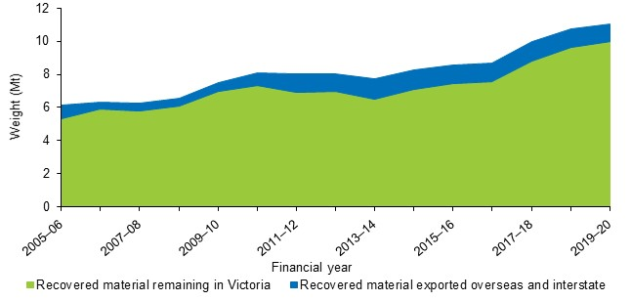

* 1. Export composition in 2019–20

Of the total quantity of materials exported (by weight) in 2019–20, metals, and paper and cardboard accounted for 90.4 per cent (0.94 Mt). Figure 23 presents the composition of materials exported for reprocessing from Victoria in 2019–20, where metals made up 50.6 per cent (0.53 Mt) and paper and cardboard made up 39.8 per cent (0.42 Mt). The remaining 9.6 per cent consisted of plastics, rubber, textiles, glass and organics.

Figure 23: Composition of materials exported for reprocessing from Victoria, 2019–20

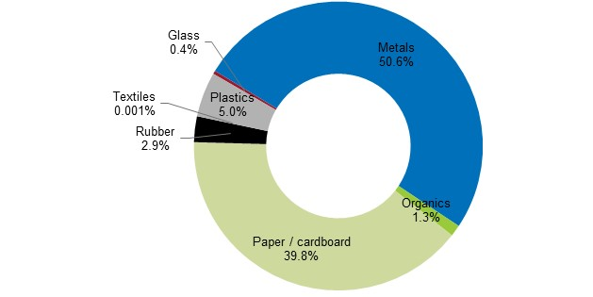

Figure 24 shows the proportions of material quantities reprocessed locally to quantities exported for reprocessing in 2018–19 and 2019–20. In 2019–20, local reprocessing for glass, paper and cardboard, plastics and rubber in Victoria increased relative to the quantities exported with glass, plastics and rubber showing the most noteworthy change. The change in glass, plastics and rubber suggests that due to the closure of some export markets for these materials, there are developments in local markets and in facilities accessing these markets both within Victoria and other jurisdictions.

Paper and cardboard was the only material to demonstrate both a decrease in the quantities exported and in the quantities that were locally reprocessed, which suggests that with the closure of some export markets for this material the market and infrastructure for recycled paper products is weak.

Metals were the only materials to demonstrate an increase in exported quantities relative to quantities reprocessed locally in 2019–20 however this was slight, and no real conclusion may be drawn. Lower value materials, such as material from C&D activities and FOGO, are rarely exported, if at all, as it is financially unviable to do so.

Figure 24: Proportions of materials reprocessed in Victoria and exported from Victoria for reprocessing by material type, 2018–19 and 2019–20

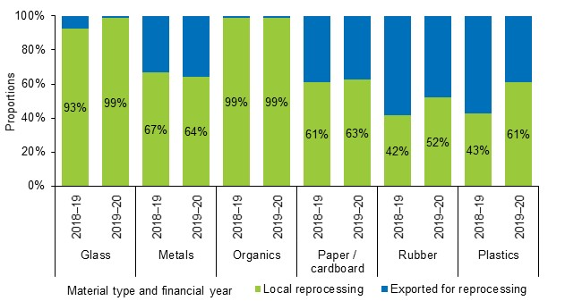

In 2019–20, local reprocessing of:

* glass increased by 64.6 per cent from 180.3 kt to 296.8 kt, which aligns with increased clearance of long-term stockpiles and use of recycled glass in construction material
* plastics increased by 44.5 per cent from 60.6 kt to 87.6 kt
* paper and cardboard decreased by 8.7 per cent from 765.4 kt to 699.2 kt, which is in line with overall reductions in paper and cardboard quantities managed
* rubber increased by 8.4 per cent from 30.0 kt to 32.6 kt
* metals decreased by 3.4 per cent from 987.6 kt to 953.8 kt.

During the same 12-month period, quantities exported for reprocessing of:

* glass decreased by 72.8 per cent from 14.4 kt to 3.9 kt
* plastics decreased by 35.9 per cent from 81.9 kt to 52.5 kt
* rubber decreased by 28.3 per cent from 41.9 kt to 30.1 kt
* paper and cardboard decreased by 14.1 per cent from 483.9 kt to 415.7 kt
* metals increased by 8.6 per cent from 486.9 kt to 528.6 kt.
  1. Export destinations and import restrictions

In 2019–20, exports of recyclable materials were sent from Victoria to around 70 destinations worldwide. Table 1 presents the top 10 destinations for exports of recyclable material from Victoria in 2019–20. These top 10 countries accounted for 94.6 per cent by weight of all material exported. The countries that accepted the most material were Bangladesh (17.1 per cent), Indonesia (14.3 per cent), China (13.3 per cent), Malaysia (13.2 per cent) and India (12.9 per cent).

Table 1: Top 10 destinations for exports of recyclables (in kt) from Victoria, 2019–20

| Destination country | Glass  (kt) | Metals  (kt) | Paper / cardboard (kt) | Plastics  (kt) | Other†  (kt) | Total  (kt) |
| --- | --- | --- | --- | --- | --- | --- |
| Bangladesh* | 1.5 | 175.1 | 1.5 | 0.0 | 0.0 | 178.1 |
| Indonesia* | 0.0 | 37.5 | 107.6 | 4.4 | 0.1 | 149.6 |
| China* | 0.0 | 20.9 | 106.8 | 10.9 | 0.8 | 139.3 |
| Malaysia* | 2.4 | 32.4 | 68.0 | 27.0 | 8.0 | 137.8 |
| India* | 0.0 | 84.5 | 37.7 | 0.1 | 12.5 | 134.7 |
| Thailand* | 0.0 | 27.6 | 48.1 | 1.0 | 0.0 | 76.7 |
| Taiwan* | 0.0 | 50.3 | 4.5 | 3.8 | 0.0 | 58.6 |
| Pakistan | 0.0 | 42.6 | 5.0 | 0.0 | 0.0 | 47.6 |
| South Korea* | 0.0 | 28.9 | 6.5 | 0.1 | 2.4 | 37.9 |
| Vietnam* | 0.0 | 5.6 | 20.2 | 1.1 | 0.0 | 26.9 |
| Top 10 destinations total | 3.9 | 505.2 | 405.9 | 48.3 | 23.8 | 987.2 |
| All destinations total | 3.9 | 528.6 | 415.7 | 52.5 | 43.4 | 1,044.0 |
| Top 10 proportion of total | 100% | 96% | 98% | 92% | 55% | 95% |

* Indicates that country had some form of restrictions on the importation of waste.   
† ‘Other’ includes rubber, textiles and organics.  
Figures in Table 1 have been rounded to the nearest hundred and may not match totals reported in other parts of this report.

Notably, in 2019–20 each material had a dominant country that received more exports from Victoria than other countries, such as:

* plastics, to Malaysia – 51.5 per cent (27.0 kt) of total plastics exported
* glass, to Malaysia – 61.7 per cent (2.4 kt) of total glass exported
* metals, to Bangladesh – 33.1 per cent (175.1 kt) of total metals exported
* paper and cardboard, to Indonesia – 25.9 per cent (107.6 kt) of total paper and cardboard exported
* the other grouping (rubber, textiles and organics), to India – 28.9 per cent (12.5 kt) of the total other grouping, which is predominantly rubber.
  1. Monthly trends in kerbside recycling material exports

In 2019–20, monthly exports of kerbside recyclable bin materials varied. Figure 25 presents the exports of paper and cardboard, metals, glass and plastics that are estimated to come from household kerbside recyclables bins. These figures are based on export quantities as reported by the ABS with estimates of the proportion that comes from kerbside recycling bins applied. These applied estimates are based on industry knowledge and were developed for the [*Recovered Resources Market Bulletin*](https://www.sustainability.vic.gov.au/research-data-and-insights/waste-data/recovered-resources-market-bulletin).

Paper and cardboard exports made up the largest component of kerbside recyclables that were exported for reprocessing at 76.1 per cent (136.6 kt) of the total materials exported. The remaining 23.9 per cent (43.0 kt) comprised 12.4 per cent (22.2 kt) plastics, 9.5 per cent (17.1 kt) metals and only 2.0 per cent (3.6 kt) glass. Figure 25 illustrates the monthly trends for exports and shows that the monthly exports of:

* paper and cardboard varied between 15.4 kt (February 2020) and 7.7 kt (May 2020)
* plastics varied between approximately 2.6 kt (July 2019) and 1.1 kt (May 2020)
* metals varied between approximately 2.3 kt (June 2020) and 1.0 kt (August 2019 and April 2020)
* glass varied from a high of 1.3 kt (July 2019) to 0 tonnes (from November 2019 to February 2020 and June 2020).

Monthly variations in export quantities reflect the nature of supply and demand for material across global manufacturing.

Figure 25: Monthly trend in kerbside recyclable material exports from Victoria, 2019–20

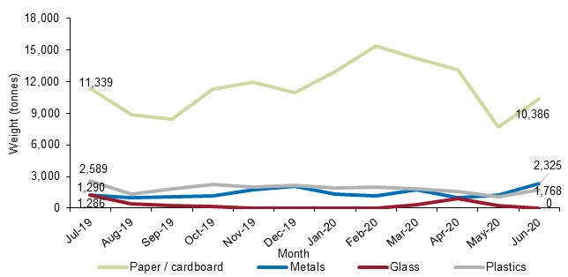

1. Waste managed in Victoria



* 1. Overall waste disposal and recovery

» More waste was managed than ever before, increasing by 3.4 per cent from 2018–19 to 15.86 Mt, the slowest rate since 2016–17.

» Total waste managed per person increased by 1.9 per cent to 2.37 tonnes, the slowest rate since 2016–17.

» Total waste recovered per person increased by 1.2 per cent to 1.65 tonnes.

» Total waste managed per million dollars of gross state product (GSP) increased by 2 per cent to 33.9 tonnes.

» The diversion rate is estimated to be 69.7 per cent, a slight decrease from 2018–19.

In 2019–20, a total of 15.86 Mt of waste was managed in Victoria, an increase of 0.53 Mt or 3.4 per cent from the previous year (15.33 Mt). Of this, the amount of waste diverted from landfill for recovery was 11.05 Mt and the amount sent to landfill was 4.81 Mt.

Given this, the overall diversion rate remained at 69.7 per cent compare with 70.2 per cent in 2018–19, meaning of the total waste generated in Victoria a larger proportion was sent to landfill than in the previous year. This was led by changes in per sector diversion rates discussed in the next section.

Over the last 10 years there has been a 24.8 per cent increase in total waste managed, a 3.6 per cent increase in total waste landfilled and a 37.0 per cent increase in total waste recovered for reprocessing. On average, total waste managed has increased at a rate of 2.5 per cent year-on-year, the waste landfilled at a rate of 0.4 per cent and the waste sent to recovery at a rate of 3.7 per cent. This illustrates a strong growth of the resource recovery industry as well as consumer behaviour during this time. Figure 26 presents the trend in waste managed in Victoria since 2010–11.

Figure 26: Waste managed (kt) in Victoria, 2010–11 to 2019–20

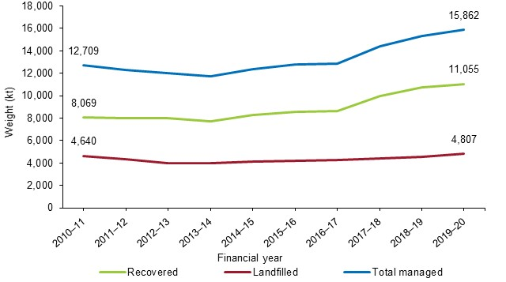

Table 2 shows the diversion rate of waste managed relative to gross state product (GSP) and population since 2010–11. Over this period the diversion rate has increased from 63.5 per cent in 2010–11 to 69.7 per cent in 2019–20 and the total waste generated per capita has increased from 2.29 tonnes per person to 2.37 tonnes per person (3.2 per cent). This shows that while we are generating more waste per person than 10 years ago, we are also recovering more.

The total tonnes of waste managed per GSP has fluctuated over the years, averaging at about 33.7 tonnes during this time but decreasing overall. Since 2010–11, waste generated per million dollars of GSP has decreased by 12.2 per cent, meaning the state has demonstrated higher economic activity relative to the tonnes of waste managed.

Table 2: Diversion rates and waste managed relative to economic and population trends in Victoria, 2010–11 to 2019–20

|  |  |  |  |  |  |  |  |  |  |  |
| --- | --- | --- | --- | --- | --- | --- | --- | --- | --- | --- |
|  | 10–11 | 11–12 | 12–13 | 13–14 | 14–15 | 15–16 | 16–17 | 17–18 | 18–19 | 19–20 |
| Diversion rate (%)† | 63.5 | 65.0 | 66.6 | 65.8 | 66.7 | 67.2 | 67.0 | 69.2 | 70.2 | 69.7 |
| Tonnes waste managed per capitaꞋ | 2.29 | 2.18 | 2.09 | 1.99 | 2.06 | 2.07 | 2.04 | 2.23 | 2.32 | 2.37 |
| Tonnes waste managed per $ million GSP* | 38.6 | 35.9 | 34.3 | 32.4 | 32.8 | 32.5 | 30.9 | 32.8 | 33.2 | 33.9 |
| Total tonnes waste managed (Mt) | 12.71 | 12.33 | 12.04 | 11.76 | 12.40 | 12.78 | 12.87 | 14.43 | 15.33 | 15.86 |

† Data on solid waste disposed of at licensed landfills, used in the calculation of diversion rate, was sourced from EPA Victoria’s landfill levy returns.

ꞋThis includes waste generated across all sectors; MSW, C&I and C&D. The Recycling Victoria target discussed in SSR includes waste from MSW and C&I only.

* Please refer to the accompanying [workbook](https://www.sustainability.vic.gov.au/research-data-and-insights/waste-data/waste-annual-reports-and-data) for the time series of GSP.

In 2019–20, compared with 2018–19, the total waste managed relative to GSP increased by 2.0 per cent to 33.9 tonnes for every million dollars of GSP, which indicates that we produced more waste relative to our state’s economic activity than in 2018–19.

With the implementation of *Recycling Victoria* it is expected that economic activity will continue with increasing efficiency of material use and the reduction or elimination of material by-products.

In 2019–20, the total waste managed relative to population increased by 1.9 per cent to 2.37 tonnes per capita, the slowest increase since 2016–17, and suggests a growing population that is more consumer conscious. An analysis of these headline figures in relation to targets set by *Recycling Victoria* is provided in the SSR.

* 1. Overall sector disposal and recovery

» The C&D sector achieved a diversion rate of 86.2 per cent, followed by C&I with 58.8 per cent and MSW with 48.0 per cent, a 4.7 percentage point increase on 2018–19.

» The C&D sector accounted for 59.7 per cent (6.59 Mt) of the total recovered materials received for reprocessing in Victoria in 2019–20, followed by C&I accounting for 25.4 per cent (2.81 Mt) and MSW accounting for 14.9 per cent (1.65 Mt).

» The amount of MSW waste recovered for reprocessing increased by 28.7 per cent from 2018–19 to 1.65 Mt.

» The amount of C&I waste recovered for reprocessing decreased by 4.7 per cent from 2018–19 to 2.81 Mt.

» The COVID-19 lockdown measures are thought to be the main driver for this observed shift in the quantities of materials sourced from C&I to MSW.

In 2019–20, a total of 7.66 Mt of waste was managed in the C&D sector, an increase of 1.4 per cent or 0.11 Mt from the previous year (7.55 Mt) (Table 3). Of this, the amount of waste diverted from landfill for recovery was 6.60 Mt and the amount sent to landfill was 1.06 Mt.

In MSW, a total of 3.44 Mt of waste was managed, an increase of 16.1 per cent from the previous year (2.96 Mt). Of this, the amount of waste diverted from landfill for recovery was 1.65 Mt, and the amount sent to landfill was 1.79 Mt.

In C&I, a total of 4.77 Mt of waste was managed, a decrease of 1.1 per cent from the previous year (4.82 Mt). Of this, the amount of waste diverted from landfill for recovery was 2.81 Mt and the amount sent to landfill was 1.96 Mt.

Given this, the diversion rate in MSW (48.0 per cent) increased by 4.7 percentage points in 2019–20 compared with 2018–19; however, the diversion rates for C&I (58.8 per cent) and C&D (86.2 per cent) decreased by 2.2 percentage points and 0.4 percentage point respectively.

Table 3: Tonnages (Mt) disposed of and received for reprocessing (including diversion rate) by source sector in Victoria, 2018–19* and 2019–20

|  |  |  |  |  |  |  |  |  |  |  |  |
| --- | --- | --- | --- | --- | --- | --- | --- | --- | --- | --- | --- |
| Financial year | Municipal† | | | C&I | | | C&D | | | Total | |
| Disp. | Rec. | Disp. | | Rec. | Disp. | | Rec. | Disp. | | Rec. |
| 2018–19 | 1.68 | 1.28 (43.3%) | 1.88 | | 2.94 (61.1%) | 1.01 | | 6.54 (86.6%) | 4.57 | | 10.77 (70.2%) |
| 2019–20 | 1.79 | 1.65  (48.0%) | 1.96 | | 2.81  (58.8%) | 1.06 | | 6.60  (86.2%) | 4.81 | | 11.05  (69.7%) |

* Figures reported for materials received by source sector have been extrapolated to include the relative proportions derived from reported data and applied to surveys that did not include a source sector for the different material types and the export data from the ABS.  
Figures in Table 3 have been rounded to the nearest thousand and individual columns may therefore not add up to the totals reported for ‘Total recovered’.  
Percentage figures in brackets are the diversion rate for that material and source sector.  
† The diversion rate calculated for Municipal (MSW) is not comparable to the kerbside diversion rate as calculated in the LGWSR, please refer to Appendix A: Comparison of survey data for details on the similarities and differences between these.

Of the 11.05 Mt of material recovered for reprocessing in 2019–20, 59.7 per cent by weight came from the C&D sector. Figure 27 illustrates the changes by source sector by weight of recovered materials received for reprocessing in 2018–19 and 2019–20.

The proportion by weight recovered from MSW increased by 3.0 percentage points to 14.9 per cent compared with 2018–19. The proportion of materials recovered by weight from both the C&I and C&D sectors decreased, with a decrease in C&I of 2.0 percentage points to 25.4 per cent and in C&D of 1 percentage point to 59.7 per cent.

This reflects growth in MSW reprocessing volumes, continuing large and steady C&D waste reprocessing volumes and a small decline in C&I waste reprocessing volumes. It is probable that the observed changes in MSW and C&I are due to the work–home balance shift brought on by COVID-19 and associated lockdown measures at the start of 2020.

Figure 27: Sector composition of recovered materials received for reprocessing (by weight) in Victoria, 2018–19 and 2019–20

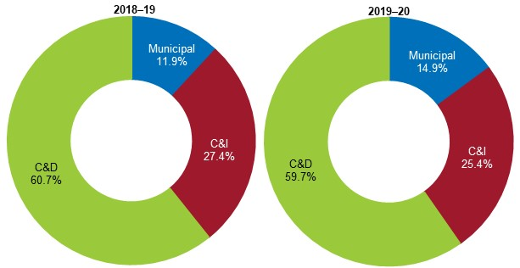

Since 2010–11, the amount of C&D material recovered for reprocessing has increased by 60.5 per cent from 4.11 Mt to 6.60 Mt, with sharp increases in 2017–18 and 2018–19 due to large-scale infrastructure works and housing development. In 2019–20, the upward trend continued but at a much slower rate than the previous 2 years, growing by 0.9 percentage point since 2018–19.

In the same 10-year period the amount of C&I material recovered for reprocessing has increased by 5.6 per cent from 2.66 Mt to 2.81 Mt, while the amount of MSW material recovered for reprocessing has increased by 27.0 per cent from 1.30 Mt to 1.65 Mt. Figure 28 shows the trend of recovered materials received for reprocessing by source sector in Victoria.

Figure 28: Source sector waste recovered for reprocessing (kt) in Victoria, 2010–11 to 2019–20

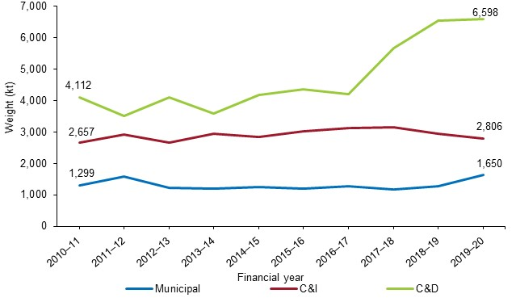

* 1. ­Overall material disposal and recovery

» Aggregate, masonry and soil made up 59.1 per cent of all material recovered for reprocessing. Metals and organics contributed 13.4 per cent and 12.5 per cent respectively, and paper and cardboard 10.1 per cent.

» The materials with the highest diversion rates were metals (91.0 per cent); aggregates, masonry and soil (85.0 per cent); glass (77.5 per cent); and paper and cardboard (66.6 per cent).

Table 4 shows the quantities (kt) of material disposed of to landfill, the amount received for reprocessing and the diversion rate (in brackets) by source sector for Victoria in 2019–20.

Across the waste and resource recovery sector, the materials that had the highest diversion rates were metals (91.0 per cent); aggregates, masonry and soil (85.0 per cent); glass (77.5 per cent); and paper and cardboard (66.6 per cent). These materials together contributed 71.8 per cent of all waste managed and 85.4 per cent of all waste recovered in Victoria in 2019–20.

The increase in the glass diversion rate is likely to be due to the clearance of long-term stored material as opposed to an increase in the recovery of material placed on the market in 2019–20. Compared with 2018–19, the overall glass diversion rate increased by 7.4 percentage points to 77.5 per cent, with increases observed in MSW and C&I of 5.3 and 7.3 percentage points respectively and a decrease of 2.2 percentage points in C&D.

For each source sector the top three materials with the highest diversion rates were:

* in MSW, metals (90.8 per cent); glass (87.9 per cent); and aggregates, masonry and soil (58.5 per cent), contributing to 25.4 per cent of total MSW tonnes managed
* in C&I, metals (91.4 per cent), paper and cardboard (72.3 per cent), and organics (47.9 per cent), contributing to 76.5 per cent of total C&I tonnes managed
* in C&D, metals (88.7 per cent); aggregates, masonry and soil (88.4 per cent); and organics (41.5 per cent), contributing to 99.1 per cent of total C&D tonnes managed.

Table 4: Quantity of material (kt) disposed of and received for reprocessing (including diversion rate) by source sector in Victoria, 2019–20*

|  |  |  |  |  |  |  |  |  |
| --- | --- | --- | --- | --- | --- | --- | --- | --- |
| Material | Municipal‡ | | C&I | | C&D | | Total | |
| Disp. | Rec. | Disp. | Rec. | Disp. | Rec. | Disp. | Rec. |
| Aggregate, masonry and soil | 68.0 | 95.8  (58.5%) | 256.3 | 114.9  (31.0%) | 827.0 | 6,327.9  (88.4%) | 1,151.2 | 6,538.7  (85.0%) |
| Glass | 39.8 | 287.5  (87.9%) | 45.4 | 12.3  (21.3%) | 2.4 | 0.9  (27.6%) | 87.6 | 300.7  (77.5%) |
| Metals | 35.0 | 347.1  (90.8%) | 91.1 | 972.9  (91.4%) | 20.7 | 162.4  (88.7%) | 146.8 | 1,482.4  (91.0%) |
| Organics | 679.4 | 645.4  (48.7%) | 689.9 | 634.5  (47.9%) | 146.1 | 103.6  (41.5%) | 1,515.3 | 1,383.5  (47.7%) |
| Paper / cardboard† | 201.3 | 203.5  (50.3%) | 349.7 | 911.0  (72.3%) | 8.4 | 0.3  (3.3%) | 559.3 | 1,114.8  (66.6%) |
| Plastics | 179.5 | 70.9  (28.3%) | 289.3 | 66.0  (18.6%) | 18.7 | 3.2  (14.6%) | 487.5 | 140.1  (22.3%) |
| Textiles | 58.9 | 0.0  (0.0%) | 126.8 | 32.0  (20.2%) | 11.1 | 0.0  (0.0%) | 196.8 | 32.0  (14.0%) |
| Rubber | 2.3 | 0.0  (0.0%) | 11.6 | 62.6  (84.4%) | 0.3 | 0.0  (0.0%) | 14.2 | 62.6  (81.5%) |
| Otherꟸ | 523.6 | 0.0  (0.0%) | 102.5 | 0.0  (0.0%) | 22 | 0.0  (0.0%) | 648.2 | 0.0  (0.0%) |
| Total | 1,787.6 | 1,650.3  (48.0%) | 1,962.5 | 2,806.2  (58.8%) | 1,056.7 | 6,598.4  (86.2%) | 4,806.9 | 11,054.8  (69.7%) |

* Figures reported for materials received by source sector have been extrapolated to include the relative proportions derived from reported data and applied to surveys that did not include a source sector for the different material types and the export data from the ABS. Figures in Table 4 have been rounded to the nearest thousand and individual columns may therefore not add up to the totals reported for ‘Total’ or to the percentage figures provided in brackets.  
Percentage figures in brackets are the diversion rate for that material and source sector.  
ꟸ ‘Other’ includes street sweepings, material recovery facility residuals, nappies, electronics.  
† Paper / cardboard is equivalent to paper and cardboard. For spacing reasons, the ‘and’ has been replaced with ‘/’.  
‡ The diversion rate calculated for Municipal (MSW) is not comparable to the kerbside diversion rate as calculated in the LGWSR, please refer to Appendix A: Comparison of survey data for details on the similarities and differences between these.

Figure 29 presents the composition of the materials recovered for reprocessing in 2019–20. Aggregate, masonry and soil made up 59.1 per cent of all material recovered for reprocessing in Victoria. The C&D sector was the primary source of aggregate, masonry and soil. The remaining 41.0 per cent of the total materials recovered for reprocessing primarily came from metals at 13.4 per cent, organics at 12.5 per cent each and paper and cardboard at 10.1 per cent.

Figure 29: Material composition of waste recovered for reprocessing (by weight) in Victoria, 2019–20

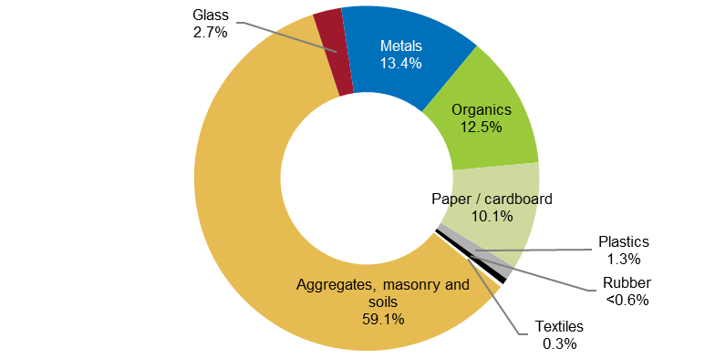

1. Glossary



|  |  |  |
| --- | --- | --- |
| Term | Acronym  (if applicable) | Description |
| Australian Bureau of Statistics | ABS | An independent statutory agency of the Australian Government responsible for statistical collection and analysis. |
| Commercial & industrial waste | C&I | Solid materials and waste generated from trade, commercial and industrial activities, including the government sector. It includes waste from offices, manufacturing, factories, schools, universities, state and government operations, and small to medium enterprises, e.g. food organics. |
| Construction & demolition waste | C&D | Solid materials and waste generated from residential and commercial construction and demolition activities, e.g. bricks and concrete. |
| Container deposit scheme | CDS | A government scheme to incentivise more and better recycling by offering a cash reward for the return of drink cans, bottles and cartons. |
| Coronavirus disease 2019 | COVID, COVID-19 | Coronavirus, also known as COVID-19, is the contagious respiratory disease that began in 2019 and has resulted in an ongoing global pandemic. |
| Council of Australian Governments | COAG | An intergovernmental forum in Australia whose role is to manage matters of national significance or matters that need coordinated action by all Australian governments. |
| Department of Environment, Land, Water and Planning | DELWP | Victorian Government department providing policy planning, preparation of legislative amendments, leadership coordination and oversight of the environment portfolio. |
| Environment Protection Authority | EPA | EPA Victoria’s role is to be an effective environmental regulator and an influential authority on environmental impacts. |
| Food organics |  | Food materials discarded from households or industry, including food processing waste, out-of-date or off-specification food, meat, fruit and vegetable scraps. Excludes liquid waste. |
| Food organics and garden organics | FOGO | Acronym for **f**ood **o**rganics / **g**arden **o**rganics. FOGO are disposed of directly into the kerbside garden organics bin system. |
| Garden organics |  | Organics derived from garden sources, such as grass clippings and tree prunings. |
| Gross state product | GSP | Gross state product is a measurement of a state’s overall economic activity. It represents the monetary value of all finished goods and services produced within the state during the financial year. GSP differs from gross domestic product (GDP) in that it measures the state’s economic activity, whereas GDP encompasses all economic activity in Australia. |
| High-density polyethylene | HDPE, PE-HD | A member of the polyethylene family of plastics, typically referred to as HDPE, used to make products such as milk bottles, pipes and shopping bags. HDPE may be coloured or opaque. PIC 2. |
| Kerbside collection |  | Materials and waste collected by local councils, including garbage, commingled recyclables and garden organics, but excluding hard waste. |
| Kilotonne | kt | A unit of weight equal to 1,000 metric tonnes. |
| Landfill |  | A waste disposal site used for the controlled deposit of solid waste onto or into land. |
| Low-density polyethylene | LDPE, PE-LD / LLD | A member of the polyolefin family of plastics, typically referred to as LDPE. LDPE is a flexible material usually used as film for packaging or as bags. PIC 4. |
| Material recovery facility | MRF | A centre for the receipt, sorting and transfer of materials recovered from the waste stream before transporting to another facility for recovery and management. At the MRF, materials may undergo mechanical treatment for sorting by characteristics such as weight, size, magnetism and optical density and may include cleaning and compression. Materials may be received as mixed streams such as commingled recyclables from households and businesses or single streams such as metals. |
| Million tonnes | Mt | A unit of weight equal to 1,000 kilotonnes. Also referred to as a megatonnes. |
| Mulch |  | Any composted or non-composted organic material, excluding plastic, that is suitable for placing on soil surfaces to restrict moisture loss from the soil and to provide a source of nutrients to aid plant growth. |
| Municipal solid waste | MSW | Solid waste managed predominantly from domestic premises (residual and hard waste) and council activities such as street sweeping, litter collection and street tree lopping. Municipal waste also includes waste dropped off at transfer stations and construction waste from residential owner / occupier renovations. |
| Nonferrous metals |  | Metals that contain very little or no iron, e.g. copper, brass, bronze and aluminium. |
| Organics |  | Any combination of food materials discarded from households or industry and / or organics derived from garden sources.  Food organics may include food processing waste, out-of-date or off-specification food, meat, fruit and vegetable scraps. Excludes liquid waste. Garden organics may include grass clippings, tree prunings, etc. |
| Packaging |  | Material used for the containment, protection, marketing or handling of product. Includes primary, secondary and tertiary / freight packaging in both consumer and industrial packaging applications. |
| Plastic Identification Code | PIC | A grading system used for the classification of polymer types, e.g. PET is PIC 1. |
| Polyethylene terephthalate | PET | A member of the polyethylene family of plastics, typically referred to as PET, used to make products such as soft drink bottles, film packaging and fabrics. PIC 1. |
| Polypropylene | PP | A member of the polyolefin family of plastics, typically referred to as PP. PP is light, rigid and glossy and is used to make products such as washing machine agitators, clear film packaging, carpet fibres and housewares. PIC 5. |
| Polystyrene or expanded polystyrene | PS, PS-E | A member of the styrene family of plastics, typically referred to as PS. PS can be either a solid or foamed and is used to make protective packaging like packing peanuts as well as yoghurt containers and disposable cutlery. PIC 6. |
| Polyvinyl chloride | PVC | A member of the polyvinyl family of plastics, typically referred to as PVC. PVC can be made into either a rigid form, used to make products such as construction pipe, bottles and bank cards, or into a soft form used to make products such as electrical cabling insulation, imitation leather and vinyl records. PIC 3. |
| Recovered |  | Materials recovered and diverted from landfill for reprocessing or use. |
| Recycle / Recycling |  | To convert waste into a reusable material. In common practice, the term is used to cover a wide range of activities, including collecting, sorting, reprocessing and reuse. |
| *Recycling Victoria* | RV | *Recycling Victoria* (short for *Recycling Victoria: A New Economy*)– a policy or framework of the Victorian Government to transition the state to a circular economy. |
| Reprocess |  | To put a material that has been used through an industrial process to change it so it can be used again. |
| Reprocessor / Reprocessing facility |  | Facility that uses an industrial process to change the physical structure and properties of materials so they can be used again. This can include facilities that dismantle products, such as tyres, e-waste and mattresses and waste-to-energy facilities that use materials to generate energy. |
| Solid waste |  | Non-hazardous, non-prescribed, solid waste ranging from municipal garbage to industrial waste. |
| Stockpiling |  | Storing of excess recovered / reprocessed materials. |
| Sustainability Victoria | SV | Statutory authority established in October 2005 under the *Sustainability Victoria Act 2005* with the key objective of facilitating and promoting environmental sustainability in the use of resources. SV works across the areas of energy, waste and water with communities, industries and government, applying the best ideas and encouraging action to enable change in environmental practices. |
| Victorian Recycling Industry Annual Survey | VRIAS | A survey carried out by SV that collects information on the tonnages of waste managed by the resource recovery sector. |
| Waste |  | Any discarded, rejected, unwanted, surplus or abandoned matter, including where intended for recycling, reprocessing, recovery, purification or sale. Anything that is no longer valued by its owner for use or sale and which is, or will be, discarded. In this document, the term ‘solid waste’ refers to non-hazardous, non-prescribed, solid waste materials ranging from municipal garbage to industrial waste. |
| *Waste and Recycling in Victoria – Local Government Waste Services Report* | LGWSR | A technical report containing the complete data analysis of waste management and recycling services by Victorian local governments. |
| *Waste and Recycling in Victoria – Recycling Industry Waste Report* | RIWR | A technical report containing the complete data analysis of waste management and recovery by the Victorian recycling industry. |
| *Waste and Recycling in Victoria – Strategic Summary Report* | SSR | A summary report containing highlights from this technical report and the accompanying LGWSR and a broader discussion of the state of waste in Victoria. |

1. Appendix A: Comparison of survey data



At a glance, Table 5 high-level summary data from *Waste and Recycling in Victoria – Recycling Industry Waste Report 2019–20* (RIWR)and *Waste and Recycling in Victoria – Local Government Waste Services Report* (LGWSR)appear quite similar.

Table 5: RIWR and LGWSR comparison at aggregated level, 2019–20

|  |  |  |  |
| --- | --- | --- | --- |
| **Data point** | **RIWR (MSW only)** | **LGWSR** | **Difference** |
| **Total waste to landfill (tonnes)** | **1,787,600** | **1,653,300** | **7.5%** |
| *Data source* | *EPA landfill levy data* | *Garbage kerbside, drop-off and other council services* |  |
| **Total recovered for reprocessing / sorted for recovery (tonnes)** | **1,554,400** | **1,229,900** | **20.9%** |
| *Data source* | *Reported recovered for plastics, paper / cardboard, glass, metals, organics* | *Kerbside recyclables and drop-off data for plastics, paper / cardboard, glass, metals, organics* |  |
| **Total generation (tonnes)** | **3,342,000** | **2,883,100** | **13.7%** |
| *Data source* | *Sum landfill and recovered* | *Sum of landfill and sorted for recovery* |  |
| **Diversion rates†** | **46.5%** | **42.7%** | **3.9%** |
| *Data source* | *Total recovered for reprocessing ÷ Total generation* | *Total sorted for recovery from kerbside ÷ Total kerbside generation* |  |

Note: All figures are rounded to the nearest 100 tonnes and sum of components may not add to totals due to rounding errors.  
† The RIWR diversion rate calculated here is different to that reported in 5.2. The RIWR diversion rate takes a subset of materials into account (namely it removes aggregates, masonry and soil; rubber and textiles) in an effort to make it more comparable (while noting differences listed below) to the kerbside diversion rate calculated in LGSWR.

However, when examining individual material stream data, as presented in Table 6, the differences become more evident.

Table 6: RIWR and LGWSR[3] comparison at material stream level, 2019–20

|  |  |  |  |  |
| --- | --- | --- | --- | --- |
|  | RIWR (tonnes) | LGWSR (tonnes) | Difference | |
| Tonnes | % |
| Plastics | 70,900 | 58,400 | 12,500 | 17.6% |
| Paper / cardboard | 203,500 | 289,400 | –85,900 | –42.2% |
| Glass | 287,500 | 168,400 | 119,100 | 41.4% |
| Metals | 347,100 | 16,600 | 330,500 | 95.2% |
| Organics | 645,400 | 697,100 | –51,700 | –8.0% |
| Total | 1,554,400 | 1,229,900 | 324,500 | 20.9% |

Note: All figures are rounded to the nearest 100 tonnes and sum of components may not add to totals due to rounding errors.

The differences observed between the two data sets could be explained by a number of factors:

* Responses by material type by source sector can vary significantly from year to year, potentially due to:
  + material entered as originating from an industrial source (e.g. a materials recovery facility), which was initially from a municipal source (a kerbside recyclable bin)
  + respondent data entry errors that were not detected in quality assurance of data.
* For some materials, metals in particular, more are captured in RIWR from municipal sources than in LGWSR (e.g. only aluminium and steel cans are counted in LGWSR for metals while RIWR is likely to contain data associated with end-of-life vehicles and large appliances that often are received by scrap metal dealers and classified as municipal waste).
* Garden waste materials collected in council services or dropped off at council facilities may be processed (e.g. mulching) onsite by council and may not be captured in RIWR.
* The clearance of stored material originating in a different year to the year it is processed in. For example, glass quantities reprocessed in 2019–20 increased due to the clearance of stored material from previous years, resulting in a large difference between the two survey results.
* Some multi-unit dwellings are serviced by private waste collection contractors that are separate to the services offered by local councils and tonnes collected in these services are not captured in LGWSR.
* There is a gap in information between LGWSR data and RIWR, for example, where materials sorted for reprocessing may not be recoverable due to post-sorting contamination.

Data in these reports are provided to SV from two different surveys, targeting different participants. Consequently, we do not expect the results to align for all material types. SV advises that figures from LGWSR should be used as the primary source of data for the municipal sector.

1. Appendix B: Data method



### Rounding of data

Figures in this report, the accompanying data workbook and the listed sources have been rounded and as a result individual values may not add up to totals. Additionally, calculated percentage figures are based on the unrounded data and may be different to those calculated using the rounded figures in the report.

### Victorian Recycling Industry Annual Survey

The Victorian Recycling Industry Annual Survey 2019–20 (VRIAS) was conducted between November 2020 and June 2021. It sought data from 99 Victorian waste reprocessing businesses (excluding the plastics reprocessors) via a voluntary online survey.

Table 7 compares the response rate for the survey between 2018–19 and 2019–20. The response rate, describing those that submitted a response or chose to opt out of this year’s survey, was 85 per cent, a decrease of 1 percentage point compared with 2018–19. The survey participation rate was 66 per cent, a decrease of 3 percentage points compared with 2018–19, as 19 businesses requested to opt out of completing the survey. The reasons for opting out included the business being non-operational (due to equipment build or upgrades) in 2019–20, the business being sold to another business or closure of the business. Only 15 businesses out of 99 did not respond.

Despite a survey participation rate of 66 per cent, SV is confident that it has captured or adequately estimated responses – based on industry knowledge and historical responses – from the major non-plastics reprocessing businesses in Victoria.

Table 7: VRIAS response rates, 2018–19 and 2019–20

|  |  |  |  |
| --- | --- | --- | --- |
|  | 2018–19 | 2019–20 | Change |
| Surveys sent | 98 | 99 | +1 |
| Submitted responses | 68 | 65 | –3 |
| Opted out response | 16 | 19 | +3 |
| Acknowledged but no response | 14 | 15 | +1 |
| Survey participation rate | 69% | 66% | –3% |
| Response rate | 86% | 85% | –1% |

The survey is voluntary, and the information is self-reported by the participating organisations. The accuracy of the information is verified by comparing previous years’ survey responses. Any significant variations are reviewed and adjusted upon consultation with the organisation. To avoid double counting, adjustments are made to account for any transfers of materials between Victorian reprocessors.

In 2019–20, Victorian reprocessors surveyed included:

* smelters and foundries of steel, aluminium and other nonferrous metals
* crushing plants and auxiliary screening of concrete, brick, asphalt and related materials
* paper and cardboard and de-inking pulp mills
* composting facilities
* glass and rubber product manufacturers.

Each non-plastic reprocessing business was emailed a link to an online survey developed for their specific industry category and asked to provide information for the 2019–20 financial year about the amount of materials diverted from landfill (recovered) and reprocessed. The type information collected included:

* tonnes received by their Victorian site
* tonnes received from other facilities
* tonnes imported or exported for reprocessing, both interstate and overseas
* tonnes stockpiled (unprocessed and processed)
* tonnes reprocessed onsite
* amount of materials disposed of to landfill due to contamination or as processing waste
* sectors from which the recovered materials for reprocessing were received
* major products made from their reprocessing operations and the subsequent markets to which the products are sold
* number of full-time equivalent staff directly employed in the company’s recycling operations
* levels of expenditure on research and development and capital investment for activities associated with reprocessing of secondary use materials.

Reprocessing recovered materials, typically an industrial process, results in a material or product that can be productively used. Energy recovery is the process by which embodied energy is captured for use. It is a form of resource recovery, but it is not reprocessing. The report does not include materials that have been collected and baled only (unless they are exported) or materials that have been stockpiled. It also does not include materials that have been resold in their original state for reuse, such as clothing sold through second-hand or charity stores.

The data collection and methodology are discussed in more detail in the *Waste and Recycling in Victoria – Strategic Summary Report* (SSR).

### Waste and Recycling in Victoria – Recycling Industry Waste Workbook

The findings in this report are based on the data findings provided in detail in the *Waste and Recycling in Victoria – Recycling Industry Waste Workbook 2019–20*. The workbook provides public access to the underlying data and includes historically available figures. This report and the workbook are available on the SV website ([sustainability.vic.gov.au](http://www.sustainability.vic.gov.au/)).

### Australian Plastics Recycling Survey data

Victorian plastics reprocessor data was obtained from the *2019–20 Australian Plastics Recycling Survey* prepared by Envisage Works. This data aims to capture plastic consumption and recycling from surveying a combination of sources including resin producers, resin importers, plastics reprocessors and plastics exporters.

Data on plastics recovery was sought from 44 plastics reprocessing businesses in Victoria. Table 8 presents the response rate breakdown from this survey. A total of 34 plastics reprocessing businesses responded to this survey in 2019–20, representing a 77 per cent survey participation rate. The response rate to this survey was 98 per cent, as a further 9 organisations responded by opting out due to negligible processing during this time period or they were not interested in participating in the survey. Only 1 reprocessor out of 44 did not respond.

Table 8: Australian plastics recycling survey response rates, 2019–20

|  |  |
| --- | --- |
| Response type | 2019–20 |
| Surveys sent | 44 |
| Submitted responses | 34 |
| Opted out response | 9 |
| Acknowledged but no response in time | 1 |
| Survey participation rate | 77% |
| Response rate | 98% |

Each plastics reprocessor in Victoria was sent a survey in Excel format and asked to give information for the 2019–20 financial year about the reprocessed amount, import / export amounts and stockpile amount for each type of polymer. The survey is voluntary, and the information is self-reported by the organisation. To avoid double counting of material flowing through the system to local reprocessors, the focus of data gathering in this survey was placed on the reprocessing stage of the plastics life cycle.

### Australian Bureau of Statistics data

Additional information was sought from the ABS on the export of materials from Victoria to overseas markets for reprocessing during the 2019–20 financial year. This data aims to capture materials exported from companies not surveyed by SV, such as export traders. Additional ABS data on population figures, GSP and consumer price index were also used in our analysis.

### Environment Protection Authority Victoria data

Data on solid waste disposed of to licensed landfills was sourced from EPA Victoria’s landfill levy returns. These returns provide data on MSW to landfill and combined solid industrial waste to landfill, which is the sum of waste from C&I and C&D. To estimate the quantities of waste going to landfill from these sectors individually, SV applied an assumed proportional split based on partially reported data from EPA Victoria. This allows for the calculation of diversion rates by source sector.

1. The method used to compile this data is provided in Appendix A: .
2. [Drought Statement (bom.gov.au)](http://www.bom.gov.au/climate/drought/#tabs=Rainfall-tracker)
3. Composition of commingled packaging post-consumer material includes data from kerbside recyclables and drop-off recyclables only, whereas the figure for total recovered in Table 5 for the LGWSR includes an additional 25 kt of hard waste recovered for reprocessing.