|  |  |
| --- | --- |
| Victorian Recycling Industry Annual Report  2018–19 |  |
| Report by: Sustainability Victoria  August 2020 |  |

|  |  |
| --- | --- |
| Authorised and published by Sustainability Victoria Level 28, Urban Workshop 50 Lonsdale Street, Melbourne Victoria 3000 Australia  Victorian Recycling Industry Annual Report 2018–19  © Sustainability Victoria 2020 August 2020  **Accessibility**  This document is available in PDF and Word format on the internet at sustainability.vic.gov.au  While reasonable efforts have been made to ensure that the contents of this publication are factually correct, Sustainability Victoria gives no warranty regarding its accuracy, completeness, currency or suitability for any particular purpose and to the extent permitted by law, does not accept any liability for loss or damages incurred as a result of reliance placed upon the content of this publication. This publication is provided on the basis that all persons accessing it undertake responsibility for assessing the relevance and accuracy of its content.  This report should be attributed to Sustainability Victoria.  This report is licensed under a Creative Commons Attribution 4.0 International licence. In essence, you are free to copy, distribute and adapt the work, as long as you attribute the work and abide by the other licence terms. Go to http://creativecommons.org/licenses/by/4.0/  to view a copy of this licence. |  |

Contents

Waste management in Victoria at a glance, 2018–19 4

Minister’s foreword 6

1 Overview 7

1.1 Introduction 7

1.2 Performance against Victoria’s waste targets 8

1.3 Key findings in 2018–19 9

2 Waste and resource recovery sector health 12

2.1 Insights and trends in the sector in 2018–19 12

2.2 Actions by the Victorian Government 15

3 Waste managed in Victoria 17

3.1 Overall disposal and recovery 17

3.2 Material specific disposal and recovery 19

4 Materials recovered 20

4.1 Source sectors of recovered materials 20

4.2 Composition of recovered materials 21

4.3 Material specific recovery data 23

4.4 Local government management of kerbside waste 33

5 Material exported for recovery 39

5.1 Annual trends in waste exports 39

5.2 Export composition in 2018–19 40

5.3 Export destinations and import restrictions 41

5.4 Monthly trends in kerbside recycling material exports 42

6 References 43

7 Acronyms and abbreviations 44

8 Glossary 45

Appendix A – Data compilation method 47

Appendix B – VRIAR comparison with VLGAWSR 50

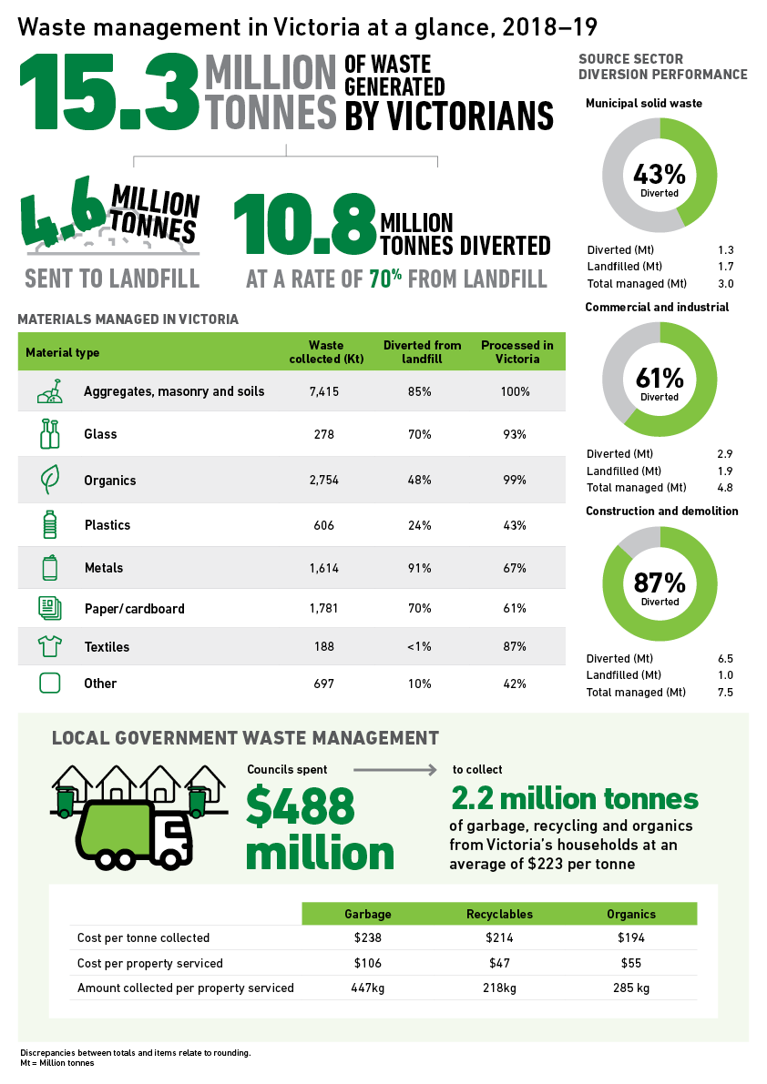

Waste management in Victoria at a glance, 2018–19



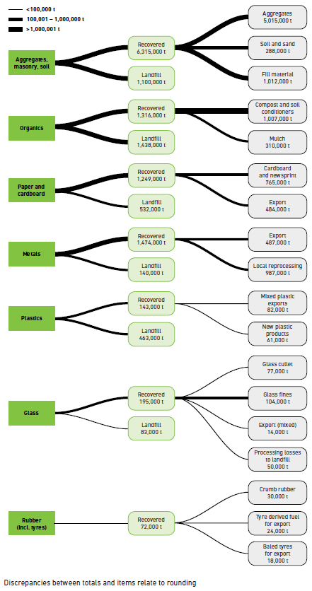

111

The Hon. Lily D’Ambrosio MP
MP Minister for Energy, Environment and Climate Change. Minister for Solar Homes
Minister’s foreword

## How Victoria’s waste is managed

The *Victorian Recycling Industry Annual Report 2018–19* collates critical data regarding how Victoria’s waste was managed over this 12-month period.

This year’s report reveals that more material was recovered for reprocessing than ever before, led by an increase in the recovery of materials from several infrastructure projects across the state.

These efforts to reuse, repair and recycle our waste will be significantly expanded over the next ten years, with the Victorian Government’s commitment to invest a record $300 million in the *Recycling Victoria* policy to transform our recycling sector, reduce waste, create thousands of jobs and set Victoria up for a more sustainable future.

The 2018–19 financial year was a challenging year for the recycling industry, with disruption to household recycling services as a result of changes in demand for recyclable materials in both local and export markets.

Despite these challenges, nearly 10.77 million tonnes of material were recovered for reprocessing from Victorian households and businesses, lifting the state’s diversion rate to 70 per cent (up 1 percentage point from 2017–18).

While this is great news for Victorians and the environment, we want to do even better.

The Victorian Government is committed to long-term improvements in the sector. Through, *Recycling Victoria,* the Industry and Infrastructure Investment Package will provide $100 million to the sector. Our investment will drive research, expand the local processing and manufacturing industry, create more products from recyclable materials and support new local jobs.

The Industry and Infrastructure Package is designed to assist businesses to improve the quality of materials recovered and increase its resilience to changing market conditions for recycled commodities. Our record investment will foster business innovation and collaboration across supply chains to reduce waste, increase recycling and reuse, and generate new streams of revenue.

Victoria is well placed to overcome the challenges currently facing our recycling sector. In partnership with local councils and industry, the Victorian Government will deliver a recycling system the community can rely on.

Read more: [vic.gov.au/transforming-recycling-victoria](https://www.vic.gov.au/transforming-recycling-victoria)

**The Hon. Lily D’Ambrosio MP  
MP Minister for Energy, Environment and Climate Change  
Minister for Solar Homes**

1. Overview
   1. Introduction

Every year, the Victorian Government surveys reprocessing organisations across the state to better understand the amount of waste recovered for recycling purposes in Victoria.

This *Victorian Recycling Industry Annual Report* (VRIAR) presents the results from the survey of resource recovery activities in 2018–19. The high response rate for this year (86 per cent) demonstrates strong engagement from the sector.

Resource recovery covers a wide range of activities, including collecting waste, sorting waste, reprocessing waste, manufacturing new products and producing energy from waste. The VRIAR provides a detailed summary of the significant quantities of materials recovered via reprocessing of waste in Victoria. These materials include aggregates, masonry and soil; glass; metals; organics; paper and cardboard; plastics; rubber; and textiles. The materials are sourced from municipal solid waste (households, also known as municipal or MSW), commercial and industrial operations (C&I), or construction and demolition sites (C&D). The VRIAR also includes data estimates and trends for materials exported from Victoria for reprocessing and waste sent for landfill disposal in Victoria.

This year, the VRIAR includes insights from a wider range of sources to provide a more comprehensive view of waste management in Victoria than in previous years.[1] These sources include:

* Environment Protection Authority (EPA) Victoria data on quantities sent to landfill
* Australian Bureau of Statistics (ABS) commodity export data
* Australian Plastics Recycling Survey on plastics consumption and recovery
* *Victorian Local Government Annual Waste Services Report 2018–19* on materials collected from households in Victoria[2]
* *Recovered Resources Market Bulletin* on resource recovery markets.

This report also contains a baseline measurement against the four key targets in the Victorian Government’s *Recycling Victoria: A New Economy* policyreleased in 2020.

In future editions of the VRIAR, data pertaining to the management of hazardous waste will also be incorporated to create a single point of reference for waste and resource recovery data in Victoria.

* 1. Performance against Victoria’s waste targets

The Victorian Government’s circular economy policy and action plan, *Recycling Victoria: A New Economy*, released in early 2020 established four targets to measure the state’s performance on waste.

Table 1 provides the performance assessment for 2018–19 as the baseline against which to measure our future progress.

Table 1: Key performance indicators against targets from Recycling Victoria, 2018–19

| Metric | Baseline and target | 2018–19 measurement | Trend |
| --- | --- | --- | --- |
| Divert 80% of waste from landfill by 2030, with an interim target of 72% by 2025 | **Baseline** | 70%  Increase of 1 percentage point from 2017–18 |  |
| Not applicable |
| **Target** |
| 80%  (2029–30) |
| Cut total waste generation by 15% per capita by 2030 | **Baseline** | 2.3  tonnes per capita  Increase of 3% from 2017–18 |  |
| 2.3  tonnes / capita  (2018–19) |
| **Target** |
| 2.0  tonnes / capita  (2029–30) |
| Halve the volume of organic materials going to landfill between 2020 and 2030, with an interim target of a 20% reduction by 2025 | **Baseline** | 1,438  thousand tonnes    Increase of 2% from 2017–18 |  |
| 1,438  thousand tonnes  (2018–19) |
| **Target** |
| 719  thousand tonnes  (2029–30) |
| Ensure every Victorian household has access to food and garden organic waste recycling  services or local composting by 2030 | **Baseline** | 12.1%  Have access to a service*  Increase of 1% from 2017–18 |  |
| Not applicable |
| **Target** |
| 100%  access to a service  (2029–30) |
| * Per cent with access captures those households that have access to food and garden organic waste collection service only. No other access services are considered. | | | |

* 1. Key findings in 2018–19

## Overall performance

* The Victorian waste and resource recovery sector managed 15.33 million tonnes of waste in 2018–19, 6 per cent more than 2017–18 and 27 per cent more than 10 years ago.
* 10.77 million tonnes of this was diverted from landfill for recovery and 4.57 million tonnes was sent to landfill, increasing the 2018–19 diversion rate to 70 per cent (up 1 percentage point).
* The 6 per cent increase in the amount of waste managed was greater than Victoria’s population growth of 2 per cent (ABS 2019a) but equivalent to its economic growth of 6 per cent (ABS 2019b) during the same period. Total waste managed per capita in Victoria increased to 2.3 tonnes.
* The increase in total waste managed was not due to changes in consumer practices but sharp increases in the amount of C&D waste generated and recovered over the last two years because of land development and major public transport infrastructure works led by the Victorian Government.
* For some materials (mainly glass, and paper and cardboard), changes in the amount that was locally reprocessed and exported for reprocessing reduced due to:
  + EPA Victoria non-compliance issues at sorting facilities resulting in site closures
  + materials entering storage with the intention that they would be later processed
  + global shifts in material commodity values and export market access
  + contamination rates in kerbside recycling collection bins.

## Sector performance

* The 3 per cent increase, from 2017–18, in waste going to landfill is lower than the 8 per cent increase in total waste recovered for reprocessing. Similarly, over 10 years, the amount of waste going to landfill has increased by 1 per cent while the amount of waste recovered for reprocessing has increased by 43 per cent, indicating greater circulation of materials (particularly from C&D) in the Victorian economy over time.
* The quantity of waste recovered from Victoria’s municipal and C&D sectors increased (by 9 and 15 per cent respectively) but decreased from the C&I sector (6 per cent) in   
  2018–19.
* Diversion rates for materials collected from MSW (43 per cent) and C&D (87 per cent) increased in 2018–19 compared with 2017–18; however, the diversion rate for C&I (61 per cent) decreased.
* Recovery from the C&D sector accounted for 61 per cent of the total recovered materials received for reprocessing in Victoria in 2018–19, followed by C&I (27 per cent) and municipal (12 per cent).
* The proportion of material recovered from each source sector varied. Key sectors with the highest levels of materials recovered include:
  + 98 per cent of aggregate, masonry and soil recovered for reprocessing came from the C&D sector.
  + 91 per cent of glass recovered for reprocessing came from the municipal sector.
  + 86 per cent of mixed food and garden organics and 90 per cent of garden organics recovered for reprocessing came from the municipal sector, and 65 per cent of timber came from the C&D sector.
  + 88 per cent of paper and cardboard recovered for reprocessing came from the C&I sector.
  + 93 per cent of plastics recovered for reprocessing came from the municipal and C&I sectors.

## Material performance

* The increase in total recovered materials in 2018–19 was largely due to increases in aggregate, masonry and soil recovered for reprocessing. This material made up close to 60 per cent of all material recovered for reprocessing in Victoria. The next most frequently recovered material for reprocessing was metals (14 per cent) followed by organics, and paper and cardboard (both 12 per cent).
* The amount of aggregate, masonry and soil recovered for reprocessing continued to increase (to 6.32 million tonnes, up 15 per cent from 2017–18) as a result of continued land development and public transport infrastructure works across Victoria.
* There was a 16 per cent decrease in the amount of paper and cardboard recovered and a 15 per cent decrease in the amount of glass recovered in 2018–19 compared with 2017–18. This decline is due to:
  + sorted materials not meeting import country contamination requirements
  + sorting losses as a result of increased contamination from kerbside recycling bins
  + mixed recyclable materials entering storage due to sorting site closures, with the intention that they would be sorted later, so impacting on the amount of material flowing through the system
  + changes in the commodity value of paper and cardboard throughout 2018–19, again leading to increased storage of sorted material.
* The volume of organics recovered for reprocessing increased by 20 per cent in 2018–19. This is likely to be due to increased collections of food and garden organics from households and businesses.
* The amount of plastics recovered for reprocessing increased by 4 per cent. Demand for plastics in local markets is increasing – the amount reprocessed locally increased by 16 per cent in 2018–19 while the amount exported for reprocessing decreased by 4 per cent.
* There was a 1 per cent increase in the amount of metal recovered from 2017–18. This trend was consistent with previous years.
* The amount of rubber reprocessed locally decreased by 30 per cent (13,000 tonnes). This is because of a spike in reprocessing quantities in 2017–18 due to tyre stockpile clean up rather than a significant decrease in 2018–19.
* Overall the materials that had the highest diversion rates were metals (91 per cent), aggregates masonry and soil (85 per cent) and glass and paper and cardboard (70 per cent each). For each source sector the materials with the highest diversion rates were:
  + in MSW, metals (91 per cent), glass (83 per cent) and organics (44 per cent)
  + in C&I, metals (92 per cent), paper / cardboard (77 per cent) and organics (50 per cent)
  + in C&D, metals (90 per cent), aggregates masonry and soil (89 per cent) and organics (51 per cent)

## Local government

* The 79 Victorian local governments spent $488 million on the provision of kerbside collection services for garbage, recyclables and organics to 2.64 million properties and collected 2.19 million tonnes.
* In 2018–19, 565,000 tonnes of recyclables was collected, a 3 per cent decline from 2017–18. In the same period, 443,000 tonnes of garden organics was collected, a 4 per cent decline was observed possibly due to the prevailing drier climatic conditions experienced in 2018–19.
* All 79 Victorian local governments provide some form of kerbside bin service to households. A total of 57 (72 per cent) local governments employed a 3-bin system while 22 (28 per cent) of local governments employed a 2-bin system in 2018–19.
* The cost to councils of providing a kerbside service increased by 14 per cent compared with 2017–18. The largest increase is attributed to recyclables, where the cost of the service rose by 49 per cent or $39.7 million dollars across the state. This is likely to be associated with the changing market value of kerbside recyclable materials.
* Almost 40 per cent of kerbside collected recyclables was sent to overseas markets for remanufacturing.
* The contamination rate in kerbside recycling bins was between 15 and 20 per cent.
* At the beginning of 2020 there was an estimated 100,000–200,000 tonnes of kerbside recyclables in metropolitan storage, mostly accumulated through 2018 and early 2019 as a result of SKM sorting facility closures.
* Commodity values for kerbside recyclable materials varied considerably throughout the year: glass and mixed plastics (plastic numbers 3 to 7) had a negative commodity value; single stream HDPE and PET had commodity values over and around $400/tonne and aluminium over $1,000/tonne; and mixed paper and cardboard and single stream old corrugated cardboard ended 2018–19 with a similar value to the start of the year.

## Local reprocessing versus material exported for reprocessing

* Victoria’s resources were predominantly reprocessed locally with 90 per cent of all recyclables processed within the state.
* Materials collected from MSW are particularly export exposed, with almost 40 per cent of all materials collected from Victorian households in 2018–19 heading overseas for reprocessing.
* The quantity of materials exported for reprocessing overseas decreased by 11 per cent compared with 2017–18 to 1.12 million tonnes, as exporters were unable to find overseas markets for recyclable materials and the amount of materials from sorting facilities declined.
* More than 90 per cent of glass and organics, and more than 60 per cent of metals, and paper and cardboard were reprocessed in Victoria. More plastics and rubber were exported for reprocessing than were reprocessed in Victoria.
* The top 10 receiving countries of Victorian exports accounted for 94 per cent of all material exported. China (24 per cent), Indonesia (17 per cent), India (14 per cent) and Bangladesh (11 per cent) accepted the most by weight.
* Monthly exports of paper and cardboard made up the largest component of kerbside recyclables that were exported for reprocessing, peaking at 14,100 tonnes in April 2019. Exports of plastics and metals were fairly steady across the year and exports of glass varied month to month in 2018–19.

1. Waste and resource recovery sector health
   1. Insights and trends in the sector in 2018–19

## SKM site closures and material storage

At the beginning of 2020 there was an estimated 100,000–200,000 tonnes of kerbside recyclables in metro storage (including glass), mostly accumulated through 2018 and early 2019 as a result of SKM sorting facility shutdowns due to non-compliance with EPA Victoria site operating conditions (EPA Victoria 2019). During these closures, there was a sustained practice of sending unsorted and single stream recyclable material to storage with the intent that it would be sorted or sold and reprocessed at a later date. Data in this report shows the impact of this practice, especially for paper / cardboard and glass. When SKM went into liquidation in October 2019 (*The Age* 2019), much of this material remained in storage. The *Recovered Resources Market Bulletin* from June 2020 (Sustainability Victoria 2020) notes that most of this stored material is now reported to have been removed, with most of it going to landfill.

SKM sorted the kerbside recyclables from 33 of 79 Victorian councils and when the company was placed into liquidation, those councils had no other option but to send their kerbside collected material to landfill until an acceptable alternative could be found. The impact of this practice, which occurred in October and November 2019, is not present in the data detailed in this report as it occurred in the 2019–20 financial year.

## Global shift in recovered material imports

The 2018–19 financial year saw a national and global shift in how recyclable commodities were utilised and traded. Following the enforcement of the Chinese National Sword policy restrictions in January 2018, other countries followed suit to introduce similar restrictions. By June 2019, eight countries had introduced restrictions or bans on the importation of recyclable materials with many signalling that import restrictions would tighten further, especially for bales of mixed grades of the same material. For some materials, Victoria has a reliance on export markets for secondary reprocessing and manufacturing, especially for materials from kerbside recycling bins (plastics, paper and cardboard).

## Mixed commodity values

In 2018–19, there was a fall in the value of mixed paper and mixed plastics arising from kerbside recycling, which reduced the overall sale value of kerbside recovered materials by around $60–$80/tonne (since the beginning of 2018). This had a significant impact on the kerbside recycling sector. Most of this loss is due to a fall in the value of mixed paper. A significant slump in virgin fibre (pulp) prices in the leading Chinese markets in May 2019 flowed through to scrap paper and paperboard prices.

## Kerbside contamination

The average kerbside contamination rate reported by Victorian councils to the 2018–19 Victorian Local Government Annual Waste Services Survey was estimated to be 10.5 per cent, an increase of 0.1 percentage points. The range reported by councils was between 2.6 and 31.4 per cent in 2018–19. This rate represents contamination as the amount of material removed during the sorting process (material that is incorrectly placed in the bin). The rate reported in the *Recovered Resources Market Bulletin* was estimated to be between 15 and 20 per cent. This rate represents contamination as the amount of material removed during the sorting process (material that is incorrectly placed in the bin) plus the amount of material lost during reprocessing due to contamination of already sorted recyclables (single stream material that is contaminated with other recyclables).

## Material flow changes in local and export reprocessing

The insights noted above effected a shift in the total volume recovered for reprocessing, the volume locally reprocessed and the volume exported for reprocessing for a number of materials. Table 2 details the material volume flows in 2018–19 and how this changed compared with 2017–18. Notably, the local reprocessing of glass decreased by 17 per cent (38,000 tonnes), which is likely to be a direct result of mixed recyclable materials entering storage with the intention that they would be sorted later. Glass exported for reprocessing increased by 24 per cent (or 2800 tonnes). This material is often exported following material recovery facility (MRF) sorting and the glass beneficiation process (the process used to remove contaminants and sort by colour and size). In a similar manner, the amount of paper and cardboard locally reprocessed and the amount exported for reprocessing both declined in 2018–19, down 10 per cent and 23 per cent respectively. There are likely to be a range of factors impacting these flows, including:

* sorted materials not meeting import country contamination requirements
* sorting losses as a result of increased contamination from kerbside recycling bins
* mixed recyclables entering storage with the intention that they would be sorted later, so impacting on the amount of material flowing through the system
* changes in the commodity value of paper and cardboard throughout 2018–19, again leading to increased storage of sorted material.

Table : Material volume changes in local and export reprocessing in 2018–19 compared with 2017–18, Victoria

| Material | Recovered for reprocessing | Locally reprocessed | Exported for reprocessing |
| --- | --- | --- | --- |
| Aggregates, masonry and soil | 6,315,000 | 6,315,000 | 0 |
| up 15% | up 15% | No change |
| Glass | 195,000 | 180,000 | 14,000 |
| down 15% | down 17% | up 24% |
| Metals | 1,474,000 | 988,000 | 487,000 |
| up 1% | up 2% | Negligible change |
| Organics | 1,316,000 | 1,303,000 | 14,000 |
| up 20% | up 20% | down 2% |
| Paper / cardboard | 1,249,000 | 765,000 | 484,000 |
| down 16% | down 10% | down 23% |
| Plastics | 143,000 | 61,000 | 82,000 |
| up 4% | up 16% | down 4% |
| Rubber | 72,000 | 30,000 | 42,000 |
| down 9% | down 30% | up 15% |

Numbers in table have been rounded and may not add up within the table or to other figures reported elsewhere in this document.

For other materials:

* The amount of plastics exported for recycling decreased by 4 per cent (3200 tonnes). This material was taken up by local reprocessing, which increased by 16 per cent (8500 tonnes).
* The amount of rubber reprocessed locally decreased by 30 per cent (13,000 tonnes). This decrease is due to a spike in reprocessing quantities in 2017–18 due to tyre stockpile clean up rather than a significant decrease in 2018–19.
* The amount of locally reprocessed aggregates, masonry and soil increased by 15 per cent (808,000 tonnes) due to continued infrastructure works and land clearing for new housing developments around Victoria.
* The local reprocessing of organics increased by 20 per cent (218,000 tonnes), reflecting new processing capacity coming online and an increase in households with access to food and garden organic waste collections.
* There was little change in the amount of metal reprocessed locally and exported for reprocessing.

## New reprocessing capacity

In 2018–19, new reprocessing infrastructure capacity was brought online in Victoria. Some of this was funded from the Victorian Government’s $26 million Resource Recovery Infrastructure Fund administered by Sustainability Victoria. The fund awarded grants over several rounds, with many projects due to come online soon. In 2018–19, the following infrastructure capacity was installed:

* around 16,000 tonnes per year of sorting and flaking capacity for mixed plastics
* over 500,000 tonnes per year for C&D material reprocessing
* around 22,000 tonnes per year for glass beneficiation.

In addition to reprocessing infrastructure capacity, the fund also provided support to councils and private enterprise for new collection infrastructure to improve landfill diversion (for example, local government food and garden organic waste collection service infrastructure).

## New recycling products developed

Sustainability Victoria supported research, development and demonstration (RD&D) projects in 2018–19 that will increase the quantity of recycled products being sold in Victoria. There are often barriers that restrict the uptake of products made from recycled materials, such as a lack of appropriate specifications and standards or the need for specific testing and approvals or product demonstration trials. The RD&D program seeks to support organisations to overcome these barriers. From December 2018, Sustainability Victoria committed funding to 12 projects totalling $2.1 million. Projects include:

* conducting a demonstration trial of plastics and glass in concrete footpaths
* developing a VicRoads specification for local roads that permits the use of crushed glass, concrete and brick and another that allows use of crumb rubber in asphalt
* constructing a demonstration road using recycled soft plastics, glass and toner cartridges in asphalt
* conducting a field trial of soft plastics and glass in asphalt road surfaces
* carrying out field testing and monitoring of recycled plastic railway sleeper performance.

The outcomes from these RD&D projects will provide the sector with new end-use markets for material recovered for recycling. Case studies highlighting the accomplishments of the projects that received grant funding can be found on the Sustainability Victoria website.[3]

* 1. Actions by the Victorian Government

## *Recycling Victoria: A New Economy* policy

Recycling Victoria is the Victorian Government’s 10-year circular economy action plan to invest more than $300 million to fundamentally transform the state’s recycling sector, reduce waste, create thousands of jobs and set Victoria up for a more sustainable future (DELWP, 2020).

Recycling Victoria will drive investment and jobs and increase the waste and recycling industry’s processing capacity. These reforms will be delivered alongside investment and innovation as a comprehensive package to provide reliable services and a strong industry for the future. It will make sure services meet and exceed community expectations, putting an end to unethical operators and waste stockpiling.

Victoria’s transition to a circular economy will be guided by four goals spanning the life cycle of materials (make, use, recycle and manage). Each goal is designed to maximise value and minimise waste.

* **Goal 1 – Design to last, repair and recycle.** Generate less waste in businesses through innovation and design; use recycled materials in products and consider impacts across product life cycles; and support business to explore new circular economy business models.
* **Goal 2 – Use products to create more value.** Help people make smart purchasing decisions and extend the life of products and support the reuse economy; and repair goods where possible.
* **Goal 3 – Recycle more resources.** Reform kerbside collections to generate more value from waste; improve the separation of recyclable materials; develop markets for recovered materials; plan for and boost investment in recycling infrastructure; embed the waste hierarchy in the management of materials; and support the development of appropriate waste-to-energy facilities.
* **Goal 4 – Reduce harm from waste and pollution.** Protect communities and the environment from high-risk and hazardous wastes.

These goals align with the United Nations Sustainable Development Goals,[4] including Goal 8 (‘promote inclusive and sustainable economic growth, employment and decent work for all’) and Goal 12 (‘ensure sustainable consumption and production patterns’).

## *Environment Protection Amendment Act 2018*

The *Environment Protection Amendment Act 2018* provides the foundation for a transformation of Victoria’s environment protection laws and EPA Victoria.

It includes a new approach to environmental issues, focusing on preventing waste and pollution impacts rather than managing those impacts after they have occurred.

The legislation will enhance the protection of Victoria’s environment and human health through a more proportionate, risk-based environment protection framework that includes:

* a preventative approach through a general environmental duty
* a tiered system of EPA permissions to support risk-based and proportionate regulatory oversight
* significant reforms to contaminated land and waste management
* increased maximum penalties
* requirements for more environmental information to be publicly available
* changes that modernise and strengthen EPA Victoria’s compliance and enforcement powers.

Due to current circumstances and to support the Victorian Government’s response to it, commencement of the *Environment Protection Amendment Act 2018* has been postponed until 1 July 2021.

## Leadership on national waste export ban

In 2018–19, the Council of Australian Governments (COAG) announced that some recycling material would be banned from export from Australia. In March 2020, it was confirmed that the ban is focused on four waste materials, namely unprocessed glass, mixed and single resin / polymer plastics, whole tyres, and mixed paper and cardboard (COAG 2020). Table 3 presents the scope of COAG material export bans, the start date of each ban and the affected 2018–19 quantities of each material.

Table : Scope of COAG waste export bans and 2018–19 export quantities

| Material | Ban details | Ban start | Amount exported (tonnes) |
| --- | --- | --- | --- |
| Unprocessed glass | Unprocessed glass, in a whole or broken state. Both formed packaging and flat sheet glass. | January 2021 | 14,400 |
| Plastics  Mixed plastics | Mixed plastics that are not of a single resin / polymer type and / or further sorting, cleaning and processing is required before use in remanufacturing. | July 2021 | 58,500 |
| Single resin / polymer plastics | Single resin / polymer plastics that have not been reprocessed (e.g. cleaned and baled PET bottles). | July 2022 | 15,700 |
| Whole tyres | All whole used tyres including baled tyres, but not including bus, truck and aviation tyres exported for re-treading to a verified re-treading facility. | December 2021 | 22,100 |
| Mixed paper and cardboard | Mixed and unsorted paper and cardboard. | July 2024 | 147,900 |

Source: COAG 2020

The Victorian Government has been a key driver in establishing the scope and breadth of the bans, recognising the value in keeping recyclable materials as local as possible as well as the need to increase the capacity of the resource recovery network. Meeting these export bans is a key driver in developing resource recovery infrastructure funding and programs in Recycling Victoria. The Victorian Government has also lobbied the Commonwealth Government to provide capital investment in waste and recycling infrastructure in order to ensure that the ban does not result in material stockpiles or valuable recyclable materials going to landfill (Premier of Victoria 2019). In July 2020, the Commonwealth Government announced the Recycling Modernisation Fund that will generate $600 million of recycling investment through Commonwealth, state and industry investment (Australian Government Department of Agriculture, Water and the Environment 2020).

1. Waste managed in Victoria

|  |
| --- |
| Key findings in 2018–19:   * More waste was managed in Victoria than ever before, increasing by 6 per cent from 2017–18 to 15.33 million tonnes. Of this, 10.77 million tonnes was diverted from landfill for recovery and 4.57 million tonnes was sent to landfill. * The diversion rate for Victoria is estimated to be 70 per cent, an increase of 1 percentage point from 2017–18. * Since 2009–10, the quantity of waste to landfill has increased at an average rate of 0.06 per cent per year (<1 per cent over 10 years) compared with an average growth rate of 4 per cent per year (43 per cent over 10 years) for materials sent for resource recovery. * Total waste managed and materials recovered per capita in Victoria increased to 2.3 tonnes and 1.6 tonnes respectively. * Waste managed relative to gross state product (GSP) increased slightly by 0.2 per cent in 2018–19 to 31.4 tonnes of waste managed for every million dollars of GSP. * The increases in tonnes managed, a principal factor in the above data, was led by recovery from construction activity and clearing of land for new developments. |

* 1. Overall disposal and recovery

In 2018–19, a total of 15.33 million tonnes of waste was managed in Victoria, an increase of 6 per cent from the previous year. Of this, the amount of waste diverted from landfill for recovery was 10.77 million tonnes and the amount sent to landfill was 4.57 million tonnes. The overall diversion rate was 70 per cent, a 1 percentage point increase on 2017–18. Diversion rates in MSW (43 per cent) and C&D (87 per cent) increased in 2018–19 compared with 2017–18; however, the diversion rate for C&I (61 per cent) decreased. Figure 1 presents the waste managed, sent to recovery or landfilled, and the diversion rate in Victoria in 2018–19 for total waste and by source sector.

Figure : Waste managed in Victoria 2018–19, total and by source sector

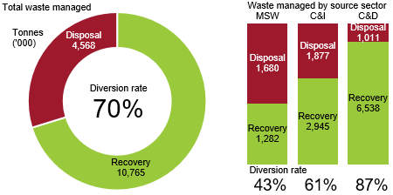

Over the last 10 years, there has been an increase in total waste managed by 27 per cent, total landfill waste by 0.6 per cent and total recovered waste by 43 per cent. The average increase of 0.06 per cent rate per year for waste going to landfill, compared with an average increase of 4 per cent per year for resource recovery, illustrates the strong growth of the resource recovery industry during this time. Figure 2 presents the trend in waste managed in Victoria since 2009–10. The increase in total managed waste was predominately in 2017–18 and 2018–19 because of additional C&D materials generated through land development and public transport works during these periods.

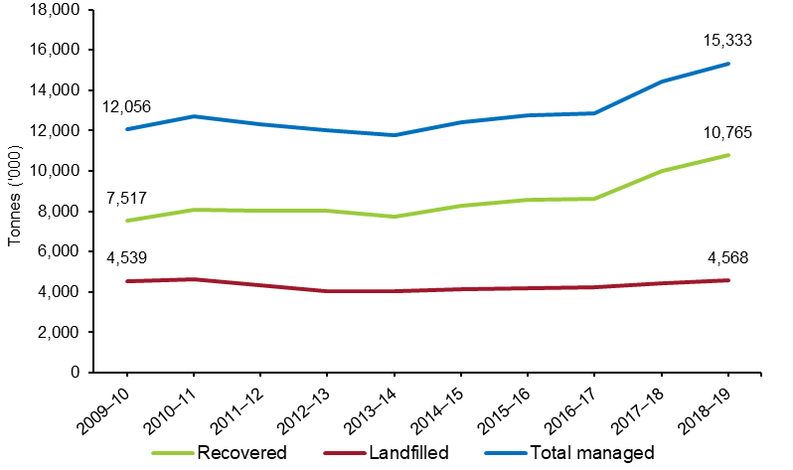Figure : Waste managed in Victoria from 2009–10 to 2018–19

Table 4 shows the increase in the diversion rate of waste since 2009–10. In 2018–19, the total waste managed per capita in Victoria increased to 2.3 tonnes. Waste managed relative to GSP increased slightly by 0.2 per cent in 2018–19 to 31.4 tonnes of waste managed for every million dollars of GSP (Table 4).

Table 4: Diversion rate and waste managed relative to economic and population trends in Victoria, 2009–10 to 2018–19

|  | 09–10 | 10–11 | 11–12 | 12–13 | 13–14 | 14–15 | 15–16 | 16–17 | 17–18 | 18–19 |
| --- | --- | --- | --- | --- | --- | --- | --- | --- | --- | --- |
| Diversion rate (%) | 62 | 63 | 65 | 67 | 66 | 67 | 67 | 67 | 69 | 70 |
| Tonnes waste managed per capita | 2.21 | 2.29 | 2.18 | 2.09 | 1.99 | 2.06 | 2.07 | 2.04 | 2.23 | 2.32 |
| Tonnes waste managed per $ million GSP | 38.3 | 38.2 | 35.7 | 33.9 | 31.9 | 32.0 | 31.0 | 29.7 | 31.3 | 31.4 |
| Total tonnes waste managed (millions) | 12.1 | 12.7 | 12.3 | 12.0 | 11.8 | 12.4 | 12.8 | 12.9 | 14.4 | 15.3 |

* 1. Material specific disposal and recovery

In 2018–19 material specific disposal and recovery varied across different source sectors. Table 5 shows the quantity of material disposed to landfill, the amount received for reprocessing and the diversion rate (figures in brackets) by source sector for Victoria in 2018–19.

Overall the materials that had the highest diversion rates were metals (91 per cent), aggregates masonry and soil (85 per cent) and glass and paper and cardboard (70 per cent each). For each source sector the materials with the highest diversion rates were:

* in MSW, metals (91 per cent), glass (83 per cent) and organics (44 per cent)
* in C&I, metals (92 per cent), paper / cardboard (77 per cent) and organics (50 per cent)
* in C&D, metals (90 per cent), aggregates masonry and soil (89 per cent) and organics (51 per cent)

Table : Quantity of material disposed and received for reprocessing (including diversion rate) by source sector in Victoria, 2018–19 (’000 tonnes and per cent diverted) *

|  |  |  |  |  |  |  |  |  |
| --- | --- | --- | --- | --- | --- | --- | --- | --- |
| Material | Municipal | | C&I | | C&D | | Total | |
| Disp. | Rec. | Disp. | Rec. | Disp. | Rec. | Disp. | Rec. |
| Aggregate, masonry and soil | 64 | 50 (44%) | 245 | 54 (18%) | 791 | 6,211 (89%) | 1,100 | 6,315 (85%) |
| Glass | 37 | 176 (83%) | 43 | 17 (29%) | 2 | 1 (30%) | 83 | 195 (70%) |
| Metals | 33 | 321 (91%) | 87 | 977 (92%) | 20 | 176 (90%) | 140 | 1,474 (91%) |
| Organics | 639 | 510 (44%) | 660 | 661 (50%) | 140 | 146 (51%) | 1,438 | 1,316 (48%) |
| Paper / cardboard | 189 | 145 (43%) | 334 | 1,104 (77%) | 8 | 0.1 (2%) | 532 | 1,249 (70%) |
| Plastics | 169 | 79 (32%) | 277 | 60 (18%) | 18 | 4 (19%) | 463 | 143 (24%) |
| Textiles | 55 | 1 (1%) | 121 | 0 | 11 | 0 | 187 | 1 (<1%) |
| Other | 494 | 0 |  | 72 (40%) | 21 | 0 | 625 | 72 (10%) |
| Total | 1,680 | 1,282 (43%) | 1,877 | 2,945 (61%) | 1,011 | 6,538 (87%) | 4,468 | 10,765 (70%) |

* Figures reported for materials received by source sector have been extrapolated to include the relative proportions derived from reported data and applied to surveys that did not include a source sector for the different material types and the export data from the ABS. Figures in Table 5 have been rounded to the nearest thousand and individual columns may therefore not add up to the totals reported for ‘Total’ or to the percentage figures provided in brackets. Percentage figures in brackets are the diversion rate for that material and source sector. “Other” includes: Rubber, street sweepings, material recovery facility residuals, nappies, electronics.

1. Materials recovered

|  |
| --- |
| Key findings in 2018–19:   * Recovery from the C&D sector accounted for 61 per cent of the total recovered materials received for reprocessing in Victoria in 2018–19, followed by C&I (27 per cent) and MSW (12 per cent). * The amount of C&D waste recovered for reprocessing continued to increase to 6.54 million tonnes, up 15 per cent from 2017–18 as a result of continued land clearing associated with new housing developments and rail and road infrastructure programs. * The increase in total recovered materials in 2018–19 was largely due to an increase in aggregate, masonry and soil recovered for reprocessing (this material made up 59 per cent of all material recovered for reprocessing in Victoria). The next most frequently recovered material for reprocessing was metals (14 per cent of the total materials) followed by organics, and paper and cardboard (both 12 per cent). * The C&D sector achieved a diversion rate of 87 per cent, followed by C&I with 61 per cent and municipal with 43 per cent. |

* 1. Source sectors of recovered materials

In 2018–19, of the 10.77 million tonnes of material recovered for reprocessing, 61 per cent by weight came from the C&D sector, an increase of 4 percentage points from 2017–18 (Figure 3). The proportion of materials recovered from the MSW sector remained steady at 12 per cent and materials recovered from the C&I sector decreased by 4 percentage points to 27 per cent compared with 2017–18. This reflects further increases in C&D waste reprocessing volumes and a small decline in C&I waste reprocessing. Figure 3 shows the slight changes by source sector of recovered materials received for reprocessing in   
2017–18 and 2018–19.

Figure : Source sectors of recovered materials received for reprocessing (by weight), Victoria, 2017–18 and 2018–19

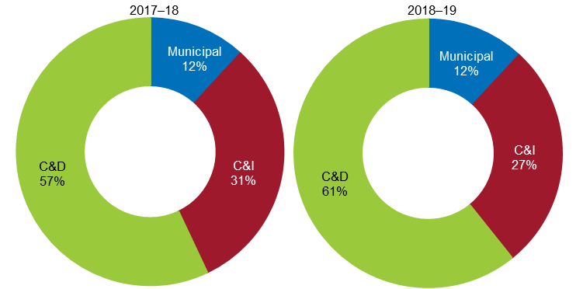

Over the last 10 years, the amount of C&D material recovered for reprocessing has increased by 85 per cent to 6.54 million tonnes in 2018–19, mainly due to a sharp increase in the current and last financial year. The amount of C&I material recovered for reprocessing has increased by 19 per cent during the same period to 2.95 million tonnes. The amount of MSW material recovered for reprocessing has decreased by 15 per cent to 1.28 million tonnes. This is likely to be due to a push by packaging manufactures and brand owners to use lighter weight packaging materials as well as changing consumer behaviours during this time, for example the move from physical print media to digital media. Figure 4 shows the trend of recovered materials received for reprocessing by source sector in Victoria.

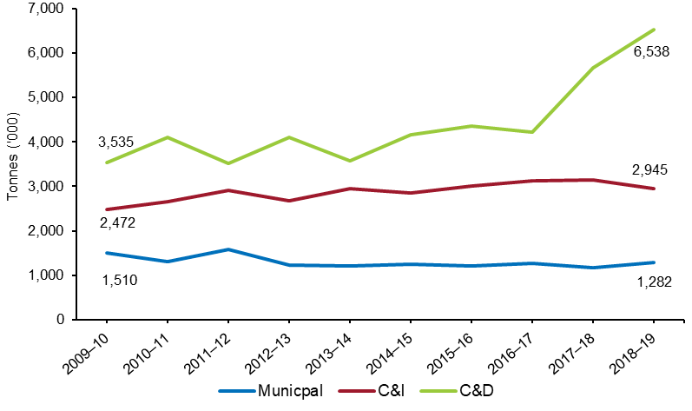Figure : Source sectors of recovered materials received for reprocessing in Victoria,   
2009–10 to 2018–19 (’000 tonnes)

* 1. Composition of recovered materials

The increase in the total recovered materials in 2018–19 was largely due to increases in aggregate, masonry and soil recovered for reprocessing. This material made up 59 per cent of all material recovered for reprocessing in Victoria (Figure 5). The C&D sector was the primary source of aggregate, masonry and soil. The remaining 41 per cent of the total materials recovered for reprocessing primarily came from metals at 14 per cent and organics and paper / cardboard each at 12 per cent.

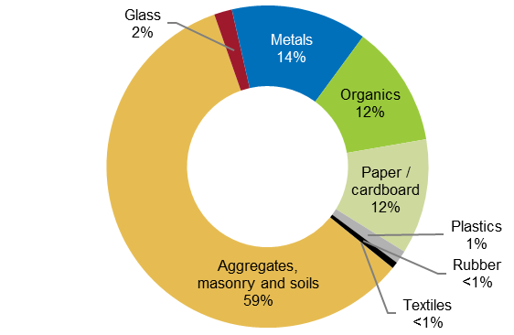Figure : Composition of material recovered for reprocessing (by weight) in Victoria,   
2018–19

Table 6 details the estimated tonnes of material recovered for reprocessing, landfilled and managed in 2018–19 from each source sector. The C&D sector generated and recovered the largest quantity of waste and as a result achieved the highest diversion rate of 87 per cent. The diversion rates for C&I (61 per cent) and MSW (43 per cent) were less.

Table : Source sectors of recovered materials received for reprocessing in Victoria, 2018–19 (’000 tonnes)*

| Material | 2018–19 | | | | 2017–18 Total | Change |
| --- | --- | --- | --- | --- | --- | --- |
| Municipal | C&I | C&D | Total |
| Aggregate, masonry and soil | 50 | 54 | 6,211 | 6,315 | 5,507 | +15% |
| Glass | 176 | 17 | 1 | 195 | 230 | –15% |
| Metals | 321 | 977 | 176 | 1,474 | 1,456 | +1% |
| Organics | 510 | 661 | 146 | 1,316 | 1,098 | +20% |
| Paper / cardboard | 145 | 1,104 | 0.1 | 1,249 | 1,481 | –16% |
| Plastics | 79 | 60 | 4 | 143 | 137 | 4% |
| Other (rubber, textiles) | 0 | 72 | 0 | 73 | 80 | –9% |
| Total recovered | 1,282 | 2,945 | 6,538 | 10,765 | 9,989 | +8% |
| Total landfilled | 1,680 | 1,877 | 1,011 | 4,568 | 4,441 | +3% |
| Total managed | 2,962 | 4,822 | 7,549 | 15,333 | 14,429 | +6% |
| Diversion rate | 43% | 61% | 87% | 70% | 69% | +1% |

* Figures reported for materials received by source sector have been extrapolated to include the relative proportions derived from reported data and applied to surveys that did not include a source sector for the different material types and the export data from the ABS. Figures in Table 6 have been rounded to the nearest thousand and individual columns may therefore not add up to the totals reported for ‘Total recovered’*.*

Table 6 also summarises the materials recovered in Victoria for reprocessing in 2018–19, compared with the previous year. In 2018–19, recovery of:

* aggregates, masonry and soil increased by 15 per cent to 6.32 million tonnes
* glass decreased by 15 per cent to 195,000 tonnes
* metals increased by 1 per cent to 1.47 million tonnes
* organics increased by 20 per cent to 1.32 million tonnes
* paper / cardboard decreased by 16 per cent to 1.25 million tonnes
* plastics increased by 4 per cent to 143,000 tonnes
* rubber and textiles combined decreased by 9 per cent to 73,000 tonnes (the majority of this was rubber).
  1. Material specific recovery data

|  |
| --- |
| Key findings in 2018–19:   * Aggregate, masonry and soil – Infrastructure and land clearing for housing developments contributed to an increase in the recovery of aggregate, concrete, rubble and plaster, all sourced primarily from the C&D sector. * Glass – There was significant stockpiling carried over from 2017–18, which resulted in a 15 per cent decrease in the amount of recovered glass from 2017–18. Export demand for glass remained steady. * Metals – There was only a 1 per cent increase in the amount of metal recovered from 2017–18. This trend was consistent with previous years. * Organics – There was a 20 per cent increase in total organics recovered from 2017–18. The main materials came from other organics, garden organics and timber. * Paper and cardboard – There was a 16 per cent decline in the amount of recovered paper and cardboard from 2017–18. This was due to mixed recyclables entering storage, sorting losses as a result of increased contamination and sorted materials not meeting import country contamination requirements. * Plastics – The amount of plastics recovered was very similar to previous financial years. There continues to be demand in local and export markets for plastics. * Other materials – Rubber and textiles are the material types under this category. The combined total of rubber and textiles only made up 1 per cent of the total recovered materials in 2018–19. |

## Aggregate, masonry and soil

In 2018–19, the amount of aggregates, masonry and soil recovered for reprocessing was 6.32 million tonnes in Victoria, an increase of 15 per cent from 2017–18. Since 2014–15, there has been a 58 per cent increase in the total amount of aggregate, masonry and soil recovered for reprocessing. Figure 6 shows the trend over the last 10 years and highlights the large increase over the last two financial years. This increase has been due to land clearing associated with new housing developments and infrastructure developments such as rail and roadworks.

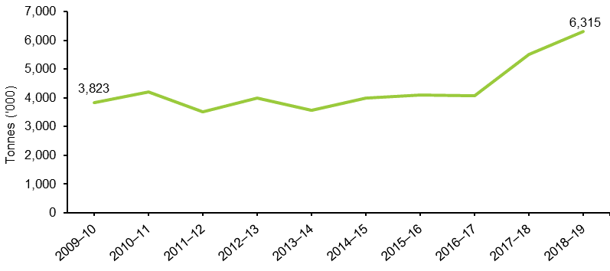Figure : Aggregate, masonry and soil wastes recovered for reprocessing, Victoria, 2009–10 to 2018–19

Figure 7 shows the tonnes (in thousands) of waste recovered for reprocessing by source sector and material types that sit under the aggregate, masonry and soil waste type. In 2018–19, there was a mix of material types recovered. This includes 43 per cent concrete at 2.71 million tonnes followed by 16 per cent clean fill (including rock and excavation stone) at 1.01 million tonnes, and 13 per cent bricks at 0.80 million tonnes. The materials were sourced primarily from the C&D sector as illustrated in Figure 7, which account for 98 per cent of the total materials recovered for reprocessing. This is a consistent trend over the last 10 years.

Figure : Aggregate, masonry and soil material types by source sector, Victoria, 2018–19

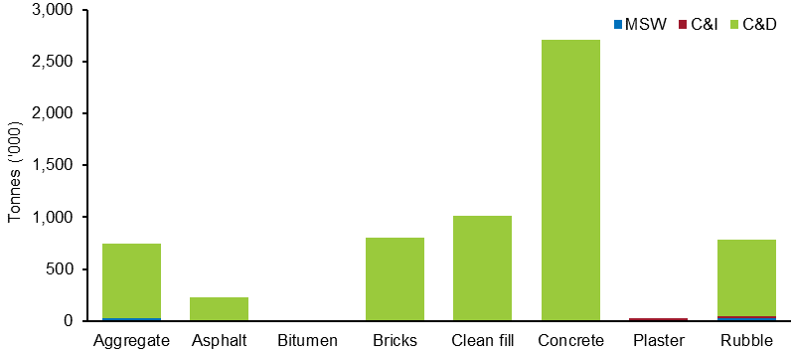

Figure 8 presents the material type composition of waste recovered for reprocessing by source sector in 2018–19. It shows:

* Rubble and aggregate were the only materials recovered from the MSW source sector at 50 per cent each.
* Plaster and rubble were the main materials recovered from the C&I source sector, at 56 per cent and 41 per cent respectively.
* A mix of materials were recovered from the C&D sector. The mix includes 43 per cent concrete, 16 per cent clean fill (including rock and excavation stone) and around 12 to 13 per cent each of rubble, aggregate and bricks.

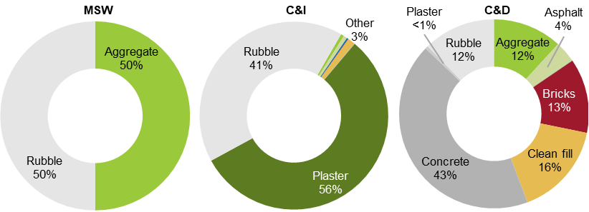Figure : Material type composition of aggregate, masonry and soil wastes recovered for reprocessing by source sector, Victoria, 2018–19

## Glass

In 2018–19, 0.19 million tonnes of glass was recovered for reprocessing in Victoria, a 15 per cent decrease from 2017–18. Of this, 14,400 tonnes (or 7 per cent) was exported for reprocessing. Over the last 10 years, the amount of glass reprocessed has varied considerably, as illustrated in Figure 9. Victoria now recovers 25 per cent more glass for reprocessing than it did in 2009–10. This is due to growing export demand and reuse of glass for road construction and asphalt production.

Over the last five years, the quantity of glass recovered for reprocessing has varied considerably. The drop in quantities between 2014–15 and 2016–17 is likely to signify glass material entering stockpiles following MRF sorting, which is not captured in the industry survey. The increase in 2017–18 is due to some of those stockpiled materials being used as replacements for other materials in construction activities, with the capacity for this market coming online in that year. The drop in 2018–19 represents issues associated with stockpiling of unsorted kerbside recyclable materials by former MRF operator SKM. The stockpiling of this waste was conducted towards the end of 2018 and the start of 2019 and was not resolved before the end of the financial year. Evidence from the *Recovered Resources Market Bulletin* (August 2019) suggests there was significant stockpiling occurring. According to the *Recovered Resources Market Bulletin* (June 2020), stockpiles have been reduced and controlled in the first half of 2020, with much of this material going to landfill because it was heavily contaminated.

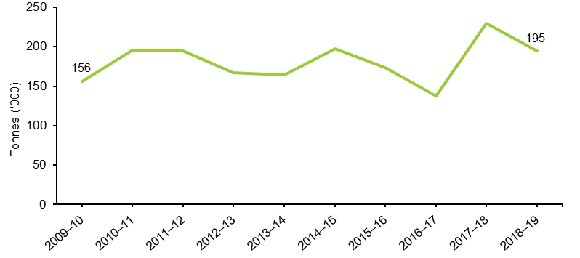Figure : Glass wastes recovered for reprocessing in Victoria, 2009–10 to 2018–19

In 2018–19, 91 per cent of total glass came from the MSW sector and most of this was container glass as illustrated in Figure 10. Around 9 per cent of glass came from the C&I sector, composed of a mixture of container glass, mixed glass and sheet or laminated glass. Less than 1 per cent came from the C&D sector and this was mainly sheet or laminated glass. Figure 10 presents the tonnes of glass material types recovered for reprocessing by source sector.

Figure : Glass material types by source sector, Victoria, 2018–19

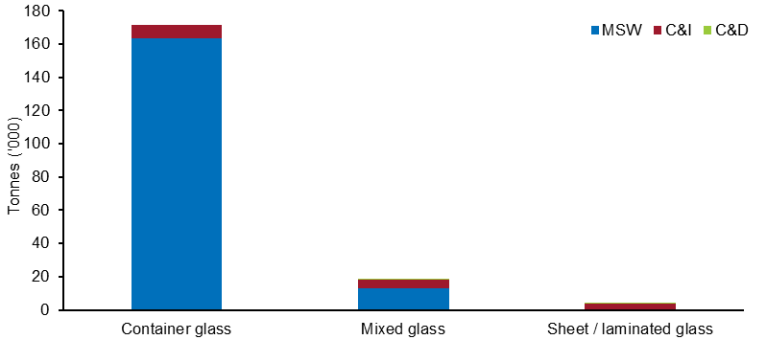

As part of the *Recycling Victoria: A New Economy* policy, the Victorian Government announced reforms to household recycling collections. The key components of this policy are to introduce a separate glass kerbside collection from Victorian households and that it will be included as an accepted material in the design of a container deposit scheme. In addition to this, as of June 2020 a small number of Victorian councils have already introduced a separate glass kerbside collection bin. These programs have a dual purpose. The first is to improve the quality of glass material coming from kerbside and consumer sources. The second is to improve the quality of the materials that remain in the mixed kerbside recycling collection bin because glass has acted as a contaminant following sorting.

## Metals

In 2018–19, 1.47 million tonnes of metal was recovered for reprocessing in Victoria, a less than 1 per cent increase from 2017–18. Of this, 988,000 tonnes (or 67 per cent) remained in Victoria for reprocessing. There has been a slight increase in the amount metal recovered for reprocessing over the last 10 years (5 per cent). Figure 11 presents the trend in metal recovered for reprocessing since 2009–10.

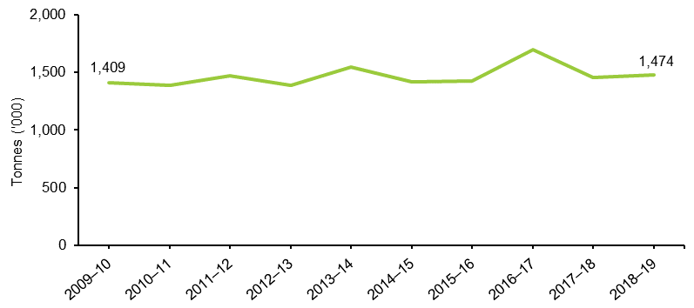Figure : Metal wastes recovered for reprocessing in Victoria, 2009–10 to 2018–19

In 2018–19, 66 per cent of metal recovered for reprocessing was sourced from the C&I sector and 22 per cent from MSW. Over the last 10 years, the C&I sector has been the predominant source for metal recovered for reprocessing. In 2018–19, ferrous metals made up 72 per cent of the total amount of metal recovered for reprocessing (Figure 12).

Figure : Metal material types recovered for reprocessing by source sector, Victoria, 2018–19

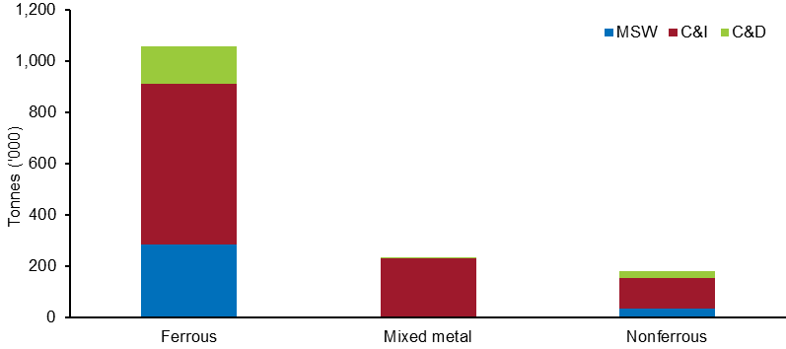

Figure 13 presents the material type composition of metal waste recovered for reprocessing by source sector in 2018–19. It shows:

* Ferrous was the main material recovered from all source sectors.
* The amount of nonferrous recovered was typically between 11 and 15 per cent from all sectors.
* Mixed metals were predominately sourced from the C&I sector at 24 per cent.

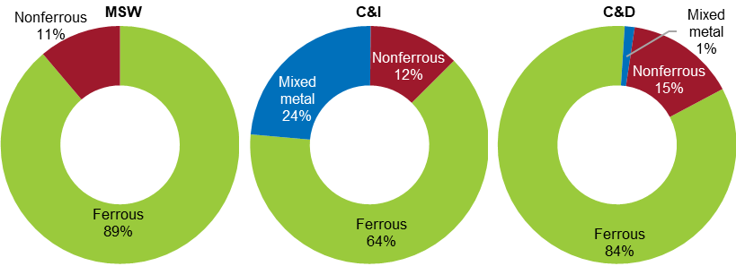Figure : Material type composition of metal wastes recovered for reprocessing by source sector, Victoria, 2018–19

## Organics

In 2018–19, 1.32 million tonnes of organics was recovered for reprocessing in Victoria, a 20 per cent increase from 2017–18. Almost all of this material remained in Victoria for reprocessing. The increase in the tonnes of organics reprocessed was led by material recovered for reprocessing from the MSW sector, which increased by 31 per cent. This is likely to be the result of expanded household organic waste collection services and processing infrastructure and a growing market for recycled organic products. There has been a steady increase in the tonnes of organics recovered for reprocessing over the last 10 years. Figure 14 presents the trend over this time.

In 2018–19, half of the organics recovered for reprocessing came from the C&I sector, followed by MSW (39 per cent).

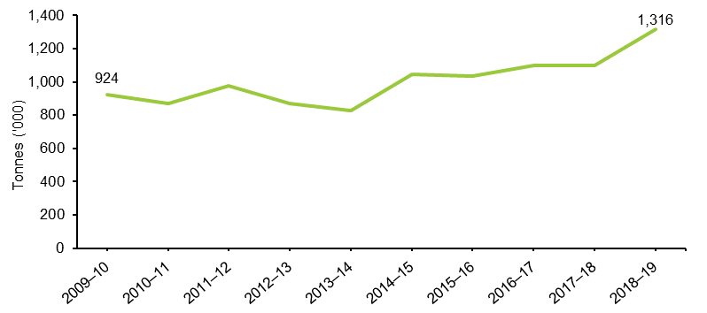Figure : Organic wastes recovered for reprocessing in Victoria, 2009–10 to 2018–19

Figure 15 illustrates the different material types that make up the organics category and the source sectors that they came from in 2018–19. Of the total organics recovered for reprocessing, 41 per cent was in the other organics material type (which includes mixed organics, non-hazardous sludges and some forestry and agricultural residuals). The remaining was made up of garden organics (26 per cent), timber (15 per cent) and mixed food and garden organics (FOGO – 11 per cent).

Figure : Organic material types recovered for reprocessing by source sector, Victoria, 2018–19

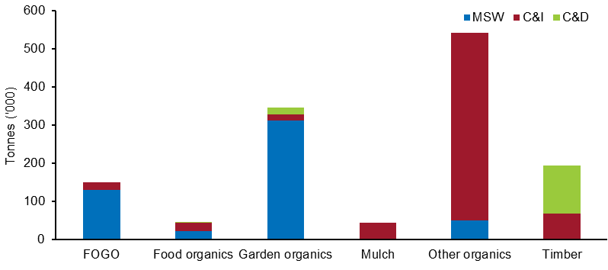

Figure 16 presents the material type composition of waste recovered for reprocessing by source sector in 2018–19. It shows:

* Garden organics made up 61 per cent of the material recovered for reprocessing from MSW. FOGO contributed to 25 per cent of the total material recovered from MSW. The significant presence of garden organics and FOGO from the MSW sector is due to the availability of kerbside collection systems provided by councils.
* Other organics was the principle material recovered from C&I at 75 per cent.
* Timber contributed to 87 per cent of the total organics recovered from the C&D sector, most of this coming from building demolition works.

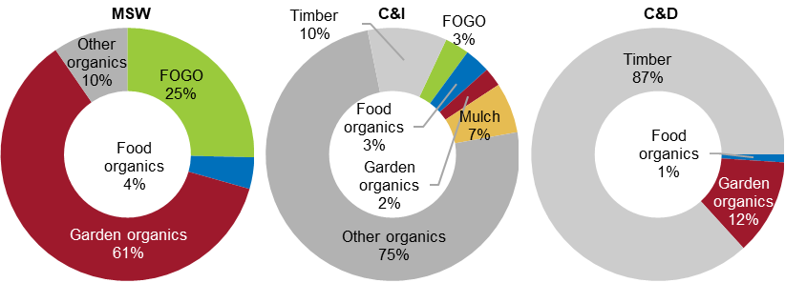Figure : Material type composition of organic wastes recovered for reprocessing by source sector, Victoria, 2018–19

## Paper and cardboard

In 2018–19, 1.25 million tonnes of paper and cardboard was recovered for reprocessing in Victoria, a 16 per cent decrease from 2017–18. The total amount of recovered paper and cardboard in Figure 17 has been consistent over the last five years. The observed decrease in 2018–19 is likely due to a range of factors, including:

* sorted materials not meeting import country contamination requirements
* sorting losses because of increased contamination from kerbside recycling bins
* mixed recyclable materials entering storage with the intention that they would be sorted later, so impacting on the amount of material flowing through the system
* changes in the commodity value of paper and cardboard throughout 2018–19, again leading to increased storage of sorted material.

According to the *Recovered Resources Market Bulletin* (August 2019), there was a relatively stable demand for recovered paper and cardboard from local manufacturers for use in new corrugated cardboard and newspaper print throughout 2018–19.

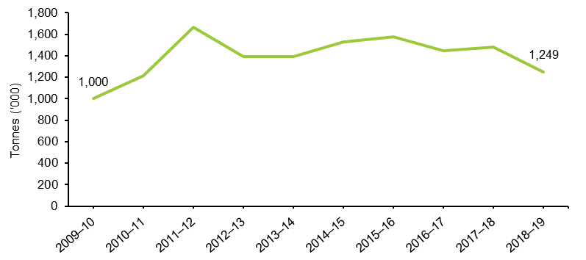Figure : Paper and cardboard wastes recovered for reprocessing in Victoria, 2009–10 to 2018–19

In 2018–19, 56 per cent of recovered paper and cardboard was paper and 44 per cent was cardboard, as illustrated in Figure 18. Additionally:

* Paper was the primary material recovered from MSW (although this may be a function of lack of detail provided by survey respondents as opposed to an actual trend).
* There was an even split of paper and cardboard recovered from the C&I sector.
* The amount of paper and cardboard recovered from the C&D sector was negligible.

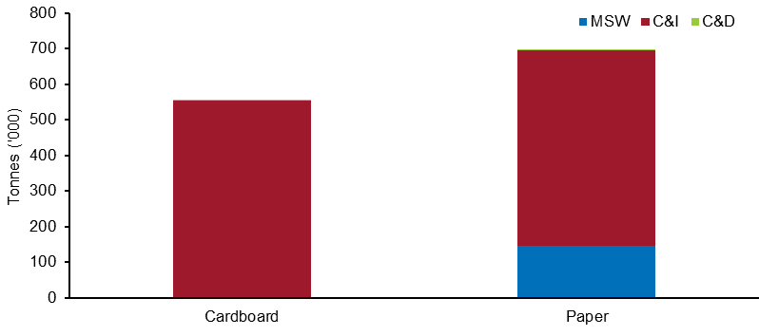Figure 18: Recovered paper and cardboard, Victoria, 2018–19

## Plastics

In 2018–19, 0.14 million tonnes of plastics was recovered for reprocessing in Victoria, a 4 per cent increase from 2017–18. Figure 19 presents the trend of plastics recovered for reprocessing over the last 10 years, which has been relatively stable.

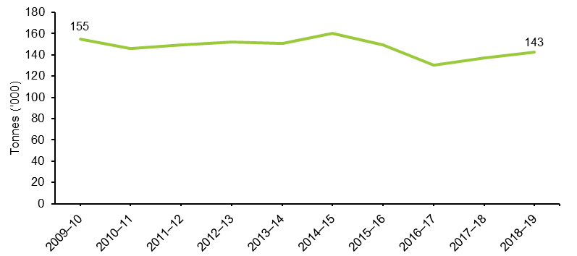Figure : Plastic wastes recovered for reprocessing in Victoria, 2009–10 to 2018–19

In 2018–19, the total amount of plastics recovered for recycling comprised of four key material types, consisting of:

* 40,000 tonnes (28 per cent) of PE-HD (high-density polyethylene) used in pipe systems, recycling bags, grocery bags, home care products and toys
* 26,000 tonnes (18 per cent) of PET (polyethylene terephthalate) used in packaging beverages and food, and in home care products
* 25,000 tonnes (18 per cent) of PE-LD / LLD (low-density polyethylene) used in plastic bags, plastic films and plastic containers
* 22,000 tonnes (16 per cent) of PP (polypropylene) used in plastic bottles caps, margarine containers, prescription bottles, car parts and protective packaging for medical equipment.

Figure 20 shows the specific material types recovered for reprocessing by source sector.

Figure : Plastic material types recovered for reprocessing by source sector, Victoria, 2018–19

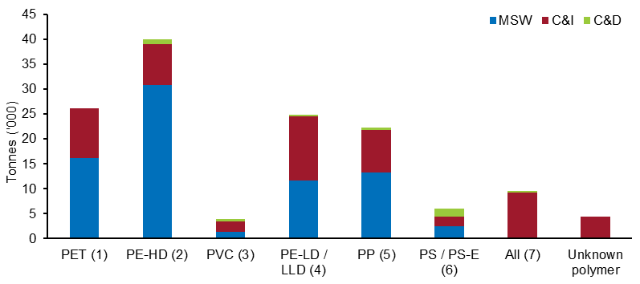

Figure 21 presents the material type composition of waste recovered for reprocessing by source sector in 2018–19. It shows the main materials recovered for reprocessing:

* Materials recovered from MSW were PE-HD (41 per cent), PET (21 per cent), PP (18 per cent) and PE-LD / LLD (15 per cent). These materials are predominantly used in consumer packaging and make up 95 per cent of all materials recovered from MSW plastics.
* Materials recovered from C&I were PE-LD / LLD (22 per cent), PET (17 per cent) and PP (15 per cent).
* Materials recovered from C&D were PS / PS-E (37 per cent – polystyrene and expanded polystyrene), PE-HD (22 per cent) and PVC (15 per cent – polyvinyl chloride, the material often using in plumbing).

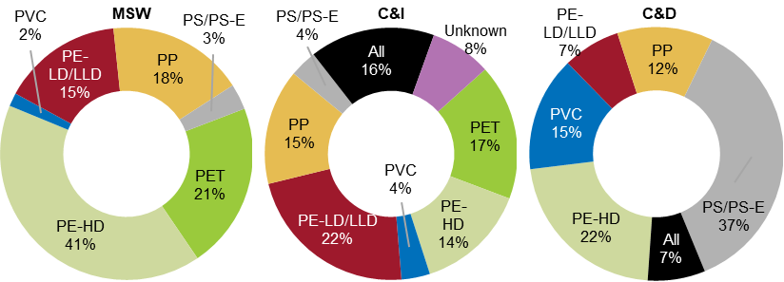Figure : Material type composition of paper and cardboard wastes recovered for reprocessing by source sector, Victoria, 2018–19

## Other materials

Other materials comprise of rubber and textiles. In 2018–19, 72,000 tonnes of rubber and 600 tonnes of textiles were recovered for reprocessing. This is less than 1 per cent of the total recovered materials in 2018–19. Figure 22 shows the trend of rubber and textile material recovered over the last 10 years. For rubber, there was 9 per cent decrease from 2017–18; however, this was due to a spike in reprocessing quantities in 2017–18 because of tyre stockpile clean up rather than a significant decrease in 2018–19. For textiles, there was an increase compared with 2017–18 quantities but an overall decrease over the last 10 years.

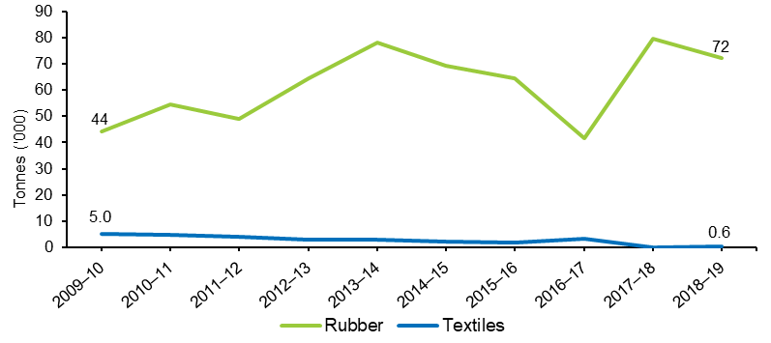Figure : Total amount of rubber and textile materials recovered for reprocessing in Victoria, 2009–10 to 2018–19

* 1. Local government management of kerbside waste

|  |
| --- |
| Key findings in 2018–19:   * The 79 Victorian local governments spent $488 million on the provision of kerbside collection services for garbage, recyclables and organics to 2.64 million properties and collected 2.19 million tonnes in these services. * The cost to councils of providing a kerbside service increased by 14 per cent compared with 2017–18. The largest increase is attributed to recyclables, where the cost of the service rose by 49 per cent or $39.7 million dollars across the state. This is likely to be associated with the changing market value of kerbside recyclable materials. * Almost 40 per cent of kerbside collected recyclables was sent to overseas markets for remanufacturing. * The contamination rate in kerbside recycling bins was between 10 and 20 per cent. * At the beginning of 2020 there was an estimated 100,000–200,000 tonnes of kerbside recyclables in metropolitan storage, mostly accumulated through 2018 and early 2019 as a result of SKM sorting facility closures. * Commodity values for kerbside recyclables varied considerably through the year: glass and mixed plastics (plastic numbers 3 to 7) had a negative commodity value; single stream HDPE and PET had commodity values over and around $400/tonne and aluminium over $1,000/tonne; and mixed paper and cardboard and single stream old corrugated cardboard ended 2018–19 with a similar value to the start of the year. |

There are three main kerbside services offered by local governments to their residents: garbage, recyclables and organics (garden only and combined food and garden). Table 7 summarises the main findings from the 2018–19 Victorian Local Government Annual Waste Services Survey for these three services.

Table : Key high-level findings from the Victorian Local Government Annual Waste Services Survey, 2018–19

| Measure | Garbage | Recyclables | Organics | Total |
| --- | --- | --- | --- | --- |
| Annual service cost | $281,187,000 | $120,972,000 | $86,047,000 | $488,205,000 |
| Tonnes collected | 1,180,700 | 565,100 | 443,500 | 2,189,200 |
| Tonnes processed | — | 505,900 | 443,400 | 949,300 |
| Total properties serviced | 2,644,000 | 2,598,000 | 1,558,000 | — |
| Cost per tonne collected | $238 | $214 | $194 | $223 |
| Cost per property serviced | $106 | $47 | $55 | — |
| Yield (kg per property serviced) | 447 | 218 | 285 | — |
| Cost per person | $43 | $18 | $13 | $74 |
| Yield (kg per person) | 179 | 86 | 67 | 332 |

Figures in Table 7 have been rounded and individual columns may not add up to the totals.

In 2018–19, the 79 Victorian local governments spent $488 million on the provision of kerbside collection services for garbage, recyclables and organics to the 2.64 million Victorian properties serviced.[5] Garbage collections accounted for more than half of the cost, with $281 million spent or 58 per cent of the total, followed by recyclables with 25 per cent and garden organics with the remaining 17 per cent.

The cost to councils of providing a kerbside service increased by 14 per cent compared with 2017–18. The largest increase is attributed to recyclables, where the cost of the service rose by 49 per cent or $39.7 million dollars across the state. This is likely to be associated with the changing market value of kerbside recyclable materials. In many cases sorters of kerbside recyclable materials now charge their councils to sort their waste where previously some facilities paid councils for their waste as this cost could be recouped by the end value of the material. This is no longer the case and as a result that arrangement has reversed.

Figure 23 presents the total tonnes of garbage, recyclables and organics collected from Victoria’s seven Waste and Resource Recovery Group regions. Due to the Metropolitan region holding the largest number of councils (and therefore the largest population), it collected the largest volume of waste. The region with the highest waste diversion rate was North East (55 per cent) followed by Barwon South West (53 per cent).

Figure :

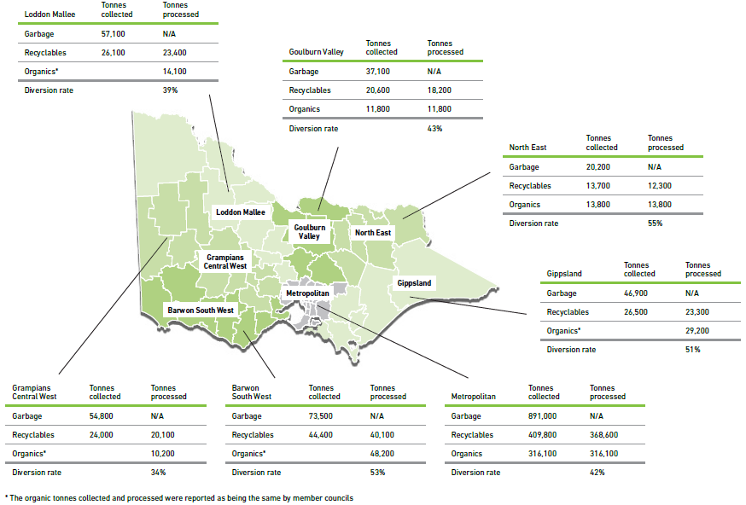

Figure 23: Total waste collected and processed from councils by Waste and Resource Recovery Group, 2018–19

## Material flow from kerbside (MSW) recycling collections

In 2018–19, between 560,000 and 580,000 tonnes of recycling was collected from Victorian households for recycling. The materials were then sorted at MRFs and either exported or reprocessed locally (with some to landfill) and then used in manufacturing new products. Figure 24 presents the estimated flows of materials from kerbside (MSW) collection through to processing destination as presented in the *Recovered Resources Market Bulletin* (Sustainability Victoria 2019).

Figure : Flows of kerbside (MSW) collection materials in Victoria, 2018–19

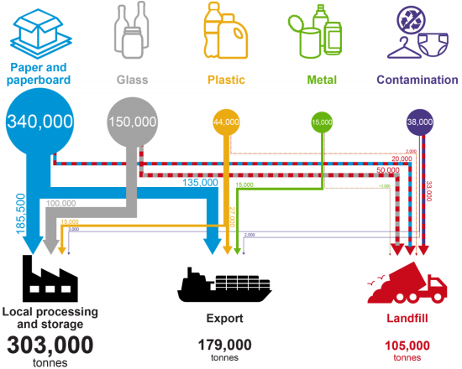

*Source: Sustainability Victoria 2019*

Evident in Figure 24 is the amount of kerbside recyclables reliant on export markets as a destination for remanufacturing, with almost 40 per cent of materials using this pathway.

## Contamination in kerbside recycling bins

The difference between the recycling bin tonnage data presented in Table 7 and in Figure 24 represents different data collection points and definitions of contamination. The data from the Sustainability Victoria *Victorian Local Government Annual Waste Services Report 2018–19* presents the contamination rate as the amount of material removed during the sorting process. The data from Sustainability Victoria’s *Recovered Resources Market Bulletin* presents the contamination rate as that figure plus the amount of material lost during reprocessing due to contamination of already sorted recyclables. As a result, the *Recovered Resources Market Bulletin* shows a larger volume of material being removed as contamination and going to landfill from kerbside recycling collections.

The contamination rate reported by Victorian councils to the 2018–19 Victorian Local Government Annual Waste Services Survey ranged from 2.6 to 31.4 per cent. The average recycling bin contamination rate for Victoria was estimated to be 10.5 per cent in 2018–19. The rate reported in the *Recovered Resources Market Bulletin* was estimated to be between 15 and 20 per cent for the same period.

## Storage of collected materials and the impact of SKM closures

At the beginning of 2020 there was an estimated 100,000–200,000 tonnes of kerbside recyclables in metropolitan storage (including glass), mostly accumulated through 2018 and early 2019 as a result of SKM sorting facility closures resulting from non-compliance with EPA Victoria site operating conditions (EPA Victoria 2019). During these closures, there was a sustained practice of sending unsorted and single stream recyclable material to storage with the intent that it would be sorted or sold and reprocessed at a later date. Data in this report shows the impact of this practice, especially for paper / cardboard and glass. When SKM went into liquidation in October 2019 (*The Age* 2019), much of this material remained in storage. The *Recovered Resources Market Bulletin* from June 2020 (Sustainability Victoria 2020) notes that most of this stored material is now reported to have been removed, with most of it going to landfill in mid-2020.

SKM sorted the kerbside recyclables from 33 of 79 Victoria councils. When the company was placed into liquidation, those councils had no other option but to send their kerbside collected material to landfill because of limits on sorting capacity at other sites. During this period (August to November 2019), approximately 54,000 tonnes of waste was sent directly to landfill from council kerbside recycling bin collections. The sorting facilities previously operated by SKM were purchased by Cleanaway in October 2019 and have been operational since December 2019 of the same year (Cleanaway 2019).

## Changing value of kerbside collected recycling

During 2018–19, commodity values for recovered kerbside materials from Victorian households varied across the year. Figure 25 presents the commodity values (in $/tonne) for typical mixes of material type commodities. Evident from Figure 25 is that there was a wide range of commodity values for sorted kerbside collected material in 2018–19:

* Glass had a negative commodity value throughout the year, reflecting the lack of local or international demand for these materials. The commodity value of glass highlights the trend of glass being used as a sand substitute in construction materials as opposed to it going back into glass products or packaging. The marker for this trend is likely to be the cost difference associated with glass beneficiation, which is required to reuse the material in products or packaging.
* Single stream HDPE and PET had commodity values over and around $400/tonne while mixed plastics (plastic numbers 3 to 7) had a negative commodity value. This reflects the demand from packaging manufactures for single stream commodities that do not require further processing.
* Recovered aluminium had the largest commodity value; however, this decreased by 19 per cent through the first half of 2018–19 but remained steady in the second half, reflecting the demand for this material. Steel maintained a steady commodity value throughout.
* The commodity value of mixed paper and cardboard did not improve throughout 2018–19 and finished the financial year at $0/tonne. Single stream old corrugated cardboard ended the 2018–19 year with a higher commodity value than when it started, reflecting demand for this material for local packaging production.

Figure : Commodity values of Victorian recovered kerbside materials ($/tonne)

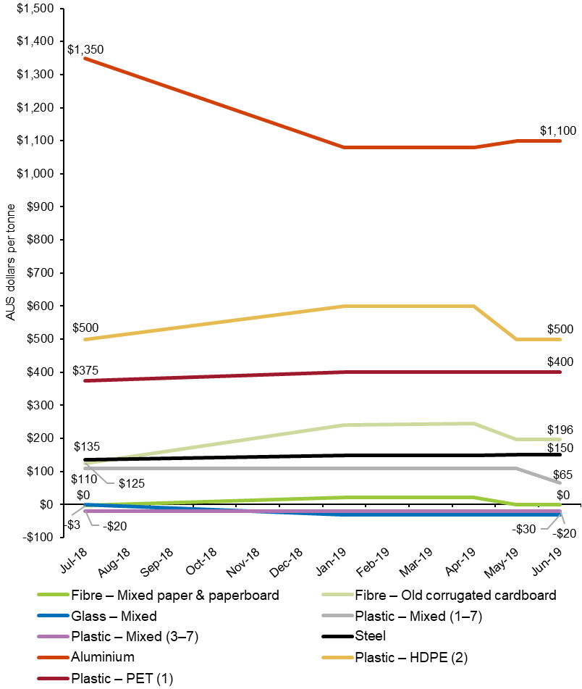

1. Material exported for recovery

|  |
| --- |
| Key findings in 2018–19:   * Victoria’s resources were predominantly reprocessed locally with 90 per cent of all recyclables processed within the state. * Materials collected from MSW are particularly export exposed, with almost 40 per cent of materials collected from Victorian households in 2018–19 heading overseas for reprocessing. * The quantity of materials exported for reprocessing overseas decreased by 11 per cent compared with 2017–18 to 1.12 million tonnes, as exporters were unable to find overseas markets for recyclable materials. * More than 90 per cent of glass and organics, and more than 60 per cent of glass, and paper and cardboard were reprocessed in Victoria. More plastics and rubber were exported for reprocessing than were reprocessed in Victoria. * The top 10 receiving countries of Victorian exports accounted for 94 per cent of all material exported. China (24 per cent), Indonesia (17 per cent), India (14 per cent) and Bangladesh (11 per cent) accepted the most by weight. * Monthly exports of paper and cardboard made up the largest component of kerbside recyclables that were exported for reprocessing, peaking at 14,100 tonnes in April 2019. Exports of plastics and metals were fairly steady across the year and exports of glass varied month to month in 2018–19. |

* 1. Annual trends in waste exports

In 2018–19, Victoria’s resources were predominantly reprocessed locally, as shown in Figure 26. Around 9.64 million tonnes (90 per cent) of recovered material remained in Victoria to be reprocessed in local plants. This is an increase of 10 per cent since 2017–18 (8.72 million tonnes).

Figure : Material reprocessed locally or exported overseas or interstate from Victoria, 2005–06 to 2018–19

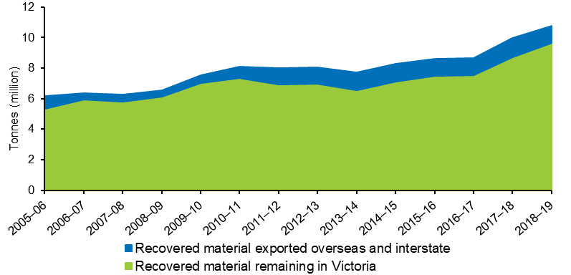

In January 2018, the international export market for recyclable materials significantly changed with several countries, led by the Chinese National Sword policy restrictions, enforcing strict contamination limits or bans on single stream materials entering their countries. As a result of this, the quantity of materials exported for reprocessing overseas decreased by 11 per cent (compared with 2017–18) to 1.12 million tonnes in 2018–19, as exporters were unable to find overseas markets for recyclable material. The key materials exported were scrap metals, paper and plastics – all globally traded commodities used in recycling operations worldwide.

* 1. Export composition in 2018–19

The composition of material sorted and exported for reprocessing from Victoria was spread across a range of materials. Metals, and paper and cardboard made up 44 and 43 per cent respectively of the total quantity exported (by weight). Figure 27 presents the composition of materials exported for reprocessing from Victorian in 2018–19.

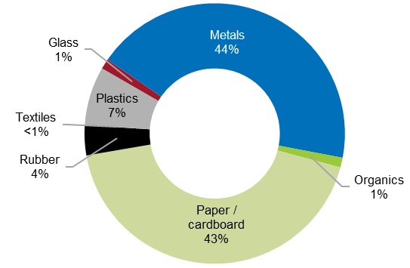Figure : Composition of materials exported for reprocessing, Victoria, 2018–19

Figure 28 shows the proportions of material reprocessed locally and exported for reprocessing in 2017–18 and 2018–19. Local reprocessing of plastics, metals, and paper and cardboard increased in Victoria in 2018–19. Rather than an indication of increased local reprocessing capacity, this may indicate the closure of some export markets for these materials, a lack of local market access and these materials entering stockpile or being sent to landfill (especially for paper and cardboard).

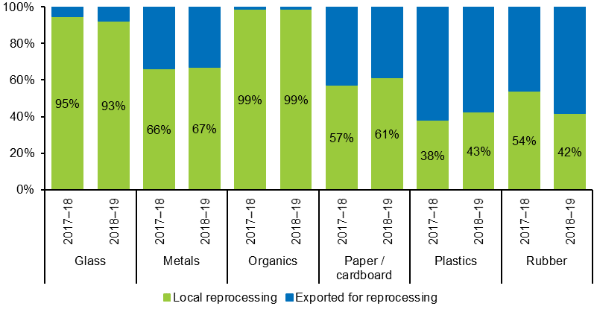Figure : Proportions of materials reprocessed in Victoria and exported for reprocessing by material type from Victoria, 2017–18 and 2018–19

The proportions of glass and rubber reprocessed locally decreased in 2018–19. Over the last 12 months, local reprocessing of:

* glass decreased by 17 per cent, likely to be due to the closure of local glass beneficiation processing capacity
* metals increased by 2 per cent
* paper / cardboard decreased by 10 per cent, which is in line with overall reductions in paper / cardboard quantities managed
* plastics increased by 16 per cent
* rubber decreased by 30 per cent, likely to be a result of stockpile clean-ups in 2017–18, which increased processed quantities in that year.

During the same period, quantities exported for the reprocessing of:

* glass increased by 24 per cent to 14,400 tonnes
* metals slightly decreased by 0.5 per cent to 486,900 tonnes
* plastics decreased by 4 per cent to 81,900 tonnes
* paper / cardboard decreased by 23 per cent to 483,900 tonnes
* rubber increased by 15 per cent to 41,900 tonnes.

Lower value materials, such as waste from C&D activities and food and garden organics, are rarely exported, if at all, as it is financially prohibitive to do so.

* 1. Export destinations and import restrictions

In 2018–19, exports of recyclable materials were sent from Victoria to around 70 destinations worldwide. Of this, 10 countries accounted for 94 per cent by weight of all material exported. The countries that accepted the most material were China (24 per cent), Indonesia (17 per cent), India (14 per cent) and Bangladesh (11 per cent). Table 8 presents the top 10 destinations for exports of recyclable material from Victoria in 2018–19.

Table : Top 10 destinations for exports of recyclables from Victoria, in tonnes, 2018–19

| Destination country | Glass | Metals | Paper / cardboard | Plastics | Other† | Total |
| --- | --- | --- | --- | --- | --- | --- |
| China* | 0 | 19,700 | 248,100 | 200 | 0 | 268,000 |
| Indonesia* | 100 | 74,800 | 74,700 | 37,800 | 100 | 187,600 |
| India* | 0 | 92,500 | 33,700 | 300 | 19,500 | 146,000 |
| Bangladesh | 2,900 | 116,100 | 2,100 | 100 | 0 | 121,300 |
| Malaysia* | 11,300 | 36,200 | 27,000 | 15,100 | 11,600 | 101,200 |
| Taiwan* | 0 | 47,900 | 5,100 | 7,900 | 0 | 60,800 |
| South Korea | 0 | 7,600 | 47,200 | 2,100 | 0 | 56,900 |
| Vietnam* | 0 | 23,100 | 30,300 | 300 | 0 | 53,700 |
| Thailand* | 0 | 22,800 | 6,600 | 1,800 | 3,700 | 35,000 |
| Pakistan | 0 | 19,800 | 2,000 | 0 | 0 | 21,700 |
| Top 10 destinations total | 14,300 | 460,500 | 476,800 | 65,600 | 34,900 | 1,052,200 |
| All destinations total | 14,400 | 486,900 | 483,900 | 81,900 | 55,700 | 1,122,700 |
| Top 10 proportion of total | 99% | 95% | 99% | 80% | 63% | 94% |

* Indicates that country had some form of restrictions on the importation of waste.   
† ‘Other’ includes rubber, textiles and organics.

Figures in Table 8 have been rounded to the nearest hundred and may not match totals reported in other parts of this report.

Notably, in 2018–19 each material had a dominant country that received more exports from Victoria than others, such as for:

* glass this was Malaysia – 79 per cent of total glass exported
* metals this was Bangladesh – 24 per cent of total metals exported
* paper and cardboard this was China – 51 per cent of total paper and cardboard exported
* plastics this was Indonesia – 46 per cent of total plastics exported
* the other grouping (rubber, textiles and organics) this was India – 35 per cent of the total other grouping, which was predominantly rubber.

Table 8 also highlights which countries implemented import restrictions on recyclable material imports during 2018–19. Despite these restrictions, exports from Victoria to these destinations were able to meet the requirements. For a comprehensive overview of countries that had restrictions on the import of recyclable material during 2018–19 please refer to the Australian Government Department of Agriculture, Water and the Environment publication *Data on Exports of Australian Wastes 2018–19* (Blue Environment 2019). Updated information on current restrictions on the import of recyclable material into other countries is available in the *Recovered Resources Market Bulletin* (Sustainability Victoria 2020).

* 1. Monthly trends in kerbside recycling material exports

In 2018–19, monthly exports of kerbside recyclable bin materials varied. Figure 29 presents the exports of paper and cardboard, metals, glass and plastics that are estimated to come from the household kerbside recyclables bin. These figures are based on export quantities as reported by the ABS, with estimates of the proportion that comes from kerbside recycling bins applied. These estimates are based on industry knowledge and were developed for the *Recovered Resources Market Bulletin*.

Paper and cardboard exports made up the largest component of kerbside recyclables that were exported for reprocessing at 71 per cent of the total. Monthly exports of paper and cardboard varied between 14,100 tonnes (April 2019) and 8100 tonnes (November 2018). Exports of plastics and metals were fairly steady across the year, varying between approximately 2300 tonnes and 1100 tonnes respectively. Exports of glass varied from a high of 2400 tonnes in May 2019 to 0 tonnes in December 2018 and in March 2019. Monthly variations in export quantities reflect the nature of supply and demand for material across global manufacturing.

Figure : Monthly trends in kerbside recyclable material exports, Victoria, 2018–19

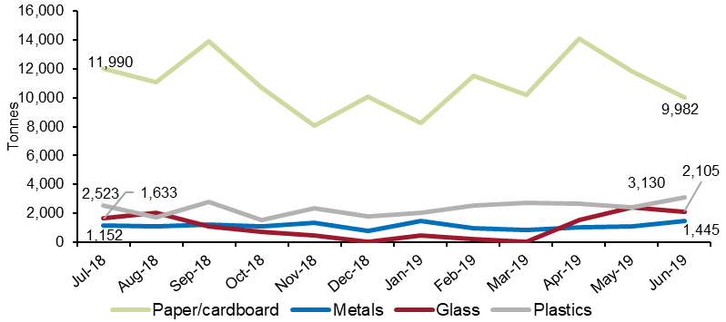

1. References

ABS (2019a) Cat no. 3101.0, Australian Demographic Statistics, Sep 2018: Table 4. Estimated Resident Population, States and Territories (Number)

ABS (2019b) Cat no. 5220.0, Australian National Accounts: State Accounts, 2017–18: Table 3. Gross State Product – Current Prices – All Sectors; State Final Demand: Current Prices

ABS (2019c) Cat no. 6401.0, Consumer Price Index, Australia, Mar 2019: Table 5. CPI: Groups, Index Numbers by Capital City

Australian Government Department of Agriculture, Water and the Environment (2020) Investing in Australia’s waste and recycling infrastructure, available from: <http://www.environment.gov.au/protection/waste-resource-recovery/recycling-modernisation-fund>

Blue Environment (2019) *Data on Exports of Australian Wastes 2018–19*, for the Australian Government Department of Agriculture, Water and the Environment, available from: [https://www.environment.gov.au/system/files/resources/23acbf02-2178-4139-81b0-58adcac4f5cd/files/data-exports-australian-wastes-2018–19.pdf](https://www.environment.gov.au/system/files/resources/23acbf02-2178-4139-81b0-58adcac4f5cd/files/data-exports-australian-wastes-2018-19.pdf)

Cleanaway (2019) Acquisition of SKM recycling assets, available from: <https://www.cleanaway.com.au/sustainable-future/acquisition-of-skm-recycling-assets/>

COAG (2020) *Phasing Out Exports of Waste Plastic, Paper, Glass and Tyres*, available from: <https://www.coag.gov.au/sites/default/files/communique/phasing-out-waste-exports-response-strategy.pdf>

EPA Victoria (2019) SKM Coolaroo regains compliance, available from: <https://www.epa.vic.gov.au/about-epa/news-media-and-updates/news-and-updates/skm-coolaroo-regains-compliance>

Premier of Victoria (2019) Victoria leads call for urgent waste funding from feds, available from: <https://www.premier.vic.gov.au/victoria-leads-call-for-urgent-waste-funding-from-feds/>

Sustainability Victoria (2019) *Recovered Resources Market Bulletin*, various dates, available from: <https://www.sustainability.vic.gov.au/Business/Investment-facilitation/Recovered-resources-market-bulletin>

Sustainability Victoria (2020) *Recovered Resources Market Bulletin*, various dates, available from: <https://www.sustainability.vic.gov.au/Business/Investment-facilitation/Recovered-resources-market-bulletin>

*The Age* (2019) ‘Recycling firm SKM Industries goes into liquidation, sale expected’, available from: <https://www.theage.com.au/national/victoria/recycling-firm-skm-industries-goes-into-liquidation-sale-expected-20191005-p52xwc.html>

Victorian Government Department of Environment, Land, Water and Planning (DELWP) (2020) *Recycling Victoria: A New Economy*, available from: <https://www.vic.gov.au/transforming-recycling-victoria>

1. Acronyms and abbreviations

| Acronym | Description |
| --- | --- |
| ABS | Australian Bureau of Statistics |
| C&D | Construction and demolition |
| C&I | Commercial and industrial |
| COAG | Council of Australian Governments |
| DELWP | Department of Environment, Land, Water and Planning |
| EPA | Environment Protection Authority Victoria |
| FOGO | Food organics and garden organics |
| MRF | Material recovery facility |
| MSW | Municipal solid waste |
| RD&D | Research, development and demonstration |
| SV | Sustainability Victoria |
| VLGAWSR | *Victorian Local Government Annual Waste Services Report* |
| VRIAR | *Victorian Recycling Industry Annual Report* |
| VRIAS | Victorian Recycling Industry Annual Survey |

1. Glossary

| Term | Explanation |
| --- | --- |
| Commercial & industrial (C&I) waste | Solid materials and waste generated from trade, commercial and industrial activities, including the government sector. It includes waste from offices, manufacturing, factories, schools, universities, state and government operations, and small to medium enterprises, e.g. food organics. |
| Construction & demolition (C&D) waste | Solid materials and waste generated from residential and commercial construction and demolition activities, e.g. bricks and concrete. |
| Department of Environment, Land, Water and Planning (DELWP) | Victorian Government department providing policy planning, preparation of legislative amendments, leadership coordination and oversight of the environment portfolio. |
| Environment Protection Authority (EPA) | EPA Victoria’s role is to be an effective environmental regulator and an influential authority on environmental impacts. |
| Food organics | Food materials discarded from households or industry, including food processing waste, out-of-date or off-specification food, meat, fruit and vegetable scraps. Excludes liquid waste. |
| Garden organics | Organics derived from garden sources, such as grass clippings and tree prunings. |
| High-density polyethylene (HDPE) | A member of the polyethylene family of plastics, used to make products such as milk bottles, pipes and shopping bags. HDPE may be coloured or opaque. |
| Kerbside collection | Materials and waste collected by local councils, including garbage, commingled recyclables and garden organics, but excluding hard waste. |
| Landfill | Sites licensed by the EPA for disposing of waste materials, which may include recyclable materials. Also known as tips. |
| Linear low-density polyethylene (LLDPE) | A member of the polyolefin family of plastics, LLDPE is a strong and flexible plastic usually used in film for packaging, bags and for industrial products such as pressure pipe. |
| Low-density polyethylene (LDPE) | A member of the polyolefin family of plastics, LDPE is a flexible material usually used as film for packaging or as bags. |
| Material recovery facility (MRF) | A centre for the receipt, sorting and transfer of materials recovered from the waste stream before transporting to another facility for recovery and management. At the MRF, materials may undergo mechanical treatment for sorting by characteristics such as weight, size, magnetism and optical density and may include cleaning and compression. Materials may be received as mixed streams such as commingled recyclables from households and businesses or single streams such as metals. |
| Mulch | Any composted or non-composted organic material, excluding plastic, which is suitable for placing on soil surfaces to restrict moisture loss from the soil and to provide a source of nutrients to aid plant growth. |
| Municipal | Solid waste managed predominantly from domestic premises (residual and hard waste) and council activities such as street sweeping, litter collection and street tree lopping. Municipal waste also includes waste dropped off at transfer stations and construction waste from residential owner / occupier renovations. |
| Nonferrous metals | Metals that contain very little or no iron, e.g. copper, brass, bronze and aluminium. |
| Packaging | Material used for the containment, protection, marketing or handling of product. Includes primary, secondary and tertiary / freight packaging in both consumer and industrial packaging applications. |
| PE-HD or HDPE | High-density polyethylene (PIC 2). Typically referred to as HDPE. |
| PE-LD / LLD or LDPE / LLDPE | Both low-density polyethylene and linear low-density polyethylene (PIC 4). Typically referred to as LDPE / LLDPE. |
| PE-LD or LDPE | Low-density polyethylene (PIC 4). Typically referred to as LDPE. |
| PE-LLD or LLDPE | Linear low-density polyethylene (PIC 4). Typically referred to as LLDPE. |
| PET | Polyethylene terephthalate (PIC 1). |
| PIC | Plastic identification code. |
| Polyethylene terephthalate (PET) | A clear, tough, light and shatterproof type of plastic, used to make products such as soft drink bottles, film packaging and fabrics. |
| Polypropylene (PP) | A member of the polyolefin family of plastics. PP is light, rigid and glossy and is used to make products such as washing machine agitators, clear film packaging, carpet fibres and housewares. |
| Recovered | Materials recovered and diverted from landfill for reprocessing or use. |
| Recycle / Recycling | To convert waste into a reusable material. In common practice, the term is used to cover a wide range of activities, including collecting, sorting, reprocessing and reuse. |
| Reprocess | To put a material that has been used through an industrial process to change it so it can be used again. |
| Reprocessor / Reprocessing facility | Facility that uses an industrial process to change the physical structure and properties of materials so they can be used again. This can include facilities that dismantle products, such as tyres, e-waste and mattresses and waste-to-energy facilities that use materials to generate energy. |
| Solid waste | Non-hazardous, non-prescribed, solid waste ranging from municipal garbage to industrial waste. |
| Stockpiling | Storing of excess recovered / reprocessed materials. |
| Sustainability Victoria (SV) | Statutory authority established in October 2005 under the *Sustainability Victoria Act 2005* with the key objective of facilitating and promoting environmental sustainability in the use of resources. SV works across the areas of energy, waste and water with communities, industries and government, applying the best ideas and encouraging action to enable change in environmental practices. |
| Waste | Any discarded, rejected, unwanted, surplus or abandoned matter, including where intended for recycling, reprocessing, recovery, purification or sale. Anything that is no longer valued by its owner for use or sale and which is, or will be, discarded. In this document, the term ‘solid waste’ refers to non-hazardous, non-prescribed, solid waste materials ranging from municipal garbage to industrial waste. |

Appendix A – Data compilation method

**Victorian Recycling Industry Annual Survey**

The Victorian Recycling Industry Annual Survey 2018–19 (VRIAS) was conducted between October 2019 and June 2020. It sought data from 98 Victorian waste reprocessing businesses (excluding the plastics reprocessors) via a voluntary online survey. The response rate to the 2018–19 survey was 86 per cent, an increase of 8 percentage points compared with 2017–18. Only 14 businesses out of 98 did not respond. The survey participation rate was 69 per cent as 16 businesses requested to opt out of completing the survey. The reasons for opting out included the business being non-operational (due to equipment build or upgrades) in 2018–19, the business being sold to another business or closure of the business. Despite a survey participation rate of 69 per cent, Sustainability Victoria is confident that it has captured responses from the major non-plastics reprocessing businesses in Victoria (Table 9).

Table : VRIAS response rates, 2017–18 and 2018–19

|  | 2017–18 | 2018–19 | Change |
| --- | --- | --- | --- |
| Surveys sent | 95 | 98 | +3 |
| Submitted responses | 66 | 68 | +2 |
| Opted out response | 8 | 16 | +8 |
| Acknowledged but no response | 21 | 14 | –7 |
| Survey participation rate | 69% | 69% | No change |
| Response rate | 78% | 86% | +8 |

Each non-plastics reprocessing business was emailed a link to an online survey developed for their specific industry category and asked to provide information for the 2018–19 financial year about the amount of materials diverted from landfill (recovered) and reprocessed. The type information collected included:

* tonnes received by their Victorian site
* tonnes received from other facilities
* tonnes imported or exported for reprocessing, both interstate and overseas
* tonnes stockpiled (unprocessed and processed)
* tonnes reprocessed onsite
* amount of materials disposed of to landfill due to contamination or as processing waste
* sector/s from which the recovered materials for reprocessing were received
* major products made from their reprocessing operations and the subsequent markets (defined by the Australian and New Zealand Standard Industrial Classification code divisions for all materials excluding organics) to which the products are sold
* number of full-time equivalent staff directly employed in the company’s recycling operations
* levels of expenditure on research and development and capital investment for activities associated with reprocessing of secondary use materials.

The survey is voluntary, and the information is self-reported by the organisation. The accuracy of the information is verified by comparing previous years’ survey responses. Any significant variations are reviewed and adjusted upon consultation with the organisation. To avoid double counting, adjustments are made to account for any transfers of materials between other Victorian reprocessors.

Although the survey collects data across a range of activities including collecting waste, sorting waste, reprocessing waste, manufacturing new products and producing energy from waste, the only information that is used in this report is the amount of material recovered for reprocessing by material type and source sector. Other quantitative and qualitative information from the survey data is used to supplement and support the findings in this report.

Reprocessing recovered materials, typically an industrial process, results in a material or product that can be productively used. Energy recovery is the process by which embodied energy is captured for use. It is a form of resource recovery, but it is not reprocessing.

To avoid double counting, this survey only focused on materials recovered for reprocessing and no other stages of the resource recovery life cycle, such as collecting, sorting and manufacturing. The survey does not include materials that have been collected and baled only (unless they are exported) or materials that have been stockpiled (the *Recovered Resources Market Bulletin* provides further details on these materials). It also does not include materials that have been resold in their original state for reuse, such as clothing sold through second-hand or charity stores.

In 2018–19, Victorian reprocessors included:

* smelters and foundries of steel, aluminium and other nonferrous metals
* crushing plants and auxiliary screening of concrete, brick, asphalt and related materials
* paper / cardboard and de-inking pulp mills
* composting facilities
* glass and rubber product manufacturers
* plastics reprocessors.

## Australian Plastics Recycling Survey

Data on plastics recovery was sought from 37 plastics reprocessing businesses in Victoria via the *2018–19 Australian Plastics Recycling Survey*. A total of 20 plastics reprocessing businesses responded to this survey in 2018–19, representing a 54 per cent survey participation rate. Table 10 presents the response rate breakdown from this survey. The response rate to this survey was 84 per cent as a further 11 organisations responded by opting out due to negligible processing during this time period or were not interested in participating in the survey. Only 6 reprocessors out of 37 did not respond.

Table : Australian plastics recycling survey response rates in 2018–19

|  | 2018–19 |
| --- | --- |
| Surveys sent | 37 |
| Submitted responses | 20 |
| Opted out response | 11 |
| Acknowledged but no response in time | 6 |
| Survey participation rate | 54% |
| Response rate | 84% |

Each plastics reprocessor in Victoria was sent a survey in excel format and asked to give information for the 2018–19 financial year about the reprocessed amount, import / export amounts and stockpile amount for each type of polymer. The survey is voluntary, and the information is self-reported by the organisation. To avoid double counting of material flowing through the system to local reprocessors, the focus of data gathering in this survey was placed on the reprocessing stage of the plastic life cycle.

## Australian Bureau of Statistics data

Additional information was sought from the ABS on the export of materials from Victoria to overseas markets for reprocessing during the 2018–19 financial year. This data aims to capture materials exported from companies not surveyed by Sustainability Victoria, such as export traders. Additional ABS data on population figures, gross state product and consumer price index were also used in our analysis.

## Environment Protection Authority Victoria data

Data on solid waste disposed of to licensed landfills was sourced from EPA Victoria’s landfill levy returns. These returns provide data on MSW to landfill and combined solid industrial waste to landfill, which is the sum of waste from C&I and C&D. To estimate the quantities of waste going to landfill from these sectors individually, Sustainability Victoria applied an assumed proportional split. This allows for the calculation of diversion rates by source sector.

## *Victorian Local Government Annual Waste Services Report* and the *Recovered Resource Market Bulletin* data

In the 2018–19 version of this report Sustainability Victoria has endeavoured to include additional data and analysis from our other data-related reports, the *Victorian Local Government Annual Waste Services Report 2018–19* (VLGAWSR) and the *Recovered Resources Market Bulletin*. Both reports focus on data related to waste collected from households in Victoria, which makes up around 20 per cent of all waste managed in the state. The results from these data reports are used to inform wider industry trends. A comparison of these datasets to VRIAR is provided in Appendix B.

## Accompanying data workbook

The findings in this report are based on the data findings provided in detail in the Victorian Recycling Industry Annual Report Workbook 2018–19. The workbook provides public access to the underlying data and includes historically available figures. This report and the workbook are available on the Sustainability Victoria website (<http://www.sustainability.vic.gov.au/>).

## Rounding of data

Figures in this report and the accompanying data workbook have been rounded and as a result individual values may not add up to totals. Additionally, calculated percentage figures are based on the unrounded data and may be different to those calculated using the rounded figures in the report.

Appendix B – VRIAR comparison with VLGAWSR

At a glance, high-level summary data from VRIAR and VLGAWSR appear quite similar (Table 11):

Table : VRIAR and VLGAWSR comparison at aggregate level, 2018–19

| Data point | VRIAR (MSW only) | VLGAWSR | Difference |
| --- | --- | --- | --- |
| **Total waste to landfill (tonnes)** | **1,680,300** | **1,567,800** | **7%** |
| *Data source* | *EPA landfill levy data* | *Garbage kerbside, drop-off and other council services* |  |
| **Total recovered / sorted for recovery (tonnes)** | **1,231,500** | **1,098,600** | **11%** |
| *Data source* | *Reported recovered for plastics, paper / card, glass, metals, organics* | *Kerbside recyclables and drop-off data for plastics, paper / card, glass, metals, organics* |  |
| **Total generation (tonnes)** | **2,911,800** | **2,691,500** | **8%** |
| *Data source* | *Sum landfill and recovered* | *Sum of landfill and sorted for recovery* |  |
| **Diversion rates** | **42%** | **43%** | **-1%** |
| *Data source* | *Total recovered ÷ Total generation* | *Total sorted for recovery from kerbside ÷ Total kerbside generation* |  |

Note: All figures are rounded to the nearest 100 tonnes.

However, individual material stream data shows considerable differences (Table 12):

Table : VRIAR and VLGASWSR comparison at a material level, 2018–19

|  | VRIAR (tonnes) | VLGAWSR (tonnes) | Difference | |
| --- | --- | --- | --- | --- |
| (tonnes) | % |
| Plastics | 78,700 | 48,400 | 30,300 | 39% |
| Paper / cardboard | 145,000 | 278,000 | –133,000 | –92% |
| Glass | 176,300 | 175,200 | 1,100 | 1% |
| Metals | 321,200 | 20,400 | 300,800 | 94% |
| Organics | 510,200 | 576,500 | –66,300 | –13% |
| Total | 1,231,500 | 1,098,600 | 133,000 | 11% |

Note: All figures are rounded to the nearest 100 tonnes.

The differences observed between the two data sets could be explained by a number of factors:

* Responses by material type by source sector can vary significantly from year to year, potentially due to:
  + respondent data entry error, unfamiliarity with business operations, confusion over data and / or the survey
  + material entered as originating from an industrial source (e.g. a materials recovery facility) which was initially from a municipal source (a kerbside recyclable bin).
* For some materials, more are captured in VRIAR from municipal sources than in VLGAWSR (e.g. only aluminium and steel cans are counted in VLGAWSR for metals while VRIAR contains data associated with end-of-life vehicles and large appliances that often are received by scrap metal dealers and classified as municipal waste).
* Garden waste materials collected in council services or dropped off at council facilities may be processed (e.g. mulching) onsite by council and may not be captured in VRIAR.
* Some multi-unit dwellings are serviced by private waste collection contractors that are separate to the services offered by local councils and tonnes collected in these services are not captured in VLGAWSR.
* There is a gap in information between VLGAWSR data and VRIAR, for example, where materials sorted for reprocessing may not be recoverable due to post-sorting contamination.

Data in these reports are provided to Sustainability Victoria from two different surveys, targeting different participants. Consequently, we do not expect the results to align for all material types. Sustainability Victoria advises that figures from VLGAWSR should be used for the municipal sector.

1. The method used to compile this data is provided in Appendix A.
2. A comparison of this dataset to VRIAR is provided in Appendix B.
3. See the Research, Development and Demonstration grants page at: <https://www.sustainability.vic.gov.au/Grants-and-funding/Research-Development-and-Demonstration-grants/>.
4. See: <https://www.un.org/sustainabledevelopment/economic-growth/>
5. Properties serviced refers to residential households and some small businesses and community groups that receive a domestic kerbside collection offered by local governments. Where the tonnes collected and cost associated with the provision of a kerbside service to small businesses cannot be separated out from the domestic service provided, then these units are included in the total properties serviced figures.