

Victorian Recycling Industry Annual Report

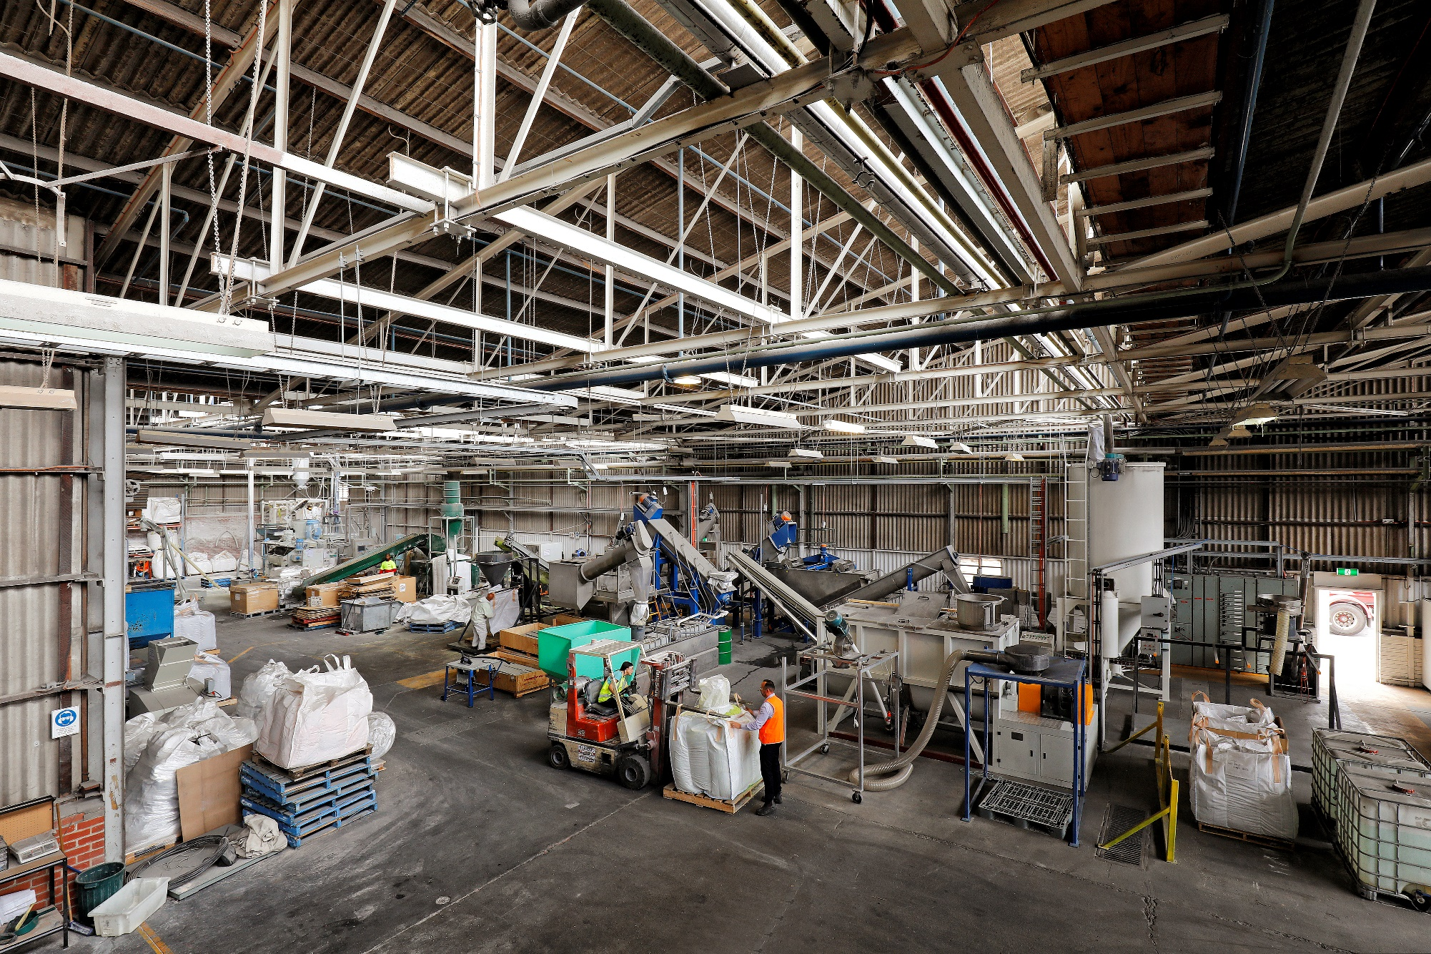2017–18



Victorian Recycling Industry Annual Report 2017–18

Authorised and published by

Sustainability Victoria,

Level 28, Urban Workshop

50 Lonsdale Street Melbourne

Victoria 3000 Australia

Victorian Recycling Industry Annual Report 2017–18

© Sustainability Victoria 2019

September 2019

**Accessibility**

This document is available in PDF and Word format on the internet at [www.sustainability.vic.gov.au](http://www.sustainability.vic.gov.au)

While reasonable efforts have been made to ensure that the contents of this publication are factually correct, Sustainability Victoria gives no warranty regarding its accuracy, completeness, currency or suitability for any particular purpose and to the extent permitted by law, does not accept any liability for loss or damages incurred as a result of reliance placed upon the content of this publication. This publication is provided on the basis that all persons accessing it undertake responsibility for assessing the relevance and accuracy of its content.

Victorian Recycling Industry Annual Report 2017–18 should be attributed to Sustainability Victoria.

Victorian Recycling Industry Annual Report 2017–18 is licensed under a Creative Commons Attribution 4.0 Australia licence. In essence you are free to copy, distribute and adapt the work, as long as you attribute the work and abide by the other licence terms. Go to <http://creativecommons.org/licenses/by/4.0/> to view a copy of this licence.



Contents

1. Introduction 4

1.1. Background 5

1.2. Key findings for 2017–18 6

1.3. Insights from the survey results in 2017–18 7

2. Total materials managed and diversion rates 9

3. Composition of recovered materials 11

4. Trends in recovered materials 12

5. Sources of recovered materials 13

6. Exports and reprocessing 14

7. Product markets 16

8. Material-specific recovery data 18

8.1. Aggregates, masonry and soil 18

8.2. Glass 20

8.3. Metals 21

8.4. Organics 22

8.5. Paper and cardboard 24

8.6. Plastics 25

8.7. Rubber 27

Appendix A: Survey methodology 28

Appendix B: VRIAR comparison with VLGAWSR 30

Glossary 32

## Introduction

The Victorian Recycling Industry Annual Report (VRIAR) summarises the amount of waste managed, landfilled and recovered in Victoria. Sustainability Victoria has collated this report every year since 1999, using survey data from Victorian waste reprocessors on the amount of material diverted from landfill (recovered), as well as landfill data provided by the Environment Protection Authority Victoria (EPA)[1] and export data from the Australian Bureau of Statistics (ABS). All figures presented in this report are from these sources.

This report provides a total state analysis of waste managed from all source sectors and non-hazardous solid waste material types. Materials for reprocessing are sourced from three sectors: municipal, commercial and industrial (C&I) and construction and demolition (C&D).

The findings in this report are based on the data findings provided in detail in the Victorian Recycling Industry Annual Report Workbook 2017–18 (the Workbook). The Workbook provides public access to the underlying data and includes historically available figures. This report and the Workbook are available on the Sustainability Victoria website ([www.sustainability.vic.gov.au/](http://www.sustainability.vic.gov.au/)).

The Victorian Local Government Annual Waste Services Report (VLGAWSR) 2017–18, released concurrently with this report, summarises waste collected by local governments in Victoria and covers the municipal waste sector only. This report is also available on the Sustainability Victoria website.

Historical figures have been recalculated and updated using rebased Gross State Product (GSP) and population figures from the ABS. The survey methodology can be found in Appendix A.

### Background

Recycling and reprocessing are well established in Victoria. The reprocessing industry recovers a wide range of recyclable materials from the waste stream such as metal, concrete, plastics, paper, glass and organics. Materials recovered by the reprocessing industry are predominantly from within Victoria, with a small amount received from interstate. Although most recovered materials are reprocessed in Victoria, some waste materials are exported interstate or overseas for reprocessing. Reprocessing industries in Victoria include:

* smelters and foundries of steel, aluminium and other non-ferrous metal
* crushing plants and auxiliary screening of concrete, brick, asphalt and related materials
* paper/cardboard and de-inking pulp mills
* composting facilities
* glass and rubber product manufacturers
* plastics reprocessors.

These and other reprocessing operations contribute significantly to the Victorian economy in employment and investment, and generate substantial cost savings in the production of more affordable (but similarly effective) recycled materials. The environmental benefits of reprocessing materials are:

* reduced greenhouse gases (methane emissions) from landfill and energy-intensive primary production processes
* savings in water and electricity in the production of metal, concrete, paper and glass by using recycled feedstock
* savings of raw materials, for example mineral ores used in virgin metal production and timber and oil used in paper production
* reduced groundwater and soil contamination from landfill, and the preservation of landfill space.

### Key findings for 2017–18

A summary of the results presented in the Victorian Recycling Industry Annual Report are provided below[2].

Percentage change from 2016–17 to 2017–18 – overall waste and resource recovery system

|  |  |  |  |  |
| --- | --- | --- | --- | --- |
| Victorian waste in 2017–18 | Managed | Landfill | Diversion rate | Recovered for reprocessing |
| **Waste managed (generated) in total**  14.43 million tonnes managed (generated)  4.44 million tonnes sent to landfill (31%)  2.2 tonnes of waste per capita  31.3 tonnes per $1M (GSP) |  |  |  |  |
| 12% | 5% | 2% | 16% |

Percentage change from 2016–17 to 2017–18 – recovered materials

|  |  |  |  |
| --- | --- | --- | --- |
| Victorian waste in 2017–18 | Recovered for reprocessing | Locally reprocessed | Exported for reprocessing |
| **Waste recovered for reprocessing in total**  *Source: Municipal 12%, C&I 32%, C&D 57%*  9.99 million tonnes recovered (69% diverted)  8.81 million tonnes reprocessed in Vic (88%)  1.18 million tonnes exported for reprocessing |  |  |  |
| 16% | 17% | 6% |
| **Aggregates, masonry and soil**  *Source: Municipal 1%, C&I 1%, C&D 98%*  5.51 million tonnes recovered for reprocessing  5.51 million tonnes reprocessed in Victoria |  |  |  |
| 35% | 35% | 0% |
| **Glass recovered**  *Source: Municipal 99%, C&I 1%*  230,000 tonnes recovered reprocessing  218,000 tonnes reprocessed in Victoria (95%)  12,000 tonnes exported for reprocessing (5%) |  |  |  |
| 67% | 62% | 312% |
| **Metals recovered2**  *Source: Municipal 25%, C&I 64%, C&D 11%*  1.46 million tonnes recovered for reprocessing  966,000 tonnes reprocessed in Victoria (66%)  489,000 tonnes exported for reprocessing (34%) |  |  |  |
| 12% | 10% | 16% |
| **Organics recovered**  *Source: Municipal 36%, C&I 60%, C&D 4%*  1.10 million tonnes recovered for reprocessing  1.08 million tonnes reprocessed in Victoria (99%)  14,000 tonnes exported for reprocessing (1%) |  |  |  |
| 0.2% | 0% | 4% |
| **Paper and Cardboard recovered**  *Source: Municipal 7%, C&I 93%, C&D <1%*  1.48 million tonnes recovered for reprocessing  849,000 tonnes reprocessed in Victoria (57%)  632,000 tonnes exported for reprocessing (43%) |  |  |  |
| 2% | 8% | -4% |
| **Plastic recovered**  *Source: Municipal 58%, C&I 41%, C&D 1%*  *Type: Packaging 73%, non-packaging 27%*  *Comp: PE-HD 29%, PET 21%, PE-LD/LLD 19%*  137,000 tonnes recovered for reprocessing  52,000 tonnes reprocessed in Victoria (38%)  85,000 tonnes exported overseas (62%) |  |  |  |
| 5% | 0.1% | 8% |
| **Rubber recovered**  *Source: Municipal 22%, C&I 78%*  *Composition: Rubber tyres 72%*  79,000 tonnes recovered for reprocessing  43,000 tonnes reprocessed in Victoria (54%)  36,000 tonnes exported for reprocessing (46%) |  |  |  |
| 91% | 108% | 75% |

### Insights from the survey results in 2017–18

Victoria managed 12 per cent more waste in 2017–18 due to: a continuous increase in construction activity; clearing of land for new developments; reprocessing of stockpiled material from previous years.

The increase in waste is not due to changes in consumer recycling practices:

* respondents confirmed that most of the extra waste was generated by a 35 per cent increase (1.44 million tonnes) in C&D materials from land development and public transport works
* no other category of waste increased at the rate of C&D materials over the period.

This year’s recovery increase can also be attributed to reprocessing some previous years’ stockpiled material, particularly the 62 per cent of additional glass and 91 per cent of additional rubber reprocessed locally. Decreases in processed tonnes in 2015–16 and 2016–17 point to these materials entering stockpiles.

Victorian commercial and industrial, construction and demolition and municipal sectors recovered more materials in 2017–18 than in any year since the survey began in 1999.

An additional 16 per cent more materials were recovered for reprocessing than the previous year, increasing the diversion rate by 2 per cent to 69 per cent in 2017–18.

As aggregates, masonry and soil are readily reprocessed and reused in Victoria, 88 percent of the additional 12 per cent of waste generated was recovered for reprocessing in Victoria. This contributed significantly to the overall increased recovery rate.

While increasing by only 0.2 per cent to 1.10 million tonnes, more organic materials were recovered in 2017–18 than in any year since data collection began.

The 5 per cent increase in waste going to landfill is much lower than the 12 per cent increase in total waste managed, indicating greater circulation of materials (particularly C&D) in the Victorian economy in 2017–18.

Victoria’s recovered resources were predominantly reprocessed locally in 2017–18, with 17 per cent more materials reprocessed in local plants in Victoria than in 2016–17.

Local reprocessing of additional C&D materials such as aggregates, masonry and soil contributed significantly to the increase in tonnes recovered.

Increased support for, and investment in, local reprocessors together with stable market conditions over the first half of 2017–18 had a positive impact on local capacity growth.

Local reprocessing of rubber, cardboard, and aggregates, masonry and soil all grew in absolute terms, and local reprocessing of glass increased by 62 per cent. Local reprocessing increased for all material types except for metals and textiles.

Local reprocessing capacity is increasing, but growth in recovered materials is occurring at an even faster rate, leading to an increasing reliance upon export markets.

The effects of changing international markets, coupled with an increasing reliance upon export capability has not yet been felt across the sector in 2017–18.

Over the year, the proportions of glass, metals, plastics and textiles reprocessed locally all decreased, with a commensurate increase in export markets, while the proportions of paper/cardboard and rubber processed locally increased.

It is possible that the impact of changes in export market availability for sorted municipal mixed paper may be reflected in the increase from 85 to 93 per cent of C&I contribution to the total of paper and cardboard recovered for reprocessing, while the municipal sector’s contribution more than halved to 7 per cent.

The key materials exported were scrap metal, paper and plastics – all globally traded commodities used in recycling operations worldwide. Municipal paper and cardboard exports faced a decline of 4 per cent over the year.

Exports of recovered materials were still strong, despite contraction of some overseas markets in the second half of the year.

In January 2018, the international export market for recyclable materials significantly changed with several countries, led by the Chinese National Sword restrictions, enforcing strict contamination limits or bans on single stream materials entering their countries.

Despite this, the quantity of materials exported for reprocessing overseas increased slightly to 1.18 million tonnes in 2017–18, as exporters were able to find short term, alternative markets for recyclable materials (see the *Recovered Resources Market Bulletin*[3], Sustainability Victoria 2019).

The municipal sector had the poorest performing diversion rate and the construction and demolition sector had highest performing.

Source sector diversion rates varied considerably. The C&D sector achieved a diversion rate of 84 per cent, the C&I sector 66 per cent and the municipal sector 44 per cent. This means that the C&D and C&I sectors recovered more tonnes than they landfilled however this was not the case for the municipal sector. Consequently, kerbside recycling systems (including organics service offerings) represent a key opportunity to improve diversion from landfill.

## Total materials managed and diversion rates

In 2017–18, 14.43 million tonnes of waste were managed in Victoria, an increase of 12 per cent from the previous year. This rise is most likely due to the extra construction and demolition materials generated through increased land development and public transport works over the period (as noted by survey respondents). Some materials were also liberated from stockpiles for reprocessing, adding to the total waste reprocessed for 2017–18.

Although 12 per cent more waste was managed, only 5 per cent more waste was sent to landfill than in 2016–17 (4.44 million tonnes in total). The amount of waste diverted from landfill for recovery increased from 8.62 million tonnes in 2016–17 to 9.99 million tonnes (16 per cent).

Figure 1 shows total waste managed, landfilled and recovered in Victoria over the last 10 years.

Figure 1: Waste managed in Victoria, 2008–09 to 2017–18

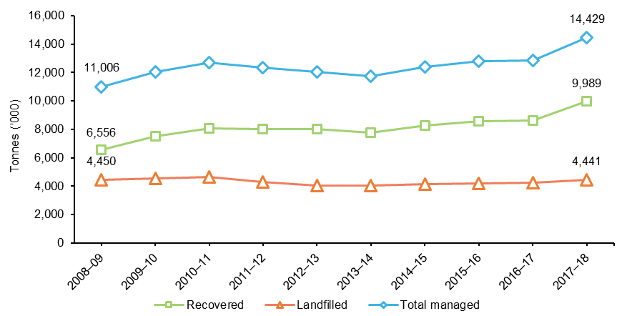

In 2017–18, Victoria’s landfill diversion rate increased from the previous year; diverting 9.99 million tonnes of materials at a diversion rate of 69 per cent. Figure 2 shows the increase in diversion rate of waste since 2008–09.

In 2017–18 the total waste managed and materials recovered per capita in Victoria increased to 2.2 tonnes and 1.5 tonnes respectively. Waste managed relative to GSP increased by 5 per cent in 2017–18 to 31.3 tonnes of waste managed for every million dollars of GSP (Table 1 and Figure 3). These increases again reflect the increase in waste managed from expanded construction and demolition activities in Victoria over the period.

Figure 2: Diversion rate of solid waste in Victoria, 2008–09 to 2017–18[4]

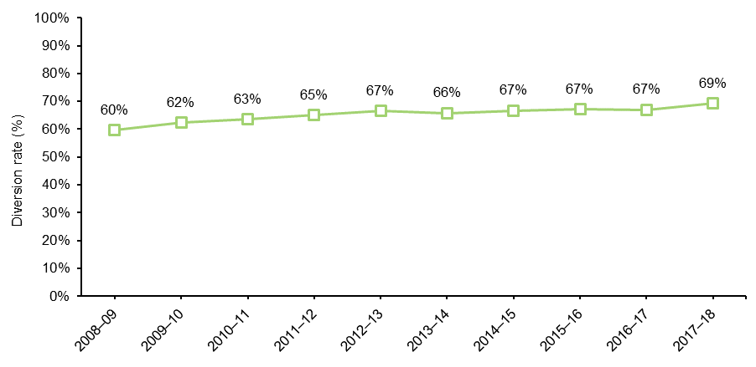

Table 1: Total waste managed relative to economic and population trends in Victoria, 2008–09 to 2017–18

|  |  |  |  |  |  |  |  |  |  |  |  |
| --- | --- | --- | --- | --- | --- | --- | --- | --- | --- | --- | --- |
|  | Unit | 2008–09 | 2009–10 | 2010–11 | 2011–12 | 2012–13 | 2013–14 | 2014–15 | 2015–16 | 2016–17 | 2017–18 |
| Waste managed  per capita | t/capita | 2.0 | 2.2 | 2.3 | 2.2 | 2.1 | 2.0 | 2.1 | 2.1 | 2.0 | 2.2 |
| Waste managed  per $million GSP | t/$ million GSP | 37.1 | 38.3 | 38.2 | 35.7 | 33.9 | 31.9 | 32.0 | 31.0 | 29.7 | 31.3 |
| Total waste managed | Million tonnes | 11.0 | 12.1 | 12.7 | 12.3 | 12.0 | 11.8 | 12.4 | 12.8 | 12.9 | 14.4 |

Figure 3: Total waste managed relative to economic and population trends in Victoria, 2008–09 to 2017–18

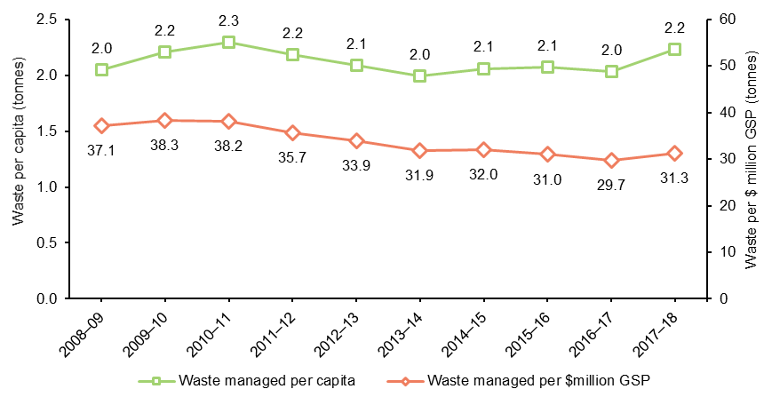

## Composition of recovered materials

Figure 4 shows the solid materials reprocessed in 2017–18 by weight. Aggregates, masonry and soil accounted for 55 per cent of all material recovered for reprocessing by weight. Metals and paper/cardboard accounted for 15 per cent each.

Figure 4: Composition of material recovered for reprocessing (by weight) in Victoria, 2017–18

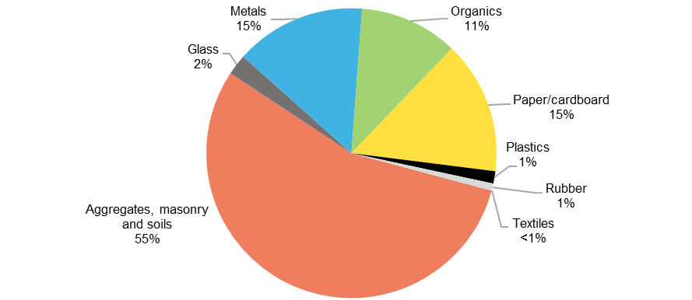

Table 2 summarises the materials recovered in Victoria for reprocessing in 2017–18, compared to the previous year. In 2017–18, recovery of:

* aggregates, masonry and soil material increased by 35 per cent to 5.51 million tonnes
* metals increased by 12 per cent[5] to 1.46 million tonnes
* glass increased by 67 per cent to 230,000 tonnes
* paper/cardboard increased by 2 per cent to 1.48 million tonnes
* organics increased by 0.2 per cent to 1.10 million tonnes
* plastics increased by 5 per cent to 137,000 tonnes
* rubber increased by 91 per cent to 79,000 tonnes.

Table 2: Total material types recovered for reprocessing in Victoria, 2017–18 and 2016–17

|  |  |  |  |
| --- | --- | --- | --- |
| Material recovered | 2017–18 (‘000 tonnes) | 2016–17 (‘000 tonnes) | Change since  2016–17 |
| Aggregates, masonry and soils | 5,507 | 4,068 | 35% |
| Glass | 230 | 137 | 67% |
| Metals | 1,456 | 1,699 | 12%5 |
| Organics | 1,098 | 1,096 | 0.2% |
| Paper/cardboard | 1,481 | 1,445 | 2% |
| Plastics | 137 | 131 | 5% |
| Rubber | 79 | 41 | 91% |
| Textiles | 0.2 | 3 | -95% |
| Total recovered | 9,989 | 8,621 | 16% |

## Trends in recovered materials

Recovery of most material categories has increased considerably over the last 10 years, with the exception of textiles and plastics (see Table 3 and Figure 5). Over the last 10 years:

* the total materials recovered in Victoria increased by 52 per cent, with 3.43 million tonnes more recovered in 2017–18 than in 2008–09
* recovery of all materials, except for plastics and textiles, increased by at least 24 per cent with aggregates, masonry and soils, and rubber increasing by 75 per cent and 118 per cent respectively
* plastics recovery decreased by 5 per cent (potentially a result of light-weighting in plastic product specifications) and textiles by 96 per cent.[6]

In 2017–18, Victoria saw the highest reported recovery quantities for aggregates, masonry and soils, glass, organics and rubber since records began.

Table 3: Total material types recovered for reprocessing in Victoria, 2017–18 to 2008–09

|  |  |  |  |
| --- | --- | --- | --- |
| Material recovered | 2017–18 (‘000 tonnes) | 2008–09 (‘000 tonnes) | Change since  2008–09 |
| Aggregates, masonry and soils | 5,507 | 3,155 | 75% |
| Glass | 230 | 186 | 24% |
| Metals | 1,456 | 1,097 | 33% |
| Organics | 1,098 | 802 | 37% |
| Paper/cardboard | 1,481 | 1,132 | 31% |
| Plastics | 137 | 144 | -5% |
| Rubber | 79 | 36 | 118% |
| Textiles | 0.2 | 4 | -96% |
| Total recovered | 9,989 | 6,556 | 52% |

Figure 5: Percentage change of tonnes of material types recovered for reprocessing in Victoria, 2017–18   
to 2008–09

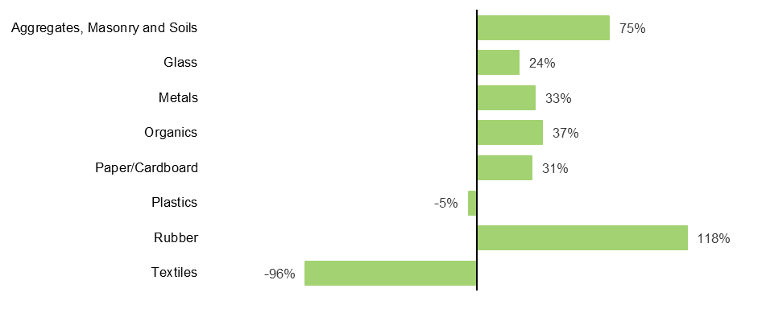

## Sources of recovered materials

In 2017–18, 57 per cent of all materials received for reprocessing by weight came from the C&D sector, an increase of 8 per cent from 2016–17 (Figure 6). The proportion of materials recovered from municipal and C&I sectors both decreased as a result. This reflects increases in C&D waste reprocessing volumes rather than a decline in municipal and C&I waste processing. Figure 6 shows the slight changes per source sector of recovered materials received for reprocessing in 2016–17 and 2017–18.

Figure 6: Source sectors of recovered materials received for reprocessing (by weight) in Victoria, 2016–17 and 2017–18

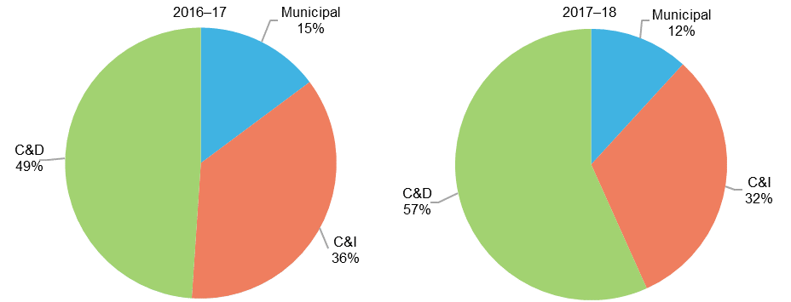

Table 4 details the estimated tonnes of material recovered in Victoria for reprocessing, landfilled and generated in 2017–18 from each source sector. The C&D sector generated and recovered the largest quantity of waste and as a result achieved the highest diversion rate (84%). This was followed by the C&I (66%) and municipal (41%) sectors.

Table 4: Source sectors of material received by reprocessors, Victoria 2017–18 (‘000 tonnes)[7]

|  |  |  |  |
| --- | --- | --- | --- |
| Material Recovered | Municipal | Commercial &  industrial | Construction & demolition |
| Aggregates, masonry and soils | 1 | 60 | 5,446 |
| Glass | 229 | 1 | 0 |
| Metals | 358 | 930 | 168 |
| Organics | 390 | 660 | 48 |
| Paper/cardboard | 102 | 1,378 | 0 |
| Plastics | 79 | 56 | 2 |
| Rubber | 17 | 62 | 0 |
| Textiles | 0.14 | 0.03 | 0 |
| Total recovered | 1,177 | 3,147 | 5,665 |
| Total landfilled | 1,718 | 1,634 | 1,089 |
| Total managed | 2.895 | 4,781 | 6,754 |
| 2017–18 diversion rate | 41% | 66% | 84% |

## Exports and reprocessing

In 2017–18, Victoria’s resources were predominantly reprocessed locally (see Figure 7). Around 8.81 million tonnes (88 per cent) of recovered material remained in Victoria to be reprocessed in local plants. This is an increase of 17 per cent since 2016–17 (7.54 million tonnes).

In January 2018, the international export market for recyclable materials significantly changed with several countries, led by the Chinese National Sword restrictions, enforcing strict contamination limits or bans on single stream materials entering their countries. Despite this, the quantity of materials exported for reprocessing overseas increased slightly to 1.18 million tonnes in 2017–18, as exporters could find alternative markets for recyclable materials in the short term (see the *Recovered Resources Market Bulletin*[8], Sustainability Victoria 2019). The key materials exported were scrap metal, paper and plastics – all globally traded commodities used in recycling operations worldwide.

To track the ongoing impact of international changes in material markets on the Victorian resource recovery sector, Sustainability Victoria has commissioned the *Recovered Resources Market Bulletin8*. The bulletin is released monthly throughout 2019 and aims to track trends in quantities and commodity value for recovered materials in local and international markets and provide key industry insights on the challenges faced.

Figure 7: Material reprocessed locally or exported overseas or interstate in Victoria, 2005–06 to 2017–18

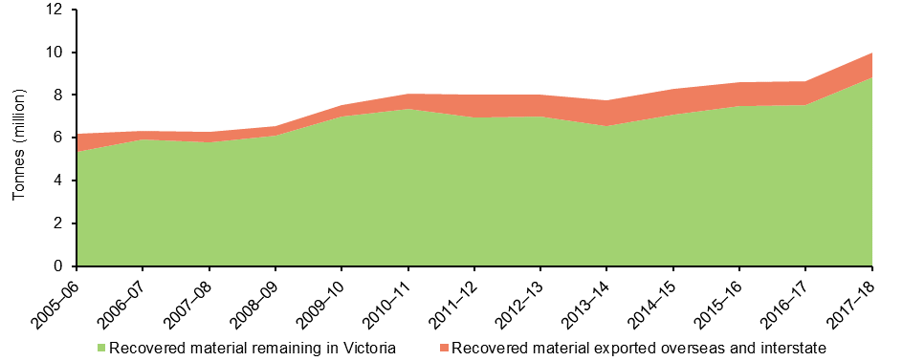

Note: The two data sources in Figure 7 combine to create a cumulative total.

Local reprocessing of every material type in Victoria increased in 2017–18, indicating an increase in local reprocessing capacity over the year (see Table 5). Over the last 12 months, local reprocessing of:

* glass increased by 62 per cent
* metal increased by 10 per cent
* paper/cardboard increased by 8 per cent
* plastic increased marginally by 0.1 per cent
* rubber increased by 108 per cent.

Quantities exported for reprocessing increased for most materials in 2017–18, except for paper/cardboard. The amount of:

* glass increased by over 300 per cent to 11,600 tonnes
* metal increased by 16 per cent to 489,000 tonnes
* plastic increased by 8 per cent to 85,000 tonnes
* paper/cardboard decreased by 4 per cent to 632,000 tonnes
* rubber increased by 75 per cent to 36,000 tonnes.

Lower value materials, such as waste from C&D activities, food and garden organics and glass fines, are rarely exported, if at all, as it is financially prohibitive to do so.

Table 5: Volume and proportions of material reprocessed in Victoria and exported for reprocessing by material type, 2016–17 and 2017–18

|  |  |  |  |  |  |  |
| --- | --- | --- | --- | --- | --- | --- |
| Material recovered | Reprocessed locally  (‘000 tonnes) | | Exported for reprocessing (‘000 tonnes) | | Proportion reprocessed locally (per cent) | |
| 2016–17 | 2017–18 | 2016–17 | 2017–18 | 2016–17 | 2017–18 |
| Aggregates, masonry and soils | 4,068 | 5,507 | 0 | 0 | 100% | 100% |
| Glass | 135 | 218 | 3 | 12 | 98% | 95% |
| Metals | 1,277 | 966 | 422 | 489 | 67%8 | 66% |
| Organics | 1,082 | 1,084 | 13 | 14 | 99% | 99% |
| Paper/cardboard | 785 | 849 | 660 | 632 | 54% | 57% |
| Plastics | 52 | 52 | 79 | 85 | 40% | 38% |
| Rubber | 21 | 43 | 21 | 36 | 50% | 54% |
| Textiles7 | 3 | 0 | 0.1 | 0.2 | 98% | 0% |
| Total recovered | 7,423 | 8,720 | 1,198 | 1,269 | 86% | 87% |

Figure 8 shows the proportions of material reprocessed locally and exported for reprocessing in 2016–17 and 2017–18. The proportions of total glass, metals, plastics and textiles reprocessed locally all decreased in 2017–18, while the proportions of paper/cardboard and rubber increased.

Figure 8: Proportions of materials reprocessed in Victoria and exported for reprocessing by material type in Victoria, 2016–17 and 2017–18

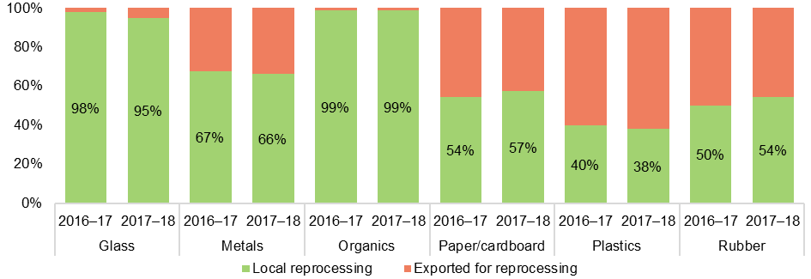

Note: Aggregates, masonry and soils and textiles are not shown in Figure 8.

## Product markets

Once reprocessed, materials are directed into different markets according to the quality and degree of processing required. Commonly reprocessed industrial materials, such as metal and rubber, are generally sold on to the manufacturing industry to produce new metal or rubber products. Recovered glass and paper are usually manufactured back into glass and paper. Paper can be recycled seven or eight times before it loses its ‘recyclability’, but glass bottles and jars can generally be recycled indefinitely. Glass aggregate (usually glass that cannot be recycled into new glass products) is increasingly used in the construction industry as a replacement for sand.

Aggregates, masonry and soil is usually directed back into the construction industry as recycled concrete, brick and rubble, which is used to build the loadbearing base layers of roads and pavements.

Organic waste is processed at licensed facilities where it is typically turned into composted soil conditioner and mulch products. Often these materials are blended with other soil products to be sold by nurseries or used in the landscaping industry. More recycled organic products are now used in high-value applications such as intensive horticulture and viticulture.

Plastics are reprocessed into an ever-growing range of valuable packaging, construction, household and automotive goods. The *2016–17 Australian Plastics Recycling Survey* lists the major product types within each application area (Table 6).

Table 6: Summary of major product types within each application area for plastic recyclables

|  |  |
| --- | --- |
| **Application area** | **Product types** |
| Agriculture | Flexible film  Twine and rope  Other agricultural applications |
| Automotive | Vehicle body  Tyres  Other automotive |
| Built environment | Pipes and cables  Windows and doors  Insulation  Fit-out  Carpet and other floor coverings  Other built environment |
| Electrical and electronic | TVs and computers  Power tools  Toys  White goods and small appliances  Other electrical and electronic |
| Packaging – municipal | Flexible packaging  Rigid packaging  Other packaging |
| Packaging – C&I | Flexible packaging  Rigid packaging  Other packaging |
| Other application area | Household products  Furniture  Clothing and footwear  Rope, cable, twine and thread  Textiles  All other applications |

Source: Envisage Works on behalf of the Australian Government Department of the Environment and Energy, *2016–17 Australian Plastics Recycling Survey: National Report*, Reservoir East, Victoria, 1 May 2018.

## Material-specific recovery data

### Aggregates, masonry and soil

In 2017–18 the amount of aggregates, masonry and soil recovered for reprocessing in Victoria increased by 35 per cent from 2016–17 to 5.51 million tonnes. The C&D sector contributed almost 100 per cent of this material. No aggregates, masonry and soil materials were exported for reprocessing.

In 2017–18, of the total aggregates, masonry and soil recovered:

concrete accounted for 48 per cent and increased by 16 per cent from the previous year to 2.62 million tonnes

rock/excavation stone accounted for 23 per cent and increased by 105 per cent to 1.28 million tonnes

whole brick and brick rubble accounted for 14 per cent and increased by 36 per cent to 797,000 tonnes

mixed aggregates, masonry and soil accounted for 10 per cent and increased by 60 per cent from 345,000 to 552,000 tonnes

asphalt accounted for 3 per cent and increased by 7 per cent to 170,000 tonnes

soil/sand accounted for 1 per cent and decreased by 16 per cent to 50,000 tonnes

plasterboard accounted for 1 per cent and increased by 5 per cent to 36,000 tonnes.

Figure 9 illustrates the breakdown of materials recovered.

Figure 9: Composition of aggregates, masonry and soil material recovered for reprocessing (by weight) in Victoria, 2017–18

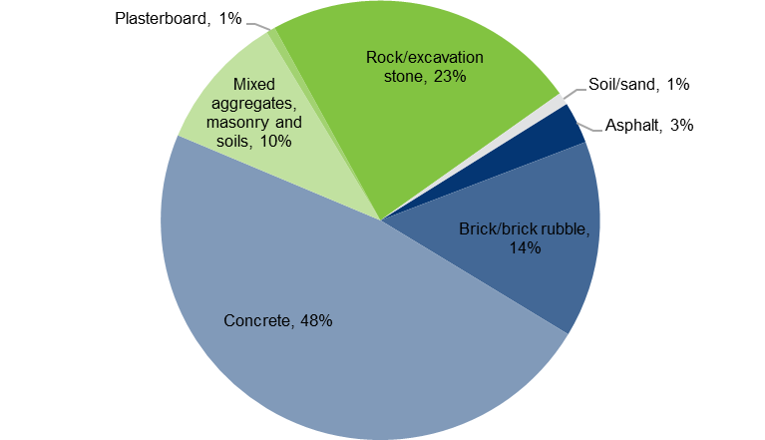

Materials coming into reprocessors varies from year to year according to available stockpile space in Victoria which, in turn, is impacted by both available feedstock and market demand for processed products. This year’s recovery increase is likely attributed to the continuous increase in construction activity, the clearing of land for new housing developments and the reprocessing of stockpiled material from previous years. Figure 10 shows the change in recovery of aggregates, masonry and soil over the last 10 years.

Figure 10: Aggregates, masonry and soil waste recovered for reprocessing in Victoria, 2008–09 to 2017–18

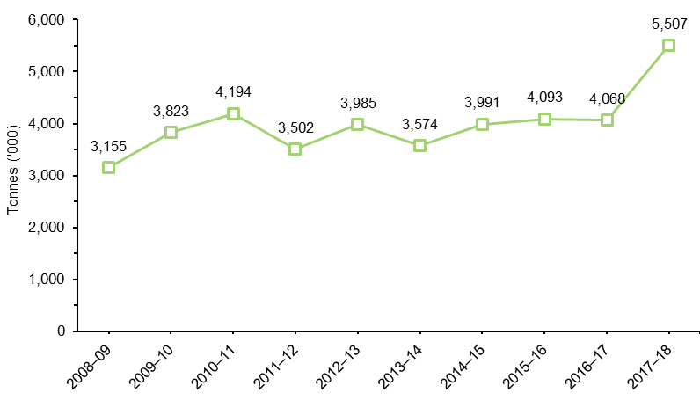

### Glass

In 2017–18, 230,000 tonnes of glass were recovered for reprocessing in Victoria; a 67 per cent increase from 2016–17 and the largest quantity of glass ever managed in Victoria. Of this, 11,600 tonnes (or 5 per cent) were exported for reprocessing.

This year’s recovery increase is likely attributed to reprocessing previous years’ stockpiled material. Decreases in processed tonnes in 2015–16 and 2016–17 reflect this material entering stockpile (see Figure 11). Thanks to research, development and demonstration (RD&D) activities conducted by the industry and supported by Sustainability Victoria, glass is increasingly being used in construction activities as a replacement for sand.

Figure 11: Glass waste recovered for reprocessing in Victoria, 2008–09 to 2017–18

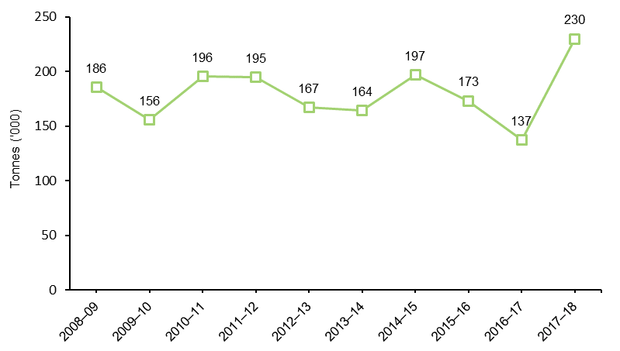

### Metals

In 2017–18, 1.46 million tonnes of metals were recovered for reprocessing in Victoria; an increase of 12 per cent from the previous year[9]. Of this, 490,000 tonnes (or 34 per cent) were exported for reprocessing. The C&I sector remained Victoria’s principal source of recovered metals, as shown in Figure 12. The C&I sector contributed 64 per cent of all metal recovered for reprocessing (down from 69 per cent the previous year). The municipal sector contributed 25 per cent of the total metal recovered (up from 23 per cent the previous year) and the C&D sector contributed 11 per cent (up from 8 per cent in 2016–17).

Figure 12: Source sectors of scrap metal received for reprocessing (by weight) in Victoria, 2017–18

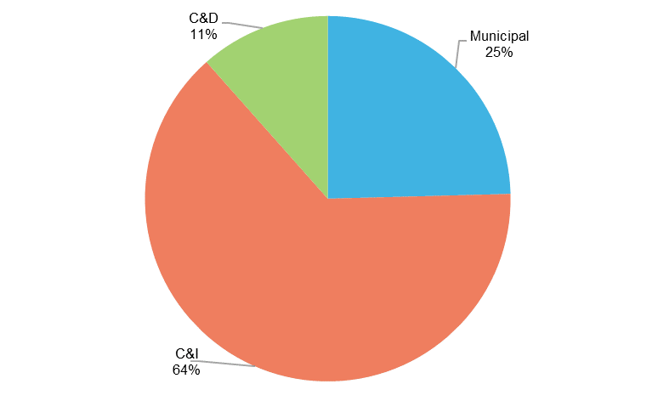

Figure 13 shows the trend in the quantity of metals recovered in Victoria.

Figure 13: Metal waste recovered for reprocessing in Victoria, 2008–09 to 2017–18

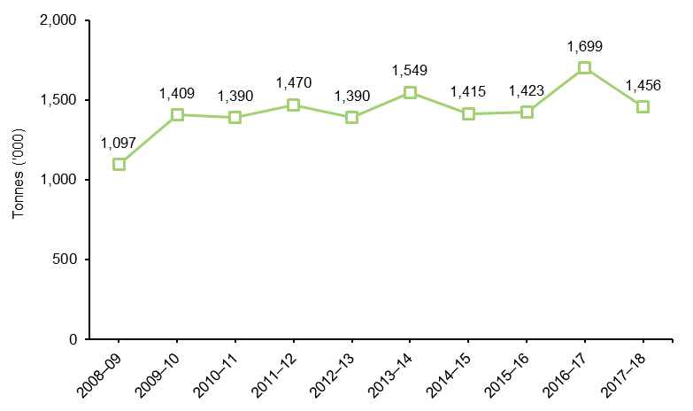

### Organics

In 2017–18, 1.10 million tonnes of organics were recovered for reprocessing in Victoria; a 0.2 per cent increase from 2016–17 and highest amount of organic material recovered in Victoria since data collection started (in 1999). Of this, 13,900 tonnes (or 1%) were exported for reprocessing. Identifying trends in this waste stream poses numerous challenges, among them the impact of environmental conditions such as long-term drought and legislated water restrictions.

In 2017–18, of the total organics recovered:

garden organics accounted for 38 per cent and decreased by 20 per cent from the previous year to 411,000 tonnes

wood and timber organics accounted for 17 per cent and decreased by 17 per cent from the previous year to 188,000 tonnes

other and mixed organics materials (a mix of different types of organics that were not separated or did not fit into any of the other organic categories) accounted for 28 per cent and increased by 106 per cent from the previous year to 308,000 tonnes – most likely due to survey respondents categorising their organic waste differently

sawdust and other forestry residuals accounted for 11 per cent and decreased by 10 per cent from the previous year to 124,000 tonnes

food organics accounted for 4 per cent and increased by 27 per cent from the previous year to 48,000 tonnes

food and garden organics (FOGO) combined accounted for 2 per cent and decreased by 34 per cent to 19,000 – most likely to survey respondents categorising their waste differently.

Figure 14 illustrates the breakdown of materials recovered.

Figure 14: Composition of organic material recovered for reprocessing (by weight) in Victoria, 2017–18

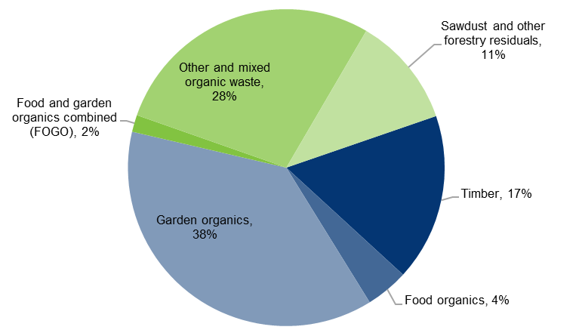

In 2017–18, the municipal sector contributed 36 per cent of the total organic waste recovered (down from 37 per cent in 2016–17). The C&I sector contributed 60 per cent (up from 56 per cent in 2016–17) and the C&D sector contributed 4 per cent (down from 7 per cent in 2016–17). See Figure 15.

Figure 15: Source sectors of organic material received for reprocessing (by weight) in Victoria, 2017–18

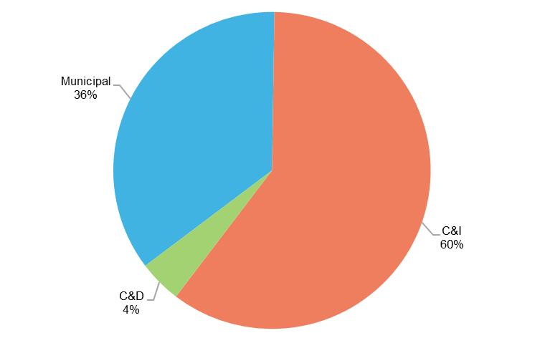

Organics recovery, although fluctuating from year to year, is generally trending upwards (see Figure 16). Some of the likely reasons for this trend are new and upgraded organics processing facilities, higher demand for recycled organics compost products and the increased collection of organic materials.

Figure 16: Organics recovered for reprocessing in Victoria, 2008–09 to 2017–18

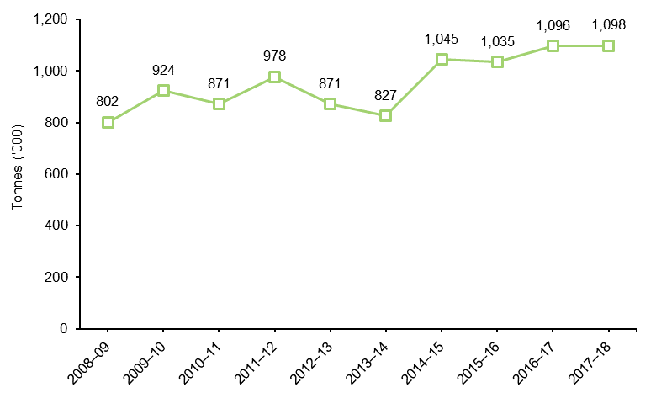

### Paper and cardboard

In 2017–18, 1.48 million tonnes of paper/cardboard were recovered for reprocessing in Victoria; with a 2% per cent increase since 2016–17. Of this, 632,000 tonnes (or 43%) were exported for reprocessing.

The C&I sector contributed 93 per cent to the total of paper/cardboard recovered for reprocessing while the municipal sector contributed 7 per cent and the C&D sector less than 1 per cent (see Figure 17). This is a large change from 2016–17 proportions (C&I sector 85 per cent, municipal sector 15 per cent) and potentially reflects of the impact of changes in export market availability for sorted municipal mixed paper.

Figure 17: Source sectors of paper/cardboard received for reprocessing (by weight) in Victoria, 2017–18

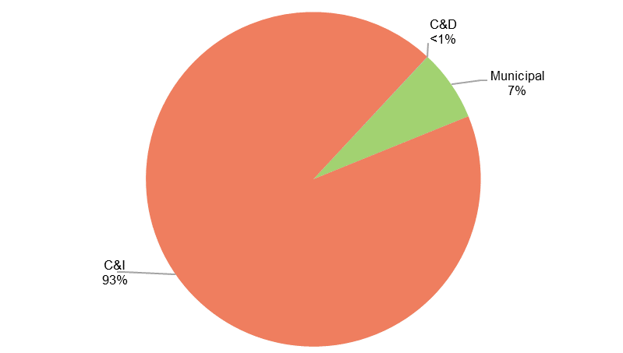

Paper/cardboard recovery has trended upwards since 2008–09 and has remained relatively stable over the last three years (see Figure 18).

Figure 18: Paper/cardboard waste recovered for reprocessing in Victoria, 2008–09 to 2017–18

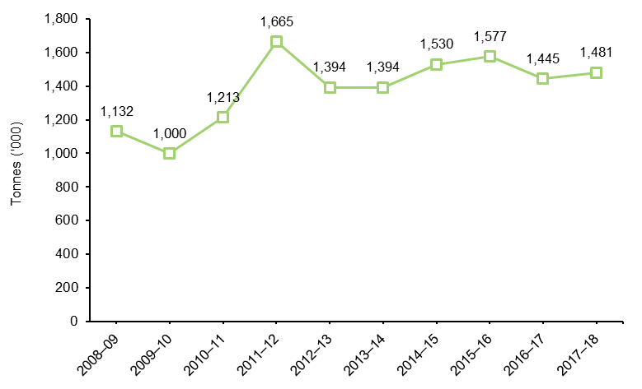

### Plastics

In 2017–18, 137,000 tonnes of plastics were recovered in Victoria; with a 5 per cent increase from 2016–17. Of this, 85,000 tonnes (or 62%) were exported for recycling. Victoria remains Australia’s leading plastic reprocessing state responsible for reprocessing 43 per cent of the national total.

In 2017–18, of the total plastics recovered:

non-packaging material (e.g. pipes, cable casing) accounted for 27 per cent of the total plastics recovered with 37,000 tonnes

domestic and industrial packaging material (used to contain, protect, market and/or handle a product) accounted for 73 per cent with 100,000 tonnes.

In 2017–18, most recovered plastics were sourced from the municipal sector (58 per cent) (for example, food and domestic packaging collected by Victoria’s councils). Most councils now collect virtually every type of plastic bottle and container (polymer types 1–6) from kerbside collections and drop-off facilities. Most of the remaining plastic comes from the C&I sector (41 per cent) and 1 per cent comes from the C&D sector, as shown in Figure 19.

Figure 19: Source sectors of plastics received for reprocessing (by weight) in Victoria, 2017–18

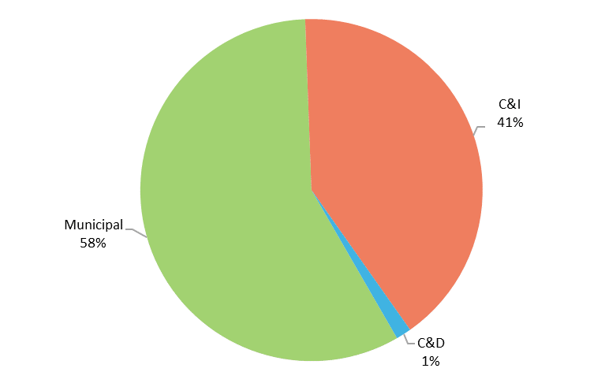

High-density polyethylene (PE-HD) used in pipes, film and blow moulded containers accounted for 29 per cent of all plastics recovered in 2017–18. Polyethylene terephthalate (PET) and low/linear low density polyethylene (PE-LD/LLD) accounted for 21 per cent and 19 per cent respectively. Polypropylene (PP), commonly used in crates, boxes and plant pots, accounted for 17 per cent. See Figure 20.

Figure 20: Composition of plastics recovered for reprocessing by polymer type (by weight) in Victoria, 2017–18

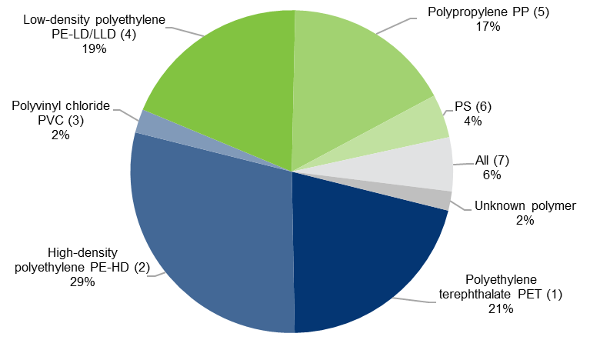

Figure 21 indicates a slight increase in recovery of plastics compared with 2016–17 following decreases in the previous two years.

Figure 21: Plastic waste recovered for reprocessing in Victoria, 2008–09 to 2017–18

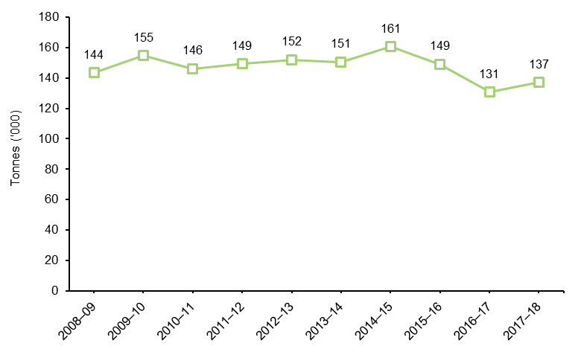

### Rubber

In 2017–18, 79,000 tonnes of rubber were recovered for reprocessing in Victoria; the most recovered since records began. This figure increased by 91 per cent from 2016–17 (from 41,000 tonnes). Of this, 36,300 tonnes (or 46%) were exported for reprocessing. This increase in tonnes recovered is likely to be from materials coming out of long-term stockpile for reprocessing (for example, the Stawell tyre stockpile clean up conducted by the EPA). See Figure 22.

Figure 22: Rubber waste recovered for reprocessing in Victoria, 2008–09 to 2017–18

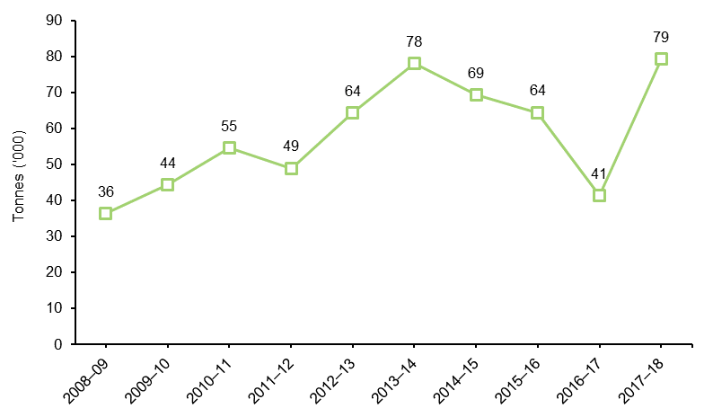

In 2017–18, of the total rubber recovered:

rubber tyres accounted for 72 per cent increasing by 51 per cent from the previous year to 57,000 tonnes

other rubber waste, including tyre buffings and tread ends, uncured rubber and extrusion waste, accounted for 28 per cent or 22,000 tonnes which was over five times the amount recovered in 2016–17 and was due to an increase in the export of this material.

In 2017–18, the C&I sector contributed significantly to the total rubber recovered for reprocessing (78 per cent). The municipal sector contributed the remaining (22 per cent). No recovery from the C&D sector was reported. This proportion has remained relatively unchanged over the years. As tyres for reprocessing are collected primarily through retailers, it is impossible to gauge the true quantities sourced from the municipal sector by surveying reprocessors alone.

## Appendix A: Survey methodology

The *Victorian Recycling Industry Annual Survey 2017–18* (VRIAS) was conducted between December 2018 and May 2019. VRIAS sought data from 95 Victorian waste reprocessing businesses (not including those reprocessing plastics), an increase to the 70 reprocessors targeted by the survey in 2016–17. Data on plastics recovery was sought from 31 plastic reprocessing businesses in Victoria via the *2017–18 Australian Plastics Recycling Survey*. In total, data was sought from 126 Victorian waste reprocessing businesses for 2017–18.

A total of 66 of the 95 non-plastics Victorian reprocessing businesses responded representing a 69 per cent response rate. Data was collected from three more reprocessors compared with the 2016–17 survey. VRIAS aims to get all large reprocessors in the state to respond to allow a comprehensive analysis of the data. However, for 2017–18 a large metal reprocessor did not provide any data. The average for the last five years of reported data was used to estimate the 2017–18 response for this business.

A total of 23 of the 31 plastics reprocessing businesses responded to the *2017–18 Australian Plastics Recycling Survey* representing a 74 per cent response rate. Overall, the two surveys achieved a response rate of 71 per cent. Nevertheless, Sustainability Victoria estimates that the reprocessors that responded to the surveys recover more than 85 per cent by weight of all material recovered in Victoria. Table 7 summarises the number of businesses receiving and responding to each survey.

Table 7: Survey response rates in 2017–18

|  |  |  |  |  |  |
| --- | --- | --- | --- | --- | --- |
| Survey | |  | Number | Percentage | |
| *2017–18 Australian Plastics Recycling Survey* | Surveys sent | 31 | | - | |
| Responses | 23 | | 74% | |
| VRIAS | Surveys sent | 95 | | - | |
| Responses | 66 | | 69% | |
| Acknowledged but no response | 21 | | 22% | |
| Total of both surveys | Surveys sent | 126 | | - | |
| Responses | 89 | | 71% | |

Each reprocessor was emailed a link to an online survey developed for their specific industry category and asked to give information for the 2017–18 financial year about the amount of materials diverted from landfill (recovered) and reprocessed, including:

* tonnes received by their Victorian site
* tonnes received from other facilities
* tonnes imported or exported for reprocessing, both interstate and overseas
* tonnes stockpiled (unprocessed and processed)
* tonnes reprocessed on-site
* amount of materials disposed of to landfill due to contamination or as processing waste
* sector/s from which the recovered materials for reprocessing were received
* major products made from their reprocessing operations and the subsequent markets (defined by the Australian and New Zealand Standard Industrial Classification code divisions for all materials excluding organics) to which the products are sold
* number of full-time-equivalent staff directly employed in the company’s recycling operations
* levels of expenditure on research and development and capital investment for activities associated with reprocessing of secondary use materials.

The survey collects data from businesses that respond. Estimates are generally not used for non-responding companies, unless the volume of material is significant and an estimation can be made with some certainty based on historical trends. The survey is voluntary so it is usual to have a degree of variation from year to year. Every attempt is made to include the large reprocessing businesses to minimise yearly variations. Data is aggregated for reporting purposes at the state level to retain confidentiality.

Resource recovery covers a wide range of activities, including collection, sorting, reprocessing, manufacture of new products and energy from waste. Reprocessing recovered materials, typically an industrial process, results in a material or product that can be productively used. Energy recovery is the process by which embodied energy is captured for use. It is a form of resource recovery, but is not reprocessing.

To avoid double counting, this survey only focuses on materials recovered for reprocessing and no other stages of the recovered material life cycle, such as collection, sorting and manufacturing. The survey does not include materials that have been collected and baled only (unless they are exported) or materials that have been stockpiled (the *Recovered Resources Market Bulletin*[10] provides further details on these materials). It also does not include materials that have been resold in their original state for reuse, such as clothing sold through second-hand or charity stores. The omission of reused materials is not in any way intended to undervalue this important activity.

Additional information was sought from the ABS on the export of materials from Australia to overseas markets for reprocessing during the 2017–18 financial year. This data aims to capture materials exported from companies not surveyed by Sustainability Victoria, such as export traders.

Data on solid waste disposed to licensed landfills was sourced from the EPA’s landfill levy returns. These returns provide data on municipal waste to landfill and a combined solid industrial waste to landfill which is the sum of waste from C&I and C&D. To estimate the quantities of waste going to landfill from these sectors individually, Sustainability Victoria applies an assumed proportional split. This allows for the calculation of diversion rates by source sector.

## Appendix B: VRIAR comparison with VLGAWSR

At a glance, high level summary data from VRIAR and VLGAWSR appear quite similar:

|  |  |  |  |
| --- | --- | --- | --- |
| Data point | VRIAR  (municipal only) | VLGAWSR | % difference |
| Total waste to landfill | 1,718,000 | 1,610,600 | -6% |
| *Data source* | *EPA landfill levy data* | *Garbage kerbside, drop-off and other council services* |  |
| Total recovered/ sorted for recovery | 1,159,000 | 1,139,700 | -2% |
| *Data source* | *Reported recovered for plastics, paper/card, glass, metals, organics* | *Kerbside recyclables and drop-off data for plastics, paper/card, glass, metals, organics* |  |
| **Total generation** | 2,895,000 | 2,750,200 | -5% |
| *Data source* | *Sum landfill and recovered* | *Sum of landfill and sorted for recovery* |  |
| **Diversion Rates** | 40% | 44% | 4% |
| *Data source* | *Total recovered ÷ Total generation* | *Total sorted for recovery from kerbside ÷ Total kerbside generation* |  |

Table 8: VRIAR and VLGASWSR tonne comparison at an aggregated level

Note: All figures are rounded to the nearest 100 tonnes

|  |  |  |  |  |
| --- | --- | --- | --- | --- |
| Main items recovered | VRIAR tonnes | VLGAWSR tonnes | Difference | |
| tonnes | % |
| Plastics | 79,200 | 52,000 | -27,200 | -34% |
| Paper/cardboard | 102,400 | 308,600 | 206,100 | 201% |
| Glass | 229,400 | 182,800 | -46,600 | -20% |
| Metals | 357,900 | 16,400 | -341,500 | -95% |
| Organics | 390,100 | 579,900 | 189,800 | 49% |
| **Total** | **1,159,000** | **1,139,700** | **-19,300** | **-2%** |

However, individual material stream data shows considerable differences:

Table 9: VRIAR and VLGASWSR tonnes comparison at a material stream level

Note: All figures are rounded to the nearest 100 tonnes

The differences observed between the two data sets could be explained by:

* responses by material type by source sector can vary significantly from year to year, potentially due to:
  + respondent data entry error, unfamiliarity with business operations, confusion over data and/or the survey
  + material entered as originating from an industrial source (e.g. a materials recovery facility) which was initially from a municipal source (a kerbside recyclable bin)
* for some materials, more are captured in VRIAR from municipal sources than in VLGAWSR (e.g. only aluminium and steel cans are counted in VLGAWSR for metals while VRIAR contains data associated with end of life vehicles and large appliances that are received by scrap metal dealers and classified as municipal waste)
* garden waste materials collected in council services or dropped off at council facilities may be processed (e.g. mulched) onsite by council and may not be captured in VRIAR
* some multi-unit dwellings are serviced by private waste collection contractors that are separate to the services offered by local councils and tonnes collected in these services are not captured in VLGAWSR
* there is a gap in information between VLGAWSR data and VRIAR, for example, where materials sorted for reprocessing may not be recoverable due to post sorting contamination.

Data in these reports are provided to Sustainability Victoria from two different surveys, targeting different components of the waste and resource recovery sector. Consequently, we do not expect the results to align for all material types. Sustainability Victoria advises that figures from VLGAWSR should be used for the municipal sector.

## Glossary

**Commercial & industrial (C&I) waste**: Solid materials and waste generated from trade, commercial and industrial activities including the government sector. It includes waste from offices, manufacturing, factories, schools, universities, state and government operations and small to medium enterprises, e.g. food organics.

**Construction & demolition (C&D) waste**: Solid materials and waste generated from residential and commercial construction and demolition activities, e.g. bricks and concrete.

**Garden organics**: Organics derived from garden sources, such as grass clippings and tree prunings.

**High density polyethylene (HDPE)**: A member of the polyethylene family of plastics, used to make products such as milk bottles, pipes and shopping bags. HDPE may be coloured or opaque.

**Kerbside collection**: Materials and waste collected by local councils, including garbage, commingled recyclables and garden organics, but excluding hard waste.

**Landfill**: Sites licensed by the EPA for disposing of materials (both waste and potentially recyclable material). Also known as tips.

**Linear low-density polyethylene (LLDPE)**: A member of the polyolefin family of plastics, LLDPE is a strong and flexible plastic usually used in film for packaging, bags and for industrial products such as pressure pipe.

**Low-density polyethylene (LDPE)**: A member of the polyolefin family of plastics, LDPE is a flexible material usually used as film for packaging or as bags.

**Mulch**: Any composted or non-composted organic material, excluding plastic, which is suitable for placing on soil surfaces to restrict moisture loss from the soil and to provide a source of nutrients to aid plant growth.

**Municipal**: Solid waste managed predominantly from domestic premises (residual and hard waste) and council activities such as street sweeping, litter collection and street tree lopping. Municipal waste also includes waste dropped-off at transfer stations and construction waste from residential owner/occupier renovations.

**Non-ferrous metals**: metals that contain very little or no iron e.g. copper, brass, bronze and aluminium.

**Polyethylene terephthalate (PET)**: A clear, tough, light and shatterproof type of plastic, used to make products such as soft drink bottles, film packaging and fabrics.

**Polypropylene (PP)**: A member of the polyolefin family of plastics. PP is light, rigid and glossy and is used to make products such as washing machine agitators, clear film packaging, carpet fibres and housewares.

**Recovered:** Materials recovered and diverted from landfill for reprocessing or use.

**Solid waste**: Non-hazardous, non-prescribed, solid waste ranging from municipal garbage to industrial waste.

**Stockpiling**: Storing materials

1. In 2014–15 a new methodology for calculating diversion rates and landfill data was introduced to better estimate the total waste disposed to landfill in Victoria. From 2014–15, landfill data includes a 15 per cent daily cover, which was excluded in previous reports. This enabled comparison with other states and the National Waste Report produced by the Australian Government Department of the Environment and Energy. Historical landfill data in the Victorian recycling industry annual report has been modified to reflect this updated methodology. This change has resulted in an approximate four percentage point drop from previously published diversion rates.
2. The figures reported in 2016–17 contained an overestimate of the amount of metal recovered for reprocessing. The reported percentage change between 2016–17 and 2017–18 is based on the revised figure, however historical tonnage figures have not been edited in this report to ensure consistency with previously reported data.
3. The *Recovered Resources Market Bulletin* can be found at: [www.sustainability.vic.gov.au/Business/Investment-facilitation/Recovered-resources-market-bulletin](http://www.sustainability.vic.gov.au/Business/Investment-facilitation/Recovered-resources-market-bulletin)
4. Landfill data collected before 2014–15 did not include 15 per cent daily cover. Historical data has since been recalculated to include this cover figure. The diversion rate in Figure 2 is based on these recalculated figures.
5. Increase calculated as per previous explanation for metals in 2016–17.
6. This is due to a lack of response to the survey from textiles recyclers for 2017–18 rather than a reflection of the actual tonnes reprocessed for the period.
7. Figures reported for materials received by source sector have been extrapolated to include the relative proportions derived from reported data and applied to surveys that did not include a source sector for the different material types and the export data from the ABS. These proportions were not applied to imports. Figures in Table 4 have been rounded to the nearest thousand and individual columns may therefore not add up to the totals reported elsewhere.
8. The *Recovered Resources Market Bulletin* can be found at: [www.sustainability.vic.gov.au/Business/Investment-facilitation/Recovered-resources-market-bulletin](http://www.sustainability.vic.gov.au/Business/Investment-facilitation/Recovered-resources-market-bulletin)
9. The figures reported in 2016–17 contained an overestimate of the amount of metal recovered for reprocessing. The reported percentage change between 2016–17 and 2017–18 is based on the revised figure, however historical tonnage figures have not been edited in this report to ensure consistency with previously reported data.
10. The *Recovered Resources Market Bulletin* can be found at: <https://www.sustainability.vic.gov.au/Business/Investment-facilitation/Recovered-resources-market-bulletin>