Victorian Market Development Strategy for Recovered Resources

May 2016

Authorised and published by

Sustainability Victoria,

Level 28, Urban Workshop

50 Lonsdale Street Melbourne

Victoria 3000 Australia

Victorian Market Development Strategy for Recovered Resources

© Sustainability Victoria 2015 (RRR003)

Designed by Sustainability Victoria.

May 2016

Accessibility

This document is available in PDF and Word format on the internet at

www.sustainability.vic.gov.au

While reasonable efforts have been made to ensure that the contents of this publication are factually correct, Sustainability Victoria gives no warranty regarding its accuracy, completeness, currency or suitability for any particular purpose and to the extent permitted by law, does not accept any liability for loss or damages incurred as a result of reliance placed upon the content of this publication. This publication is provided on the basis that all persons accessing it undertake responsibility for assessing the relevance and accuracy of its content.

Victorian Market Development Strategy for Recovered Resources should be attributed to Sustainability Victoria.

Victorian Market Development Strategy for Recovered Resources (excluding all case studies) is licensed under a Creative Commons Attribution 4.0 Australia licence. In essence, you are free to copy, distribute and adapt the work, as long as you attribute the work and abide by the other licence terms. Go to http://creativecommons.org/licenses/by/4.0/ to view a copy of this licence.



# Contents

Contents 3

1. Foreword 4

2. Executive summary 5

3. Victoria’s integrated waste and resource recovery system 7

4. Consultation 8

5. Defining the challenge 9

4.1. Why does Victoria need a market development strategy for recovered resources? 9

4.2. The Victorian Government’s role in market development 10

4.3. Market development in a circular economy 11

6. Strategy approach 13

5.1. Strategic framework 13

5.2. Key intervention areas 15

5.3. Prioritisation methodology for market development of recovered resources 16

5.4. Five year market development material and product priorities 18

7. Framework for operational delivery 20

6.1. Recover and manufacture 21

6.1.1. Improve the quality of recovered resources to support manufacturing 21

6.1.2. Improve consolidation and aggregation of recovered materials to contribute to growth in manufacturing 22

6.2. Production and use 23

6.2.1. Improve the performance of products incorporating recovered resources 23

6.2.2. Increase the use of products incorporating recovered resources 25

8. Framework for planning and decision making 27

7.1.1. Cross-government coordination within an integrated, statewide waste management framework 28

7.1.2. Adopt appropriate, evidence based approaches to government intervention 29

7.1.3. Capitalise on policy and market signals supporting resource recovery 30

9. Implementation and reporting 31

10. Further reading 32

Appendix 1 – Five year actions for priority materials and products 33

Acronyms 34

Glossary 34

# Foreword

Victoria is one of the leading states in waste and resource recovery. Almost eight million tonnes of valuable materials are diverted from landfill annually, representing a 70 per cent recovery rate[1]. This is a result of the combined efforts of the Victorian community, local government, business, the resource recovery industry and the manufacturing sector.

The Victorian Government understands the importance of strong markets for recycled materials and is committed to supporting product manufacturing, to ensure we get the most value from our recovered resources.

The value of resource recovery activities in Victoria is about $840 million annually, and the sale of recovered materials and products is worth an extra $1.3 billion[2] each year. Integrated, long term planning is essential in driving growth and providing confidence in markets for recovered resources, in order to create investment in new technologies, products and jobs.

Victoria’s plan to position the State as a leader in waste management and resource recovery, the *Statewide Waste and Resource Recovery Infrastructure Plan*, provides a 30 year road map to improve the recovery of valuable resources.

The *Victorian Market Development Strategy for Recovered Resources* (the Strategy) is a key deliverable of this Plan and seeks to support further development in resource recovery and reduce existing market barriers.

The Strategy presents opportunities for government, industry and research partnerships focused on innovation to maximise the value of recovered materials and supports the development of quality products that meet the needs of end markets. In turn, this will support future economic development and job creation in Victoria.

Victoria has a strong history of producing quality products thanks to advances in product design, development and application, as well as investment in research and innovation.

We are committed to maintaining confidence in the quality of products made from recovered and recycled resources.

I invite you to share in these opportunities for Victoria’s growth, where a new approach to market development for recovered resources brings both environmental and economic benefits to our State.

Hon Lily D’Ambrosio

**Minister for Energy, Environment and Climate Change**

# Executive summary

Market development for recovered resources is about creating and expanding appropriate and sustainable markets for the use of recovered materials and products. It is critical to the success of Victoria’s integrated waste and resource recovery system[3].

The long term vision and roadmap for improving Victoria’s waste and resource recovery infrastructure system is outlined in the *Statewide Waste and Resource Recovery Infrastructure Plan* (state infrastructure plan). The roadmap acknowledges that action is required to minimise the impact on the community environment and climate change; maximise resources recovered; and develop sustainable markets for recovered resources.

|  |  |
| --- | --- |
| Despite Victorians’ strong desire to support recycling, recovering valuable resources and remanufacturing materials also relies on establishing suitable market demand for products utilising recovered resources. Victoria has experienced some challenges in the demand for recovered materials, which not only have economic implications, but can cause environmental, community amenity and public health impacts. In Victoria, some recovered materials are being generated by a ‘push’ from the supply side rather than a ‘pull’ for their demand, as materials for remanufacturing into new products. | **What is the ‘push’ and ‘pull’ effect?**  Resource recovery has largely been driven by a ‘push’ to divert waste from landfill, which has been strongly supported by the community’s desire to recycle. This ‘push’ or supply of materials has not always been matched by consumer and industry ‘pull’ or demand for products made from recovered resources. This imbalance in supply and demand of recovered resources can result in stockpiles of these materials, and can reduce the viability of some resource recovery industries. |

The *Victorian Market Development Strategy for Recovered Resources* (Strategy) seeks to address these challenges, to realise the full economic value of resource recovery opportunities, while protecting the environment, community amenity and public health. It presents opportunities for proportionate government intervention within a market based system. This approach acknowledges that intervention should only be considered when markets for recovered resources are compromised, and the benefits of intervening outweigh the costs. It encourages focused interventions to achieve the most effective outcomes, and frames this within a resource efficiency model of a circular economy[4]. This approach shifts thinking from end-of-life concepts, towards practices that are ‘restorative’ and support materials and components being reused or recycled many times over.

The development of the Strategy has included comprehensive community, industry and government engagement. This consultation and feedback has informed the market development challenges, intervention opportunities, actions and how priority can be assigned to waste materials and products to determine appropriate government interventions.

|  |  |
| --- | --- |
| Within the context of Victoria’s integrated waste and resource recovery system, the Strategy offers a coordinated approach to government engagement in market development for recovered resources over the next 30 years, with a review every five years.  The Strategy presents government interventions to address supply and demand challenges that aim to:   * improve the quality of recovered resources to support manufacturing * improve consolidation and aggregation of recovered materials to support growth in manufacturing * improve the performance of products incorporating recovered resources * increase the use of products incorporating recovered resources. | **Who should read this?**  The waste and resource recovery industry; manufacturers; and state and local governments.  **Why read this?**  The Strategy identifies where the Victorian Government may intervene to stimulate production industries and markets for recovered resources in Victoria, by reducing barriers and supporting the right conditions for product markets to grow and mature. |

The interventions and actions to deliver these outcomes are focused on:

* research and development
* product specifications
* product procurement
* product stewardship.

To ensure the currency of activities, high level actions and material priorities are presented for the first five years of the Strategy’s implementation. The statewide priority materials and products for attention include:

* organics (including timber)
* rubber (tyres)
* e-waste
* flexible plastics
* glass fines
* concrete and bricks.

The implementation of actions over the first five years of the Strategy will be presented in Sustainability Victoria’s (SV) annual business plan, and in other related material and product focused programs such as the *Victorian Organics Resource Recovery Strategy* (VORRS).

# Victoria’s integrated waste and resource recovery system

In 2014 legislative amendments to the *Environment Protection Act 1970* established the Victorian Waste and Resource Recovery Infrastructure Planning Framework. The framework provides the structure for strategic planning for waste and resource recovery that integrates planning at the state level with planning for local and regional communities.

Figure 1 conveys the priorities of this integrated, statewide approach to waste and resource recovery in Victoria. The [state infrastructure plan provides](http://www.sustainability.vic.gov.au/our-priorities/statewide-waste-planning/2015-2020-priorities/statewide-waste-and-resource-recovery-infrastructure-plan) Victoria with a 30 year long term vision and roadmap to guide future planning for resource recovery infrastructure. [Regional implementation plans](http://www.sustainability.vic.gov.au/our-priorities/statewide-waste-planning/2015-2020-priorities/regional-waste-and-resource-recovery-implementation-plans) are guided by the state infrastructure plan, and identify local waste and resource recovery infrastructure needs over a 10 year timeframe for each of the seven Victorian Waste and Resource Recovery Groups (WRRGs).

Complementary work is supporting the delivery of the state infrastructure plan’s vision. The suite of initiatives are supporting the state infrastructure plan by:

* leading targeted waste [education](http://www.sustainability.vic.gov.au/our-priorities/statewide-waste-planning/2015-2020-priorities/victorian-community-and-business-waste-education-strategy) to facilitate reduced waste generation, improve resource recovery and increase the community’s participation and understanding of waste management and resource recovery infrastructure and services
* stimulating and supporting [markets](http://www.sustainability.vic.gov.au/our-priorities/statewide-waste-planning/2015-2020-priorities/victorian-market-development-strategy-for-recovered-resources) for products made from recovered resources, (the role of this Strategy)
* improving the recovery of [organic](http://www.sustainability.vic.gov.au/our-priorities/statewide-waste-planning/2015-2020-priorities/victorian-organics-strategy) material to reduce the community, environment and public health impacts of organic waste
* facilitating [collaborative procurement](http://www.sustainability.vic.gov.au/services-and-advice/local-government/collaborative-procurement-service) of waste and resource recovery services and infrastructure for local governments
* facilitating industry and local government [investment](http://www.sustainability.vic.gov.au/services-and-advice/business/investment-facilitation-service) in new waste and resource recovery infrastructure
* improving the quality, timeliness and accessibility of waste and resource recovery [data](http://www.sustainability.vic.gov.au/services-and-advice/local-government/waste-data-service).

**Figure 1: Initiatives to achieve Victoria’s integrated waste and resource recovery system**

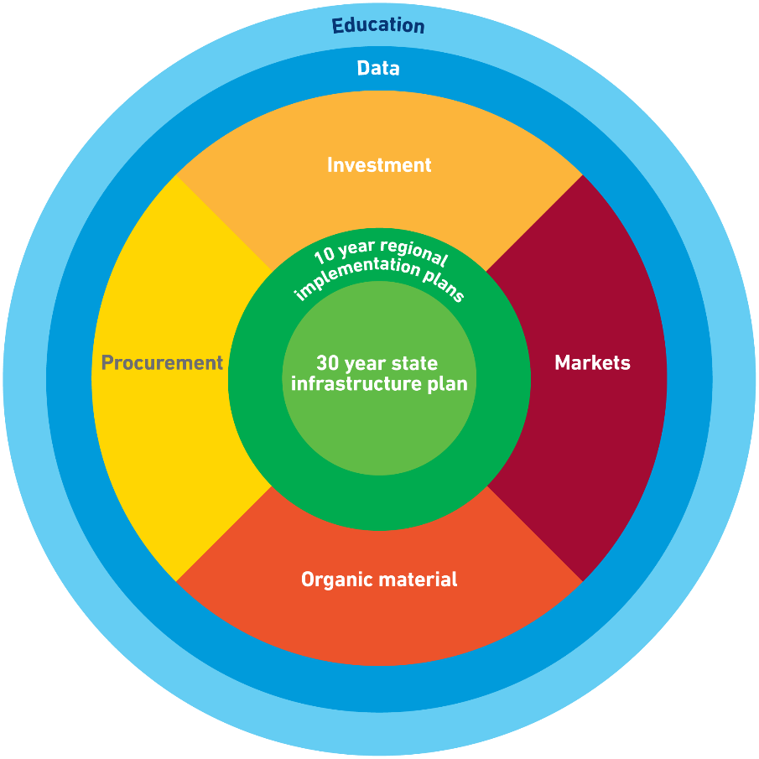

Links to the initiatives highlighted in Figure 1 are more specifically addressed in Sections 6 and 7 of the Strategy. These sections identify where the initiatives outlined in Figure 1 have a role in supporting market development outcomes through the delivery of high level five year actions.

The waste and resource recovery priorities outlined in Figure 1 are also aligned with legislative requirements under the *Environment Protection Act 1970*, *Planning and Environment Act 1987*, *Transport Integration Act 2010* and the *Sustainability Victoria Act 2005*.

# Consultation

In 2013-14, SV conducted industry market analysis on a range of priority and emerging materials (see Figure 2 below and documentation in ‘Further reading’). Market development barriers, intervention opportunities and potential criteria for prioritising recovered resources were drawn from this industry market analysis work. These market development barriers, opportunities, actions and potential prioritising criteria were tested during [two further rounds of consultation](http://www.sustainability.vic.gov.au/our-priorities/statewide-waste-planning/2015-2020-priorities/victorian-market-development-strategy-for-recovered-resources) on the *Victorian Market Development Strategy for Recovered Resources Discussion Paper* (Discussion Paper) in 2014 and *draft Strategy* in 2015.

**Figure 2: Consultation to support the Victorian Market Development Strategy for Recovered Resources**

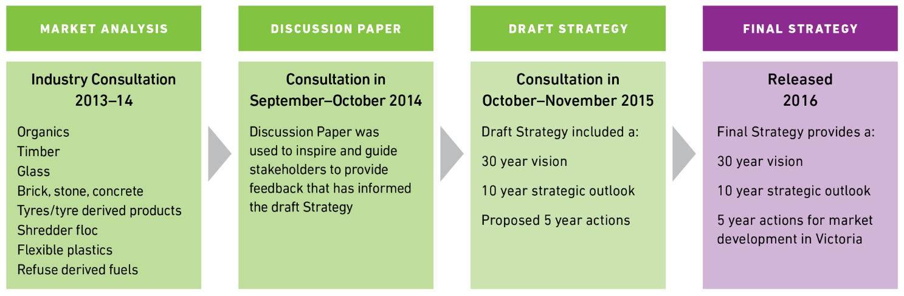

The consultation has ensured that the Strategy encapsulates a diversity of views and meets the needs of relevant stakeholders. The outcomes of the Discussion Paper and draft Strategy consultations are referenced in ‘Further reading’, and show strong support for the market development barriers, intervention opportunities, actions and criteria for prioritising recovered resources in this Strategy.

In the engagement process outlined in Figure 2 and in the development of this Strategy, SV has continued to engage and work collaboratively with:

* Victorian Government environment portfolio partners; including Department of Environment, Land, Water and Planning (DELWP), Environment Protection Authority Victoria (EPA) and the Waste and Resource Recovery Groups (WRRGs)
* Victorian Government departments and agencies beyond the portfolio partners
* industry and end markets e.g. generators, waste service companies, material processors, manufacturers, end-users
* peak business and industry associations
* local government
* community.

# Defining the challenge

## 4.1. Why does Victoria need a market development strategy for recovered resources?

Market development for recovered resources is about creating and expanding appropriate and sustainable markets for the use of recovered materials and products.

Victoria's population is growing fast. Since 2000 the population has grown from 4.8 to 5.8 million. By 2043 we anticipate a population of 8.9 million. As a consequence, the amount of waste being generated and requiring management is also increasing. At the current rate of increase, by 2043 total waste generation will rise from 12.2 to 20.6 million tonnes per year[5].

Victorians have a strong desire to support recycling, which is evident in the community’s participation in kerbside recycling. In 2013-14 almost 8 million tonnes of valuable material was recovered from waste streams in Victoria, representing a 70% recovery rate[6] (see documentation on material recovery and flows in ‘Further reading’). The Victorian waste and resource recovery sector employs around 8,000 people with an annual turnover of $2.2 billion[7]. The value of the resource recovery activities in Victoria is estimated to be about $840 million and the sale of recovered materials and products is worth an additional $1.3 billion[8]. However, recovering valuable resources and remanufacturing materials is only one part of the resource recovery cycle, because the viability of activities also relies on market demand. In Victoria, some recovered materials are being generated by a ‘push’ from the supply side rather than a ‘pull’ for their demand as materials for remanufacturing into new products.

Victoria has experienced some challenges in the demand for recovered materials, which not only has economic implications, but can cause environmental, community amenity and public health impacts. Common challenges and barriers for market development were identified through industry market analysis in 2013 and reinforced during broader stakeholder consultation that supported the preparation of this Strategy (see Table 1 below and documentation in ‘Further reading’).

**Table 1: Common market development challenges / barriers identified during industry market analysis and confirmed through stakeholder consultation**

|  |  |
| --- | --- |
| **Supply / demand** | **Common challenges / barriers** |
| **Supply** | Products designed for obsolescence and /or not designed for disassembly, with multiple material components |
| The quantity of recovered resources needs to underpin investment to support long term supply |
| The quality of recovered resources needs to underpin investment to support long term supply |
| Costs of processing infrastructure and transport for often low value materials |
| **Demand** | Regulatory gaps |
| Low margin material markets, competing with cheap virgin materials or product imports (sometimes leading to material stockpiling) |
| Market price fluctuations resulting in material stockpiling and / or export |
| Limited information promoting the effectiveness / qualities of products with recycled content, often resulting in unfounded yet negative perceptions about these products |

## 4.2. The Victorian Government’s role in market development

The Strategy is seeking to address the barriers which are limiting the expansion of market development activities, to realise the full economic value of resource recovery opportunities - while protecting the environment, public health and amenity.

There are a number of levels at which government can engage in market development. The approach adopted in this Strategy supports proportionate government intervention within a market based system, where:

* Victorian Government programs and investment will be proportionate to the significance of the environmental, public health and economic problems being addressed
* risk analysis will inform the assessment of challenges in determining a proportionate response and / or intervention
* responses and interventions will identify what will be achieved as a result of that response or intervention
* innovation will be supported where it can improve productivity and standards of living.

This reflects the Victorian Department of Treasury and Finance’s (DTF) approach to ensure that a determination of risk is made on the level of government intervention[9]. In applying this to market development, government intervention could be considered when markets are compromised, and the benefits of intervening outweigh the costs. It encourages focused intervention to achieve the most effective outcome. Sections 5.2 and 5.3 present the decision making processes that have been applied to the determination of interventions and prioritising of materials and products.

## 4.3. Market development in a circular economy

The linear ‘take-make-dispose’ supply chain approach to production and consumption is being challenged by a model of resource efficiency that is circular in nature. This is commonly referred to as a circular economy and its approach to market development for recovered resources seeks to create:

“…*more value from each unit of resource by recovering and regenerating products and materials at the end of each service life*.”[10]

The circular economy borrows from concepts such as Cradle-to-Cradle and Industrial Ecology (see ‘Glossary’). Like these approaches, it shifts thinking from end-of-life concepts, towards practices that are ‘restorative’ and support materials and components being reused or recycled many times over. This includes processes that design out waste and obsolescence to improve material and system efficiency through opportunities focused on disassembly, reuse, reprocessing and energy recovery.

As the circular supply chain improves resource productivity, the concept is gaining interest from industry. Multinational companies operating in Australia including Veolia[11] and Suez[12] have signed up to circular economy initiatives through their United Kingdom operations, alongside organisations including the Waste and Resources Action Programme (WRAP) UK[13].

Figure 3 presents high level resource flows when circular economy principles are applied to Victoria. It suggests there are three key phases in the circular approach including consumption, resource recovery and manufacturing. The linear ‘take-make-dispose’ supply chain approach to manufacturing and consumption is made circular by resource recovery, which brings materials back into the cycle for remanufacturing. The Strategy presents market development opportunities for recovered resources within this circular cycle of productive resource use.

The World Economic Forum[14] acknowledges that the circular economy approach can be applied to supply chains functioning at a local level, as well as those supporting complex global multi-tier material flows. This applies to Victoria where recovered resources may in some instances be exported interstate or overseas and flow into larger multi-tier supply chain loops.

**Figure 3: Resource flows when circular economy principles are applied[15]**

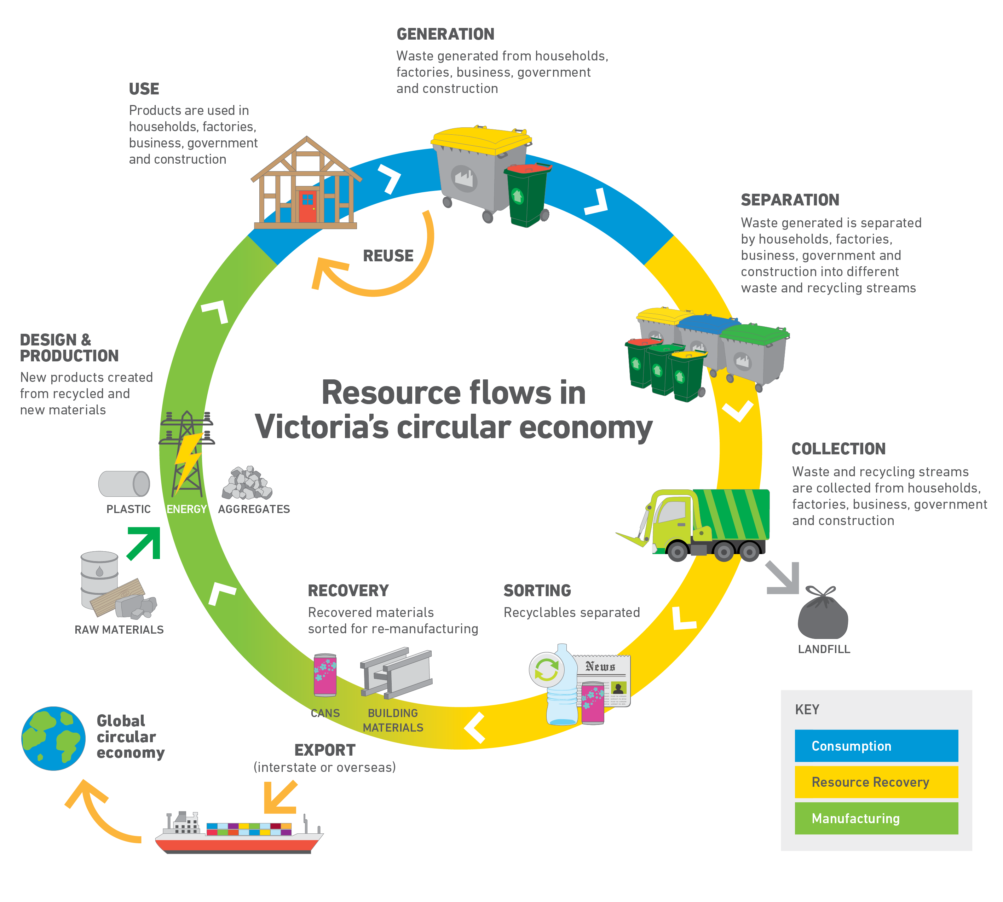

# Strategy approach

|  |
| --- |
| The Strategy seeks to:   * meet community expectations for resource recovery activities that improve the environment, community amenity and public health, while stimulating markets for the use of recovered materials for positive economic return * support conditions for the resource recovery and manufacturing sectors to grow by maximising the value of recovered materials and developing quality products for end markets * increase investment in and the purchase of products made from recovered materials by promoting their qualities and functionality. |

## Strategic framework

To support the delivery of Victoria’s integrated waste and resource recovery system, Table 2 (over page) presents the framework for the Strategy, including its purpose, vision, strategic directions, goals and anticipated outcomes.

|  |  |
| --- | --- |
| **Strategic Directions** | **Proposed approaches** that will be applied over the Strategy’s 30 year life. |
| **Goals** | **Overarching observable and measurable** [**result**](http://www.businessdictionary.com/definition/end-result.html)**s** that will be sought within the Strategy’s 30 year life. |
| **Outcomes** | **Overarching deliverables** that will be sought within the Strategy’s 10 year strategic outlook. |
| **Actions** | **Activities** to be implemented and reviewed within a five year timeframe (presented in Sections 6 and 7). |

The high level five year actions are outlined in Sections 6 and 7. Appendix 1 outlines the relationship between the delivery of these actions and the priority materials and products. Further detail on the implementation of actions over the first five years of the Strategy will be presented in SV’s annual business plan, and in other related material and product focused programs such as the VORRS.

Links to the suite of complementary initiatives highlighted in Figure 1 are more specifically addressed in the high level actions presented in Sections 6 and 7.

**Table 2: Framework of the Victorian Market Development Strategy for Recovered Resources**

|  |  |  |  |  |  |  |
| --- | --- | --- | --- | --- | --- | --- |
| **Purpose:** *To outline where state government may intervene to stimulate production industries and markets for recovered resources in Victoria by reducing barriers and supporting the right conditions for product markets to grow and mature.* | | | | | | |
| **Vision:** *Victoria has an integrated, statewide approach to market development within the principles of a circular economy, which supports mature and expanding production industries and markets for recovered resources.* | | | | | | |
| **Strategic directions** | | | | | | |
| **Framework for operational delivery** | | | | **Framework for planning and decision making** | | |
| **Recover and manufacture** | | **Production and use** | |
| **Improve the quality of recovered resources to support manufacturing** | **Improve consolidation and aggregation of recovered materials to contribute to growth in manufacturing** | **Improve the performance of products incorporating recovered resources** | **Increase the use of products incorporating recovered resources** | **Cross government coordination within an integrated, statewide waste management framework** | **Adopt appropriate, evidence based approaches to government intervention** | **Capitalise on policy and market signals supporting resource recovery** |
| **Goals** | | | | | | |
| **Maximised recovery of clean materials for reuse and manufacturing** | **Viable quantities of materials recovered to support manufacturing** | **Design and production standards for products using recovered resources** | **Procurement of products using recovered resources** | **Effective statewide collaboration and engagement for market development** | **Decision making that is informed by current knowledge and information** | **Delivery of government policy that supports market mechanisms** |
| **Outcomes** | | | | | | |
| * Investment and collaborative procurement that supports the recovery of quality materials * Improved source segregation of material types * Reduced contamination in recovered material | * Co-location of resource recovery and manufacturing activities (‘hubs and spokes’ network), supported by investment and collaborative procurement to improve material flows and use * Investment by business to capture and consolidate viable quantities of recovered resources to supply state, national and global manufacturing markets * A growing manufacturing industry using recovered resources | * Influence product and packaging design in manufacturing, to minimise waste during production and support disassembly, reuse or recycling at end-of-life * Investment in research and innovation to overcome challenges and capitalise on opportunities for the use of recovered resources in product development * Quality standards and specifications applied to products with recovered resources | * Information dissemination programs that address challenges and opportunities for the uptake of products with recovered resources * Procurement processes that support the use of products with recovered resources that meet quality standards / specifications | * Coordinated investment planning, implementation, evaluation and reporting | * Application of criteria that supports decision making for prioritising materials and products for market development interventions * Collation and dissemination of data and information to support the development of markets for products with recovered resources | * Utilise price signals as an incentive to investment in resource recovery (e.g. landfill levy) * Long term purpose of landfills to be only for the management of treated residual waste |

## Key intervention areas

Figure 4 presents government intervention areas to support market development for recovered resources, which are grouped under three key themes. The interventions acknowledge the:

* barriers and challenges identified through industry market analysis (see Section 4.1 and ‘Further reading’)
* Victorian Government’s role in market development (see Section 4.2)
* findings of consultation with stakeholders (see Section 3 and ‘Further reading’)
* inter-dependencies within the integrated statewide framework for waste and resource recovery planning and delivery (see Figure 1).

The high level actions to deliver the Strategy in its first five years are outlined in Sections 6 and 7. The actions presented in these Sections are all framed within the intervention areas outlined in Figure 4.

The core market development interventions presented in Figure 4 are unique to this Strategy. These core interventions are supported by infrastructure and education interventions that will be delivered through other initiatives outlined in Figure 1.

Figure 4 highlights that government interventions for market development operate within an overarching policy and regulatory framework for the State. The current regulatory framework will support the implementation of interventions and general management of recovered resources. For example, where recovered materials may be stockpiled (e.g. tyres and glass fines), and where stockpiling could be a legitimate response to market fluctuations or the result of market barriers, current regulations would come into play where this stockpiling was causing environmental or public health impacts. Figure 4 also acknowledges other dependencies, which include the importance of data governance and information dissemination in the implementation of government interventions for market development.

**Figure 4: Government intervention areas to support market development for recovered resources**

|  |  |  |  |  |  |  |  |  |  |  |
| --- | --- | --- | --- | --- | --- | --- | --- | --- | --- | --- |
| **Policy, regulation and data governance**   |  |  |  | | --- | --- | --- | | **Infrastructure interventions** | **Core market development interventions** | **Education interventions** | | Infrastructure investment to improve quantity and quality of recovered resources | Research and development (material / product performance and development) | Education for industry and consumers | | Resource recovery infrastructure hubs | Product specifications (quality standards) | | Product procurement | | Product stewardship |   **Information dissemination to stakeholders** |

## Prioritisation methodology for market development of recovered resources

A methodology was developed to assign priority for market development of recovered materials and products. This will support decision making to inform market development program planning and interventions into the future.

The market for recovered resources encompasses the entire value-chain from generation and collection of waste through to consumption of the recycled product. For the purpose of the methodology this value-chain is split into two components.

* Waste generation, recovery and SUPPLY to material processors.
* Production and DEMAND for recycled product.

A successful market for recovered resources depends on how these two components function. In essence this means:

* an adequate, reliable, and relatively clean SUPPLY of recovered resources to processors[16], manufacturers and exporters
* sufficient consumer DEMAND for products containing recovered resources in order to meet end market supply.

Table 1 presents some of the common supply and demand side market development challenges and barriers.

The development and application of the methodology has drawn on:

* a review of industry and government prioritising methodologies
* market development barriers, intervention opportunities and potential criteria for prioritising recovered resources, drawn from industry market analysis work and tested during consultation on the Discussion Paper
* input from the Australian Council of Recycling (ACOR) and the Victorian Competition and Efficiency Commission (VCEC).

Figure 5 provides a summary of the methodology (over page). It highlights two pathways for decision making. Pathway 1 acknowledges that government policy commitments will always be prioritised. Other products and materials will be assessed by applying Pathway 2.

**Figure 5: Summary of the prioritisation methodology for market development of recovered resources**

**Manufacturing** to **Use**

Market demand barrier criteria:

* Feedstock security
* Feedstock management / product demand imbalances
* Product competition
* Product quality and performance issues
* Market / customer availability

**Generation** to **Manufacturing**

Market supply barrier criteria:

* Generation amounts
* Geographic distribution and ease of aggregation
* Separation and contamination removal
* Environment / public health and safety risk profile
* Processing or manufacturing capacity

**Pathway 2**

**Pathway 1**

**Government policy commitments**

**Market challenges / barriers for business**

Materials or products prioritised high, medium or low based on assessment of:

* supply challenges / barriers

and / or

* demand challenges / barriers

Government intervention and SV business planning criteria (includes but not limited to):

* Community expectation
* Regulatory mechanisms
* Environmental benefits (e.g. Life cycle assessment)
* Government return on investment (ROI)
* Existing government support
* Industry / business interest

**SV market development material and product priorities**

**Government intervention and SV business planning**

**Initial list of high and medium materials and products**

## 5.4. Five year market development material and product priorities

Application of the methodology provides a list of materials and products that will be the focus of market development actions for the first five years of the Strategy. The associated implementation of actions linked to these materials and products will be presented in SV’s annual business plan and in other related material and product focused programs such as the VORRS. In line with the five year review cycle for the Strategy, the actions and materials and products for intervention will be assessed at that point.

Table 3 presents a list of statewide material and product priorities for market development, and Appendix 1 links these to actions in the first five years of the Strategy’s implementation. Table 4 presents a high level summary for each of the material and product priorities.

WRRGs may determine through the development of their regional implementation plans that they have their own regional market development priorities in addition to the statewide priorities identified in Table 3. Any regional market development activities will complement the implementation of actions supporting the statewide priorities.

**Table 3: Market development material and product priorities for the first five years of the 30 year Strategy**

|  |  |
| --- | --- |
| **Supply side priority materials / products**  **(Generation to manufacturing)** | * Organics (including timber) * Rubber (tyres) * E-waste * Flexible plastics |
| **Demand side priority materials / products**  **(Manufacturing to use)** | Products derived from:   * Organics (including timber) * Rubber (tyres) * Concrete and brick * Glass fines * Flexible plastics |

**Table 4: High level summary of five year market development material and product priorities[17]**

|  |
| --- |
| **Organics (including timber)**   * In 2013-14 approximately 2 million tonnes of organic waste was generated in Victoria, with about 0.82 million tonnes being recovered and 1.19 million tonnes landfilled. * Contamination in recovered organics is a key challenge limiting the uses for end products. * Organic material is often produced significant distances from markets. * Application of manufacturing and product standards for compost is voluntary and creates challenges for industry. * Timber remains a significant component of waste landfilled and Victoria will face challenges in the coming years to handle volumes of treated timber as well as finding suitable market solutions for stockpiled timber. * Opportunities exist to identify clear quality standards for recycled organics in association with the provision of evidence to end markets about the benefits of using these recycled organic products. * For more information: [Victorian Organics Resource Recovery Strategy](http://www.sustainability.vic.gov.au/our-priorities/statewide-waste-planning/2015-2020-priorities/victorian-organics-strategy)   **Rubber (tyres)**   * The End of Life (EoL) tyre market in Victoria was 90,791 tonnes in 2013-14. 77% was recovered for export, and 12% was recycled locally. The remaining 11% was unknown, and assumed to be stockpiled or exported without registration with Customs[18]. * EoL tyre management has become an issue in recent years with practices seeing some tyre collectors stockpiling EoL tyres to avoid processing fees or disposal charges. This is presents safety issues including the fire risk from tyre stockpiles. * The Victorian Government has amended regulations to ensure tyres are stored safely. The *Environment Protection (Scheduled Premises and Exemptions), (Industrial Waste Resource) and (Fees) Regulations 2015*, introduced on 29 April 2015, require applicable premises to store waste tyres in accordance with the *Victorian Fire Services Guidelines*, minimising fire risk and hazards to human health and the environment. * Opportunities are also focusing on attracting and facilitating investment to assist in the development of new markets for waste tyres in Victoria. This has included working with a range of stakeholders on product development, specifications and procurement to stimulate EoL tyre markets. * For more information: [Waste tyres in Victoria](http://www.sustainability.vic.gov.au/services-and-advice/business/waste-tyre-storage) and [Tyres](http://www.nepc.gov.au/resource/stocks-and-fate-end-life-tyres-2013-14-study)   **E-waste**   * E-waste includes electrical or electronic equipment with a power cord or battery that has been discarded. * In 2013-14, television and computer waste generated in Australia was estimated to be 131,000 tonnes. * In Victoria it was estimated that approximately 15,280 tonnes of TV and computer waste was recovered (29% of what was recovered nationally). * E-waste generation is rapidly increasing. Components contain toxic heavy metals as well as some valuable materials. * Currently recycling of e-waste in Victoria (and nationally) is mainly centred on televisions and computers. Victoria supports the National Television and Computer Recycling Scheme. * To protect environmental health and support increased recovery, the government is currently investigating implementation of an e-waste ban in Victoria following appropriate research and regulatory assessment being undertaken. * Any ban on e-waste to landfill will be undertaken alongside a coordinated approach to developing a sustainable recovery industry. Activities may include education for communities and businesses, support to improve collection, sorting and processing capacity and other actions to ensure best-practice recovery of e-waste in Victoria. * For more information: [E-waste](http://www.delwp.vic.gov.au/environment-and-wildlife/e-waste)   **Flexible plastics**   * About 172,000 tonnes of flexible plastic waste was generated in Victoria in 2014-15. * It is estimated that in 2014-15, 16,892 tonnes of flexible plastics were recovered for reprocessing in Victoria. Around 83% was low density polyethylene (PE-LD) or linear low density polyethylene (PE-LLD), 14% was polypropylene (PP) and the remainder was mostly high density polyethylene (PE-HD). * Challenges for flexible plastics include the availability of quality feedstocks and the price sensitivities of collection, transport and processing into quality products when compared to similar products made from virgin plastics and timber. * Most flexible plastics are thermoplastics, which are inherently more difficult to recycle and are often reprocessed into lower value products. * To determine the viability of local market solutions, further research is needed into the feasibility of product recovery, development, specifications and procurement. * For more information: [Flexible plastics](http://www.sustainability.vic.gov.au/~/media/resources/documents/publications%20and%20research/research/market%20analysis/market%20analysis%20flexible%20plastic%20sept%202014%20pdf.pdf)   **Concrete and brick**   * In 2013 – 14 about 4.32 million tonnes of aggregates, masonry and soil waste was generated in Victoria, with 3.574 million tonnes (83%) recovered. For the materials recovered, concrete made up 1.964 million tonnes (55%), and brick / brick rubble was 0.367 million tonnes (10%). * Demand and market growth is predominantly driven by the cost of these recycled materials relative to virgin materials and their proximity to end use applications. * Product research and specification development are supporting new markets for these recycled materials particularly in civil construction applications. * Opportunities exist in continuing to develop products and specifications, while addressing and overcoming barriers to product acceptance and procurement. * For more information: [Brick, stone and concrete](http://www.sustainability.vic.gov.au/~/media/resources/documents/publications%20and%20research/research/market%20analysis/market%20analysis%20bricks%20stone%20concrete%20sept%202014%20pdf.pdf)   **Glass fines**   * An estimated 257,000 tonnes of glass waste is generated each year in Victoria and while 195,000 tonnes or 76% is recovered, only 124,000 tonnes or 48% is recycled back into glass cullet for glass manufacturing. The remaining 52% is made up of glass fines and stockpiles. * The stockpiles of recovered glass in Victoria are estimated at over 300,000 tonnes and are largely contaminated with ceramics, stoneware, Pyrex and plastic. * The two main outputs of glass reprocessing are glass fines and cullet. Cullet is a higher grade product and is primarily used as an input in the production of glass bottles. Glass fines are of a lower grade and can be used in civil construction applications. * Due to the low economic value of glass fines and challenges with sorting and contamination, it is prone to stockpiling when prices are low. * Product research and development is supporting new markets for glass fines particularly in civil construction applications. * Opportunities exist in continuing to develop products, while addressing product specifications and overcoming barriers to product acceptance and procurement. * For more information: [Glass](http://www.sustainability.vic.gov.au/~/media/resources/documents/publications%20and%20research/research/market%20analysis/market%20analysis%20glass%20sept%202014%20pdf.pdf) |

# Framework for operational delivery

The framework for operational delivery of market development for recovered resources draws on earlier content in the Strategy. This is summarised in the diagram below.

|  |  |  |  |  |  |  |  |  |  |  |  |  |  |  |  |  |  |  |  |
| --- | --- | --- | --- | --- | --- | --- | --- | --- | --- | --- | --- | --- | --- | --- | --- | --- | --- | --- | --- |
| **Figure 6: Strategic framework for operational delivery**   |  |  |  | | --- | --- | --- | |  |  |  | | **Strategic Directions** |  | **Table 2**  **Page 13** | | **Goals** | | **Outcomes** | | **Government interventions** |  | **Figure 4**  **Page 14** | | **Priority materials / products** | **Sections 5.3 & 5.4**  **Pages 15 - 19** | |  |  |  | | **High level actions** |  | **Sections 6.1 & 6.2**  **Pages 20 - 25** | |

The framework that follows presents:

* four strategic directions, with their associated goals and outcomes
* government interventions and associated high level actions.

The implementation of the high level actions presented in Section 6 will be focused on the statewide priority materials and products identified in Table 3. Appendix 1 highlights that the actions presented in:

* Section 6.1 focus on the **supply** side priority materials and products
* Section 6.2 focus on the **demand** side priority materials and products.

The actions will support the delivery of the Strategy in its first five years. The implementation of these actions will be presented in SV’s annual business plan, and in other related material and product focused programs such as the VORRS.

## Recover and manufacture

|  |
| --- |
| Improve the quality of recovered resources to support manufacturing |
| Maximised recovery of clean materials for reuse and manufacturing. |
| * Investment and collaborative procurement that supports the recovery of quality materials. * Improved source segregation of material types. * Reduced contamination in recovered material. |
| **Challenges**   * The quality of recovered resources is often impacted by contamination. * Where the quality of recovered resources as a feedstock for manufacturing is compromised, this can hinder investment. * Products are often designed and manufactured overseas with multiple material components, which are a challenge to disassemble and recover at end-of-life. |
| **Solution**  Product stewardship, investment and collaborative procurement opportunities for resource recovery services and infrastructure, to support activities such as product design, source segregation and sorting to reduce contamination, which provides cleaner materials for manufacturers. Undertake these activities in partnership with education programs to reinforce approaches that reduce contamination in materials entering the system. |
| **ACTIONS**  **Collaborative procurement**   * Develop guidelines, templates and training, to include content where appropriate, that addresses options for:   + source segregation and sorting of recovered materials   + approaches that reduce contamination in recovered materials entering the system for manufacturing. * Establish a waste and resource recovery procurement network to share knowledge, experience and best practice within local government on the collaborative procurement of resource recovery services and infrastructure, including the benefits of source separation, material sorting and reduced contamination in recovered resources.   **Investment facilitation**  Develop commercially-friendly summaries / guides of procurement processes, to include content where appropriate, that addresses the investment benefits for manufacturing associated with:   * source segregation and sorting of recovered materials * approaches that reduce contamination in recovered materials.   **Product stewardship**   * Influence existing and new national product stewardship arrangements to improve outcomes for:   + product design   + source separation and reduced contamination in the recovery of end-of-life products. * Identify priority products for future intervention.   **Education**  Develop education programs for community and business focused on improving resource recovery and reducing contamination of waste streams. |

|  |
| --- |
| Improve consolidation and aggregation of recovered materials to contribute to growth in manufacturing |
| Viable quantities of materials recovered to support manufacturing. |
| * Co-location of resource recovery and manufacturing activities (‘hubs and spokes’ network), supported by investment and collaborative procurement to improve material flows and use. * Investment by business to capture and consolidate viable quantities of recovered resources to supply state, national and global manufacturing markets. * A growing manufacturing industry using recovered resources. |
| **Challenges**   * The quantity and long term supply of recovered resources needs to underpin investment in material recovery infrastructure and manufacturing that uses recovered resource feedstocks. * Costs of recovery and manufacturing infrastructure and transport for often low value materials. * Protections through land use planning that facilitate the co-location of resource recovery and manufacturing hubs and spokes. |
| **Solution**  Land use planning, product stewardship, investment and collaborative procurement that facilitate the consolidation and aggregation of recovered materials, to encourage long term material supply and investment in resource recovery services, infrastructure and manufacturing. |
| **ACTIONS**  **Collaborative procurement**   * Develop collaborative procurement guidelines, templates and training to facilitate the consolidation and aggregation of recovered materials. * Establish a waste and resource recovery procurement network to share knowledge, experience and best practice within the local government sector on the collaborative procurement of resource recovery services and infrastructure, including the benefits of consolidation and aggregation of recovered materials.   **Investment facilitation**  Develop commercially-friendly summaries / guides of procurement processes, to include content where appropriate, that addresses the investment benefits associated with:   * recovery systems and infrastructure that consolidate and aggregate recovered resources * manufacturing that uses recovered resource feedstocks.   **Product stewardship**   * Influence existing and new national product stewardship arrangements to effectively manage the environmental, health and safety impacts of products where appropriate, at points in the supply chain including the consolidation and aggregation of end-of-life products. * Identify priority products for future intervention.   **Infrastructure – land use planning**  The implementation of the state infrastructure plan and regional implementation plans will support local government to develop mechanisms at a local level to ensure adequate long term provision of suitably located and appropriately zoned land for waste and resource recovery activities. These plans sit alongside and inform Victoria’s broader land use planning policy framework. |

## Production and use

|  |
| --- |
| Improve the performance of products incorporating recovered resources |
| Design and production standards for products using recovered resources |
| * Influence product and packaging design in manufacturing, to minimise waste during production and support disassembly, reuse or recycling at end-of-life. * Investment in research and innovation to overcome challenges and capitalise on opportunities for the use of recovered resources in product development. * Quality standards and specifications applied to products with recovered resources. |
| **Challenges**   * Products designed for obsolescence and / or not designed for disassembly, with multiple material components. * Products using recovered resources that are of low quality and undermine confidence in the market for recycled products. * Limited research presenting evidence on the application, effectiveness and quality of products with recovered resources. * Product specifications not developed or not incorporating the use of recovered resources where these materials offer an alternative feedstock option. |
| **Solution**  The quality, performance and use of products incorporating recovered resources will be enhanced by:   * research with a focus on innovation in product design and development, which incorporates the assessment and dissemination of product performance to potential markets * application of research outcomes to inform the review of existing and development of new product specifications. |
| **ACTIONS**  **Research and development**  Create conditions that facilitate innovation by supporting government, industry and research partnerships, with a focus on remanufacturing to optimise and add value to:   * product and packaging design and production to minimise waste and support component disassembly for enhanced end-of-life resource recovery * the design and development of processing approaches and products using recovered resources * the assessment of performance of products incorporating recovered resources in potential end-use applications * the dissemination of findings to inform and influence broader product and process design, specification development and commercialisation activities * market analysis to support the identification of emerging products and recovered resources for future market development interventions.   **Product specifications**  Facilitate government and industry partnerships to:   * capitalise on research for the design, development and application of products using recovered resources, in the development of quality standards and product specifications * disseminate quality standards and product specifications to manufacturers developing products using recovered resources * ensure compliance in the promotion and application of quality standards and product specifications to products using recovered resources, including any associated certification or accreditation processes linked to the product standard or specification.   **Product stewardship**   * Support and seek to influence existing and new national product stewardship arrangements to apply quality standards and product specifications to the design, development and application of products using recovered resources. * Identify priority products for future intervention. |

|  |
| --- |
| **Investing in R&D pays off for Close the Loop**  Since its inception in 2000, Close the Loop has continuously invested in research and development (R&D) to identify innovative ways to improve resource recovery and create new end products for industry.  Close the Loop is a Melbourne-based resource recovery and recycling company. Its core business is recovering imaging supplies (cartridges) for printers and copiers, with 30,000 active collection points across Australia.  The strong focus on R&D has seen the company grow from a single idea to a business that employs 200 people, including a subsidiary in the United States. Close the Loop invests around 2% of its annual revenue in R&D.  Close the Loop has recently been working with Sustainability Victoria on a project to commercialise the use of recycled toner powder from printer cartridges in asphalt. Toner powder predominantly consists of small particles of very high grade engineering plastics and these same plastics are commonly used to modify bituminous binders for asphalt roads. Bitumen is the black glue in asphalt. Asphalt is the finished road; a combination of bitumen and crushed rock.  The asphalt additives made by Close the Loop improve the quality and carbon footprint of asphalt at no extra cost. It has better longevity, reducing whole-of-life costs.  To ensure that its product would meet industry standards, Close the Loop formed a strategic partnership with an industry collaborator, EDI Downer. EDI Downer helped with the R&D, providing both knowledge and equipment to develop the asphalt additive to the right specification.  While this may look like a recent opportunity, it is the culmination of more than 10 years of R&D. Thanks to the knowledge and expertise gained from their investment in R&D, Close the Loop was able to seize a business opportunity with global implications. |

|  |
| --- |
| **Melbourne International RoRo Automotive Terminal’s investment in recycled materials**  Melbourne International RoRo Automotive Terminal Pty Ltd (MIRRAT) is investing $65 million into the development of an expanded terminal at Webb Dock West for the importation of vehicles, machinery and equipment.  Design and construction of the facility was awarded to CPB Contractors (formerly Leighton Contractors) in 2014. MIRRAT’s construction includes over 135,000 square metres of pavements, office buildings, workshops and warehouses. The facility is expected to be operational around mid-2016, with the capacity to ultimately manage the throughput of one million vehicles annually.  MIRRAT’s project supply chain has a strong sustainability focus. The project is addressing material and resource efficiency in a range of ways as it works towards achieving both Infrastructure Sustainability Council of Australia (ISCA) and Green Star certification.  A highlight has been the comprehensive use of recycled material in pavement and trench construction. Recycled crushed concrete, brick, glass and asphalt have been used on the project as an alternative to virgin aggregate and sand extracted from quarries.  Efficient design and a guaranteed supply of recycled materials prepared to quality specifications has delivered program advantages and resulted in:   * Over 260,000 tonnes of recycled concrete, brick and glass used in pavement construction * 7,500 tonnes of recycled glass used in over 10 kilometres of trenches * Up to 30 per cent of recycled asphalt used in pavement surfacing   The MIRRAT development demonstrates the central role civil contractors can play in project design, management and delivery.  _______________________________________  **Opportunities for local government**  Local government is also an important influencer in the acceptance of recycled materials in civil pavement and trench construction. Councils are both an end user on their own capital works projects and a specifier in instances such as subdivisional works, which are often contracted out to civil construction companies. Councils that are proactive about recycling are not simply supporting the collection of materials from kerbside, they are actively specifying and procuring recycled materials for applications including pavement and trench construction. |

|  |
| --- |
| Increase the use of products incorporating recovered resources |
| Procurement of products using recovered resources. |
| * Information dissemination programs that address challenges and opportunities for the uptake of products with recovered resources. * Procurement processes that support the use of products with recovered resources that meet quality standards / specifications. |
| **Challenges**   * Focus is often on the procurement of services and infrastructure to recover and process resources, but not on the markets which will procure end products. This can create a ‘push’ from the supply side of recovered resources, rather than a ‘pull’ based on the demand for products using recovered resources, and can result in material stockpiling. * Research and specification development may not always result in the procurement of products with recovered resources. * Limited information disseminating the attributes and quality of products using recovered resources to relevant professions or consumer markets, often resulting in unfounded yet negative perceptions about these products. |
| **Solution**  Procurement of services and infrastructure that influences both the quality and buy-back of end products using recovered resources. Dissemination of research and quality standards for products using recovered resources to appropriate professions or consumer markets, so that these products are either specified for procurement or directly purchased. |
| **ACTIONS**  **Collaborative procurement**   * Develop collaborative procurement guidelines, templates and training, to facilitate the buy-back of end products where they meet agreed quality standards. * Participate in the waste and resource recovery procurement network to share knowledge, experience and best practice within the local government sector on the collaborative procurement of resource recovery services and infrastructure, including the benefits of buy-back of end products where they meet agreed quality standards.   **Product procurement**   * Explore leveraging opportunities for government procurement of products with recovered resources where these meet agreed applications and quality standards. * Identify peak industry bodies, professional associations and procurement service providers and partner with them to influence professional development and information dissemination to facilitate greater specification (e.g. in tenders, contracts etc.) and procurement of products with recovered resources where these meet agreed applications and quality standards. * Investigate and identify innovative approaches to procurement that could expand opportunities for the specification and purchase of products with recovered resources (e.g. Forward Commitment Procurement – see the Glossary). * Investigate opportunities for point of sale information where products with recovered resources may be purchased through the retail sector. |

|  |
| --- |
| **Leveraging Victorian government procurement for sustainability outcomes**  Tyre Stewardship Australia (TSA) is an industry led and funded initiative to implement a national tyre product stewardship scheme in Australia. TSA promotes the safe handling and disposal of end-of -life (EoL) tyres, as well as the development of viable markets for an estimated 52 million EoL tyres generated annually in Australia.  In late 2014 Sustainability Victoria supported the Department of Treasury and Finance (DTF) in making changes to state government procurement policies to better support the national tyre product stewardship scheme and associated sustainability outcomes for the Victorian community. An amendment was made to the *Victorian Government Standard Motor Vehicle Policy* to specify all state government departments, agencies, authorities and associated business enterprises, procure tyre related services from suppliers that participate in the national tyre product stewardship scheme.  The policy change has strengthened TSA’s endeavours and industry engagement in the national tyre product stewardship scheme. It was instrumental in securing commitment from tyre industry stakeholders including some brand owners, who until the policy change, had not signed up to the national scheme.  The national product stewardship scheme will see millions of dollars of funding come annually from an Australian Competition and Consumer Commission endorsed 25 cent levy on every equivalent passenger unit (EPU) tyre imported into Australia. This will fund TSA’s activities in Victoria, including auditing and accrediting the EoL tyre supply chain, and the creation of a market development fund to increase processing and demand for tyre derived product. |

# Framework for planning and decision making

The framework for planning and decision making on market development for recovered resources draws on earlier content in the Strategy. This is summarised in the diagram below.

|  |  |  |  |  |  |  |  |  |  |  |  |  |  |  |  |  |  |  |  |
| --- | --- | --- | --- | --- | --- | --- | --- | --- | --- | --- | --- | --- | --- | --- | --- | --- | --- | --- | --- |
| **Figure 7: Strategic framework for planning and decision making**   |  |  |  | | --- | --- | --- | |  |  |  | | **Strategic Directions** |  | **Table 2**  **Page 13** | | **Goals** | | **Outcomes** | | **Government interventions** |  | **Figure 4**  **Page 14** | | **Priority materials / products** | **Section 5.3 & 5.4**  **Pages 15 - 19** | |  |  |  | | **High level actions** |  | **Section 7**  **Pages 27 - 29** | |

The framework that follows presents:

* three strategic directions, with their associated goals and outcomes
* government interventions and associated high level actions.

The implementation of the high level actions presented in Section 7 will be focused on ensuring the framework for planning and decision making is applied to the ongoing management and determination of priority materials and products (see Section 5.3). The actions presented in Section 7 will support the delivery of the Strategy in its first five years. The implementation of these actions will be presented in SV’s annual business plan.

|  |
| --- |
| 7.1.1. Cross-government coordination within an integrated, statewide waste management framework |
| Effective statewide collaboration and engagement to support market development. |
| * Coordinated investment planning, implementation, evaluation and reporting. |
| **Challenge**  A high level diversion scenario developed for the state infrastructure plan, projects that in 30 years an additional 1,500,000 tonnes of materials could be diverted from landfill annually for recovery. These additional tonnes are over and above what would occur under a business as usual approach that maintains current trends of generation, recovery and landfill. This state implementation plan scenario estimates that an additional $550-810 million in new infrastructure would be required for Victoria to maximise resource recovery from its waste flows over the next 30 years[19]. To support market development by attracting this investment, a coordinated approach is needed from government to provide timely, informed and responsive advice on waste and resource recovery opportunities to investors. |
| **Solution**  The development and delivery of the state infrastructure plan and associated investment facilitation activities which will inform investment proponents on waste and resource recovery opportunities. |
| **ACTIONS**  **Investment facilitation**   * Establish a cross-government coordination committee for waste and resource recovery infrastructure investment. * Establish and operate the investment facilitation function to attract and facilitate investment in Victoria's waste and resource recovery infrastructure. * Develop marketing collateral for distribution across relevant state and commonwealth government agencies. * Develop a website tailored to current and prospective waste and resource recovery sector investors. * Promote investment opportunities to relevant government agencies. * Transform state infrastructure plan data into an online, interactive tool to make this information accessible to potential investors to inform their investment decisions. * Develop and maintain an online repository of waste and resource recovery data and information. * Inform prospective investors of the value of the social licence to operate in reducing risk and increasing the likely success of their investment (social licence – see the Glossary). * Develop best-practice guidelines for prospective investors to generate the social licence to operate.   **Waste data governance**   * Develop and implement mechanisms that would allow full sharing of key data sets across EPA, SV, DELWP and WRRGs. * That SV release raw data from both the *Victorian Recycling Industries Annual Survey* and the *Victorian Local Government Annual Survey* as soon as it becomes available using suitable caveats and explanatory notes. * Investigate options for more frequent data collection from industry and local government. |

|  |
| --- |
| Adopt appropriate, evidence based approaches to government intervention |
| Decision making that is informed by current knowledge and information. |
| * Application of criteria that supports decision making for prioritising materials and products for market development interventions. * Collation and dissemination of data and information to support the development of markets for products with recovered resources. |
| **Challenge**  Determining the priority materials and products that require some level of government intervention, and ensuring that the interventions are based on evidence to address material or product supply and / or demand barriers, within government policy and resourcing considerations. |
| **Solution**  The application of an assessment framework that evaluates risk and assigns priority to materials and products (the ‘prioritisation methodology for recovered resources’ in Section 5.3). The methodology will support intervention and program planning for market development and relies on evidence including data and industry market analysis work. |
| **ACTIONS**  **Prioritising recovered resources**  The ‘prioritisation methodology for recovered resources’ is outlined in Section 5.3. This has been applied to determine the ‘priority’ and ‘maintenance’ materials and products that will be the primary focus for the high level actions outlined in Section 6.  **Waste data governance**   * Develop and implement mechanisms that would allow full sharing of key data sets across EPA, SV, DELWP and WRRGs. * That SV release raw data from both the *Victorian Recycling Industries Annual Survey* and the *Victorian Local Government Annual Survey* as soon as it becomes available using suitable caveats and explanatory notes. * SV in collaboration with EPA, DELWP, WRRGs and local government, review the ‘Data collection and reporting guidelines for waste management facilities in Victoria’ and if appropriate roll this data collection method out to facilities across the State. * Investigate options for more frequent data collection from industry and local government. * Investigate options for the provision of disaggregated data (waste, recycling and disposal) from waste service contractors.   **Investment facilitation**   * Develop marketing collateral for distribution across relevant state and commonwealth government agencies. * Develop a website tailored to current and prospective waste and resource recovery sector investors. * Transform state infrastructure plan data into an online, interactive tool to make this information accessible to potential investors to inform their investment decisions. * Develop and maintain an online repository of waste and resource recovery data and information.   **Research and development**  Facilitate innovation by supporting government, industry and research partnerships, with a focus on optimising and adding value to a range of activities (see Section 6.2.1). This will include market analysis to support the identification of emerging products and recovered resources for future market development interventions following the current five year action plan for this Strategy. |

|  |
| --- |
| Capitalise on policy and market signals supporting resource recovery |
| Delivery of government policy that supports market mechanisms. |
| * Utilise price signals as an incentive to investment in resource recovery (e.g. landfill levy). * Long term purpose of landfills to be only for the management of treated residual waste. |
| **Challenge**  In 2013-14 almost 8 million tonnes of valuable material was recovered for reuse and remanufacturing, representing a 70% recovery rate[20]. As an example, of the 8 million tonnes recovered, 3.57 million tonnes were aggregates, masonry and soil. The reprocessing of these materials is a high volume business that faces competition from virgin quarry materials. It is probable that recovery rates of these very heavy materials have increased in tandem with increases to the landfill levy[21]. |
| **Solution**  Supporting a shift to waste being viewed as a resource and facilitating the long term purpose of landfills to only receive treated residual waste. By capitalising on pricing signals such as the landfill levy and adopting a circular economy approach, the linear ‘take-make-dispose’ supply chain approach to manufacturing and consumption can be made circular through enhanced resource recovery, which brings materials back into the cycle for remanufacturing. |
| **ACTIONS**  **Infrastructure**  Implementation of the state infrastructure plan goal that landfills will only be used for receiving and treating waste streams from which materials that can be viably recovered have been extracted.  **Investment facilitation**   * Establish and operate the investment facilitation function to attract and facilitate investment in Victoria's waste and resource recovery infrastructure. * Develop an investment pitch for Victoria's waste and resource recovery sector. * Develop an investment prospectus for Victoria's waste and resource recovery sector. * Develop marketing collateral for distribution across relevant state and commonwealth government agencies. * Develop a website tailored to current and prospective waste and resource recovery sector investors. * Transform state infrastructure plan data into an online, interactive tool to make this information accessible to potential investors to inform their investment decisions. * Develop and maintain an online repository of waste and resource recovery data and information. |

# Implementation and reporting

SV is the Victorian Government’s lead agency delivering integrated waste and resource recovery programs. SV will coordinate the delivery, evaluation and reporting on the Strategy, on behalf of the Victorian Government’s environment portfolio.

Within the context of Victoria’s integrated waste and resource recovery system, the Strategy offers a coordinated approach to government engagement in market development for recovered resources over the next 30 years, with a review every five years. To ensure currency, the high level actions presented will be implemented over the first five years of the Strategy.

The detailed implementation of the Strategy’s actions will be presented in SV’s annual business plan, and in other related material and product focused programs such as the VORRS. Reporting on the delivery of the Strategy’s actions will be presented in SV’s annual report.

# Further reading

In acknowledging that there are diverse interests associated with market development for recovered resources in Victoria, the information below provides further context, research and data for interested readers.

Draft Strategy consultation report

[Discussion Paper for Draft Market Development Strategy for Recovered Resources Consultation Findings at January 2015](http://www.sustainability.vic.gov.au/~/media/resources/documents/our%20priorities/integrated%20waste%20management/consultation%20findings%20-%20victorian%20market%20development%20strategy%20for%20recovered%20resources.pdf)

[The Discussion Paper](http://www.sustainability.vic.gov.au/~/media/resources/documents/our%20priorities/integrated%20waste%20management/discussion%20paper%20-%20victorian%20market%20development%20strategy%20for%20recovered%20resources.pdf)

[Statewide Waste and Resource Recovery Infrastructure Plan](http://www.sustainability.vic.gov.au/our-priorities/statewide-waste-planning/2015-2020-priorities/statewide-waste-and-resource-recovery-infrastructure-plan)

[Investment Facilitation Framework](http://www.sustainability.vic.gov.au/services-and-advice/business/investment-facilitation-service)

[Collaborative Procurement Framework](http://www.sustainability.vic.gov.au/services-and-advice/local-government/collaborative-procurement-service)

[Victorian Community and Business Waste Education Strategy](http://www.sustainability.vic.gov.au/our-priorities/statewide-waste-planning/2015-2020-priorities/victorian-community-and-business-waste-education-strategy)

[Waste Data Service](http://www.sustainability.vic.gov.au/services-and-advice/local-government/waste-data-service)

[**Victorian Recycling Industries Annual Survey, 2013-14**](http://www.sustainability.vic.gov.au/~/media/resources/documents/publications%20and%20research/research/recycling%20in%20victoria/victorian%20recycling%20industries%20annual%20survey%202013-14/victorian%20recycling%20industries%20annual%20survey%202013-14%20pdf.pdf)

* [Figure 7 Flow of material for reprocessing, Victoria 2013-14](http://www.sustainability.vic.gov.au/~/media/resources/documents/publications%20and%20research/research/recycling%20in%20victoria/victorian%20recycling%20industries%20annual%20survey%202013-14/victorian%20recycling%20industries%20annual%20survey%202013-14%20pdf.pdf#page=12) (Figure 7, page 12)
* [Recovery and trends](http://www.sustainability.vic.gov.au/~/media/resources/documents/publications%20and%20research/research/recycling%20in%20victoria/victorian%20recycling%20industries%20annual%20survey%202013-14/victorian%20recycling%20industries%20annual%20survey%202013-14%20pdf.pdf#page=14) (Section 3.1, pages 14-15)
* [Overall composition of material](http://www.sustainability.vic.gov.au/~/media/resources/documents/publications%20and%20research/research/recycling%20in%20victoria/victorian%20recycling%20industries%20annual%20survey%202013-14/victorian%20recycling%20industries%20annual%20survey%202013-14%20pdf.pdf#page=15) (Section 3.2, pages 15-17)
* [Sources of recyclables](http://www.sustainability.vic.gov.au/~/media/resources/documents/publications%20and%20research/research/recycling%20in%20victoria/victorian%20recycling%20industries%20annual%20survey%202013-14/victorian%20recycling%20industries%20annual%20survey%202013-14%20pdf.pdf#page=17) (Section 3.3, pages 17-18)
* [Reprocessing and exports](http://www.sustainability.vic.gov.au/~/media/resources/documents/publications%20and%20research/research/recycling%20in%20victoria/victorian%20recycling%20industries%20annual%20survey%202013-14/victorian%20recycling%20industries%20annual%20survey%202013-14%20pdf.pdf#page=18) (Section 3.4, pages 18-20)
* [Product markets](http://www.sustainability.vic.gov.au/~/media/resources/documents/publications%20and%20research/research/recycling%20in%20victoria/victorian%20recycling%20industries%20annual%20survey%202013-14/victorian%20recycling%20industries%20annual%20survey%202013-14%20pdf.pdf#page=20) (Section 3.5, pages 20-21)
* [Metal recovery](http://www.sustainability.vic.gov.au/~/media/resources/documents/publications%20and%20research/research/recycling%20in%20victoria/victorian%20recycling%20industries%20annual%20survey%202013-14/victorian%20recycling%20industries%20annual%20survey%202013-14%20pdf.pdf#page=22) (Section 4, pages 22-24)
* [Aggregates, masonry & soil recovery](http://www.sustainability.vic.gov.au/~/media/resources/documents/publications%20and%20research/research/recycling%20in%20victoria/victorian%20recycling%20industries%20annual%20survey%202013-14/victorian%20recycling%20industries%20annual%20survey%202013-14%20pdf.pdf#page=25) (Section 5, pages 25-27)
* [Paper and cardboard recovery](http://www.sustainability.vic.gov.au/~/media/resources/documents/publications%20and%20research/research/recycling%20in%20victoria/victorian%20recycling%20industries%20annual%20survey%202013-14/victorian%20recycling%20industries%20annual%20survey%202013-14%20pdf.pdf#page=28) (Section 6, pages 28-29)
* [Organics recovery](http://www.sustainability.vic.gov.au/~/media/resources/documents/publications%20and%20research/research/recycling%20in%20victoria/victorian%20recycling%20industries%20annual%20survey%202013-14/victorian%20recycling%20industries%20annual%20survey%202013-14%20pdf.pdf#page=30) (Section 7, pages 30-32)
* [Glass recovery](http://www.sustainability.vic.gov.au/~/media/resources/documents/publications%20and%20research/research/recycling%20in%20victoria/victorian%20recycling%20industries%20annual%20survey%202013-14/victorian%20recycling%20industries%20annual%20survey%202013-14%20pdf.pdf#page=33) (Section 8, pages 33-34)
* [Plastic recovery](http://www.sustainability.vic.gov.au/~/media/resources/documents/publications%20and%20research/research/recycling%20in%20victoria/victorian%20recycling%20industries%20annual%20survey%202013-14/victorian%20recycling%20industries%20annual%20survey%202013-14%20pdf.pdf#page=35) (Section 9, pages 35-37)
* [Rubber recovery](http://www.sustainability.vic.gov.au/~/media/resources/documents/publications%20and%20research/research/recycling%20in%20victoria/victorian%20recycling%20industries%20annual%20survey%202013-14/victorian%20recycling%20industries%20annual%20survey%202013-14%20pdf.pdf#page=38) ( [Section 10, pages 38-39)](http://www.sustainability.vic.gov.au/~/media/resources/documents/our%20priorities/integrated%20waste%20management/swwrip/iwm%20draft%20swrrip%202013-2043%20-%20sections%201%20to%208%20-%20sept%202013.pdf#page=26)
* [Textile recovery](http://www.sustainability.vic.gov.au/~/media/resources/documents/publications%20and%20research/research/recycling%20in%20victoria/victorian%20recycling%20industries%20annual%20survey%202013-14/victorian%20recycling%20industries%20annual%20survey%202013-14%20pdf.pdf#page=40) (Section 11, pages 40-41)
* [Summary of materials recovered for reprocessing, Victoria 2004-05 to 2013-14](http://www.sustainability.vic.gov.au/~/media/resources/documents/publications%20and%20research/research/recycling%20in%20victoria/victorian%20recycling%20industries%20annual%20survey%202013-14/victorian%20recycling%20industries%20annual%20survey%202013-14%20pdf.pdf#page=44) (Appendix B, pages 44-46)

**Organic resource recovery**

[Victorian Organics Resource Recovery Strategy](http://www.sustainability.vic.gov.au/our-priorities/statewide-waste-planning/2015-2020-priorities/victorian-organics-strategy)

[Recycled Organics Market Development](http://www.sustainability.vic.gov.au/services-and-advice/business/recycled-organics-market-development)

**Market analysis of recovered resources**

* [Brick, stone and concrete](http://www.sustainability.vic.gov.au/~/media/resources/documents/publications%20and%20research/research/market%20analysis/market%20analysis%20bricks%20stone%20concrete%20sept%202014%20pdf.pdf)
* [Flexible plastics](http://www.sustainability.vic.gov.au/~/media/resources/documents/publications%20and%20research/research/market%20analysis/market%20analysis%20flexible%20plastic%20sept%202014%20pdf.pdf)
* [Glass](http://www.sustainability.vic.gov.au/~/media/resources/documents/publications%20and%20research/research/market%20analysis/market%20analysis%20glass%20sept%202014%20pdf.pdf)
* [Organics summary](http://www.sustainability.vic.gov.au/~/media/resources/documents/publications%20and%20research/research/market%20analysis/market%20analysis%20organics%20sept%202014%20pdf.pdf) and [full report](http://www.sustainability.vic.gov.au/~/media/resources/documents/publications%20and%20research/research/market%20analysis/market%20analysis%20full%20report%20organics%20sept%202014.pdf)
* [Refuse derived fuel](http://www.sustainability.vic.gov.au/~/media/resources/documents/publications%20and%20research/research/market%20analysis/market%20analysis%20refuse-derived%20fuel%20sept%202014.pdf)
* [Shredder floc](http://www.sustainability.vic.gov.au/~/media/resources/documents/publications%20and%20research/research/market%20analysis/market%20analysis%20shredder%20floc%20sep%202014.pdf)
* [Timber](http://www.sustainability.vic.gov.au/~/media/resources/documents/publications%20and%20research/research/market%20analysis/market%20analysis%20timber%20sept%202014%20pdf.pdf)
* [Tyres](http://www.sustainability.vic.gov.au/~/media/resources/documents/publications%20and%20research/research/market%20analysis/market%20analysis%20end-of-life%20tyres%20sept%202014.pdf)

**Business case**

[Recycled materials in pavement construction](http://www.sustainability.vic.gov.au/services-and-advice/local-government/recycled-materials-in-pavement)

**Product stewardship and other material specific programs**

* [Television and computer recycling](http://www.sustainability.vic.gov.au/services-and-advice/households/waste-and-recycling/television-and-computer-recycling)
* [Battery recycling](http://www.sustainability.vic.gov.au/services-and-advice/households/waste-and-recycling/batteryback)
* [Paint product stewardship](http://www.sustainability.vic.gov.au/services-and-advice/business/paint-stewardship)
* [Timber recycling fund](http://www.sustainability.vic.gov.au/services-and-advice/funding/recent-allocated-funding/timber-recycling-fund)
* [Waste tyres in Victoria](http://www.sustainability.vic.gov.au/services-and-advice/business/waste-tyre-storage)
* [Recycled mixed plastics](http://ecobuy.org.au/recycled-plastics-toolkit)

# Appendix 1 – Five year actions for priority materials and products

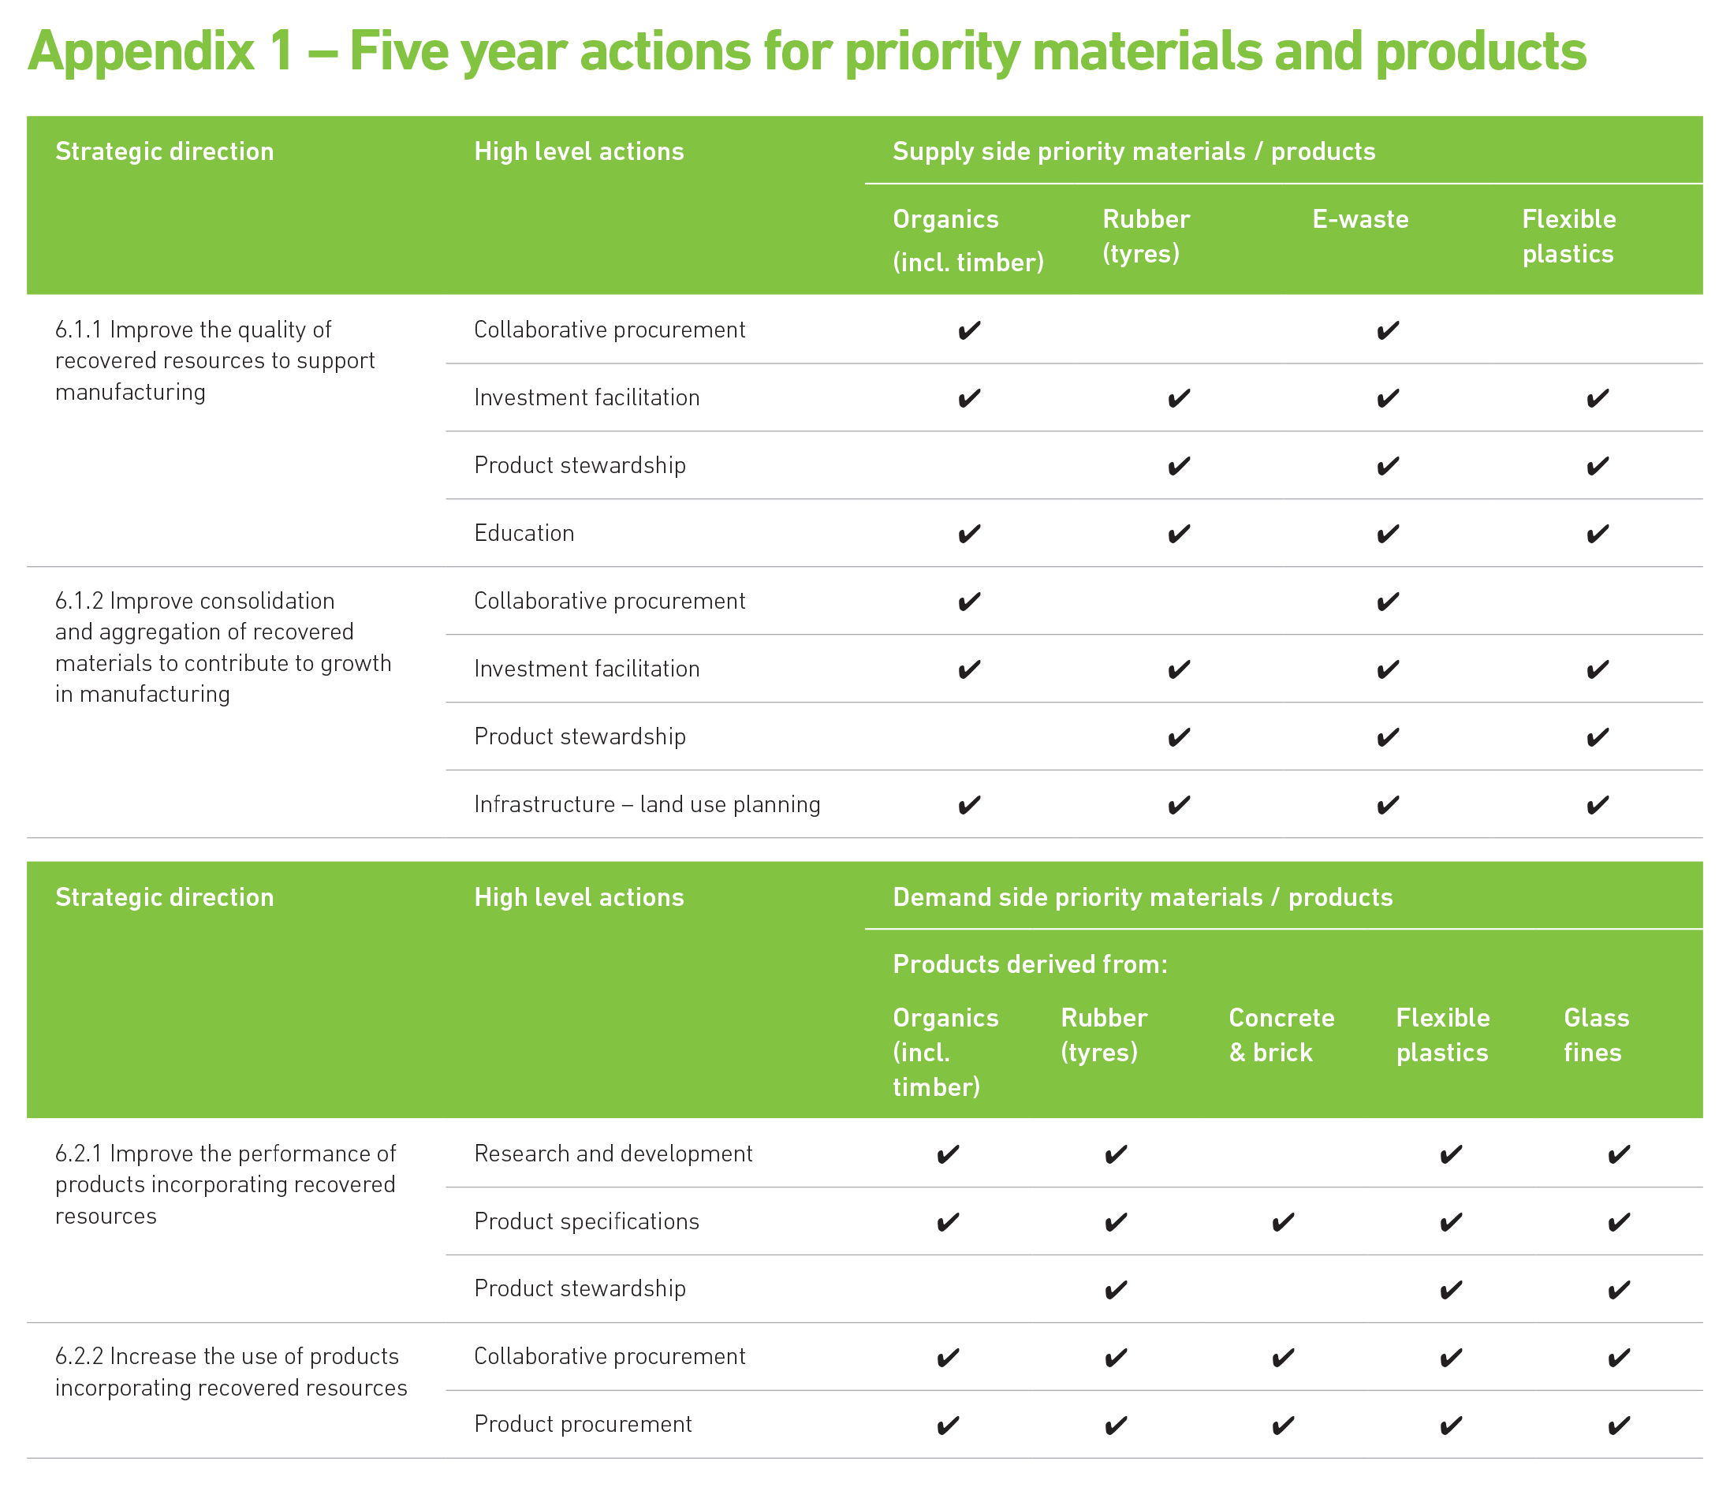

# Acronyms

|  |  |
| --- | --- |
| **Acronym** | **Phrase or word** |
| Collaborative procurement | Collaborative procurement service |
| DELWP | Department of Environment, Land, Water and Planning |
| DTF | Department of Treasury and Finance |
| EPA | Environment Protection Authority Victoria |
| Investment facilitation | Investment facilitation service for waste and resource recovery infrastructure |
| SV | Sustainability Victoria |
| State infrastructure plan | Statewide Waste and Resource Recovery Infrastructure Plan |
| Discussion Paper | Victorian Market Development Strategy for Recovered Resources Discussion Paper |
| Strategy | Victorian Market Development Strategy for Recovered Resources |
| WRRGs | Waste and Resource Recovery Groups |
| Regional implementation plan | Regional Waste and Resource Recovery Implementation Plan |
| VORRS | Victorian Organics Resource Recovery Strategy |

# Glossary

| **Term** | **Explanation** |
| --- | --- |
| Collaborative procurement | Collaborative procurement is where two or more councils work together to procure waste and resource recovery services and/or infrastructure by consolidating waste materials or products to maximise environmental, social and economic outcomes[22]. |
| Cradle-to-Cradle[23] | This framework seeks to create production techniques that are not just efficient but are essentially waste free. In Cradle-to-Cradle production all material inputs and outputs are seen either as technical or biological nutrients. Technical nutrients can be recycled or reused with no loss of quality and biological nutrients can be composted or consumed. |
| E-waste | Electronic waste (e-waste) describes electrical or electronic equipment with a power cord or a battery and its parts that have been discarded by the owner as waste without the intention of reuse. E-waste includes but is not limited to computers, televisions, consumer electronics, whitegoods, power tools etc. |
| Flexible plastics | Flexible plastic includes packaging (such as bags, pouches, sachets, wraps) and flexible polymer wraps used in logistics (such as pallet wrap, silage wrap, or wheat storage bags). These products are typically made of a range of polymer types including low density polyethylene (PE-LD), linear low density polyethylene (PE-LLD), high density polyethylene (PE-HD) and polypropylene (PP). |
| Forward Commitment Procurement[24] | A model that involves providing advance information of future needs, early engagement with potential suppliers and – most importantly – the incentive of a forward commitment: an agreement to purchase a product that currently does not exist, at a specified future date, providing it delivers agreed performance levels and cost. |
| Glass fines[25] | Glass which has been recovered from the waste stream but is considered unsuitable for use in glass manufacturing due to difficulty sorting (i.e. particles too small) and / or contamination. |
| Industrial Ecology[26] | The study of material, water and energy flows through industrial systems. It focuses on connections between operators within the ‘industrial ecosystem’, and aims to create a closed-loop process in which waste serves as an input. |
| Industrial ecosystem[27] | Industrial systems incorporating the four ecosystem principles of roundput (recycling or cascading), diversity, locality and gradual change. |
| Market development for recovered resources | Market development for recovered resources is about creating and expanding appropriate and sustainable markets for the use of recovered materials and products by:   * entering new markets * engaging new users * increasing per person usage. |
| Processors | Those involved in cleaning, pulping, grinding and other forms of recovered resource preparation. |
| Product procurement | For the purposes of this Strategy, it is the act of obtaining or buying products containing recovered resources. |
| Product specification | For the purposes of this Strategy, it is a document setting out standards and procedures designed to ensure products containing recovered resources are safe, reliable and consistently perform the way they were intended to. |
| Product stewardship | A concept of shared responsibility by all sectors involved in the manufacture, distribution, use and disposal of products, which seeks to ensure value is recovered from products at end-of-life. |
| Recycling | A term that may be used to cover a wide range of activities, including collection, sorting, reprocessing and manufacture into new products. |
| Reuse | Recovering value from a discarded resource without processing or remanufacture. |
| Social licence to operate | The concept has evolved from broader concepts of ‘corporate social responsibility’ and is based on the idea that a business not only needs appropriate government or regulatory approval but also a ‘social licence’. The social licence is the acceptance that is continually granted to a business by the local community or other stakeholders to operate. |

1. Sustainability Victoria, *Victorian Recycling Industries Annual Survey 2013 - 14*, 2015
2. Waste Management and Environment, *Inside Waste Industry Report*, p. 69, 2014–15
3. Integrated waste and resource recovery is the management of the entire waste system including avoidance, generation, collection, recovery, reuse, treatment and disposal.
4. The concept of the circular economy is outlined in Section 4.3
5. Sustainability Victoria, *Statewide Waste and Resource Recovery Infrastructure Plan - Victoria 2015-44,* Executive Summary, 2015
6. Sustainability Victoria, *Victorian Recycling Industries Annual Survey 2013 - 14*, 2015
7. Sustainability Victoria, *Statewide Waste and Resource Recovery Infrastructure Plan - Victoria 2015-44,* Executive Summary, 2015
8. Waste Management and Environment, *Inside Waste Industry Report*, p. 69, 2014–15
9. Department of Treasury and Finance, *Victorian Guide to Regulation*, 2011
10. Ellen Macarthur Foundation, *Towards the Circular Economy 2, Opportunities for the Consumer Goods Sector*, 2013
11. <http://www.veolia.com/en/veolia-group/media/news/veolia-joins-forces-project-mainstream-help-develop-circular-economy>
12. SITA UK, *Achieving the vision of no more waste. Engaging in the circular economy*
13. <http://www.wrap.org.uk/content/wrap-and-circular-economy>
14. World Economic Forum, *Towards the Circular Economy: Accelerating the scale-up across global supply chains*, January 2014
15. Sustainability Victoria, *Statewide Waste and Resource Recovery Infrastructure Plan - Victoria 2015-44,* p. 47, 2015
16. See definition of processor in Glossary.
17. Content is sourced from a range of references in Section 9 – Further reading. Some of the references are highlighted in this table, others can be accessed in Section 9 - Further reading, if more information is sought.
18. Hyder Consulting (April 2015), *Stocks and fate of end of life tyres 2013-14 study* for the National Environment Protection Council (disaggregated Victorian data provided after consultation with Hyder Consulting)
19. Sustainability Victoria, *Statewide Waste and Resource Recovery Infrastructure Plan - Victoria 2015-44*, Sections 2.4.1 and 2.4.2, 2015
20. Sustainability Victoria, *Victorian Recycling Industries Annual Survey 2013 - 14*, 2015
21. Sustainability Victoria, *Statewide Waste and Resource Recovery Infrastructure Plan - Victoria 2015-44*, Executive Summary and Section 5.3, 2015
22. Sustainability Victoria *Collaborative procurement guidelines for regional waste and resource recovery groups 2015*, p. 2
23. <http://www.sustainabilitydictionary.com/cradle-to-cradle/>
24. DEFRA, *Commission on Environmental Markets and Economic Performance Report*, p. 43, November 2007
25. Netbalance, *Market analysis of timber, glass, brick, stone and concrete final report*, p. 8, August 2013
26. <http://www.ellenmacarthurfoundation.org/circular-economy/circular-economy/the-circular-model-brief-history-and-schools-of-thought>
27. Korhonen, J. *Four ecosystem principles for an industrial ecosystem*, Journal of Cleaner Production 9 (2001) pages 253-259, 2001