Recycled products in pavement construction

A business case for councils to use local recycled products in pavement construction

Updated September 2015

Background
The use of recycled products in pavement construction introduces an opportunity for councils to better manage the future cost of pavement construction and maintenance. Recycled crushed concrete, crushed brick, glass fines, Reclaimed Asphalt Pavement (RAP) and crumbed rubber now supplement traditional virgin aggregate and sand extracted from quarries, competing on criteria of quality, price and availability. Recycled products also offer many long term environmental benefits.
Shortages in quarry materials in the Sydney market has seen prices rise by up to 70 % due to increased haulage distances and associated costs. Reports of similar challenges are emerging in Victorian markets.
Currently in Victoria, over 500 quarries produce around 500 million tonnes of heavy construction materials per year in a competitive market place. Each Victorian requires on average 8 tonnes per year of quarry material to support the building of roads, houses and other infrastructure to service their needs. However, viable locations for future quarries are becoming increasingly limited as urban development and environmental constraints sterilise some known virgin resources. Continued demand for pavement construction materials will over a 10 – 40 year period exhaust the supply from some existing quarries, forcing the supply of Victorian quarry resources to move progressively further away from demand – much like the circumstances in New South Wales where the increased cost of haulage greatly impacted prices for virgin materials.
This business case presents the competitiveness of local recycled products in pavement construction. Recommendations for councils to procure local recycled products for pavement construction are also provided.
Understanding the business case
There is a viable business case for councils to use local recycled products in pavement construction, based on and subject to the dimensions of quality, price and availability.

Quality
Recycled products perform as well as traditional quarry materials

VicRoads specifications for the use of recycled products in pavement construction are developed through robust testing and trials. This ensures that their use is in appropriate low risk fit for purpose applications and that VicRoads accredited recycled products are of excellent quality and performance.
A list of VicRoads accredited recycled product suppliers is available in the VicRoads Code of Practice RC500.03: Management of Quarry Reference Specimens and the VicRoads Code of Practice RC500.02: Registration of Crushed Rock Mixes details the physical characteristics of virgin and recycled products required for pavement construction
https://www.vicroads.vic.gov.au/business-and-industry/design-and-management/design-standards-and-manuals/technical-publications-az

False perceptions, about the quality of recycled products, exist at the local government level (and beyond) and need to be overcome in order for recycled products to compete equitably. At a minimum, councils should ensure that Sections 812, 820 and 821 (http://webapps.vicroads.vic.gov.au/VRNE/csdspeci.nsf) of VicRoads specifications are included in road design and procurement documentation to provide contractors the option to use a local supply of VicRoads accredited recycled products when it is fit for purpose.

Price
Recycled products can be cost competitive with quarry materials

The key components of the cost of pavement construction materials are the cost of production and the cost of haulage. The cost of production for recycled and quarry products are similar. However, the cost of haulage is a significant component of delivered cost (due to the materials bulk and weight) and is sensitive to the unique factors that govern the availability and location of products for supply.

In areas of availability, local recycled products are cost competitive with and often cheaper than quarry materials (whose prices have generally been trending upward over the past decade).

The impact of haulage on total cost of pavement construction
The haulage cost component for both quarry materials and recycled products can be seen by the change in price as a project location (points 1 and 2 on the diagram) moves closer or further away from each material source.

The relationship of delivered cost to geographical location of source material and potential location of project shows that there are regions where prices are expected to be competitive and it would be practical for recycled product to supplement virgin quarry material.
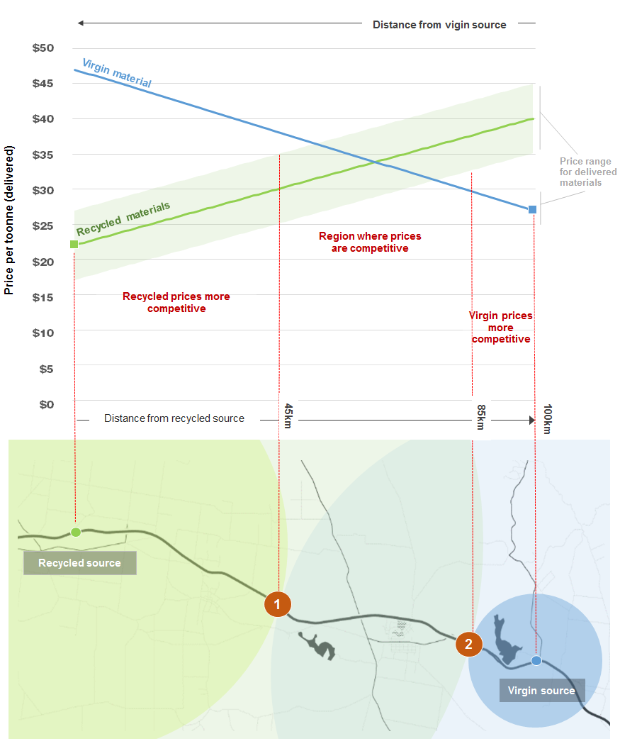

Availability
Access to recycled products is project specific

Virgin quarry materials are locally limited by geology which is characterised by basalt resources in the west and granite and sand in the east of Victoria. However, the varied geology around Melbourne does enable a range of quarried material to be available. The increasing difficulty for extractive industries to access new quarry sites due to urban growth planning and issues with approvals does present a barrier to entry.
Recycled products are limited by the location of Construction and Demolition (C&D) recycling facilities and their proximity to C&D activities.
In general, the economic range of current recycled products is limited to around 30 km due to the proximity of surrounding quarry resources, while quarry material can sometimes be hauled over 100 km to regional areas.

The business case for using recycled products is expected to strengthen in the future:
- as the availability of virgin materials from existing quarries becomes exhausted, and where the location of viable future quarry sites move further away from demand (i.e. the location of pavement construction and maintenance works)
- if the location of C&D recycling infrastructure and local supply of recovered C&D materials becomes more dispersed, particularly in regional areas.

Mobile crushers can expand the reach of recycled products

Mobile crushers have emerged as a technology that could benefit regional recovery of Construction and Demolition (C&D) materials and re-use of recycled products in pavement construction. They can reduce the cost of haulage associated with either transporting recovered C&D materials to a recycling plant (by moving the crusher to the source of the C&D activity) or by transporting recycled crushed product from the crusher to the project site (by moving the crusher to the project site). This is especially useful for small deposits of recovered C&D material across a number of regional transfer station sites. Crushing can allow for re-use on site for small local projects and mass reduction to consolidate and transport for larger projects.

To alleviate capital requirements and project-to-project type usage of mobile crushers, a possible solution could be to establish a share arrangement between regional councils (this could be facilitated by Regional Waste and Resource Recovery Groups http://www.sustainability.vic.gov.au/who-we-are/our-partners/waste-and-resource-recovery-groups)

Pavement construction material resource map of Victoria

C&D Recycling facility
Quarry or mine area (existing)
Current extractive industry tenement
Extractive Industry Interest area

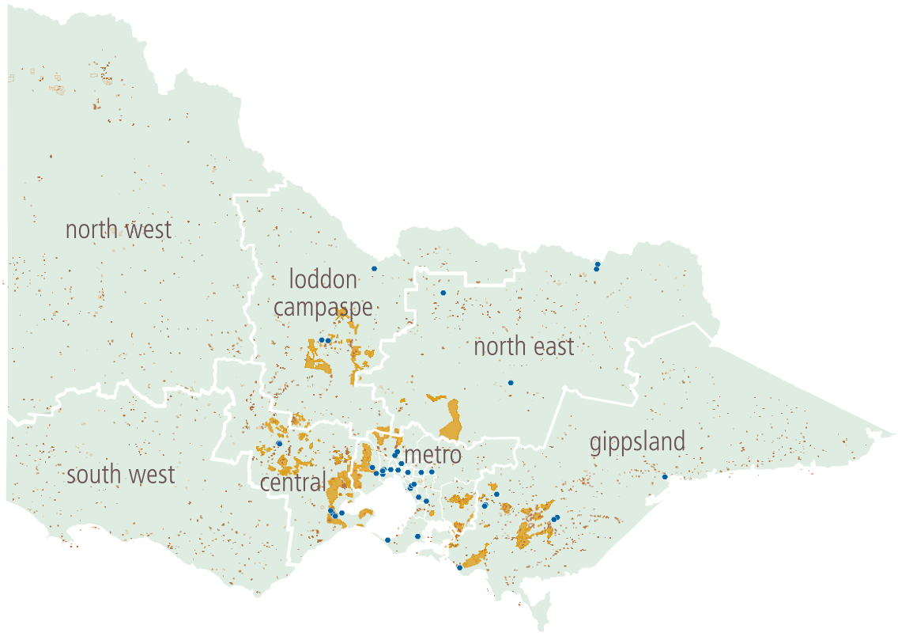

Note: the regions outlined in this document align with the Municipal Association of Victoria’s (MAV’s) engagement with local councils not the Regional Waste and Resource Recovery Group regions.

Comparison of the location of quarries and C&D recycling facilities by region
Region | Quarries |  | C&D recycling facilities
Metropolitan Melbourne
West of Melbourne | The Western region and south toward Geelong is well serviced with quarry material and has the capacity to supply this material to other regions.
North  of Melbourne | Existing quarry resources in northern Melbourne provide a range of material; with those areas identified for future extractive industries (i.e. extractive interest areas) likely to become used for housing. | Over 20 C&D recycling facilities operate in metropolitan Melbourne. These facilities are mainly located in the outer regions where it is economic to operate (i.e. where facilities can be built and located in reasonable proximity to C&D activity).  Facilities are mainly clustered in the west and south east of Melbourne, with a handful of facilities in the north and south east.
South  of Melbourne | There is limited supply of quarried rock in the south of metropolitan Melbourne where mainly sand exists.
East  of Melbourne | While there is reasonable supply of a range of quarry materials at present, continued high demand in this growth area will require additional quarrying resources to be available in the future.
Regional Victoria
Central | There is strong availability of basalt towards Geelong and stretching north east to Ballarat (as identified in extensive extractive industry interest areas). |  | The Geelong area is reasonably well serviced by at least four C&D recycling facilities, while at least two facilities operate in Ballarat.
South west | Many basalt, scoria and tuff quarries exist in the region. However, the construction of wind farms – some of which require access tracks up to one metre thick to take the weight of the cranes – could exhaust high quality quarry resources. |  | C&D recycling infrastructure in the south west of Victoria is very limited, with no facilities identified in the SWRRIP data (Sustainability Victoria, 2015).
North west | Supply of high quality quarry material in this region is limited as there is little hard rock geology in the Mallee. Hard rock sources are limited to sites near Swan Hill, Charlton and Horsham. |  | C&D recycling infrastructure in the north west of Victoria is very limited, with no facilities identified in the SWRRIP data (Sustainability Victoria, 2015).
North  (Loddon Campaspe) | Supply in this region is reasonable due to the combination of existing basalt, granite and sand sources |  | C&D recycling facilities are scattered throughout the regions most populated areas (as identified SWRRIP data Sustainability Victoria, 2015). Facilities are located in Bendigo, Echuca and Dunolly.
North East | A range of quarry materials are available along the main transport route of the Hume Freeway with only local sources available in the Eastern Highlands. |  | C&D recycling facilities are scattered throughout the regions most populated areas (as identified SWRRIP data Sustainability Victoria, 2015). Facilities are located in Wodonga, Shepparton and Mansfield.
East  (Gippsland) | Limited basalt or granite hard rock quarries are available in the Latrobe Valley and near Bairnsdale although a range of sand sources are available. |  | C&D recycling facilities are scattered throughout the regions most populated areas (as identified SWRRIP data Sustainability Victoria, 2015). This includes the Latrobe Valley and Bairnsdale, while single facilities are also identified near Neerim and Wonthaggi.

Long-term benefits of using recycled products in pavement construction
Beyond the fundamental and immediate economic case, the use of recycled products offer a range of long-term benefits including:
- reduced impact on the environment through efficient use of extractive industries ( natural resources)
- reduced waste to landfill (and increased life of local landfill facilities)
- reduced energy required to produce pavement construction materials. Recycled products are less energy intensive to produce than quarry materials
- some alleviation of conflict over use of land in regional growth planning.

VicRoads sustainable procurement and specifications

VicRoads is a national leader in the use of recycled products in pavement construction and take an equal opportunity approach to specification that is intended to allow contractors to choose between equivalent recycled or virgin quarry materials (i.e. based on price and availability). Refer to the VicRoads Sustainable Procurement Guidelines for further information https://www.vicroads.vic.gov.au/planning-and-projects/environment/resources-and-recycling

Relevant VicRoads specifications and technical documents concerning the use of recycled products in pavement design include:

VicRoads Specification 2011
http://webapps.vicroads.vic.gov.au/VRNE/csdspeci.nsf
Section 812: Crushed rock for pavement base and sub-base
Section 820: Crushed concrete for pavement sub-base and light duty base
Section 821: Cementitious treated crushed concrete for pavement sub-base

VicRoads Technical Note 107: Use of recycled materials for road construction
https://www.vicroads.vic.gov.au/~/media/files/ technicaldocuments/guidelines/technical%20note%20tn%20 107%20%20recycled%20materials%20used%20in%20road%20 construction.ashx
VicRoads Code of Practice RC500.03: Management of Quarry Reference Specimens.
VicRoads Code of Practice RC500.02: Registration of Crushed Rock Mixes.
https://www.vicroads.vic.gov.au/business-and-industry/design-and-management/design-standards-and-manuals/technical-publications-az
If you have any questions on the quality and performance of recycled products in pavement construction contact Graeme Newman, VicRoads Quarry Materials Specialist on 0407 102 549.
Recommendations for councils

At a minimum, council’s should begin to better understand their current use, potential use and barriers to greater uptake of recycled products in their pavement construction and maintenance programs. It is recommended that councils
- Understand your pavement construction and maintenance needs and if there is opportunities to use local recycled product.
- Commit to use of recycled products which meet VicRoads specifications as equivalent to virgin quarry material. This may be through a formal purchasing policy.
- Investigate your current use of, availability and potential barriers for recycled products in your council. This may include:
- reviewing the locations of VicRoads accredited quarry and recycled product suppliers in and around your council area
- requiring contractors to report their use of recycled products in projects (to help set a baseline)
- developing a strategy to increase the overall use of recycled products by addressing barriers and identifying projects where higher proportions of recycled products are suitable (e.g. for low-risk applications).
- Meet with your local VicRoads accredited recycled product suppliers to discuss your needs and their products.
- Discuss the benefits of using recycled products in pavement construction with your contractors.
- Include sections 812, 820 and 821 of the VicRoads specification in road design and procurement documentation to provide contractors the option to use fit for purpose material.
Councils with a local supply of recycled products should be supplementing virgin aggregate with recycled material in Class 2, 3 and 4 pavement sub bases and aim to use recycled products across all their pavement projects according to VicRoads specifications

Construction and Demolition recyclers in Victoria

Metropolitan Melbourne
A&R Second-hand Dealers
Alex Fraser (north, south-east and west)Altona North Recycling
Anglo Australian Demolition Co
Apex Waste Collection
Beaver Bricks
Boral
Budget Demolition & Recyclers
Canterbury Courtyard & Roofing
Chadwick Demolition
City Circle Demolitions (south-east and west)
Clayton Brick & Timber Salvage/Diver Demolitions
Delta Group
Eastern Recycling & Waste Transfer Centre
Ecobricks (east and west)
Konstruct Recycling
Melbourne Recycling Centres
Paddy's Bricks
SITA
Steptoe's Renovation Supplies
Sunshine Groupe

Central
Geelong area
Bernie Leen & Sons
Geelong Restorers Barn
Local Mix Concrete
Regional Recycle

Ballarat area
Ballarat Concrete Recycling
Chris Bev Pty Ltd
David Eldridge Pty Ltd

Gippsland
A1 Concrete Recycling
Building Bitz
Drouin Waste Recyclers & Waste Transfer Station
G&J Crosby Contractors
Gippsland Concrete Recyclers
Neerim South Quarry & Concrete recycling
Traralgon Concrete products
Whelan's Earthmoving

Loddon Campaspe
A&R Second-hand Dealers
Hopley
Macca's Demolition & Secondhand Building Materials

North east
Crowbar Demolitions
Delaney AP & Co
Jackson's Earth Moving and Concrete Recyclers
Mansfield Construction Pty Ltd

Refer to VicRoads Code of Practice RC500.03: Management of Quarry Reference Specimens for a list of VicRoads accredited suppliers
https://www.vicroads.vic.gov.au/~/media/files/technicaldocuments/codes%20of%20practice/code%20of%20practice%20rc%2050003%20%20management%20of%20quarry%20reference%20specimens.ashx

This business case has been developed in partnership by, Sustainability Victoria, VicRoads and the Municipal Association of Victoria.

