|  |  |
| --- | --- |
| Greenhouse gases from the waste sector and opportunities for reduction |  |
| Randell Environmental Consulting and Sustainability Victoria  August 2019 |  |

|  |  |
| --- | --- |
| Authorised and published by  Sustainability Victoria Level 28, Urban Workshop 50 Lonsdale Street Melbourne  Victoria 3000 Australia  Greenhouse gases from the waste sector and opportunities for reduction  © Sustainability Victoria 2019  Updated and published August 2019  ISBN 978-1-920825-48-5 (PDF)  Publication co-produced in association with:   * Randell Environmental Consulting * Blue Environment Pty Ltd * RMIT University   **Accessibility**  This document is available in PDF and Word format on the internet at  [www.sustainability.vic.gov.au](http://www.sustainability.vic.gov.au)  While reasonable efforts have been made to ensure that the contents of this publication  are factually correct, Sustainability Victoria  gives no warranty regarding its accuracy, completeness, currency or suitability for any particular purpose and to the extent permitted  by law, does not accept any liability for loss  or damages incurred as a result of reliance  placed upon the content of this publication.  This publication is provided on the basis  that all persons accessing it undertake  responsibility for assessing the relevance and accuracy of its content.  This report should be attributed to  Sustainability Victoria.  This report is licensed under a Creative  Commons Attribution 4.0 Australia licence.  In essence, you are free to copy, distribute and adapt the work, as long as you attribute the  work and abide by the other licence terms.  Go to [http://creativecommons.org/licenses/by/4.0/](http://creativecommons.org/licenses/by/4.0/%20)  to view a copy of this licence. |  |

Contents

1 Introduction 5

2 Summary – key findings and opportunities to reduce GHG emissions 6

2.1 Overall waste sector emissions 6

2.2 Gross emissions from infrastructure (scope 1-2) 6

2.3 Transport emissions 7

2.4 Net emissions from waste sector infrastructure and transport (scopes 1-3) 7

2.5 Potential GHG emissions reductions 7

2.6 Key interventions to reduce GHG emissions 7

3 Method 8

3.1 Data frameworks and sources 8

3.2 Study boundaries and NGERS scope 1, 2 and 3 emissions 8

3.3 GHG emissions modelling - scope 1, 2, and 3 emissions boundaries 10

3.4 GHG waste sector model transport boundary 11

3.5 Peer review 11

4 Results – GHG emissions from Victoria’s waste and resource recovery sector in 2014-15 12

4.1 Total emissions from Victorian waste sector 13

4.2 Resource recovery and disposal infrastructure emissions 15

4.3 Transport emissions from Victorian waste sector 17

4.4 Combined infrastructure and transport emissions 19

4.5 Results sensitivity analysis 23

4.6 Uncertainty of results 25

5 Key opportunities and potential interventions to reduce GHG emissions 26

5.1 Steel recycling 27

5.2 Plastics recycling 30

5.3 Paper and cardboard recycling 32

5.4 Licenced landfills 35

6 References 39

1. Introduction

The Statewide Waste and Resource Recovery Infrastructure Plan (SWRRIP), published by Sustainability Victoria (SV) in June 2015 and updated April 2018 identifies that one of the biggest challenges to Victoria over the next 30 years will be mitigating and adapting to the impact of climate change (refer Section 2.7). The SWRRIP outlines the role of the waste and resource recovery sector and includes Action 3.6 - *to carry out research and provide guidance to industry and local government to reduce greenhouse gas emissions and to mitigate the impact of climate change on waste and resource recovery facilities and services*.

.

SV engaged Randell Environmental Consulting (REC), in association with Blue Environment and RMIT, to complete an assessment of greenhouse gases (GHG) emissions from the waste sector in 2016.

The study included:

* a GHG emissions profile of the waste and resource recovery for the sector for 2014-15 including collection, sorting, reprocessing, energy recovery and disposal to landfill of solid non-hazardous waste; taking into consideration emissions associated with transport, energy, and fugitive emissions
* GHG emissions model for the sector – enabling analysis for scope 1, 2 and 3 emissions normalised by different factors
* high-level opportunities for emissions reductions across the sector
* potential interventions for government or industry to reduce GHG emissions for the most emissions-intensive activities.

This report outlines the findings and opportunities for the sector. It will also help inform the first five-yearly waste sector pledge, which will describe government actions to reduce Victoria’s emissions as required under Victoria’s *Climate Change Act* 2017. The first sector pledges for the period to 2025 will be finalised by August 2020.

1. Summary – key findings and opportunities to reduce GHG emissions

The following outlines the main findings from the GHG emissions profile for 2014-15 and key opportunities to reduce emissions from Victoria’s waste and resource recovery sector.

* 1. Overall waste sector emissions
* The emissions profile for waste managed in Victoria is significantly different to the emissions profile for waste generated in Victoria. This study considers both, but focuses on waste managed in Victoria. The most significant differences in the waste generation profile were:
  + higher emissions for the reprocessing of paper/cardboard and aluminium
  + higher emission offsets from the recycling of aluminium, paper/cardboard and steel
  + once recycling offsets are included (scope 1-3), steel infrastructure shifted from the largest emitter of GHG emissions to the largest GHG ‘sink’. However, opportunities exist to improve steel recycling efficiency. Indeed, with commodity prices remaining at sustained lows, the steel recycling industry may be interested in reducing operating costs by reducing electricity consumption, and in turn GHG emissions.
* Significant amounts of wastes were exported for processing (nationally and internationally). Aluminium was almost entirely recycled outside Victoria, as was most of the paper/cardboard. For steel and plastic about half of the recycling occurred in Victoria and around half occurred outside Victoria.[1]
  1. Gross emissions from infrastructure (scope 1-2)
* Total emissions from electricity consumption during steel recycling was the largest gross contributor from the sector, with plastics recycling also a significant contributor. These emissions could be significantly reduced by using electricity from renewable or less emissions-intensive energy sources.
* Licensed landfills were the largest gross emitter of total GHG emissions from site operations (from landfill gas). These emissions could be significantly reduced by improving landfill gas capture and energy recovery rates[2].
* Per tonne, unlicensed landfill infrastructure emissions were by far the highest; however, given the tonnages received, overall emissions were not significant.
* Gross total emissions from organics recycling via open windrow and in-vessel composting were minor in the context of the overall Victorian sector GHG emissions.
* If aluminium and paper/cardboard were processed in Victoria, rather than interstate or overseas, the Victorian sector emissions (for infrastructure emissions scope 1 and 2) would be significantly higher.
  1. Transport emissions
* For all infrastructure types – apart from Resource Recovery Centres/Transfer Stations (RRC) and Sorting/Materials Recovery Facilities (MRFs) – transport emissions (scope 1-3) per tonne of waste received were only a small portion of the emissions from each infrastructure type.
* Construction and Demolition (C&D) waste collection for recycling results were by far the largest GHG emissions per tonne, followed by Commercial and Industrial (C&I) organics collection. There may be opportunities to improve the collection network efficiency for these materials.
* Emissions from paper/cardboard transport to interstate recycling infrastructure dominated the transport emissions profile. Opportunities may exist to consolidate paper/cardboard before transport for bulk hauling.
  1. Net emissions from waste sector infrastructure and transport (scopes 1-3)
* Steel recycling in Victoria is ‘carbon negative’ despite having the most significant scope 2 emissions and the exporting of significant tonnages to international markets for processing.
* Glass recycling, plastic recycling, open windrow and in-vessel composting are carbon negative in Victoria.
* Licensed landfill emissions are offset by about a third from electricity generation from landfill gas burning. Opportunities exist to improve landfill gas recovery and further offset landfill GHG emissions.
  1. Potential GHG emissions reductions

The following examples outline the potential scale of emissions reductions:

* Increasing diversion of organics from landfill by 50 per cent would result in a reduction in emissions of 12 per cent (when modelled on scope 1-3).
* Halving the transport distances to MRFs for Municipal Solid Waste (MSW) and C&I waste streams would reduce sector emissions by about 4 per cent.
* Increasing the average methane gas recovery rate from the assumed 60 per cent to 75 per cent for all landfills would reduce emissions by around 20 per cent (alternatively, energy capture through waste-to-energy technologies may be preferable to landfill).
  1. Key interventions to reduce GHG emissions

The industries with the highest estimated emissions associated with scope 1 and 2 emissions were steel recycling, licensed landfill, plastic recycling and paper/cardboard recycling. Key interventions include process improvements, use of improved technologies and use of renewable or less GHG intensive sources of electricity. These are outlined in detail in section 5.

1. Method
   1. Data frameworks and sources

The accounting systems for GHG emissions and sinks are well-developed. Primary references for these include:

* [National Greenhouse and Energy Reporting (Measurement) Determination](https://www.comlaw.gov.au/Details/F2015C00525/Html/Text) (the NGER Determination) and associated technical guidelines
* [National Greenhouse Accounts Factors](https://www.environment.gov.au/system/files/resources/3ef30d52-d447-4911-b85c-1ad53e55dc39/files/national-greenhouse-accounts-factors-august-2015.pdf)
* [Australian Greenhouse Emissions Information System](http://ageis.climatechange.gov.au/) (from which the average recovery rate for landfill gas in Victoria can be derived).

These references provide key factors, such as average fugitive emissions per tonne of waste composted or landfilled, or emissions per unit of diesel consumed. They also set an overarching framework of assumptions, such as ignoring oxidation of organic matter to produce carbon dioxide on the grounds that this is part of the natural carbon cycle.

These primary references did not provide comprehensive data on emissions from specific operations. Many of these were individually constructed for this project using a range of sources, such as life cycle assessments (LCAs) and industry studies. These studies considered: consumption of gas, diesel and power; oxidation of plastics (for waste to energy facilities); fugitive emissions; and waste throughputs (so that data could be presented on a ‘per tonne processed’ basis).

The full list of references used is listed section 6.

* 1. Study boundaries and NGERS scope 1, 2 and 3 emissions

The interactions between the waste sector and climate change can be examined within different boundaries.

The Intergovernmental Panel on Climate Change (IPCC) system, which is used for national accounting, includes only ‘end-of-pipe’ emissions. In this system, outlined in chapter 5 of the NGER Determination, emissions from solid waste are restricted to: methane emissions from landfills; methane and nitrous oxide emissions from organics processing and landfill gas flares; and carbon dioxide (CO2) from thermal processing of fossil-fuel based waste.

In NGER reporting, which applies to facilities emitting more than 25 kt CO2 equivalent (CO2-e) emissions, waste sector reporters must include all their direct (‘scope 1’) emissions (including from fossil fuel use) as well as indirect emissions from electricity use (‘scope 2’).

Some other indirect aspects (‘scope 3’) are excluded from both systems, but are typically included in holistic studies of the solid waste sector’s emissions, such as in LCAs. These include, for example, offsets from recycling (e.g. metal recycling produces much fewer emissions than virgin manufacture so there is a carbon benefit to the extent that recycling offsets virgin manufacture) and offsets of fossil fuel energy by renewable energy sourced from landfill gas.

We included these aspects in this study; the emissions modelling allows for the boundary to be adjusted to include or exclude scope 3. The boundaries of the emissions modelling are discussed further in section 3.3.

TABLE 1: Scope 1,2 and 3 emissions definitions for this report[3]

|  |  |  |
| --- | --- | --- |
| Scope 1 emissions | Scope 2 emissions | Scope 3 emissions |
| * Direct emissions from waste infrastructure (e.g. use of fossil fuels, emission of landfill methane) * Emissions from intra-state transport of waste including transport from collections and processing (illustrated in Figure 1) | * Emissions that result from electricity use by Victorian waste infrastructure (i.e. emissions from the burning of coal at power stations). | Scope 3 emissions are more complex as they include both GHG emission reductions (offsets) and emission contributions. The scope 3 emissions included are:   * Offsets from use of recycled materials (assuming 1:1 substitution of average virgin product). E.g., aluminium has a large GHG offset because of the energy savings from recycling aluminium compared to smelting alumina to create aluminium. * Offsets from use of renewable energy derived from waste (assuming 1:1 substitution of average Victorian electricity). For example, offsets from landfill gas energy recovery * Offsets from sequestration of biogenic carbon in soils and landfills (assuming average ‘permanent storage’ = proportion remaining after 100 years). Examples, carbon storage in landfills and carbon storage from compost in soils. * Emissions associated with the extraction, processing and delivery of fossil fuels that are considered in scope 1 and scope 2 emissions. Example, emissions from extraction and refining of crude oil to produce diesel and petrol. * Emissions from international shipping of wastes. |

* 1. GHG emissions modelling - scope 1, 2, and 3 emissions boundaries

The following boundaries are applied under NGERS scope 1, 2, and 3 emissions. To understand the results, these boundaries need to be well understood.

Figure 1 provides an illustration of the boundaries of the GHG modelling, including the boundaries for NGERS scope 1, 2, and 3 emissions.

The following needs to be noted on scope 3 emissions inclusions:

* these are not ‘true’ scope 3 emissions as this term is designed for use by companies
* values and factors are based on best available average values obtained without primary research
* other emission sources typically included in scope 3 emissions are considerably less significant and are not included in the emissions modelling.

FIGURE 1: GHG emissions modelling boundaries, including NGERS scope 1, 2 and 3

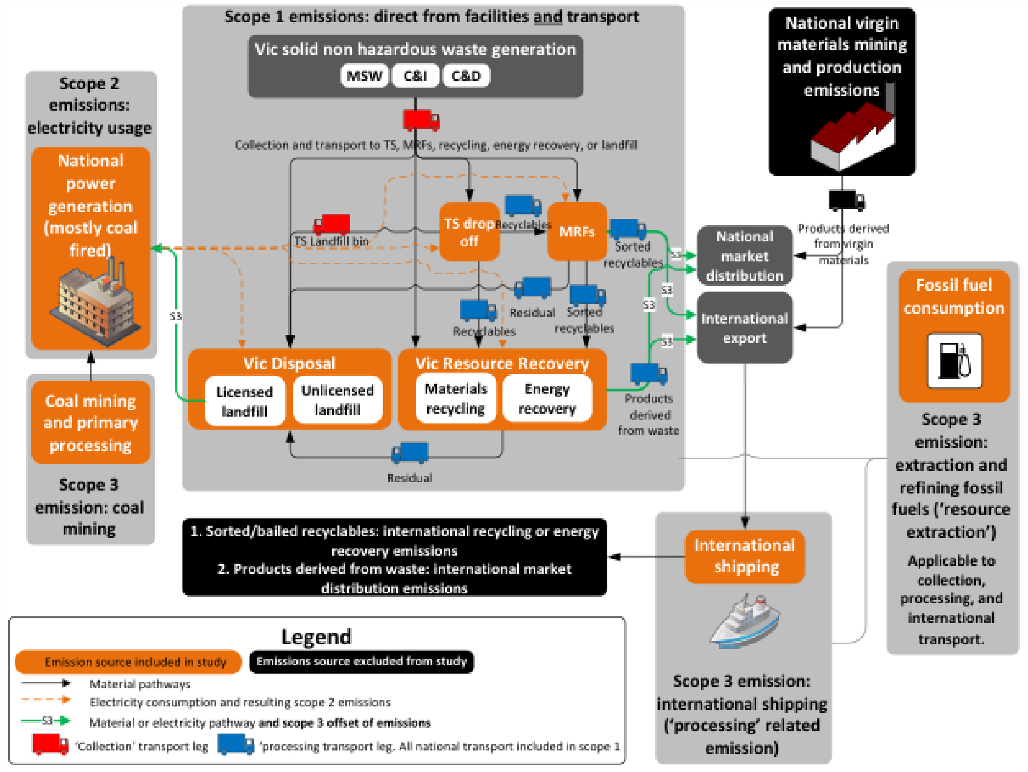

* 1. GHG waste sector model transport boundary

Tables 2 and 3 (below) pertain to the study boundary of the transport modelling component.

TABLE 2: Boundary summary of waste sources for transport inclusions

|  |  |  |  |  |  |  |  |  |
| --- | --- | --- | --- | --- | --- | --- | --- | --- |
| Waste sources | MSW recycling | C&I recycling | C&D recycling | MSW organics | C&I organics | MSW landfill | C&I landfill | C&D landfill |
| Collections (filling the truck) | ✓ | ✓ | ✓ | ✓ | ✓ | ✓ | ✓ | ✓ |
| Drop off to transfer station | ✓ | ✓ | ✓ | ✓ | ✓ | ✓ | ✓ | NA |
| Delivery to MRF or landfill | ✓ | ✓ | NA | NA | NA | ✓ | ✓ | ✓ |

**TABLE 3: Boundary summary of separated materials for transport inclusions**

|  |  |  |  |  |  |  |  |  |  |
| --- | --- | --- | --- | --- | --- | --- | --- | --- | --- |
| **Separated material recycling** | Paper | Glass | Plastic | Steel | Aluminium | Rubber / tyres | C&D | Organics | Textiles |
| Subsequent delivery to processor or exporter | ✓ | ✓ | ✓ | ✓ | ✓ | ✓ | ✓ | ✓ | ✓ |
| Delivery to foreign port/ processor | S1&2 NA S3 ✓ | S1&2 NA S3 ✓ | S1&2 NA S3 ✓ | S1&2 NA S3 ✓ | S1&2 NA S3 ✓ | S1&2 NA S3 ✓ | NA | NA | S1&2 NA S3 ✓ |
| Delivery of product to market | ✓ | ✓ | ✓ | ✓ | ✓ | ✓ | ✓ | ✓ | ✓ |
| Delivery of residuals to disposal | ✓ | ✓ | ✓ | ✓ | ✓ | ✓ | ✓ | ✓ | ✓ |

* 1. Peer review

Enda Crossin of RMIT provided a detailed peer review of the GHG emissions modelling, which resulted in some amendments and general improvements.

1. Results – GHG emissions from Victoria’s waste and resource recovery sector in 2014-15

This section provides estimates of GHG emissions from the Victorian waste and resource recovery sector in 2014-15. The results are based on the tonnages of solid non-hazardous waste managed[4] in Victoria.

For some waste types (e.g. aluminium and paper/cardboard) the Victorian waste generation[5] tonnages are significantly higher than the tonnages processed in Victoria. The results presented in this section detail and discuss opportunities for the emissions from waste managed in Victoria.

The results in this section are presented by:

* aggregated total emissions from the waste infrastructure in 2014-15[6]
* detailed emissions from resource recovery and disposal (waste infrastructure emissions)
* detailed emissions from transport (transport emissions)
* the combined totals for the detailed emissions from infrastructure and transport.

Each set of charts is followed by a discussion. High level opportunities to reduce GHG emissions mostly follows the combined totals presentation in section 4.4.

## Gaps and ‘zero’ values in emission results

There are several instances where zero values are reported for emissions from waste infrastructure; discussed below.

For both e-waste and anaerobic digestion infrastructure, estimates of GHG emissions per tonne of waste received are included in the modelling. However, SV reported zero tonnage of recovery for waste types that are sent to these infrastructure types at the time of analysis, hence, emissions reported are zero. If updated recovery tonnages are inputted for these waste types, the modelling would provide estimated GHG emissions.

For both pyrolysis and textile waste infrastructure, no references were identified to derive estimates for infrastructure emissions (scope 1-3). SV reported zero tonnage processed by pyrolysis in 2014-15, so this gap is not significant currently. SV reported around 3000 tonnes of textile recovery in 2014-15. The emissions associated with the recovery of textiles in Victoria remains a gap, however, it is not significant in the context of the overall emissions profile.

For infrastructure types apart from pyrolysis, textile, e-waste, and anaerobic digestion, any apparent zero values will be due to the large scale required to present the data in the chart.

* 1. Total emissions from Victorian waste sector

Figure 2 (A, B and C) illustrates the total emissions from the Victorian waste and resource recovery sector in 2014-15, for both waste managed and waste generated in Victoria (tonnes CO2-e).

The most striking aspect of Figure 2 is the significant amount of export of wastes for processing (nationally and internationally). Aluminium was mostly recycled outside Victoria. Most paper and cardboard was also processed outside Victoria. For steel and plastic recycling about half occurred in Victoria.

Figure 2 (A, B and C) illustrates that the GHG emissions profile for waste managed in Victoria was significantly different to the GHG emissions profile for waste generated in Victoria. The most significant differences in the waste generation profile were:

* Much higher emissions from the processing of paper/cardboard and aluminium recycling
* much higher emission offsets from the recycling of aluminium, paper/cardboard and steel.

The following observations are made for waste managed in Victoria:

* Figure 2(A) illustrates that licenced landfills were the largest emitter of GHG emissions from the operation of the site and transport of wastes to sites. It is more than double the next highest emitter which is paper/cardboard infrastructure.
* Once electricity consumption is considered (scope 1 and 2) the largest emitter of GHG emissions was steel recycling infrastructure. Significant tonnages of steel are still recycled in Victoria, which explains the high result for steel recycling. As illustrated in Figure 3, aluminium and paper/cardboard have higher GHG emissions per tonne of recovery than steel. However, because most aluminium and paper/cardboard were sent interstate or overseas for processing lower emissions are reported.
* Figure 2(C) illustrates that once recycling offset are included (scope 1-3), steel infrastructure shifts from the largest emitter of GHG emissions to the largest GHG ‘sink’. This is not to say opportunities do not exist to improve steel recycling efficiency. Indeed, with commodity prices remaining at sustained lows, the steel recycling industry may be interested in reducing their operating costs by reducing electricity consumption and in turn, their GHG emissions.
* When considering scope 1-3 emissions:
  + licensed landfills are the largest GHG emitters
  + MRFs are the second largest emitters
  + paper/cardboard recycling infrastructure is the third most significant emitter.

FIGURE 2: Overall emissions profile (tonnes CO2-e) for waste managing in Victoria 2014-15 (A): SCOPE 1 (B): SCOPE 1&2 (C): SCOPE 1,2&3

**(A)**

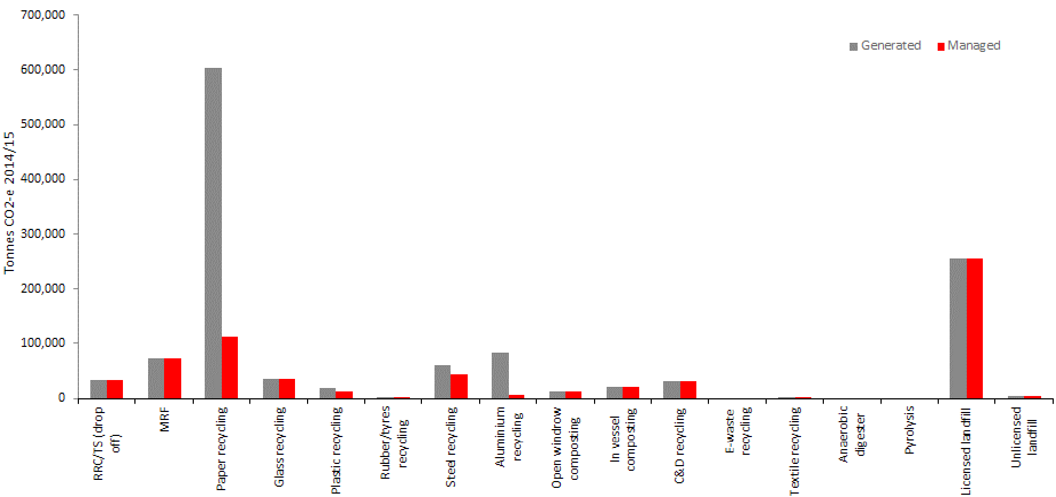

**(B)**

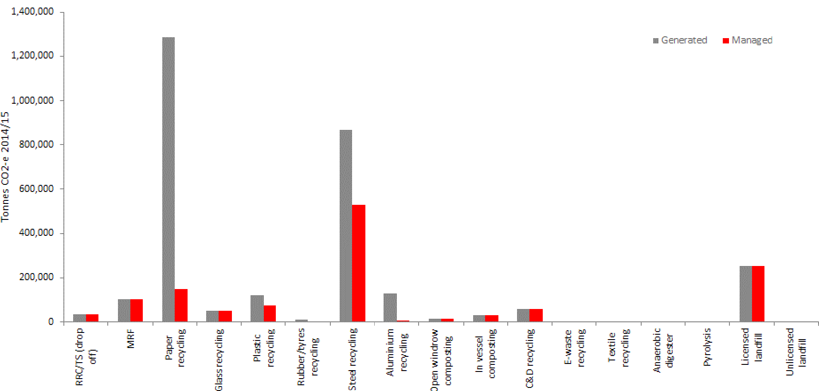

**(C)**

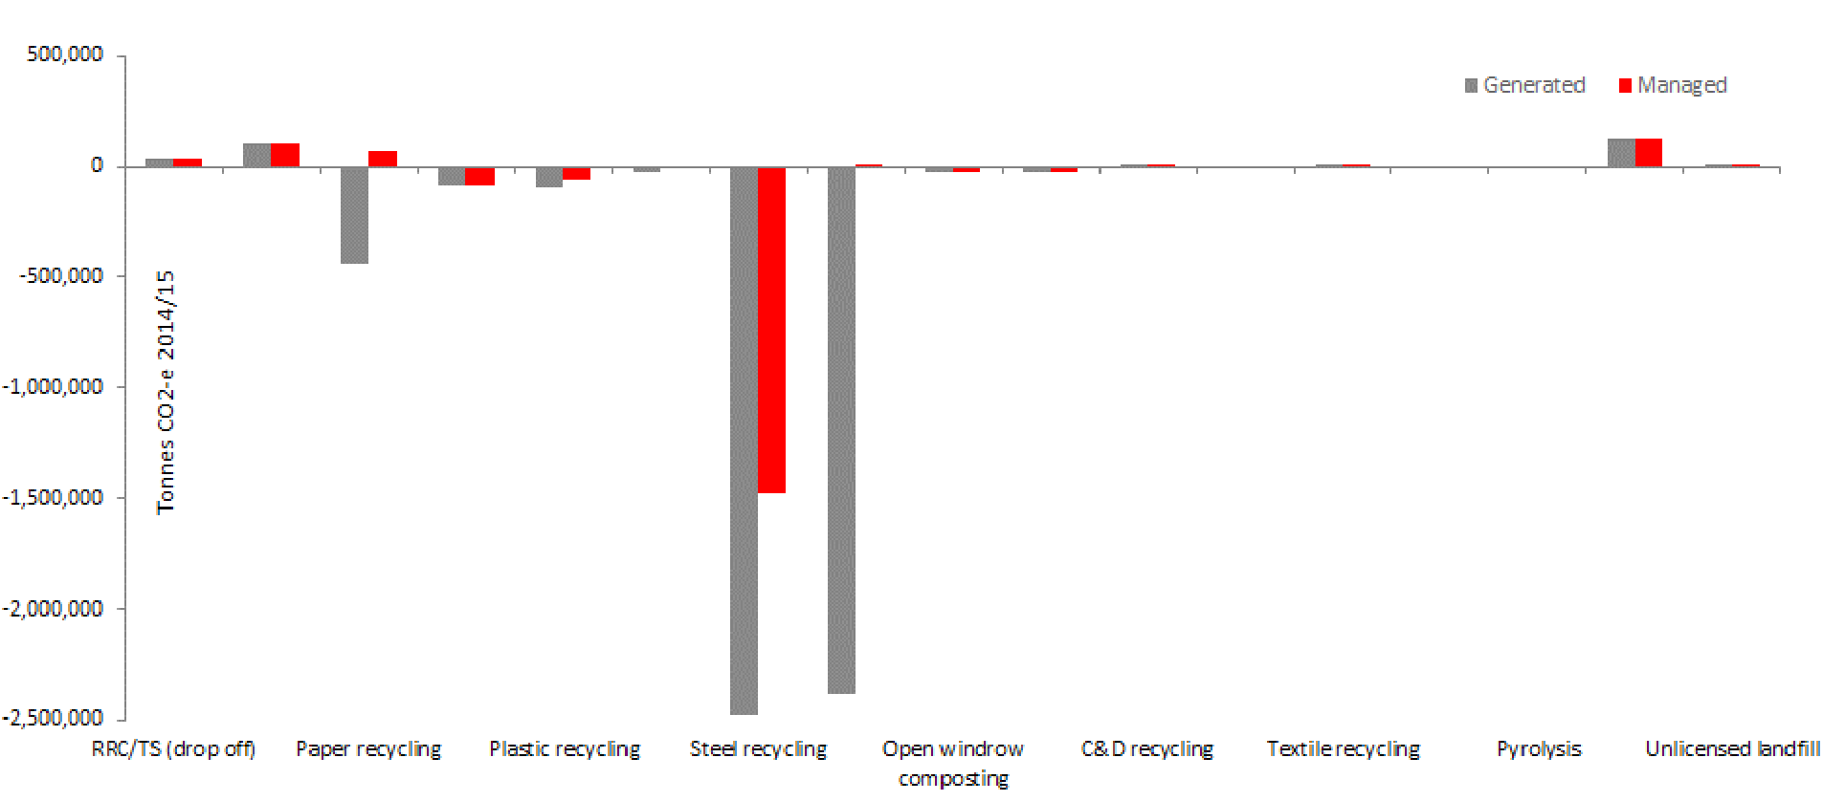

* 1. Resource recovery and disposal infrastructure emissions

The following details the GHG emissions from resource recovery processes (recycling and energy recovery) and disposal for Victoria in 2014-15.

This focuses on emissions from operating the infrastructure; hence, it excludes all transport data including national transport from scope 1 emissions data.

* + 1. Emissions from infrastructure per tonne of waste received (kg CO2-e / t)

Figure 3 details the GHG emissions for each infrastructure type for each tonne of waste received. The results include GHG emissions resulting directly from the operation of the facilities (scope 1 and 2 emissions).

Figure 3 illustrates that:

* Unlicensed landfills had the highest emissions per tonne of waste received, due to a general lack of gas recovery and combustion, resulting in high methane emission rates per tonne.
* Emissions from aluminium and paper/cardboard recycling were a both a close second. Aluminium recycling emissions were mostly associated with gas use onsite and some power consumption. Paper/cardboard recycling emissions were more evenly associated with power consumption and onsite emissions.
* Steel and plastic recycling emissions were dominated by emissions resulting from electricity consumption.

FIGURE 3: Emissions from infrastructure per tonne of waste received (kg CO2-e / t of waste)

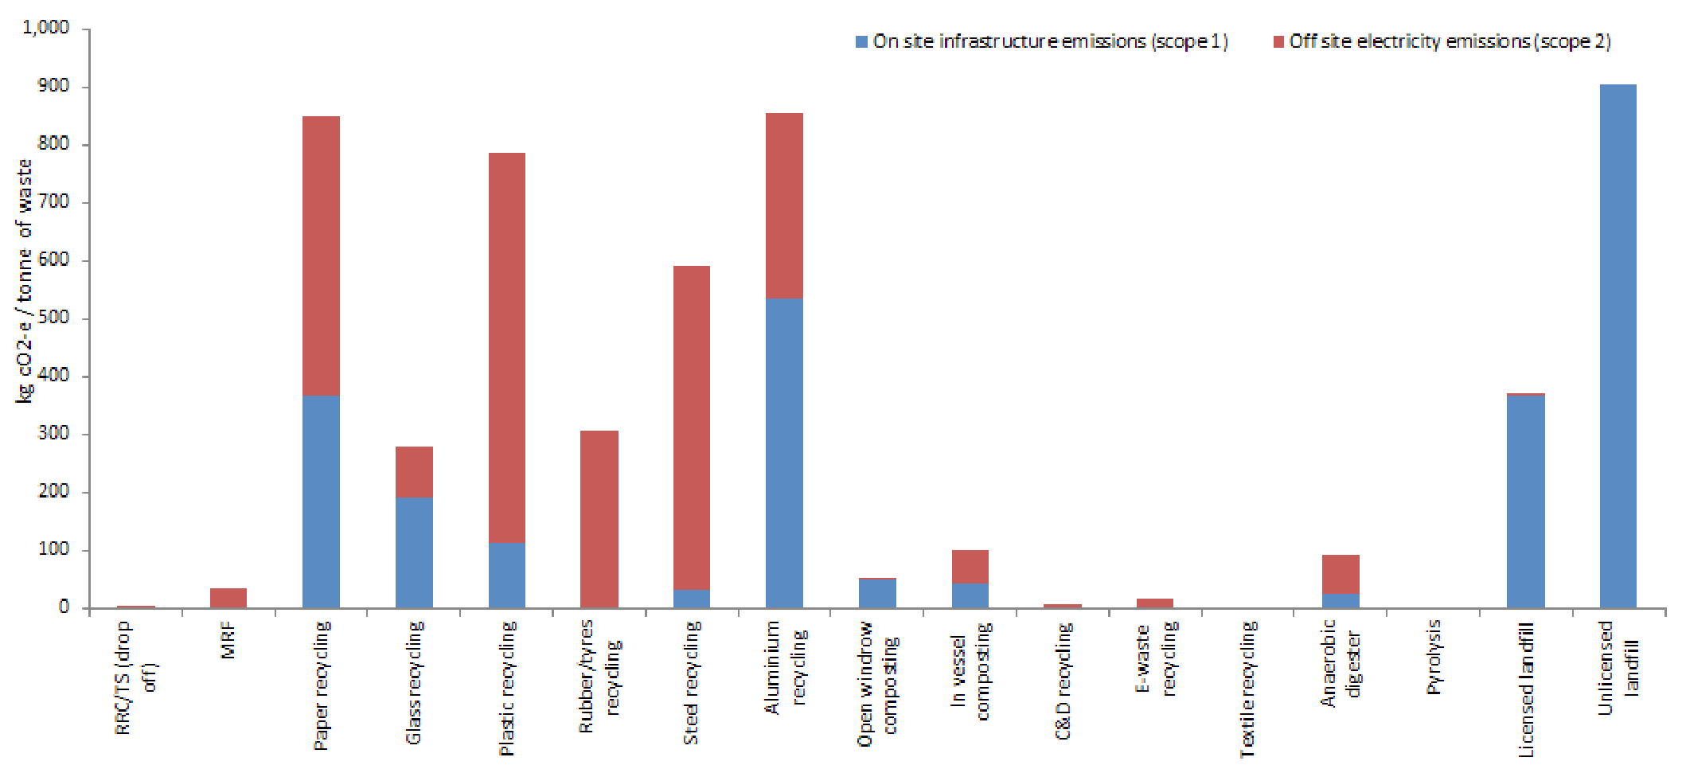

* + 1. Total scope 1 and 2 emissions from infrastructure (tonnes CO2-e)

Figure 4 details the total GHG emissions for each infrastructure type, for the total tonnages of waste received in 2014-15. The results include GHG emissions resulting directly from the resource recovery or disposal facilities (scope 1 emissions, including landfill gas emissions) and scope 2 emissions.

Figure 4 results have some similarities to Figure 2(B) which illustrates that the transport emissions (excluded from Figure 4) were not very significant for most of the infrastructure types (with the exceptions of RRCs, MRFs and paper/cardboard recycling).

The largest gross emitter of GHG emissions (from infrastructure operations) was steel recycling infrastructure, followed by licensed landfills, and then (with significantly lower emissions) paper/cardboard, plastic and glass recycling.

FIGURE 4: Total emissions from infrastructure in 2014-15 for waste managed in Victoria (tonnes CO2-e)

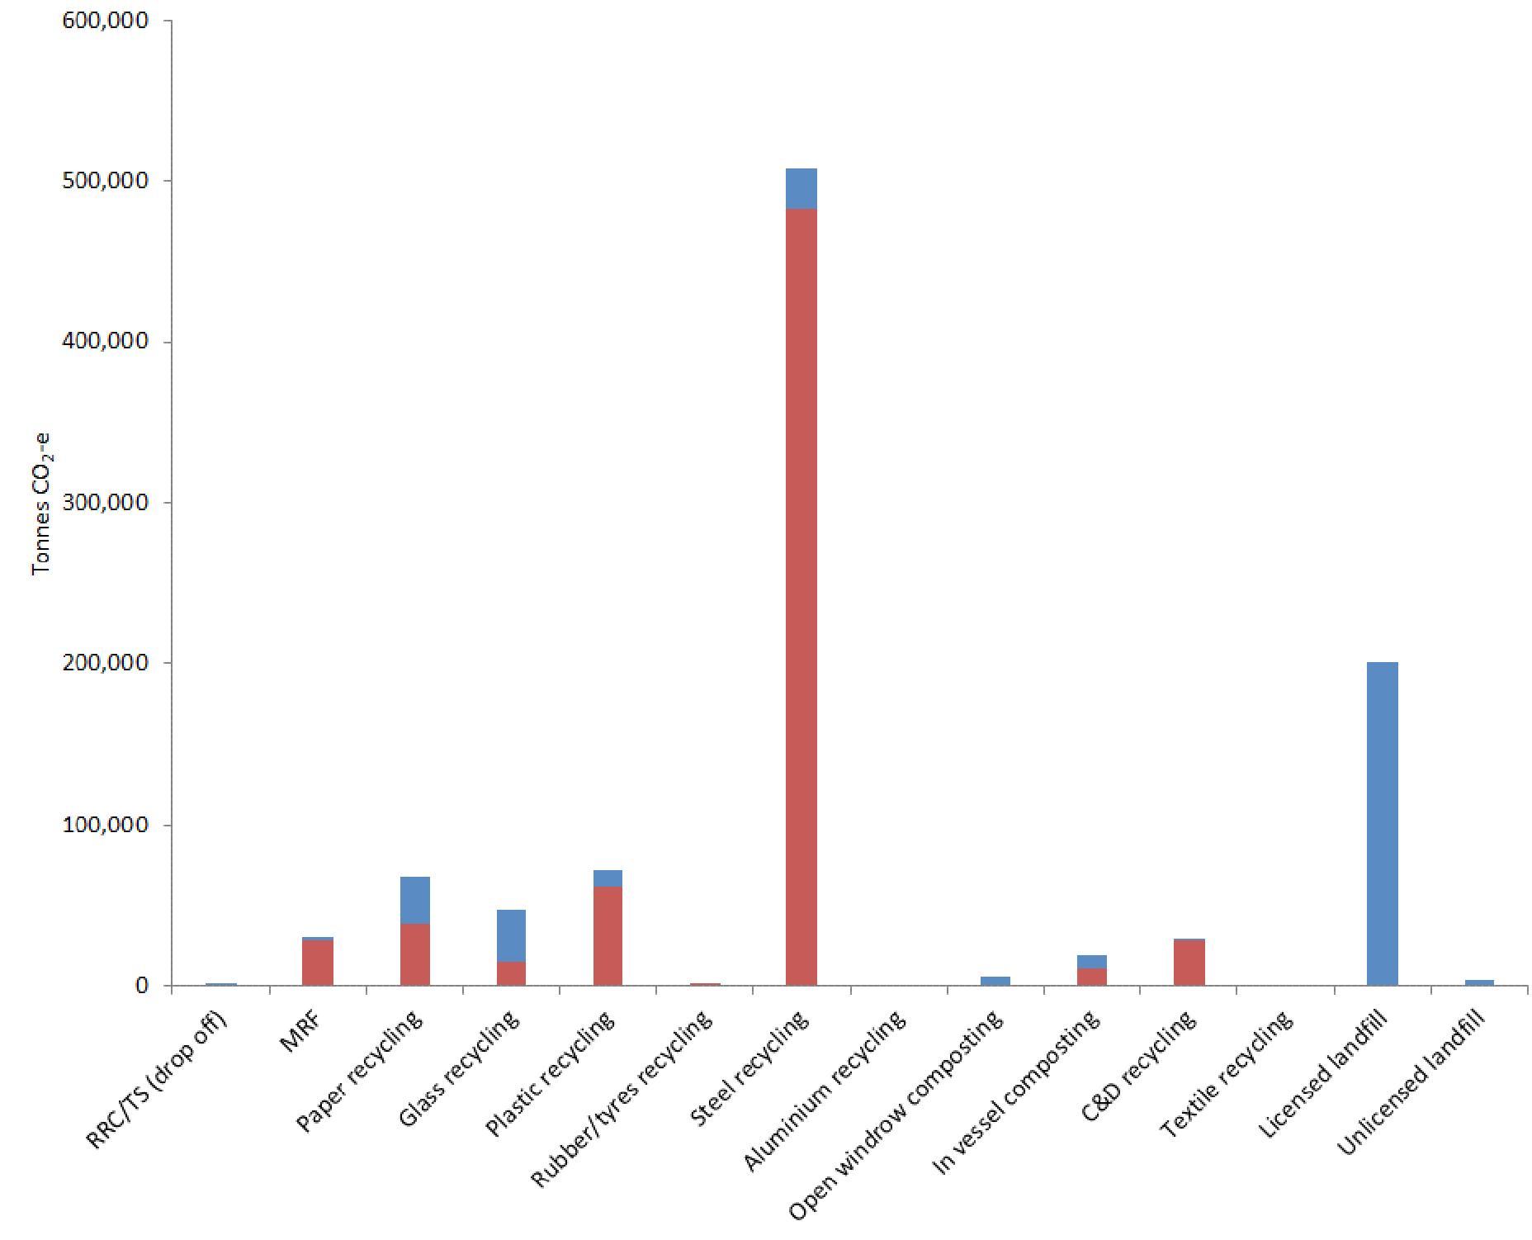

* + 1. Total emissions from infrastructure including scope 3 infrastructure emissions (tonnes CO2-e)

Figure 5 details the total GHG emissions for each infrastructure type, for the total tonnages of waste received at each infrastructure type in 2014-15 for scope 1 and 2 emissions. In addition, the results include scope 3 infrastructure emissions, taking into consideration substitution of recycled materials for virgin materials, substitution of energy from organic waste for fossil fuels, and sequestration of biogenic carbon in soils and landfills.

FIGURE 5: Total emissions from infrastructure 2014-15, including scope 3 infrastructure emissions, for waste managed in Victoria (tonnes CO2-e)

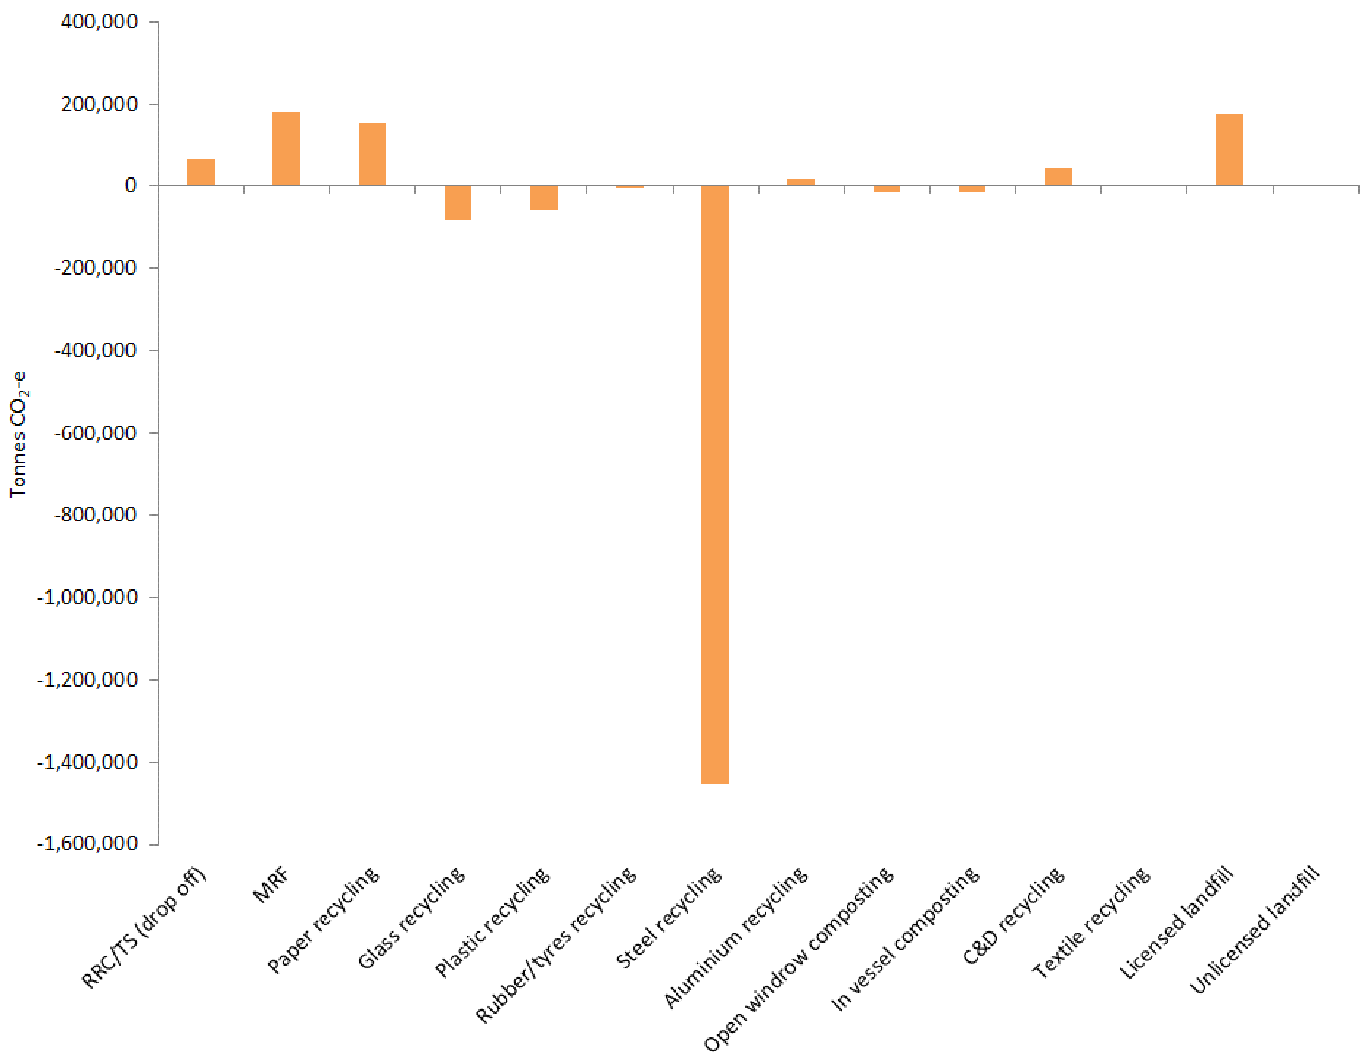

*Note: negative emissions refer to offsets or sequestration that result in less CO2-e in the atmosphere’*

The largest net emitters of GHG emissions (scope 1-3) from infrastructure operations in Victoria were licensed landfills and MRFs followed by paper/cardboard recycling.

* 1. Transport emissions from Victorian waste sector

The following details the emissions from the transport of waste in Victoria in 2014-15 and excludes all emissions from infrastructure operation.

The results include emissions from all national and international transport. The results also include transport emissions associated with the extraction and refining of fossil fuels used both in transport and during infrastructure operation.

* + 1. Emissions per tonne of waste transported (collection and processing) (kg CO2-e/t)

Figure 6 details the GHG emissions from transporting each tonne of waste. It includes transport emissions associated with the collection and processing of waste. Figure 7 illustrates the transport associated with collection and processing.

All transport emissions above have some scope 3 emissions from resource extraction for fuel refining. All collection transport scope 3 emissions result from resource extraction.

C&D waste collection for recycling accounted for by far the largest GHG emissions per tonne, followed by C&I organics collection. This suggests that there may be opportunities to improve the collection network efficiency for these materials.

For waste processing, transport emissions were dominated by emissions from paper/cardboard and aluminium. This correlates with the large tonnages sent interstate and overseas for processing, resulting in higher transport emissions per tonne of recycled waste.

Plastic and metals processing transport emissions result mainly from international shipping to overseas markets.

FIGURE 6: Emissions from transport per tonne of waste transported (kg CO2-e / t of waste)

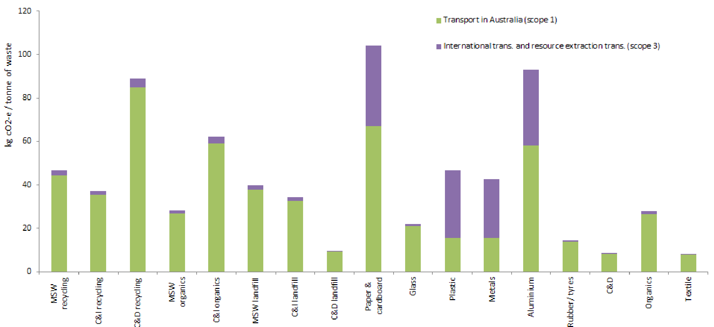

* + 1. Total emissions from transport (collection & processing) (tonnes CO2-e)

Figure 7 details the total GHG emissions for transporting waste in Victoria in 2014-15. It includes transport emissions associated with the collection and processing of waste.

The emissions from paper/cardboard transport to interstate recycling infrastructure dominated the transport emissions profile. Should this management option continue, efficiency opportunities could be investigated, such as improved consolidation of paper and cardboard before transport and improvements in bulk hauling.

FIGURE 7: Total emissions from transport of waste in 2014-15 (collection and processing) (tonnes CO2-e)

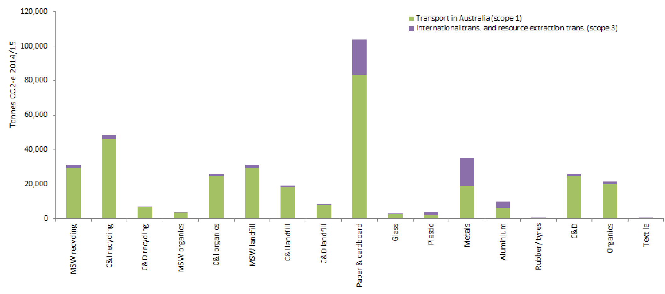

* + 1. Emissions from transport by infrastructure type (total and per tonne)

Figure 8 details the GHG emissions per tonne and in total for transporting waste in Victoria in 2014-15. The emissions are presented by the infrastructure type that receives the waste.

Considering transport emissions per tonne of waste:

* this was highest for RRCs as transport to RRCs is significant for most material types
* paper/cardboard and aluminium recycling emissions per tonne follow due to interstate transport (discussed previously)
* transport emissions per tonne for the remaining infrastructure types were reasonably consistent
* transport emissions associated with C&D recycling were notably low. The high per tonne emissions associated with collection of C&D waste (shown in Figure 6) were offset by the low transport emissions per tonne for processing (also shown in Figure 6) resulting in an overall low emission per tonne for C&D recycling.

Total transport emissions:

* were dominated by paper and cardboard, for reason noted earlier
* transport of waste to MRFs and licensed landfills resulted in the second highest emissions reflecting the large tonnages
* steel recycling and C&D recycling followed
  + C&D recycling transport emissions were from transport within Victoria
  + steel recycling emissions mostly related to international shipping.

FIGURE 8: Total and per tonne of emissions in 2014-15 from transport by infrastructure type

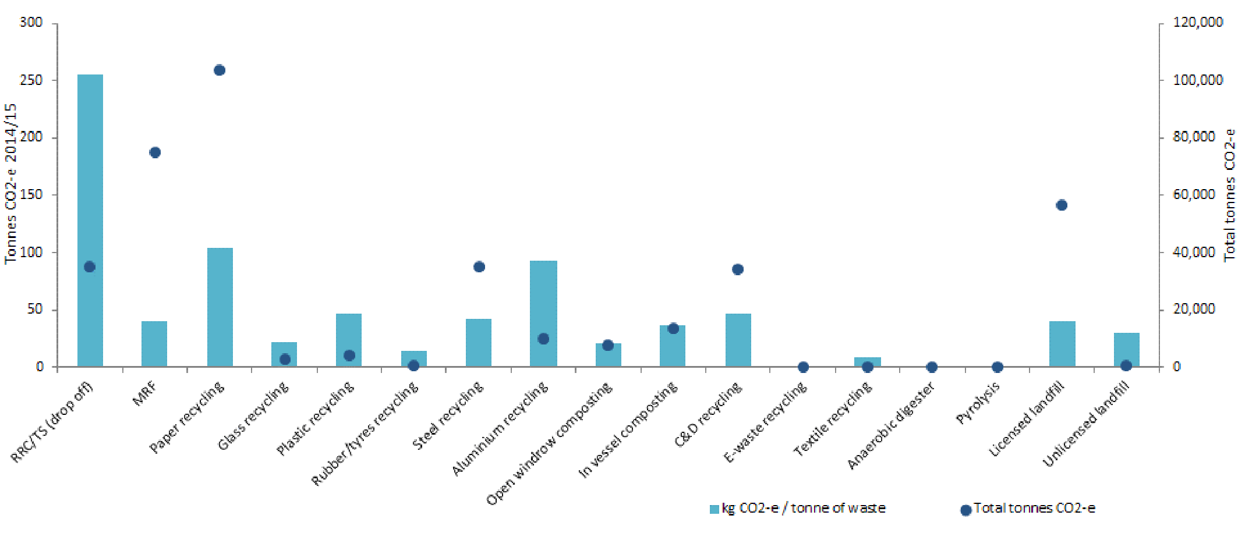

* 1. Combined infrastructure and transport emissions

This section details GHG emissions from both the operation of waste infrastructure and transport of waste in Victoria for 2014-15. Only section 4.4.2 includes scope 3 infrastructure emissions.

* + 1. Emissions from infrastructure (scope 1, 2) and transport (scope 1- 3)

Figure 9 details the GHG emissions profile for infrastructure types for each tonne of waste received and Figure 10 details the total GHG emissions for all infrastructure types, for the total tonnages of waste received at each infrastructure type in 2014-15.

For both figures the results include scope 1 and 2 emissions resulting from the operation of the facilities and all transport emissions (scope 1-3).

FIGURE 9: Emissions profile per tonne of waste from infrastructure and transport (kg CO2-e / t of waste)

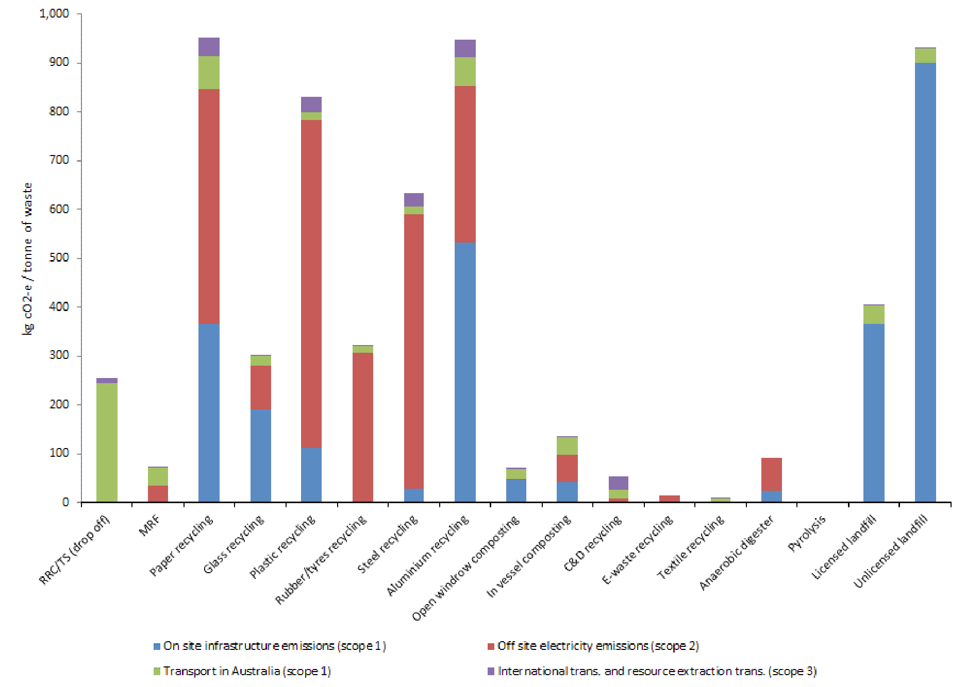

FIGURE 10 Total emissions from infrastructure and transport for waste managed in Victoria in 2014-15 (tonnes CO2-e)

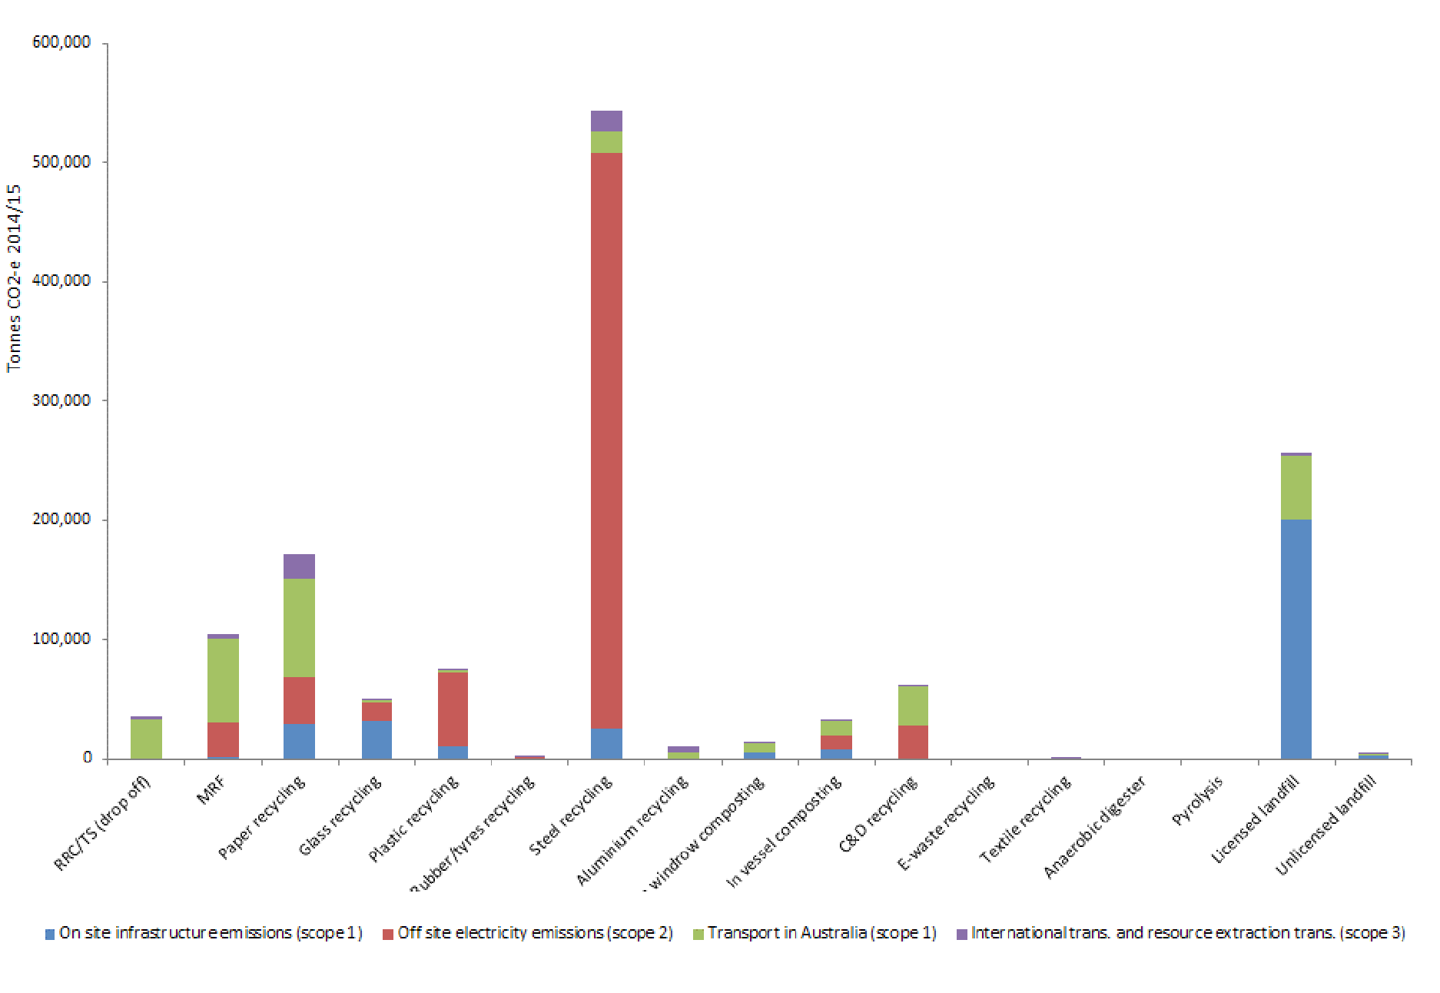

Figures 9 and 10 illustrate:

* Total GHG emissions resulting from electricity consumption during steel recycling was the largest gross contributor from the Victorian waste sector. These emissions could be significantly reduced using renewable energy sources.
* Licensed landfills were by far the largest gross emitter of total GHG emissions from site operations (from landfill gas). These emissions could be significantly reduced by improving landfill gas capture and energy recovery rates.
* Total GHG emissions from paper/cardboard transport become a more significant proportion of overall emissions for waste managed in Victoria due to the long transport distances required for processing interstate and overseas.
* Total GHG emissions resulting from electricity consumption during plastics recycling was a significant contributor to emissions from the Victorian waste sector. This could be significantly reduced using electricity from renewable or less emissions-intensive energy sources.
* If aluminium and paper/cardboard were processed in Victoria, rather than interstate or overseas, the Victorian waste sector GHG emissions (for infrastructure emissions scope 1 and 2) would be significantly higher
* Unlicensed landfill infrastructure GHG emissions per tonne were by far the highest; however, given the tonnages received, overall emissions were not significant.
* For all infrastructure types (apart from transfer stations and MRFs) transport emissions (scope 1-3) per tonne of waste received are only a small portion of the GHG emissions.
* The gross total GHG emissions from organics recycling via open windrow and in-vessel composting were minor in the context of the overall Victorian waste sector emissions.
  + 1. Emissions from infrastructure (scopes 1-3) and transport (scopes 1–3) emissions (tonnes CO2-e)

Figure 11 details the total GHG emissions for each infrastructure type for the total tonnages of waste received at each infrastructure type in 2014-15. The results include all emissions from infrastructure operation (scopes 1-3) and from waste transport (scopes 1-3). Figure 2 (C) also details scope 1-3 for both infrastructure and transport emissions. However, Figure 11 details each emission rather than the overall net emissions. Scope 3 facility emissions include emissions offsets substitution of recycled materials for virgin materials, substitution of energy from organic waste for fossil fuels, and sequestration of biogenic carbon in soils and landfills.

FIGURE 11: Total emissions from infrastructure (scope 1-3) and transport (scope 1-3) for waste managed in Victoria (2014-15), (tonnes CO2-e)

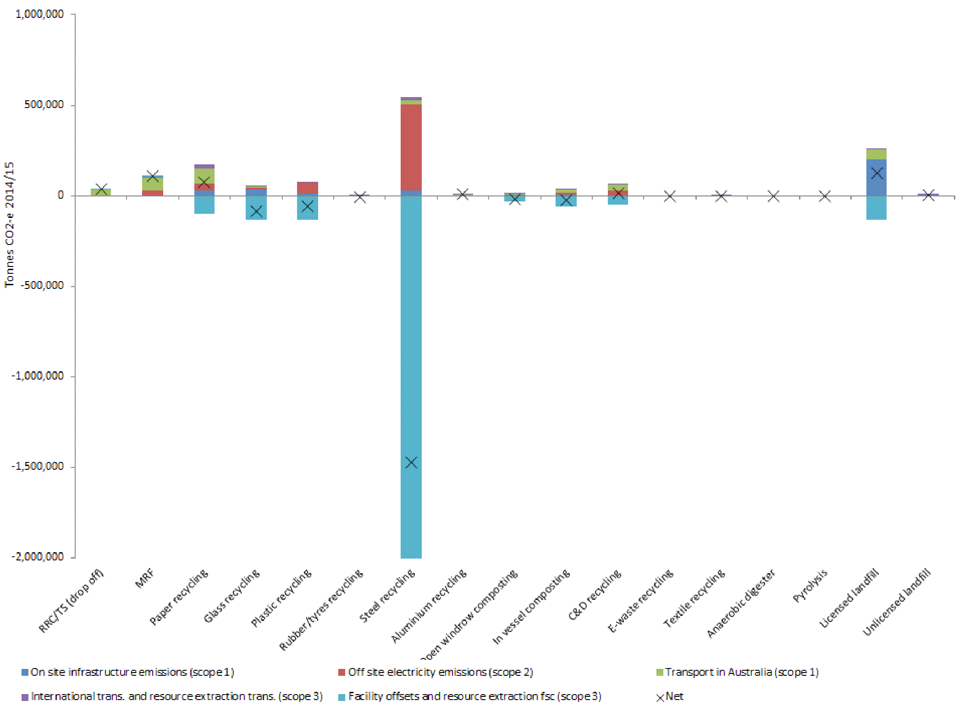

*Note: negative emissions refer to offsets or sequestration that result in less CO2-e in the atmosphere’*

Figure 11 illustrates:

* Steel recycling in Victoria was ‘carbon negative’ despite having the most significant scope 2 emissions from electricity consumption and the exporting of significant tonnages to international markets for processing.
* Glass recycling, plastic recycling, open windrow and in-vessel composting were carbon negative in Victoria.
* Licensed landfill emissions were only offset by about a third from electricity generation from landfill gas burning. Opportunities exist to improve landfill gas recovery and further offset landfill GHG emissions.
  1. Results sensitivity analysis

A sensitivity analysis assessed impacts to the emissions calculations as a result of modelling adjustments made to show how similar real world interventions might result in reductions in GHG emissions from the sector.

The following was adjusted:

* transport distances between different transportation points
* methane gas recovery rate from landfill.

Table 2 shows the changes that were made in the modelling and the resulting changes to the emissions results. The change associated with the model adjustment was assessed for:

* total tonnes CO2-e (see ‘Total change’ column)
* percentage change within the sub-sector (see ‘Sub sector’ column)
* the entire waste sector (see ‘% change waste sector’ column)
* against all GHG emissions from Victoria (see ‘Overall Victoria’ column).

Note, all sub-sectors are assessed on their scope 1-3 emissions except for organics processing where scope 1 and 2 emissions were assessed. This is because of the significant offsets (which are attributed to scope 3) achieved by organics processing. By excluding these offsets, we can examine the changes in emissions attributable to changes in the transportation distances for organics.

Table 2 (refer sensitivities 5 and 18, bolded) show that:

* Halving the transport distances to MRFs for MSW and C&I waste streams in metropolitan and regional areas would reduce emissions from the sector by about 4 per cent.
* Increasing the average methane gas recovery rate from the assumed 60 per cent to 75 per cent for all landfills would reduce GHG emissions by around 20 per cent.

TABLE 2” Victorian GHG waste sector model, results sensitivity analysis

|  |  |  |  |  |  |  |  |
| --- | --- | --- | --- | --- | --- | --- | --- |
|  | Sensitivity tested | Sector where change is realised | Scope applied | Total change (CO2-e) | Percentage change |  |  |
|  | Subsector | Change (waste sector) | Overall |
| 1 | Halving of distance to metro MRF from metro MSW collections | Resource Recovery | 1-3 | 2,591 | 0.2 | 0.2 | 0.002 |
| 2 | Halving of distance to metro MRF from metro MSW collections and metro C&I collections | 5,991 | 0.4 | 0.4 | 0.005 |
| 3 | Halving of distance to regional MRF from regional MSW collections | 7,739 | 0.6 | 0.6 | 0.007 |
| 4 | Halving of distance to regional MRF from regional MSW collections and regional C&I collections | 17,893 | 1.3 | 1.3 | 0.015 |
| ***5*** | ***Combination of 1 to 4*** | ***23,884*** | ***1.7*** | ***1.8*** | ***0.020*** |
| 6 | Halving of distance to metro C&D recycler from C&D collections | 6,014 | 0.4 | 0.4 | 0.005 |
| 7 | Halving of distance to metro MRF from metro RRC | 1,934 | 0.1 | 0.1 | 0.002 |
| 8 | Halving of distance to metro and regional MRF from metro and regional RRC | 7,408 | 0.5 | 0.5 | 0.006 |
| 9 | Halving of distance to Vic organics processor from average organics MSW organics collections | Organics | 1-2 | 3,303 | 7.3 | 0.3 | 0.003 |
| 10 | Halving of distance to Vic organics processor from average MSW, C&I, C&D organics collections and RRC (all) | 5,513 | 12.2 | 0.4 | 0.005 |
| 11 | Halving of distance to farm gate (organics market) from Vic organics processor | 4,542 | 10.1 | 0.3 | 0.004 |
| *12* | *Combination of 10 and 11* | *10,055* | *22.3* | *0.8* | *0.009* |
| 13 | Halving of distance to metro landfill from metro MSW collections | Landfill | 1-3 | 5,381 | 4.2 | 0.4 | 0.005 |
| 14 | Halving of distance to metro and regional landfill from metro and regional MSW collections | 10,442 | 8.2 | 0.8 | 0.009 |
| 15 | Halving of distance to metro landfill from metro RRC | 1,166 | 0.9 | 0.1 | 0.001 |
| 16 | Halving of distance to metro and regional landfill from metro and regional RRC | 2,205 | 1.7 | 0.2 | 0.002 |
| 17 | Reduction of methane gas recovery rate from landfill (by -15%) | 89,372 | 70.4 | 6.6 | 0.076 |
| **18** | **Increase of methane gas recovery rate from landfill (by +15%)** | **86,003** | **67.8** | **6.4** | **0.073** |
| *19* | *Combination of 8 and 16* | RR and Landfill | *1-3* | *9,613* | *0.8* | *0.7* | *0.008* |

* 1. Uncertainty of results

There are two points where the modelling is uncertain. The first point is in the scope 1, 2 and 3 estimates of CO2 emissions obtained from the National Greenhouse Accounts Factors (DoE 2015). This document provides emissions factors for different fuel types (for stationary and transportation purposes) and electricity consumption by end users, which are used in the model. Another document, the Technical Guideline for the Estimation of Greenhouse Gas Emissions by Facilities in Australia (DoE 2014), provides uncertainty estimates for the values found within DoE (2015) based on a 95 per cent confidence interval (that is, we can be 95 per cent confident that a value falls within the +/- percentage range around an estimate). These uncertainty values are applied in the modelling, however applying these values to the final summary outputs is problematic.

Rather than applying these values to the summary outputs, we estimate that the uncertainty for overall emissions associated with technology and transportation to be in the range of +/- 5 per cent. This is based on the individual uncertainty values provided for different fuel types and the emissions profile as presented in Figure 10.

It is important to note that there are other areas of the model where uncertainty may arise due to the accuracy (or lack thereof) of input data or assumptions applied in the model. Additional uncertainty may arise from the:

* accuracy of input tonnage and fate data supplied by SV for 2014-15
* accuracy of recycling source sector data obtained from the regional waste and resource recovery database for 2013-14 data
* electricity, diesel and gas consumption at different facility types
* split of tonnages between metropolitan and regional areas based on DELWP (2015) household data
* estimated split of organics tonnages to different processing technologies based on Blue Environment industry knowledge
* split of the ‘Organics other’ category of data, based on discussions between SV and the project team
* assumptions around the collection origin of materials (truck collections versus RRC drop-offs)
* estimated proportions for materials processed in Victoria, interstate or overseas
* assumed average transport distances used between different from and to points for waste transport
* assumed percentage of full waste transport vehicles and the current back haul rates applied to each leg of the transport model. While additional uncertainty may result from the above, the information required to reduce this uncertainty is not available.

Despite these uncertainties, the background data referenced in the model provides a reasonable estimate of the GHG emissions from the waste sector in Victoria. RMIT peer review also noted that the modelling had used a current and complete set of references.

1. Key opportunities and potential interventions to reduce GHG emissions

The industries with the highest estimated emissions associated with scope 1 and 2 emissions identified from Figure 12 are steel recycling, licensed landfill, plastic recycling and paper/cardboard recycling.

FIGURE 12: Total scope 1 and 2 GHG emissions from industries managing waste in Victoria

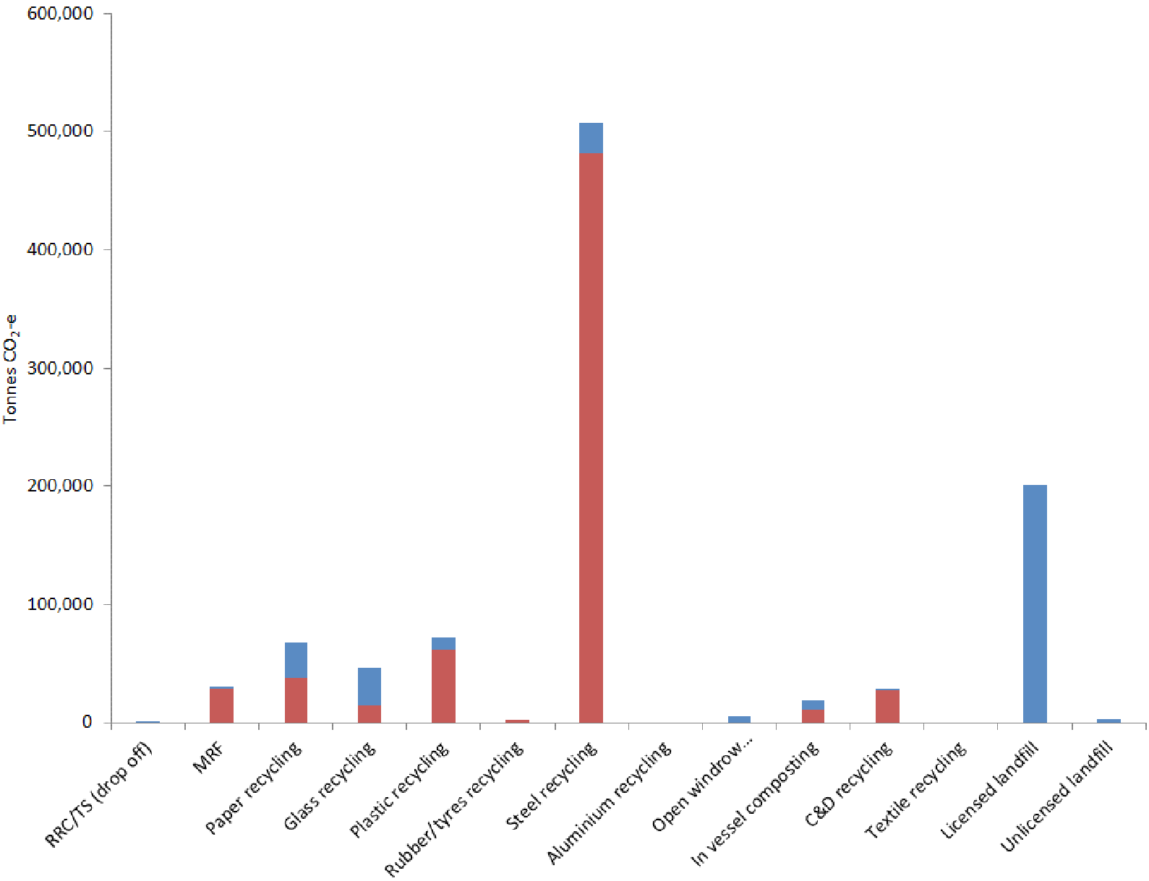

The estimated emissions from these industries, in kg CO2-e per tonne of waste and overall emissions in tonnes CO2-e, are presented in Table 3 along with the total tonnes of waste material managed in each industry.

TABLE 3: Per tonne and overall scope 1 and 2 GHG emissions form industries managing waste in Victoria

|  |  |  |  |  |  |  |
| --- | --- | --- | --- | --- | --- | --- |
| Industry | GHG Emissions / t (t CO2-e/t) | | Tonnes managed | Overall GHG emissions (t CO2-e) | | |
| Scope 1 | Scope 2 | Scope 1 | Scope 2 | Scope 3 |
| Steel recycling | 30.0 | 560.6 | 859,752 | 25,779 | 481,942 | 507,721 |
| Licensed landfill | 364.1 | 0.1 | 3,466,400 | 200,820 | 34 | 200,853 |
| Plastic recycling | 113.0 | 672.0 | 91,900 | 10,385 | 61,783 | 72,167 |
| Paper recycling | 367.1 | 481.0 | 80,000 | 29,369 | 38,481 | 67,850 |

For recycling industries, most GHG emissions are generated because of electricity demand for operation of plant equipment (i.e. scope 2). The following outlines examples of common and best practice opportunities to reduce GHG emissions from recycling (of steel, plastic, and paper/cardboard) and from licensed landfill infrastructure.

Emissions from landfills arise almost entirely from scope 1 which includes emissions associated with the decomposition of waste in landfill and fuel for machinery used for processing waste during landfilling.

* 1. Steel recycling
     1. Steel recycling sites in Victoria

The Victorian steel recycling industry is detailed in the SWRRIP. There are three operating steel recycling sites, all located in Melbourne:

* Norstar Steel
* OneSteel (in 2019 owned by GFG Alliance and operating as Liberty One Steel)
* Sims Metal.

Of these sites, in 2016, only OneSteel processes scrap steel using an Electric Arc Furnace (EAF) to generate new products for sale[7]. Norstar and Sims are understood to send all steel for processing offsite (either nationally or to export).

* + 1. Steel recycling processes

The most common method of recycling steel is using an Electric Arc Furnace (EAF) as opposed to a Blast Furnace (BF) or Basic Oxygen Furnace (BOF), which is predominantly used for the processing of virgin materials (IIP 2016a). According to Worrell et al (2010), in an EAF scrap steel is melted via electric arcs created between a cathode and one (for direct current) or three (for alternating current) anodes. The electrodes are made of carbon and are consumed in the reprocessing operation. Up to 50 per cent of the energy inputs to the process are in the form of electrical energy (Kirschen et al 2010). Efficiencies in heat loss, electrical loss, slag composition/generation and furnace turn-around time have been proven to reduce the amount of electrical energy required.

Once the EAF process is completed the liquid steel is tapped into ladles and secondary processes can be performed, for example, rolling into sheets. The key difference between EAF and BF technologies is the type of raw materials they consume (World Steel Association, 2012). For BF/BOF the inputs are iron ore and coal while EAF uses electricity as its main non-material input. In Worrell et al (2008) it was estimated that the overall energy intensity of BF/BOF is 14.8 GJ/tonne of steel compared with 2.6 GJ/t of steel for EAF. This large difference in energy intensity to produce virgin steel versus recycled steel is evident in the significant emissions offsets, which are part of scope 3 reporting (as detailed previously).

* + 1. Steel recycling scope 1 and 2 emissions

Figure 13 shows the source of GHG emissions from the facility types which handle steel materials and the split between scope 1 and 2 emissions. Scope 1 and 2 emissions from steel recycling infrastructure were estimated at 508,000 tCO2-e (or approximately 591 kg CO2-e/t of recovered material). Other emissions associated with steel recycling total 1,800 tCO2-e, mostly from materials recovery facility (MRF) operations.

FIGURE 13: Total scope 1 and 2 GHG emissions for waste managed in Victoria’s Steel recycling industry

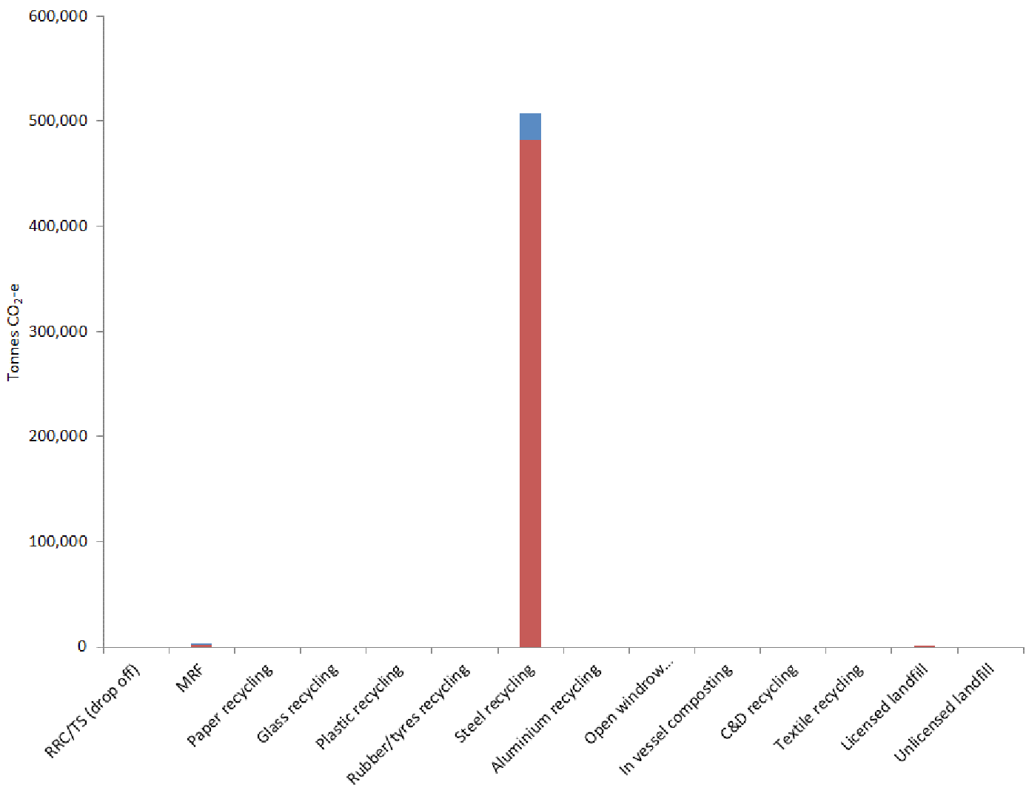

Most GHGs arise from the actual reprocessing of material and fall under scope 2 (off-site emissions from electricity production). This reflects Victoria’s current dependence on brown coal for electricity generation. While steel recycling and the EAF process is proven to be more energy efficient than virgin steel production, significant opportunities remain to reduce emissions by powering steel recycling with renewable electricity sources or less GHG-intensive generation than electricity generated from burning brown coal.

* + 1. Best practice emissions reduction

The World Steel Association (2016) outlines two components of the EAF industry where potential improvements in energy efficiency can be achieved. These are summarised as the transfer of best practice technology (development, sharing and implementation between different companies and plants) and the optimisation of operations and controls.

### Technology transfer

Improvements in technology used throughout the EAF process can greatly reduce electricity consumption. IIP (2016b) provides a list of 33 technologies which have been demonstrated to provide energy savings or reductions in GHG emissions. In 2010 the Asia Pacific Partnership for Clean Development and Climate released The State-of-the-Art Clean Technologies (SOACT) for Steelmaking Handbook and provided a comprehensive assessment of technologies used in steel making (from virgin or recycled materials) which can help reduce energy consumption and emissions. In both examples, the technologies are developed by steel mills throughout the world and show the types of savings achievable through technology updates. It also shows that transferring proven technologies is an important industry trend. Opportunities to transfer technologies greatly depend on the type and age of current equipment and the EAF mill in Victoria.

### Optimisation of operations and controls

The optimisation of operations and controls can be implemented across all areas of EAF steelmaking. A study presented on World Steel Association (2010b) reports that Tata Steel Europe reduced their energy use (and therefore their CO2-e emissions) through optimisation of plant equipment. The review and rationalisation of process equipment included examining equipment to establish the energy base load for cooling fans, motors and dust extraction and then looking at systems to reduce the base load. The program resulted in a 2.5 per cent reduction in energy use in one of the company’s mills. Further examples of control improvements have achieved reductions of up to 14 per cent for electricity and 6 per cent for natural gas consumption (IIP 2016b).

* + 1. Current best practice in Victoria

In 2008, OneSteel, and the University of New South Wales (UNSW), developed and installed best practice technology at their Laverton (Vic) and Rooty Hill (NSW) EAF steel processing mills. The technology replaced an input to the EAF process with a recyclable material which reduces waste and improves the energy efficiency of the process (OneSteel 2016a).

In the traditional EAF process, coke or anthracite is injected to produce a foaming slag that acts as a blanket over molten steel during steelmaking, helping to insulate the material and reduce heat loss (World steel association 2010a). Technology developed by OneSteel and UNSW – called Polymer Injection Technology (PIT) – uses recycled polymers (particularly old car tyres and high-density polyethylene plastic) as alternative carbon injectants to produce the foaming slag required in EAF steelmaking, resulting in a more efficient and improved foaming slag requiring a smaller quantity of injectant. This reduces energy consumption by cutting heat losses from the molten steel, and improves productivity by compressing the power-on time. It was estimated that electrical energy consumption was reduced by up to 3 per cent in two separate EAF mills (OneSteel 2016a). As of November 2016, OneSteel (2016b) estimates that it uses the equivalent of between 20,000 and 40,000 tyres per month in the PIT process at its facilities in Laverton and Rooty Hill. According to OneSteel, since installing the technology at their plants, steelmakers in Thailand, South Korea, the United Kingdom and Norway have licensed the technology for use in their own EAF mills (OneSteel 2016b).

* 1. Plastics recycling
     1. Plastics recycling sites in Victoria

The Victorian plastics recycling industry is detailed in the SWRRIP, which states: “*Victoria is home to about half of Australia’s plastics reprocessors and recycles a significant proportion of Australia’s recovered plastics. The Plastics and Chemical Industries Association (PACIA) identified 37 plastic reprocessors in Victoria, 35 of which are in metropolitan Melbourne, making it the major reprocessing hub for plastics in Victoria*” (SV, 2015, page 87). The SWRRIP (2018) recorded 24 reprocessing facilities in Victoria and estimates that 65 per cent of recovered plastic was exported for processing.

When compared to the steel recycling industry in Victoria, the plastics industry is more diverse and made up of a range of different sized businesses with varied focus areas and products.

* + 1. Plastics recycling processes

The process for the recycling plastics can involve sorting, screening, shredding, compacting, washing, drying, melting, reforming and granulation. The exact processes used and the requirements for energy, fuel, water and other inputs at each stage of the process depend greatly on the type of plastic (PET, HDPE, etc.) and quality of material being recycled (Jansen 2012). Experiments in the energy mass balance field have shown the variations in consumption of energy by material type and recycling process, namely:

* Jansen (2012) measured the energy consumption at each stage of the recycling process for HDPE, the main consumers of energy were found to be the shredder, washer and dryer (the experimental process did not contain a melting phase). It was noted that in the processes examined approximately 90 per cent of energy used is converted to heat.
* ImpEE (2006) estimated the total energy required to recycle a single PET bottle into pellet form. The project estimated the energy requirements of transport, washing, shredding and melting. Based on the estimates of activities undertaken at the recycling plant level, melting consumed 64 per cent of total energy requirements. However, some processes that would be expected to be undertaken were not included in the assessment.
  + 1. Plastics recycling scope 1 and 2 emissions

Figure 14 shows the source of GHG emissions from the facility types which handled plastics and the split between scope 1 and scope 2 emissions. The emissions from plastic recycling infrastructure in Victoria in 2014-15 were estimated at 72,000 tCO2 (or approximately 785kg CO2-e/t of material). Other emissions associated with plastic total 900 tCO2-e from MRFs and less than five tCO2-e for landfill disposal.

FIGURE 14: Total scope 1 and 2 emissions for waste managed in Victoria’s plastics recycling industry

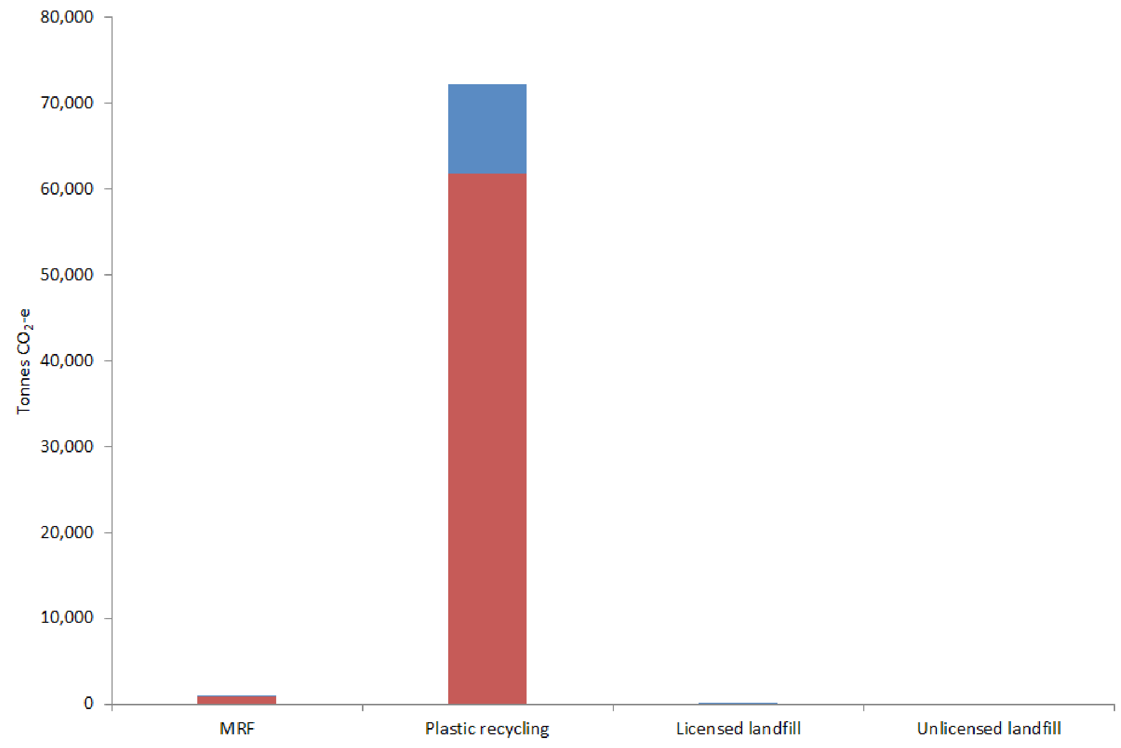

Most emissions associated with the recycling of plastic arise from the actual reprocessing of material and fall under scope 2. This illustrates that the processes used in plastic recycling in Victoria are heavily dependent on electricity consumption, which in Victoria generates significant amounts of GHG emissions through the burning of brown coal.

* + 1. Best practice emissions reduction

Due to the large range of plastics and processing techniques for plastics reprocessing, standardised best practice methods for reducing energy consumption are difficult to source. Much of the advertised improvements for improving efficiency in the recycling of plastic are because of material efficiency in product formation or using composite products, which reduce the amount of plastics used in manufacturing. These material efficiencies can have the impact of reducing requirements on resource use (energy, waster, etc.) and transportation fuel use due to lighter materials and improved compaction during waste transportation. For example, in Japan and Colombia, Coca-Cola has developed a lightweight twistable bottle. This bottle in conjunction with consumer communication has helped to improve the density of materials during waste transport (Coca-Cola 2012).

* + 1. Opportunities for additional GHG reductions

The Australian Government Department of the Environment and Energy (2016a) maintains the Energy Efficiency Exchange (EEX), which was a joint initiative between Australian and state and territory governments to support energy management and energy efficiency strategies amongst industries in Australia. The EEX provides information on the opportunities available to manufacturers in the chemicals and plastics industry that could be applied to plastics recyclers. The types of opportunities outlined for increasing energy efficiency include optimisation and maintenance of existing equipment, improving heat and power recovery, implementation of process innovation and equipment upgrades and design of output products to enable energy efficiency (e.g. in transportation). While these activities are not specific to plastic recyclers they highlight important areas in industrial processes where energy efficiency savings can be achieved.

As an example of the opportunities in improving heat and power recovery, Arena et al (2003) found that the total energy required to produce one kilogram of recycled PET flakes ranged between 42 and 55 MJ. This range depended on whether the process wastes created during sorting and reprocessing were sent to energy recovery. The assessment suggests that an energy saving of approximately 23 per cent can be achieved if process waste is utilised in energy recovery in either an onsite process or a wider waste to energy solution.

The recovery of embodied energy (via waste to energy plant) from plastic recycling process residues in Victoria would offset some of the energy consumption (and associated emissions) from the operation of plastics recycling infrastructure.

* 1. Paper and cardboard recycling
     1. Paper/cardboard recycling sites in Victoria

Most of Victoria’s recycled paper and cardboard is processed in paper mills in Victoria and NSW, which process a mixture of virgin and recovered materials to produce various grades of paper and cardboard.

Two of Visy’s paper mills recycled most of Victoria’s recovered paper and cardboard in 2015: one in Coolaroo (Victoria) and a larger facility in Tumut regional NSW.

In 2013, Australian Paper upgraded its waste paper recycling plant at its paper mill in Maryvale in Victoria, providing an additional 80,000 tonnes of paper recycling capacity (Australian Paper 2016), around 6 per cent of Victorian waste stream tonnages.

International export is significant at around 40 per cent (Net Balance, 2012 p60).

* + 1. Paper/cardboard recycling process

The processes used in the recycling of paper and cardboard involve sorting, pulping, de-inking, screening, drying/pressing and rolling. The requirements at each stage of the process differ with the quality of the recovered input material and the required output product. In most circumstances, paper mills are designed to process a mix of virgin and recovered materials and so also have provisions for converting raw materials (wood) into pulp. This involves machines that prepare (stripping or chipping), mechanically or chemically pulp and bleach raw materials to create pulp, which is used similarly to pulp from recovered paper and cardboard from the waste stream.

The energy and thermal requirements for processing paper and cardboard differ depending on the desired quality of the output paper product. Australian Institute of Energy (2016) outlines that packaging paper requires 150 to 200 kWh/t of material processed while 100 per cent recycled office paper requires 400 to 500 kWh/t and 650 to 1,100 MJ/t in thermal energy (these output product types are at the low and high end of the range). Thermal energy is used in the process to heat water or produce steam and is generated from a combination of natural gas, onsite power generation, and off-site electricity.

The combined paper and cardboard manufacturing/recycling processes generate significant quantities of waste. The main types of waste recovered include fibre waste, degraded fibre waste, pine and eucalyptus wood fines and bark, and a liquid/sludge waste known as black liquor[8]. These mostly organic wastes from the combined paper and cardboard manufacturing /recycling processes generate additional GHG emissions during decomposition. However, since the 1930s, the paper industry has been able to significantly offset their need for energy from fossil fuels (reducing GHG emissions) by recovering energy from wastes generated during the pulping process in onsite recovery boilers. The black liquor waste stream is typically used for onsite power generation. The other waste streams such as degraded or contaminated fibre have historically been sent to landfill where they generate significant amounts of GHG emissions per tonne of material landfilled. However, recent innovations have reduced the tonnages of these waste to landfill (see discussion below).

* + 1. Paper/cardboard recycling scope 1 and 2 emissions

Figure 15 shows the source of GHG emissions between the facility types that handled paper and cardboard and the split between scope 1 and 2 emissions. The total GHG emissions from paper/cardboard reprocessing infrastructure were estimated at 68,000 tCO2 (or approximately 848 kg CO2-e/t of material). Other emissions associated with paper/cardboard total 26,100 tCO2 for MRFs and 55,200 tCO2 for landfill disposal.

*Note: the landfill disposal emissions included in Figure 15 result from emissions from paper and cardboard that is sent directly to landfill without reprocessing. Figure 15 does not include the GHG emissions associated with the landfilling of residues from the combined paper and cardboard manufacturing/recycling process. Residues from paper mills are often disposed of on-site and are not transported offsite for disposal.*

FIGURE 15: Total scope 1 and 2 GHG emissions for waste managed by Victoria’s paper and cardboard recycling industry

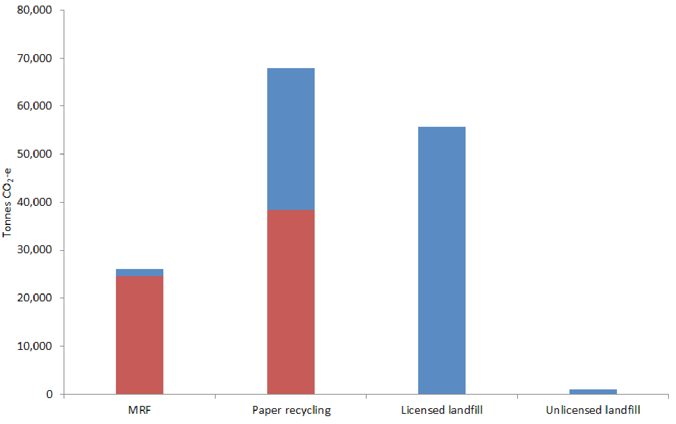

Most emissions associated with paper/cardboard recycling arise from the actual reprocessing of material and fall roughly equally into scope 1 and 2 emissions. This suggests that the processes used in paper recycling are equally dependent on fuels (e.g. diesel, gas) and electricity from offsite.

Also, apparent in Figure 15 are the emissions associated with the organic decomposition of unprocessed paper and cardboard in landfill which releases GHG emissions. These emissions are considered as a part of the emissions for licensed landfill, see section 5.4.

* + 1. Best practice emissions reduction

Examples of improvements to systems used in paper/cardboard recycling plants which have resulted in improved material efficiencies and reduced energy consumption are available from mills around the world. The Australian Government’s Department of the Environment and Energy (2016b), IIP (2016c), Kramer et al (2009) and the European Commission JRC Institute for Prospective Technological Studies (2015) provide several examples where improvements in technology have resulted in savings in requirements for electrical and heat energy. These include:

* a study by NCASI (2001) which suggests that replacing a vat batch pulper with a continuous drum pulper in de-inking operations can reduce energy consumption by 25 per cent
* a funded project by United States Department of Energy (2004), which demonstrated a reduction in boiler fuel consumption by 39,000 GJ/year as a result of the installation of a heat exchanger to recover heat from effluent streams and generate warm shower water for filtered water used in material reprocessing
* a secondary separation pulping system installed at a plant in Japan (NEDO 2008) that reduced downstream contamination, improved daily throughput and reduced yearly energy requirements by 146,800 kWh
* an incineration plant installed at a German mill which used rejected material as its main feedstock (European Commission JRC Institute for Prospective Technological Studies, 2015). The mill, which had a yearly production of 370 kt, reduced its energy consumption by 66,000 MWh
* a heat recovery system replaced dryers with stationary siphons and recovered steam at the paper drying process stage in a mill in America. The investment achieved energy savings of 0.89 GJ/t from improved drying efficiencies (Kramer et al 2009).

Further examples of energy efficiency savings can be found in the references listed above.

* + 1. Best practice in Victoria

In 2011, Visy Recycling completed the installation of co-generation infrastructure at their Coolaroo mill to generate electricity and heat from process waste materials. The $50 million plant was built with the help of a $2 million grant from SV.

At the time, Visy estimated that the plant would produce 30MW of thermal and 3MW electrical power. The fuel source is degraded paper fibres and a small percentage of plastic fragments generated on site as part of the recycling process. Visy estimated that the plant would divert 100,000 tonnes of waste from landfill each year, saving the company several million dollars in landfill costs. Visy estimated the plant would reduce the mill’s reliance on natural gas for thermal energy by about 50 per cent and the sites reliance on grid electricity by 10 per cent[9].

The Coolaroo co-generation processes were developed to increase investment in cleaner energy solutions (compared with coal fired power generation). The outputs of the systems help to reduce the amount of energy required from off-site electricity generation and reduce outputs to landfill.

Since 2011, the performance of the co-generation plant at Coolaroo has been subject to a legal battle between Visy and the engineering company RCRT. The actual performance of the Coolaroo plant since installation is unknown.

Australian Paper (2013) provides an account of energy use and GHG emissions from the Maryvale mill. In 2013, Maryvale produced 670,000 tonnes of black liquor which was used to generate some 8,300 GJ of energy providing a major offset to the mill’s fossil fuel energy demands and resulting GHG emissions.

Figure 16 includes the trends in sources of energy used by Australian Paper from 2009-13. The chart illustrates an increase in the amount of energy generated onsite from renewable energy and a decline in the energy used per tonne of paper and cardboard generated. ‘Direct’ energy refers to the use of natural gas and indirect refers to offsite electricity.

FIGURE 16: Australian Paper Maryvale site energy use trends

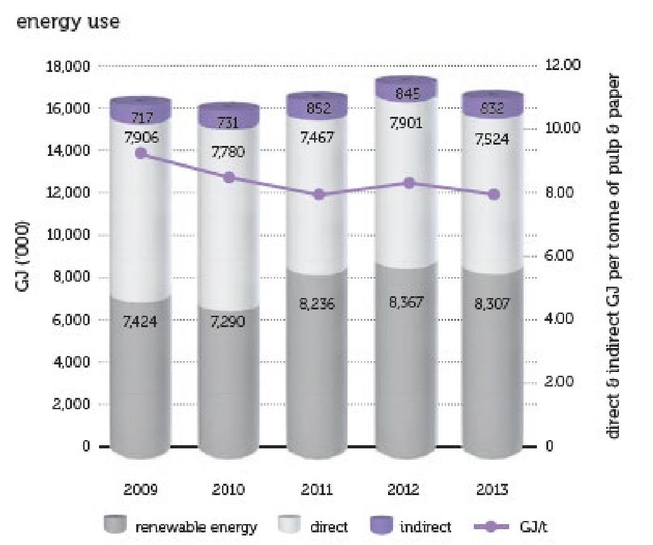

* + 1. Opportunities for additional GHG reductions

Australian Paper (2013) discusses the Maryvale mill’s ongoing program to reduce waste sent to landfill. Australian Paper reported that it had eliminated six waste streams previously sent to landfill. Australian Paper is licensed to compost some of its organic wastes onsite (up to 110,000 tonnes per year). However, the Maryvale site still operates a landfill onsite that is licensed to receive paper pulp. There may be opportunities to recover energy from paper pulp currently sent to landfill onsite at Maryvale and reduce GHG emissions. Any co-generation infrastructure used to recover energy and heat from the paper pulp should carefully consider any lessons from the Visy co-generation plant (which processes paper pulp historically sent to landfill).

* 1. Licenced landfills
     1. Landfill sites in Victoria

The total number of licensed landfills in Victoria is reducing as some sites reach capacity and the Victorian Government implements stronger strategic planning control over the development of new landfills. The SWRRIP (2018) states that there were 47 licensed landfills operating in Victoria at June 2016.

The EPA lists 75 closed landfills that are subject to post-closure pollution abatement notices, most of which accepted municipal waste during operation and are therefore likely to be producing GHG emissions.

* + 1. Landfill infrastructure GHG emissions

The microbial degradation of organic wastes in landfill produces landfill gas which is a potent GHG, made up of around 50 per cent methane and 50 per cent carbon dioxide. The methane component of landfill gas can be oxidised (burned) and converted to carbon dioxide and water. Methane has a global warming potential factor 25 times that of carbon dioxide over the standard 100-year assessment timeframe, so the oxidation of methane to carbon dioxide and water results in significant emission reductions.

The amount of landfill gas generated at a landfill site is closely related to the quantities of organic material landfilled at the site. Landfill gas is not generated instantly and typically the emissions from a landfill accepting organic wastes will increase during its operational life then gradually decline post closure, continuing for several decades (typically reducing significantly 30 years post closure).

Where landfill gas (and methane) volumes are sufficient, methane can be collected to drive power plants or as a substitute fuel. Where landfill gas volumes are insufficient to support energy recovery, there may still be sufficient methane to run a flare. While this does not allow for recovery of embodied energy, it still reduces methane emissions.

* + 1. Landfill scope 1 and 2 emissions

As shown in Figure 12 (p25), emissions for licenced landfills were the second largest emitter of scope 1 and 2 emissions in 2014-15. The landfill emissions arose almost entirely from scope 1 emissions associated with the decomposition of waste with a minor contribution from fuel for machinery during landfilling (compaction dozers).

* + 1. Best practice emissions reduction

In Victoria, best practice management of landfill gas is set out in EPA Victoria’s Best Practice Environmental Management Guideline – Siting, design, operation and rehabilitation of landfills (August 2015) (Landfill BPEM).

Best practice management of landfill gas depends on the amount of landfill gas generated. Table 4, from the Landfill BPEM, summarises best practice technology for differing landfill gas generation rates.

TABLE 4: EPA Landfill BPEM recommended landfill gas management technologies

|  |  |
| --- | --- |
| Landfill gas generation rate  (m3 / hr) | Potentially suitable landfill gas treatment technologies |
| >1000 | * Combined heat and power generation * Substitute fuel * Power generation * Intermittent use and off-time flaring * High temperature flaring |
| >250 to <1000 | * Power generation * Intermittent use and off-time flaring * High temperature flaring * Low-calorific flaring |
| >100 to <250 | * Power generation * High temperature flaring * Low-calorific flaring * Other oxidation and discharge  (e.g. passive flares, biofilters. Biocover) |
| <100 | * Other oxidation and discharge  (e.g. passive flares, biofilters. Biocover) |

* + 1. Other opportunities for GHG reductions

In Victoria, the installation of best practice landfill gas management infrastructure is well developed for large metropolitan landfills accepting putrescible waste, where landfill gas is combusted to generate electricity which is fed into the grid. The development of landfill gas energy recovery on large landfills has been driven by economic incentives from:

* sale of renewable energy certificates
* sale of electricity
* credits from the Emissions Reduction Fund and various predecessor programs.

The development of best practice landfill gas management infrastructure for medium and small municipal waste landfills in regional centres and rural areas is not well developed in Victoria. This presents a significant opportunity to reduce GHG emissions.

For landfills receiving less than 100,000 tonnes of putrescible waste per year, it is typically not viable to install landfill gas driven power generation infrastructure onsite because the gas volumes are insufficient. Where landfill gas driven power generation is not viable, EPA recommends flaring of the landfill gas to oxidise the methane.

### CASE STUDY: Micro-flares for medium-sized landfill gas treatment

There is no collated database on gas collection infrastructure at Victorian landfills; the following opportunity estimate is based on site knowledge and estimates.

Industry consultation suggests a lower annual tonnage limit of 10,000 tonnes per annum of MSW below which it is typically not viable to operate micro-flares. It is also important to note that it will take several years of landfilling for a new landfill to accumulate enough waste and begin generating a steady flow of landfill gas for flaring.

Nine current or recently closed municipal sites are known to typically receive (or to have received) more than 100,000 tonnes of waste per year. It is understood that all these larger landfill sites are connected to landfill gas power generation infrastructure. About 25 of the remaining 42 open municipal landfills receive more than 10,000 tonnes per year and, unless they are new, are likely to be able to capture and flare gas. Based on site knowledge, it is estimated that at least half of these medium-sized sites have no gas management equipment. Flares may also be feasible on some of the 75 closed landfills that currently do not collect gas.

The Commonwealth Department of the Environment and Energy reports national greenhouse gas inventory data on its Australian Greenhouse Emissions Information System (AGEIS), based mainly on data from sites reporting under the NGERs system. The AGEIS indicates that in 2013-14, Victoria recovered 2.77 Mt CO2-e in 2013-14, or 61 per cent of the methane generated in landfills.

If flaring equipment was installed at all medium-sized landfills (open or closed), we estimate that a further 180,000 t CO2-e could be recovered annually. This represents 4 per cent of landfill methane generated and is equivalent to the emissions of about 80,000 average cars.

It should be noted that Victoria is easily the best performing state in terms of landfill gas capture. Victoria’s 2013-14 data reported in the AGEIS equates to a 61 per cent recovery rate compared with 41 per cent in New South Wales, 32 per cent in Queensland and 26 per cent in South Australia.

### Example – Wangaratta landfill micro-flares: a cost-effective way to reduce GHG emissions

The Rural City of Wangaratta Council owns and operates a licensed landfill at Bowser, which has been operating since the early 1990s and is expected to be operational until at least 2023. It receives about 15,000 tonnes of putrescible M each year[10].

Council installed three micro-flares at the site to treat landfill gas. Figure 17 shows the micro-flare setup including (from right to left) the landfill gas extraction point with a solar-powered blower (to create a low level of suction), a solar-powered flow meter for data recording, connection to a condensation ‘knock out’ and flame arrestor and the flare. The landfill gas is ignited by a fail-safe solar/battery-powered ignition spark that continuously provides an ignition point. The photo also illustrates the securing of the flare system to the ground to ensure that the flare cannot tip over and start a fire[11].

To ensure optimal gas capture and delivery to the flare, Council installed a network of landfill gas collection pipes within the first layer of the landfill capping (not visible as beneath the capping surface) in a herringbone pattern.

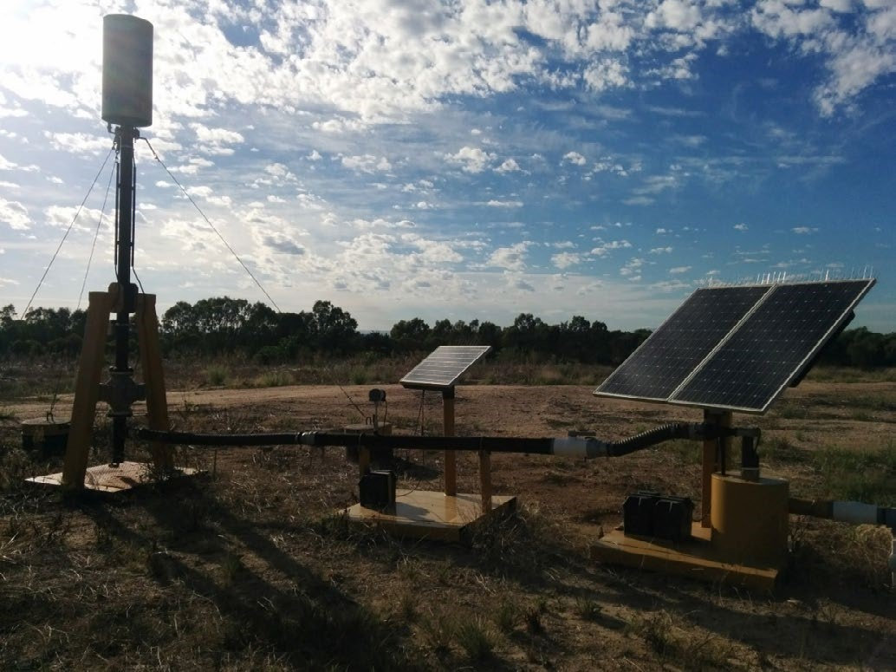FIGURE 17: Micro-flare installed at Wangaratta landfill

1. References

ABS (Australian Bureau of Statistics 2014), Catalogue number 9208.0: Survey of Motor Vehicle Use, Australia, 12 months ended 31 October 2014, available at <http://www.abs.gov.au/ausstats/abs@.nsf/mf/9208.0/>

ACOR (Australian Council of Recyclers Inc 2008), Australian Recycling Values – A net benefits assessment, 22 February

ADAS (2008) Energy Audit of the Kerbside Recycling Services – The London Borough of Camden

Alternative Fuels Data Center (2014) Alternative Fuels Data Center – Fuel Properties Comparison, available at [http://www.afdc.energy.gov/fuels/fuel_comparison_chart.pdfhttp://www.afdc.energy.gov/fuels/fuel_comparison_chart.pdf](http://www.afdc.energy.gov/fuels/fuel_comparison_chart.pdf)

Astrup T, Fruergaard T and Christensen TH (2009b) Recycling of plastic: accounting of greenhouse gases and global warming contributions, Waste Management and Research, vol 28 issue 8, November

Astrup T, Moller J and Fruergaard T (2009b) Incineration and co-combustion of waste: accounting of greenhouse gases and global warming contributions, Waste Management and Research, vol 28 issue 8, November

Australian Transport Council (2006) National guidelines for transport system management in Australia, available at: <http://transportinfrastructurecouncil.gov.au/publications/files/national_guidelines_volume_3.pdf>

Australian Trade (2016) Container sizes, available at [www.australiatrade.com.au/Shipping/ContainerSizeSales/](http://www.australiatrade.com.au/Shipping/ContainerSizeSales/)

Australian Government (2015) National Greenhouse and Energy Reporting (Measurement) Determination 2008, July 1 available at [https://gov.au/Details/F2015C00525/Html/Text#_ Toc423517144](https://gov.au/Details/F2015C00525/Html/Text%23_%20Toc423517144)

Australian Government (2016a) National Greenhouse Gas Inventory – Kyoto Protocol classifications, available at <http://ageis.climatechange.gov.au/>

Australian Government (2016b) Carbon Credits (Carbon Farming Initiative-Source Separated Organic Waste) Methodology Determination 2016, February 4, available at <https://www.legislation.gov.au/Details/F2016L00098>

Australian Institute of Energy (2016) Energy Value and Greenhouse Emission Factor of Selected Fuels, available at <http://www.aie.org.au/AIE/Energy_Info/Energy_Value.aspx>

Blue Environment (2011) Landfill prescribed distance rule analysis, prepared for the Department of the Environment, 19 September

Boldrin A, Andersen JK, Moller J, Favoino, E and Christensen TH (2009) Composting and compost utilization: accounting of greenhouse gases and global warming contributions, Waste Management and Research, vol 28 issue 8, November

Dadd MF (2007) Carbon footprint assessment using Life Cycle thinking of a Material Recycling Facility (MRF): NEWS’ MRF as a case study, University of East Anglia, August

Damgaard A, Larsen AW and Christensen TH (2009) Recycling of metals: accounting of greenhouse gases and global warming contributions, Waste Management and Research, vol 28 issue 8, November

Daugaard DE and Brown RC (2003) Enthalpy for Pyrolysis for Several Types of Biomass, Energy Fuels, vol 17 (4), pp 934-939

Department of the Environment (2014) Technical guideline for the estimation of greenhouse gas emissions by facilities in Australia: National Greenhouse and Energy Reporting (Measurement) Determination 2008, available at [http://www.environment.gov.au/ system/files/resources/da7bde5c-1be2-43f7-97d7-d7d85bb9ad6c/ files/nger-technical-guidelines2014.pdf1ad53e55dc39/files/nationalgreenhouse-accounts-factors-august-2015.pdf](http://www.environment.gov.au/%20system/files/resources/da7bde5c-1be2-43f7-97d7-d7d85bb9ad6c/%20files/nger-technical-guidelines2014.pdf1ad53e55dc39/files/nationalgreenhouse-accounts-factors-august-2015.pdf%20)

Department of the Environment (2015) National Greenhouse Accounts Factors Australian National Greenhouse Accounts, available at [http://www.environment.gov.au/system/files/ resources/3ef30d52-d447-4911-b85c-1ad53e55dc39/files/nationalgreenhouse-accounts-factors-august-2015.pdf](http://www.environment.gov.au/system/files/%20resources/3ef30d52-d447-4911-b85c-1ad53e55dc39/files/nationalgreenhouse-accounts-factors-august-2015.pdf%20)

Department of Water, Environment, Land and Planning (2015), Victoria in Future 2015, available at [http://www.dtpli.vic.gov.au/ data-and-research/population/census-2011/victoria-in-future-2015](http://www.dtpli.vic.gov.au/%20data-and-research/population/census-2011/victoria-in-future-2015%20)

EAA (2008) Environmental Profile Report for the European Aluminium Industry: Life Cycle Inventory data for aluminium production and transformation processes in Europe, ECBC (European Cetacean Bycatch Campaign 2001) Standard conversion factors, available at <http://www.eurocbc.org/Standard%20Conversion%20Factors%20dti_converfactors.pdf>

Eisted R, Larsen AW and Christensen TH (2009) Collection, transfer and transport of waste: accounting of greenhouse gases and global warming contribution, Waste Management and Research, vol 28 issue 8, November

Elgas (2016) LPG Conversions: Gas kg, Litres, MJ, kWh & m³, available from: <http://www.elgas.com.au/blog/389-lpg-conversions-kg-litresmj-kwh-and-m3>

Energetics (2012) Australian Steel Chain Footprint Project, prepared for Steel Stewardship Forum, May

Environment Protection Authority Victoria (2015), Best Practice Environmental Management Guideline – Siting, design, operation and rehabilitation of landfills

Franklin Associates (2011) Life Cycle Inventory of 100% postconsumer HDPE and PET recycled resin from postconsumer containers and packaging, January

Grant T (2007) Life Cycle Assessment of Waste Strategy Options, prepared for SV by the Centre for Design at RMIT, December

ICF Consulting (2006) Life-Cycle Greenhouse Gas Emission Factors for Scrap Tires, May

Iowa State University (2008) Liquid Fuel Measurements and Conversions, available from: [https://www.extension.iastate.edu/ agdm/wholefarm/pdf/c6-87.pdf](https://www.extension.iastate.edu/%20agdm/wholefarm/pdf/c6-87.pdf%20)

Larsen AW, Merrild H and Christensen TH (2009) Recycling of glass: accounting of greenhouse gases and global warming contributions, Waste Management and Research, vol 28 issue 8, November

Manzone M (2015) Energy consumption and CO2 analysis of different types of chippers used in wood biomass plantations, Applied Energy, vol 156, pp 686-692

McDougall F, White P, Franke M and Hindle P (2001) Integrated Solid Waste Management: a Life Cycle Inventory (second edition), Blackwell Science

Merrild H and Christensen TH (2009) Recycling of wood for particle board: accounting of greenhouse gases and global warming contributions, Waste Management and Research, vol 28 issue 8, November

Merrild H, Damgaard A and Christensen TH (2009) Recycling of paper: accounting of greenhouse gases and global warming contributions, Waste Management and Research, vol 28 issue 8, November

Moller J, Boldrin A and Christensen TH (2009) Anaerobic digestion and digestate use: accounting of greenhouse gases and global warming contributions, Waste Management and Research, vol 28 issue 8, November

Natural Gas (2016) About Natural Gas – Reference Guides, available at <http://www.natural-gas.com.au/about/references.html>

Net Balance (2012) The Australian recycling sector, prepared for Department of Sustainability, Environment, Water, Population and Communities, January

PE Americas (2010) Life Cycle Impact Assessment of Aluminium Beverage Cans, prepared for Aluminium Association Inc, May 21

Pickin J (1996) Paper and the Greenhouse Effect: A Life Cycle Study, honours thesis for the University of Melbourne

Rafique RHU (2012) Life Cycle Assessment of Waste Car Tyres at Scandinavian Enviro Systems, Masters thesis for Chalmers University of Technology, December

RMIT University (2008) Life cycle comparison of crushed concrete aggregate with traditionally quarried stone aggregate, prepared by Carre A and Rouwette R at the Centre for Design for Alex Fraser Group, 30 May

RMIT University (2013) LCA of Kerbside Recycling in Victoria: Appendix B – Inventory Report, prepared by Carre A. at the Centre for Design for Sustainability Victoria, September

RMIT University (2015) LCA of Kerbside Recycling in Victoria: Final Issue, prepared by Carre A, Crossin E and Clune S at the Centre for Design for SV, October

Rodrigue JP, Comtois C and Slack B (2013) The geography of transport systems, available at <https://people.hofstra.edu/geotrans/eng/ch8en/conc8en/fuel_consumption_containerships.html>

Recycled Organics Unit of the University of NSW (2001) Greenhouse Gas Emissions from Composting Facilities, prepared for the Central Coast Waste Board, September

Recycled Organics Unit of the University of NSW (2003) Life Cycle Inventory and Life Cycle Assessment for Windrow Composting Systems, prepared for the NSW Department of Environment and Conservation, October

Recycled Organics Unit of the University of NSW (2006) Life Cycle Inventory and Life Cycle Assessment for Windrow Composting Systems, prepared for the NSW Department of Environment and Conservation, September

Smith A, Brown K, Ogilvie S, Rushton K and Bates J (2001) Waste Management Options and Climate Change. Prepared by AEA Technology for the European Commission, DG Environment, Luxembourg, <http://ec.europa.eu/environment/waste/studies/climate_change.htm> .

Song Q, Wang Z, Li J and Zeng X (2013) The life cycle assessment of an e-waste treatment enterprise in China, The 7th International Conference on Waste Management and Technology (ICWMT) 2012, published in Journal of Material Cycles and Waste Management, May.

SRU (2013) Assessment of recycling infrastructure: current status and future opportunities (final project report), prepared for Australian Packaging Covenant, April

Sustainability Victoria (undated) Victorian municipal solid waste transport impact analysis – DRAFT

Sustainability Victoria (2014) Fact sheet: Market summary – recycled glass, available at [www.sustainability.vic.gov.au](http://www.sustainability.vic.gov.au)

Sustainability Victoria (2015) Victorian local government annual survey 2012-13, available at [www.sustainability.vic.gov.au](http://www.sustainability.vic.gov.au)

Sustainability Victoria (2015b) Investment factsheet: End-of-life tyre, available at [www.sustainability.vic.gov.au](http://www.sustainability.vic.gov.au)

Sustainability Victoria (2015c) Investment factsheet: Textile waste

Sustainability Victoria (2015d), Regional Waste Resource Recovery Database

Sustainability Victoria (2015e) Statewide Waste and Resource Recovery Infrastructure Plan - Victoria 2015-44.

Sustainability Victoria (2018) Statewide Waste and Resource Recovery Infrastructure Plan, available at <https://www.sustainability.vic.gov.au/About-us/What-we-do/Strategy-and-planning/Statewide-Waste-and-Resource-Recovery-Infrastructure-Plan>

Sustainability Victoria (2015f) Victorian Recycling Industries Annual Survey 2013-14, available at [www.sustainability.vic.gov.au](http://www.sustainability.vic.gov.au)

US EPA (1998) Greenhouse Gas Emissions from Management of Selected Materials in Municipal Solid Waste. Background Document A, Attachment 1: A Partial Life Cycle Inventory of Process and Transportation Energy for Boxboard and Paper Towels, prepared by Franklin Associates

US EPA (2010) Energy Efficiency Improvement and Cost Saving Opportunities for the U.S. Iron and Steel Industry: An ENERGY STAR guide for Energy and Plant Managers, October

US EPA (2015) Documentation for Greenhouse Gas Emission and Energy Factors Used in the Waste Reduction Model (WARM), March

Woolridge AC, Ward GD, Phillips PS, Collins M and Gandy S (2005) Life cycle assessment for reused/recycling of donated waste textiles compared to use of virgin material: An UK energy saving perspective, Resources, Conservation and Recycling: 46, 94–103

WYG (2012) Review of Kerbside Recycling Collections Schemes in the UK in 2010/11, March

1. Changes in international policies from 2018 have impacted on the export of recyclable materials. At the time of publication, this situation remains in a state of flux. Nevertheless, this study provides relevant insight and the opportunities to reduce emissions remain valid.
2. Waste to energy facilities for residual waste, separate to landfills, had not yet been established in Victoria and were not considered for this study.
3. For modelling simplicity, we ignore the minor transport issues associated with consolidation activities, MSW hard waste, hazardous waste, C&I green waste collections and charity activities.
4. The emissions profile for waste ‘managed’ in Victoria excludes the emissions associated with the resource recovery or disposal of wastes at interstate and international facilities. It includes the emissions for the transport leg to interstate and international facilities in scope 1 and 3 emissions respectively (as illustrated in Figure 1).
5. The emissions profile for waste generated in Victoria provides as estimate of the emissions resulting from the transport, resource recovery, and disposal of all solid non-hazardous waste generated in Victoria including the tonnages sent interstate or overseas for processing. The estimate of emissions from waste generated in Victoria assumes the emissions per tonne for material processed overseas are identical to those processed within Australia.
6. This section (only) illustrates the total emissions for waste generated and managed in Victoria to illustrate the wastes that are processed interstate or overseas in significant tonnages.
7. See: <http://steelstewardship.com/lifecycle/iron-and-steelmaking> (viewed April 2017)
8. [http://www.australianpaper.com.au/sustainability/environmentalsustainability/waste-recycling/](http://www.australianpaper.com.au/sustainability/environmental-sustainability/waste-recycling/) (accessed March 2017)
9. Source: [http://www.insidewaste.com.au/general/news/1012872/visyusd50m-wte-plant](http://www.insidewaste.com.au/general/news/1012872/visy-usd50m-wte-plant) (accessed March 2017)
10. Source: [http://www.wangaratta.vic.gov.au/council/documents/images/ WasteManagementStrategy1.pdf](http://www.wangaratta.vic.gov.au/council/documents/images/WasteManagementStrategy1.pdf) p7
11. Despite the securing of the flare Council do not operate the flare on total fire ban days