

**REPORT**

Gas Water Heater Retrofit Trial

|  |  |
| --- | --- |
|  |  |

Gas Water Heater Retrofit Trial

© Sustainability Victoria 2016 RSE029

June 2016

Authorised and published by

Sustainability Victoria,

Level 28, Urban Workshop

50 Lonsdale Street Melbourne

Victoria 3000 Australia

Accessibility

This document is available in PDF

and Word format on the internet at

www.sustainability.vic.gov.au

ISBN 978-1-920825-16-4

While reasonable efforts have been made to ensure that the contents

of this publication are factually correct, Sustainability Victoria gives no

warranty regarding its accuracy, completeness, currency or suitability

for any particular purpose and to the extent permitted by law, does

not accept any liability for loss or damages incurred as a result of

reliance placed upon the content of this publication. This publication

is provided on the basis that all persons accessing it undertake

responsibility for assessing the relevance and accuracy of its content.

The *Gas Water Heater Retrofit Trial*

should be attributed to Sustainability Victoria.

The *Gas Water Heater Retrofit Trial*

(excluding all trade marks and logos) is licensed under

a Creative Commons Attribution 4.0 Australia license. In essence,

you are free to copy, distribute and adapt the work, as long as

you attribute the work and abide by the other license terms.

Go to http://creativecommons.org/licenses/by/4.0/

to view a copy of this license.



# Foreword

There is a general recognition that the existing housing stock represents the largest potential for energy saving and greenhouse abatement in the residential sector. However, few studies have looked at how *inefficient* existing houses *actually* are, the extent to which their level of energy efficiency can be *practically* upgraded, or the cost and cost-effectiveness of doing this.

In 2009 Sustainability Victoria commenced a program of work to address these information gaps. Through the *On-Ground Assessment* study data was collected from a reasonably representative sample of 60 existing (pre-2005) Victorian houses and used to: determine the energy efficiency status of the houses; identify the energy efficiency upgrades which could be practically applied to the houses; and, to estimate the upgrade costs and energy bill savings which could be achieved. The results of this initial work are published as *The Energy Efficiency Upgrade Potential of Existing Victorian Houses* [SV 2015].

The results presented in the *On-Ground Assessment* study report are estimates based on *modelling*, using data collected from real houses and focussing on the energy efficiency upgrades which could be practically applied to the houses. The next phase of our work on the existing housing stock has been to *implement* energy efficiency upgrades in houses and assess the actual impacts achieved. Through the *Residential* *Energy Efficiency Retrofit Trials* we are implementing key energy efficiency retrofits[1] in existing houses and monitoring the impact to assess actual costs and savings, the impact of the upgrades on the level of energy service provided, and householder perceptions and acceptance of the upgrade measures. We are also seeking to identify practical issues which need to be taken into consideration when these upgrades are implemented.

In this report we present the results of our small *Gas Water Heater* *Retrofit Trial,* inwhich old 2- to 3-Star gas storage water heaters were replaced with new high efficiency gas water heaters in six houses in 2015; at five of the houses a 5.1-Star gas storage water heater was used as the replacement, and at one house a 6.1-Star equivalent gas instantaneous water heater was used. Householder surveys and metering of the water heaters before and after the retrofits were used to assess the qualitative and quantitative impacts of the retrofits. In addition to assessing the impact of the water heater retrofits, a key aim of this study was to obtain better information on how Victorian households actually use hot water, an area where there is currently little information.

Gas water heating is currently the main form of water heating used in Victorian households and is present in around 1.6 million homes, with around 932,400 of these being gas storage units. Modelling for the *On-Ground Assessment* study estimated that replacing an existing gas storage water heater with a 5-Star gas storage water heater would give average energy savings of around 3,417 MJ per year, average greenhouse gas emission savings of 189 kg CO2-e per year, and average energy bill savings of $59.8 per year for an average payback of 11.8 years. Based on this, we estimate that if all existing gas storage water heaters were replaced with 5-Star gas storage water heaters this would result in Victoria-wide gas savings of around 3.2 PJ per year, total energy bill savings of around $55.8 Million per year, and total greenhouse gas emission savings of around 176.2 kt CO2-e per year.

The monitoring undertaken during the trial suggests that average daily hot water use in Victorian households (average occupancy of 2.5 people) is around 101 Litres per day, or an average daily water heating task of around 17.2 to 17.6 MJ per day. While this estimated average is based on only a small study, it is consistent with the results of a larger South Australian study (12 houses), and suggests that average hot water use is significantly lower than the 200 Litres per day (or water heating task of 37.7 MJ per day) which is the basis of the current Energy Labelling test for gas water heaters. The implication of this is that the current Energy Rating Label for gas water heaters is likely to overestimate the annual energy consumption for the average household, and does not allow households to accurately compare the energy performance of gas instantaneous and gas storage water heaters under average usage conditions. A gas instantaneous water heater with the same Star Rating as a gas storage water heater (say 5-Stars) will have the same energy performance as the storage water heater when satisfying a water heating task of 37.7 MJ per day, but will be more efficient and have a lower energy consumption than the gas storage water heater when the water heating task is below 37.7 MJ per day, and this disparity increases as the water heating task becomes lower. For a hot water demand higher than 37.7 MJ per day the 5-Star gas storage system would be expected to be more efficient than the 5-Star gas instantaneous system.

The *Trial* showed that there was considerable variability in hot water use between houses, and that daily use was also highly variable even within the same household. Average daily hot water use before the retrofits (in the 5 houses where daily data was available) was 144.9 Litres per day with a standard deviation of 95.2 Litres per day, and after the retrofits was 169.3 Litres per day with a standard deviation of 93.9 Litres per day.

The *Retrofit Trial* found that replacing an old existing gas storage water heater with a new high efficiency gas water heater can generate reasonable energy, greenhouse gas and energy bill savings. Based on the Trial’s monitoring results it was estimated that across the six participating houses the average annual gas saving was 3,921 MJ per year (18.8% of the pre-retrofit energy consumption), resulting in average greenhouse emission savings of 271 kg CO2-e per year, and average energy bill savings of $78.4 per year. Savings were estimated to be highest (10,854 MJ per year) in the one house where a 6.1-Star equivalent gas instantaneous water heater was used as the replacement; this compared to an average saving of 2,535 MJ per year in the five houses where a 5.1-Star gas storage water heater was used as the replacement.

The results of this *Trial* suggest that, due to the average hot water consumption being well below 200 Litres per day, in many cases replacing an existing gas storage water heater with a high efficiency gas instantaneous water heater could be a better option than replacing with a high efficiency gas storage water heater, although replacement costs when installing a gas instantaneous water heater are likely to be higher due to the need to install a larger gas line for the instantaneous water heater.

If the gas water heater retrofit was undertaken at, or near, the end of life of the existing water heater, we estimate that the average payback period for investing in a high efficiency gas water heater would be 10.3 years, based on an average upgrade cost of $806. The payback for the upgrade to the 6.1-Star gas instantaneous water heater – undertaken at one house only - was estimated at 9.1 years, even though the upgrade cost was above average ($1,981), due to the higher energy savings achieved by upgrading to a gas instantaneous water heater in this case. As residential gas prices are expected to increase in real terms in coming years, it is likely that the upgrade to a high efficiency gas water heater will become progressively more cost effective over time.

As part of the *Trial* we compared the measured performance of the new high efficiency gas water heaters in the field with the performance that would be expected from their Gas Energy Ratings. It was found that in practice the gas storage water heaters were less efficient in the field than expected, even when the impact of the lower ambient air temperature during the trial (11.3oC) compared to the ambient air temperature used for the energy labelling test (20oC) was taken into account. The lower air temperature increases the daily maintenance rate of the storage water heaters and therefore decreases the overall efficiency of the storage systems. This worse than expected performance may be due to a number of reasons: wind and rain conditions experienced in the field may have increased the daily maintenance rate even further; and, the jets on the gas burners may not have been optimised for the gas supply conditions during the installation of the water heaters, resulting in some degradation in performance.

Based on the results of this *Trial* we recommend that consideration be given to making the following changes to the current Energy Labelling test used for gas water heaters:

* Base the labelling test on a more realistic hot water usage pattern and a lower average daily water heating task. For example, the labelling test might be based on a water heating task of 20 MJ per day, and simulation under AS/NZS4234 used to estimate the energy consumption for a range of daily water heating tasks (say 0, 20, 40, 60 MJ per day), and the results weighted to calculate the comparative energy consumption figure and Energy Rating for the Energy Rating Label. This would allow consumers to more accurately assess the relative performance of different gas water heaters under normal usage;
* Change the ambient air temperature used for calculating the annual Comparative Energy Consumption of gas water heaters to reflect the average ambient air temperature in Victoria, the largest market for gas water heaters. The test could still be undertaken at 20oC, and simulation under AS/NZS4234 used to calculate the maintenance rate and start-up energy at a lower ambient temperature (e.g. 15oC);
* The key energy performance test results (conversion efficiency, daily maintenance rate, start-up energy, etc) could be made publicly available and used in on-line calculators to allow people to more accurately estimate the annual energy consumption and costs for different gas water heaters, based on their climatic location and hot water use; and,
* Further work is required to understand the impact that exposure to wind and rain conditions has on the operation of both gas storage and gas instantaneous water heaters. If, as expected, this is found to further increase the maintenance rate of gas storage water heaters, and the start-up energy of gas instantaneous units, a correction factor could be developed and used to help estimate the tested efficiency and energy consumption of the water heaters.

Data collected during the *Retrofit Trial* suggests that gas storage water heaters do not perform as well in the field as expected, even when the lower ambient air temperatures are taken into account, and industry sources suggest this may be because the gas burners have not been optimised correctly when the water heaters were installed. This warrants further investigation for both gas storage and instantaneous water heaters, and if identified as a problem might be addressed via an education program for installers.

Both the Victorian and the South Australian studies suggest that cold water temperatures experienced in the field are higher than those used in AS/NZS4234, the standard that is commonly used to calculate the annual energy consumption of water heaters. The zone cold water temperatures used in this standard could be reviewed in light of data available on measured cold water temperatures.

# Acknowledgements

This study is based on the analysis of data and information collected from gas water heater retrofit trials undertaken at six Victorian houses. We would like to especially thank these households for their participation in the study by allowing access to their houses to enable monitoring and data collection to be undertaken, the replacement of the existing gas water heater with a new high efficiency gas water heater, providing access to their gas billing data, and for participating in qualitative surveys before and after the retrofits were undertaken.

Sustainability Victoria contracted EnviroGroup Australia Pty Ltd to manage household recruitment and liaison, on-site data collection, manage the gas water heater retrofits and to prepare a brief project report. In particular we would like to thank Ryan Mosby, who was EnviroGroup’s project manager for this work. Sustainability Victoria also engaged Energy Efficient Strategies to install metering equipment to monitor the operation of the gas water heaters and to undertake an analysis of the data collected during the *Trial*, and we would like to thank Jack Brown (meter installation) and Lloyd Harrington (data analysis) for their contribution to the project.

We have acknowledged the different organisations which were involved in the *Gas Water Heater Retrofit Trial* below.

|  |  |
| --- | --- |
| Project conception, design & funding, and project oversight | Sustainability Victoria |
| Lead contractor / project manager | EnviroGroup Australia Pty Ltd |
| Household recruitment and liaison | EnviroGroup Australia Pty Ltd |
| Data collection and householder surveys | EnviroGroup Australia Pty Ltd |
| Metering strategy and installation of the metering equipment | Energy Efficient Strategies |
| Gas water heater retrofits | Plumbing sub-contractor engaged by EnviroGroup Australia Pty Ltd |
| Project implementation report | EnviroGroup Australia Pty Ltd |
| Analysis of data | Energy Efficient Strategies  Additional data analysis by Sustainability Victoria |
| Preparation of final report | Sustainability Victoria |

Contents

Foreword 3

Acknowledgements 6

Abbreviations and Acronyms 9

Glossary 10

1. Introduction 11

Background to the trial 11

How the trial was undertaken 13

Overview of the report 15

2. Energy use by gas water heaters 16

Introduction 16

Energy use by gas water heaters 18

Hot water use 18

Water heating task 19

Gas water heater energy use 20

3. Hot water use of the *Trial* houses before retrofit 25

Housing Sample 25

Daily hot water use prior to the retrofits 26

Daily water heating task prior to the retrofits 29

Daily energy consumption and efficiency of water heaters prior to retrofit 31

Timing of hot water use during the day 32

4.0 Impact of the gas water heater retrofits 35

Introduction 35

Householder perceptions 35

General satisfaction with water heater 35

Changes to the use of hot water 36

Other benefits and issues 37

Hot water use after the retrofits 37

Water heating task after the retrofits 39

Energy consumption after the retrofits 42

Economics of retrofitting 46

Impact of retrofit on the use of hot water 47

Field performance of water heaters compared to theoretical performance 48

5. Summary and Conclusions 52

Summary 52

Conclusions 56

References 59

APPENDICES 60

A1: Analysis methodology 60

Introduction 60

Metering 60

Gas data analysis 60

Hot water data analysis 61

Estimation of annual gas consumption 65

A2: Detailed householder survey results 67

Introduction 67

General satisfaction with gas water heater 67

Changes noticed after the retrofit 67

A3: Monitoring results for each house 70

House GWH1 71

House GWH2 74

House GWH3 78

House GWH4 82

House GWH5 83

House GWH6 87

# Abbreviations and Acronyms

|  |  |
| --- | --- |
| **ABS** | Australian Bureau of Statistics |
| **Approx.** | Approximately |
| **Av.** | Average |
| **c** | cents |
| **CO2-e** | Carbon dioxide equivalent |
| **oC** | Degrees Celsius |
| **Diff.** | Difference |
| **EES** | Energy Efficient Strategies |
| **Elec.** | Electricity |
| **Est.** | Estimated |
| **Ex.** | Excluding |
| **GHG** | Greenhouse gas |
| **K** | Kelvin. This is the standard metric unit of temperature. 1 K is equivalent to 1oC. Differences in temperature are normally expressed in Kelvin, however for simplicity in this report we generally express differences in temperature in degrees Celsius. |
| **kg** | Kilogram |
| **kt** | Kiloton (1 kt = 1,000 Tonnes) |
| **kW** | Kilowatt, used to measure electrical power consumption (1 kW = 1,000 Watts) |
| **kWh** | Kilowatt-hour, used to measure electrical energy consumption. (1 kWh = 1,000 Wh = 3.6 MJ) |
| **GWh** | Giga-watt hours (1 GWh = 1,000,000 kWh) |
| **L** | Litres |
| **m** | metres |
| **MEPS** | Minimum energy performance standards |
| **MJ** | Megajoule, used to measure energy consumption |
| **No.** | Number |
| **OGA** | On-Ground Assessment |
| **PJ** | Petajoule, used to measure energy consumption (1 PJ = 1,000,000,000 MJ) |
| **SV** | Sustainability Victoria |
| **Temp.** | Temperature |
| **W** | Watts, used to measure electrical power consumption |
| **Wh** | Watt-hour, used to measure electrical energy consumption |
| **Yr(s)** | Year(s) |

# Glossary

|  |  |
| --- | --- |
| **Daily maintenance rate** | This is the daily energy consumption of a gas storage water heater that is required to maintain the hot water stored by the water heater at the necessary temperature. This energy is required to make up the energy losses that occur through the walls of the hot water cylinder (see standing losses). |
| **Heating cycle efficiency** | In this report this is defined as the daily water heating task divided by the total daily gas consumption of the water heater *minus* any gas consumption by the gas pilot (storage water heaters), expressed as a percentage. It is a measure of how efficiently the water heater heats hot water and maintains it at the required thermostat setting. |
| **Hot water event** | This is the amount of hot water (in Litres) which is drawn off from the water heater for a single discrete use of hot water. |
| **Overall efficiency** | This is the total water heating task divided by the total energy consumption for a specific time period, expressed as a percentage. In this report this is either based on a specific day of operation, or on the entire pre-retrofit or post-retrofit monitoring period. |
| **Recovery cycle** | A recovery cycle is implemented when hot water drawn from a storage water heater causes the main burner to ignite to heat the cold water which has entered the cylinder to the required thermostat setting. |
| **Recovery efficiency** | This is the efficiency of heat transfer from the main gas burner to the water in a gas storage water heater. In this report we also refer to this as the burner efficiency. |
| **Standing losses** | These are the heat losses which occur through the walls of a storage water heater due to the temperature difference between the heated water and the ambient air temperature. For gas storage water heaters this is also referred to as the daily maintenance rate. |
| **Start-up losses** | These are the heat losses which occur in gas instantaneous water heaters. It is the energy required to heat the combustion chamber and the heat exchanger of the water heater to operational temperature. |
| **Water heating task** | This is the amount of energy in the hot water that is output from the water heater. It is related to the amount of hot water used (in Litres), the difference in temperature between the hot water output and cold water input to the water heater, and on the specific heat capacity of water. In this report we refer to the daily water heating task. |

# 1. Introduction

## Background to the trial

There is a general recognition that the existing housing stock represents the largest potential for energy saving and greenhouse abatement in the residential sector. However, few studies have looked at how *inefficient* existing houses *actually* are, the extent to which their level of energy efficiency can be *practically* upgraded, or the cost and cost-effectiveness of doing this.

In 2009 Sustainability Victoria commenced a program of work to address these information gaps. Through the *On-Ground Assessment* *(OGA)* study data on the building shell, lighting and appliances was collected from a reasonably representative sample of 60 existing (pre-2005) stand-alone Victorian houses and used to: determine the energy efficiency status of the houses; identify the energy efficiency upgrades which could be practically applied to the houses; and, estimate the upgrade costs and energy bill savings from implementing the upgrades.

Through the *OGA* study we assessed the cost-effectiveness of a total of 21 different building shell, lighting and appliance upgrades which could be applied to the 60 existing houses which participated in the study. The results of this analysis are summarised in Table 1 [SV 2015] – the results have been normalised to show the estimated average annual savings and costs for the 60 houses studied. The replacement of an existing gas or electric water heater with a high efficiency new gas water heater was found to be one of the more cost effective energy efficiency upgrades modelled. It was estimated that this would result in average annual energy savings of 1,463 MJ per year *across the stock* of 60 houses studied, average greenhouse savings of 330 kg CO2-e per year, and average energy bill savings of $58.2 per year for a payback of 8.2 years[2]. In those houses where a gas storage water heater was replaced with a high efficiency model it was estimated that there would be an average gas saving of 3,417 MJ per year, average greenhouse saving of 189 kg CO2-e per year, and an average energy bill saving of $59.8 for an average payback of 11.8 years.

FIGURE 1: GAS WATER HEATER OWNERSHIP IN VICTORIA**[3]**

The graph shows the both the total number of gas water heaters installed in Victorian houses for selected years between 1999 and 2014 (blue column) as well as the percentage of all houses which have gas water heating (red line).

Data on gas water heater ownership in Victoria is presented in Figure 1. This shows that the number of gas water heaters has increased fairly steadily since the late 1990s so that in 2014 there were around 1.6 million gas water heaters installed, accounting for around 71.7% of all households. The ABS data suggests that in 2014 around 58% of these gas water heaters, or 932,400 units, were of the gas storage type. If all of these gas water heaters were upgraded to a high efficiency gas storage water heater, the results from the *OGA* study suggest that this would result in a Victoria-wide gas saving of around 3.2 PJ per year – or around 2.9% of total residential gas use – total energy bill savings of around $55.8 Million per year, and total greenhouse gas savings of around 176.2 kt CO2-e per year.

TABLE 1: AVERAGE IMPACT OF ALL UPRADE MEASURES, ACROSS THE STOCK OF 60 *OGA* STUDY HOUSES

|  |  |  |  |  |  |  |  |  |  |  |  |
| --- | --- | --- | --- | --- | --- | --- | --- | --- | --- | --- | --- |
|  |  | **Av. Energy Saving (MJ/Yr)** | | |  | |  |  | | |  |
| **Across stock** | **% Houses Applied To** | **Gas** | **Elec** | **Total** | **Av. GHG Saving (kg/Yr)** | **Av. Saving ($/Yr)** | | | **Av. Cost ($)** | **Av. Payback (Yrs)** | |
| LF Shower Rose | 56.7% | 1,333 | 69 | **1,402** | 95 | $57.9 | | | $48.8 | 0.8 | |
| Ceiling Insulation (easy) | 11.7% | 958 | 32 | **990** | 64 | $19.3 | | | $78.6 | 4.1 | |
| Lighting | 93.3% | - | 1,202 | **1,202** | 365 | $93.5 | | | $535.8 | 5.7 | |
| Draught Sealing | 98.3% | 7,809 | 221 | **8,030** | 496 | $153.9 | | | $1,019.8 | 6.6 | |
| Clothes Washer | 55.0% | 135 | 16 | **152** | 12 | $24.9 | | | $190.9 | 7.7 | |
| Water Heater – High Eff. Gas | 58.3% | 460 | 1,004 | **1,463** | 330 | $58.2 | | | $477.3 | 8.2 | |
| Ceiling Insulation (difficult) | 33.3% | 1,630 | 68 | **1,698** | 111 | $33.8 | | | $278.2 | 8.2 | |
| Heating | 80.0% | 6,239 | 215 | **6,454** | 411 | $125.9 | | | $1,110.6 | 8.8 | |
| Refrigerator | 86.7% | - | 1,202 | **1,202** | 365 | $93.5 | | | $1,103.7 | 11.8 | |
| Reduce Sub-Floor Ventilation | 21.7% | 589 | 12 | **601** | 36 | $11.2 | | | $166.7 | 14.9 | |
| Seal Wall Cavity | 50.0% | 903 | 24 | **927** | 57 | $17.6 | | | $270.4 | 15.3 | |
| TV | 95.0% | - | 696 | **696** | 273 | $54.1 | | | $964.3 | 17.8 | |
| Ceiling Insulation (Top Up) | 43.3% | 853 | 22 | **875** | 54 | $16.6 | | | $335.3 | 20.2 | |
| Underfloor Insulation | 40.0% | 1,803 | 10 | **1,813** | 102 | $32.4 | | | $784.7 | 24.3 | |
| Dishwasher | 43.3% | - | 112 | **112** | 34 | $10.4 | | | $258.1 | 24.9 | |
| Clothes Dryer – Heat Pump | 45.0% | - | 353 | **353** | 107 | $27.5 | | | $727.7 | 26.5 | |
| Cooling | 40.0% | - | 160 | **160** | 49 | $12.5 | | | $464.8 | 37.3 | |
| Wall Insulation | 95.0% | 5,283 | 130 | **5,412** | 331 | $102.5 | | | $3,958.7 | 38.6 | |
| Drapes & Pelmets | 100.0% | 2,209 | 54 | **2,263** | 139 | $42.9 | | | $2,035.9 | 47.5 | |
| Double Glazing | 100.0% | 2,278 | 66 | **2,344** | 146 | $45.0 | | | $12,145 | 270 | |
| External Shading | 31.7% | - | 9 | **9** | 3 | $0.7 | | | $463.6 | 694 | |
| **Total (ex Double Glazing)** | | **30,203** | **5,610** | **35,813** | **3,434** | **$989** | | | **$15,274** | **15.4** | |
| **Total (ex Drapes)** | | **30,273** | **5,621** | **35,894** | **3,441** | **$991** | | | **$25,383** | **25.6** | |

Note that energy bill savings in Table 1 are based on a gas tariff of 1.75c/MJ, and electricity tariffs of 28c/kWh (peak) and 18c/kWh (off peak). Savings for low flow (LF) shower rose, washing machine and dishwasher also include water bill savings. The upgrade measures have been costed based on commercial rates and do not include any government incentives which might be available.

The next phase of Sustainability Victoria’s work on existing houses has been to trial retrofit measures and assess the actual impacts achieved. Through the *Residential* *Energy Efficiency Retrofit Trials* we are *implementing* key energy efficiency retrofits[4] in existing houses and monitoring the impacts to assess actual costs and savings, the impact of the upgrades on the level of energy service provided, and householder perceptions and acceptance of the upgrade measures. We are also seeking to identify practical issues which need to be taken into consideration when these upgrades are implemented.

As part of the *Retrofit Trials* we investigated the replacement of existing gas storage water heaters with new high efficiency gas water heaters. The main reasons for undertaking this trial are that gas storage water heaters are currently the main type of water heater used in Victorian houses, and have the potential for significant energy savings if upgraded to a high efficiency model. While the analysis undertaken for the *OGA* study shows that larger energy savings are possible if gas storage water heaters are replaced by gas-boosted solar water heaters, this is a more expensive upgrade and has a much longer payback. It was estimated that this upgrade would result in an annual average energy saving of 11,317 MJ per year, an average greenhouse gas saving of 560 kg CO2-e per year, and an average energy bill savings of $189.9 per year. The average cost of the upgrade, without any financial incentives[5], was estimated to be $4,657 per year, giving an average payback of around 24.5 years. [SV2015]

The *Retrofit Trial* also provided the opportunity to collect data on hot water usage in Victorian households and to assess the operation of gas water heaters in the field. To our knowledge, there has been only two previous published studies on hot water use in Victorian houses: the national Residential End Use Monitoring Program (REMP) collected data from five houses located in Melbourne in 2010 over a one-year period [E3 2012]; and, a study undertaken by the Victorian Solar Energy Council [VSEC 1987] collected data from 14 houses in 1985 and 1986[6].

## How the trial was undertaken

The *Gas Water Heater Retrofit Trial* was undertaken in 2015, and involved the replacement of the existing gas storage water heaters with high efficiency gas water heaters in a total of six houses located in Melbourne. The *Retrofit Trial* involved a number of key steps:

1. EnviroGroup recruited the households to participate in the trial. Recruitment was undertaken via their website, monthly e-mail newsletter and Facebook page. The key target was households with at least three occupants which had an existing gas water heater with a Gas Energy Rating that was 3-Stars or less and that was at least 12 years old. An on-line survey was used to collect the details of households which expressed interest in the *Trial* and a short list was prepared from this list. Site visits were used to confirm the suitability of the households and the final list of participating households selected in consultation with Sustainability Victoria. Details of the houses which participated in the trials are provided in Chapter 3;
2. Energy Efficient Strategies developed a metering strategy and installed a range of metering equipment at the participating houses to monitor the operation of the gas water heaters and to obtain information on household hot water use both before and after the retrofits. The metering equipment was installed around five weeks prior to the gas water heater retrofits and left in place for at least five weeks after the retrofits were undertaken. The monitoring period commenced around mid-April 2015 and continued to around the end of June 2015, with the gas water heater retrofits undertaken during the period 20th to 29th May.

A gas meter with a pulsed output (1 pulse = 0.01 m3 gas) linked to a pulse counter set to a 30 second logging interval was installed on the gas supply to the water heater. A water meter with a pulsed output (1 pulse = 13.8 mL of water) linked to a pulse counter set to a 30 second logging interval was installed on the cold water supply to the water heater to measure the amount of hot water used. Temperature sensors/data loggers with a logging interval of 30 seconds were also installed on the cold water supply to the water heater and the hot water outlet from the water heater[7]. Two temperature meters set to a 10 minute logging interval were used to record the ambient temperature of the air around the gas water heater. In addition to this a number of temperature sensors were connected to the pipe leading to the hot water outlets for the bathroom, kitchen and laundry sink, and plug in power meters were connected to the washing machine and dishwasher (if present). This metering equipment was used to help identify where the hot water was being used. Readings were also taken from the gas and water sub-meters when first installed, after the water heater retrofits and when the meters were removed;

1. Brief householder surveys were conducted before and after the retrofits were undertaken. These were used to collect information on the household’s use of hot water, their level of satisfaction with the performance of the water heater, and any noticeable impacts of the water heater retrofits;
2. The gas water heater retrofits were undertaken around five weeks after the start of the monitoring period by plumbing contractors engaged by EnviroGroup. In most cases the existing gas storage water heaters was replaced with a 5.1-Star gas storage water heater. In one of the houses (GWH5) the existing gas storage water heater was replaced with a 6.1-Star *equivalent* instantaneous[8] gas water heater. This system is capable of continuously delivering 26 litres of water per minute where the water has been heated by 25oC[9] above the cold water temperature;
3. All surveys, data and images collected during the *Gas Water Heater* *Retrofit Trial* were provided to Sustainability Victoria. Sustainability Victoria engaged Energy Efficient Strategies to analyse the data to help identify the impacts of the gas water heater retrofits, including estimating the energy savings which could be achieved over a one-year period. This was supplemented by analysis undertaken by Sustainability Victoria. The results of the analysis are presented in this report, and a detailed description of the methodology used by EES is provided in Appendix A1.

## Overview of the report

In Chapter 2 we provide an introduction to the energy consumption of gas water heaters, to help put the results of the *Retrofit Trial* into context.

In Chapter 3 we provide information on the houses which participated in the *Gas Water Heater* *Retrofit Trial*, and present data on the hot water use of these households prior to the retrofits. In particular we look at their average daily hot water usage as well as how this daily usage varied across the monitoring period, where the hot water was used in the houses, the timing of hot water use during the day, the average ‘water heating task’ of the households and the average gas consumption of the water heaters.

In Chapter 4 we discuss the qualitative and quantitative impact of the gas water heater retrofits, including householder perceptions of the impact on the service provided by their water heater and on their hot water use, and present data on the impact that the retrofits have had on their average daily hot water use, average daily water heating task, and the average daily gas consumption of their water heaters. We also discuss the economics of the retrofits in terms of the costs, estimated annual energy and energy bill savings, greenhouse gas emission savings, and the financial payback on the investment in the retrofit.

In Chapter 5 we present our summary and conclusions.

More detailed data and analysis is presented in the Appendices. In Appendix A1 we describe the methodology that was used by Energy Efficient Strategies to analyse the data that was collected during the *Gas Water Heater Retrofit Trial*. In Appendix A2 we present the detailed responses to the householder surveys that were conducted before and after the retrofits to identify any changes in householder satisfaction with the operation of their gas water heater, as well as to identify any changes which occurred after the retrofits were undertaken. In Appendix A3 we present the detailed monitoring results from each of the six houses which participated in the *Retrofit Trial*.

# 2. Energy use by gas water heaters

## Introduction

Gas water heating is the main form of water heating used in Victoria, and is currently used in around 1.6 million homes. In this chapter we provide an overview of the factors that influence the energy consumption of gas water heaters to provide some context for the results observed in the *Gas Water Heater Retrofit Trial*. The two main types of conventional gas water heater are the gas storage water heater and the gas instantaneous water heater (sometimes also referred to as a gas continuous flow water heater). The key elements of these water heaters are shown in the diagrams in Figure 2. In this *Trial* existing gas storage water heaters were replaced with a new high efficiency gas water heater. In five of the six houses the existing water heater was replaced with a gas storage water heater, and in one of the houses it was replaced with a gas instantaneous water heater.

FIGURE 2: MAIN TYPES OF GAS WATER HEATER

Insulation

Gas input

|  |  |
| --- | --- |
| The figure is a schematic diagram of a gas storage water heater, showing the key components of this type of water heater.  Storage cylinder  Flue  Pilot light  Gas burner  Cold water in  Hot water out  Gas storage water heater | Electronic control board  Flue  The figure is a schematic diagram of a gas instantaneous water heater showing the key components of this type of water heater.  Flow rate sensor  Gas burner  Heat exchanger  Combustion fan  Electrical input  Hot water out  Cold water in  Gas input  Gas instantaneous water heater |

***Gas storage water heaters*** heat cold water and store the heated water in an insulated cylinder or tank, ready for use. The water in the cylinder is heated by a gas burner located at the bottom of the cylinder, with the operation of this burner controlled by a thermostat to maintain a relatively constant hot water temperature. A small gas pilot (or pilot light) is located next to the main burner. This burns continuously and typically consumes around 6 to 8 MJ per day (2,190 to 2,920 MJ per year). The pilot ignites the gas in the main burner when this is switched on by the thermostat to initiate a water heating cycle. This usually happens when around 5% to 10% of the storage capacity of the cylinder (or around 5 to 20 Litres) is drawn off from the cylinder, or after a period when no water is drawn off from the cylinder and the hot water temperature falls below a certain level. When operating in heating mode, heat is transferred from the gas burner to the water via the base of the cylinder, and from the hot exhaust gasses to the water as these gasses pass up the flue. The efficiency of heat transfer from the gas burner to the water in the cylinder is generally in the range of around 75% to 90%. [E3 2012]

In addition to the energy required to heat the water, energy is required to make up for heat losses which occur through the walls of the hot water cylinder due to the relatively large temperature difference between the hot water stored in the cylinder (typically in the range of 55oC to 65oC) and the ambient air temperature in the location where the water heater is situated. For storage water heaters these are generally known as “standing losses”, although for gas storage water heaters they are usually referred to as the “daily maintenance rate” and expressed in MJ per day. The gas pilot provides a constant small heat input that helps to maintain the temperature of the hot water in the cylinder, although from time to time the thermostat will initiate a “maintenance recovery cycle” so that the main gas burner can re-heat the water and bring it back up to the required thermostat setting. The gas use associated with the daily maintenance rate – gas pilot and gas used during the maintenance recovery cycle – is relatively constant over a year, and can account for around 4,000 MJ to 8,000 MJ per year. It is largely independent of the amount of hot water used, and means that gas storage water heaters have an overall quite low efficiency where households have low hot water use. [E3 2012]

The standing losses depend on the temperature difference between the hot water stored in the cylinder and ambient air temperature, as well as how well insulated the hot water cylinder is. This means that a hot water cylinder that is located outside will have higher standing losses than a hot water cylinder that is located inside, due to the higher temperature difference.

***Gas instantaneous water heaters*** heat cold water as it is required for use in the home, and do not store heated water. A water heating cycle is initiated when a hot water tap is switched on and cold water starts to flow through the system. The gas burner is switched on and heats the cold water as it passes through the heat exchanger. Older gas instantaneous water heaters had a gas pilot light and a constant rate gas burner. This meant that the gas use for the pilot light was largely wasted energy, and that the temperature of the heated water depended on the cold water temperature and the flow rate of the water through the system. Modern gas instantaneous water heaters use an electronic ignition instead of a pilot light, and have a variable rate gas burner and electronic control system which allows the water to be heated to a fairly constant temperature over the unit’s normal operating range (e.g. up to the maximum rated flow rate)[10]. The efficiency of heat transfer from the gas burner to the water via the heat exchanger is generally in the range of around 75% to 80%, although some high efficiency condensing systems with conversion efficiencies greater than 85% are now available. [E3 2012]

Due to the way they operate, there is a delay between the time that a hot water tap is switched on in the home and when hot water at a useable temperature starts to flow out of the gas instantaneous water heater, and this could increase the amount of hot water used to some extent. In contrast, hot water will start to flow out of a gas storage water heater as soon as a hot water tap is switched on.

As gas instantaneous water heaters do not store water they do not have standing losses. However, there is a small energy loss each time the water heater starts up - typically in the range of 0.2 to 0.4 MJ – and this is associated with heating the combustion chamber and heat exchanger of the water heater to operational temperature before any useful hot water is output from the system. Due to the start-up losses, the overall efficiency of the gas instantaneous systems depends on the number of hot water draw-offs that occur during the day; the larger the number of draw offs for a given daily hot water use, the lower their overall efficiency will be. Their overall efficiency is higher than for gas storage water heaters for small hot water users (see below). [E3 2012]

Modern gas instantaneous water heaters also require an electrical connection to operate the combustion fan, electronic ignition and the control system. They generally have a fairly low level of electricity consumption, ranging from around 20 MJ per year for no hot water use up to around 278 MJ per year for a hot water use of around 300 Litres per day. [EES 2015]

## Energy use by gas water heaters

The energy use of gas water heaters, and water heaters in general, depends on the amount of hot water used, the temperature difference between the cold water input to the water heater and its hot water output, the energy performance characteristics of the water heater (its conversion efficiency and losses), and to some extent the ambient operating conditions of the water heater such as the air temperature.

### Hot water use

The amount of hot water used is one of the key determinants of the amount of energy used by a gas water heater, with higher hot water use generally corresponding to higher energy consumption. A range of factors impact on a household’s hot water consumption [E3 2012, EES 2015]:

***Number and age of occupants***

The higher the number of occupants, the higher the hot water use. Also, the presence of teenagers tends to be associated with greater hot water use for showering, and the presence of young children is associated with greater hot water use in the bath and for clothes washing.

***Hot water use for showering***

The amount of hot water used for showering depends on the frequency and length of showers, as well as the flow rate of the shower rose(s). Showering is one of the main areas of hot water use in houses, typically accounting for around two-thirds of all hot water use. Taking shorter showers and using a low flow shower rose can significantly reduce hot water use for showering, as well as overall hot water use.

***Frequency of use of the bath***

A typical bath can use around 80 Litres of hot water, so taking frequent warm baths will significantly increase hot water consumption.

***Installation and use of the washing machine and dishwasher***

The type of water connection to the washing machine and dishwasher (if present), as well as the frequency of use of these appliances and the cycle choice (wash temperature) impacts on the amount of hot water used. Where households wash clothes in warm or hot water this can also represent a significant area of hot water use, and top loading washing machines tend to have a higher water consumption compared to front loading machines. Top loading machines have both a hot and cold water connection, so draw hot water from the water heater if a warm wash cycle is used. Front loading machines tend to have only a cold water connection, and so generally heat any water internally using electricity. Many households now wash only, or mainly, using a cold wash cycle and this can reduce overall hot water use. Most dishwashers have only a cold water connection, and heat water internally, although some have either a hot and cold water connection, or only a hot water connection, and draw water from the water heater.

***Hot water pipes***

The layout of the pipework in the home and use of lagging (pipe insulation) can also impact on the amount of hot water used. Long pipe runs to the main hot water outlets increase the wastage of hot water and therefore overall hot water use. This increases the time it takes for hot water from the water heater to reach the tap or shower rose. When the tap is switched off a small amount of hot water remains in the pipe, and will cool down unless there is another draw off of hot water soon after. Long pipe runs also mean that the hot water cools down more by the time it reaches the hot water outlets, and this increases the amount of hot water that needs to be mixed with cold water to achieve an acceptable temperature for personal or clothes washing. Pipe lagging (insulation) can reduce these heat losses.

***Ambient conditions***

The ambient conditions such as the cold water temperature and the internal air temperature can also impact on hot water use. During the winter months, when the cold water is at a lower temperature, more hot water needs to be mixed with cold water to achieve an acceptable temperature for personal or clothes/dishes washing. Also, when internal air temperatures are lower, the temperature of the shower water and/or shower flow rate may need to be higher, and/or showering times may need to be longer for the occupant to feel comfortable.

Average hot water use is generally considered to be in the range of around 100 to 125 Litres per day, although there is little measured data currently available on the amount of hot water actually used by Victorian households. A study undertaken by the Victorian Solar Energy Council in 1985 and 1986 [VSEC 1987] collected data on hot water use through surveys, bill analysis and on-site metering in fourteen houses, although no figure is provided for hot water use (in Litres per day) in the report on this study. The study estimated an average water heating task of around 35 MJ per day, which corresponds to a daily hot water use of around 186 Litres per day[11].

A more recent study was undertaken of hot water use in five houses in Melbourne for around one-year starting in February 2010 as part of the national Residential End Use Monitoring Program (REMP) [E3 2012]. This study found an average hot water use of only 87.8 Litres per day for an average house occupancy of 2.8 people, or an average use of 31.4 Litres per person per day. For an average household with 2.5 people, this suggests a hot water use of only around 78.5 Litres per day. This study was based on a small sample size, and the hot water consumption of the houses was substantially lower than expected, with two of the houses having very low usage levels. It is likely that the housing sample was atypical, and so these results cannot be generalised across all Victorian households.

Yarra Valley Water have undertaken water end-use metering studies which collected detailed data on total water use in Melbourne households in both winter [YVW 2011] and summer [YVW 2012] months. The winter study found an average indoor water use for all purposes of 109 Litres per person per day, with 80 Litres per person per day of this used for showering, baths, clothes washing and dishwashing and taps, areas that could use some hot water. The summer study found an average indoor water use of 127.5 Litres per day, with 72 Litres per person per day used in areas that could consume hot water. It was found that indoor water use was substantially lower than the 169 Litres per person per day found in a 2004 study. The recent Yarra Valley Water studies suggest that average indoor water use *for all purposes* is currently around 76 Litres per person per day[12], or around 190 Litres per day for the average household. Only some of this water use will be hot water; if hot water use accounted for 50% to 60% of total indoor water use, this suggests a daily hot water use for an average household of around 95 to 114 Litres per day, or around 38 to 46 Litres per person per day.

A more recent South Australian study, which monitored hot water use in twelve houses located in Adelaide over a full year [DMITRE 2014], found an average household use of around 107 Litres per day, or an average use of 39 Litres per person per day. For an average Victorian household with 2.5 people, this would correspond to an average use of 97.5 Litres per day.

### Water heating task

The energy input that a water heater must provide to heat a certain volume of water to the required temperature is known as the “water heating task”. This can also be considered to be the energy output of the water heater, and is sometimes referred to as the hot water delivery. The daily water heating task is the amount of energy that is required to raise the temperature of the volume of hot water used each day from the cold water temperature to the hot water temperature. So, in addition to the amount of hot water used, the “size” of the daily water heating task (expressed in MJ per day) depends on the temperature difference between the hot and cold water temperatures.

The 1987 Victorian study found an average water heating task of 35 MJ per day [VSEC 1987], while the recent South Australian study found an average water heating task of only 17.3 MJ per day [DMITRE 2015], almost half of the average Victorian task in the mid-1980s. There are a number of reasons that could explain a substantially lower water heating task today compared to the mid-1980s: average household sizes are now lower; there is now greater use of low flow shower roses and showering times may be shorter; there is greater use of front loading washing machines and households are increasingly washing clothes in cold water; and, there is greater use of dishwashers and dishwashers are more water efficient. Higher cold water temperatures in Adelaide compared to Melbourne could also be partly responsible.

While the temperature of the hot water output from a water heater remains fairly constant throughout the year, the cold water temperature changes, being warmer during the summer months than during the winter months. This means that the size of the water heating task tends to vary throughout the year. The VSEC study found that the water heating task in the summer months was 80% of the annual average water heating task, while in the winter months it was 120% of the average water heating task [VSEC 1987].

### Gas water heater energy use

The daily gas consumption of gas water heaters is the sum of the energy required to heat the amount of hot water used each day – a variable component – and the daily energy losses which, for gas storage water heaters, are largely independent of the amount of hot water used. The amount of energy required to heat the hot water used is equal to the daily water heating task (MJ per day) divided by the conversion efficiency of the water heater’s gas burner (also referred to as the recovery efficiency of the water heater)[13]. The daily energy losses are the daily maintenance rate for gas storage water heaters, and the total daily start-up losses for gas instantaneous water heaters (which depend on the number of start-ups during the day). As noted above, gas instantaneous water heaters also have a small electricity consumption.

FIGURE 3: ENERGY RATING LABEL FOR GAS WATER HEATERS

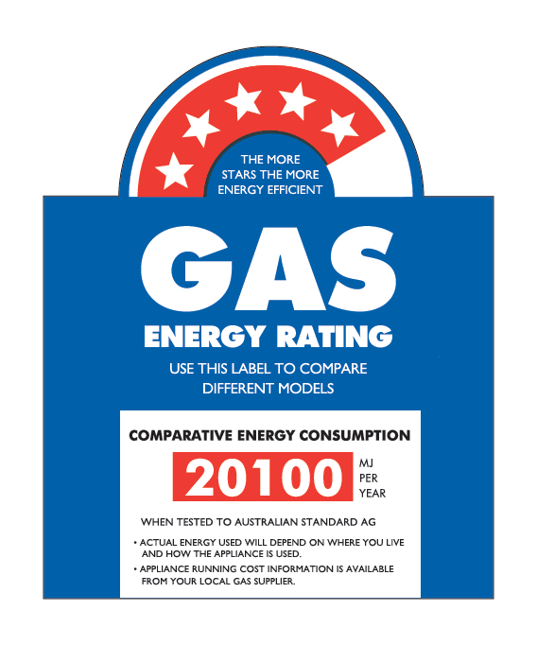

Information on the energy efficiency of gas water heaters is provided on the Gas Energy Rating Labels which are required to be displayed on new gas water heaters when they are sold, as part of the gas appliance certification scheme in Australia. The labels have a Star Rating from 1 to 6 Stars at the top of the label – the more stars the more energy efficient the water heater is – and also provide an annual energy consumption figure in MJ per year in a red box (Comparative Energy Consumption) in the middle of the label.

The Comparative Energy Consumption and Star Rating figure used on the Gas Energy Rating Labels are now based on laboratory testing to Australian and New Zealand Standard *AS/NZS 5263.1.2:2016*[14], which assesses their energy use and energy efficiency for a daily water heating task of 37.7 MJ per day (13,761 MJ per year), equivalent to a hot water use of 200 Litres per day where the water is heated by 45oC above the cold water temperature (or nominal hot water temperature of 60oC and a cold water temperature of 15oC). The Star Ratings are based on the tested annual energy consumption of a given gas water heater relative to a 1 Star reference water heater which consumes 28,900 MJ per year. An additional star is achieved for each 2,023 MJ per year reduction in annual gas consumption (or 7% of the base gas consumption). [E3 2012]

The water heater testing is undertaken in a laboratory test room, with the ambient air temperature specified as 20oC plus or minus 1oC. The cold water temperature is specified as 15oC plus or minus 1oC, and the hot water temperature as 60oC plus or minus 1oC. *AS/NZS 5236.1.2* assumes 19 start-ups per day for the determination of the annual energy consumption of the gas instantaneous water heaters.

The test conditions that are used to determine the Energy Ratings of gas water heaters are quite different to those likely to be experienced under actual use. Average hot water use (around 100 to 125 Litres per day) is believed to be substantially lower than the 200 Litres per day used in the current test. Also, the ambient air temperature of 20oC is higher than is likely to be experienced by gas water heaters located outside in many parts of Victoria – in Southern Victoria the average air temperature over a year is around 14 to 15oC. For storage water heaters this lower ambient air temperature means that in practice the standing losses (or daily maintenance rate) is likely to be higher than the tested value – for a hot water temperature of 60oC this would increase the standing losses by 13.8% or by around 550 to 1,100 MJ per year. Also, water heaters located outside will be subjected to both wind and rain conditions, which may increase the standing losses even further. Due to the way that they operate, instantaneous gas water heaters are less likely to be affected by the ambient air temperature and incidence of wind and rain.

*AS/NZS 5236.1.2* sets a minimum “thermal efficiency” of gas water heaters to be 75% at their nominal gas consumption rate, and also sets an upper limit on the daily maintenance rate of storage gas water heaters. For the reference (1 Star) gas water heater this is equal to 27.3 MJ per day. In 2013, mandatory minimum energy performance standards (MEPS) were introduced nationally for gas water heaters through the Equipment Energy Efficiency (E3) Program[15]. The MEPS regulations mean that gas water heaters with an Energy Rating less than 4-Stars can no longer be sold.

While the Gas Energy Rating Labels allow consumers to make a quick comparison between the energy efficiency of different gas water heaters *for a daily hot water use of 200 Litres per day* (or daily water heating task of 37.7 MJ per day), and this data is publicly available in registers published by the gas certification authorities[16], no public information is available on key elements of gas water heater efficiency including the burner (or recovery) efficiency, maintenance rate of gas storage systems and the start-up energy and electricity consumption of gas instantaneous water heaters. [E3 2012] This is the information that is necessary to estimate the energy consumption of gas water heaters for different (generally lower) levels of hot water use, and in different ambient temperature conditions.

In order to achieve a specific Star Rating on the Gas Energy Rating Label, it is possible to alter two parameters, the burner (or recovery) efficiency and the daily energy losses (maintenance rate and start-up losses). This means that two different water heaters that achieve the same Star Rating could have a different energy consumption at hot water loads other than 37.7 MJ/day. [EES 2015]

As noted above the Gas Energy Rating Label used for water heaters is based on a hot water use of 200 Litres per day, and this is higher than average hot water use. However, due to the way they operate a gas storage water heater and a gas instantaneous water heater with the same Star Rating (e.g. 5-Stars) which have around the same annual energy consumption at 200 Litres per day, will have quite different energy use when hot water use is somewhat less than this. To illustrate this issue we have modelled the energy use of a number of gas storage water heaters (3-Star and 5-Star) and gas instantaneous water heaters (5-Star and 6-Star) over a wide range of daily water heating tasks. For this exercise we have assumed certain performance characteristics for the water heaters[17]. Also, following [EES 2015] we have based the number of daily starts for gas instantaneous water heaters on *AS/NZS4234:2008[18].* Thisincludes a function that calculates the number of daily start-ups based on the daily hot water task (MJ per day). This is approximately a straight line represented by 3.4 + 0.4 starts per MJ of hot water delivered.

Figure 4 shows how the estimated annual gas consumption of the different water heaters modelled varies for water heating tasks ranging from 0 MJ per day up to 50 MJ per day. While the 5-Star gas storage water heater and 5-Star gas instantaneous water heater have around the same annual gas consumption for a hot water task of 37.7 MJ per day (200 Litres per day) the gas consumption of the storage water heater is somewhat higher than the instantaneous water heater at the lower end of the hot water use range. When the daily hot water use is high, above 37.7 MJ per day, the annual gas consumption of the 5-Star storage water heater is lower than the energy consumption of the 5-Star instantaneous system.

FIGURE 4: MODELLED ENERGY CONSUMPTION OF GAS WATER HEATERS

The graph shows the theoretical annual energy use of a number of gas water heaters over a range of daily water heating tasks from 0 to 50 MJ per day. It covers 3-Star and 5-Star gas storage systems, and 5-Star and 6-Star gas instantaneous systems.

Figure 5 compares the overall efficiency of the gas water heaters which have been modelled. This is the daily water heating task divided by the daily gas consumption (ignoring the small electricity consumption for the gas instantaneous water heaters). It is clear that at the lower end of the hot water usage range (below 25 MJ per day) the instantaneous gas water heaters are much more efficient than the gas storage water heaters, and that they maintain this high level of efficiency down to a fairly low level of hot water use (5 MJ per day). In contrast, the overall efficiency of the gas storage water heaters decreases significantly as the daily hot water use decreases. This is because for a low level of hot water use the effectively fixed standing losses (wasted energy) become a significant proportion of the daily energy requirement. The energy consumption of the instantaneous water heaters are more directly related to the amount of hot water used and the start-up losses, and for low hot water use these start-up losses are also likely to be quite low.

FIGURE 5: MODELLED OVERALL EFFICIENCY OF GAS WATER HEATERS

The graph shows the theoretical overall efficiency of a number of gas water heaters for dialy water heating tasks ranging from 0 to 50 MJ per day. Water heaters covered include 3-Star and 5-Star gas storage systems, and 5-Star and 6-Star gas instantaneous systems.

To provide some context for this *Retrofit Trial*, we have modelled the gas energy savings which are expected when a 3-Star gas storage water heater – typical of an older existing unit – is replaced with either a 5-Star gas storage water heater or a 6-Star gas instantaneous water heater. The results of this modelling are presented in Figure 6. For an average hot water use in the range of 100 to 125 Litres per day (water heating task in the range of 19 to 24 MJ per day) the energy savings from the replacement with a 6-Star gas instantaneous system are nearly twice as large as the savings from replacing with a 5-Star gas storage system.

FIGURE 6: ESTIMATED ENERGY SAVINGS FROM GAS WATER HEATER RETROFITS

The graph shows the theoretical estimated annual energy savings from replacing a 3-Star gas storage water heater with either a 5-Star gas storage water heater (blue line) or a 6-Star gas instantaneous water heater (red line).

# 3. Hot water use of the *Trial* houses before retrofit

## Housing Sample

Details of the 6 houses which participated in the *Gas Water Heater* *Retrofit Trial* are shown in Table 2, including details of the existing and replacement gas water heater. Prior to the retrofits all houses had gas storage water heaters with star ratings in the range of 2- to 3-Stars[19], with the age of these ranging from 11 to 25 years old. In most of the houses the existing water heater was located outside, but in two of the houses (GWH3 and GWH5) the existing water heater was located inside. All replacement water heaters were located outside. The households were occupied by between 3 and 4 people (average 3.5).

The estimated average daily hot water use of the households[20] prior to the retrofits ranged from only 68.6 Litres per day up to 258.1 Litres per day [EES 2016], with the average use being 141.4 Litres per day. The average use of hot water per person per day ranged from 22.9 Litres per day up to 86.0 Litres per day, with an average of 40.4 Litres per person per day. For the average Victorian household with around 2.5 people this suggests an average daily hot water use of 101 Litres per day. This average daily use per person found in the *Retrofit Trial* is broadly consistent with the results of a recent South Australian study which monitored the use of twelve water heaters over a full year [DMITRE 2014] and found an average usage of 39 Litres per person per day.

TABLE 2: DETAILS OF THE HOUSES WHICH PARTICIPATED IN THE GAS WATER HEATER RETROFIT TRIAL

|  |  |  |  |  |  |  |
| --- | --- | --- | --- | --- | --- | --- |
| **House No** | **No. of People\*** | **Existing Water Heater** | **Age (Yrs)** | **Replacement Water Heater** | **Est. Daily Hot Water Use (Litres/Day)** | **Litres per person per day** |
| GWH1 | 3A | 170 Litre, gas storage Located outside | 25 | 5.1-Star, gas storage Located outside | 258.1 | 86.0 |
| GWH2 | 2A, 1C | 135 Litre  3.2-Star gas storage Located outside | 15 | 5.1-Star, gas storage Located outside | 68.6 | 22.9 |
| GWH3 | 2A, 2C | 135 Litre 3.4-Star gas storage Located inside | 16 | 5.1-Star, gas storage Located outside | 176.9 | 44.2 |
| GWH4 | 2A, 2C | 135 Litre gas storage Located outside | 21 | 5.1-Star, gas storage Located outside | 96.5 | 24.1 |
| GWH5 | 1A, 2C | 135 Litre 2-Star gas storage Located inside | 22 | 6.1-Star, gas instantaneous Located outside | 73.6 | 24.5 |
| GWH6 | 2A, 2C | 135 Litre  3.2-Star gas storage Located outside | 11 | 5.1-Star, gas storage Located outside | 174.6 | 43.7 |
| **Av.** | **3.5** |  | **18.3** |  | **141.4** | **40.4** |

* **A** = Adults, **C** = Children

## Daily hot water use prior to the retrofits

It is evident from Table 2 that there was a significant variation in the average daily use of hot water across the six houses involved in the *Retrofit Trial*. In addition to this there was a significant variation in the hot water usage in the houses from day-to-day. Figure 7 shows the distribution of daily hot water use prior to the retrofits in the five houses for which this data is available[21] broken down into 20 Litre bins. The average daily hot water use for these hoses before the retrofits was 144.9 Litres per day, and the standard deviation across all daily hot water use measurements was 95.2 Litres per day. Houses GWH2 and GWH5, which had the lowest average daily hot water use, also had quite a narrow distribution of hot water use, while the houses with the highest daily hot water use (GWH1, GWH3 and GWH6) display a very wide distribution of daily hot water use.

FIGURE 7: DISTRIBUTION OF DAILY HOT WATER USE PRIOR TO THE RETROFITS

The graph shows the percentage distribution of daily hot water use in five of the Retrofit Trial houses prior to the retrofits, based on 20 Litre usage bins ranging from 0 to 20 Litres per day to 480 to 500 Litres per day. The average hot water distribution for all houses is also shown.

As was noted in Chapter 2, the daily hot water use of the households depends on the number of people in the household and the composition of the household, the temperature of the hot water, the frequency of showers and baths, the flow rate of the shower rose and the time spent showering, the volume of the bath and various sinks that are used, and the use of hot water for clothes washing and dishwashing.

At the start of the *Gas Water Heater* *Retrofit Trial* the households were surveyed to obtain information on their use of hot water. The frequency of hot water use reported by the households is shown in Table 3, and householder estimates of the main areas where hot water is used is provided in Table 4. With an average frequency of 2.45 showers per day (or 17.2 per week) Table 3 suggests that showering is responsible for the majority of hot water use in the houses, and this corresponds with householder perceptions of where their hot water is used reported in Table 4, with an average score of 64.2%. Washing clothes on a warm wash cycle (11.7%), the bath (10.0%) and washing dishes in the sink (10.0%) were the next main areas of hot water use identified by the households. While using a warm wash cycle for washing clothes had a fairly low average frequency of use this will use more hot water per load washed that washing dishes in the sink. Washing hands for personal hygiene and rinsing dishes in hot water before washing in the dishwasher or sink were seen to be fairly minor uses of hot water.

Most households reported that their use of hot water on the weekend was similar to their use of hot water during the working week, although households GWH5 and GWH6 reported that they used more hot water on weekends due mainly to clothes washing.

TABLE 3: FREQUENCY OF HOT WATER USE REPORTED BY HOUSEHOLDS

|  |  |  |  |  |  |
| --- | --- | --- | --- | --- | --- |
| **House No** | **Showers per day** | **Shower time (mins)** | **Baths per week** | **Times dishes washed in sink per week** | **Times clothes washed on warm cycle per week** |
| GWH1 | 3 | 5 | 4 | 5 | - |
| GWH2 | 3 | 4 | - | - | 4 to 5 |
| GWH3 | 3 | 4 | 1 | 14 | 2 |
| GWH4 | 2 | 5 to 6 | 6 | 7 to 8 | - |
| GWH5 | 1.7[22] | A - 5 to 6; C - 10 | - | 21 | 4 to 5 |
| GWH6 | 2 | 5 | 4 | 7 | 5 |
| **Av** | **2.45** | **5.3** | **2.5** | **9.1** | **2.7** |

TABLE 4: BREAKDOWN OF HOT WATER USE ESTIMATED BY HOUSEHOLDS

|  |  |  |  |  |  |  |
| --- | --- | --- | --- | --- | --- | --- |
| **House Code** | **Showers** | **Bath** | **Washing hands** | **Rinsing dishes** | **Washing dishes in sink** | **Washing clothes** |
| GWH1 | 70% | 20% | 5% | 5% | - | - |
| GWH2 | 80% | - | - | - | - | 20% |
| GWH3 | 40% | 30% | - | - | 15% | 15% |
| GWH4 | 75% | 10% | - | 5% | 10% | - |
| GWH5 | 50% | - | 5% | - | 25% | 20% |
| GWH6 | 70% | - | 5% | - | 10% | 15% |
| **Av** | **64.2%** | **10.0%** | **2.5%** | **1.7%** | **10.0%** | **11.7%** |

The average breakdown of where hot water is used by the *Retrofit Trial* households is quite similar to the average breakdown of hot water use modelled as part of the Sustainability Victoria’s *On Ground Assessment* Study [SV 2015]. In the *OGA* study the estimated average daily use of hot water for the 60 participating houses was 124.2 litres per day, or an average use of 42.3 Litres per person per day. The estimated breakdown of the hot water use (see Figure 8) took into consideration the measured flow rate of the houses’ shower roses, the number of people in the household and average showering behaviour (as estimated by Yarra Valley Water based on their end-use metering studies [YVW 2011 & 2012]), details of the clothes washers and dishwashers found in the houses combined with reported use of these appliances by the households[23], and estimates of hot water use for washing dishes in the sink and personal hygiene based on the Yarra Valley Water studies.

FIGURE 8: ESTIMATED BREAKDOWN OF HOT WATER USE FROM THE OGA STUDY

The pie chart shows the estimated breakdown of hot water use based on modelling for SV's On-Ground Assessment study. It covers showering, clothes washing, dishwasher, hand dish-washing, and personal hygene (bath, sink). 

While the total amount of hot water used was measured as part of the *Gas Water Heater Retrofit Trial*, it was not possible to measure the use of the hot water by the various end-use areas in the houses. However, the analysis of the data undertaken by EES has enabled us to identify the amount of hot water used by hot water events[24] of different sizes. The results of this analysis are shown in Figure 9. It is expected that the larger hot water use events (greater than 30 Litres) would be associated with showering and baths, and that the smaller hot water use events (1 Litre to less than 10 Litres) would be associated with hand washing, rinsing and washing dishes, and clothes washing. Hot water events in the range of 10 to 30 litres might be related to dishwashing and clothes washing, and could also be related to showering in houses which had low flow shower roses, short showering times or a combination of both. Based on the five houses for which data is available it was found that 66.9% of all hot water use was for hot water events greater than 30 Litres. Some houses had considerable use within the 10 to 30 Litre range (GWH2 and GWH6), and if this is taken into account[25] the estimated proportion of hot water used for showering and baths increases to 76.5%, similar to that estimated by the householders.

EES also calculated the average hot water flow rate for the different hot water event ranges (see Table 5). We have used this data to estimate the average flow rate for hot water events in the range of 30 to 100 Litres, as this should give a reasonable estimate of the hot water flow rate during showering. This suggests that household GWH1 has the highest shower flow rate and this, combined with relatively high use of the bath, may be one reason why this household had the highest average daily hot water use. Households GWH2 and GWH6 seem to have the lowest shower flow rate. In the case of GWH2 this low shower flow rate, combined with reported short shower times (supported by the data in Figure 9 above) and the fact that they did not use a bath, may account for this household having the lowest hot water use.

FIGURE 9: DISTRIBUTION OF HOT WATER USE BY DIFFERENT HOT WATER EVENT SIZES

The graph provides a frequency distribution of hot water event sizes in five of the six participating houses, as weall as the average frequency distribution of these houses. 

TABLE 5: AVERAGE HOT WATER FLOW RATE FOR DIFFERENT HOT WATER EVENT SIZES

|  |  |  |  |  |  |
| --- | --- | --- | --- | --- | --- |
| **How Water Event** **Range (Litres)** | **Average hot water flow rate (litres per minute)** | | | | |
| **GWH1** | **GWH2** | **GWH3** | **GWH5** | **GWH6** |
| <= 0.1 Litres | 0.0 | 0.0 | 0.0 | 0.0 | 0.0 |
| > 0.1 to <= 1 Litres | 0.7 | 0.6 | 0.7 | 0.7 | 0.7 |
| > 1 to <= 5 Litres | 2.3 | 2.2 | 2.1 | 2.1 | 2.0 |
| > 5 to <= 10 Litres | 4.4 | 3.1 | 2.1 | 3.7 | 2.8 |
| > 10 to <= 30 Litres | 6.9 | 3.8 | 4.0 | 4.3 | 3.4 |
| > 30 to <= 50 Litres | 7.3 | 4.3 | 5.9 | 6.4 | 3.8 |
| > 50 to <= 75 Litres | 8.3 | 4.9 | 8.0 | 7.4 | 4.1 |
| > 75 to <= 100 Litres | 9.6 | 4.9 | 7.9 | 7.4 | 4.7 |
| > 100 Litres | 10.3 | - | 6.4 | 9.1 | 6.4 |
| **Av > 30 to <= 100** | **8.4** | **4.7** | **7.2** | **7.0** | **4.2** |

## Daily water heating task prior to the retrofits

Information on the average daily use of hot water in the *Retrofit Trial* houses prior to the retrofits being undertaken is provided in Table 2 above. However, the average daily use of hot water is not necessarily a good indication of the average daily water heating task*,* or the energy content of the hot water used each day. The water heating task depends on the difference in the temperature between the hot water drawn from the water heater and the cold water input to it, as well as the amount of hot water used. Houses with a higher hot water temperature will tend to have a lower daily usage of hot water, because less hot water needs to be mixed with cold water to achieve the water temperatures required for showering and bathing, as well as washing clothes and dishes.

EES estimated the average daily cold water and hot water temperatures at each house, the amount of hot water used and the daily water heating task in mega joules per day (MJ/day). This data is summarised in Table 6 for the pre-retrofit period, which covered the period mid-April to mid-May, 2015.

TABLE 6: AVERAGE DAILY WATER HEATING TASK OF HOUSES PRIOR TO RETROFIT

|  |  |  |  |  |  |
| --- | --- | --- | --- | --- | --- |
| **House No** | **Est. Daily Use of Hot Water before Retrofit (Litres/Day)** | **Av hot water temperature before retrofit (oC)** | **Av cold water temperature before retrofit (oC)** | **Av temperature difference**  **(oC)** | **Av daily water heating task before retrofit**  **(MJ/day)** |
| GWH1 | 258.1 | 50.5 | 16.5 | 34.0 | 37.7 |
| GWH2 | 68.6 | 67.0 | 17.6 | 49.4 | 14.2 |
| GWH3 | 176.9 | 52.2 | 17.1 | 35.1 | 26.5 |
| GWH4 | 96.5 | 67.0 | 16.8 | 50.2 | 20.1 |
| GWH5 | 73.6 | 48.0 | 16.8 | 31.2 | 9.7 |
| GWH6 | 174.6 | 66.3 | 17.4 | 48.9 | 35.9 |
| **Av** | **141.4** | **58.5** | **17.0** | **41.5** | **24.0** |

The average cold water temperatures at the houses were very similar, but there is a significant variation in the average temperature of the hot water drawn from the water heaters, with this ranging from only 48.0oC (GWH5) to 67oC (GWH2 and GWH4). Based on the water heating task, house GWH1 is still seen to be the highest user of hot water, but house GWH6 now ranks a close second, due to it having a fairly high hot water temperature. Similarly, house GWH2 now ranks as the second lowest user of hot water and GWH5 as the lowest user of hot water, because the hot water temperature at GWH5 is lower than at GWH2.

The average daily water heating task across the six houses prior to the retrofits (mid-April to mid-May) was 24.0 MJ per day, or an average of 6.86 MJ per person per day based on the average occupancy of 3.5 people. For an average Victorian household with 2.5 people, this suggests an average daily water heating task at this time of year of 17.2 MJ per day[26]. This result is quite similar to that found in the South Australian study of 12 water heaters located in Adelaide monitored over a year. In this case the average daily water heating task over the full year was 17.3 MJ per day or 6.28 MJ per person per day based on an average occupancy of 2.75 people. [DMITRE 2014] As the cold water temperatures in Melbourne would be expected to be lower than the cold water temperatures in Adelaide, it is expected that the average daily water heating task would be higher than for the South Australian study. In this case the average cold water temperature over the monitoring period was 20.0oC.

The occupants at house GWH5 reported that they limited their use of hot water prior to the retrofits due to their existing water heater being faulty, and this is likely to have reduced their daily water heating task below what it would otherwise have been and, therefore, reduced the average water heating task across the six houses. After the retrofits their daily water heating task increased from 9.7 MJ per day to 15.1 MJ per day (equivalent to 13.5 MJ per day if we make allowance for the lower cold water temperature after the retrofit). If we assume that the average water heating task at house GWH5 prior to the retrofits would have been 13.5 MJ per day had its water heater not been faulty, this increases the average water heating task across the six houses to 24.7 MJ per day or 7.07 MJ per person per day. This suggests a water heating task of 17.6 MJ per day for the average 2.5 person Victorian household. However, it is important to keep in mind that this estimate is based on only a small sample of households, and a much larger sample would be required to obtain a more robust estimate of average Victorian hot water use.

## Daily energy consumption and efficiency of water heaters prior to retrofit

The data collected during the pre-retrofit monitoring period was analysed by EES to obtain information on the average daily gas use of the water heaters and the average energy efficiency of the water heaters prior to the retrofits. This data is summarised in Table 7. The table shows the average total daily gas energy consumption of the water heaters, and breaks this down in to the estimated average daily energy use of the gas pilot and the estimated average daily energy use for heating the water[27]. For the majority of the houses the gas pilot consumes around 8 MJ per day. For house GWH4 the estimated pilot use is much higher, 25.9 MJ per day. It is not known why the gas pilot consumption for this water heater was so much higher, although it suggests that this water heater was faulty. At house GWH5 the gas pilot consumption is much lower, only 2.2 MJ per day. This is because this water heaters was faulty and the gas pilot often went out[28]. The average daily gas use of the water heaters was 52.3 MJ per day, more than double the average daily hot water task of 24.0 MJ per day. This is because of the energy use by the gas pilot, heat losses from the hot water stored in the water heater (the standing losses) as well as the energy losses which occur when gas burner is heating the water in the hot water cylinder during a water heating cycle.

TABLE 7: AVERAGE ENERGY CONSUMPTION AND EFFICIENCY OF EXISTING GAS WATER HEATERS

|  |  |  |  |  |  |  |  |
| --- | --- | --- | --- | --- | --- | --- | --- |
| **House No** | **Av. Water Heating Task (MJ/day)** | **Av. Pilot energy (MJ/day)** | **Av. Water Heating Energy (MJ/day)** | **Av. Total Energy (MJ/day)** | **Heating cycle efficiency (%)** | **Overall efficiency (%)** | **Est Annual Energy**  **(MJ)** |
| GWH1 | 37.7 | 7.9 | 53.8 | 61.7 | 70.0% | 61.1% | 23,583 |
| GWH2 | 14.2 | 7.7 | 41.8 | 49.5 | 33.9% | 28.8% | 21,340 |
| GWH3 | 26.5 | 8.7 | 40.6 | 49.3 | 65.3% | 53.8% | 18,466 |
| GWH4 | 20.1 | 25.9 | 30.5 | 56.4 | 65.9% | 35.6% | 20,404 |
| GWH5 | 9.7 | 2.2 | 23.6 | 25.8 | 42.6% | 37.6% | 15,859 |
| GWH6 | 35.9 | 7.5 | 63.7 | 71.2 | 58.0% | 50.4% | 25,719 |
| **Av** | **24.0** | **10.0** | **42.3** | **52.3** | **56.0%** | **44.6%** | **20,895** |

Table 7 gives two figures for water heater efficiency. The “heating cycle efficiency” is a measure of how efficiently the gas burner heats water in the cylinder and maintains it at the required temperature. It is the ratio of the water heating task and the water heating energy. For most of the systems this is in the range of 58% to 70%, although houses GWH2 (33.9%) and GWH5 (42.6%) have quite low heating cycle efficiencies. The water heating energy is the daily gas consumption of the water heater minus the energy consumption of the gas pilot light. This is the energy required to heat cold water to the hot water temperature as well as some of the energy that is required to counter the standing losses and maintain the hot water in the cylinder at the required temperature. Note that heat from the pilot light also helps to maintain the temperature of the hot water in the cylinder to some extent.

The “overall efficiency” is the ratio of the water heating task and the total energy, and takes into account both the energy consumed by the gas pilot and the energy required for heating the water. The overall efficiency ranges from 28.8% to 61.1%, and the average overall efficiency is only 44.6%. The average efficiency is slightly lower than the overall efficiency of a 3-Star gas storage water heater for a water heating task of 24 MJ per day (around 47%, see Figure 5 above). This may be because the actual efficiency is lower than the tested efficiency due to higher standing losses for the three water heaters located outside, degradation of the efficiency of some water heaters over time, and also due to some water heaters being faulty (GWH4 and GWH5).

In general, the overall efficiency of the water heaters is lower for the houses which have a low water heating task. This is because the standing losses make up a higher proportion of the total daily gas use. The houses with the higher daily water heating task tend to have the highest overall efficiency, although this also depends on the heating cycle efficiency. GWH1 has the highest overall efficiency, partly because it has the highest daily water heating task and partly because it has the highest heating cycle efficiency. The water heaters at houses GWH2 and GWH5 have a low overall efficiency as they have both a low heating cycle efficiency and a relatively low daily water heating task. The water heater at house GWH4 also has a low overall efficiency, and this is mainly due to the high energy use by the gas pilot at this house.

EES have estimated the annual energy consumption of the existing water heaters based on the data that was collected during the pre-retrofit monitoring period[29]. The estimated average energy consumption of the gas water heaters prior to the retrofits was 20,895 MJ per year. This is reasonably consistent with the average annual gas consumption of gas storage water heaters estimated in SV’s *OGA* study. In this case the estimated annual gas consumption was 16,685 MJ per year for an average house occupancy of 2.8 people. [SV 2015] This suggests an annual gas consumption of around 20,856 MJ per year when scaled up to an average occupancy of 3.5 people.

## Timing of hot water use during the day

Data from the *Trial* has been analysed to obtain information on how the use of hot water varies throughout the day, both in terms of the amount of hot water used (demand profile) and the water heating task (delivery profile) [EES 2016]. House GWH4 has been excluded from the analysis as the water meter at this house failed. The results of this analysis are shown in Figures 10 and 11. These daily profiles show the percentage of the average daily hot water use (or demand) and water heating task (or delivery) which occurs during each hour of the day. The profiles are very similar for hot water use and water heating task, and the profiles for all houses display a similar shape. Peak hot water demand occurs during the morning hours from around 6:00 to 10:00 hours, with another smaller peak evident in the evening from around 17:00 to 20:00 hours. This daily usage profile is quite similar to the one obtained in the South Australian study [DMITRE 2014].

FIGURE 10: AVERAGE DAILY HOT WATER DEMAND PROFILE, BEFORE RETROFIT

The graph shows the average percentage of total daily water use that occurs during each hour of the day for five of the participating households.  The average daily distribution of hot water use by these houses is also shown.

FIGURE 11: AVERAGE DAILY HOT WATER DELIVERY PROFILE, BEFORE RETROFIT The graph shows the average percentage of the total daily water heating task which occurs during each hour of the day, for five of the participating households. The average daily distribution of the water heating task for these houses is also shown.

In addition to the data on how hot water use and the water heating task vary throughout the day, we have compiled data on how the gas consumption of the water heaters varies throughout the day[30] and compared this with the water heating task. Figure 12 is based on the average for the five houses for which data was available, and presents the results as a frequency distribution. Figure 13 shows the same information but is based on the average energy consumption in each hour of the day. The shapes of the two distributions are similar, although the gas consumption seems to lag slightly behind the water heating task. This is expected, as the temperature of the water in the hot water cylinder has to fall before re-heating is initiated. Also, the gas consumption is significantly higher than the water heating task. This is due to inefficiencies in the conversion of the heat from the gas burner into hot water, and also due to the daily maintenance rate of the gas storage water heaters (pilot light and heat losses through the walls of the cylinder).

FIGURE 12: AVERAGE DAILY GAS CONSUMPTION AND HOT WATER DELIVERY PROFILES, BEFORE RETROFIT

The graph compares the average daily percentage distribution of the water heating task (orange line) with the average daily distribution of gas usage (blue line), for the five houses where this data is available.

FIGURE 13: AVERAGE DAILY GAS CONSUMPTION AND HOT WATER DELIVERY PROFILES, BEFORE RETROFIT

The graph compares the average daily distribution of the water heating task (orange line) with the average daily distribution of gas usage (blue line), for the five houses where this data is available. The distributions are based on the energy use (in MJ) during each hour of the day.

# 4.0 Impact of the gas water heater retrofits

## Introduction

Two approaches were taken to assess the impact of the gas water heater retrofits. Householder surveys were undertaken before and after the retrofits to assess householder satisfaction with their water heating system, and to help identify any specified changes that householders noticed following the retrofits. In addition to this the metering data from the post-retrofit period was analysed and compared to the data from the pre-retrofit period [EES 2016].

## Householder perceptions

The households which participated in the *Retrofit Trial* were asked a series of questions before and after the retrofits were undertaken to obtain information on their satisfaction with the performance of their gas water heater, and on other possible impacts of the gas water heater retrofit. The detailed responses to these questions are provided in Appendix A2.

### General satisfaction with water heater

Householders were asked to rate their general level of satisfaction with their gas water heater[31]. The results are summarised in Figure 14. The average satisfaction rating prior to the retrofits was 3.3, indicating that overall the households were reasonably happy with their existing gas water heater. Exceptions to this were GWH4 where the existing water heater was seen as being “Very old and inefficient” and which had been repaired multiple times, and GWH5 where the existing unit was faulty and the pilot light would have to be re-lit each morning as it would go out when the system was not in use. Following the retrofits the average satisfaction rating rose to 4.6 indicating that overall the households were very satisfied with the new water heating system. Key reasons for this were that the households now did not have to worry about running out of hot water (GWH1,GWH3, GWH5) or that the new system was seen to be working better than the older one (GWH3).

FIGURE 14: HOUSEHOLDER SATISFACTION WITH THEIR GAS WATER HEATER

The column chart shows the reported level of satisfaction of the households with their water heater before and after the retrofits. Satisfaction is rated on a scale of 1 (extremely unsatisfied) to 5 (extremely satisfied).

A selection of the more detailed householder comments are provided below. A number of households noted that after the retrofits the hot water was not as hot as before. This may have been due to a thermal mixing valve placed on the hot water outlet to limit the temperature of the water supplied to the house to around 50oC, or may have been due to the water heater limiting the temperature of the hot water. In GWH4 this meant that water sometimes had to be boiled in a kettle to obtain a temperature sufficient for washing dishes in the sink. Some houses saw this as an advantage as the lower water temperatures were safer. Information on the average hot water temperatures before and after the retrofits is provided in Table 7.

TABLE 7: AVERAGE HOT WATER TEMPERATURE, BEFORE AND AFTER RETROFIT

|  |  |  |
| --- | --- | --- |
| **House No** | **Before** | **After** |
| GWH1 | 50.5 | 50.6 |
| GWH2 | 67.0 | 53.3 |
| GWH3 | 52.2 | 54.5 |
| GWH4 | 67.0 | 55.0 |
| GWH5 | 48.0 | 45.7 |
| GWH6 | 66.3 | 57.9 |
| **Average** | **58.5** | **52.8** |

**Householder comments regarding satisfaction with their water heating**

*Before* – Getting old. Would fail eventually. *After* – Very happy, has been seamless. Showers never run out of hot water. Bath never runs out. (GWH1)

*Before* – Very old and inefficient. *After* – All fine, no issues. (GWH2)

*Before* – Very old and inefficient. Repaired multiple times. *After* – Water hasn’t been as hot since the new system was installed. Kitchen – water isn’t hot enough for dishes but this is probably the new plumbing regulations. Bathroom – hot water not as hot as the old system, but good for showers. (GWH4)

*Before* – Faulty and old. Have to light in the morning to get hot water as the pilot light would go out. *After* – The unit uses a lot of water for the hot water to get to the kitchen tap. The water is not as hot. Bathroom – it takes a long time for the hot water to reach the bathroom. Water is not as hot. (GWH5)

***Issues***

Household GWH5 noted that it now took a long time for the hot water to reach the kitchen and the bathroom. This may have been because the original water heater at this house was located inside and would have been close to the hot water outlets. This unit was replaced by an instantaneous gas water heater located outside, so the pipe runs would have been longer. In addition to this there is a short delay until the instantaneous gas water heater has heated to cold water up to the full output temperature.

### Changes to the use of hot water

Householders were asked to comment on whether or not there had been any changes to their use of hot water following the retrofits. In general they reported that they had not changed their use of hot water, or had not changed it significantly. GWH5 was an exception to this. The existing water heater at this house was faulty, which limited the amount of hot water that could be used and the timing of showers. The new water heater meant that they were now able to all have showers in the morning.

Householders were also asked to comment on whether there had been any changes to the length of time that people spent showering following the retrofits. Most houses reported that the amount of time spent in the shower was about the same after the retrofits. GWH1 reported that they were spending more time in the shower, but linked this to the colder winter conditions after the retrofits rather than to the water heater retrofit. GWH5 reported that they now spent more time in the shower because their existing water heater was faulty and after the retrofits they did not have to worry about running out of hot water.

### Other benefits and issues

Householders were asked to comment on any perceived benefits of the gas water heater retrofits as well as any issues that resulted from the retrofits. A number of households (GWH1, GWH3) indicated that they had not really noticed any changes since the existing water heater was replaced. A number of households (GWH4, GWH5 and GWH6) noted that they no longer had to worry about the water heater not working and running out of hot water. Two houses noted that the hot water temperature was lower following the retrofit. At GWH4 this was seen as an advantage in the bathroom as there was less chance of children burning themselves with hot water, although in the sink this was seen as a disadvantage as the water was not hot enough to wash dishes in the sink and had to be supplemented by water boiled in a kettle at times. Household GWH5 reported that the hot water now took longer to reach the kitchen tap, and this was resulting in increased use of hot water.

**Householder comments on the benefits of the water heater retrofit**

*Benefits* – Don’t have to worry about hot water system not working. Don’t have to worry about kids burning themselves in the bath. *Issues* – Find hot water system not hot enough in the kitchen sometimes – need to boil kettle when doing the dishes. (GWH4)

*Benefits* – Don’t have to light the unit every morning. Know that won’t run out of hot water. Takes up less room in the house because unit moved outside. *Issues* – Probably use more hot water because don’t have to worry about running out. Cooler water than last unit. Use more water because hot water takes a long time to reach the (kitchen) tap.

## Hot water use after the retrofits

Table 8 compares the average daily hot water use before the retrofits with the situation after the retrofits, and also compares the average hot water temperature before and after the retrofits. Average daily hot water use has increased from 141.4 litres per day to 160.5 litres per day, an increase of 13.5%. This corresponds with a decrease in the average temperature of the hot water from 58.5oC to 52.8oC, a decrease of 9.7%. This means that the apparent increase in daily hot water use can be largely attributed to the reduction in the temperature of the hot water, as more water needs to be drawn from the water heaters to achieve suitable temperatures for showering, baths and warm water clothes washing. It is evident from Table 8 that the largest increase daily hot water use (GWH2 and GWH4) generally corresponds to the largest decrease in average hot water temperature. GWH5, which recorded the largest increase in hot water use (52.6%), is the exception to this, suggesting that in this case there was a significant increase in hot water use after the retrofit. The survey results for this house suggest that this was because the faulty nature of the existing water heater at this house resulted in limited hot water use. House GW3 recorded a slight reduction in daily hot water use, and this corresponded to a small increase in the temperature of the hot water at this house after the retrofit.

TABLE 8: HOT WATER USE AND TEMPERATURE, BEFORE AND AFTER RETROFIT

|  |  |  |  |  |  |  |
| --- | --- | --- | --- | --- | --- | --- |
| **House No** | ***Av. Hot Water Use (Litres/day)*** | | | ***Av. Hot Water Temperature (oC)*** | | |
| **Before** | **After** | **Change** | **Before** | **After** | **Change** |
| GWH1 | 258.1 | 278.3 | 7.8% | 50.5 | 50.6 | 0.2% |
| GWH2 | 68.6 | 94.0 | 37.0% | 67.0 | 53.3 | -20.4% |
| GWH3 | 176.9 | 166.4 | -5.9% | 52.2 | 54.5 | 4.3% |
| GWH4 | 96.5 | 133.0 | 37.8% | 67.0 | 55.0 | -17.9% |
| GWH5 | 73.6 | 112.3 | 52.6% | 48.0 | 45.7 | -4.8% |
| GWH6 | 174.6 | 178.9 | 2.5% | 66.3 | 57.9 | -12.7% |
| **Av** | **141.4** | **160.5** | **13.5%** | **58.5** | **52.8** | **-9.7%** |

A small increase in daily hot water use after the retrofits was expected, as the post-retrofit period corresponds to the colder May to June period, when both internal temperatures and the cold water temperature are likely to be cooler than during the pre-retrofit period. This means that slightly more hot water will need to be combined with the cold water to achieve acceptable washing temperatures.

Figure 15 compares the distribution of the daily hot water use in all five houses for which data was available before and after the retrofits. As was the case before the retrofits, there is also a wide variation in the daily hot water use after the retrofits. The average daily hot water use of the five houses for which data is available is 169.3 Litres per day, with a standard deviation of 93.9 Litres per day. There were fewer days of low hot water use (20 to 60 litres per day) after the retrofits than before, and in general there were more days of higher hot water use (80 litres per day or greater) after the retrofits. This is consistent with the observed increase in the average daily use of hot water after the retrofits.

FIGURE 15: DISTRIBUTION OF DAILY HOT WATER USE BEFORE AND AFTER RETROFITS

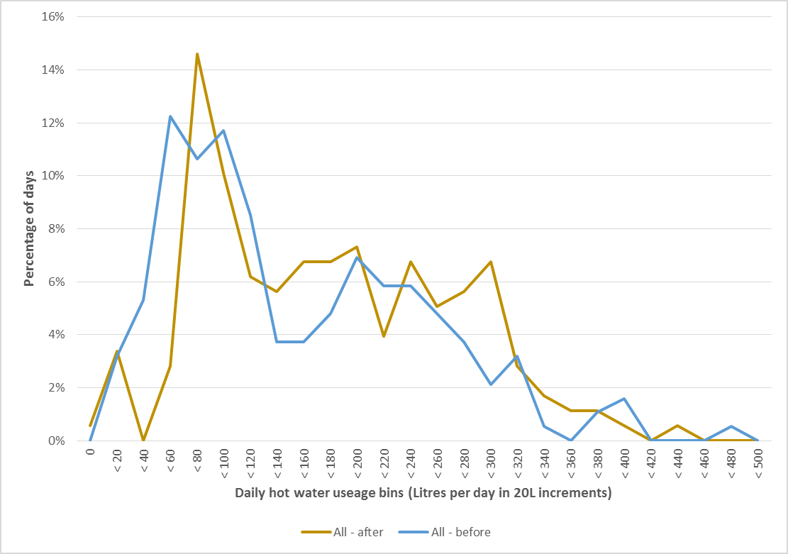

Figures 16 and 17 provide a comparison of the hot water demand (or use) profile before and after the retrofits. Figure 16 shows the proportion of the total daily hot water use that occurs during each hour of the day, and Figure 17 shows the average amount of hot water in litres that is used during each hour of the day. The daily hot water demand profile after the retrofits is quite similar to the situation before the retrofits, although there was more hot water use in the latter part of the morning (8 am to 10 am) and in the late afternoon (around 5 pm) after the retrofits, and less hot water use during the early morning hours (2 am to 4 am).

FIGURE 16: AVERAGE DAILY HOT WATER DEMAND PROFILE, BEFORE AND AFTER RETROFIT

The graph compares the average distribution of hot water use throughout the day across five of the houses, for both before (blue) and after (orange) the retrofits. In both cases the distribution shows the percentage of total daily hot water consumption used during each hour of the day.

FIGURE 17: AVERAGE DAILY HOT WATER DEMAND PROFILE, BEFORE AND AFTER RETROFIT

The graph compares the average distribution of hot water use throughout the day across five of the houses, both before (blue) and after (orange) the retrofits. In both cases the distribution shows the amount of hot water in Lires used during each hour of the day.

## Water heating task after the retrofits

The daily water heating task is the amount of energy in the hot water that is used each day. In addition to the amount of hot water used each day (Litres), it depends on the difference between the hot water temperature and the cold water temperature. We have seen above (Table 8) that the average hot water temperature after the retrofits was lower than before, and this is likely to be at least partly responsible for the observed increase in the average daily use of hot water. As the *Retrofit Trial* was undertaken over the period mid-April to end-June there was also a reduction in the cold water temperature over this period.

Figure 18 [EES 2016] shows how the daily average cold water temperature at the inlet to the water heater changed over the entire monitoring period, for the five houses for which this data is available. It can be seen that the cold water temperatures were similar at all houses and that in all cases the temperature declined by around 4oC over the monitoring period. The graph also shows the cold water temperature that is assumed for Zone 4 (the climate zone in which Melbourne is located), in Australian and New Zealand Standard *AS/NZS4234: 2008 Heated Water Systems – Calculation of energy consumption*, a standard which sets out a methodology for calculating the energy consumption of water heating systems. The actual cold water temperatures recorded at the houses are somewhat higher – by around 3 to 4oC – than is assumed in this standard, suggesting that the calculation methodology in the standard will over-estimate the energy required for water heating. This is consistent with the South Australian study [DMITRE 2015], which found that over a full year the average recorded cold water temperature (20oC) was 2.3oC higher than the average specified in *AS/NZS 4234:2008* (17.7oC).

FIGURE 18: COLD WATER INLET SUPPLY TEMPERATURES OVER THE MONITORING PERIOD

The graph shows the average daily cold water temperature at five of the houses over the entire monitoring period. This is compared to the cold water temperature that is used in AS/NZS4234 as the basis of estimating water heater energy use in the Melbourne climatic zone.

Table 9 provides a comparison of the average daily water heating task in each of the houses before and after the retrofit. The average water heating task has increased from 24.0 MJ per day to 26.5 MJ per day, an increase of 10.4%. At the same time the average daily cold water temperature has decreased from 17.1oC before the retrofits to 14.0oC after the retrofit, and this reduction in cold water temperature will tend to increase the size of the water heating task for the same amount of hot water use. However, as can be seen from Table 8 above this reduction in average cold water temperature also corresponds to a reduction in the average hot water temperature, so that in fact the average difference between hot and cold water temperature faced by the water heaters has decreased from 41.4oC to 38.9oC, a decrease of 6.1%. This decrease in the average temperature difference combined with the increase in daily hot water use (13.5%) would be expected to result in an increase in the water heating task of around 6.6% after the retrofits. The fact that the observed increase in the water heating task was 10.4% suggests that some of the increase in the daily water heating task is due to increased hot water use. Much of this increase seems to have occurred at house GWH5, where the average daily hot water task increased by 55.7%, although this increased hot water use seems to have been mainly due to the original water heater being faulty and not to any economic rebound effect (see page 47).

TABLE 9: AVERAGE DAILY WATER HEATING TASK BEFORE AND AFTER THE RETROFITS

|  |  |  |  |  |  |  |  |  |  |
| --- | --- | --- | --- | --- | --- | --- | --- | --- | --- |
| **House No** | ***Av Water Heating Task* (MJ/day)** | | | ***Av. Cold Water Temperature (oC)*** | | | **Av. Temperature difference (oC)** | | |
| **Before** | **After** | **Change** | **Before** | **After** | **Change** | **Before** | **After** | **Change** |
| GWH1 | 37.7 | 44.3 | 17.5% | 16.5 | 13.6 | -18.1% | 34.0 | 37.1 | 9.1% |
| GWH2 | 14.2 | 15.2 | 7.0% | 17.6 | 14.6 | -17.0% | 49.4 | 38.7 | -21.6% |
| GWH3 | 26.5 | 28.1 | 6.0% | 17.1 | 14.2 | -17.0% | 35.1 | 40.3 | 14.7% |
| GWH4 | 20.1 | 22.8 | 13.4% | 17.3 | 14.1 | -18.6% | 49.7 | 40.9 | -17.7% |
| GWH5 | 9.7 | 15.1 | 55.7% | 16.8 | 13.4 | -20.1% | 31.2 | 32.3 | 3.4% |
| GWH6 | 35.9 | 33.6 | -6.4% | 17.4 | 14.0 | -19.5% | 48.9 | 43.9 | -10.2% |
| **Av** | **24.0** | **26.5** | **10.4%** | **17.1** | **14.0** | **-18.4%** | **41.4** | **38.9** | **-6.1%** |

FIGURE 19: AVERAGE DAILY HOT WATER DELIVERY PROFILE, BEFORE AND AFTER RETROFIT

The graph shows the average distribution of the water heating task throughout the day across five of the houses, for both before (blue line) and after (orange line) the retrofit. The distributions show the percentage of the total daily water heating task that is used during each hour of the day.

Figures 19 and 20 show the average daily hot water delivery profile, or how the water heating task varied throughout the day, both before and after the retrofits, based on the five houses for which data is available. Figure 19 is based on the proportion of the daily water heating task which occurs during each hour of the day and Figure 20 shows the average water heating task (in MJ) during each hour of the day. This presents a very similar picture to Figures 16 and 17 above relating to the variation in hot water use during the day.

FIGURE 20: AVERAGE DAILY HOT WATER DELIVERY PROFILE, BEFORE AND AFTER RETROFIT

The graph shows the average distribution of the water heating task throughout the day across five of the houses, for both before (blue line) and after (orange line) the retrofit. The distributions show amount of the water heating task (in MJ) that is used during each hour of the day.

## Energy consumption after the retrofits

Data on the gas consumption of the water heaters before and after the retrofits is summarised in Table 10. This shows the average total daily gas consumption of the water heaters (in MJ per day) during the pre- and the post-retrofit periods. The total daily gas consumption is also broken down into the average daily energy use of the gas pilot light and the average daily energy use for heating water. If the pre- and post-retrofit periods are compared, overall there has been a 4.1 MJ per day (7.9%) reduction in gas consumption resulting from the gas water heater retrofits. Gas consumption increased at houses GWH1 and GWH3. If these houses are ignored then the average daily gas consumption decreased from 50.7 MJ per day to 40.9 MJ per day, or a decrease of 9.8 MJ per day (19.5%).

TABLE 10: IMPACT OF RETROFITS ON THE GAS CONSUMPTION OF THE WATER HEATERS

|  |  |  |  |  |  |  |  |  |  |
| --- | --- | --- | --- | --- | --- | --- | --- | --- | --- |
| **House No** | ***Av Total Gas Consumption***  ***(*MJ/day)** | | | ***Av Gas Pilot Consumption* (MJ/day)** | | | ***Av Gas Consumption for Water Heating***  **(MJ/day)** | | |
| **Before** | **After** | **Change** | **Before** | **After** | **Change** | **Before** | **After** | **Change** |
| GWH1 | 61.7 | 72.7 | 17.8% | 7.9 | 6.9 | -12.0% | 53.8 | 65.8 | 22.2% |
| GWH2 | 49.5 | 39.8 | -19.6% | 7.7 | 7.4 | -3.7% | 41.8 | 32.4 | -22.4% |
| GWH3 | 49.3 | 53.0 | 7.5% | 8.7 | 7.4 | -14.2% | 40.6 | 45.6 | 12.2% |
| GWH4 | 56.4 | 44.4 | -21.3% | 25.9 | 7.3 | -72.0% | 30.5 | 37.2 | 21.9% |
| GWH5[32] | 25.8 | 18.6 | -27.9% | 2.2 | 0.0 | -100.0% | 23.6 | 18.6 | -21.3% |
| GWH6 | 71.2 | 60.6 | -14.9% | 7.5 | 8.1 | 8.1% | 63.7 | 52.4 | -17.7% |
| **Av** | **52.3** | **48.2** | **-7.9%** | **10.0** | **6.2** | **-37.9%** | **42.3** | **42.0** | **-0.8%** |

There has been a reduction in the gas use for the pilot light of 3.8 MJ per day. This is mainly due to a large reduction in the gas consumption of the gas pilot at GWH4 (this water heater was believed to be faulty), and a slight reduction in the gas consumption of the gas pilot at GWH5. In this latter case the initial gas pilot consumption was low, due to the existing water heater being faulty. The existing water heater at this house was replaced with a gas instantaneous unit which has no gas pilot. The energy consumption of the gas pilot should be largely independent of the ambient air temperature.

There has been a slight reduction (0.3 MJ per day or 0.8%) in the average daily gas consumption for heating the water. This reduction in daily gas consumption represents a larger saving than might be expected. As is shown in Table 9, the average daily water heating task increased by 2.5 MJ per day (10.4%) after the retrofits, partly due to the lower temperature of the cold water in the post-retrofit period and partly due to an increase in the amount of hot water used. The relationship between the water heating task and energy used by the water heater before and after the retrofit is summarised in Figure 21. [EES 2016] The direction of arrows in this Figure is from the old water heater to the new water heater (old = diamond and new = square). Note that there is a small expected increase in the water heating task for the new water heaters due to seasonal usage effects that apply between the pre- and post-retrofit periods, and there is some expected increase in operating energy as winter has colder ambient conditions and colder inlet water temperatures (which partially explains the expected increase in the water heating task). For houses GWH2, GWH4 and GWH5 the water heating task increased after the retrofit while the gas consumption decreased. For house GWH6 the water heating task was slightly reduced after the retrofit and there was a larger reduction in the gas use. At houses GWH3 and GWH5 both the water heating task and the gas use increased after the retrofits, by around about the same amount.

FIGURE 21: RELATIONSHIP BETWEEN AVERAGE DAILY WATER HEATING TASK AND GAS USE, BEFORE AND AFTER RETOFIT

The graph plots the average daily water heating task agains the average daily gas consumption of the water heaters at the six houses, before and after retrofit. Arrows are used to connect the existing water heater with the new high efficiency water heater.

Where a gas storage water heater is used the daily gas consumption for water heating also includes some energy required to maintain the temperature of the hot water in the cylinder to make up for the standing losses. As the air temperature decreases, the temperature difference between the hot water in the cylinder and the ambient air increases, which tends to increase the standing losses, and this component of the daily energy consumption would be expected to have increased in the post-retrofit period[33]. At four of the houses (GWH1, GWH2, GWH4 and GWH6) the existing and replacement water heaters were located outside. Figure 22 shows how the average daily outside temperature varied for house GWH1. In this case the average outside temperature before the retrofit was 13.5oC and after the retrofit was 11.4oC, a difference of 2.1oC.

FIGURE 22: AVERAGE DAILY OUTSIDE AIR TEMPERATURE, GWH1

The graph shows the average daily outside temperature recorded at house GWH1 both before (blue line) and after (orange line) the retrofit.

FIGURE 23: AVERAGE DAILY AMBIENT AIR TEMPERATURE, GWH3

The graph shows the average ambient air temperature for the gas water heater at house GWH3 both before (blue line - inside) and after (orange line - outside) the retrofit.

At the houses where the existing water heater was located inside but the replacement water heater was located outside (GWH3 and GWH5) the situation was quite different. Figure 23 provides a comparison of the average daily ambient air temperature around the existing internal gas water heater at GWH3 with the average daily outside temperature after the retrofit. In this case the average temperature has gone from 18.6oC to 11.0oC, a decrease of 7.6oC. This larger decrease in the ambient air temperature around the gas water heater will tend to have a bigger impact on the standing losses of the water heater, although this is only relevant to GWH3 where the replacement was a storage water heater. Gas instantaneous water heaters don’t have standing losses but do have some start-up energy loss when the hot water is first drawn off as the heat exchanger is brought up to operating temperature. These losses would be expected to be slightly higher for a system located outside, such as the replacement unit at GWH5, as the heat exchanger will start at a lower temperature.

The analysis undertaken by EES allows us to compare the efficiency of the existing water heaters with the efficiency of the replacement water heaters (see Table 11). The average heating cycle efficiency across the six houses has increased from 56.0% in the pre-retrofit period to 63.5% in the post-retrofit period, and the average overall efficiency has increased from 44.6% to 56.7%. The heating cycle efficiency has increased in houses GWH2, GWH5 and GWH6, although has decreased in the other three houses. The largest increase in cycle efficiency was observed at GWH5 where a faulty 2-Star gas storage water heater was replaced with a 6.1-Star instantaneous gas water heater located outside. The decrease in the heating cycle efficiency observed at house GWH3 may be partly due to the replacement system being located outside and the increased standing losses associated with this. In the case of house GWH4 the apparent reduction in the heating cycle efficiency probably reflects the significant reduction in the pilot energy (25.0 to 7.3 MJ per day); the seemingly faulty gas pilot of the existing water heater is likely to have distorted the heating cycle efficiency as this would have provided a significant heat input.

TABLE 11: COMPARISON OF EFFICIENCY AND ANNUAL ENERGY USE, BEFORE AND AFTER RETROFIT

|  |  |  |  |  |  |  |  |  |  |  |
| --- | --- | --- | --- | --- | --- | --- | --- | --- | --- | --- |
| **House No** | ***Heating Cycle Efficiency (%)*** | | | ***Overall Efficiency (%)*** | | | ***Estimated Annual Energy Use (MJ)*** | | | |
| **Before** | **After** | **Diff.** | **Before** | **After** | **Diff.** | **Before** | **After** | **Saving** | **Diff.** |
| GWH1 | 70.0% | 67.3% | -3.9% | 61.1% | 60.9% | -0.4% | 23,583 | 24,344 | -761 | -3.2% |
| GWH2 | 33.9% | 46.4% | 36.8% | 28.8% | 38.3% | 32.9% | 21,340 | 16,717 | 4,623 | 21.7% |
| GWH3 | 65.3% | 58.4% | -10.6% | 53.8% | 52.9% | -1.6% | 18,466 | 18,190 | 277 | 1.5% |
| GWH4 | 65.9% | 61.2% | -7.1% | 35.6% | 51.3% | 43.9% | 20,404 | 14,748 | 5,656 | 27.7% |
| GWH5 | 42.6% | 84.1% | 97.5% | 37.6% | 81.2% | 115.9% | 15,859 | 5,005 | 10,854 | 68.4% |
| GWH6 | 58.0% | 63.9% | 10.1% | 50.4% | 55.5% | 10.2% | 25,719 | 22,840 | 2,879 | 11.2% |
| **Av** | **56.0%** | **63.5%** | **13.6%** | **44.6%** | **56.7%** | **63.0%** | **20,895** | **16,974** | **3,921** | **18.8%** |

The largest improvement in efficiency has occurred at GWH5 where the existing 2-Star gas storage system was replaced with a 6.1-Star gas instantaneous system. In this case the heating cycle efficiency increased from 42.6% to 84.1%, and the overall efficiency increased from 37.6% to 81.2%, an increase of 115.9%. For the five other houses at which there was a like-for-like gas storage replacement the increase in efficiency was much lower. In this case the average heating cycle efficiency across the five houses increased from 58.6% to 59.4%, and the average overall efficiency increased from 45.9% to 51.8%, an increase of 12.7%. Some of this large difference is due to the fact that the existing storage water heater at GWH5 was the least efficient of the existing water heaters and was faulty, some was due to the fact that the instantaneous gas water heater was more efficient than the replacement storage water heater – 6.1-Stars compared with 5.1-Stars – but a key reason is likely to be that at the relatively low water heating task faced by the water heaters the gas instantaneous systems are inherently more efficient as they do not have energy consumption associated with a gas pilot light or standing losses.

EES have analysed the data from the pre- and post-retrofit monitoring period to estimate the annual energy consumption of the gas water heaters before and after the retrofits[34]. This analysis was based on the average water heating task at each house over the monitoring period, scaled to take into account changes in the cold water temperature throughout the year. It also took into account the measured performance of the existing and replacement water heaters, and the changes in average air temperatures throughout the year. The results of this analysis are also shown in Table 11. The average annual gas saving across all of the houses was estimated to be 3,921 MJ per year, or a saving of 18.8%. Consistent with the observed increase in water heater efficiencies, the energy saving achieved from replacing the existing 2-Star gas storage system with a 6.1-Star gas instantaneous system at house GWH5 was significantly larger than where the existing gas storage systems were replaced with a 5.1 Star gas storage system. In the case of GWH5 the estimated annual energy saving was 10,854 MJ per year (68.4%) compared with the estimated average saving across the other five houses of 2,535 MJ per year (11.6%).

## Economics of retrofitting

The estimated annual energy savings from the water heater retrofits have been used to estimate the annual energy bill savings[35]. This has been combined with data on the installation cost of the water heaters to estimate the payback periods for the investment in the gas water heater upgrades. The estimated annual greenhouse savings achieved from the retrofits have also been calculated, and the results of this analysis are shown in Table 12.

The average annual gas bill saving resulting from the gas water heater retrofits was estimated to be $78.4 per year based on current gas tariffs, and the average annual greenhouse gas saving was estimated to be 217 kg CO2-e per year. Consistent with the results for the energy savings the annual energy bill and greenhouse gas savings achieved by the upgrade to the 6.1-Star gas instantaneous water heater at GWH5 - $217.1 per year and 599 kg CO2-e per year respectively – are considerably larger than the average savings achieved at the other five houses where the existing gas water heater was upgraded to a 5.1-Star storage system - $51.0 per year and 140 kg CO2-e per year respectively.

The savings achieved at houses GWH1 and GWH3 were not consistent with the savings achieved at the other four houses. If these two houses are eliminated from the analysis the average annual energy bill savings are $120.0 per year and the average annual greenhouse savings are 331 kg CO2-e per year.

The average total cost (equipment and installation) for the water heater upgrades was $2,061. The cost of the upgrade to the gas instantaneous water heater at GWH5 was somewhat higher than this ($3,236) as the existing water heater had to be decommissioned and a new water heater located outside, which also involved the installation of a new gas line. The average cost of the like-for-like gas storage water heater upgrades was $1,825. Based on this *total installation cost* the *stock average[36]* payback period for the upgrades across the six houses was 26.3 years. The payback period for GWH5 was 14.9 years compared to the average payback for the other five houses of 36.0 years. If GWH1 and GWH3 are eliminated from the analysis, the average payback across the other four houses was 17.7 years.

In practice, most households would only upgrade their gas water heater at the end of its life, and so the upgrade cost is just the difference (Diff. Cost) between the new high efficiency model and the cost of the average gas storage water heater of around $1,255[37]. The average differential cost of the water heater upgrades was estimated to be around $806, with the differential cost of the upgrade to the instantaneous gas water heater ($1,981[38]) being much larger than the average differential cost of the upgrade to a high efficiency gas storage system ($570). Viewed from this perspective the average payback period was 10.3 years, with the payback at GWH5 (9.1 years) being lower than the average payback for the other five houses (11.3 years). Note that in houses GWH2, GWH4 and GWH6 the payback period is lower than for house GWH5, and this is due to the substantially lower differential cost at these houses. If houses GWH1 and GWH3 are eliminated from the analysis the stock average payback is 7.3 years.

TABLE 12: COSTS, SAVINGS AND PAYBACKS FROM THE WATER HEATER RETROFITS

|  |  |  |  |  |  |  |  |  |  |
| --- | --- | --- | --- | --- | --- | --- | --- | --- | --- |
| **House No** | **No of people** | **New Water Heater** | **Cost**  **($)** | **Energy Saving (MJ/yr)** | **GHG Saving (kg/yr)** | **Energy Saving ($/yr)** | **Payback (Yrs)** | **Diff. Cost**  **($)** | **Payback (Yrs)** |
| GWH1 | 3 | 5.1 Star storage  outside | $1,745 | -761 | -42 | -$15.2 | -114.7 | $490 | -32.2 |
| GWH2 | 3 | 5.1 Star storage  outside | $1,782 | 4,623 | 255 | $92.5 | 19.3 | $527 | 5.7 |
| GWH3 | 4 | 5.1 Star storage  outside | $2,109 | 277 | 15 | $5.5 | 380.9 | $854 | 154.2 |
| GWH4 | 4 | 5.1 Star storage  outside | $1,745 | 5,656 | 312 | $113.1 | 15.4 | $490 | 4.3 |
| GWH5 | 3 | 6.1 Star Instant.  outside | $3,236 | 10,854 | 599 | $217.1 | 14.9 | $1,981 | 9.1 |
| GWH6 | 4 | 5.1 Star storage  outside | $1,745 | 2,879 | 159 | $57.6 | 30.3 | $490 | 8.5 |
| **Av – All** | **3.5** |  | **$2,061** | **3,921** | **217** | **$78.4** | **26.3** | **$806** | **10.3** |
| **Av - Storage** | **3.6** |  | **$1,825** | **2,535** | **140** | **$51.0** | **36.0** | **$570** | **11.3** |
| **Av Ex 1 & 3** | **3.5** |  | **$2,127** | **6,003** | **331** | **$120.0** | **17.7** | **$872** | **7.3** |

## Impact of retrofit on the use of hot water

As part of the study we investigated whether the gas water heater retrofits had an impact on the way in which the households used their water heating. In particular, we investigated whether or not there was a *rebound* effect associated with the water heater retrofits. This is sometimes called the take-back effect. Some economists argue that energy efficiency measures result in lower energy savings than expected (anywhere between 10 to 50% less), because consumers choose to take some of the energy savings as a higher level of energy service. For example the Productivity Commission’s report on its inquiry into energy efficiency [PC 2005] states that “energy efficiency makes energy appear cheaper relative to other items as less money is required to purchase the same energy services. Consequently, the household will tend to use more energy”. In the context of the gas water heater retrofits the presence of a rebound would mean that householders chose to use more hot water because the unit cost of water heating is now lower.

Table 8 above provides information on average hot water use before and after the retrofits. Across the six houses the average daily use increased from 141.4 Litres per day before the retrofits to 160.5 Litres per day after the retrofits, an increase of 13.5%. However, lower average hot water temperatures after the retrofits meant that more hot water needed to be used to provide the same level of energy service for personal and clothes washing. The daily water heating task provides a more accurate indication of the level of energy service provided by the water heaters before and after the retrofits (see Table 9 above). The average daily water heating task across the six houses increased from 24.0 MJ per day to 26.5 MJ per day, an increase of 10.4%. Some of this increase was due to the lower cold water temperatures experienced after the retrofit (14.0oC) compared to before (17.1oC), requiring additional energy to raise the temperature of the water to the necessary level.

Hot water use and the daily water heating task do seem to have increased at houses GWH1 and GWH5. At GWH1 the hot water temperature after the retrofit was about the same as before, hot water use increased by 7.8%, and the water heating task increased by 17.5%. However, this increase in hot water use does not seem to have been due to the water heater retrofit. The house occupants noted that they used more hot water because they were now spending more time in the shower due to the cold winter that was experienced in 2015. At GWH5 hot water use increased by 52.6% after the retrofits while the hot water temperature declined only slightly (48.0oC to 45.7oC) and the water heating task increased by 55.7%. This clear, and quite large increase in hot water use, does not seem to be due to the new high efficiency water heater being installed. The existing water heater was faulty, and the occupants noted that this severely limited their use of hot water prior to the retrofit. The installation of a new, properly functioning, water heater meant that they no longer had to limit their hot water use. It seems very likely that this increase in hot water use would have been experienced regardless of the efficiency of a new water heater, so it cannot be considered as rebound.

It has been argued that because gas instantaneous water heaters can provide a continuous flow of hot water this has the potential to increase hot water use – as householders don’t need to worry about running out of hot water – and in some cases this could increase energy consumption. In this study only one gas instantaneous water heater was installed, and while hot water consumption did increase this can largely be attributed to the fact that the existing water heater was faulty. A much larger study would need to be undertaken to determine whether the replacement of gas storage systems with instantaneous systems tends to increase hot water consumption.

While there has been some increase in hot water use and in the water heating task after the retrofit, most of this can be explained by lower hot water temperatures after the retrofit and lower cold water temperatures, which are consistent with normal seasonal changes experienced by all households. The cooler weather during the post-retrofit period may also have increased hot water use for showering/bathing as longer showering times or higher shower water temperatures may have been required to maintain comfort. In the two houses where there was a clear increase in the level of energy service provided after the retrofits this can largely be explained by either longer showering times due to colder weather (GWH1) or a properly functioning hot water heater meaning that hot water use no longer needed to be limited after the retrofit (GWH5). There is little if any evidence of a rebound effect operating to increase hot water use in this *Retrofit Trial*.

## Field performance of water heaters compared to theoretical performance

The data collected during this *Trial* provided an opportunity to compare the performance of the new high efficiency gas water heaters in the field with their performance based on their Energy Labelling test. The maintenance rate of gas storage water heaters and the start-up energy of the gas instantaneous water heaters used in the Energy Labelling test are based on measurements undertaken in a room with an ambient air temperature of 20oC. The average annual ambient air temperature in Melbourne is typically in the range of 14oC to 15oC, somewhat lower than the Energy Labelling test conditions, and the average air temperature during the post-retrofit monitoring period in this *Trial* was even lower than this (around 11oC). Lower ambient air temperatures should result in a higher daily maintenance rate for storage water heaters and higher start-up losses for instantaneous gas water heaters.

We have used the data on the daily water heating task and the daily gas usage to estimate the maintenance rate for four of the new 5.1-Star gas storage water heaters during the post-retrofit monitoring period[39]. A scatter diagram was plotted for each water heater and the daily maintenance rate estimated from the Y-axis intercept of a line of best fit applied to the data points. (See Appendix A3 for the diagrams for each house.) The daily maintenance rate estimated from this process is shown in Table 13, and ranges from 12.9 MJ per day to 19.7 MJ per day, with an average of 16.3 MJ per day. As data on the tested value of the maintenance rate is not published for new gas water heaters we do not know what this is, but for a 5.1-Star gas storage water heater we would expect it to be around 11 to 13 MJ per day. As expected, the value estimated from field measurements in the post-retrofit period is higher than this.

TABLE 13: ESTIMATED MAINTENACE RATE OF 5.1-STAR GAS STORAGE WATER HEATERS

|  |  |
| --- | --- |
| **House No.** | **Est Maintenance Rate (MJ/day)** |
| GWH1 | 19.7 |
| GWH2 | 17.6 |
| GWH3 | 14.9 |
| GWH6 | 12.9 |
| **Av** | **16.3** |

To obtain an understanding of how the field performance of the 5.1-Star gas storage water heaters used in the *Trial* compared to the theoretical performance of a 5.1-Star gas water we calculated the overall efficiency of the gas water heaters on a day-by-day basis as the water heating task varied[40]. The results for all four 5.1-Star gas storage water heaters for which data was available were combined and plotted on a scatter diagram, and a line of best fit[41] used to estimate the average efficiency for this water heater over a range of water heating tasks (from 0 to 60 MJ per day). This was then compared with the theoretical performance of a 5.1-Star gas water heater[42] where the maintenance rate was adjusted to take into account an average ambient air temperature of 11.3oC[43]. The results of this analysis are shown in Figure 24. We have also plotted the field data for the 6.1-Star gas instantaneous water heater on this chart, although note that in this case the overall efficiency is based *only on gas use* and does not take into account the relatively small electricity consumption of the water heater. The overall efficiency would be lower if the electricity use was taken into account.

It is clear that the overall efficiency of the 5.1-Star gas storage water heaters in the field is worse than would be expected based on the tested performance of the water heaters, even when the impact of the lower ambient air temperature on the maintenance rate is taken into account. For water heating tasks in the range of 10 to 30 MJ per day, the field performance of the water heaters is around 6 to 10 percentage points lower than would be expected. This may be because the externally located water heaters would have been subjected to wind and rain conditions, which may have increased standing losses, and therefore the daily maintenance rate, further. Further testing is warranted to explore this issue to assess how significant it is. If warranted, the results of this testing could be used to develop an adjustment factor which could be applied as part of the Energy Labelling test, so that the tested performance of the water heaters was a closer match to their field performance.

Industry sources have suggested that this issue might be due to the gas burners on the water heaters not being optimised for the gas supply at the time of installation, resulting in some degradation in performance. EES noted that the difference in performance occurs across a wide range of water heating tasks, and is present even at the higher end of the operating range when the daily maintenance rate has a much lower impact on total energy consumption[44].

FIGURE 24: FIELD VS THEORETICAL PERFORMANCE OF 5.1-STAR GAS STORAGE WATER HEATERS

The graph uses field data from four of the gas storage water heaters to estiamte the average overall efficiency of the 5.1-Star gas storage water heater for water heating tasks ranging from 0 to 60 MJ per day. This is compared with the theoretical performance of a 5.1-Star gas storage water, adjusted to take into account the ambient air temperature during the post-retrofit period. Data for the 6.1 Star gas stroage water heater is also shown on the graph. 

TABLE 14: ACTUAL OVERALL EFFICIENCY VS THEORETICAL EFFICIENCY

|  |  |  |  |  |  |  |
| --- | --- | --- | --- | --- | --- | --- |
| **House No.** | **Actual** | | | **Theoretical** | | **Difference** |
| **Task**  **(MJ/day)** | **Energy (MJ/day)** | **Eff (%)** | **Energy (MJ/day)** |  |
| GWH1 | 44.3 | 72.7 | 60.9% | 66.9 | 66.2% | 108.6% |
| GWH2 | 15.2 | 39.8 | 38.2% | 32.3 | 47.1% | 123.3% |
| GWH3 | 28.1 | 53.0 | 53.0% | 47.6 | 59.0% | 111.3% |
| GWH6 | 33.6 | 60.6 | 55.4% | 54.2 | 62.0% | 111.8% |
| **Av** | **30.3** | **56.5** | **53.6%** | **50.3** | 60.3% | **112.5%** |

We have also compared the actual overall efficiency of the four gas storage water heaters with their theoretical efficiency, adjusted to take into account the lower ambient air temperature (see Table 14). This was based on the average water heating task and average daily gas use in the post-retrofit monitoring period. In most cases the theoretical efficiency is around 9 to 12% higher than the actual efficiency, although for GWH2 the theoretical efficiency was 23.3% higher.

It is also clear from Figure 24 that the 6.1-Star gas instantaneous water heater had a much higher overall efficiency than the 5.1-Star gas storage water heater, even up to a water heating task of 50 MJ per day, and that the efficiency of the water heater was fairly constant (slight downward slope) over the entire operating range measured. This was expected due to the higher Star Rating of the instantaneous water heater, and also due to gas instantaneous water heaters not having standing losses.

To explore whether the gas instantaneous water heaters are less likely to be impacted by the cooler ambient air temperatures when located outside we modelled the theoretical overall efficiency of both a 6-Star gas instantaneous and 5-Star gas storage system under the Energy Labelling test conditions (20oC ambient) and the ambient air temperatures experienced during the post-retrofit monitoring period (11.3oC ambient)[45]. The results of this analysis are shown in Figure 25.They suggest that the overall efficiency of the gas storage water heaters are indeed impacted to a greater extent by the lower ambient air temperature. Over a range of water heating tasks from 10 to 30 MJ per day, the overall efficiency of the gas storage water heater is 90.2% to 94.1% of the overall efficiency of the same water heater at an ambient air temperature of 20oC, while the gas instantaneous water heater is 96.5% to 97.4% of the overall efficiency at an ambient air temperature of 20oC.

FIGURE 25: THEORETICAL IMPACT OF LOWER AMBIENT AIR TEMPERATURE ON OVERALL EFFICIENCY

The graph compares the efficiency of  gas water heaters tested in an ambient air temperature of 20oC and 11.3oC over a range of water heating tasks from 0 to 50 MJ per day. Comparisons are provided for a 5-Star gas storage water heater and a 6-Star gas instantaneous water heater.

# 5. Summary and Conclusions

## Summary

Through the *Gas Water Heater Retrofit Trial* Sustainability Victoria investigated the replacement of older existing gas storage water heaters with new high efficiency gas water heaters; in five of the houses the replacement was a 5.1-Star gas storage water heater and in one of the houses the replacement was a 6.1-Star (equivalent) gas instantaneous water heater. In addition to assessing the impact of this water heater retrofit a key aim of the *Trial* was to also collect data on hot water use by Victorian households, an area where little data currently exists.

Gas water heating is the main form of water heating currently used in Victorian households and is present in around 1.6 million houses. Of these, we estimate that around 932,400 units are gas storage water heaters. The replacement of an existing water heater (gas or electric) with a high efficiency gas water heater was one of the more cost-effective measures identified for existing houses in Sustainability Victoria’s *On-Ground Assessment* Study [SV 2015]. Where an existing gas storage water heater was replaced by a high efficiency gas storage water heater it was estimated that this would give average energy savings of 3,417 MJ per year, average greenhouse gas savings of 189 kg CO2-e per year, and average energy bill savings of $59.8 per year for a payback of 11.8 years. If all existing gas storage water heaters in Victoria were upgraded to a high efficiency gas storage water heater the results from the *OGA* study suggest that this would result in Victoria-wide gas savings of around 3.2 PJ per year – or around 2.9% of total residential gas use – total energy bill savings of around $55.8 Million per year, and total greenhouse gas savings of around 176.2 kt CO2-e per year.

A total of six houses were recruited to participate in the *Gas Water Heating Retrofit Trial*. Metering equipment was installed to measure the gas consumption of the water heaters as well as their hot water output. In addition to this temperature sensors were used to monitor both the cold water inlet and hot water outlet temperature of the water heater, and the ambient air temperature around the water heaters. The metering equipment was installed in mid-April 2015, the retrofits were undertaken during the period 20th to 29th May, and the monitoring equipment removed at the end of June 2015. Householder surveys were undertaken before and after the retrofits to assess the qualitative impacts of the water heater retrofits.

All the existing water heaters were gas storage water heaters, with Gas Energy Ratings in the range of 2- to 3-Stars. Four of the units were located outside and two of the units (GWH3 and GWH5) were located inside. The age of the water heaters ranged from 11 years to 25 years, and the average age was 18.3 years. The households had either 3 or 4 occupants, and the average occupancy was 3.5 people.

Prior to the retrofits the average daily hot water use of the households was 141.4 Litres per day, or 40.4 Litres per person per day. For the average household (2.5 people) this suggests an average daily hot water use of 101 Litres per day. The average hot water temperature was 58.5oC, the average cold water temperature 17.0oC, and the average difference between hot and cold water temperatures was 41.5oC. There was considerable variation in the average daily hot water use between the houses (from 68.1 Litres per day to 258.1 Litres per day), and there was also a significant variation in the hot water used in all houses from day to day. The existing water heater at house GWH5 was faulty and this led the occupants to limit their use of hot water. If the water heater had been functioning properly it is likely that their hot water usage would have been higher, and that the average hot water use across the six houses would have been slightly higher.

While the areas where the hot water was used were not measured directly in the *Trial*, the householder surveys suggested that the vast majority of the hot water (average of 64.2% across the houses) was used for showering, followed by clothes washing (11.7%), use in the bath and for washing dishes in the sink (each 10.0%). Use of hot water for washing hands (2.5%) and rinsing dishes (1.7%) was felt to be very low. These results are consistent with modelled estimates prepared as part of SV’s *OGA* study, and also with results collected during the *Trial* on the size of different hot water draw-offs.

Prior to the retrofits, the average daily water heating task, or the energy output by the water heaters, was 24.0 MJ per day, or an average of 6.86 MJ per person per day. This suggests that for the average Victorian household (occupancy of 2.5 people) the water heating task is around 17.2 MJ per day at this time of year, and this is likely to be close to the annual average figure. If the faulty nature of the existing water heater at GWH5 is taken into account, the daily water heating task increases to 7.07 MJ per person per day, or 17.6 MJ per day for the average household. This is reasonably consistent with the average daily water heating task of 17.3 MJ per day or 6.28 MJ per person per day, found in a recent South Australian study [DMITRE 2015] which monitored twelve houses over a full year. However, it should be noted that SV’s *Retrofit Trial* was quite small, and that a much larger sample of households would be required to obtain an accurate estimate of average Victorian hot was usage.

The average daily gas consumption of the water heaters prior to the retrofits was 52.3 MJ per day, resulting in an overall efficiency for water heating of 44.6%. This is lower than the expected overall efficiency for a 3-Star gas storage water heater for the same heating task (around 47%), and this is likely to be due to a number of factors: lower ambient air temperatures and weather conditions such as wind and rain resulting in a higher maintenance rate than tested in the laboratory; and degradation of efficiency over time – two of the existing water heaters (GWH4 and GWH5) seem to have been faulty. Based on the data collected during the pre-retrofit monitoring period, EES estimated that the average annual gas consumption of the existing water heaters was 20,895 MJ per year.

Data on the time of day that the hot water was used prior to the retrofits was obtained as part of the study. This is also related to the timing of the water heating task during the day and the timing of the gas consumption of the water heaters. Peak hot water usage was found to occur during the morning hours from around 6:00 am to 10:00 am, with another smaller peak evident in the evening from around 17:00 to 20:00 hours. This was similar to the hot water usage profile found in the DMITRE study.

At five of the houses the existing gas storage water heater was replaced with a 5.1-Star gas storage water heater, and at one of the houses (GWH5) the existing internal gas storage water heater was replaced with a 6.1-Star gas instantaneous water heater. In all cases the replacement water heaters were located outside.

Overall, the households that participated in the *Gas Water Heater Retrofit Trial* were reasonably happy with the retrofit, with the average satisfaction rating for their water heater increasing from 3.3 (on a scale of 1 to 5) before the retrofits to 4.6 after the retrofits. Key reasons for this were that the households no longer had to worry about running out of hot water (GWH1, GWH3, GWH5) or that the new system was seen to be working better than the older one (GWH3).

A number of the households noted that after the retrofits their hot water was not as hot as before, and in one of the households (GWH4) this meant that water sometimes had to be boiled in a kettle to obtain a temperature sufficient for washing dishes in the sink. Some of the houses saw this lower temperature as a benefit, at least in the bathroom, as it was safer. The average hot water temperature after the retrofits was 52.8oC compared to an average temperature before the retrofits of 58.5oC. In some of the houses (GWH2, GWH4 and GWH6) the average hot water temperature was reduced from the around 66 to 67oC before the retrofits to 53 to 58oC after the retrofits. This reduction in hot water temperature may have been due to a thermal mixing valve being placed on the new water heater to limit the temperature of the supplied water to around 50oC, or may have been due to the water heaters limiting the temperature of their hot water output.

The occupants at household GWH5 noted that it took longer for water to reach the hot water outlets after the retrofits. At this house the original internal storage water heater was replaced with an instantaneous water heater located outside. The increased delay in hot water flowing out of the taps was likely to be due to the greater distance between the water heater and outlets after the retrofit, as well as the start-up period of the instantaneous water heater.

Most houses reported that their use of hot water after the retrofits was about the same as before the retrofits, although some houses reported that usage was slightly higher (GWH1) but that this was due to the colder than normal winter meaning people spent longer in the shower rather than the water heater replacement. The measured average daily hot water use increased to 160.5 Litres per day, an increase of 13.5%. Much of this observed increase in the use of hot water can be explained by the fact that the average hot water temperature after the retrofits was lower than before (52.8oC after compared to 58.5oC before), meaning that more hot water had to be drawn from the water heater to achieve acceptable temperatures for washing and bathing. Also, the colder temperatures in the second half of the retrofit trial are likely to have meant some increased hot water use, due to people either taking longer showers or setting the temperature of shower water slightly higher to maintain comfort levels.

A large increase in hot water use (52.6%) was observed at house GWH5. This seems to have been because the existing water heater was faulty and this resulted in the householders limiting their hot water use. The average daily water heating task was only 9.7 MJ per day, the lowest of all the households that participated in the trial. After the retrofits the occupants no longer had to limit their use of hot water.

There is little or no evidence that an economic rebound effect has been responsible for the observed increase in hot water use after the retrofits.

The average water heating task after the retrofit was 26.5 MJ per day, an increase of 10.4% compared to the pre-retrofit situation. Some of this increase is likely to have been due to the lower average cold water temperatures after the retrofit (14.0oC after compared to 17.1oC before), and some due to the higher hot water use after the retrofits in some houses.

The average daily gas consumption of the water heaters after the retrofits was 48.2 MJ per day, a decrease of 7.9%. Significant decreases (15% to 28%) were observed in four of the households (GWH2, GWH4, GWH5 and GWH6), and increases were observed at two of the houses (GWH1 and GWH3). In the case of GWH1 the observed increase in gas use after the retrofits was because the overall efficiency of the water heaters before and after the retrofit were very similar, and because there was some increase in hot water use after the retrofits. In the case of GWH3 the observed increase was partly the result of the water heater being relocated from inside the house to outside the house, increasing the daily maintenance rate of the water heater. The largest reduction in gas consumption (27.9%) occurred at house GWH5.

The daily distribution of hot water use, water heating task and gas use after the retrofits was quite similar to the situation before the retrofits.

After the retrofits the average overall efficiency of the water heaters at the houses increased to 56.7%, compared to 44.6% prior to the retrofits. The overall efficiency increased at four of the households (GWH2, GWH4, GWH5 and GWH6) and decreased slightly at two of the households, from 61.1% to 60.9% at GWH1, and from 53.8% to 52.9% at GWH3. The largest increase occurred at house GWH5 where the overall efficiency increased from 37.6% (faulty storage system) to 81.2% (6.1-Star instantaneous system). When interpreting these results it needs to be kept in mind that the change in the ambient operating conditions after the retrofits was expected to increase the standing losses of the storage water heaters and lead to some reduction in overall efficiency compared to the pre-retrofit situation. For the water heaters located outside the ambient air temperature reduced from an average of around 13.5oC before the retrofit to around 11.4oC afterwards, a reduction of 2.1oC. Where the water heaters were located inside prior to the retrofits (GWH3 and GWH5) the average internal temperature was higher (around 18.6oC), so the reduction in temperature after the retrofits was larger (around 7.6oC).

The estimated average annual gas consumption of the water heaters after the retrofits was 16,974 MJ per year – assuming that the water heating tasks before and after the retrofits was the same, a reduction of 3,921 MJ per year (or 18.8%). The results suggest that annual gas savings will be achieved at five out of the six houses (ranging from 277 to 10,854 MJ per year), and that there will be a slight increase in gas use at house GWH1 where the existing water heater appeared to be performing very well, even though it was quite old. Consistent with the other results observed, the largest energy savings are estimated for GWH5 where the replacement water heater was a gas instantaneous unit. The average saving at the five houses where the replacement was a gas storage water heater was 2,535 MJ per year.

In the *OGA* study the average annual energy saving from upgrading an existing gas storage water heater to a high efficiency 5-Star gas water heater was estimated to be 3,417 MJ per year. The average savings achieved in this small retrofit trial are a bit larger than this, although this is mainly due to the upgrade of one existing water heater to a 6.1-Star gas instantaneous unit. Where a like-for-like upgrade to a 5.1 Star gas storage water heater was undertaken the average saving (2,535 MJ per year) was a bit lower than estimated in the *OGA* study.

The observed energy savings were estimated to result in an average gas bill saving of $78.4 per year based on current gas tariffs, and the average greenhouse saving was estimated to be 217 kg CO2-e per year. The upgrade at house GWH5 was estimated to result in an annual energy bill saving of $271.1 per year and greenhouse gas savings of 599 kg CO2-e per year. At the other five houses the average energy bill saving was estimated to be $51.0 per year and the average greenhouse saving 140 kg CO2-e per year.

The average total cost (equipment and installation) for the water heater upgrades was $2,061, giving a stock average payback of 26.3 years. The cost of the upgrade to the instantaneous water heater at GWH5 was above average ($3,236) due to the need to relocate an existing water heater outside and the installation of a new gas line, and this resulted in a payback of 14.9 years. The average cost of the like-for-like gas storage water heater upgrades was $1,825, giving an average payback across these houses of 36.0 years.

In practice, most households would only undertake this replacement at the end of life of their existing water heater, meaning that the upgrade cost is only the difference between the additional cost of the high efficiency unit at the standard gas water heater. In this case the average differential upgrade cost is only around $806, with the upgrade to the instantaneous gas water heater ($1,255) still being higher than the upgrade to the high efficiency gas water heater ($570). The average payback in this case is only 10.3 years, 9.1 years for the upgrade to the instantaneous gas water heater and 11.3 years for the upgrade to the gas storage water heaters.

The *Retrofit Trial* provided the opportunity to compare the actual performance of some high efficiency gas water heaters in the field, with the performance that would be expected from their Gas Energy Ratings. The Energy Labelling test for gas water heaters is based on testing undertaken in a room that is maintained at around 20oC. This ambient air temperature will affect the measured daily maintenance rate of gas storage water heaters and the start-up energy of gas instantaneous water heaters, parameters that are used to calculate the annual energy consumption figure printed on the label and to calculate the Energy Rating. In Melbourne the average annual temperature is generally in the range of 14oC to 15oC, and during the *Retrofit Trial* the average ambient air temperature was lower than this. This means that in practice the daily maintenance rate and start-up losses, and therefore the gas consumption, of the water heaters will be higher in Melbourne than is indicated on the Gas Energy Rating Label.

Analysis of data collected from the *Trial* shows that the daily maintenance rate of the gas storage water heaters is indeed higher than would be expected from their Energy Rating, and that the new 5.1-Star gas storage water heaters used in the *Trial* are less efficient (by around 12.5%) than expected, even when the lower ambient air temperatures in the post-retrofit monitoring period are taken into account. Unlike in a test laboratory, gas storage water heaters located outside in Melbourne are subjected to wind and rain conditions and this is likely to explain some of the difference observed between their field performance and performance expected from their Energy Rating. It may also be because the gas burners on the storage systems were not optimised for the gas supply conditions when the water heaters were installed.

As no electrical consumption data was collected for the 6.1-Star gas instantaneous water heater it was not possible to directly calculate its overall efficiency and compare it with the performance expected from its Energy Rating. However, the unit’s overall efficiency of converting gas energy into hot water was very high and stayed nearly constant at around 80% over its entire operating range. In this sense it displayed a much higher level of efficiency than the new gas storage water heaters, especially below a daily water heating task of 25 MJ per day, which seems to account for the majority of households. Our analysis also suggests that the ambient air temperature has a lower impact on gas instantaneous water heaters than on gas storage water heaters.

## Conclusions

The *Gas Water Heating Retrofit Trial* has shown that the replacement of an old existing gas storage water heater with a new high efficiency gas water heater can generate reasonable energy, greenhouse and energy bill savings, and result in a moderate payback (around 10 to 11 years on average) if the replacement is undertaken when the existing unit has failed or is close to its end of life. As gas prices seem likely to increase in real terms in coming years the cost effectiveness of this upgrade should improve over time.

The *Trial* has also shown that for many households the replacement of an existing gas storage water heater with a high efficiency gas instantaneous water heater could generate larger savings than replacing it with a high efficiency gas storage water heater. Gas water heaters carry Energy Rating Labels that use a Star Rating to compare the relative energy efficiency and annual energy consumption of different models. This test is based on a gas use of 200 Litres per day (with the temperature raised 45oC above the cold water temperature) or a water heating task of 37.7 MJ per day. However, average daily hot water use now seems to be substantially lower than this, and gas instantaneous water heaters are inherently more efficient than gas storage systems at lower levels of hot water use. The daily maintenance rate of gas storage water heaters remains relatively fixed regardless of the amount of hot water used, and this can substantially reduce the efficiency of storage systems at lower hot water usage levels.

Some have suggested that gas instantaneous water heaters have the potential to increase hot water use, either reducing the energy savings achieved or, in some cases, increasing energy consumption. While in this *Trial* hot water use did increase after the gas instantaneous water heater was installed (one house only), this seems to have been largely because the existing storage system was faulty resulting in the householders limiting their hot water use before the retrofit. A much larger study would need to be undertaken to determine if the use of gas instantaneous systems tended to increase hot water use.

In the *Retrofit Trial* the average daily water heating task of the six houses prior to the retrofits was found to be around 24.7 MJ per day – or around 17.6 MJ per day for the average Victorian household - and the highest daily task was 37.7 MJ per day. While this was a small study, the measured average hot water usage and water heating task was consistent with a larger (12 houses) South Australian study. Due to the way that they operate, a gas instantaneous water heater with the same Star Rating as a gas storage water heater (say 5 Stars) will have a higher overall efficiency, and therefore lower energy consumption, when the water heating task is less than 37.7 MJ per day, and this difference becomes quite pronounced when the water heating task is less than 25.0 MJ per day. Further, the highest efficiency gas instantaneous water heaters have higher Star Ratings (6-Stars up to a claimed equivalent 7 Stars) than the highest efficiency gas storage water heaters, increasing their savings potential.

The *Trial* found that the measured performance of the gas storage water heaters in the field in the Melbourne climate was worse than their performance when measured in the laboratory as part of the Gas Energy Rating Label test. One reason for this is that this test is conducted in a test room with an ambient air temperature of 20oC, while the typical annual average air temperature in Melbourne is in the range of 14 to 15oC. While an ambient air temperature of 20oC might be appropriate in warmer climates and where a gas water heater is located inside, most gas water heaters are now located outside. This lower ambient air temperature would be expected to result in the standing losses of the gas storage water heaters in Melbourne being around 14% higher in the field than in laboratory testing. In addition to this, water heaters installed outside are exposed to both wind and rain conditions, and these are likely to increase the standing losses even further. Due to the way that they operate, the performance of the gas instantaneous water heaters in the field is likely to be much closer to their tested performance.

Further investigation is warranted to assess the extent to which the energy performance of gas water heaters in the field differs from their performance in the current laboratory test, and the results of this *Trial* suggest that consideration could be given to the following changes:

* Average daily hot water use now seems to be much less than 200 Litres per day (or a water heating task of 37.7 MJ per day), and even in the same household there is considerable variation in hot water use from day to day. To ensure that the energy labelling test and the Gas Energy Rating labels provide consumers with accurate information, the labelling test should be based on a more realistic hot water usage pattern and a lower average daily water heating task. For example, the labelling test might be based on a water heating task of 20 MJ per day, simulation under AS/NZS4234 used to estimate the energy consumption for a range of daily water heating tasks (say 0, 20, 40, 60 MJ per day), and the results weighted to calculate the comparative energy consumption figure and Energy Rating for the Energy Rating Label. This would allow consumers to more accurately assess the relative performance of different gas water heaters under normal usage;
* Victoria is the largest market for gas water heaters, and most water heaters are now installed outside, where the average ambient air temperature is lower than the 20oC used in the current test. Consideration could be given to changing the ambient air temperature used for calculating the comparative energy consumption of gas water heaters to reflect the average ambient air temperature in Victoria. The test could still be undertaken at 20oC, and simulation under AS/NZS4234 used to calculate the maintenance rate and start-up energy at a lower ambient temperature (e.g. 15oC);
* The key energy performance test results (conversion efficiency, daily maintenance rate, start-up energy, etc) could be made publicly available and used in on-line calculators to allow people to more accurately estimate the annual energy consumption and costs for different gas water heaters, based on their climatic location and hot water use;
* Further work is required to understand the impact that exposure to wind and rain conditions has on the operation of both gas storage and gas instantaneous water heaters. If, as expected, this is found to further increase the maintenance rate of gas storage water heaters, and the start-up energy of gas instantaneous units, a correction factor could be developed and used to help estimate the tested efficiency and energy consumption of the water heaters.

Field data collected during the *Retrofit Trial* suggests that gas storage water heaters do not perform as well in the field as expected from laboratory testing, even when the lower ambient air temperatures are taken into account, and industry sources suggest this may be because the gas burners have not been optimised correctly when the water heaters were installed. This issue may also apply to gas instantaneous water heaters. This warrants further investigation, and if identified as a problem might be addressed via an education program for installers.

Both the Victorian study and the South Australian study suggest that cold water temperatures experienced in the field are higher than those used in AS/NZS4234. The zone cold water temperatures used in this standard could be reviewed in light of data available on measured cold water temperatures.

# References

|  |  |
| --- | --- |
| **ABS 2007** | ABS 4602.0 *Environmental Issues: People’s Views and Practices*, Australian Bureau of Statistics, March 2007 |
| **ABS 2011** | ABS 4602.2 *Household Water and Energy Use, Victoria*. Australian Bureau of Statistics, October 2011 |
| **AS/NZS4234** | *AS/NZS4234:2008 – Heated water systems – calculation of energy,* Standards Australia, 21/8/08 |
| **DMITRE 2014** | *Residential Water Heater Baseline Data – Final Report,* Whaley, D., Liddle, R., Mudge, L., Harmer, E., Wasim, S., Sustainable Energy Centre, UniSA, for the Department for Manufacturing, Innovation, Trade, Resources and Energy, 21/5/14. |
| **E3 2012** | *Water Heating Data Collection and Analysis – Residential End Use Monitoring Program (REMP),* Energy Efficient Strategies for the Equipment Energy Efficiency Committee, April 2012 |
| **EES 2015** | *SV Cost Calculator Project: Model Documentation,* prepared by Energy Efficient Strategies for Sustainability Victoria, October 2015 (unpublished). |
| **EES 2016** | *Analysis of Retrofit Trial Data: Water Heaters*, Energy Efficient Strategies for Sustainability Victoria, April 2016 (unpublished) |
| **PC 2005** | *The Private Cost Effectiveness of Improving Energy Efficiency,* Productivity Commission Inquiry, No. 36, 31 August, 2005. |
| **SV 2015** | *The Energy Efficiency Upgrade Potential of Existing Victorian Houses*, Sustainability Victoria, December 2015. |
| **VSEC 1987** | *Pilot Study to Define the Patterns and Quantities of Domestic Hot Water Consumption in Victoria,* Guthrie, K. & Kimpton, Victorian Solar Energy Council, January 1987 (part of NERDDC project 817). |
| **YVW 2011** | *Yarra Valley Future Water. Residential Water Use Study Volume 1 – Winter 2010,* Yarra Valley Water, July 2011 |
| **YVW 2012** | *Yarra Valley Future Water. Residential Water Use Study Volume 2 – Summer 2012,* Yarra Valley Water, August 2012 |

# APPENDICES

# A1: Analysis methodology

## Introduction

This appendix sets out the methodology used by Energy Efficient Strategies to analyse the data collected during the *Gas Water Heater Retrofit Trial*. It is based directly on the documentation provided in the report prepared by Lloyd Harrington [EES 2016], with some minor edits.

## Metering

Data for most houses was recorded using interval meters as follows:

* Gas data: 30 second intervals (5 minutes in one house);
* Water flow data: 30 second intervals (note that the data logger failed in house GWH4); and,
* Hot and cold water pipe temperature measurements: 30 second intervals

In addition, temperature sensors were placed on selected hot water taps that were accessible. In most cases these were sinks in the bathroom and the sink in the kitchen. Where the washing machine had a hot water connection (top load) this was also measured where accessible. Electricity consumption data was recorded for clothes washers and dishwashers. All of these readings were at 10 minute intervals.

The data that was collected by the meters/sensors was stored on an internal memory card in the interval meters, and this was downloaded following the completion of the *Retrofit Trial*.

The Excel spreadsheet of the raw data collected during the *Trial* was used as the basic format for analysis. This contained all raw data for each site, with each tab representing a separate meter. In most cases the date and time was included as a single column (composite value).

Manual meter readings on gas and water meters were taken at the start of the project, at the time when the water heater was changed over and at the end of the project. This allowed verification of data to make sure none was missing. The exact time of the meter reading was not always known, so there was sometimes a small mismatch compared to the logged data. Often a water heater was emptied or filled at the changeover, which is not representative of normal usage. However, the total volumes for the project generally agreed within 100 Litres or so (typically around 1% for water and 0.1% for gas), so this is very satisfactory.

## Gas data analysis

Each house was monitored for a period of 65 to 80 days, so this represents around 200,000 records at 30 second intervals. The average energy content of the natural gas burnt in the water heaters - obtained from recent gas bills for the individual houses - was used in the analysis to convert the metered gas use (m3) into energy measured in mega joules (MJ). All gas meters were configured to provide one pulse for each 10 Litres of gas (0.01 m3). The heating value of the gas in most houses was around 38.8 MJ/m3, so a single pulse represents about 0.388 MJ of gas energy. At a gas flow rate of 38.8MJ per hour approximately 100 pulses per hour would be recorded, or one every 36 seconds. Water heaters with a lower gas flow rate (some were as low as 20 MJ per hour) would show a pulse once a minute or once per 90 seconds. So, even when the burner was on continuously, the data would exhibit intermittent pulses during a recovery cycle when water was being heated.

The temperature sensor on the gas meter was effectively an ambient air temperature reading. This was not used for analysis as a separate ambient air temperature sensor (sometimes two) was installed in most cases, and this was used as the primary sensor.

The gas data logger recorded cumulative pulses over the monitoring period. Pulses for each data recording interval (30 seconds) were calculated as the difference from one record to the next. In all cases for storage water heaters, the difference was always 0 or 1 pulse. The MJ of gas input for each record was calculated as the gas heating rate times the number of pulses divided by 100.

The next step was to scan forward to ascertain when the next gas pulse occurred by search for the next 1 – this was displayed as the number of rows until the next pulse. Where this gap was less than the specified value (usually around 5 records) then the current record was tagged as part of a single heating cycle. Otherwise it was tagged as Pilot (energy consumed by the pilot light). This approach effectively labels all heating cycles as clusters with all other periods labelled as Pilot.

The first record in each heating cycle cluster was identified and the length of the cycle in minutes and the energy in the cycle in MJ was summed for the current cycle. A separate tag was added that identified all cycle starts and all pilot events where there was any gas consumption. Filtering on non-blank records for the last field allowed the key gas consumption data to be extracted for each house.

## Hot water data analysis

Each house was monitored for a period of 65 to 80 days, so this represents around 200,000 records at 30 second intervals. All water meters were configured to provide 72.5 pulses per litre of hot water (one pulse for each 13.79 millilitre (ml)). Water volume was metered on the cold water inlet to the water heater to ensure that the meter calibration remained within specification.

With such fine resolution of the water entering the water heater, a lot of very small events of less than 100 ml (0.1 Litre) were found to be occurring on most systems (most were a single pulse = 13.79 ml). During a heating cycle in a storage system, the water temperature increases and the water volume expands slightly. Excess water is normally expelled through an expansion valve, as there is a check valve on the water heater inlet to stop back flow. Many of these small events are likely to be making up the water volume in the storage tank as the water heater cools between heating cycles. The volume of water lost in these very small events is generally small, less than 1% of the total volume of hot water used. The theoretical expansion loss for water supplied at 15°C and a hot water storage temperature of 60°C should be about 1.6%. The apparent expansion losses from all houses (assuming that all events < 0.1 litre were associated with expansion loss) were less than 1%, which is lower than expected in most cases.

As for gas meters, the water pulses were recorded as a cumulative value by the data logger. For each 30 second record, the volume of hot water flow was calculated from the difference in cumulative pulses between records. Unlike gas, most hot water events have a significant flow rate (e.g. 2 to 5 litres per minute) which represents around 10 to 40 pulses per 30 second period. A flag in the spreadsheet that showed whether hot water was being used or not during each record was added (1 or 0). A similar approach to the analysis of the gas cycles was used where the first record in a hot water event was identified. Data for the whole hot water event was then summed to give the event length in minutes, event volume in litres and the event flow rate. The hot water event details (excluding blanks) were then copied to the summary sheet for further detailed analysis. This approach treats overlapping hot water use in different end uses as a single event. However, overlapping events are likely to be relatively rare in practice.

The water data logger also had two temperature sensors embedded in copper tags that were used to measure pipe temperatures. These tags were mounted on the metal pipes with heat conducting paste and fully enclosed and taped with soft insulation, which was firmly strapped to ensure good contact with the pipes.

For many of the storage water heaters there was some heat conduction along the cold pipe when there was no hot water flow. This meant that the recorded pipe temperature was significantly above the ambient temperature for the cold pipe when there was no hot water flow. For some, the cold water temperature was closer to the ambient temperature, especially where there was a significant run of exposed pipe before the inlet. Conversely, the hot water sensor was usually located close to the hot water outlet but often downstream of a heat trap, so the hot water temperature sensor usually recorded a temperature significantly colder than the hot water storage temperature when there was no hot water flow (but usually warmer than ambient air). When hot water was used, cold water would flow past the cold water temperature sensor and the recorded temperature would fall (or sometimes rise if the air was very cold). Similarly, hot water would flow past the hot water temperature sensor and the recorded temperature would always rise. As there is some thermal mass associated with the pipes upstream of each sensor, the temperature tends towards a stable value the longer the hot water flow event persists. In winter when the air temperature was colder than the cold water supply temperature, a slug of cooler water would enter the water heater. The temperature would then revert to the supply temperature within a minute or so of water flow.

FIGURE A1: PLOT OF WATER VOLUME, COLD WATER TEMPERATURE AND HOT WATER TEMPERATURE DURING LOGGING

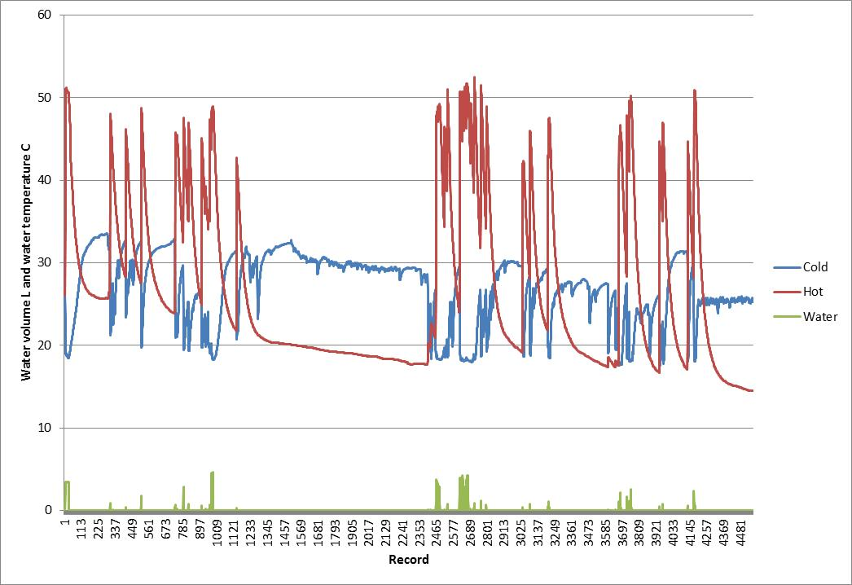

Some investigation showed that for hot water events of more than about 15 litres, or 5 records (150 seconds), the cold and hot temperatures reached fairly stable values. One particular issue was that where a long run of outside pipe was present before the inlet of the water heater, a slug of cooler water (in winter) or warmer water (in summer) would pass the temperature sensor before settling to the cold water supply temperature. This made analysis more complex for the cold inlet, which is why a dynamic window associated with each hot water event was used. The cold water temperature was the ***average*** temperature that occurred during the hot water event across a window that extended from 150 secs after the start of the water event (if longer than 150 secs or 5 records) or from the start (if shorter than 150 secs) through a period that included 1 minute (2 records) after the end of the hot water event. The cold water supply temperature could then be accurately assessed if only larger hot water events (typically >15 litres) were examined over the monitoring period. This method showed a very stable and slowly changing cold water supply temperature over the monitoring period (see Figure A2), which was found to decline over the monitoring period as expected.

The hot water temperature was the maximum temperature that occurred during the hot water event (plus a small window at the end). A small window at the end of each hot water event was added as it was found that the minimum/maximum sometimes occurred a minute or two after the hot water flow stopped. As the hot water temperature always increased during a hot water event, a maxima was the best measure. The variation in the hot water temperature is within the expect hysteresis of the stored hot water control and the variability of the mixing valve (where present). Some of the old storage systems had highly variable delivery temperatures. Both hot and cold temperature measurements showed significant thermal mass in the system (mass of pipes) with a time constant of more than 1 minute to adjust the temperature, which is why a dynamic assessment window was needed to more accurately assess the cold water supply temperature.

FIGURE A2: PLOT OF EVENT HOT AND COLD WATER TEMPERATURES AS A FUNCTION OF EVENT SIZE

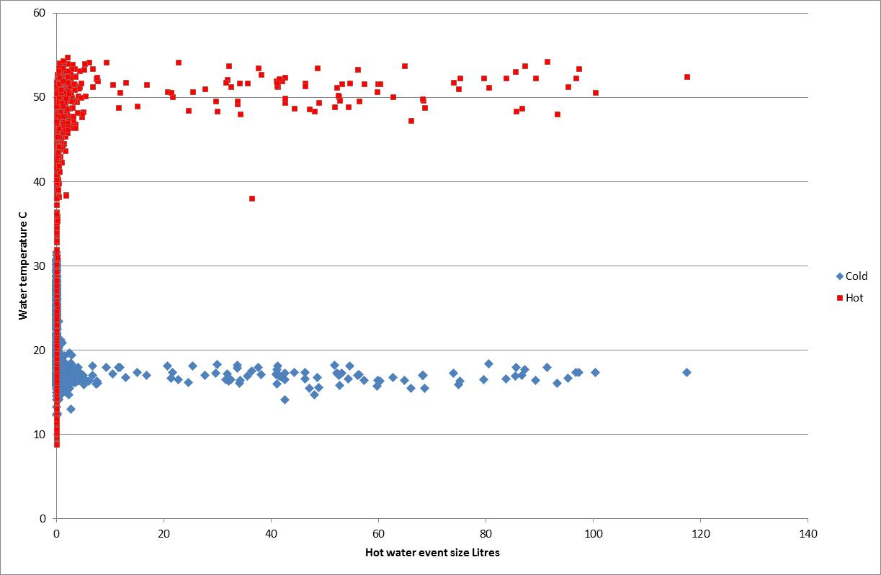

Note: these are recorded over several months so represent changing cold water conditions.

Another approach was also examined that used a volume weighted temperature measurement for both hot and cold water. This showed quite satisfactory results as the impact of very small events is discounted by the volume of hot water. This tends to underestimate the hot water delivery temperature by a few degrees, mainly due to the time constant of the thermal mass of the pipe. The result for the cold water temperature was quite good in that it was a bit more variable than that pure supply temperature estimated by the period method, but this is probably more indicative of the cold water temperature received by the water heater. Note that both volume weighted approaches suffer from the time lag associated with thermal mass and slow temperature change in the pipes. The weighted average cold temperature was sometimes above the cold supply temperature (event average) and sometimes below, depending on conduction from the water heater and the ambient conditions. The weighted average value has the added advantage of being fairly simple to calculate (unlike the dynamic event window).

When daily values for larger events are plotted over time, a pattern becomes clear. The following example is for House GWH1. (Note that event data is filtered for larger hot water events only while weighted values are volume weighted daily averages for all hot water events.)

Based on the temperature analysis, a constant value for hot water temperature is allocated to each water heater (separate value before and after the water heater changeover) and a function (line of best fit) is developed for the cold water temperature over the monitoring period (based on the event average).

These nominal values are used to calculate hot water energy for each event.

FIGURE A3: PLOT OF EVENT HOT AND COLD WATER TEMPERATURE FOR LARGER EVENTS OVER THE MONITORING PERIOD, HOUSE GWH1

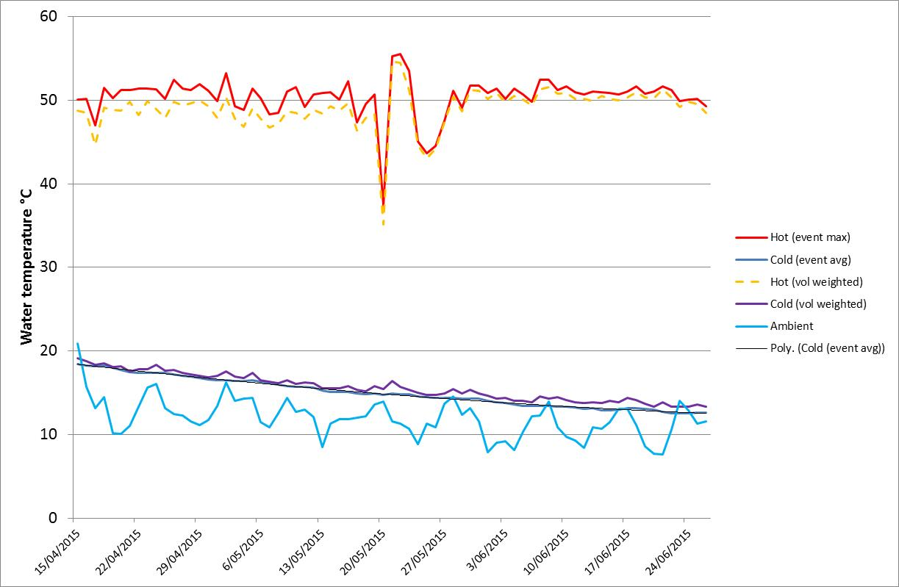

The next step was to separately examine the temperature sensors that have been strapped to hot water pipes that feed individual hot water taps, typically on the sink in the bathroom and in the kitchen. These sensors recorded temperature of the pipe every 10 minutes. This is fairly crude, but a rise in average temperature of more than 3 K indicates that hot water is likely to have been used in the previous 10 minutes. A flag was added to the raw temperature data to indicate whether hot water use was evident. For each hot water event, a lookup was undertaken to see whether there was hot water used on any of the monitored end uses – if so, these are marked with TRUE. This flag needs to be treated as a qualitative marker for several reasons. Firstly, the temperature flag goes on only once and it is possible that there are several small uses over a period longer than 10 minutes which are difficult to interpret from the data. Secondly, a temperature flag is not a unique indicator of hot water end use. For example, someone may use a hot tap in the bathroom before or after they take a shower. So it is not possible to differentiate the specific end use and allocate all hot water to one end use or another as all end uses are not monitored. The third consideration is that each 10 minute data interval for temperature recording corresponds to some 20 records in the hot water use data (30 seconds). There may be several hot water events in that 10 min period, some of which may be for other end uses. Sometimes two different temperature flags may be present across several hot water events. However, the temperature flags do seem to indicate an approximate allocation of hot water use in a qualitative sense.

For most houses, some water using appliances were also monitored, typically a clothes washer and sometimes a dishwasher. The use of these appliances is also marked with a flag when they are on. For these appliances, a review of the data can reveal whether the operation of the appliance appears to correlate with hot water use. If using hot water, clothes washers tend to use a significant volume of hot water at the start of the cycle. In contrast, dishwashers connected to hot water (relatively unusual) tend to use smaller volumes two or three times through the cycle. Two dishwashers appeared to be connected to hot water (at least for some cycles) but these did not have pipe temperature sensors. The problem with electrical measurements is that the cycles for these appliances are quite long (several hours in many cases) and there may be some coincidental hot water use during the period, so this needs to be interpreted with caution. Pipe sensors on appliances appear to provide better flags for hot water use. It is important to note that in the summary sheet only the parts of the appliance cycle that coincide with hot water events are shown. The full appliance cycles against all hot water records can be examined in the raw data sheets.

The next step was to undertake daily calculations for a range of parameters such as water temperatures, hot water use, hot water energy, gas input energy and overall performance. A range of other performance parameters were then calculated, such as:

* Comparative data before and after such as hot water volume, hot water energy, gas energy and overall task efficiency
* Analysis on the basis of hot water event size and likely end use for hot water
* Time of day hot water use and hot water energy.

## Estimation of annual gas consumption

Based on the analysis of monitoring data for the old and new water heater, it was possible to estimate an annual energy consumption for both systems. The overall principle is as set out in AS/NZS4234[46] for Zone 4, with specific variations as set out below.

**Hot water demand**: given that the monitoring period was from April to June, the hot water demand is likely to be in an “intermediate to winter” demand level. AS/NZS4234 assumes a seasonal energy demand profile of 1.0 in winter (winter peak demand = June, July, August and September) and minimum hot water demand of 0.7 of the winter peak in summer (see Table A5 of the standard). This monthly variation in hot water demand was assumed for the annual energy modelling. The average hot water demand recorded over the monitoring period (centred on May) was assumed to be 0.95 of the winter peak demand for the house, so this average value was scaled to estimate the winter peak demand for the house in MJ per day of hot water delivered.

TABLE A1: COMPARISON of AS/NZS4234 AND ASSUMED COLD WATER TEMPERATURES FOR ENERGY MODELLING

|  |  |  |  |
| --- | --- | --- | --- |
| **Month** | **AS/NZS4234 Cold Water Temp (°C)** | **Assumed Cold Water Temp (°C)** | **Assumed Ambient Air Temp (°C)** |
| Jan | 20 | 20 | 20.28 |
| Feb | 20 | 20 | 19.69 |
| Mar | 18 | 18 | 18.24 |
| Apr | 15 | 16 | 15.08 |
| May | 11 | 14 | 12.13 |
| Jun | 9 | 13 | 9.83 |
| Jul | 8 | 12 | 9.45 |
| Aug | 10 | 13 | 10.20 |
| Sep | 12 | 15 | 12.11 |
| Oct | 15 | 16 | 14.03 |
| Nov | 17 | 17 | 16.67 |
| Dec | 19 | 19 | 18.03 |

Note: Air temperatures based on BoM Tullamarine for 2005-2014 inclusive 1 min data.

**Cold water temperatures**: AS/NZS4234 assumes a specific monthly average cold water temperature for the calculation of hot water energy consumption. Monitoring from this project suggests that the assumed temperatures in AS/NZS4234 are too cold for the winter months, so a slightly modified temperature profile has been used, based on the results measured in homes. The values assumed are set out in Table A1 (values that are different to AS/NZS4234 are shown in the cells shaded grey).

**Ambient temperature**: For the purpose of adjusting heat loss values (maintenance rate) through the year for the calculation of annual energy consumption, the average monthly air temperature for Melbourne Bureau of Meteorology (BoM) Tullamarine has been used as listed in Table A1. This is based on 1 min data for the years 2005 to 2014 inclusive.

**Maintenance rate**: Based on detailed analysis for each water heater, the nominal maintenance rate at test conditions was estimated. This was based on an evaluation of daily energy consumption for the old and new water heaters over the entire monitoring period, adjusted for actual conditions during operation. This nominal maintenance rate was then scaled according to changes in ambient conditions through a typical year, based on an average ambient temperature profile.

**Recovery Efficiency**: The estimated recovery efficiency for each unit monitored was based on the total hot water energy over the monitoring period over the total gas energy consumed minus the estimated maintenance rate.

**Annual energy consumption**: Annual energy was calculated from the seasonal monthly hot water demand divided by the estimated recovery efficiency plus the seasonally adjusted monthly maintenance rate. Each monthly value was summed to give an annual estimate.

# A2: Detailed householder survey results

## Introduction

Surveys were conducted before and after the gas water heater were undertaken to identify any changes in householder satisfaction with the operation of their gas water heater, as well as to identify any changes which occurred after the retrofits were undertaken. The detailed results for each household which participated in the study are provided below.

## General satisfaction with gas water heater

Householders were asked to rate their level of satisfaction with the pool pump on a scale of 1 (extremely unsatisfied) to 5 (extremely satisfied) both before and after the pump was replaced. The detailed results are provided in Table A2.

TABLE A2: HOUSEHOLDER RATING OF SATISFACTION WITH THE WATER HEATER

|  |  |  |  |  |
| --- | --- | --- | --- | --- |
| **House Code** | **Before** | **After** | **Difference** | **Comments** |
| GWH1 | 4 | 5 | **1** | *Before* - Getting old. Would fail eventually. *After* - Very happy, has been seamless. Showers - never run out of hot water. Bath - never run out. |
| GWH2 | 4 | 5 | **1** | *Before* - Very old and inefficient. *After* - All fine, no issues. |
| GWH3 | 5 | 5 | **0** | *Before* - Very happy with the old unit. Just that it is old and most likely inefficient. *After* - Working as well as the old hot water system. Looking forward to seeing our gas bill. |
| GWH4 | 1 | 4 | **3** | *Before* - Very old and inefficient. Repaired multiple times.  *After* - Water hasn't been as hot since new system installed. Kitchen - hot water isn't hot enough (for dishes) but this is probably new plumbing regulations. Bathroom - hot water not as hot as old system, but good for bath and showers. |
| GWH5 | 2 | 3.5 | **1.5** | *Before* - Faulty and old, inefficient. Have to light in the morning to get hot water as pilot light would go out.  *After* - The unit uses a lot of water for the hot water to get to the kitchen tap. Kitchen - takes a long time for hot water to get to the kitchen. Water is not as hot. Bathroom - takes a long time for hot water to reach the bathroom. Water is not as hot. |
| GWH6 | 4 | 5 | **1** | *Before* - Not really an issue with old unit. Just old and likely [to be] inefficient. *After* - No issues. Haven't noticed that it's been changed. |
| **Average** | **3.33** | **4.58** | **1.25** |  |

## Changes noticed after the retrofit

Householders were asked a series of questions to obtain information regarding any changes which they had made to their use of hot water following the gas water heater retrofits.

Table A3 presents the householder comments regarding whether there had been any changes to their use of hot water following the retrofits. In general the households reported that they had not changed their use of hot water, or had not changed it significantly. GWH5 was the exception to this. The existing water heater at this house was faulty, which limited the amount of hot water that could be used and the timing of showers. The new water heater meant that they were now able to all have showers in the morning.

TABLE A3: ANY CHANGES TO THE USE OF HOT WATER FOLLOWING THE RETROFITS

|  |  |
| --- | --- |
| **House No** | **Householder Comments** |
| GWH1 | No changes. |
| GWH2 | No changes to way we use hot water. |
| GWH3 | No changes to our usage. |
| GWH4 | No significant change in usage since new system was installed. |
| GWH5 | Don't have to worry about running out of hot water so we all have showers in the morning. Don't have to light the unit every day. |
| GWH6 | No changes have been made. |

Table A4 presents the householder comments regarding whether there had been any changes to the length of time that people spend in the shower following the retrofits. Most houses reported that the amount of time spent in the shower was about the same after the retrofits. GWH1 reported that they were spending more time in the shower, but linked this to the winter conditions rather than the water heater retrofit. GWH5 reported that they now spent more time in the shower. As was the case with the general use of hot water (Table A2) this was because their existing water heater was faulty and after the retrofits they did not have to worry about running out of hot water.

TABLE A4: ANY CHANGES TO THE LENGTH OF TIME PEOPLE SPEND IN THE SHOWER

|  |  |
| --- | --- |
| **House No** | **Householder Comments** |
| GWH1 | More time - Because of the long winter. |
| GWH2 | About the same. No change, really don't notice the difference. |
| GWH3 | About the same. We haven't had to worry about running out of hot water. |
| GWH4 | About the same. |
| GWH5 | More time - can relax in the shower now without worrying about running out of hot water. |
| GWH6 | About the same - maybe a little bit less. More aware of energy use since installed. |

Table A5 presents householder comments regarding any perceived benefits of the gas water heater retrofits as well as any issues that resulted from the retrofits. A number of the households (GWH1, GWH3) indicated that they had not really notice any changes since their existing water heater was replaced. A number of households (GWH4, GWH5 and GWH6) noted that they no longer had to worry about the water heater not working or running out of hot water. Two households noted that the hot water temperature was lower following the retrofit. At GWH4 this was seen as an advantage in the bathroom as there was less chance of children burning themselves with the hot water, although in the kitchen this was seen as a disadvantage as the water was not hot enough to wash dishes in the sink and had to be supplemented by water boiled in a kettle at times. Household GWH5 reported that the hot water now took longer to reach the kitchen tap, and this was resulting in increased hot water use.

TABLE A5: PERCEIVED BENEFITS AND ISSUES OF THE GAS WATER HEATER RETROFITS

|  |  |
| --- | --- |
| **House No** | **Householder Comments** |
| GWH1 | No issues. |
| GWH2 | No response |
| GWH3 | Nothing to note. We are very happy as we haven't even noticed that the system has been replaced. |
| GWH4 | *Benefits* - Don't have to worry about hot water system not working. Don't have to worry about kids burning themselves in bath.  *Issues* - Find hot water system not hot enough in the kitchen sometimes - need to boil kettle when doing the dishes. |
| GWH5 | *Benefits* - Don't have to light the unit every morning. Know that won't run out of hot water. Takes up less room in house because unit moved outside.  *Issues* - Probably use more hot water because don't have to worry about running out. Cooler water than last unit. Use more water because hot water takes a long time to reach tap (kitchen). |
| GWH6 | No issues. More hot water, doesn't run out. Expect that it will be a lot more efficient. |

# A3: Monitoring results for each house

Below we provide a summary of the data collected from the metering equipment which was installed for each of the houses which participated in the *Gas Water Heater Retrofit Trial*. This includes details of the existing and replacement water heater, details of the monitoring period, and details of the average hot water use and energy consumption before and after the retrofits. A description of the key features of the different households prepared by Energy Efficient Strategies [EES 2016] is also included.

A range of graphs which provide information on the usage and energy consumption of the gas water heaters before and after retrofit are also provided:

* Daily gas use of water heater vs daily hot water consumption. Note that the gas use before the retrofit is indicated by the *blue* columns and the gas use after the retrofit is indicated by the *green* columns. The daily water use is shown by the orange line;
* Frequency distribution of daily hot water use, before and after the water heater retrofit;
* Average daily hot water demand profile before and after the retrofit. This shows the average hot water usage during each hour of the day in Litres, based on the pre- and post-retrofit monitoring period;
* Average daily hot water delivery profile, before and after the water heater retrofit. This shows the average water heating task during each hour of the day in MJ, based on the pre- and post-retrofit monitoring period;
* Average water heater daily gas input profile, before and after the retrofit. This shows the average amount of gas consumed by the water heater during each hour of the day in MJ, based on the pre- and post-retrofit monitoring period;
* The average daily water heating delivery profile (MJ) compared to the average daily gas input profile (MJ). Separate graphs are provided for the situation before the retrofit and the situation after the retrofit;
* A scatter diagram of daily gas consumption and daily water heating task, before and after the retrofits. Linear lines of best fit are applied to the data points both before and after the retrofits, and the y-axis intercepts of these lines can be used to estimate the daily maintenance rate of the water heaters in the pre- and post-retrofit monitoring periods;
* A scatter diagram of the overall efficiency of the water heaters on a daily basis compared to the daily water heating task, before and after the retrofits. Lines of best fit (generally logarithmic) have been applied to the before and after data sets to indicate the average efficiency characteristics over the operating range for which data is available. This allows the efficiency of the existing and replacement water heaters to be compared over their operating range.

## House GWH1

Start date: 15/4/15

Retrofit date: 20/5/15

End date: 26/6/15

|  |  |  |
| --- | --- | --- |
| **Parameter** | **Before retrofit** | **After retrofit** |
| Number of people | 3 – 3 adults | 3 – 3 adults |
| Gas water heater model | 170 litre gas storage, located outside. 25 years old. | 5.1-Star gas storage, located outside. |
| Average daily hot water use | 258.1 litres per day | 278.3 litres per day |
| Average cold water temperature | 16.5oC | 13.6oC |
| Average hot water temperature | 50.5oC | 50.6oC |
| Average temperature difference | 34.0oC | 37.1oC |
| Average daily water heating task | 37.7 MJ per day | 44.3 MJ per day |
| Average daily gas use | 61.7 MJ per day | 72.7 MJ per day |
| Average daily gas pilot use | 7.9 MJ per day | 6.9 MJ per day |
| Average daily water heating gas use | 53.8 MJ per day | 65.8 MJ per day |
| Estimated annual gas use | 23,583 MJ per year | 24,344 MJ per year |

Hot water demand at GWH1 was in the medium to high range. While the existing water heater for this house was very old (1988) it appeared to be performing well and the replacement water heater appeared to be of comparable performance. Both water heaters appeared to have an outlet temperature of about 51°C. It appeared that neither the dishwasher nor the clothes washer used hot water.

The graph shows the daily hot water use (orange line) and daily gas use (columns) of the water heater over the monitoring period. The daily gas use of the water heater before the retrofit is shown in blue and after the retrofit in green.

The graph compares the frequency distribution of daily hot water use before (blue line) and after (orange line) the retrofits. The graphs show the percentage of days in each monitoring period that daily hot water use was in a certain 20 Litre range, from 0 to 20 litres per day up to 480 to 500 Litres per day.

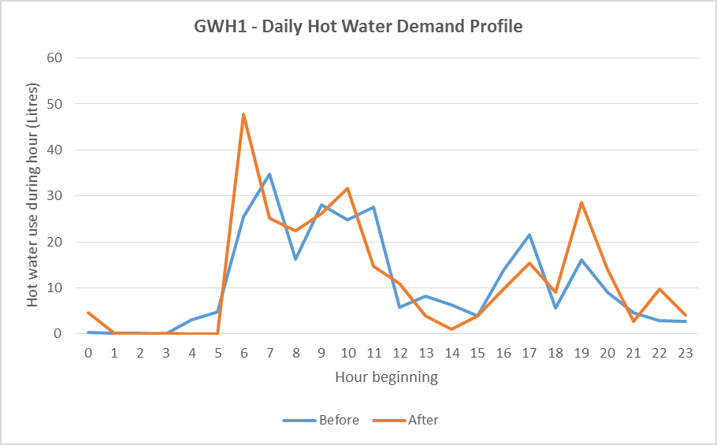

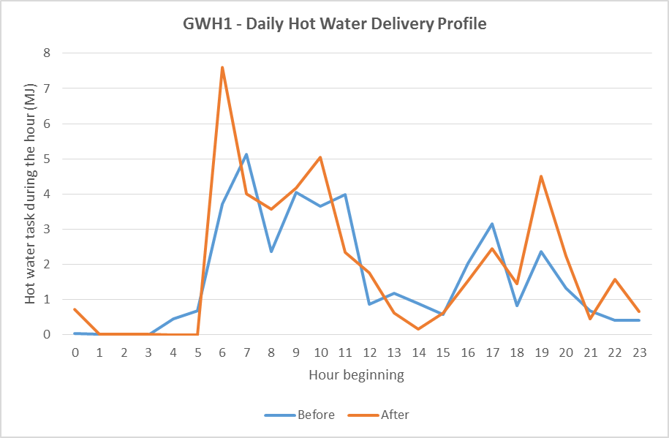

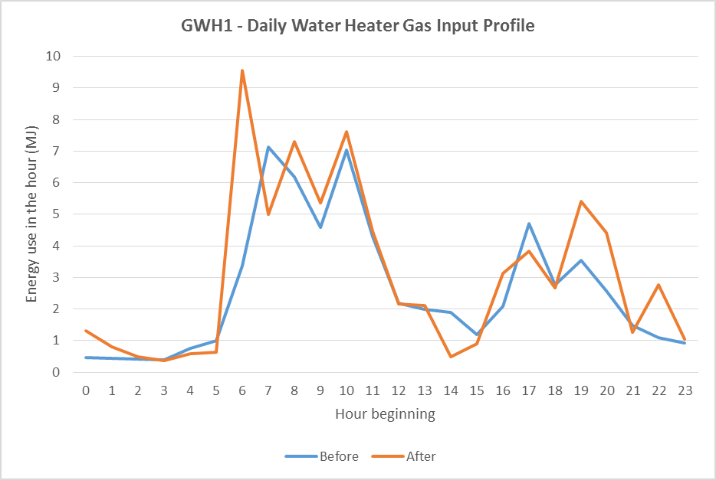

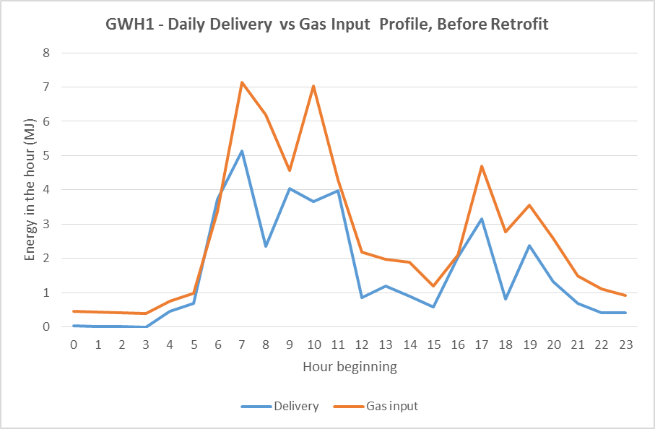

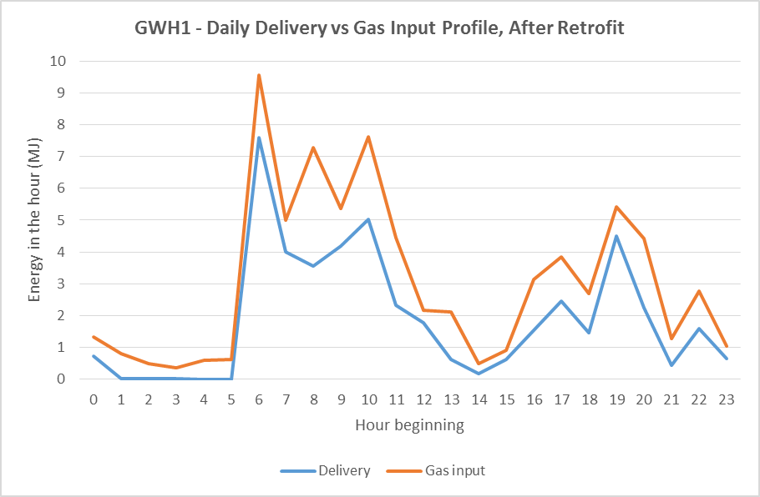

The graph is a scatter diagram which plots the daily water heating task against the daily gas use for both the pre-retrofit period (blue dots) and the post-retrofit period (orange dots). Linear lines of best fit are plotted for each data set, and the y-axis intercept of these lines provide an estimate of average daily maintenance rate of the water heaters during the monitoring period.

The graph is a scatter diagram which plots the daily water heating task against the overall efficiency of the water heater for both the pre-retrofit period (blue dots) and the post-retrofit period (orange dots). Logarithmic lines of best fit are plotted for each data set to give an indication of the average efficiency of the water heaters over their operating range during the monitoring period.

## House GWH2

Start date: 16/4/15

Retrofit date: 21/5/15

End date: 26/6/15

| **Parameter** | **Before retrofit** | **After retrofit** |
| --- | --- | --- |
| Number of people | 3 – 2 adults and 1 child | 3 – 2 adults and 1 child |
| Gas water heater model | 135 litre 3.2-Star gas storage, located outside, 15 years old | 5.1-Star gas storage, located outside |
| Average daily hot water use | 68.6 litres per day | 94.0 litres per day |
| Average cold water temperature | 17.6oC | 14.6oC |
| Average hot water temperature | 67.0oC | 53.3oC |
| Average temperature difference | 49.4oC | 38.7oC |
| Average daily water heating task | 14.2 MJ per day | 15.2 MJ per day |
| Average daily gas use | 49.5 MJ per day | 39.8 MJ per day |
| Average daily gas pilot use | 7.7 MJ per day | 7.4 MJ per day |
| Average daily water heating gas use | 41.8 MJ per day | 32.4 MJ per day |
| Estimated annual gas use | 21,340 MJ per year | 16,717 MJ per year |

Hot water demand at GWH2 was low. The existing water heater for this house was made in 2000 but its operating efficiency was quite low, so the replacement water heater provided some significant energy savings. The hot water temperature in the old water heater was around 67°C while the new water heater appeared to have an outlet temperature of about 53°C, so this in part explains why there is an increase in hot water volume after the retrofit. It appeared that the dishwasher at this house is associated with some hot water events and these appear to be about 2.5 litres. No hot water appeared to be used by the clothes washer during the monitoring period.

The graph shows the daily hot water use (orange line) and daily gas use (columns) of the water heater over the monitoring period. The daily gas use of the water heater before the retrofit is shown in blue and after the retrofit in green.

The graph compares the frequency distribution of daily hot water use before (blue line) and after (orange line) the retrofits. The graphs show the percentage of days in each monitoring period that daily hot water use was in a certain 20 Litre range, from 0 to 20 litres per day up to 480 to 500 Litres per day.

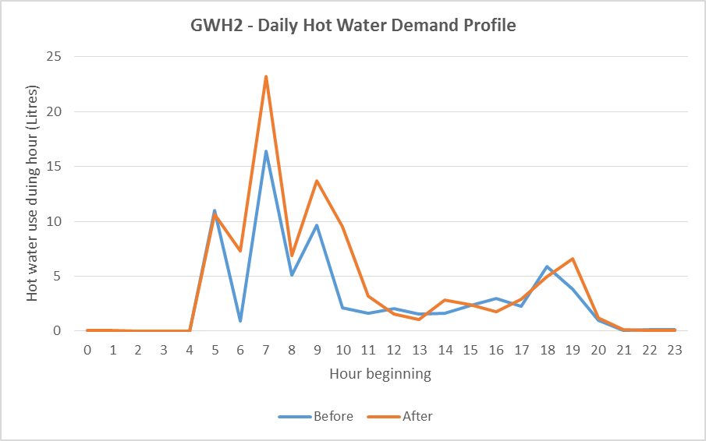

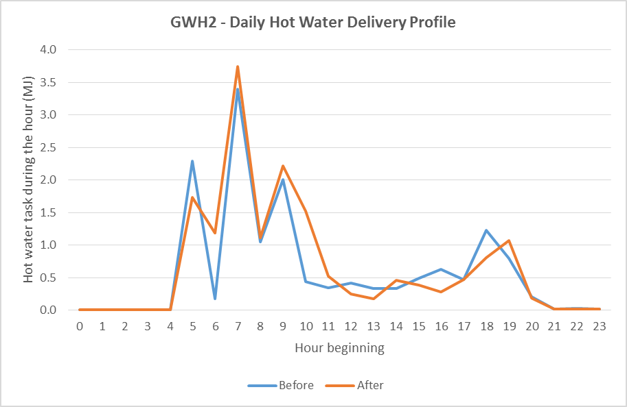

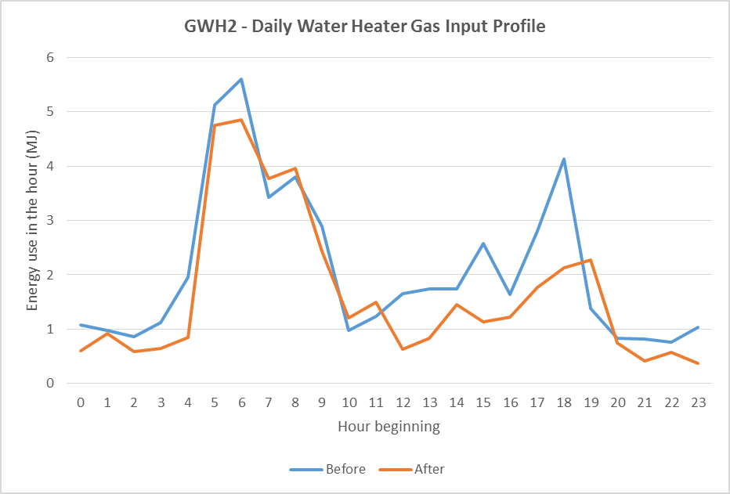

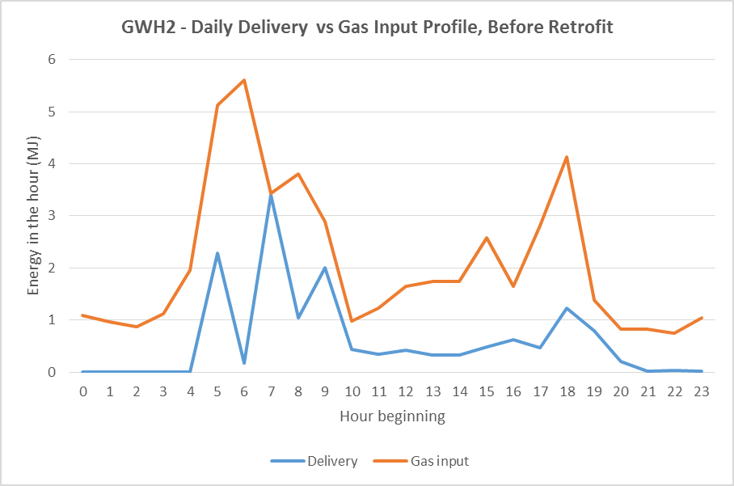

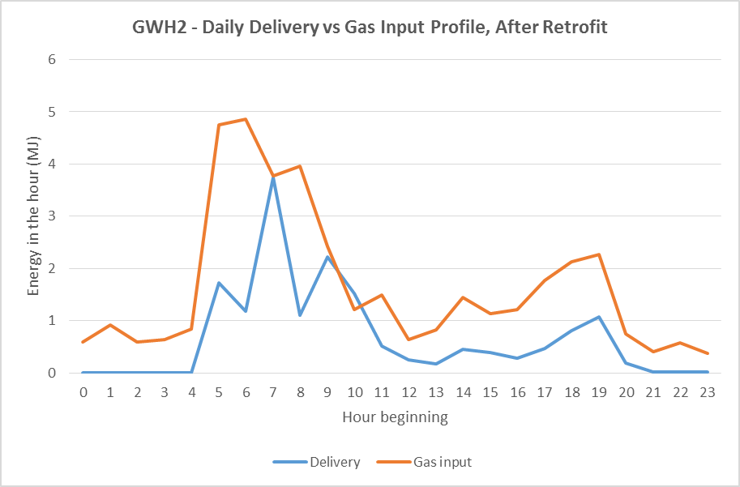

The graph is a scatter diagram which plots the daily water heating task against the daily gas use for both the pre-retrofit period (blue dots) and the post-retrofit period (orange dots). Linear lines of best fit are plotted for each data set, and the y-axis intercept of these lines provide an estimate of average daily maintenance rate of the water heaters during the monitoring period.

The graph is a scatter diagram which plots the daily water heating task against the overall efficiency of the water heater for both the pre-retrofit period (blue dots) and the post-retrofit period (orange dots). Logarithmic lines of best fit are plotted for each data set to give an indication of the average efficiency of the water heaters over their operating range during the monitoring period.

## House GWH3

Start date: 16/4/15

Retrofit date: 27/5/15

End date: 30/6/15

|  |  |  |
| --- | --- | --- |
| **Parameter** | **Before retrofit** | **After retrofit** |
| Number of people | 4 people – 2 adults and 2 children | 4 people – 2 adults and 2 children |
| Gas water heater model | 135 litre, 3.4-Star gas storage, located inside, 16 years old | 5.1-Star gas storage, located outside |
| Average daily hot water use | 176.9 litres per day | 166.4 litres per day |
| Average cold water temperature | 17.1oC | 14.2oC |
| Average hot water temperature | 52.2oC | 54.5oC |
| Average temperature difference | 35.1oC | 40.3oC |
| Average daily water heating task | 26.5 MJ per day | 28.1 MJ per day |
| Average daily gas use | 49.3 MJ per day | 53.0 MJ per day |
| Average daily gas pilot use | 8.7 MJ per day | 7.4 MJ per day |
| Average daily water heating gas use | 40.6 MJ per day | 45.6 MJ per day |
| Estimated annual gas use | 18,466 MJ per year | 18,190 MJ per year |

Hot water demand at GWH3 was medium. The existing water heater for this house was made in 1999 but was operating fairly well, so the replacement water heater provided only modest savings (mostly on days of lower hot water demand). The hot water temperature in the old water heater was quite erratic ranging from around 48°C to 58°C, while the new water heater appeared to have an outlet temperature of about 54°C. The clothes washer at this house used hot water with hot water events typically in the range 15 litres to 45 litres. The water heater at this house was moved from the laundry to outside, so there is a discontinuity in the ambient air temperature that the water heater was operating in.

The graph shows the daily hot water use (orange line) and daily gas use (columns) of the water heater over the monitoring period. The daily gas use of the water heater before the retrofit is shown in blue and after the retrofit in green.

The graph compares the frequency distribution of daily hot water use before (blue line) and after (orange line) the retrofits. The graphs show the percentage of days in each monitoring period that daily hot water use was in a certain 20 Litre range, from 0 to 20 litres per day up to 480 to 500 Litres per day.

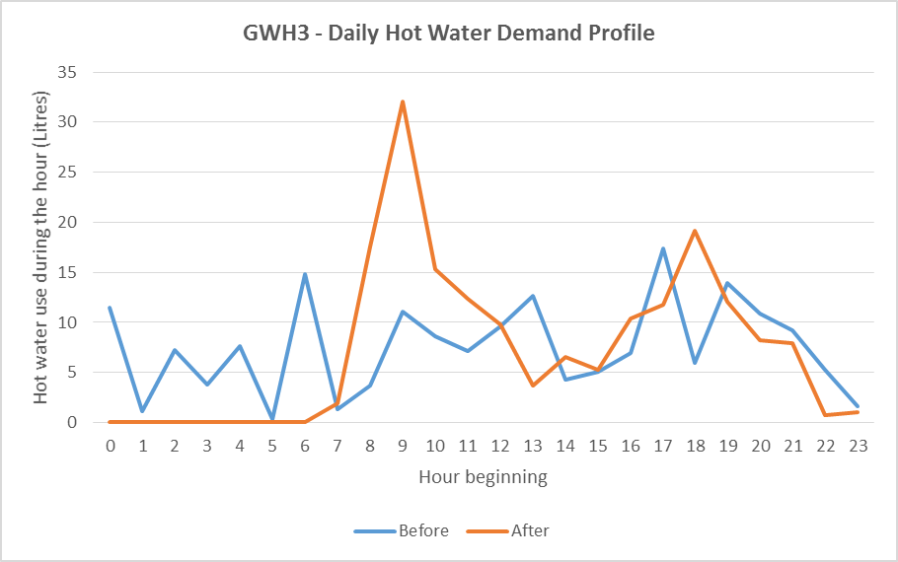

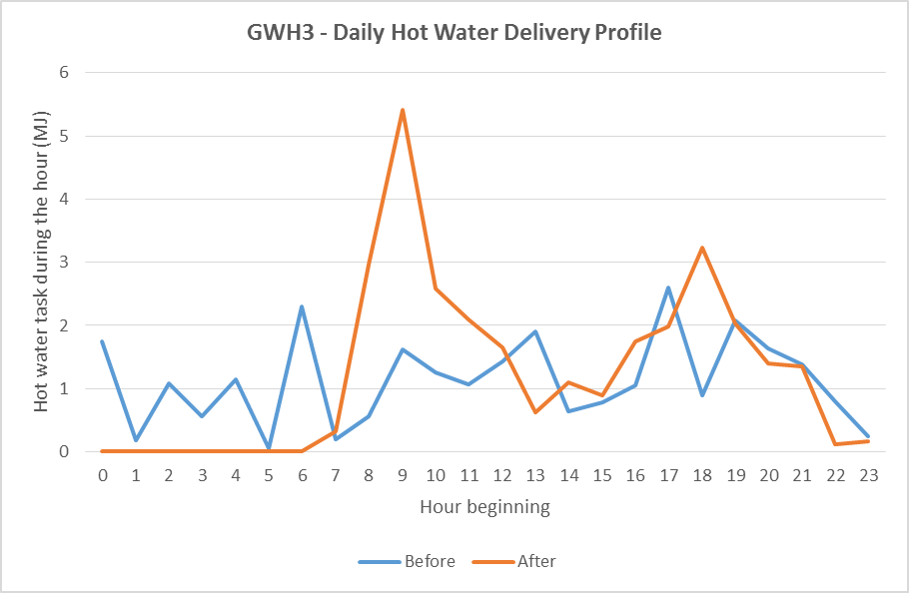

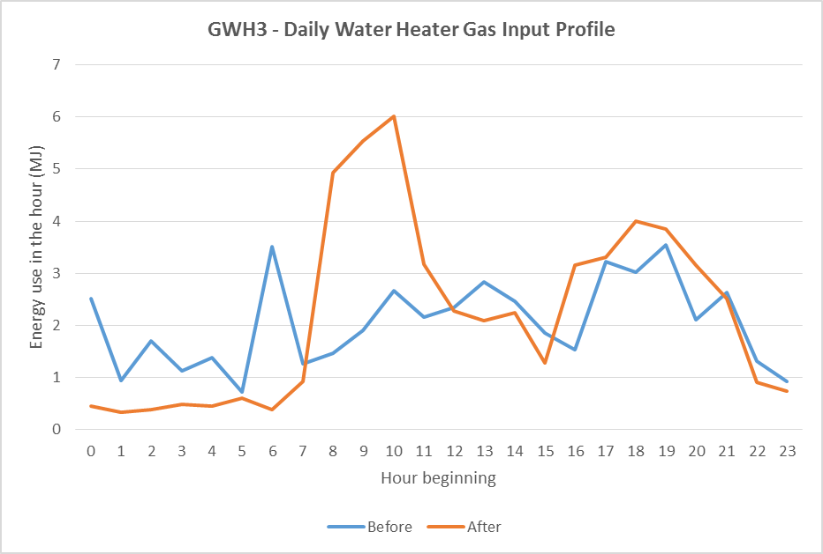

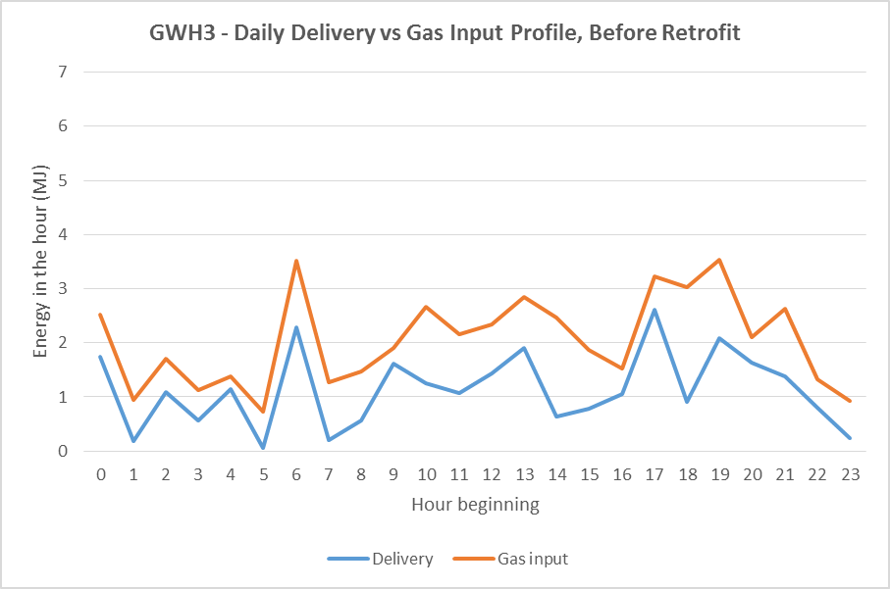

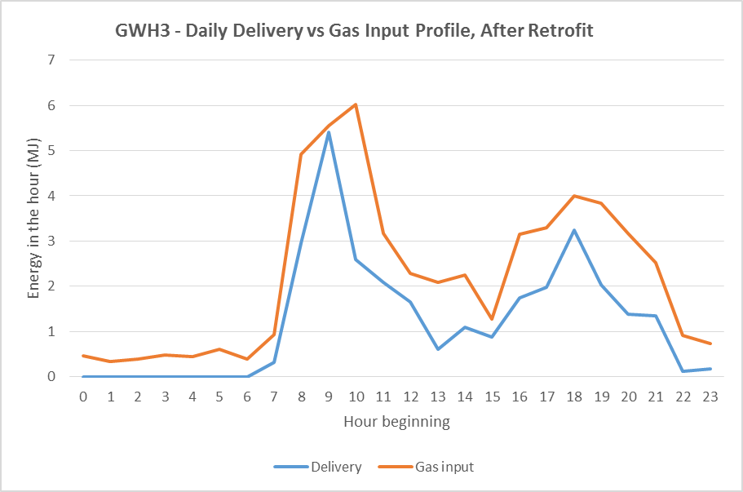

The graph is a scatter diagram which plots the daily water heating task against the daily gas use for both the pre-retrofit period (blue dots) and the post-retrofit period (orange dots). Linear lines of best fit are plotted for each data set, and the y-axis intercept of these lines provide an estimate of average daily maintenance rate of the water heaters during the monitoring period.

The graph is a scatter diagram which plots the daily water heating task against the overall efficiency of the water heater for both the pre-retrofit period (blue dots) and the post-retrofit period (orange dots). Logarithmic lines of best fit are plotted for each data set to give an indication of the average efficiency of the water heaters over their operating range during the monitoring period.

## House GWH4

Start date: 16/4/15

Retrofit date: 20/5/15

End date: 26/6/15

|  |  |  |
| --- | --- | --- |
| **Parameter** | **Before retrofit** | **After retrofit** |
| Number of people | 4 people – 2 adults and 2 children | 4 people – 2 adults and 2 children |
| Gas water heater model | 135 litre gas storage, located outside, 21 years old | 5.1-Star gas storage, located outside |
| Average daily hot water use | 96.5 litres per day | 133.0 litres per day |
| Average cold water temperature | 16.8oC | 14.1oC |
| Average hot water temperature | 67.0oC | 55.0oC |
| Average temperature difference | 49.7oC | 40.9oC |
| Average daily water heating task | 20.1 MJ per day | 22.8 MJ per day |
| Average daily gas use | 56.4 MJ per day | 44.4 MJ per day |
| Average daily gas pilot use | 25.9 MJ per day | 7.3 MJ per day |
| Average daily water heating gas use | 30.5 MJ per day | 37.2 MJ per day |
| Estimated annual gas use | 20,404 MJ per year | 14,748 MJ per year |

Hot water demand at this house was fairly low, and below average for a four person household. The existing water heater for this house was made in 1995 and was not operating all that well, so the replacement water heater provided good savings. The water data logger at this house failed, so only limited results are available, and the analysis of water use is based on the readings taken at the start and end of the monitoring period, and when the water heater was replaced. The hot water temperature in the old water heater was quite erratic ranging from around 60°C to 70°C while the new water heater appeared to have an outlet temperature of about 55°C, although these are only estimates as temperatures were hard to estimate without water flow data.

The graph shows the daily gas use (columns) of the water heater over the monitoring period. The daily gas use of the water heater before the retrofit is shown in blue and after the retrofit in green. There was no daily hot water use data available for this house, due to the failure of the water meter.

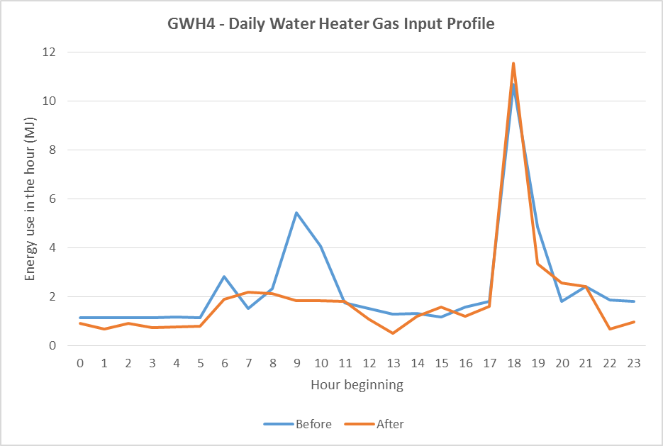

## House GWH5

Start date: 16/4/15

Retrofit date: 29/5/15

End date: 30/6/15

|  |  |  |
| --- | --- | --- |
| **Parameter** | **Before retrofit** | **After retrofit** |
| Number of people | 3 people – 1 adult and 2 children | 3 people – 1 adult and 2 children |
| Gas water heater model | 135 litre, 2-Star gas storage, located inside, 16 years old | 6.1-Star gas instantaneous, located outside |
| Average daily hot water use | 73.6 litre per day | 112.3 litres per day |
| Average cold water temperature | 16.8oC | 13.4oC |
| Average hot water temperature | 48.0oC | 45.7oC |
| Average temperature difference | 31.2oC | 32.3oC |
| Average daily water heating task | 9.7 MJ per day | 15.1 MJ per day |
| Average daily gas use | 25.8 ML per day | 18.6 MJ per day |
| Average daily gas pilot use | 2.2 MJ per day | 0.0 MJ per day |
| Average daily water heating gas use | 23.6 MJ per day | 18.6 MJ per day |
| Estimated annual gas use | 15,859 MJ per year | 5,005 MJ per year |

Hot water demand at GWH5 was very low. The existing water heater for this house was made in 1993 and was operating quite poorly. The pilot light would go out regularly and so the gas usage appears as large gas events that are widely spaced. This was very inconvenient for the users. This mode of operation made the overall efficiency of the water heater look better than it actually was in that the maintenance rate was low and the recovery efficiency appeared high, but the hot water service delivery was poor. The replacement water heater was an instantaneous system which provided very large savings (a 30% decrease in energy with a 48% increase in hot water demand). The estimated annual change in energy (if the old system had been working correctly) was a 68% decrease in energy.

The gas monitoring for this house was the only one where a standard pulse counter was used on 5 minute intervals, so the event resolution on the gas side was not as good as it could have been for an instantaneous system. The electrical consumption of the gas water heater was not recorded, which would have provided good data on hot water event sizes that triggered operation of the unit. The hot water temperature in the old water heater was very erratic ranging from around 40°C to 52°C (because the pilot light often went out and the tank cooled) while the new water heater had an outlet temperature of about 45.8°C which was very stable. The clothes washer used hot water on a few occasions (rarely) with events typically in the range 10 litres to 55 litres. This is a good example to illustrate the case where a poor or inadequate appliance that is replaced appears to facilitate an increase in energy service (a type of nominal rebound, but this is not economically driven).

The graph shows the daily hot water use (orange line) and daily gas use (columns) of the water heater over the monitoring period. The daily gas use of the water heater before the retrofit is shown in blue and after the retrofit in green.

The graph compares the frequency distribution of daily hot water use before (blue line) and after (orange line) the retrofits. The graphs show the percentage of days in each monitoring period that daily hot water use was in a certain 20 Litre range, from 0 to 20 litres per day up to 480 to 500 Litres per day.

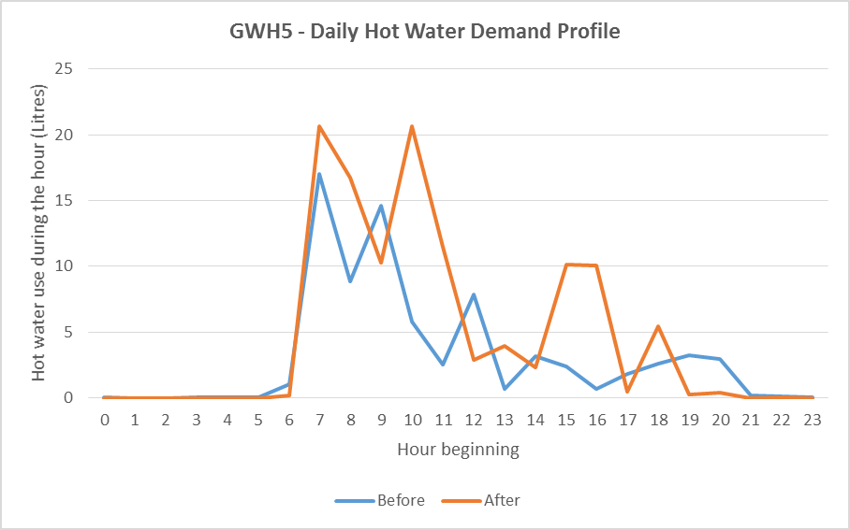

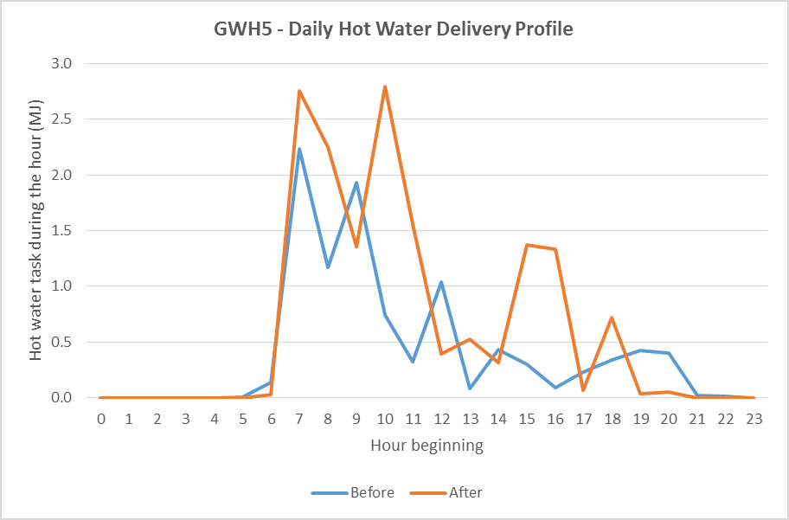

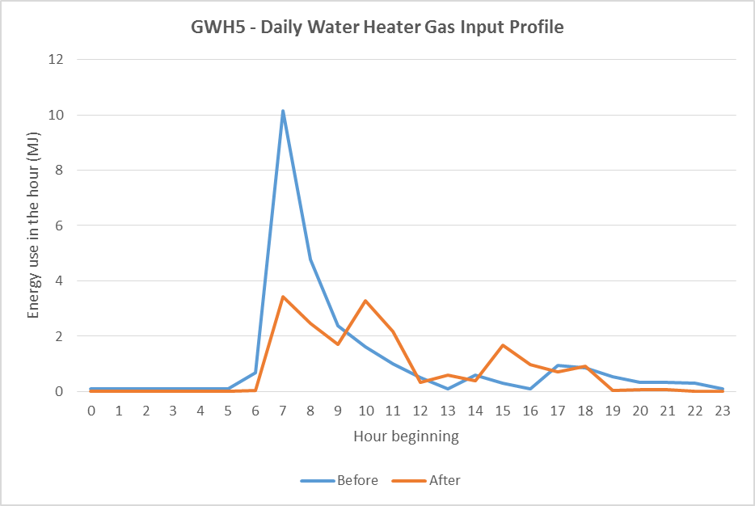

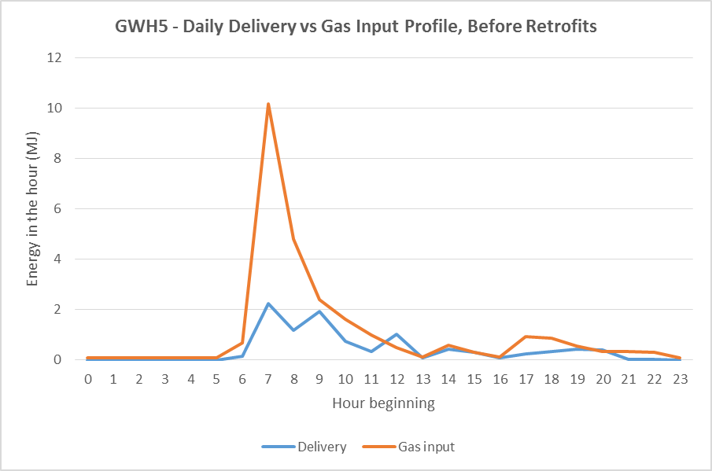

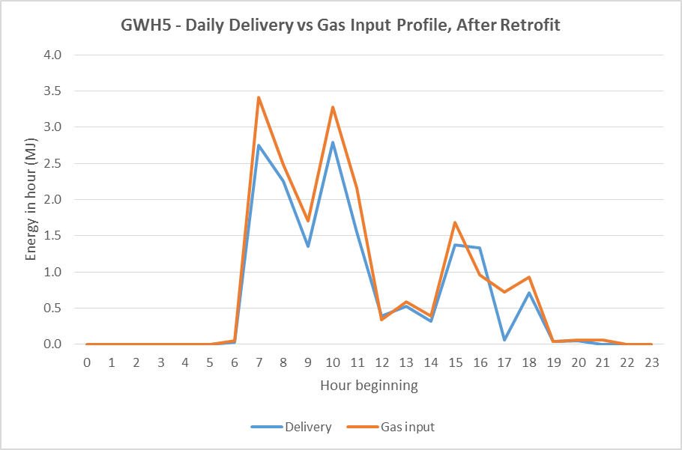

The graph is a scatter diagram which plots the daily water heating task against the daily gas use for both the pre-retrofit period (blue dots) and the post-retrofit period (orange dots). Linear lines of best fit are plotted for each data set, and the y-axis intercept of these lines provide an estimate of average daily maintenance rate of the water heaters during the monitoring period.

The graph is a scatter diagram which plots the daily water heating task against the overall efficiency of the water heater for both the pre-retrofit period (blue dots) and the post-retrofit period (orange dots). Logarithmic lines of best fit are plotted for each data set to give an indication of the average efficiency of the water heaters over their operating range during the monitoring period.

## House GWH6

Start date: 17/4/15

Retrofit date: 21/5/15

End date: 30/6/15

|  |  |  |
| --- | --- | --- |
| **Parameter** | **Before retrofit** | **After retrofit** |
| Number of people | 4 people – 2 adults and 2 children | 4 people – 2 adults and 2 children |
| Gas water heater model | 135 litre, 3.2-Star gas storage, located outside, 11 years old | 5.1-Star gas storage, located outside |
| Average daily hot water use | 174.6 litres per day | 178.9 litres per day |
| Average cold water temperature | 17.4oC | 14.0oC |
| Average hot water temperature | 66.3oC | 57.9oC |
| Average temperature difference | 48.9oC | 43.9oC |
| Average daily water heating task | 35.9 MJ per day | 33.6 MJ per day |
| Average daily gas use | 71.2 MJ per day | 60.6 MJ per day |
| Average daily gas pilot use | 7.5 MJ per day | 8.1 MJ per day |
| Average daily water heating gas use | 63.7 MJ per day | 52.4 MJ per day |
| Estimated annual gas use | 25,719 MJ per year | 22,840 MJ per year |

Hot water demand at GWH6 was above average. The existing water heater for this house was made in 2004 and was operating reasonably well. The replacement water heater appeared to be of comparable performance so the savings were only very modest. The hot water temperature in the old water heater was a bit erratic ranging from around 68°C while the new water heater had an outlet temperature of about 58°C. Despite the change in temperature, there was little change in hot water demand (volume) and a small decrease in energy. It appeared that the dishwasher is associated with some hot water events that are about 5 litres. No hot water appeared to be used by the clothes washer.

The graph shows the daily hot water use (orange line) and daily gas use (columns) of the water heater over the monitoring period. The daily gas use of the water heater before the retrofit is shown in blue and after the retrofit in green.

The graph compares the frequency distribution of daily hot water use before (blue line) and after (orange line) the retrofits. The graphs show the percentage of days in each monitoring period that daily hot water use was in a certain 20 Litre range, from 0 to 20 litres per day up to 480 to 500 Litres per day.

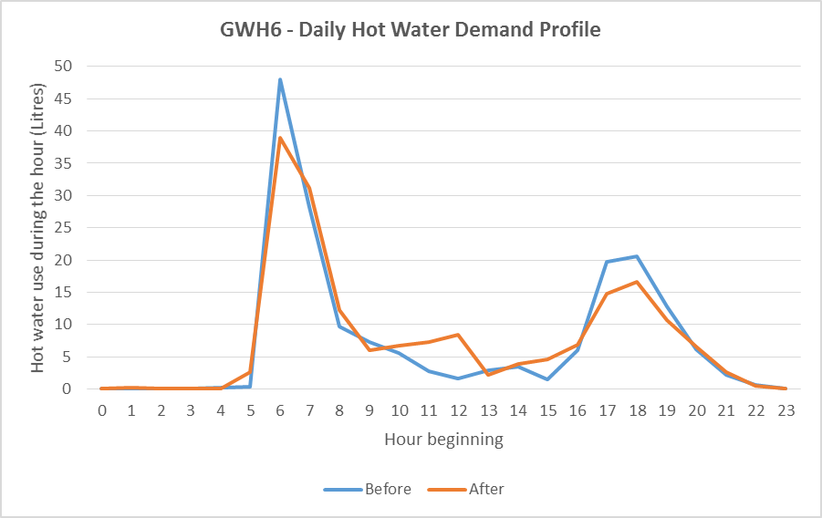

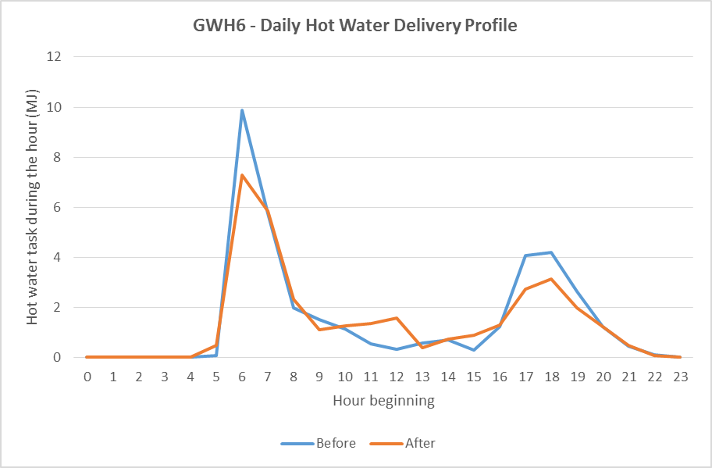

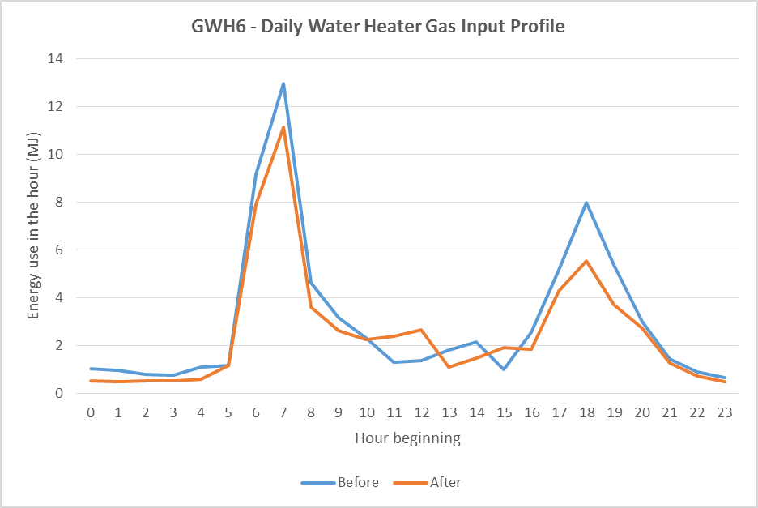

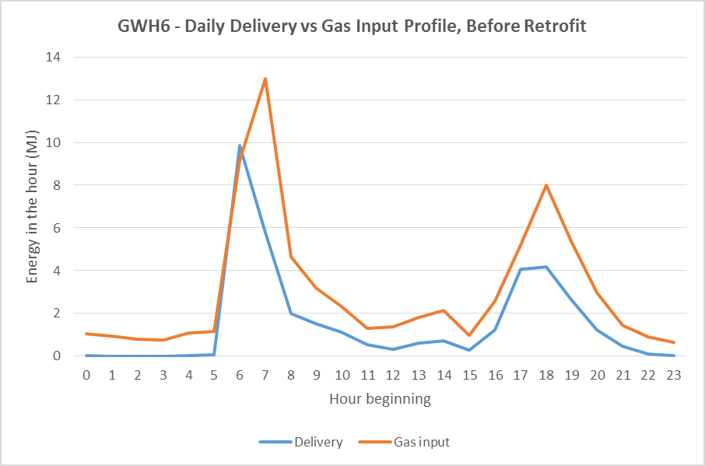

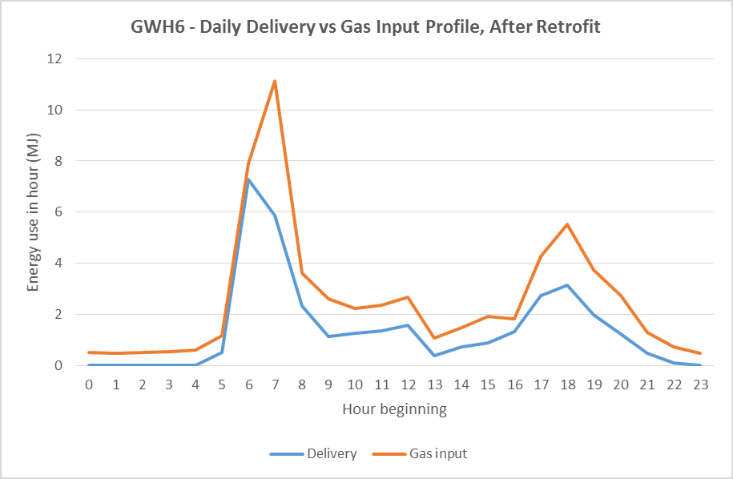

The graph is a scatter diagram which plots the daily water heating task against the daily gas use for both the pre-retrofit period (blue dots) and the post-retrofit period (orange dots). Linear lines of best fit are plotted for each data set, and the y-axis intercept of these lines provide an estimate of average daily maintenance rate of the water heaters during the monitoring period.

The graph is a scatter diagram which plots the daily water heating task against the overall efficiency of the water heater for both the pre-retrofit period (blue dots) and the post-retrofit period (orange dots). Logarithmic lines of best fit are plotted for each data set to give an indication of the average efficiency of the water heaters over their operating range during the monitoring period.

1. To end 2015 we have trialled halogen downlight replacements, comprehensive draught sealing, pump-in cavity wall insulation, gas heating ductwork upgrades, combined gas heating ductwork and gas furnace upgrades, window film secondary glazing, pool pump replacements, heat pump clothes dryers, solar air heaters, external shading, halogen downlight replacements combined with ceiling insulation remediation, gas water heater upgrades and some comprehensive whole house retrofits.
2. In those houses in which the water heater upgrade was modelled the average savings were 2,509 MJ/yr (energy), 566 kg CO2-e per year (greenhouse), and $99.8 per year (energy bill) for an average payback of 8.2 years.
3. Data for 2008 to 2014 based on ABS 4602.0.55.001 *Environmental Issues: Energy Use and Conservation* – the data was compiled by ABS for SV. Data for 2005 to 1999 based on [ABS 2005]. Note that data has been adjusted by SV to remove the “don’t know” responses.
4. To end 2015 we have trialled halogen downlight replacements, comprehensive draught sealing, pump-in cavity wall insulation, gas heating ductwork upgrades, combined gas heating ductwork and gas furnace upgrades, window film secondary glazing, pool pump replacements, heat pump clothes dryers, solar air heaters, external shading, gas water heater upgrades, halogen downlight replacements combined with ceiling insulation remediation and some comprehensive whole house retrofits.
5. The replacement of an existing gas water heater with a gas-boosted solar water heater is eligible to obtain a financial incentive through both the Small Technology Certificate (STC) scheme and the Victorian Energy Efficiency Target (VEET) scheme. Based on current STC and VEET certificate prices this would generate a financial incentive of around $1,200 to $1,400.
6. A recent study for the South Australian Government monitored the operation of different types of water heaters in twelve houses located in Adelaide over a one year period. [DMITRE 2014]
7. The sensors were firmly taped to the metal pipes and had pipe lagging wrapped around them so that the measured the surface temperature of the pipes. This meant that they sensed the temperature of the water within the pipe but with a bit of a delay.
8. These systems are also referred to as continuous flow water heaters. Note that the official Energy Rating scale for gas water heaters stops at 6-Stars, however some gas instantaneous water heaters are more efficient and have a lower gas consumption than a model that just meets the 6-Star rating. For simplicity in this report we refer to this as a 6.1-Star model.
9. For a cold water temperature of 15oC, this would mean that the water was heated to 40oC, which is typical of the water temperature used for showering.
10. The rated flow rate of a gas instantaneous water heater is expressed in Litres per minute, and is usually based on heating water to a temperature 25oC above the cold water temperature, or a temperature of around 45oC.
11. Assuming a temperature rise of 45oC from the cold water temperature to the hot water temperature – for a cold water temperature of 15oC this would correspond to hot water at 60oC.
12. This is simply the average of the winter and summer use.
13. This is the percentage of energy in the gas that is transferred into the hot water.
14. The full title of this standard is *AS/NZS 5263.1.2: 2016 Gas appliances: Part 1.2: Gas fired water heaters for hot water supply and/or central heating*, 11 February 2016.
15. For further information see: <http://www.energyrating.gov.au/products/water-heaters/gas-water-heaters>
16. For example, the Australian Gas Association publishes this data in their Product Directory which can be accessed at: <http://www.aga.asn.au/product_directory> . Data on the gas water heaters which have been registered for MEPS under the E3 Program can be obtained from: <http://reg.energyrating.gov.au/comparator/product_types/62/search/>
17. 3 Star gas storage – burner efficiency of 75.2% and daily maintenance rate of 18 MJ per day; 5 Star gas storage – 83.7% burner efficiency and daily maintenance rate of 12 MJ per day; 5 Star gas instantaneous – burner efficiency of 76% and start-up losses of 0.39 MJ; 6 Star gas instantaneous – burner efficiency of 83.4% and start-up losses of 0.33 MJ. Note that different combinations of burner efficiency and maintenance rate (or start-up losses) can give the same Star Rating.
18. *AS/NZS 4234:2008 Heated water systems - Calculation of energy consumption*.
19. Note that it was not possible to identify the Star Rating of all existing water heaters.
20. This is the daily hot water use calculated by EES from the metering data. It is based on the temperature of the hot water that is output from the water heaters and has not been normalised to a specific temperature (e.g. 60oC) or temperature rise (e.g. 45oC).
21. The pulse counter attached to the water meter installed at house GWH5 failed, so no interval data was available for this house. The average hot water usage data for this house was obtained from readings of the water meter when the meter was first installed, after the retrofit, and when the meter was removed.
22. In this household the adult had 1 shower per day, one child had 2 showers per week and one had 3 showers per week.
23. Historical energy labelling data was used to estimate the hot water use per cycle for both the washing machine and the dishwasher. In the case of the clothes washers the estimate took into account the householder reported usage on warm and cold wash cycles.
24. This is the amount of hot water (in Litres) which is drawn off from the water heater in a single hot water use event.
25. For these houses the hot water use for events in the range of 10 to 30 Litres was taken into account.
26. Due to the time of year this average water heating task of 17.2 MJ per day should be approximately the same as the annual average water heating task.
27. In this case the “water heating energy” includes both the energy required to heat the water during a water heating (recovery) cycle, and the energy required to re-heat the water during a maintenance recovery cycle.
28. Note that this also resulted in a lower heating cycle efficiency as the gas pilot provides some heat input to the water.
29. See Appendix A1 for further information on the methodology used.
30. This analysis is also based on the entire monitoring period and excludes house GWH4.
31. Householders ranked their level of satisfaction on a rating scale from 1 to 5 where: 1 = extremely unsatisfied; 3 = satisfied; and 5 = extremely satisfied.
32. Note that at the replacement water heater at GWH5 was an instantaneous gas water heater this does not have a pilot light. This water heater will also have some electricity consumption, but this is quite small and has been ignored for our analysis.
33. The gas pilot (around 7 to 8 MJ per day) provides some heat input into the storage cylinder and helps to make up the standing losses to some extent. In our analysis the rest of the energy required to address the standing losses is included in the gas consumption for water heating.
34. See Appendix A1 for more details of the methodology used.
35. This estimate is based on a natural gas cost of 2 c/MJ.
36. This is the average installation cost divided by the average annual energy bill savings, as opposed to the average of the payback periods for each house.
37. This is the estimated average total installation cost of a gas storage water heater from *The Household Appliances Market in Australia 2012*, Volume 4 Hot Water Systems, BIS Shrapnel.
38. Note that the upgrade cost could be less than this if the location of the existing gas storage and gas instantaneous system was the same and if a new gas line did not have to be installed.
39. Data was not available for GWH4 as the water meter failed at this house.
40. This is the daily water heating task divided by the daily gas consumption of the water heater. This was undertaken for all houses except GWH4 – See Appendix 3 for detailed results.
41. In this case it was found that a polynomial line gave the highest level of correlation for the line of best fit.
42. In this case it was assumed the burner efficiency was 84.0% and the maintenance rate was 11.65 MJ/day. Note that different combinations of burner efficiency and maintenance rate will result in a 5.1 Star rating at the water heating task of 37.7 MJ per day, which is the basis of gas water heater energy labelling.
43. The maintenance rate was adjusted by a factor of (60 – 11.3)/40, or 1.22.
44. Correspondence with Lloyd Harrington of EES, July 2016.
45. It was assumed the 5-Star storage system had a burner efficiency of 83.7% and a maintenance rate of 12 MJ per day. It was assumed the 6-Star instantaneous system had a burner efficiency of 83.4% and start-up losses of 0.33 MJ. Both maintenance rate and start-up losses were increased by a factor of 1.22 to take into account the ambient temperature of 11.3oC experienced in the field.
46. AS/NZS 4234:2008 *Heated Water Systems – Calculation of energy consumption.* In this standard Zone 4 is the climatic zone in which Melbourne is located.