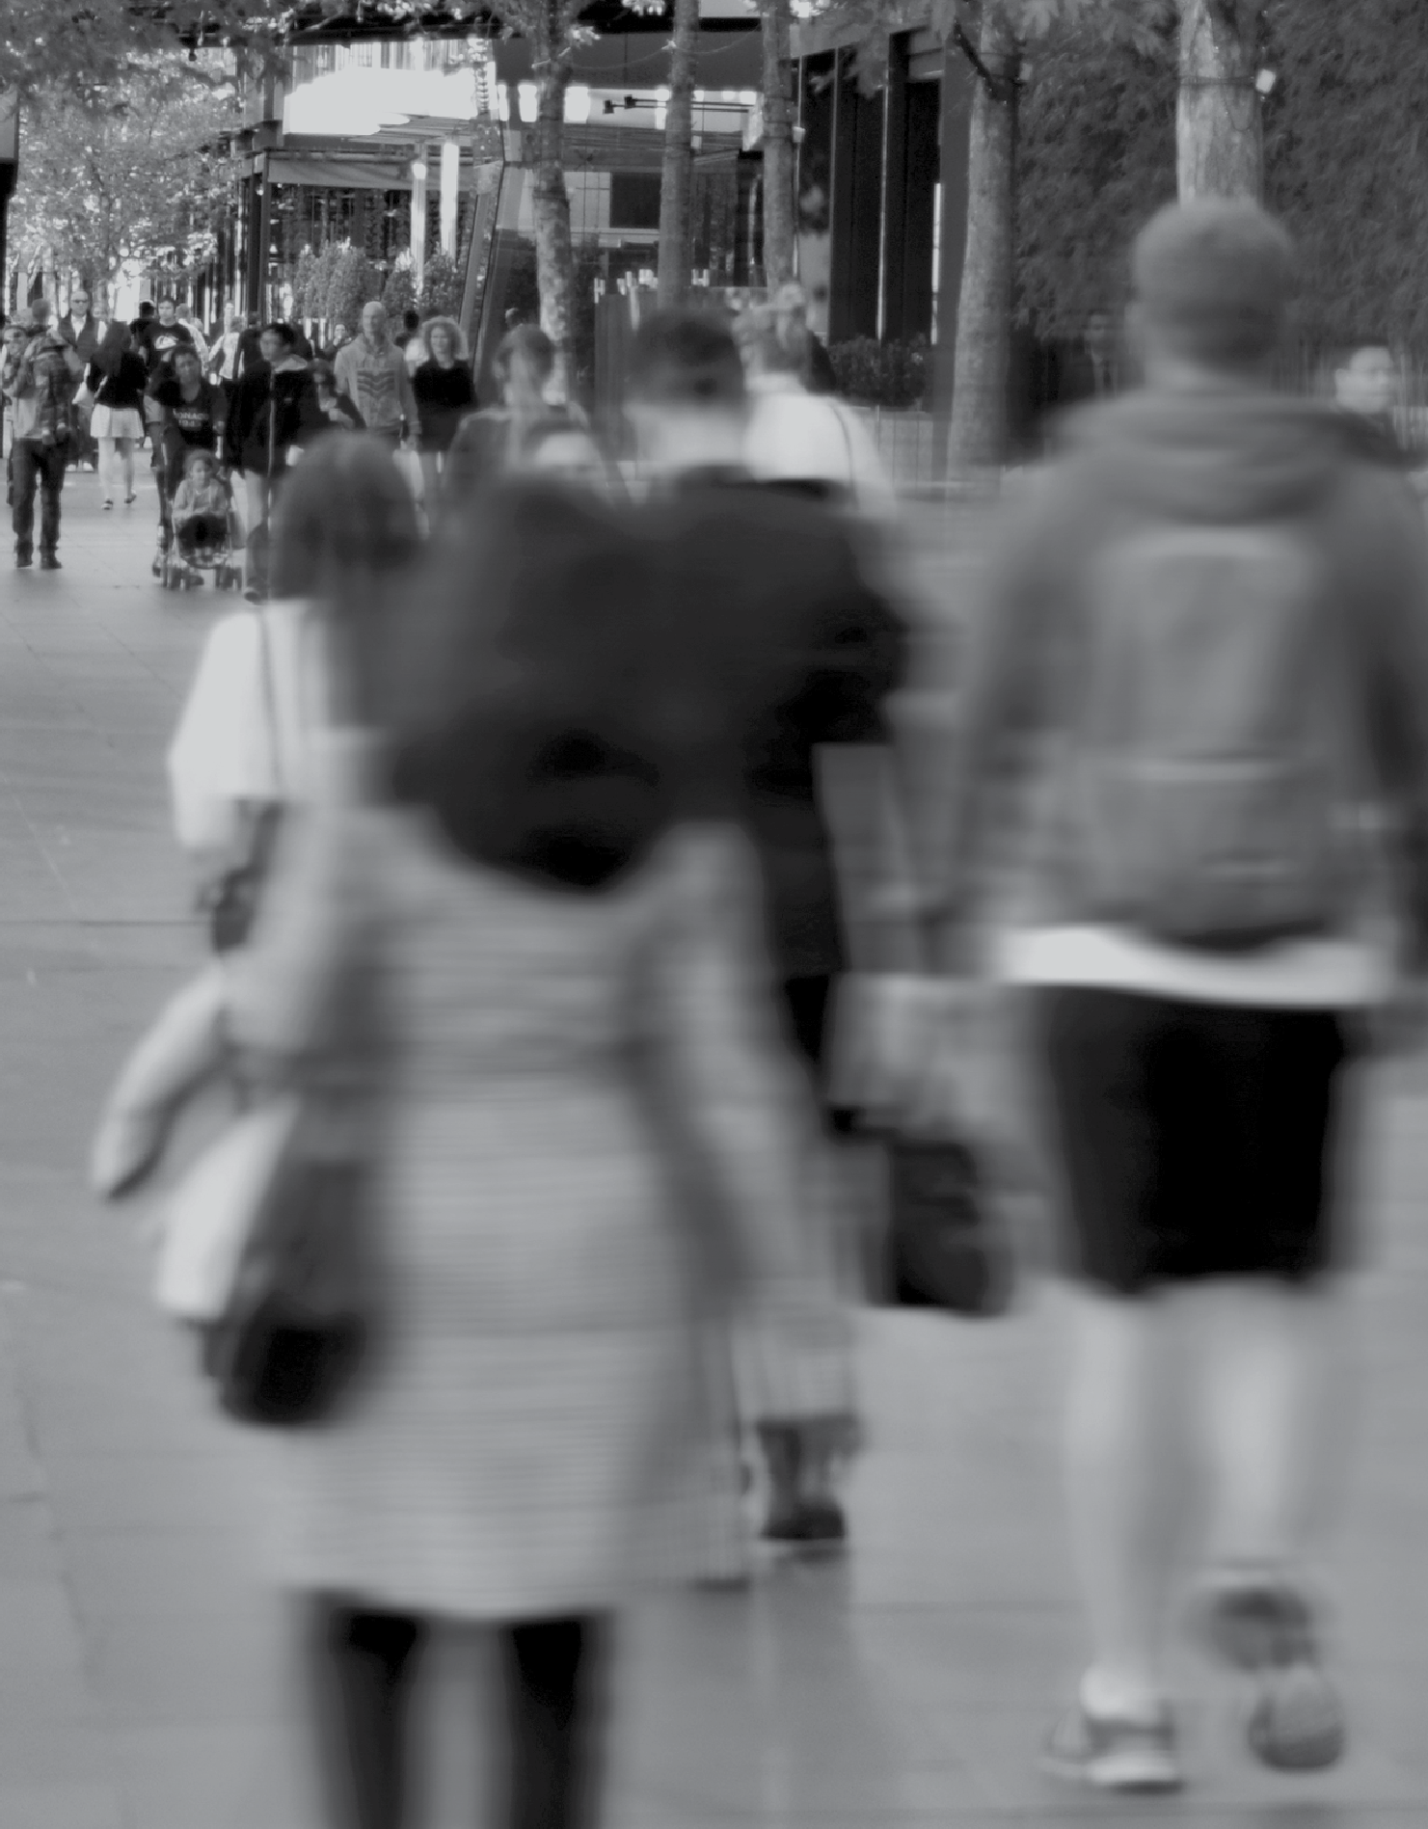
VICTORIANS’ PERCEPTIONS OF CLIMATE CHANGE
REGIONAL REPORT – WIMMERA SOUTHERN MALLEE

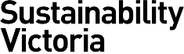
KEY FINDINGS – SOCIAL RESEARCH ON CLIMATE CHANGE ATTITUDES AND BEHAVIOURS

Contents
Introduction 3
Key findings at a glance 4
Detailed findings 6
Priority of climate change 6
Causation of climate change 7
Level of concern 8
Willingness to act 10
Impacts of climate change 14
Leadership and responsibility 16
Government climate change targets 18
Support for renewable energy 19
Everyday behaviours 20
Advanced actions 22
How the Victorian Government can support individuals 23

Wallis Market and Social Research achieved accreditation to the International Standard ISO20252 in September 2007. The Company is committed to maintaining administrative and operational procedures which comply with these accreditation requirements and to improving its performance in all aspects of the service it delivers to its customers. Wallis is an active participant in the market research industry, with senior staff making significant contributions to the Australian Market and Social Research Society (AMSRS) and the Association of Market and Social Research Organisations (AMSRO). As such we actively pursue the ethical objectives of the industry.
In addition to having attained the highest Industry accreditation, Wallis also participates in the Australian Achiever Awards, which recognises the customer service excellence of Australian companies. The Company has been awarded a high commendation every year since the inception of these awards in 1999.

Introduction
Sustainability Victoria (SV) engaged an external research provider, Wallis Market and Social Research, to conduct a state wide survey to collect baseline quantitative data on Victorian residents’ attitudes, beliefs and behaviours in relation to climate change. The results will be used by SV and other relevant Departments to inform program development and policy.
This report is one of a series of reports prepared for each of nine regional groupings, which were taken from the Regional
Development Victoria classification1. Each regional report provides a descriptive analysis of results for that specific region, and compares the regional results to overall state results for Victoria.

Methodology
The main survey was administered using a telephone interview methodology, with an online follow-up survey emailed to those respondents who agreed to take part in further research.
A total of 3,333 Victorians aged 15 years and over took part in the telephone survey; of these, 451 also completed the follow-up online survey.
Telephone interviews were conducted from 17 November to 14 December 2016, following a pilot test among a small sample of Victorians. The online survey was conducted from 19 December 2016 to 20 January 2017, during which two reminders were emailed to nonresponders.

Sample Design
The sampling frames used for the telephone survey – randomly generated telephone numbers (probability sample) plus a list of existing phone numbers (regional booster sample) – ensured the widest possible coverage of the Victorian population.
The survey sample was carefully designed and controlled to enable regional analysis while providing results that can be projected to the broader population with confidence.
The sample was designed to deliver a minimum of 200 interviews in each of nine regional groupings. Weighting was applied to correct for the over-sampling of regional areas, as well as demographic
differences between the probability sample and the regional booster sample, to ensure that the total sample is representative of the Victorian population.

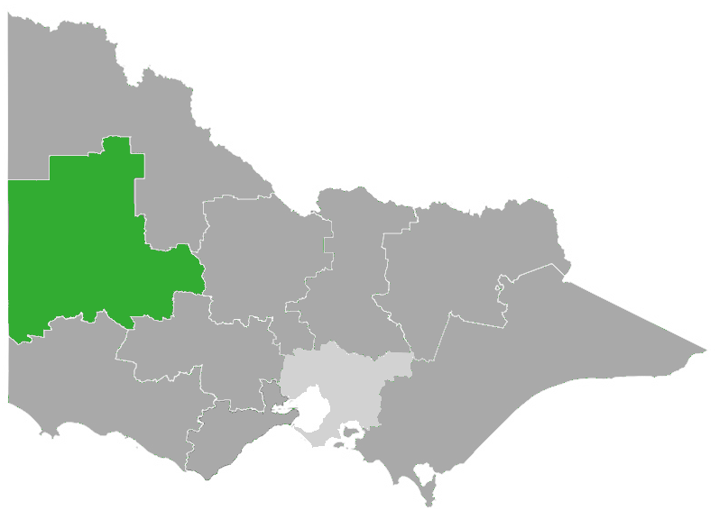
1Source: http://www.rdv.vic.gov.au/regional-partnerships

Wimmera Southern Mallee
LGAs in the region:
› Hindmarsh Shire
› Horsham Rural City
› Northern Grampians Shire
› West Wimmera Shire
› Yarriambiack Shire
The table below shows the broad demographic characteristics of the survey respondents for the Wimmera Southern Mallee region, showing the unweighted and weighted distributions.

FIGURE 1: SAMPLE DISTRIBUTION

 | Unweighted n=210  % | Weighted n=210  %
GENDER
Male  Female | 46  54 | 49  51
AGE
Under 40  40-64  65 and over | 13  49  38 | 32  43  25
EDUCATION
University Degree or higher  TAFE/Technical/ Vocational  Completed high school  Did not complete high school  Still at school | 27  28  19  26  0 | 9  35  25  30  1
COUNTRY OF BIRTH
Australia  Elsewhere | 92  8 | 94  6

Key findings in Wimmera Southern Mallee at a glance
Climate change is happening and requires action

87%

say climate change exists and humans are contributing to it;
63%

agree that climate change is an issue that requires urgent action now
71%

believe their actions can help reduce the impact of climate change

The community want action on climate change from:
85%
State Government
79%
Local Government
80%
Business & industry
79%
All individuals

Residents are willing to take action

68%
56%

are willing to take action on climate change

prefer to buy from businesses that show they are acting on climate change

Wimmera Southern Mallee residents have observed the impacts of climate change and are concerned about future impacts

80% concerned Water shortages & drought

32% concerned Coastal erosion & changes to sea level
78% concerned
Crop failures or declines
in agriculture
59% concerned
Heatwaves
84% concerned
Severe bushfires

39% concerned
Air pollution
52% concerned
Severe storms & floods

Around two-thirds believe that more bushfires, storms/flooding, drought and coastal erosion have occurred in Victoria during the past 10 years. The majority know that climate change is influencing the occurrence of these events.

Wimmera Southern Mallee is supportive of renewable energy
Wimmera Southern Mallee shows strong support
for net zero emission and renewable energy targets
72% 77%
support the net support the
zero emissions renewable target by 2050 energy targets
(25% by 2020
and 40% by 2025)

80%

would support wind turbines in their local area

86%
44%

would support solar panels in their local area

interested in taking part in community renewable energy projects

Detailed findings

Priority of climate change

When prompted, climate change ranked sixth on a list of issues of importance in Victoria; with three in ten Victorians (30%) nominating climate change as one of the top three most important issues facing the state today. Overall, younger people ranked climate change higher; the issue ranks fifth among Victorians aged 18-24 (41% mentioned climate change as a top three priority), and climbs to second spot behind education among Victorians aged 15-17, (56% mentioned climate change as a top three priority).
As seen in Figure 2 below, those in Greater Melbourne are more likely to mention climate change in the top three (32%), while those in Wimmera Southern Mallee are less likely to do so (22%) compared to the rest of Victoria.
Healthcare, education and roads and transport are the top three issues for those in Wimmera Southern Mallee. In contrast to the regional average, Wimmera Southern Mallee ranked the cost of living and housing much lower on the scale of importance (36% compared to 51%).

FIGURE 2: TOP 3 PRIORITY MENTIONS BY LOCATION
Victoria
Greater Melbourne
Regional VIC
Wimmera Southern Mallee
% 100
80
63 66
65
60
60
59
56 58
51
53
57
51
52 51
54
58
46 45 48
40
36
30
32
23 22
20
0
Healthcare
Cost of living and housing
The economy and jobs
Education
Roads and Climate change transport
Ranking:
1 1 1 1
2 2 4 5
3 3 2 4
4 4 3 2
5 5 5 3
6 6 6 6

51

Source: A1a/b/c.
Base: Total sample (VIC: n=3,333 | GM: n=1,424 | Reg VIC n=1,909 | Wimmera Southern Malle n=213)

To avoid influencing responses to this question the survey topic was introduced as “an important issue facing Victorians” and did not mention that climate change was the focus of the survey until after this question.
In other national and international surveys on this topic, climate change consistently ranks below the more day to day and ‘hip pocket’ issues such as healthcare and the cost of living. However, despite low relative ranking of priority, results throughout this report show that climate change is recognised by the majority of Victorians as a serious issue that requires action from all sectors including government, business and individuals.

Causation of climate change

The clear majority of Victorians (91%) accept some level of human causality for climate change:
› 3% think climate change is ‘entirely caused by natural processes’, and
› 4% of Victorians hold the opinion that ‘there is no such thing as climate change’.
Figure 3 below compares the results for Wimmera Southern Mallee with Victoria overall, Greater Melbourne, and Regional Victoria. While the figures show a small amount of variation, there were no statistically significant differences in acceptance of human causation or scepticism on the basis of location.

FIGURE 3: OPINIONS ABOUT CLIMATE CHANGE CAUSALITY
Victoria
Greater Melbourne
Regional VIC
Wimmera Southern Mallee
0
20
40
60
80
100 %
Entirely caused by hum an activity Mainly caused by human activity
Partly natural and partly caused by human activity

Mainly caused by natural processes Entirely caused by natural processes
Not happening, there is no such thing as climate change

Don't know

 |  |  |  |  |  |  |  |  |  |  |  |  |  |  | NET:  Scepticism | NET: Some human  causation
 |  |  |  |  |  |  |  |  |  |  |  |  |  |  | 7% | 91%
12 |  |  | 34 |  |  | 38 |  |  |  | 7 |  | 3 | 4 | 2
 |  |  |  |  |  |  |  |  |  |  |  |  |  |  | 6% | 92%
13 |  |  | 36 |  |  |  | 36 |  |  | 7 |  | 3 | 4 | 2
 |  |  |  |  |  |  |  |  |  |  |  |  |  |  | 8% | 90%
9 |  | 29 |  |  | 43 |  |  |  | 9 |  |  | 4 | 4 | 2
 |  |  |  |  |  |  |  |  |  |  |  |  |  |  | 10% | 87%
5 | 19 |  |  | 51 |  |  |  | 12 |  |  | 5 | 6 |  | 3

Source: A2
Base: Total sample (VIC: n=3,333 | GM: n=1,424 | Reg VIC n=1,909 | Wimmera Southern Malle n=213)

Level of concern

Almost four in five Victorians (78%) stated some level of concern about climate change. There were several variations among the demographic subgroups, with levels of concern being higher among:
› younger age groups (82% among those aged under 40)
› females (81%)
› residents of Greater Melbourne (81%)
› those with a university degree (39% are ‘very concerned’ compared to 27% average).

Figure 4 below compares the results for Wimmera Southern Mallee with Victoria overall, Greater Melbourne and Regional Victoria. Results indicate that concern about climate change is lower in Wimmera Southern Mallee (64%) compared to both the Regional (71%) and State averages (78%), but still represents two-thirds of respondents.

FIGURE 4: CONCERN ABOUT CLIMATE CHANGE
Slightly concerned
Quite concerned
Very concerned
%100
80
78
81
71
60
27
28
64
22
16
40
26
28
22
17
20
25
24
27
31
0
Victoria
Greater Melbourne
Regional VIC Wimmera
Southern Mallee
Source: B2
Base: Total sample

Reasons for concern
When asked to explain what they were concerned about in relation to climate change, the most commonly stated responses included:
› The impact on future generations
Victoria, 76%; Wimmera Southern Mallee, 52%,
› The state of the planet
Victoria, 48%; Wimmera Southern Mallee, 45%,
› The impact on health / quality of life
Victoria, 38%; Wimmera Southern Mallee, 37%.

Need for action now
Four out of five Victorians (78%) agree that ‘climate change is an issue that requires urgent action now’. As might be expected, the level of agreement with this statement was higher among those who stated a high level of concern about climate change (96% agreement among those ‘very’ or ‘quite’ concerned).
As seen in Figure 5 agreement with this statement was higher in Greater Melbourne (80%) than in Regional Victoria (72% average). The level of agreement in Wimmera Southern Mallee (63%) was lower than the State and Regional average.

FIGURE 5: AGREEMENT THAT CLIMATE CHANGE IS AN ISSUE THAT REQUIRES URGENT ACTION NOW

78 80
72
 | 44 |  | 46
 |  |  |  |  | 39 | 63
 |  |  |  |  |  |  | 27
 | 34 |  | 35 |  | 34 |  | 36

Source: D4e | Base: All who believe in some human causation of climate change
Agree
Strongly agree
100
80
60
40
20
0
Victoria
Greater Melbourne
Regional VIC Wimmera Southern Mallee

Willingness to act

The majority of Victorians (80%) are at least somewhat willing to take action to tackle climate change with a third (33%) stating they are “very willing”.
Willingness to act on climate change showed a very similar pattern to concern about climate change in terms of demographic variations; it is higher among the younger age groups (88% among those aged under 25, and 83% among those aged 25-49), and slightly higher among females (83% compared to 77% of males).
Figure 6 below compares the results for Wimmera Southern Mallee with Victoria overall, Greater Melbourne and Regional Victoria. Willingness to act on climate change was lower in Wimmera Southern Mallee than both the state and regional average.

FIGURE 6: WILLINGNESS TO ACT ON CLIMATE CHANGE
Somewhat willing
Very willing
% 100
80
60
40
20
0
Victoria
Greater Melbourne
Regional VIC Wimmera
Southern Mallee

80 81 77
68
 | 33 |  | 35 |  | 29
 |  |  |  |  |  |  | 18
 | 46 |  | 46 |  | 48 |  | 50

Source: A3 | Base: All who believe in some human causation of climate change

Motivators for action
Reasons for willingness to act included the desire to protect the environment for future generations, and /or to do their part to ensure the health of the planet.

Barriers to action
Reasons for not being willing to act were mostly related to denial that humans are causing climate change, or the attitude that there is nothing they can do about it personally, or lack of knowledge about what they can do.

Engagement
Engagement with the topic of climate change is reasonably high across Victoria, with three-quarters of respondents (74%) stating some level of interest in news items, documentaries or other types of information about climate change.
The Figure below compares results across the various locations and shows that engagement is significantly lower in Wimmera Southern Mallee, 58%.

FIGURE 7: INTEREST IN INFORMATION ABOUT CLIMATE CHANGE

74 76
69
 | 29 |  | 29
 |  |  |  |  | 26 | 58
 |  |  |  |  |  |  | 18
 | 46 |  | 47
 |  |  |  |  | 42 |  | 40

Source: B1 | Base: Total sample
%
100
Somewhat Interested
Very interested
80
60
40
20
0
Victoria
Greater Melbourne
Regional VIC Wimmera
Southern Mallee

Willingness to act - other measures
Willingness to act is strongly related to self-efficacy, that is, the belief that there are meaningful things one can do to reduce the impact of climate change. Analysis revealed that the more concerned someone is about climate change, and the more they believe they can make an impact, the more likely they are to state a willingness to take action on climate change.
The Figures below show the results from two measures; self-efficacy and feeling positive about being part of a community-wide movement to help tackle climate change. The results are shown for Wimmera Southern Mallee along with Victoria overall, Greater Melbourne, and the average for Regional Victoria.
Self-efficacy is consistently high across Victoria, whereas feeling positive about being part of community-wide action on climate change varies in a similar pattern to concern about climate change; higher in Greater Melbourne (74%) and lower in Regional Victoria (63%). Wimmera Southern Mallee had lower scores on both these measures.

FIGURE 8: SELF-EFFICACY FIGURE 9: FEELING POSITIVE ABOUT BEING PART OF COMMUNITY ACTION
Agree
Strongly agree
% 100

80
60
40
20
0
Victoria
Greater Melbourne
Regional Wimmera
VIC
Southern Mallee
DK/REF:
3%
3%
2%
2%
82 83 81
 | 28 |  | 29 |  | 27 | 71
 |  |  |  |  |  |  | 28
 | 54 |  | 54 |  | 54
 |  |  |  |  |  |  | 43

Agree
Strongly agree
% 100

80
71
74
63
60
55
40
20
0
Victoria Greater Regional Wimmera Melbourne VIC Southern
Mallee
DK/REF:
2%
2%
2%
1%

27

28
25
14

46

44

38

40

Source: D4g | Base: Module 2 | Source: D4b | Base: All who believe in some human causation

Pledge to TAKE2
Although awareness of the TAKE2 program was relatively low, the results regarding likelihood of making a pledge indicate potential for a good level of support for the program, with 67% of Victorians saying they are very or somewhat likely to pledge to TAKE2.
This proportion appears lower for the Wimmera Southern Mallee region, but the difference is not statistically significant.

FIGURE 10: LIKELIHOOD OF MAKING A PLEDGE TO TAKE2
Somewhat likely
Very likely
% 100

80

60

40

20

0
Victoria
Greater Regional Wimmera Melbourne VIC Southern
Mallee

67 68 67
58
 | 27 |  | 29 |  | 21
 |  |  |  |  |  |  | 10
 |  |  |  |  | 45 |  | 48
 | 41 |  | 39

Source: C10a | Base: Module 3

Victoria is joining other leading states and regions around the world in committing to do our part to reduce emissions in line with international community’s 2015 agreement in Paris. TAKE2 is Victoria’s collective climate change pledge initiative to reach net zero emissions by 2050, and keep the global temperature rise to under 2 degrees. Businesses, community groups, local governments, schools and individuals can participate. Sustainability Victoria is the lead agency for voluntary pledges to take action on climate change. For more information on the TAKE2 program and
how to get involved, please visit the website.

Impacts of climate change

All survey respondents were asked to state if they have noticed any change in the occurrence of extreme weather and/or environmental events in Victoria over the past 10 years, and if so, whether or not they think that climate change is influencing these changes.
For the most part, the majority perceive that there has been an increase in each event. Among those who have noticed an increase in these extreme weather and/or environmental events, the vast majority linked these events to climate change.
Figure 11 below compares findings for the Wimmera Southern Mallee to the state average. Those in the Mallee region were most likely to say they have observed an increase in water shortage and drought (67%); severe bushfires (63%) and severe storms and floods (65%).
Figure 12 shows that those in the Wimmera Southern Mallee region were less likely than others to say that climate change is influencing the increasing occurrence of drought, severe storms and floods, crop failures and bushfires; – however, around half or more still held the opinion that this was the case.

FIGURE 11: OBSERVATIONS OF THE IMPACTS OF CLIMATE CHANGE

Noticed any changes in the occurrence of… | MORE |  | LESS |  | NO CHANGE |  | DON'T KNOW
 | VIC  % | WSM  % | VIC  % | WSM  % | VIC  % | WSM  % | VIC  % | WSM  %
Severe bushfires | 61 | 63 | 4 | 3 | 29 | 34 | 6 | 0
Severe storms and floods | 58 | 55 | 4 | 3 | 30 | 41 | 8 | 2
Air pollution | 55 | 48 | 6 | 8 | 31 | 39 | 9 | 5
Coastal erosion and changes to sea levels | 52 | 41 | 4 | 6 | 21 | 28 | 22 | 26
Crop failures or declining agriculture | 50 | 54 | 8 | 9 | 20 | 28 | 22 | 9
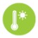 Heatwaves | 49 | 45 | 11 | 7 | 32 | 46 | 7 | 2
Water shortage and drought | 47 | 67 | 15 | 11 | 29 | 19 | 9 | 3

FIGURE 12: IS CLIMATE CHANGE INFLUENCING?

Climate change is influencing the observed increase in this? | YES
 | VIC  % | WSM  %
Heatwaves | 90 | 80
Coastal erosion and changes to sea levels | 89 | 80
Water shortage and drought | 84 | 61
Severe storms and floods | 83 | 61
Crop failures or declining agriculture | 82 | 66
Severe bushfires | 71 | 49
Source: B5/B6 | Base: Total sample

Concern about the impacts
For each of the extreme weather and/or environmental events, all respondents were asked to state how concerned they are about each one directly affecting their local area in the foreseeable future. As shown in the Table below, levels of concern are quite high across the board, with water shortage and declining agriculture topping the list.
The Chart below compares the results for Wimmera Southern Mallee with Victoria overall, Greater Melbourne and Regional Victoria.
Results indicate that people in Regional Victoria are more likely than those in Greater Melbourne to be concerned about the impacts of:
› severe bushfires, 84% compared to 62%;
› crop failures/declining agriculture, 79% compared to 68%; and,
› water shortage /drought, 79% compared to 70%.
For people in Wimmera Southern Mallee, concern about severe bushfires (84%) is highest, followed by water shortage and drought (80%) and crop failures/declining agriculture (78%).
Their concern about air pollution and coastal erosion is lower than the state average with fewer than two in five saying they are concerned about the future impact of these events

FIGURE 13: PROPORTION WHO ARE CONCERNED ABOUT EACH ENVIRONMENTAL EVENT

 |  | Victoria | Greater Melbourne | Regional VIC | Wimmera  Southern Mallee  %
 |  | % | % | %
 | Water shortage and drought | 72 | 70 | 79 | 80
 | Crop failures or declining agriculture | 71 | 68 | 79 | 78
 | Severe bushfires | 68 | 62 | 84 | 84
 | Air pollution | 68 | 72 | 57 | 39
 | Heatwaves | 67 | 67 | 66 | 59
 | Severe storms and floods | 65 | 64 | 68 | 52
 | Coastal erosion and changes to sea levels | 51 | 53 | 45 | 32
Source: B5/B6 | Base: Total sample

Leadership and responsibility

The Victorian community believes that government, individuals, and business and industry should all be taking action on climate change. Figure 14 shows, for each entity, the proportion of people who believe it should “lead action” or “contribute to action” on climate change, and compares results for Wimmera Southern Mallee to the state average.
› 93% of Victorians believe the State Government should be acting on climate change – either in a leadership role or as a contributor- the figure was lower in Wimmera Southern Mallee, but still substantial at 85%.
› Figure 15 (opposite) shows that 22% think the Victorian Government is doing "the right amount" but the majority (61%) think the State Government should be doing more; the results for Wimmera Southern Mallee were slightly lower but did not differ significantly to the average.

FIGURE 14: LEADERSHIP ON CLIMATE CHANGE
95
87
95
79
95
80
93
85
91
77
89
79
87
77
State average
WSM
%
Contribute
Lead

The Australian Government
26
69
41
46

Individuals
78
17
68
11

Businesses and industry
60
35
65
15

State Government
45
48
59
26

Environmental groups
47
44
50
27

Local government
56
33
60
18

The media
51
36
50
27
Source: C1 | Base: Module 3 (VIC: n=1,000 | Wimmera Southern Mallee n=67) | results exclude DK/REF

State Government action

FIGURE 15: SHOULD THE STATE GOVERNMENT BE DOING MORE?
% 100

80
Should be doing more
61
63
57
58
60
The right amount

Should be doing less
40
Don't know / ref used
20

0
22
5
12
Victoria
20
4
12
Greater Melbourne
25
6
12
Regional VIC
27
7
8
Wimmera Southern Mallee
Source: C3 | Base: Module2

Government climate change targets

Support for the Victoria's emissions and renewable energy targets is high – both targets are strongly supported. The Chart below compares the results for Wimmera Southern Mallee with the state average; awareness and support in Wimmera Southern Mallee is similar to the state average.

FIGURE 16: AWARENESS OF AND SUPPORT FOR VICTORIAN GOVERNMENT TARGETS
Net zero greenhouse gas emissions by 2020
%
No - not aware at all
Have heard something like that

Yes - aware of that specific target
Support the target:
78% 72%
25% from renewable energy sources by 2020, and 40% by 2025
%
No - not aware at all
Have heard something like that

Yes - aware of both specific targets
Support the target:
84% 77%

 | 62 |  |  | 42
 |  |  |  | 21
 | 13 |  |  | 35
 | 24
Victoria |  |  | WSM

 | 56 |  |  | 51
 |  |  |  | 13
 | 19
 |  |  |  | 36
 | 24
Victoria |  |  | WSM

› Approximately one-quarter, 24%, of Victorians were aware of the net zero greenhouse gas emissions by 2050 target, and 13% were vaguely aware that a target has been set.  › 78% of Victorians support this target.  › Support for the target is stronger among younger Victorians; 88% of those aged 25-39 years.  › The results for Wimmera Southern Mallee were similar to the state average. | › Approximately one-quarter, 24% of Victorians were aware of the renewable energy targets, and a further 19% were vaguely aware that targets were set.  › 84% of Victorians support these targets  › Support for the targets was stronger among 25-39 year age group, 93%.  › The results for Wimmera Southern Mallee were similar to the state average.

Source: C4a/C4b/C5a/C6a | Base: Module 2

Reasons for supporting the targets:
› "I think this is an opportunity to change our economy to move away from fossil fuels and be innovative."
› "I think even if the human population is only partly responsible for increasing greenhouse gases, with more people it'll get worse, so we should be trying to reduce things."
› "Because we need to make the change to the way we make energy and it needs to be sustainable."
› "It needs to be done as the population is increasing over time. So we need to be able to produce food and have clean air."

Support for renewable energy

As shown in Figure 17 below, levels of support for the renewable energy targets is consistently high across the state. The graph also shows each region's levels of concern about climate and indicates that high levels of support for renewable energy is not necessarily dependent on high levels of concern.
For Wimmera Southern Mallee, both measures (concern about climate change and support for the targets) are lower but not significantly different to the state average.

FIGURE 17: CONCERN ABOUT CLIMATE CHANGE AND SUPPORT FOR RENEWABLE ENERGY TARGETS
Concerned about climate change
Support renewable energy targets
%
78 84
81 86
81
71
76
68
83
76
84
77
80
84
75
82
72
79
86
79
77
56
63
64
Victoria Greater Regional Gippsland Barwon Central Goulburn Great Melbourne VIC Highlands South Coast
Mallee Loddon Ovens Wimmera Campaspe Murray Southern
Mallee
Source: B2/C6a | Base: Total sample (B2) / Module 2 (C6a)

As well as supporting the targets, the majority of Victorians are supportive of renewable energy infrastructure in their local area with 75% saying they would support wind turbines in their local area, and 89% saying they would support solar panels in their local area, providing access to renewable energy.
Figure 18 shows the levels of support for both sources of renewable energy, for Victoria overall, Greater Melbourne, regional Victoria, and each regional grouping. Interestingly, support for wind turbines is higher in Wimmera Southern Mallee compared to other locations (although this difference not statistically significantly). Support for solar panels in on par with the state average.

FIGURE 18: SUPPORT FOR WIND TURBINES AND SOLAR PANELS
Support wind turbines in my area
Support solar panels in my area
%
89
89
88
75 75
75
80
86
Victoria
Greater Melbourne
Regional VIC
Wimmera Southern Mallee
Source: D4d | Base: Module 1 (wind turbines) Module 2 (solar panels)

Everyday behaviours

The majority of Victorians are already taking positive action to reduce energy use. The Charts below show the everyday actions that people can do now but may need some encouragement to do. Actions that most people said they always do included buying energy efficient appliances, 51%, and limit the amount of food thrown out, 50%.
The Charts compare the results for Wimmera Southern Mallee with the State average and other regions; red squares indicate a significantly lower proportion, and blue squares indicate a significantly higher proportion compared to other regions.

FIGURE 19: TAKE-UP OF EVERYDAY BEHAVIOURS
34  6 |  |  | 4  6  6 |  | 2  10
 | 21 |  | 18 |  | 7
 |  |  |  |  | 18
 | 35 |  | 34
 |  |  |  |  | 33
 | 31 |  | 33 |  | 30

Always Often Sometimes Rarely Never NA/Ref/DK
Actively reduce car use Actively limit energy used to heat and cool the home

% 6 6
6

28
 | 15 |  | 22
 | 16
 |  |  | 19
 | 28 |  |  |  | 17
 |  |  | 25
 |  |  |  |  | 21
 | 23
 |  |  | 20 |  | 19
 | 13
 |  |  | 7 |  | 8

Victoria Regional VIC WSM
%

Victoria Regional VIC WSM

Choose to buy energy efficient household appliances
53 23 |  |  |  |  | 21  7
 | 4  14 |  | 12 |  | 11
 |  |  | 23 |  | 20
 | 23
 |  |  | 57 |  | 59
 | 51

% 3

Victoria Regional VIC WSM
Limit the amount of food thrown out

% 5 6
3 13 12
 | 5  15 |  | 13 |  | 12
 | 25 |  | 24 |  | 18
 |  |  |  |  | 60
 |  |  | 55
 | 50

Victoria Regional VIC WSM

Encourage others to adopt pro climate change behaviours
 | 1  19 |  | 1  24 |  | 1  29
 | 15
 |  |  | 14
 |  |  |  |  | 17
 | 27
 |  |  | 27
 |  |  |  |  | 24
 | 20
 |  |  | 19
 |  |  |  |  | 15
 | 17
 |  |  | 15 |  | 13

%

Victoria Regional VIC WSM
Buy any household energy from a green supplier
%
 | Don't know, 47 |  | Don't  know, 44 |  | Don't  know, 49
 | No, 20 |  | No, 19
 |  |  |  |  | No, 16
 | Yes, 33 |  | Yes, 36 |  | Yes, 35

Victoria Regional VIC WSM

Source: D1a/b/c/d/e/f | Base: Total sample

Motivations and barriers for everyday behaviours
The most commonly stated motivations for undertaking everyday basic included cost, convenience, and comfort. Concern for the environment was a reasonably strong motivator, but not the highest.
A selection of comments from those in the Wimmera Southern Mallee region is shown below.

Motivations | Barriers
Actively reduce car use
"Health is number one and convenience as much as anything else." | "The only public transport we have in the town is a bus that takes you to Melbourne, Bendigo or Ballarat."
Actively limit energy to heat and cool the home
"It's probably the way I've been brought up. We've never been big spenders and we pay attention to what we do and don't use." | "Because my wife tends to dial up whatever temperature she wants for the heater and air conditioner."
Choose to buy energy efficient household appliances
"Only because it keeps my bills down and not using as much energy as you should." | "Because I buy what I want and what I think is usable."
Limit the amount of food thrown out
"We can't afford it and it's wasteful. We've always been in a situation where we didn't have a lot of money, and couldn't waste food. So we have to plan, everything is used." | "Because we eat all our food, as we've got three kids."
Encourage others to adopt pro climate change behaviours
"For their own sake and for the sake of our future generations. And, I guess, for the sake of climate change." | "It's their own business what they do, I'm not forcing my opinions on others."
Buy any household energy from green supplier
"We have solar panels and they build up a sizeable credit and over the winter we use a bit of that." | "I wanted to change to save money, but other companies don't offer it."

Advanced actions

To better understand the actions that Sustainability Victoria might support in the future, it is important to gauge the level of interest (framed within a five year period) in a selection of 'advanced' behaviours. They are considered ‘advanced’ because they have high upfront costs and require a level of planning by those who wish to adopt them.
Respondents were presented with the five advanced behaviours shown below, and asked to state their level of interest in each one; the level of interest in taking up these actions within the next 5 years was high. The Figure below shows the proportion who are 'very' or 'somewhat' interested in each action, for Victoria overall, Greater Melbourne, regional average and the Wimmera Southern Mallee Region. Notable findings include:
› Wimmera Southern Mallee respondents are less interested in purchasing 100% green power (48% compared to 76% state average);
› They are also less interested in generating their own household energy and feeding excess back into the grid (50% compared to 74% average);
› Interest in other actions was also lower however differences were not statistically significant.

FIGURE 20: INTEREST IN ADVANCED BEHAVIOURS
Victoria
Greater Melbourne
Regional VIC
Wimmera Southern Mallee
76
68
48
74
69
50
71
72
68
58
58
58
58
44
56
49
39
% 0
20
40
60
80
100

Purchasing 100% of your household energy through a green power supplier
78

Generating own household energy needs and feeding excess energy back
75

Installing solar energy battery storage
systems for your home

Participating in community projects for renewable energy or climate change

Getting an electric car or a more fuel-
efficient car
59

Source: D3a/b/c/d/e.Base: Module 1 and accept some human causation | Results exclude “already doing this”

How the Victorian Government can support individuals

Survey respondents were asked to comment on what they think the State Government could do to support individual action on climate change, with 62% being able to think of suggestions. The comments were coded into themes as shown in the Table below. Across Victoria, the majority of comments related to education (providing information on what people can do to tackle climate change), providing incentives and/or subsidising solar and other renewable energy sources, and providing funding for community programs.

FIGURE 21: SUGGESTIONS FOR HOW THE VICTORIAN GOVERNMENT CAN SUPPORT INDIVIDUAL ACTION

Suggestions for how to support individual action | ALL VIC  (n=523)  %
Education / promotion of climate change issues | 30
Support / promote / subsidise solar power | 23
Support / promote renewable energy | 18
Reduce waste and pollution | 16
Provide funding / financial incentives | 13
Improved public transport / cycle tracks | 9
Increase legislation / regulation of business and industry | 4
Better recycling / waste reduction | 3
More schemes such as the Green Energy Lighting scheme | 3
Support / promote green cars | 3
Reduce / ban plastic bags | 2
Plant more trees / re-vegetation | 1
Other | 10
Source: F4 | Base: Module 3

Further information
For more information contact Sustainability Victoria info@sustainability.vic.gov.au

Sustainability Victoria Level 28, Urban Workshop,
50 Lonsdale Street, Melbourne VIC 3000
Phone (03) 8626 8700
sustainability.vic.gov.au

Published by Sustainability Victoria.
Summary of key findings – Climate Change Social Research
© Sustainability Victoria, September 2017 ENG075

Victorian Perceptions of Climate Change (excluding all trade marks and logos) is licensed under a Creative Commons Attribution 4.0 Australia licence. In essence, you are free to copy, distribute and adapt the work, as long as you attribute the work and abide by the other licence terms. Go to
http://creativecommons.org/licenses/by/4.0/ to view a copy of this licence.

