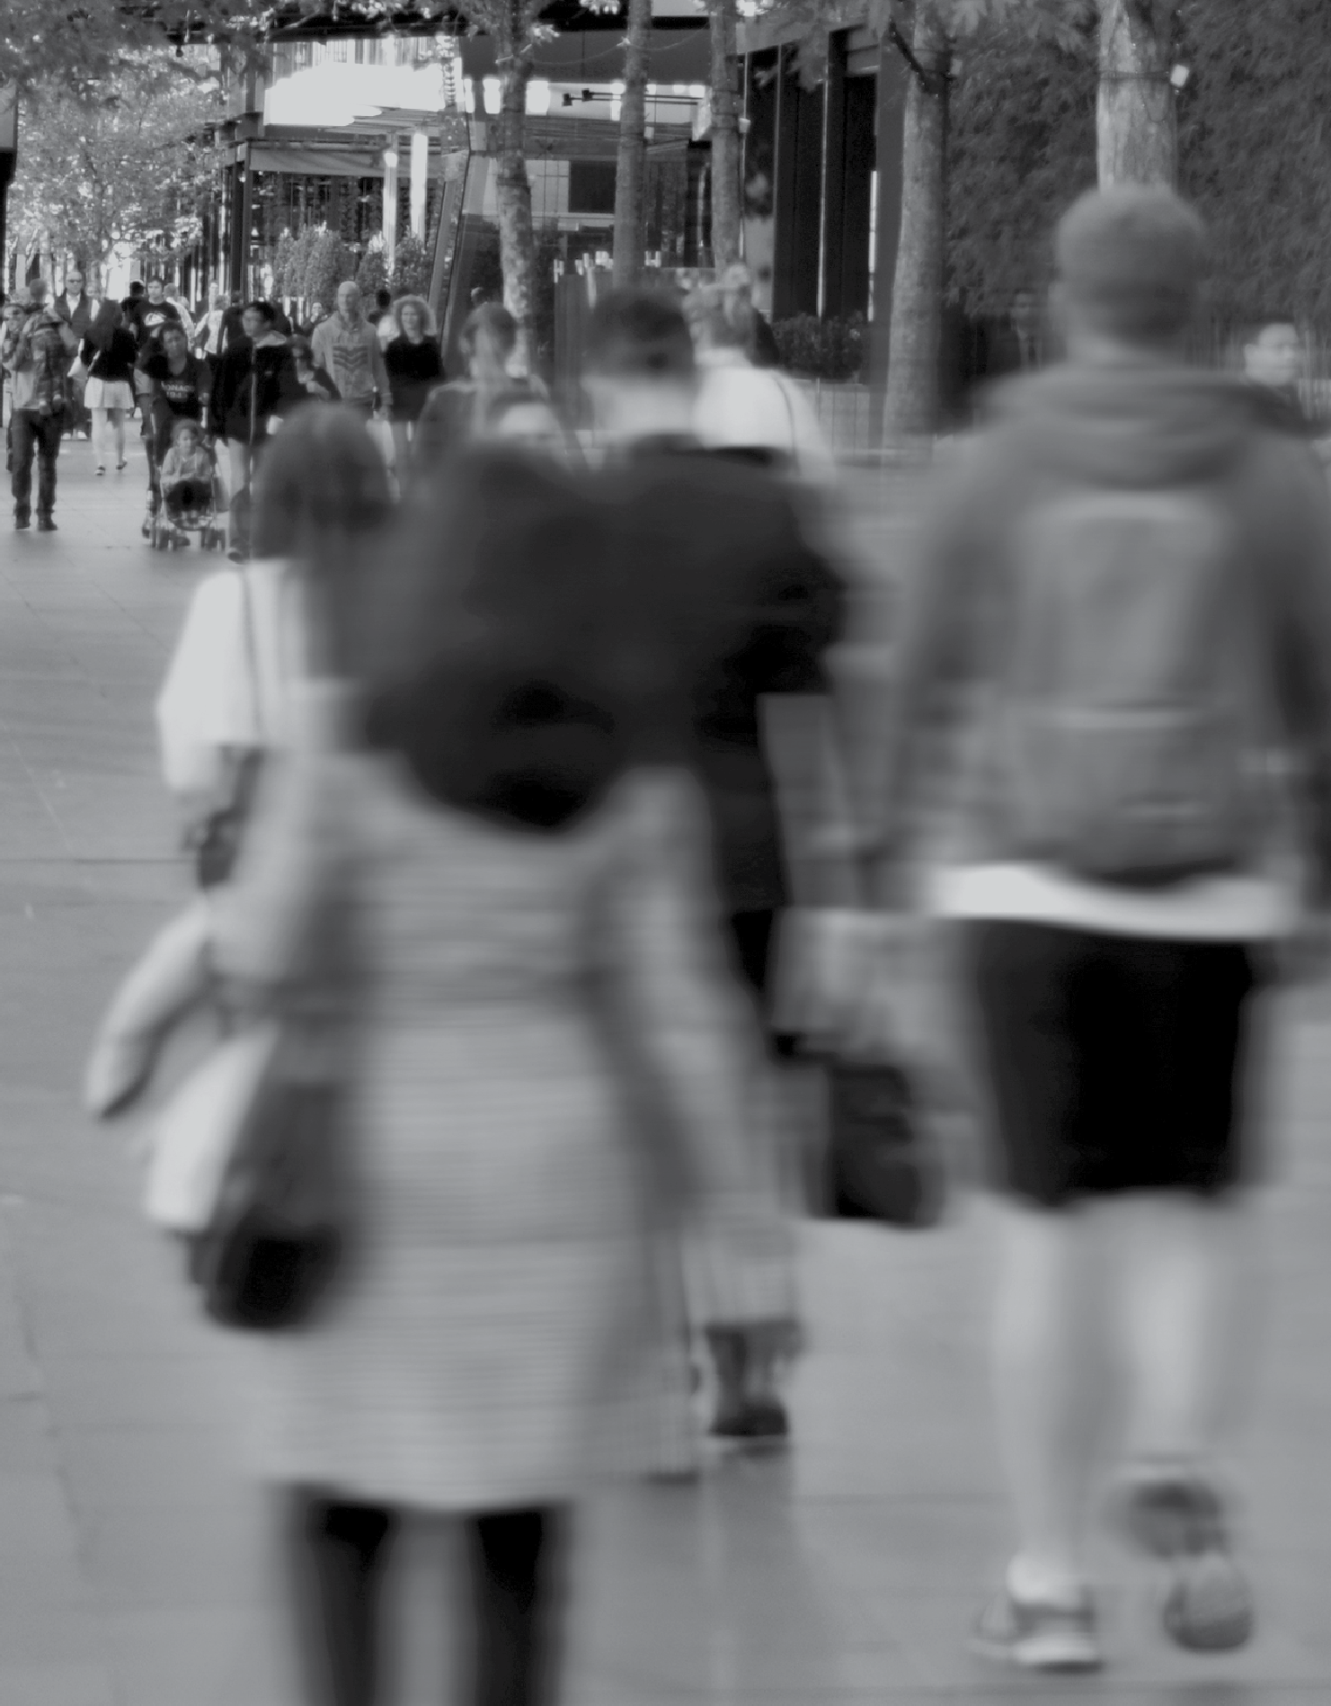
VICTORIANS’ PERCEPTIONS OF CLIMATE CHANGE
REGIONAL REPORT – CENTRAL HIGHLANDS

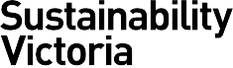
KEY FINDINGS – SOCIAL RESEARCH ON CLIMATE CHANGE ATTITUDES AND BEHAVIOURS

Contents
Introduction 3
Key findings at a glance 4
Detailed findings 6
Priority of climate change 6
Causation of climate change 7
Level of concern 8
Willingness to act 10
Impacts of climate change 14
Leadership and responsibility 16
Government climate change targets 18
Support for renewable energy 19
Everyday behaviours 20
Advanced actions 22
How the Victorian Government can support individuals 23

Wallis Market and Social Research achieved accreditation to the International Standard ISO20252 in September 2007. The Company is committed to maintaining administrative and operational procedures which comply with these accreditation requirements and to improving its performance in all aspects of the service it delivers to its customers. Wallis is an active participant in the market research industry, with senior staff making significant contributions to the Australian Market and Social Research Society (AMSRS) and the Association of Market and Social Research Organisations (AMSRO). As such we actively pursue the ethical objectives of the industry.
In addition to having attained the highest Industry accreditation, Wallis also participates in the Australian Achiever Awards, which recognises the customer service excellence of Australian companies. The Company has been awarded a high commendation every year since the inception of these awards in 1999.

Introduction
Sustainability Victoria (SV) engaged an external research provider, Wallis Market and Social Research, to conduct a state wide survey to collect baseline quantitative data on Victorian residents’ attitudes, beliefs and behaviours in relation to climate change. The results will be used by SV and other relevant Departments to inform program development and policy.
This report is one of a series of reports prepared for each of nine regional groupings, which were taken from the Regional
Development Victoria classification1. Each regional report provides a descriptive analysis of results for that specific region, and compares the regional results to overall state results for Victoria.

Methodology
The main survey was administered using a telephone interview methodology, with an online follow-up survey emailed to those respondents who agreed to take part in further research.
A total of 3,333 Victorians aged 15 years and over took part in the telephone survey; of these, 451 also completed the follow-up online survey.
Telephone interviews were conducted from 17 November to 14 December 2016, following a pilot test among a small sample of Victorians. The online survey was conducted from 19 December 2016 to 20 January 2017, during which two reminders were emailed to nonresponders.

Sample Design
The sampling frames used for the telephone survey – randomly generated telephone numbers (probability sample) plus a list of existing phone numbers (regional booster sample) – ensured the widest possible coverage of the Victorian population.
The survey sample was carefully designed and controlled to enable regional analysis while providing results that can be projected to the broader population with confidence.
The sample was designed to deliver a minimum of 200 interviews in each of nine regional groupings. Weighting was applied to correct for the over-sampling of regional areas, as well as demographic
differences between the probability sample and the regional booster sample, to ensure that the total sample is representative of the Victorian population.
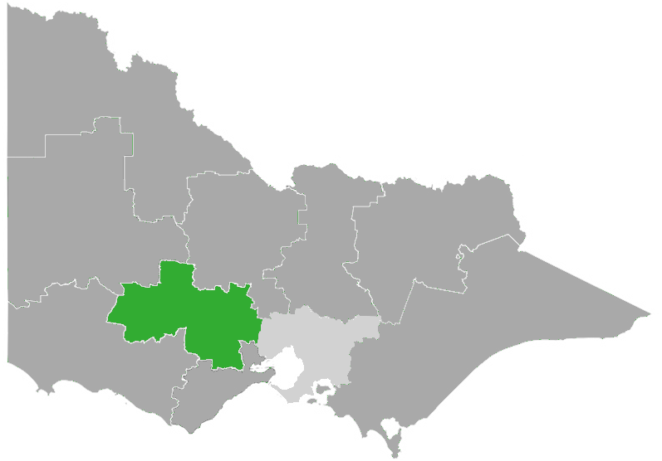
1Source: http://www.rdv.vic.gov.au/regional-partnerships

Central Highlands Region
LGAs in the region:
› Ararat Rural CityGreater Geelong City
› Ballarat City
› Golden Plains Shire
› Hepburn Shire
› Moorabool Shire
› Pyrenees Shire
The table below shows the broad demographic characteristics of the survey respondents for the Central Highlands region, showing the unweighted and weighted distributions.

FIGURE 1: SAMPLE DISTRIBUTION

 | Unweighted n=210  % | Weighted n=210  %
GENDER
Male  Female | 50  50 | 50  50
AGE
Under 40  40-64  65 and over | 20  46  34 | 39  42  19
EDUCATION
University Degree or higher  TAFE/Technical/ Vocational  Completed high school  Did not complete high school  Still at school | 34  31  18  17  0 | 14  41  27  18  0
COUNTRY OF BIRTH
Australia  Elsewhere | 91  9 | 92  8

Key findings in Central Highlands at a glance
Climate change is happening and requires action

89%

say climate change exists and humans are contributing to it;
79%

agree that climate change is an issue that requires urgent action now
80%

believe their actions can help reduce the impact of climate change

The community want action on climate change from:
94%
State Government
93%
Local Government
91%
Business & industry
96%
All individuals

Residents are willing to take action

83%
71%

are willing to take action on climate change

prefer to buy from businesses that show they are acting on climate change

Central Highlands residents have observed the impacts of climate change and are concerned about future impacts

85% concerned Water shortages & drought

40%concerned Coastal erosion & changes to sea level
85% concerned
Crop failures or declines
in agriculture
70% concerned
Heatwaves
86% concerned
Severe bushfires

61%concerned
Air pollution
74% concerned
Severe storms & floods

Around two-thirds believe that more bushfires, storms/flooding, drought and coastal erosion have occurred in Victoria during the past 10 years. The majority know that climate change is influencing the occurrence of these events.

Central Highlands is supportive of renewable energy
Central Highlands shows strong support for
net zero emission and renewable energy targets
70% 84%
support the net support the
zero emissions renewable target by 2050 energy targets
(25% by 2020
and 40% by 2025)

81%
90%
51%

would support wind turbines in their local area

would support solar panels in their local area

interested in taking part in community renewable energy projects

Detailed findings

Priority of climate change

When prompted, climate change ranked sixth on a list of issues of importance in Victoria; with three in ten Victorians (30%) nominating climate change as one of the top three most important issues facing the state today. Overall, younger people ranked climate change higher; the issue ranks fifth among Victorians aged 18-24 (41% mentioned climate change as a top three priority), and climbs to second spot behind education among Victorians aged 15-17, (56% mentioned climate change as a top three priority).
Figure 2 below shows the proportions who mentioned each issue as one of the top three issues facing the state. Results are shown for Victoria overall, Greater Melbourne, Regional Victoria and the Central Highlands.
When looking at the issue of climate change, results for the Central Highlands are the same as the overall Victorian average (30%) but higher than the Regional average, (23%).
Healthcare was the issue of highest concern for the Central Highlands (65%) followed by education (53%), and the economy and jobs (50%).

FIGURE 2: TOP 3 PRIORITY MENTIONS BY LOCATION
Victoria
Greater Melbourne
Regional VIC
Central Highlands
% 100
80
60
60
59
63 65
56 58
57
51 47
53
51
50
52 51
54 53
46
45
48 48
40
30
32
30
23
20
0
Healthcare
Cost of living and housing
The economy and jobs
Education
Roads and Climate change transport
Ranking:
1 1 1 1
2 2 4 5
3 3 2 3
4 4 3 2
5 5 5 4
6 6 6 6
Source: A1a/b/c.
Base: Total sample (VIC: n=3,333 | GM: n=1,424 | Reg VIC n=1,909 | Central Highlands n=211)

To avoid influencing responses to this question the survey topic was introduced as “an important issue facing Victorians” and did not mention that climate change was the focus of the survey until after this question.
In other national and international surveys on this topic, climate change consistently ranks below the more day to day and ‘hip pocket’ issues such as healthcare and the cost of living. However, despite low relative ranking of priority, results throughout this report show that climate change is recognised by the majority of Victorians as a serious issue that requires action from all sectors including government, business and individuals.

Causation of climate change

The clear majority of Victorians (91%) accept some level of human causality for climate change:
› 3% think climate change is ‘entirely caused by natural processes’, and
› 4% of Victorians hold the opinion that ‘there is no such thing as climate change’.
Figure 3 below compares the results for Central Highlands with Victoria overall, Greater Melbourne, and Regional Victoria. There were no statistically significant differences in acceptance of human causation or scepticism, by location..

FIGURE 3: OPINIONS ABOUT CLIMATE CHANGE CAUSALITY
Victoria
Greater Melbourne
Regional VIC
Central Highlands
0
20
40
60
80
100 %
Entirely caused by hum an activity

Mainly caused by human activity

Partly natural and partly caused by human activity

Mainly caused by natural processes

Entirely caused by natural processes
Not happening, there is no such thing as climate change Don't know

 |  |  |  |  |  |  |  |  |  |  |  | NET:  Scepticism | NET: Some human  causation
 |  |  |  |  |  |  |  |  |  |  | 2  2  2  2 | 7% | 91%
12 |  | 34 |  |  | 38 |  |  | 7 | 3 | 4
 |  |  |  |  |  |  |  |  |  |  |  | 6% | 92%
13 |  | 36 |  |  |  | 36 |  | 7 | 3 | 4
 |  |  |  |  |  |  |  |  |  |  |  | 8% | 90%
9 | 29 |  | 43 |  |  |  | 9 |  | 4 | 4
 |  |  |  |  |  |  |  |  |  |  |  | 9% | 89%
13 |  | 29 |  | 41 |  |  | 6 |  | 4 | 5

Source: A2
Base: Total sample (VIC: n=3,333 | GM: n=1,424 | Reg VIC n=1,909 | Central Highlands n=211)

Level of concern

Almost four in five Victorians (78%) stated some level of concern about climate change. There were several variations among the demographic subgroups, with levels of concern being higher among:
› younger age groups (82% among those aged under 40)
› females (81%)
› residents of Greater Melbourne (81%)
› those with a university degree (39% are ‘very concerned’ compared to 27% average).
Figure 4 below compares the results for Central Highlands with Victoria, Greater Melbourne and Regional Victoria overall. Concern about climate change in Central Highlands (77%) is higher than the Regional average (71%) but on par with the Victorian average (78%).

FIGURE 4: CONCERN ABOUT CLIMATE CHANGE
%
100
Slightly concerned
Quite concerned
Very concerned
80
78
81
71
77
60
27
28
22
27
40
26
28
22
23
20
25
24
27
27
0
Victoria
Greater
Melbourne
Regional VIC Central Highlands
Source: B2
Base: Total sample

Reasons for concern
When asked to explain what they were concerned about in relation to climate change, the most commonly stated responses included:
› The impact on future generations
Victoria, 76%; Central Highlands, 63%,
› The state of the planet
Victoria, 48%; Central Highlands, 37%,
› The impact on health / quality of life
Victoria, 38%; Central Highlands, 40%.

Need for action now
Four out of five Victorians (78%) agree that ‘climate change is an issue that requires urgent action now’. As might be expected, the level of agreement with this statement was higher among those who stated a high level of concern about climate change (96% agreement among those ‘very’ or ‘quite’ concerned).
As seen in Figure 5 agreement with this statement was higher in Greater Melbourne (80%) than in Regional Victoria (72% average). The level of agreement in the Central Highlands (79%) was higher than the regional average (72%).

FIGURE 5: AGREEMENT THAT CLIMATE CHANGE IS AN ISSUE THAT REQUIRES URGENT ACTION NOW

78 80 79
72
 | 44 |  | 46 |  |  |  | 49
 |  |  |  |  | 39
 | 34 |  | 35 |  | 34
 |  |  |  |  |  |  | 29

Source: D4e | Base: All who believe in some human causation of climate change
%
100
Agree
Strongly agree
80
60
40
20
0
Victoria
Greater Melbourne Regional VIC
Central Highlands

Willingness to act

The majority of Victorians (80%) are at least somewhat willing to take action to tackle climate change with a third (33%) stating they are “very willing”.
Willingness to act on climate change showed a very similar pattern to concern about climate change in terms of demographic variations; it is higher among the younger age groups (88% among those aged under 25, and 83% among those aged 25-49), and slightly higher among females (83% compared to 77% of males).
Figure 6 below compares the results for Central Highlands with Victoria overall, Greater Melbourne and Regional Victoria. Willingness to act on climate change in the Central Highlands (83%) is slightly higher that the state average, although the difference is not statistically significant.

FIGURE 6: WILLINGNESS TO ACT ON CLIMATE CHANGE
%
100
Somewhat willing
Very willing
80
81
83
80
77
60
33
35
29
30
40
20
46
46
48
53
0
Victoria
Greater Melbourne Regional VIC Central Highlands

Source: A3 | Base: All who believe in some human causation of climate change

Motivators for action
Reasons for willingness to act included the desire to protect the environment for future generations, and /or to do their part to ensure the health of the planet.
Barriers to action
Reasons for not being willing to act were mostly related to denial that humans are causing climate change, or the attitude that there is nothing they can do about it personally, or lack of knowledge about what they can do.

Engagement
Engagement with the topic of climate change is reasonably high across Victoria, with three-quarters of respondents (74%) stating some level of interest in news items, documentaries or other types of information about climate change.
The Figure below compares the results for Central Highlands with Victoria overall, Greater Melbourne, and Regional Victoria. Engagement is similar compared to the state average, but higher than the regional average.

FIGURE 7: INTEREST IN INFORMATION ABOUT CLIMATE CHANGE
Somewhat Interested
Very interested
% 100
80
74
76
69
73
60
29
29
26
30
40
20
46
47
42
43
0
Victoria
Greater Melbourne Regional VIC
Central Highlands

Source: B1 | Base: Total sample

Willingness to act - other measures
Willingness to act is strongly related to self-efficacy, that is, the belief that there are meaningful things one can do to reduce the impact of climate change. Analysis revealed that the more concerned someone is about climate change, and the more they believe they can make an impact, the more likely they are to state a willingness to take action on climate change.
The Figures below show the results from two measures; self-efficacy and feeling positive about being part of a community-wide movement to help tackle climate change. The results are shown for the Central Highlands along with Victoria overall, Greater Melbourne, and the average for Regional Victoria.
Self-efficacy is consistently high across Victoria, whereas feeling positive about being part of community-wide action on climate change varies in a similar pattern to concern about climate change; higher in Greater Melbourne (74%) and lower in Regional Victoria (63%).

FIGURE 8: SELF-EFFICACY FIGURE 9: FEELING POSITIVE ABOUT BEING PART OF COMMUNITY ACTION
82 83 81 80
 | 28 |  | 29 |  | 27 |  | 17
 |  |  |  |  |  |  | 64
 | 54 |  | 54 |  | 54

% 100  80  60  40  20  0 |  | Agree | Strongly agree |  |  | % 100  80  60  40  20  0 | Agree  71 74  27 28  44 46 |  | Strongly agree  69  63  25 30  38 39
 |  | Victoria Greater | Regional | Central |  |  | Victoria | Greater | Regional | Central
 |  | Melbourne | VIC | Highlands |  |  |  | Melbourne | VIC | Highlands
DK/REF: |  | 3% 3% | 2% | 5% |  | DK/REF: | 2% | 2% | 2% | 1%

Source: D4g | Base: Module 2 | Source: D4b | Base: All who believe in some human causation

Pledge to TAKE2
Although awareness of the TAKE2 program was relatively low, the results regarding likelihood of making a pledge indicate potential for a good level of support for the program, with 67% of Victorians saying they are very or somewhat likely to pledge to TAKE2.
This proportion appears higher for the Central Highlands region, but the difference is not statistically significant.

FIGURE 10: LIKELIHOOD OF MAKING A PLEDGE TO TAKE2
Somewhat likely
Very likely
%100
80 77
60
40
20
0
Victoria
Greater Regional Central Melbourne VIC Highlands

67 68 67 |  |  |  |  |  |  | 25
 | 27 |  | 29 |  | 21
 |  |  |  |  |  |  | 51
 |  |  |  |  | 45
 | 41 |  | 39

Source: C10a | Base: Module 3

Victoria is joining other leading states and regions around the world in committing to do our part to reduce emissions in line with international community’s 2015 agreement in Paris. TAKE2 is Victoria’s collective climate change pledge initiative to reach net zero emissions by 2050, and keep the global temperature rise to under 2 degrees. Businesses, community groups, local governments, schools and individuals can participate. Sustainability Victoria is the lead agency for voluntary pledges to take action on climate change. For more information on the TAKE2 program and
how to get involved, please visit the website.

Impacts of climate change

All survey respondents were asked to state if they have noticed any change in the occurrence of extreme weather and/or environmental events in Victoria over the past 10 years, and if so, whether or not they think that climate change is influencing these changes.
For the most part, the majority perceive that there has been an increase in each event. Among those who have noticed an increase in these extreme weather and/or environmental events, the vast majority linked these events to climate change.
Figure 11 below compares the results for the Central Highlands region to the state average; those in Central Highlands were more likely to say they have observed an increase in water shortage and drought compared to the state average.
Figure 12 shows that Victorians clearly understand that climate change is influencing the increasing occurrence of extreme weather and environmental events. The linking of extreme weather and climate change is highest for
heatwaves, with nine out of ten people (92% in the Central Highlands) stating that climate change is influencing the frequency of these.

FIGURE 11: OBSERVATIONS OF THE IMPACTS OF CLIMATE CHANGE

Noticed any changes in the occurrence of… | MORE |  | LESS |  | NO CHANGE |  | DON'T KNOW
 | VIC  % | CtrHigh  % | VIC  % | CtrHigh  % | VIC  % | CtrHigh  % | VIC  % | CtrHigh  %
Severe bushfires | 61 | 65 | 4 | 3 | 29 | 25 | 6 | 7
Severe storms and floods | 58 | 65 | 4 | 4 | 30 | 25 | 8 | 6
Air pollution | 55 | 50 | 6 | 10 | 31 | 34 | 9 | 6
Coastal erosion and changes to sea levels | 52 | 55 | 4 | 2 | 21 | 19 | 22 | 24
Crop failures or declining agriculture | 50 | 56 | 8 | 13 | 20 | 17 | 22 | 14
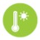 Heatwaves | 49 | 53 | 11 | 8 | 32 | 34 | 7 | 6
Water shortage and drought | 47 | 59 | 15 | 9 | 29 | 25 | 9 | 7

FIGURE 12: IS CLIMATE CHANGE INFLUENCING?

Climate change is influencing the observed increase in this? | YES
 | VIC  % | CtrHigh  %
Heatwaves | 90 | 92
Coastal erosion and changes to sea levels | 89 | 86
Water shortage and drought | 84 | 77
Severe storms and floods | 83 | 83
Crop failures or declining agriculture | 82 | 77
Severe bushfires | 71 | 67
Source: B5/B6 | Base: Total sample

Concern about the impacts
For each of the extreme weather and/or environmental events, all respondents were asked to state how concerned they are about each one directly affecting their local area in the foreseeable future. As shown in the Table below, levels of concern are quite high across the board, with water shortage and declining agriculture topping the list.
The Chart below compares the results for Central Highlands with Victoria overall, Greater Melbourne and Regional Victoria.
Results indicate that people in Regional Victoria are more likely than those in Greater Melbourne to be concerned about the impacts of:
› severe bushfires, 84% compared to 62%;
› crop failures/declining agriculture, 79% compared to 68%; and,
› water shortage /drought, 79% compared to 70%.
Greater Melbourne is more concerned than regional areas about coastal erosion and rising sea levels, 53% compared to 45%.
With the exception of coastal erosion the Central Highlands region has higher proportions of people concerned about the impacts of climate change than the Regional average, however these differences were not statistically significant.

FIGURE 13: PROPORTION WHO ARE CONCERNED ABOUT EACH ENVIRONMENTAL EVENT

 |  | Victoria | Greater  Melbourne | Regional  VIC | Central Highlands  %
 |  | % | % | %
 | Water shortage and drought | 72 | 70 | 79 | 85
 | Crop failures or declining agriculture | 71 | 68 | 79 | 85
 | Severe bushfires | 68 | 62 | 84 | 86
 | Air pollution | 68 | 72 | 57 | 61
 | Heatwaves | 67 | 67 | 66 | 70
 | Severe storms and floods | 65 | 64 | 68 | 74
 | Coastal erosion and changes to sea levels | 51 | 53 | 45 | 40
Source: B5/B6 | Base: Total sample

Leadership and responsibility

The Victorian community believes that government, individuals, and business and industry should all be taking action on climate change. Figure 14 shows, for each entity, the proportion of people who believe it should “lead action” or “contribute to action” on climate change, and compares results for Central Highlands to the state average. In the Central Highlands region, 96% said that individuals should act on climate change action – either leading or contributing.
› Figure 14 shows that 93% of Victorians believe the State Government should be acting on climate change – either in a leadership role or as a contributor.
› Figure 15 (opposite) shows that 22% think the State Government is doing 'the right amount' but the majority (61%) think it should be doing more; the results for Central Highlands did not differ significantly to the state average.

FIGURE 14: LEADERSHIP ON CLIMATE CHANGE
The Australian Government
69
95
94
95
Individuals
96
95
Businesses and industry
91
93
State Government
94
91
Environmental groups
95
89
Local government
93
87
The media
88
State average
Central Highlands
%
Contribute
Lead
26
22
73
78
17
83
13
60
35
50
41
45
48
40
54
47
44
49
46
56
33
66
27
51
36
61
26
Source: C1 | Base: Module 3 (VIC: n=1,000 | Central Highlands n=58) | results exclude DK/REF

State Government action

FIGURE 15: SHOULD THE STATE GOVERNMENT BE DOING MORE?
% 100
Should be doing more
80
61
63
57
63
The right amount
60
Should be doing less
40
Don't know / ref used
20

0
22
5
12
Victoria
20
4
12
Greater Melbourne
25
6
12
Regional VIC
20
4
13
Central Highlands
Source: C3 | Base: Module2

Government climate change targets

Support for the Victoria's emissions and renewable energy targets is high – both targets are strongly supported. The Chart below compares the results for Central Highlands with the state average; awareness and support in Central Highlands is not significantly different to the State average.

FIGURE 16: AWARENESS OF AND SUPPORT FOR VICTORIAN GOVERNMENT TARGETS
Net zero greenhouse gas emissions by 2020
%
No - not aware at all
Have heard something like that

Yes - aware of that specific target
Support the target:
78% 70%
25% from renewable energy sources by 2020, and 40% by 2025
%
No - not aware at all
Have heard something like that

Yes - aware of both specific targets
Support the target:
84% 84%

 | 62 |  |  | 72
 | 13
 | 24 |  |  | 9
 |  |  |  | 19
Victoria |  |  | Ctr High

 | 56 |  |  | 47
 |  |  |  | 22
 | 19
 |  |  |  | 31
 | 24
Victoria |  |  | Ctr High

› Approximately one-quarter, 24%, of Victorians were aware of the net zero greenhouse gas emissions by 2050 target, and 13% were vaguely aware that a target has been set.  › 78% of Victorians support this target.  › Support for the target is stronger among younger Victorians; 88% of those aged 25-39 years.  › Support in the Central Highlands was not statistically significantly different to the state average. | › Approximately one-quarter, 24% of Victorians were aware of the renewable energy targets, and a further 19% were vaguely aware that targets were set.  › 84% of Victorians support these targets  › Support for the targets was stronger among 25-39 year age group, 93%.  › Support for the targets in the Central Highlands was the same as the state average.

Source: C4a/C4b/C5a/C6a | Base: Module 2

Reasons for supporting the targets:
› "I'm hoping that it will lead to cleaner air and less pollution. Earlier than 2050 would be good; not everyone will be around by 2050."
› "Because if we keep going the way we are, the ozone will get bigger and have more effect on the environment."
› "By the time the future comes, there will be a lot more changes. A lot of the cars and trucks cause pollution, with their emissions."
› "I support it but they should do it sooner because it might be too late. It's a big problem and they need to get onto it sooner."

Support for renewable energy

As shown in Figure 17 below, levels of support for the renewable energy targets is consistently high across the state. The graph also shows each region's levels of concern about climate and indicates that high levels of support for renewable energy is not necessarily dependent on high levels of concern.
In the Central Highlands, concern about climate change is 77% while support for the renewable energy targets is higher at 84%.

FIGURE 17: CONCERN ABOUT CLIMATE CHANGE AND SUPPORT FOR RENEWABLE ENERGY TARGETS
Concerned about climate change
Support renewable energy targets
%
78 84
81 86
81
71
76
68
83
76
80
84
75
82
72
79
86
79
77
63
64
Goulburn Great
South Coast
Mallee Loddon Ovens Wimmera Campaspe Murray Southern
Mallee
77
84

56
Victoria Greater Regional
Melbourne VIC
Gippsland Barwon
Central Highlands
Source: B2/C6a | Base: Total sample (B2) / Module 2 (C6a)

As well as supporting the targets, the majority of Victorians are supportive of renewable energy infrastructure in their local area with 75% saying they would support wind turbines in their local area, and 89% saying they would support solar panels in their local area, providing access to renewable energy.
Figure 18 shows the levels of support for both sources of renewable energy, for Victoria overall, Greater Melbourne, regional Victoria, and the Central Highlands. Support is higher for wind turbines in the Central Highlands (however, this difference was not statistically significant to the state or regional average).

FIGURE 18: SUPPORT FOR WIND TURBINES AND SOLAR PANELS
Support wind turbines in my area
Support solar panels in my area
%
89
89
88
75 75
75
81
90
Victoria
Greater Melbourne
Regional VIC
Central Highlands

Source: D4d | Base: Module 1 (wind turbines) Module 2 (solar panels)

Everyday behaviours

The majority of Victorians are already taking some positive actions to reduce energy use. The Charts below compare the results for Central Highlands with the State average and other regions; red squares indicate a significantly lower proportion and blue squares indicate a significantly higher proportion compared to other regions.
Results indicate a larger proportion of people in Central Highlands 'rarely' or 'never' reduce their car usage (55% in total compared to 40% average across other regions). This could reflect fewer public transport options than other regions and/or longer distances to travel.

FIGURE 19: TAKE-UP OF EVERYDAY BEHAVIOURS
6
21
34
4
6
6
18
7
3
8
24

35
34
28
31
33
31
Always Often Sometimes Rarely Never NA/Ref/DK

Actively reduce car use Actively limit energy used to heat and cool the home
% %
 | 6 |  | 6 |  | 5  20
 | 15 |  | 22
 | 16
 |  |  | 19 |  | 33
 | 28
 |  |  | 25
 |  |  |  |  | 17
 | 23
 |  |  | 20 |  | 20  5
 | 13
 |  |  | 7

Victoria Regional VIC Central
Highlands

Choose to buy energy efficient household appliances
4
14
53
3
12
23
113
14

20
23
23
51
57
61
%

Victoria Regional VIC Central
Highlands

Encourage others to adopt pro climate change behaviours
 | 1  19 |  | 1  24 |  | 0  27
 | 15
 |  |  | 14 |  | 14
 | 27
 |  |  | 27 |  | 21
 | 20 |  |  |  | 19
 |  |  | 19
 | 17 |  |  |  | 19
 |  |  | 15

%

Victoria Regional VIC Central
Highlands

Victoria Regional VIC Central
Highlands

Limit the amount of food thrown out
3 13 13
 | 5  15 |  | 5  13 |  | 6  11
 | 25 |  | 24 |  | 26
 | 50 |  | 55 |  | 53

%

Victoria Regional VIC Central
Highlands

Buy any household energy from a green supplier
 | Don't  know, 47 |  | Don't know, 44 |  | Don't  know, 47
 | No, 20 |  | No, 19 |  | No, 15
 |  |  | Yes, 36 |  | Yes, 38
 | Yes, 33

%

Victoria Regional VIC Central
Highlands

Source: D1a/b/c/d/e/f | Base: Total sample

Motivations and barriers for everyday behaviours
The most commonly stated motivations for undertaking everyday basic included cost, convenience, and comfort. Concern for the environment was a reasonably strong motivator, but not the highest.
A selection of comments regarding motivators and barriers from those in the Central Highlands is shown below.

Motivations | Barriers
Actively reduce car use
"I enjoy walking if it is nice weather. It is good exercise." | "We live in regional area so we end up driving everywhere because it is a process."
Actively limit energy to heat and cool the home
"Watching the cost of power, and trying to keep that down, as well as being sensible." | "Cost doesn't really affect us. We don't really watch the cost of it."
Choose to buy energy efficient household appliances
"It's cheaper to run, although more expensive to buy. Cheaper to run and better for the environment." | "As long as the appliance does what I want it to do I don't care."
Limit the amount of food thrown out
"I don't like waste, we grow a lot of our own food so I pick what I require for most meals and freeze the rest." | "Waste is a part of life. I don't try to do anything with scraps except maybe give them to the dog or cat."
Encourage others to adopt pro climate change behaviours
"To sustain a healthy environment so that it lasts for millions or billions of years. I want to increase the life span of the planet." | "I don't force any others about adopting behaviours for climate change because I don't believe there is any climate change."
Buy any household energy from green supplier
"It was one of the best value for money at the time, and as part of that they use some renewable energy." | "I'm a person that if it's not broken, don't repair. So I'm happy with the old fashioned way, the old power company."

Advanced actions

To better understand the actions that Sustainability Victoria might support in the future, it is important to gauge the level of interest (framed within a five year period) in a selection of 'advanced' behaviours. They are considered ‘advanced’ because they have high upfront costs and require a level of planning by those who wish to adopt them.
Respondents were presented with the five advanced behaviours shown below, and asked to state their level of interest in each one; the level of interest in taking up these actions within the next 5 years was high.
The Figure below shows the proportion who are 'very' or 'somewhat' interested in each action, for Victoria overall, Greater Melbourne, regional average and the Central Highlands Region.
While there were no statistically significant differences in the level of interest by location, it is important to note the following:
› Central Highlands respondents appear less interested in community-based renewable energy projects (53%) and more interested in generating their own energy (74%);
› Central Highlands respondents had a slightly higher level of interest in electric cars (54%) compared to other regions (49%), which is consistent with the finding that they are a little more car dependent than other areas.

FIGURE 20: INTEREST IN ADVANCED BEHAVIOURS
Victoria
Greater Melbourne
Regional VIC
Central Highlands
76
68
69
74
69
71
72
68
58
58
58
53
56
49
% 0
20
40
60
80
100

Purchasing 100% of your household energy through a green power supplier
78

Generating own household energy needs and feeding excess energy back
75
74

Installing solar energy battery storage
systems for your home
72

Participating in community projects for renewable energy or climate change

Getting an electric car or a more fuel-
efficient car
59
54
Source: D3a/b/c/d/e.Base: Module 1 and accept some human causation | Results exclude “already doing this”

How the Victorian Government can support individuals

Survey respondents were asked to comment on what they think the State Government could do to support individual action on climate change, with 62% being able to think of suggestions. The comments were coded into themes as shown in the Table below. Across Victoria, the majority of comments related to education (providing information on what people can do to tackle climate change), providing incentives and/or subsidising solar and other renewable energy sources, and providing funding for community programs.

FIGURE 21: SUGGESTIONS FOR HOW THE VICTORIAN GOVERNMENT CAN SUPPORT INDIVIDUAL ACTION

Suggestions for how to support individual action | ALL VIC  (n=523)  %
Education / promotion of climate change issues | 30
Support / promote / subsidise solar power | 23
Support / promote renewable energy | 18
Reduce waste and pollution | 16
Provide funding / financial incentives | 13
Improved public transport / cycle tracks | 9
Increase legislation / regulation of business and industry | 4
Better recycling / waste reduction | 3
More schemes such as the Green Energy Lighting scheme | 3
Support / promote green cars | 3
Reduce / ban plastic bags | 2
Plant more trees / re-vegetation | 1
Other | 10
Source: F4 | Base: Module 3

Further information
For more information contact Sustainability Victoria info@sustainability.vic.gov.au

Sustainability Victoria Level 28, Urban Workshop,
50 Lonsdale Street, Melbourne VIC 3000
Phone (03) 8626 8700
sustainability.vic.gov.au

Published by Sustainability Victoria.
Summary of key findings – Climate Change Social Research
© Sustainability Victoria, September 2017 ENG075

Victorian Perceptions of Climate Change (excluding all trade marks and logos) is licensed under a Creative Commons Attribution 4.0 Australia licence. In essence, you are free to copy, distribute and adapt the work, as long as you attribute the work and abide by the other licence terms. Go to
http://creativecommons.org/licenses/by/4.0/ to view a copy of this licence.

