Contents

Welcome to 2019-20 3

Message from the Chair and Interim CEO 3

2020 and beyond 4

How we’re tracking towards SV2020 4

Priorities for the year 5

Helping Victorians to act on climate change 6

Transitioning places and precincts 6

Connecting communities (social licence and systems) 6

Supporting practical action 6

SV2020 Strategic Outcomes 7

Helping Victorians use resources wisely 10

Transitioning industry and marketplace toward circular economy 10

Leading and implementing the statewide infrastructure plan 10

Supporting practical action 11

SV2020 Strategic Outcomes 11

Our culture 14

SV2020 Strategic Outcomes 14

Budget 15

Our Board 17

Our organisational structure 18

2019-20 Sustainability Victoria

Business Plan

# Welcome to 2019-20

## Message from the Chair and Interim CEO

The year ahead is the final year of our SV2020 strategy, and we look forward to finishing what we started in 2015. Our goal is to support Victorians to thrive, to see what’s possible and work together to get there. In 2015, we set out to restore Victoria’s environmental leadership, build on our statewide waste infrastructure plan and apply the same consultative approach to community driven action on climate change. TAKE2, the world’s first government led climate pledge program, seeks commitment at all levels to the transition needed to get to net zero emissions. Over the past four years, significant changes to industry and policy have brought new challenges and opportunities. In 2019-20 and in the years ahead, our task is to accelerate Victoria’s transition to a State that keeps harmful emissions from our atmosphere and resources within our economy.

There is a growing momentum in Victoria, Australia and across the world toward net zero emission and the war on waste. We are all on this planet together and in Victoria, all creating the State of the future. At Sustainability Victoria (SV), we help make these large-scale issues real, practical and actionable for people. We have the knowledge and agility to work across a wide range of places, spaces and people, to protect the resources we share, the lifestyle we enjoy and the environment that makes it all possible.

In everything SV does, we aim to deliver multiple benefits for Victorians, across health and wellbeing, job creation and infrastructure, research and development, connecting communities and, of course, protecting the environment.

This year, SV will continue helping communities to design their own net zero emission futures, focusing on what can be done in a variety of places, from net zero emissions plans within a school to business precincts, to entire towns and cities. Fairness guides what we do, and we want to be sure that no Victorian is left behind in the transition. Our Healthy Homes and Home Energy Upgrade programs improve the thermal comfort of homes for low income households and those with complex healthcare needs, while researching the positive effect of this action on human health. These programs also invest in the sustainability skills and qualifications of regional tradespeople.

As our population continues to grow, the Victorian Government is investing record amounts in the capacity of Victoria’s resource recovery industry. SV will ensure our 30-year plan for Victoria’s waste and resource recovery infrastructure and its implementation strategies remain up to date with the latest trends and pressures in the industry and develop a data roadmap to build strong evidence for future industry investment and infrastructure. This year, the Victorian Government is also supporting the use of recycled products and materials through its own procurement initiatives.

SV has a statutory role to facilitate environmental sustainability in the use of resources, but we recognise that true sustainability is achieved when we take a systems approach that includes health, economy and engaged communities. In 2019-20, the Victorian Government will develop a circular economy policy toward a future where waste is designed out and products and materials are kept circulating at their greatest value for as long as possible. Our ongoing focus on market development and support to the recycling industry helps build market confidence in recycled products. A true circular economy requires commitment from industry, government and the community and we look forward to working closely with Victorians across different sectors to make it happen.

Victoria is an amazing place to live and we want to keep it that way. It’s up to all of us to help shape the State of the future.

## 2020 and beyond

Our vision, purpose and mission to 2020 continues to guide the strategic initiatives of this year’s business plan and how we will plan initiatives for the next several years.

|  |  |  |
| --- | --- | --- |
| Our vision  is for a sustainable, thriving Victoria | Our purpose  is to mobilise Victorians to create a better environment, now and for our future | Our focus is on  1 Enabling Victorians to act on climate change  2 Using resources wisely |

SV helps Victorians save energy and move to renewable energy, waste less, recycle more and transition to a net zero emissions lifestyle

## **How we’re tracking towards SV2020**



SV operates under the Sustainability Victoria Act 2005 as a statutory agency of the Victorian State Government in the Environment and Climate Change portfolio. We report to the Minister for Energy, Environment and Climate Change, the Hon Lily D’Ambrosio. We are responsible for delivering the Statewide Waste and Resource Recovery Infrastructure Plan, as well as contributing to policy and legislative outcomes, including under the Climate Change Act 2017, Victorian Climate Change Framework, Energy Efficiency and Productivity Strategy, Renewable Energy Action Plan, the New Energy Technologies Sector Strategy, and the Recycling Industry Strategic Plan.

<insert Portfolio graphic>

# Priorities for the year

|  |  |
| --- | --- |
| **A strong finish to 2020**   1. **Build capacity in the Victorian waste and resource recovery industry**   Support and invest in the capacity of the resource recovery sector, including investment facilitation and targeted grants to the opportunities identified in the 2018 *Recycling Industry Strategic Plan*.   1. **Drive progress toward net zero emissions by 2050**   Work with members of the TAKE2 network to fulfil their pledges to act on climate change and support the further development of net zero emissions plans across different sectors of the community as well as continue to ensure emission reduction outcomes from other projects including First Rate5, energy efficiency and food waste programs are maximised.   1. **Putting power back in hands of Victorians**   Meet our 2019-20 annual targets for energy efficiency and thermal comfort improvements in Victorian homes through retrofit and upgrades in the Healthy Homes, Home Energy Upgrade and Zero Carbon Homes programs. Complete Community Renewable Energy projects underway in Latrobe Valley, Bendigo and Ballarat. | **A head start on 2023**   1. **Net Zero Emissions Future**   Support communities (including local governments, business and community organisations) to realise their vision of net zero emissions which contribute to State’s emission reduction targets.   1. **Circular Economy**   Prepare a systems-based strategy for future programs that will deliver the Victorian Government’s circular economy policy, including a food waste roadmap that identifies interventions across the entire supply chain |

# Helping Victorians to act on climate change

The task of reaching net zero emissions by 2050 is complex. We help people to choose the meaningful actions they can take in their homes, communities and businesses. We’re working with communities to design their own net zero emission future, tailored to the places and precincts where they live, work and play. Building on the foundational work already undertaken by those communities at the forefront of the transition and working with TAKE2 members from local government, business and community organisations, SV will build a collective impact program that brings these actions together around places like schools, precincts, regional towns and cities to support a just and prosperous transition to a low carbon economy.

## Transitioning places and precincts

*We will focus on specific places or regions as a way of supporting change to decarbonise those communities and their surroundings.*

* Support the completion of the Community Renewable Energy projects underway in communities of Latrobe Valley, Bendigo and Ballarat, and share the learnings and resources across the broader Victorian community energy sector.
* Assist schools to embed sustainability into their curriculum, operations and community leading to reductions in resource use and increase in local biodiversity.
* Engage households on waste avoidance, energy efficiency and climate change through social media and targeted campaigns.
* We will work with 10 communities and assist them to work towards a net zero emissions future. We will enable community, business, government, householders to collaborate on a positive approach forward, together.

## Connecting communities (social licence and systems)

*We will support Victorian communities to plan their own net zero emissions future.*

* Conduct youth forums, establishing an ongoing mechanism for youth consultation and ideation for the State of the future.
* Promote a systemic approach to climate change action through engaging with industry and community sectors on potential high emissions reduction areas such as zero carbon concrete.
* Deliver the next phase of TAKE2 by offering pledging organisations and individuals the opportunity to network and collaborate on actions to address climate change. The program will offer business, community organisations and local government the ability to share knowledge and resources while contributing to the state’s overall goal of net zero emissions by 2050.
* Promote greater public awareness and understanding of the health impacts of climate change, and the action people can take.

## Supporting practical action

*We will provide practical support for Victorians to transition to a net zero emissions economy.*

* Facilitate participation of TAKE2 organisations in the uptake of renewable energy Power Purchase Agreements (PPAs) through linking them to the Business Renewables Centre or other PPA processes.
* Work with 22 councils in the Local Government Energy Saver Program to undertake energy upgrades on existing community facilities such as pools, libraries, kindergartens, halls, performing arts centres, and civic centres that delivers electricity and maintenance cost savings, reduced greenhouse gas emissions, and increased appeal and comfort to users.
* 10 communities have commenced community emissions profiles.
* 6 Community Power Hub pipeline projects have reached installation stage.
* Improve 50 commercial buildings average National Australian Built Environment Rating System (NABERS) star rating by 1.
* Work with Volume Home Builders to provide technical and marketing expertise to builders on the development, marketing and sales of leading-edge zero net carbon homes.
* Lower energy bills and improve thermal comfort for households with low income or ongoing health issues through the Healthy Homes and Latrobe Valley Energy Upgrades programs.
* Deliver 3 pilot projects to test barriers to sustainable finance uptake by businesses.

## SV2020 Strategic Outcomes

United Nations Sustainable Development Goals (UNSDG) are part of the 2030 agenda for sustainable development, adopted by all United Nations Member States in 2015, to provide a shared blueprint for global peace and prosperity for people and the planet, now and into the future.

Sustainability Victoria's work primarily supports the following goals

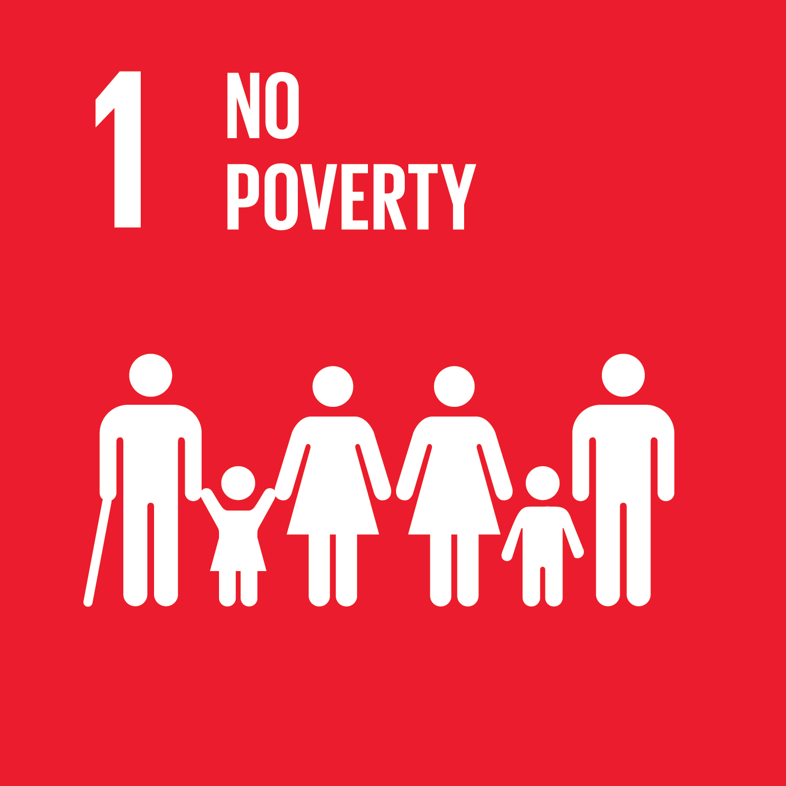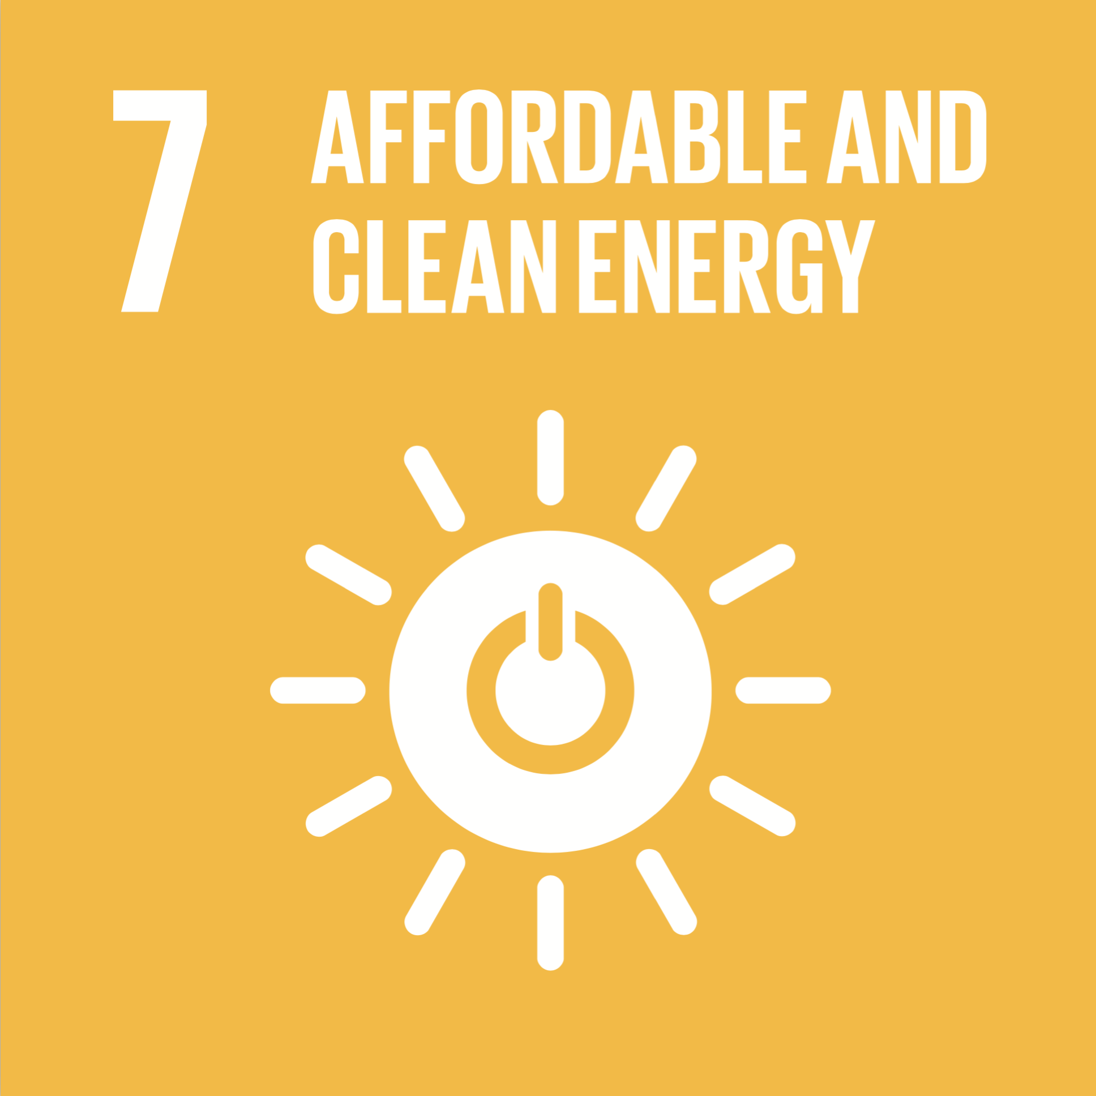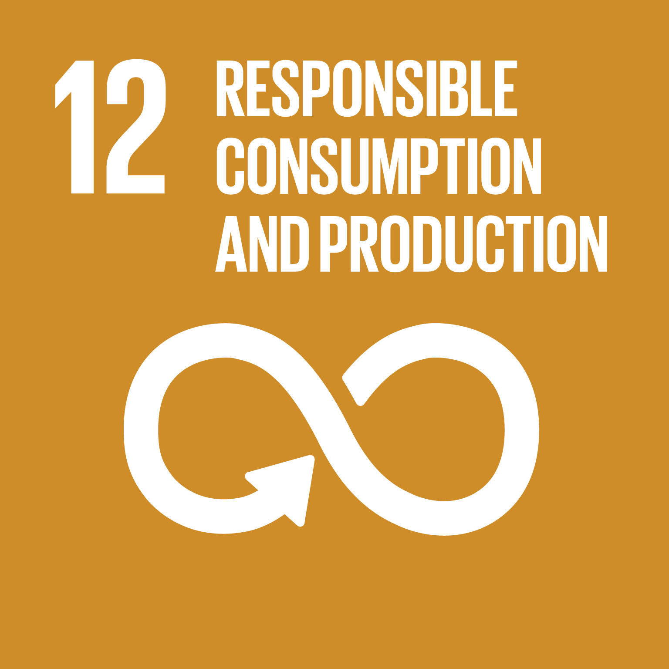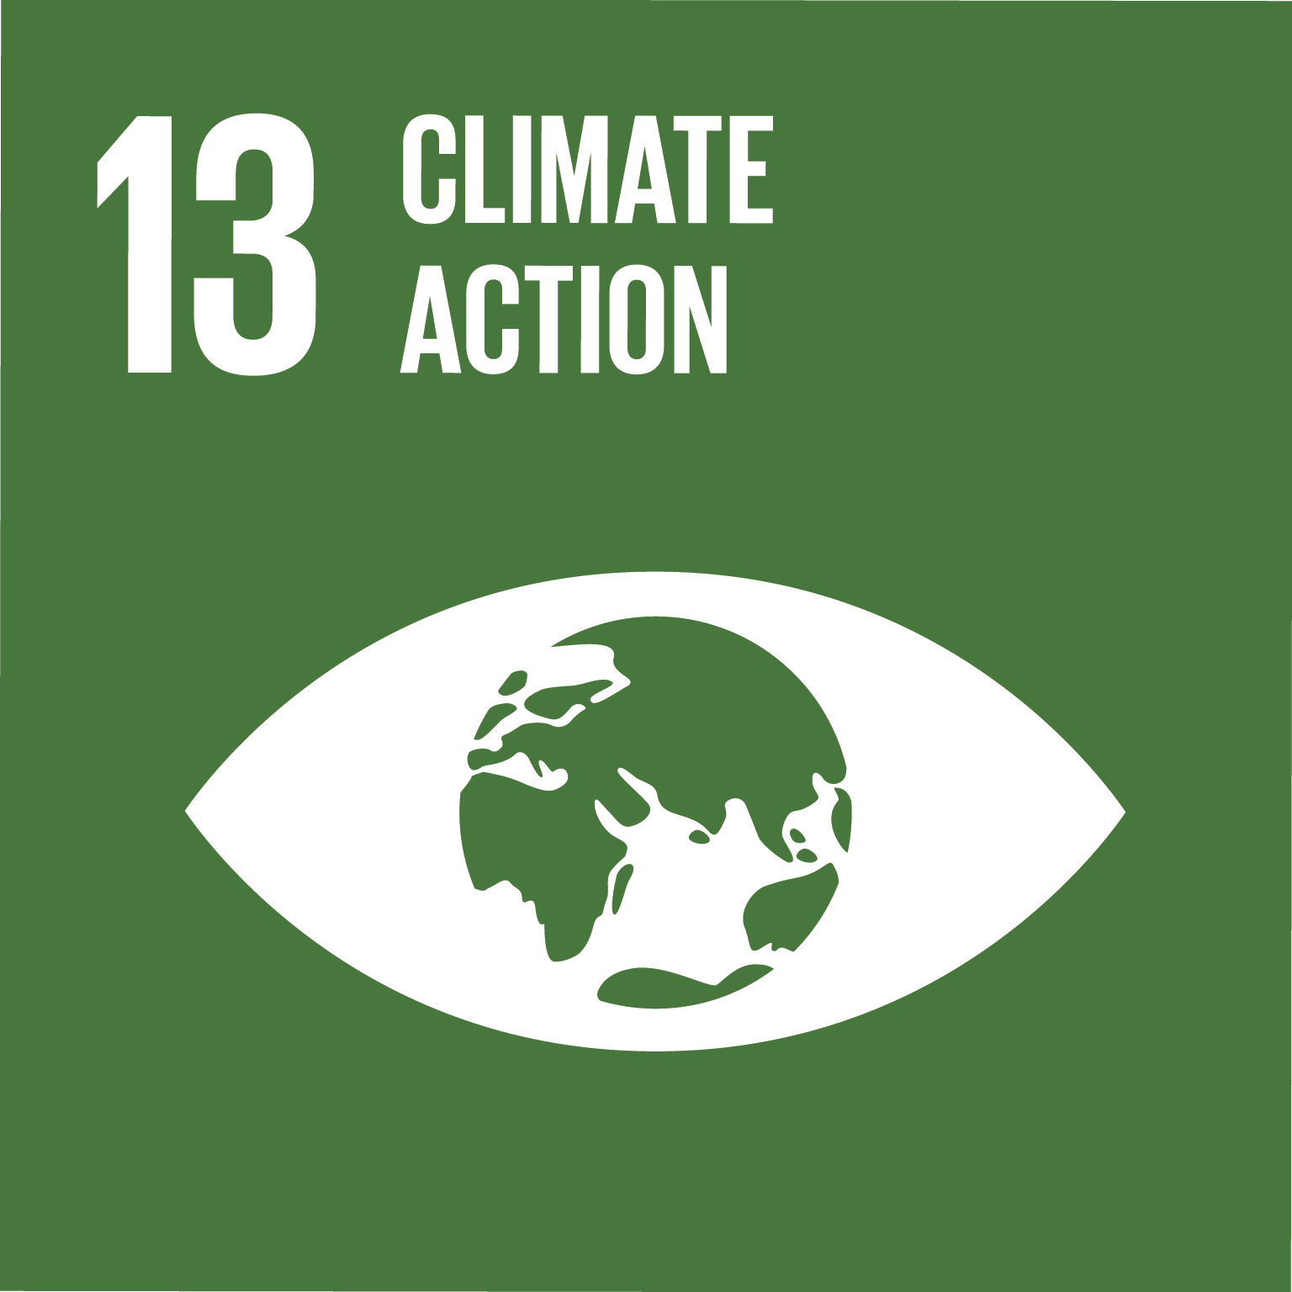

|  |  |  |
| --- | --- | --- |
| **Victorians save on energy costs** | | |
| **Outcome indicator** | **Outcome measure & 2019-20 target** | **Link to UN SDG action\*** |
| Reduce energy bills for Victorians | Annual energy bill savings of **$25 million** for Victorians participating in SV programs | 7.1 |
| SV’s continued participation in the national Equipment Energy Efficiency (E3) program to deliver energy efficient appliance standards and labelling, contributed to Victorians saving **$300 million** on their annual energy bills | 7.1 |
| Increase schools acting on climate change and using their resources wisely | **700** schools active in the ResourceSmart Schools program | 7.1 |
| Reduce energy use by Victorian schools, businesses, local governments and communities participating in SV programs | ResourceSmart Schools save **6 million kWh** annually | 7.1 |
| **44 million kWh** saved annually by businesses, local governments and communities participating in SV programs | 7.1 |
| Increase renewable energy capacity in Victoria | **400 kW** of renewable energy capacity added by Community Power Hub projects | 7.2 |
| **600 kW** of renewable energy capacity installed for resource constrained councils | 7.2 |
| Improve energy efficiency performance of commercial buildings | **50** commercial buildings improved their average NABERS rating by 1 star | 7.3 |
| Increase supply of Zero Net Carbon homes by Volume Home Builders | **2** Zero net carbon display homes completed | 7.1 & 7.3 |

*United Nations Sustainable Development Goals (UNSDG) are part of the 2030 agenda for sustainable development, adopted by all United Nations Member States in 2015, to provide a shared blueprint for global peace and prosperity for people and the planet, now and into the future.

|  |  |  |
| --- | --- | --- |
| **Net zero emissions** | | |
| **Outcome indicator** | **Outcome measure & 2019-20 target** | **Link to UN SDG action** |
| Reduce Victorian greenhouse gas emissions | SV programs reduced greenhouse gas emissions by **240,000** **tCO2-e** | 13.1 |
| Actions facilitated by SV through the TAKE2 network since 2018 contributes to reducing greenhouse gas emissions by a cumulative 2 million **tCO2-e** annually, once fully implemented | 13.1 |
| SV’s continued participation in the national Equipment Energy Efficiency (E3) program to deliver energy efficient appliance standards and labelling, contributed to reducing annual greenhouse gas emissions by **1.5 million tCO2-e** | 13.1 |
| **Sustainable housing upgrades reduce energy bills for Victorian low-income and health-affected households** | | |
| **Outcome indicator** | **Outcome measure & 2019-20 target** | **Link to UN SDG action** |
| Reduce energy bills for Victorian low-income and health affected households | **775** low-income and health affected households received home energy upgrades | 1.5 & 7.1 |

|  |  |  |
| --- | --- | --- |
| **Victorians recognise that climate change is a significant issue facing Victoria** | | |
| **Outcome indicator** | **Outcome measure & 2019-20 target** | **Link to UN SDG action** |
| Increase proportion of the Victorian population who rank climate change in the top 3 issues of importance | **33%** of the Victorian population ranked climate change in the top 3 issues of importance | 13.3 |
| **1,200** organisations in the TAKE2 network | 13.3 |
| Individuals, communities and businesses committed to **115,000** TAKE2 actions | 13.3 |

# Helping Victorians use resources wisely

Our state's waste generation rate per person has remained relatively stable for the past 10 years, but our population is growing fast and our systems must be ready to face these challenges. The Victorian Government’s circular economy policy will guide the next steps across Victoria to encourage people towards conscious consumption and manufacturers toward product stewardship. As Victoria transitions to a circular economy, SV will continue to explore upstream interventions such as waste avoidance, product design and stewardship. We continue to support a stronger recycling sector and foster a domestic remanufacturing sector that can use recycled materials to create new products ready for market. We want to let people know how they can make sure their waste goes to a better place, working with kerbside collectors, resource recovery industry and businesses to close the loop and reuse as much as possible.

## Transitioning industry and marketplace toward circular economy

*We will support Victoria’s industries toward greater capacity for recycling and build market confidence in recycled products.*

* Support the Victorian ban on e-waste in landfill through 50 new or upgraded e-waste facilities.
* Provide investment facilitation services to opportunities identified in the Recycling Industry Strategic Plan and 6 targeted grants toward reducing packaging waste to landfill.
* Promote recovery of organic waste and market development in its beneficial uses, such as composts for Victoria’s agriculture sector and generation of heat and power.
* Facilitate procurement and use of recycled products and materials in infrastructure projects.
* Develop and deliver education and behaviour change campaigns and projects to improve recycling, e-waste collection, and avoidance of food waste and single-use plastic bags.
* Support research, development and demonstration projects that increase the quantity of recycled products being sold in Victoria, including identifying how to address barriers to uptake, exploring new uses and demonstrating performance characteristics for recovered products.

## Leading and implementing the statewide infrastructure plan

*We will ensure our statewide plan and strategies remain up to date with the latest trends and pressures in the industry.*

* The Statewide Waste and Resource Recovery Infrastructure Plan (SWRRIP) is used to inform investment, plans and decisions to ensure that Victorian waste and resource recovery infratructure network meets the needs of Victoria.
* Continue to implement the SWRRIP and prepare an update that reflects recent data and changes to the waste and resource recovery industry
  + Conduct an evaluation of the SWRRIP.
  + Undertake an infrastructure gap analysis.
  + Plan for hazardous waste infrastructure needs to be incorporated.
* Lead national stewardship approach to photovoltaic systems.
* Develop a data road map to improve quality and accessibility to a statewide data repository and support informed evidence-based decisions by industry and government.
* Develop methodology to capture, measure, monitor and report on impact of the circular economy policy, assisting the Victorian transition.
* Collaborate with and support the Waste and Resource Recovery Groups and local governments in the design and implementation of programs.
* Review progress on waste strategies and develop plans to monitor implementation across the state.
* Lead national research projects on consumer food waste reduction through the Fight Food Waste Cooperative Research Centre.

## Supporting practical action

*We will provide tactical support for the Victorian community to use resources wisely.*

Invest the Resource Recovery Infrastructure Fund, and encourage greater industry investment, in infrastructure to improve recycling of paper, cardboard, plastics and glass.

* Deliver behaviour change campaigns on e-waste, recycling, food waste and plastic bags to encourage Victorians to take practical steps to minimise and better manage their waste.
* Provide funding, guidance and education to local governments to expand food organics collection.
* Through the Love Food Hate Waste (LFHW) program, provide practical support for the hospitality industry to minimise food waste and reduce costs.
* Conduct research into how food waste is generated from paddock to plate to inform potential future interventions and the Victoria Government’s circular economy policy development.
  + Identify 30 interventions to halve food waste.
  + Complete a cost benefit analysis on 5 key interventions to halve food waste.
* Design and deliver industry development funding to assist new entrants into the recycling sector and invest in remanufacturing infrastructure to improve the market for recycled material products.
* Publish 8 Recovered Resources Market Bulletins showing month to month changes in commodity prices, material flows and stockpiles across Victoria to attract new investment by new entrants into the recycling market.

## SV2020 Strategic Outcomes

|  |  |  |
| --- | --- | --- |
| **Improved Resource Recovery Rate in Victoria** | | |
| **Outcome indicator** | **Outcome measure & 2019-20 target** | **Link to UN SDG action** |
| Increase Victorian Resource Recovery Rate | SV’s programs increased Victoria’s resource recovery rate by **2%** and influence an additional **2%** increase | 12.5 |
| Improve accessibility to e-waste collection facilities | Delivered **50** new or upgraded e-waste facilities (to reach a total of 80 facilities overall) | 12.5 |
| Increased awareness of e-waste and how to dispose of it following the e-waste to landfill ban by **25%** | 12.8 |
| Improve Victorians’ awareness of correct recycling and plastic bag behaviours | Recycling and plastic bag focused behaviour programs collectively reached **1 million** Victorians | 12.8 |
| Increase uptake of recycled materials | SV invested **$1.2 million** into innovative research development and demonstration projects that address barriers to the increased uptake of recycled materials | 12.5 |
| SV supported the commercialisation or demonstration of **2** Research Development and Demonstration projects on products with recycled content | 12.5 |
| Technical expertise and data provided to at least **2** government projects leading to the purchase of recycled products or materials | 12.7 |
| Reduce toxic chemicals going into landfill | **5,000** Victorians disposed of their toxic household chemicals via Detox Your Home chemical collection events across Victoria | 12.4 |

|  |  |  |
| --- | --- | --- |
| **Victoria’s waste and resource recovery sector has the capacity to meet the needs of a growing Victoria** | | |
| **Outcome indicator** | **Outcome measure & 2019-20 target** | **Link to UN SDG action** |
| Increase capacity in Victoria’s waste and resource recovery sector | An additional **150,000 tonnes** of capacity added to the waste and resource recovery sector | 12.5 |
| **$7 million** of SV investment leveraged an additional **$23 million** infrastructure investment by the waste and resource recovery sector | 12.5 |

|  |  |  |
| --- | --- | --- |
| **Zero organic material goes to landfill** | | |
| **Outcome measure & target** |  | **Link to UN SDG action** |
| Reduce organics going landfill | Local government organics services diverted **20,000 tonnes** of organics from landfill | 12.3 |
| **2** councils implemented a new or improved food organics collection systems with funding and support from SV | 12.3 |
| **50%** of households applied food waste reduction behaviours at home | 12.3 |
| **200** hospitality businesses reduced food waste through participation in the LFHW program | 12.3 |
| **10,000 tonnes** of capacity added to recover organic waste for beneficial uses, including composts for Victoria’s agriculture sector and generation of heat and power | 12.3 |

# Our culture

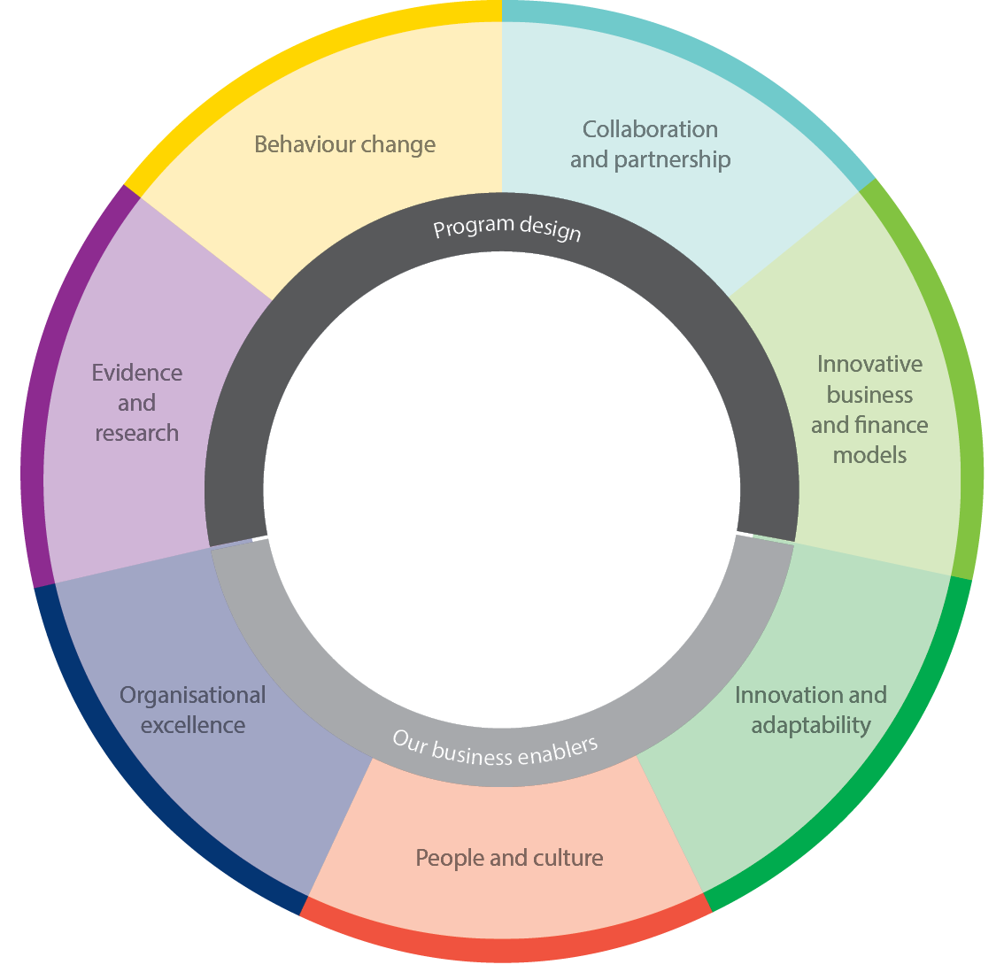At SV, we recognise that if we want to ignite change in Victoria to transition to a net zero emissions and circular economy, it begins with harnessing and developing the full potential of our people. We encourage SVers to bring their full and authentic selves to work, to be passionate about making a difference for the environment, surrounded by knowledgeable peers and supported to be agile through flexible working conditions and strong technology. We drive a constructive culture of continuous learning, agility and leadership. At SV, we encourage our staff to deliver amazing work, develop their knowledge and skills, and to take strong sustainability principles with them to all their future workplaces.

Our internal service providers help staff to collaborate, explore and create impact toward the State of the future. We work across the organisation on program design, delivery and evaluation, building a shared understanding of what needs to be delivered and working together to get there.

**Corporate projects 2019-20**

* Develop a social procurement strategy to enhance SV’s procurement.
* Migrate to a cloud-based approach to SV’s information technology and digital systems.
* Share and promote SV’s research and data.
* Encourage greater engagement with SV via social and digital platforms.

|  |  |  |
| --- | --- | --- |
| SV2020 Strategic Outcomes **Our people have a deep understanding of the Victorian community and are empowered to lead the transition to the State of the Future** | | |
| **Outcome indicator** | **Outcome measure & 2019-20 target** | **Link to UN SDG action** |
| Increase engagement with Victorians through our various online platforms | SV engages with **10%** of Victorians through our various online platforms | 12.8 |
| SV has **70,000** social media followers | 12.8 |
| Increase staff engagement with the work SV does | **74%** of SV employees feel engaged with the work SV does |  |
| Increase SV staff behaviour change capability | **60%** of staff complete introductory Behaviour Change training |  |

# Budget

|  |  |  |  |  |  |
| --- | --- | --- | --- | --- | --- |
| **Sustainability Victoria** | | |  |  |  |
| The budget expenditure for Sustainability Victoria’s 2019–20 Business Plan is $63,989,039.  Sustainability Victoria's legislated landfill levy distribution for 2019–20 is estimated to be $19,104,919. | | | | | | |
|  |  |  |  |  |  |

*Solar Victoria transitioned to DELWP on 1 July 2019. The expenses included in Sustainability Victoria Budget for 2019-20 relate to completion of Solar Victoria’s Phase 1 rebates.

Distribution of total 2019-20 budget and funding source as shown in the above table:

|  |  |  |  |  |  |
| --- | --- | --- | --- | --- | --- |
|  |  |  |  |  |  |
| |  |  |  |  |  |  |  |  |  |  | | --- | --- | --- | --- | --- | --- | --- | --- | --- | --- | | **Sustainability Victoria's three year indicative forward cashflow** | | | | | | | | | | | Sustainability Victoria has in place a Long-Term Financial Plan which seeks to ensure the organisation's financial sustainability. Sustainability Victoria will maintain an adequate financial buffer in outward years to ensure the organisation is able to meet its financial commitments. | | | | | | | | | | |  | |  | |  | | | **SV 3 year cash flow forecast** | | |  | | **2019-20** | | **2020-21** | **2021-22** | |  | | |  | | **$** | | **$** | **$** | |  | | |  | |  | |  |  | | Landfill Levy | | |  | | 19,104,919 | | 18,682,542 | 18,249,606 | | Interest & Other Revenue | | |  | | 528,960 | | 482,394 | 150,714 | | Tied project funding | | |  | | 30,076,280 | | 12,968,500 | 12,236,500 | | Other Tied Funding | | |  | | 2,607,148 | | 2,646,255 | 2,685,949 | |  | | |  | |  | |  |  | | **Total Cash inflows** | | |  | | **52,317,307** | | **34,779,691** | **33,322,768** | |  | | |  | |  | |  |  | | **Total Cash outflows** | | |  | | **60,371,197** | | **55,191,711** | **38,064,659** | |  | | |  | |  | |  |  | | **Net Cash inflow/(outflow)\*** | | |  | | **(8,053,891)** | | **(20,412,020)** | **(4,741,891)** | |  | | |  | |  | |  |  | | **Opening Cash Balance - 1 July** | | |  | | **40,213,509** | | **32,159,618** | **11,747,598** | |  | | |  | |  | |  |  | | **Closing Cash Balance - 30 June** | | |  | | **32,159,618** | | **11,747,598** | **7,005,707** | |  | | *The Solar outflows from FY18-19 do not form part of expenditure in the FY19-20 budget as these have been expensed as part of the prior financial year. | | | | | | | | | | **Net cash is declining in 2019-20 and 2020-21 as a result of tied funded initiatives requiring subsidisation from core landfill levy funding. | | | | | | | | | | | | | | | |

# Our Board

Heather Campbell – Chair

Sarah Clarke – Deputy Chair

Peter Castellas

Vicky Darling

Megan Flynn

Judi Harris

Kerry Osborne

Jennifer Lauber Patterson

Neil Pharaoh

# Our organisational structure

<As of 30 August 2019>