Water audit tool
ResourceSmart Schools

Contents
Using the water audit tool 3
Water in schools 5
Tips and tricks for a successful audit 6
Teacher/facilitator audit checklist 7
Worksheet: School water meter reading 10
Worksheet: Gather background information with school staff 12
Worksheet: Taps 14
Worksheet: Drinking fountains 17
Worksheet: Toilets and urinals 19
Worksheet: What else uses water at your school? 22
Worksheet: Outdoor water use 23
Worksheet: Indoor water use 25
Worksheet: Tank water use 26
Appendix 1: Water meter form example 27
Appendix 2: More water activities 28
Appendix 3: Curriculum links 30
Glossary 32

Using the water audit tool
Welcome to the ResourceSmart Schools (RSS) water audit tool.
The audit tool helps you investigate and record information on water use and water infrastructure at your school, such as taps, toilets, tanks, fountains, irrigation, showers and appliances. You can then analyse the collected data to find ways to save water and record your ideas and next steps in your water action plan.
ResourceSmart Schools audit their water use every year and upload results, photos and presentation(s) to the RSS online system as part of the water module. The first audit provides baseline data and subsequent audits monitor your progress against baseline data.
The water module is one of five modules in the RSS program. The other modules are core, biodiversity, energy and waste. Schools must accomplish a set number of actions to complete each module and receive a certificate valid for four years.

What’s included in this tool?
- Checklists to guide teachers/facilitators through the audit
- Tips and tricks for completing the audit
- Two worksheets to complete before audit day and seven worksheets to complete on audit day
- Resources to help with your audit and to link activities to the Victorian Curriculum (see the appendix)
- Glossary of water terms

What does the audit involve?
Teachers and students will work together to assess water use at their school. Teachers will need to do some preparation and follow-up work (see Teacher/facilitator audit checklist) and students will complete some worksheets.

Who should do the audit?
The student worksheets are best suited to students in Years 3 to 10, with the supervision and guidance of a teacher.

How long does the audit take?
Teachers will use their discretion to determine a realistic timeframe for each step of the audit investigation.

How does the audit link to the Victorian Curriculum?
Exploring the concept of water, which includes a water audit, contributes to several learning areas in the Victorian Curriculum (see Appendix 3: Curriculum links). Involving students in this audit will also help with:
- Critical and creative thinking: Responding effectively to environmental, social and economic challenges requires young people to be creative, innovative, enterprising and adaptable, with the motivation, confidence and skills to use critical and creative thinking purposefully.
- Mathematics: Conducting a water audit can incorporate using units of measurement, data and interpretation, chance, patterns, fractions, decimals and numbers.
Download curriculum guides from the Sustainability Victoria website

Where can I find more information?
Visit the Sustainability Victoria website for a module checklist and ‘how to’ guide packed full of ideas on how to work with students and the school community to reduce water use.

Water in schools
Water is the most essential ingredient for life on Earth. We depend on it for almost everything we do from eating, drinking, energy and transport.
Australia is one of the driest continents on Earth. Much of our accessible water comes from our groundwater. Groundwater, more commonly called aquifers, is the water that has seeped into the soil and sand through cracks in the ground or rocks and which eventually flow into rivers, lakes or the ocean.
When students understand where water comes from and the processes involved in getting water to the school, they will better understand how precious it is and how best to use it.
Schools lose the most water in ‘wet areas’ like toilets, showers and drinking fountains. In 2019, ResourceSmart Schools collectively saved almost 200,000 kilolitres of water – that would fill up 80 Olympic-size swimming pools. They did this by reducing potable water use and improving water management.

Tips and tricks for a successful audit
Follow these tips for a smoother audit:

Pick a regular audit date
Check the forecast to avoid extreme weather events and audit your water use in the same month each year so you can monitor trends.

Notify school staff
Talk to maintenance staff about your planned audit so they understand what you are doing and to check their availability on audit day.

Gather water meter data before audit day
Calculate your water consumption before audit day by taking water meter(s) readings for eight days (from Monday to Monday). Record your data in the School water meter reading worksheet.

Consider interviews in your planning
Ideally, you will carry out your water audit over one day. You need to complete two worksheets before audit day:
- Gather background information with school staff
- School water meter reading
It is important to do this before audit day so you will know where the main water appliances are located and what areas to audit.
On audit day, students will be asked to interview ground staff, gardeners or other relevant staff to complete two worksheets:
- Outdoor water use
- Indoor water use
If these staff are unavailable on audit day, get the worksheets completed before audit date as the interviews will enrich your discussions and inform your water action plan.

Use the audit checklist
The teacher/facilitator checklist takes you step-by-step through the audit and will help you get everything ready in advance.

Teacher/facilitator audit checklist

Before audit day

Step 1: Gather background water management information
- Upload 12 months of water bills in the RSS online system to set your baseline data.
- Complete the School water meter reading worksheet eight days before the audit to identify how many water meters you have, peak times and volume.
- Complete the Gather background information with school staff worksheet by talking with your school principal, business manager, students and other staff members to get insights into parts of your water management you don’t usually see.
- Print student worksheets.
- Print an aerial map of your school. If your school doesn’t have an aerial map, you can use Google Maps.

Step 2: Organise equipment
Each pair/small group will need:
- Aerial map of school grounds and/or floor plans of your school
- Allocated student worksheet
- Pens and clipboards
- Camera to gather evidence for your RSS water module, presentations and audit assessment.

On audit day

Step 3: Introduce water audit tool
- Check that students understand all the terms used.
- Review the method with the students (see Step 4).
- Conduct safety briefing.
- Establish student pairs or small groups and designate areas to audit.

Step 4: Collect data
- Students audit the school with the guidance of the teacher.
- Walk around the school’s designated areas to audit and record water audit findings using the following worksheets:
  - Taps and Drinking fountains to identify any leaks.
  - Toilets and urinals to identify leaks and flush details.
  - What else uses water at your school to identify other water usage sources.
  - Indoor water use and Outdoor water use to identify more water information by interviewing ground staff, gardeners or other relevant people. You will need to make sure these people are available for interview on audit day.
  - Tank water use if applicable at your school.

During or just after audit day

Step 5: Complete water action plan
- Discuss the students’ findings – what is the current state of water in your school?
- Brainstorm what your school can do better or differently to reduce portable water use and increase water efficiency.
- Populate the water action plan template with findings and recommendations. List actions in priority order (highest to lowest).
- Upload water audit results, photos and presentation(s) to RSS water module in the RSS online system as support and evidence.

After the audit

Step 6: Communicate and implement
- Encourage students to present findings and recommendations to principal, assistant principal and school council (buildings and grounds subcommittee).
- Communicate to the wider community through:
  - presentation(s) during whole school assembly
  - stories and hints in the school newsletter, school blog and your social media channels
  - stall at school fair
  - letter-drop in local area
  - Kids teaching Kids conferences
  - teacher and principal’s conferences.
- Upload presentation(s) to RSS online system as support and evidence.
- Get the water action plan approved by the principal, assistant principal and business manager.
- Upload the approved action plan to the water module in the RSS online system and incorporate it into your School Environment Management Plan (SEMP).

Step 7: Monitoring for continued engagement
Ongoing monitoring will tell you how effective you have been in implementing changes and reducing water use.
- Recruit monitors to look regularly for leaks and dripping taps and report these for maintenance.
- Complete yearly water audit.
- Update water bills in the RSS online system to monitor seasonal trends. Use the reporting function to compare your water use over time and with other Victorian schools.
- Write stories about your water audit and savings to share in newsletters or on your school’s intranet, website and social media channels.
- Compare impact and achievements with baseline (reflect on where you started).
- Communicate and celebrate your success with your school community!

Worksheet: School water meter reading

To be completed the week before audit day
Name(s):_________________________________________________Date_________
Find the water meter(s) at your school. Some schools have more than one meter – you will receive a bill for each meter that you have. If you have more than one meter, collect data for each meter.
Read the school water meter(s) over eight consecutive days to see how many kilolitres (kL) of water is used from the mains water supply. Record your data in the table below. Note: It is important to record your data at the same time each day.
To work out water use for the school day, subtract the reading at the start of the day from the reading at the end of the day. Appendix 1 has a completed water meter reading form as a guide. If you are part of another water program like SWEP you may already have access to this information online.

Water consumption over eight days
 | Date of meter reading | Reading at the start of the day (kL) | Reading at the end of the day (kL) | Water use for the school day (kL) | After hours water use for school day* (kL) | Total water consumption for the day (kL)
Monday
Tuesday
Wednesday
Thursday
Friday |  |  |  |  | n/a
Monday |  |  | n/a | n/a | n/a | n/a
A Total water consumption for the week (add up Monday to Friday totals. Do not include weekend water use in Friday total)
B Total weekend water use (the difference between Friday afternoon’s water reading and the next Monday morning’s water reading)
Total water consumption over seven (7) days (Add A+B)
*The difference between the recording at the end of the day and start of the next school day.

Water use per student
Volume of water used during the week (A) | kL
Total number of students at the school (B)
Water used per student per week (A divided by B)
Note: To convert your kL reading into litres multiply by 1,000.

Questions
What did you notice?

When are the peak times for water use?

What is happening in the school at these times?

Worksheet: Gather background information with school staff

To be completed before audit day
Interview your school principal and/or business manager to gather background information. This information will be useful when drafting your water action plan.

Questions
How many water meters does the school have? You will have separate bills for each water meter.

Does the school purchase any recycled water? This will come from taps and pipes that are purple, and the water will be used for irrigation or flushing toilets – recycled water is not for drinking.

Walk around your school and identify when and where are irrigation systems used. Can you see water reaching beyond the targeted area or any run-off where water is not being absorbed in the area being irrigated?

Where else can you see water being used?

Where are outdoor taps and water fountains located?

Which rooms have taps? You should expect to find taps in rooms used for science, arts and cooking, in toilets and changing rooms, staffrooms, canteen, kitchens etc.

What appliances does your school have that use water? These may include dishwashers, washing machines, fridges that have an icemaker, hot drink dispensers, Zip / hot water services etc.

Worksheet: Taps
Name(s):__________________________________________________Date_________
Use the drip chart to calculate how much water your taps lose each day through drips. Record each tap below, including its location and the type of drip.

Drip rates
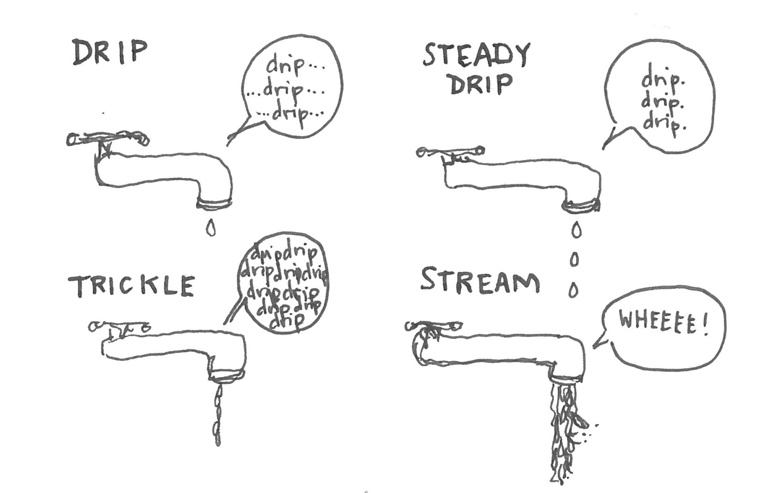

Drip chart
Drip type | Total litres lost per minute | Total water loss per day
No drip (N) | – | –
Drip (D) (1 drop per second) | 0.005 litres per minute | 7.2 litres
Steady drip (SD) | 0.08 litres per minute | 115.2 litres
Trickle (T) | 0.27 litres per minute | 388.8 litres
Stream (S) | 0.83 litres per minute | 1195.2 litres

Tap locations and water loss
Tap location and use  What is the tap used for? Irrigation, hand washing, cooking, art room, etc. | Tap type:  twist (T) or timed push (TP) | Drip type: N, D, SD, T, S | Total water lost through drips each day (litres per day)

Questions
Did you find any issues with taps that increase water loss? If yes, what did you find? Examples could be timed taps that run for too long or twist taps that are hard to turn off.

What can your school do to save tap water?

Would putting up signs or more information help? If yes, what could the signs say?

Worksheet: Drinking fountains
Use the drip table to calculate how much water your drinking fountains are losing each day through drips. Record details of each tap, including the location and the type of drip.
Name(s):_________________ _________________________________Date_________

Drip rates

Drip chart
Drip type | Total litres lost per minute | Total water loss per day
No drip (N) | – | –
Drip (D) (1 drop per second) | 0.005 litres per minute | 7.2 litres
Steady drip (SD) | 0.08 litres per minute | 115.2 litres
Trickle (T) | 0.27 litres per minute | 388.8 litres
Stream (S) | 0.83 litres per minute | 1195.2 litres

Drinking fountain locations and water loss
Drinking fountain location | Drip type: N, D, SD, T, S | Total water lost through drips each day (litres per day)

Questions
Did you find any issues with fountains that increase water loss? If yes, what did you find? Examples could be leaking water or the water stream flowing too high or at a weird angle.

What can your school do to save drinking fountain water?

Would signs or more information help? If yes, what could the signs say?

Worksheet: Toilets and urinals
Name(s):__________________________________________________Date:_________
How many toilets and urinals are in your school? What type of flush do they have? Are they flushed using tank water or potable water (water from the mains water supply)? Do any toilets or urinals leak? Record your findings in the tables below.

Single or dual flush toilet?
- A single flush (S) toilet only has one button to flush and uses about 11 litres of water per flush.
- A dual flush (D) toilet has two buttons. The half-flush button uses about 3 litres per flush. The full-flush button uses about 6 litres per flush.

How many toilets are at your school?
Toilet location | No. of toilets | Who uses these toilet (staff, students, visitors, others)? | Type of flush (S or D) | Source of water to flush toilets (tank or potable) | Any leaks?

Total toilets at my school: _________

How many urinals are at your school?
Urinal location | No. of urinals | Who uses these urinals (staff, students, visitors, others)? | Type of flush (pushbutton, waterless, sensor, timer) | Source of water to flush urinal (tank or potable) | Are any urinals leaking?

Total urinals at my school: _________

List of leaking toilets and urinals
Location (mark on a school map or give specific details) | Toilet (T) or urinal (U) | What type of leak?  Trickle (T), random flush (R), or pouring into the bowl (P)

Question
How can your school reduce toilet and urinal water use?

More information
The volume of water used by toilets and urinals can be an easy target for water savings, but water savings can be made in many places in your school. Check out Melbourne Water's water saving guide for schools

Worksheet: What else uses water at your school?
Name(s):__________________________________________________Date_________
What other facilities and appliances use water in your school? Think about dishwashers, instant hot water taps (e.g. zip boil), showers, filtered water, bottle refill stations, swimming pool, boarding school facilities, laundry, irrigation. Record your findings in the table below.

Other water use sources
Item | Location | Water efficiency rating, if known | Comments (any leaks, approx. age of appliance)

Question
How can your school reduce water use from these sources?

Worksheet: Outdoor water use
Name(s):_______________________________________________Date_________
How is water used outside of your school? Interview ground staff or gardeners and record your results below.

Outdoor water use interview notes
Question | Answer (yes/no) | Location | Comments
Do you put mulch on garden beds to save water?
Are there water-wise plants in the school gardens?
Does our school have a manual or automatic irrigation system?
If the system is automatic, how many irrigation/watering stations does our school have? If the system is manual, describe how it is operated.
What is the total running time for our school irrigation system? (Minutes per day) Note seasonal trends.
How often and at what times is it operated?
Does our school have a groundwater bore? If so, what does it irrigate?
Does our school collect rain or stormwater for garden watering?
Does our school have any landscaping that is water sensitive or designed to slow stormwater? For example, swales to slow stormwater, wetlands to filter stormwater or a rain garden?
Does the school have future plans and actions to reduce outside potable water use or to capture water run-off from roof or asphalt surfaces?
Do we have water tanks at school? If yes, what are they used for?

Question
How can your school reduce outside water use?

Worksheet: Indoor water use
Name(s):_________________________________________________Date_________
How is water used inside your school? Interview school maintenance staff and record your answers in the table below.

Indoor water use interview notes
Question | Answer (yes/no) | Location | Comments
Do you have water monitoring systems and equipment in place and are you collecting and recording data?
Have you installed signage about water conservation practices in staffrooms, toilets, bathrooms, canteen, art rooms and classrooms?
Do you use non-water-based approaches to cleaning where possible?
Have you retrofitted flow controllers to key usage areas?
Do you have rinse and wash protocols in place (where applicable) for science, art, food, technology, material technology and first aid rooms?
Have staff and students participated in local waterways projects and activities?
Do staff and/or students mentor other schools?
Do students and staff communicate about water-related issues with other schools across the state, nation and globe?
Do staff and/or students give presentations on their school water and stormwater programs to other schools at conferences and professional development events?

Worksheet: Tank water use
Name(s):___________________________________________Date_________
If you have water tanks at your school, record tank information below. Refer to the Outdoor water use worksheet to see if ground staff mentioned tanks and how they are used.

Tank water use
Water tank location | Tank size | What is the water used for?

Calculate water tank volume
Some water tanks have an information panel listing how many litres it can hold. If this panel is not visible, the easiest was to calculate the volume is to measure the height and radius of the tank.
We can use this formula to calculate volume: V = πR² x h
- V = volume of a cylinder
- π = pi
- R = radius of the tank
- h = height of the tank
To calculate the volume of water in the tank, h is the height of the water in the tank rather than the height of the tank.
Alternatively, look for a volume calculator online.

Appendix 1: Water meter form example
Here is an example of a completed water meter form to show you how to calculate water use.

Sample water meter form
 | Date of meter reading | Reading at the start of the day 8:30am (kL) | Reading at the end of the day 3:30pm (kL) | Water use of the school day (kL) | After hours water use for school day* (kL) | Total water consumption for the day (kL)
Monday | 10/10/2018 | 3335.66 | 3336.83 | 1.17 | 2.17 | 3.34
Tuesday | 11/10/2018 | 3339 | 3341 | 2 | 1 | 3
Wednesday | 12/10/2018 | 3342 | 3344 | 2 | 0.83 | 2.83
Thursday | 13/10/2018 | 3344.83 | 3348 | 3.17 | 1 | 4.17
Friday | 14/10/2018 | 3349 | 3351 | 2 | n/a | 2
Monday | 17/10/2018 | 3355.67 | n/a | n/a | n/a | n/a

A Total water consumption for the week (Add up Monday to Friday totals. Do not include weekend water use in Friday total) | 15.34
B Total weekend water use (the difference between Friday afternoon’s water reading and the next Monday morning’s water reading) | 4.67
Total water consumption over seven days (A+B) | 20.01
*This is the difference between the recording at the end of the day and start of the next school day.
Water use per student
Volume of water used during the week (A) | 15.34 kL
Total number of students at the school (B) | 825
Water used per student per week (A divided by B)  Note: To convert your kL reading into litres multiply by 1,000. | 0.01859 kL  18.59L

Appendix 2: More water activities

Study your water bill
Look back on at least one or, if possible, two years of bills to see how much water your school uses. This will be easy if you have entered your billing data in the RSS online system. It is common to see variable water use over the year.
Each water corporation has its own price structure, so contact your water corporation for help reading your bill. This includes help to understand the cost of providing your water, sewage, trade waste and recycled water services.
Use your water bills to calculate:
- the average cost of water (cents per kL)
- your annual water consumption (if you are billed quarterly add the four bills for the year)
- average daily water use for the year in litres (back page of bill).

Calculate the average water flow rate
You can work out the average water flow rate from a tap by following these steps:
- Turn the tap on full and place a measuring jug under the tap for ten seconds
- Turn off the tap and measure the water collected in the container
- Multiply the amount collected by six to give you a litre per minute flow rate
Alternatively, use a water flow measuring cup like the one pictured below. You can buy these online or from some hardware stores.
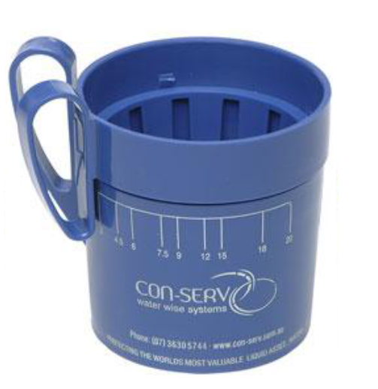
Photo: Measuring cup

Calculate how much water your school uses to flush toilets
How much water does your school use to flush toilets? Conduct a survey to find out how many times the school toilets are flushed every day. You can survey your own class then estimate for other classes the number of times your toilets are used in a day. To calculate the total number of litres used (Column C), multiply the total number of flushes (Column B) for each type of toilet by the amount of water used in each flush (Column A). A x B = CA
A Type of toilet | B No. of flushes per day | C No. of litres used per day
Single flush (about 15 L)

Dual flush – half-flush (about 4 L)

Dual flush – full-flush (about 6 L)

Total volume of water used per day from flushing toilets | Litres
Total volume of water used per week from flushing toilets | Litres

Question
How can your school reduce water used for flushing toilets?

Appendix 3: Curriculum links
Exploring the concept of water, which includes a water audit, contributes to several different learning areas in the Victorian Curriculum F–10. The table below lists examples of how a water audit can contribute to student learning outcomes in Years F to 10.
For more inspiration, read about sustainability as a cross-curriculum priority on the Victorian Curriculum website or download the RSS curriculum guides

Linking water audits with the Victorian Curriculum
Levels | Learning area | Content description
Foundation to Level 2 | Science | - Earth’s resources are used in a variety of ways (VCSSU047)  - Living things have a variety of external features and live in different places where their basic needs, including food, water and shelter, are met (VCSSU042)
Years 3 and 4 | Science | - Science knowledge helps people to understand the effects of their actions (VCSSU056)
Years 3 and 4 | Geography | - Collect and record relevant geographical data and information from the field and other sources (VCGGC074)
Years 3 and 4 | Health and physical education | - Describe strategies to make the classroom and playground healthy, safe and active spaces (VCHPEP095)
Years 3 and 4 | Ethical capability | - Explore the extent to which particular acts might be regarded by different people as good or bad, right or wrong, better or worse, and explain why (VCECU005)
Years 5 and 6 | Science | - Scientific understandings, discoveries and inventions are used to inform personal and community decisions and to solve problems that directly affect people’s lives (VCSSU073)
Years 5 and 6 | Economics and business | - Explore the concept of opportunity cost and explain how it involves choices about the alternative use of limited resources and the need to consider trade-offs. (VCEBR002)  - Identify the types of resources (natural, human and capital) and explore the ways societies use them in order to satisfy the needs and wants of present and future generations. (VCEBR003)
Years 5 and 6 | Ethical capability | - Discuss how ethical principles can be used as the basis for action, considering the influence of cultural norms, religion, world views and philosophical thought on these principles. (VCECU010)
Years 7 and 8 | Science | - Some of Earth’s resources are renewable, but others are non-renewable (VCSSU100)  - Water is an important resource that cycles through the environment (VCSSU101)  - Science and technology contribute to finding solutions to a range of contemporary issues; these solutions may impact on other areas of society and involve ethical considerations (VCSSU090)
Years 7 and 8 | Geography | - The challenges of managing and planning Australia’s urban future (VCGGK126)
Years 7 and 8 | Ethical capability | - Investigate criteria for determining relative importance of matters of ethical concerns (VCECU016)
Years 9 and 10 | Geography | - Environmental worldviews of people and their implications for environmental management (VCGGK146)

Glossary
Bore water, also known as artesian water, is water that has collected in aquifers, or natural underground wells, that can be accessed via a bore or well.
Greywater is water that has been used for other domestic-like activities, like shower water and laundry and hand basin water. Greywater storage needs to meet Environmental Protection Authority guidelines. Greywater storage systems need to be managed in the same way as septic tanks.
Irrigation is the watering of land to grow plants, whether that’s small areas like kitchen gardens and garden beds, or large areas such as grassy ovals.
Potable water is commonly known as drinking water. It is safe for drinking and food preparation.
Rainwater is water that has fallen as rain or has been obtained from rain and stored in tanks for different uses.
Recycled water is wastewater that has been collected and treated so it can be used again for a variety of purposes. Some schools have access to recycled water from their water retailer. Recycled water from your retailer will be in purple pipes and is not suitable for drinking. It can be used as an alternative for irrigation, cleaning and other activities that do not require drinking quality water.
Reticulated water refers to the piped-water network, more familiarly known as town water or mains water. Non-reticulated water comes from sources other than the piped-water network, such as bore water or tank water.
Stormwater is surface run-off from rain and storm events that enters the stormwater drainage system. The water, pollution and debris flow untreated through the stormwater drains into our rivers, creeks, lakes and bays.
Swales are linear channels in the ground that collect and transport water and filter pollution, sediment and nutrients from it. They also slow stormwater flows into drains.
SWEP is the Schools Water Efficiency Program
Tank water is water stored in tanks after being collected via pipes and gutters, for example from building roofs or bought from water retailers.
Trade waste is all liquid waste discharged into the sewer system, such as water used when preparing food, cleaning dishes or washing the kitchen.
Wastewater includes everything drained from the staffroom kitchen, art room, science labs, sick bay, laundry or bathroom and anything flushed down the toilet. All wastewater goes into the sewer. It is also known as blackwater or sewage.
Water harvesting is simply collecting water to store for later use. Usually water is collected from building roofs and stored in tanks.

