Biodiversity in schools
A practical ‘how to’ guide for Victorian schools

© Sustainability Victoria ENG063 July 2016
Assistance in developing this guide has been provided by the Department of Environment, Land, Water and Planning (DELWP), CERES, Greening Australia, Landcare Australia, Parks Victoria and Zoos Victoria.
Authorised and published by Sustainability Victoria,
Level 28, Urban Workshop
50 Lonsdale Street Melbourne Victoria 3000 Australia
Accessibility
This document is available in PDF and Word format at www.sustainability.vic.gov.au
While reasonable efforts have been made to ensure that the contents of this publication are factually correct, Sustainability Victoria gives no warranty regarding its accuracy, completeness, currency or suitability for any particular purpose and to the extent permitted by law, does not accept any liability for loss or damages incurred as a result of reliance placed upon the content of this publication. This publication
is provided on the basis that all persons accessing it undertake responsibility for assessing the relevance and accuracy of its content.
The Biodiversity in Victorian Schools guide should be attributed to Sustainability Victoria.
The Biodiversity in Victorian Schools guide (excluding all trade marks and logos) is licensed under a Creative Commons Attribution 4.0 Australia licence. In essence, you are free to copy, distribute and adapt the work, as long as you attribute the work and abide by the other licence terms.
Go to http://creativecommons.org/licenses/by/4.0/ to view a copy of this licence.

Contents
Introduction 2
ResourceSmart Schools – a whole of school approach 3
Step one: Understand your school’s biodiversity 4
Step two: Make a plan 7
Step three: Live your plan 10
Glossary 12
Further information 13

ResourceSmart Schools online www.resourcesmartschools.vic.gov.au

Introduction
Biodiversity is the variety of life across the planet, right down to the life in your school grounds, including you. Biodiversity is found in genetic diversity, species diversity and ecosystem diversity.
It recognises the connection of everything with each other and with the environment, to form ecosystems. Ecosystems exist everywhere on land, in rivers, along coasts and in the ocean.
Sustainability Victoria has developed this ‘how-to’ biodiversity guide for schools. The guide outlines the key steps to understand and improve the biodiversity in your school grounds and surroundings. Building sustainability into every aspect of school
life not only benefits our environment, it also helps schools to reduce their costs and supports communities to increase their quality of life.
Biodiversity strengthens and enriches life. Biodiversity is important as it builds a resilient environment that can respond to change and supports healthy ecosystems.
We benefit from healthy ecosystems and biodiversity in four key ways:
- Biologically. Biodiversity drives many of the processes that make life possible such as climate regulation, water supply, pollination, food, shelter, health and genetic strength.
- Financially. Biodiversity contributes to our economy by providing resources for research and medicine, as well as the tourism industry.
- Culturally. Plants and animals play an important role in our everyday lives, providing us with stories, play, beauty, peace and inspiration. They contribute to our cultural identity and spiritual enrichment.
- Ethically. We have a responsibility to protect and nurture the biodiversity on Earth for the benefit of all living things now and into the future.
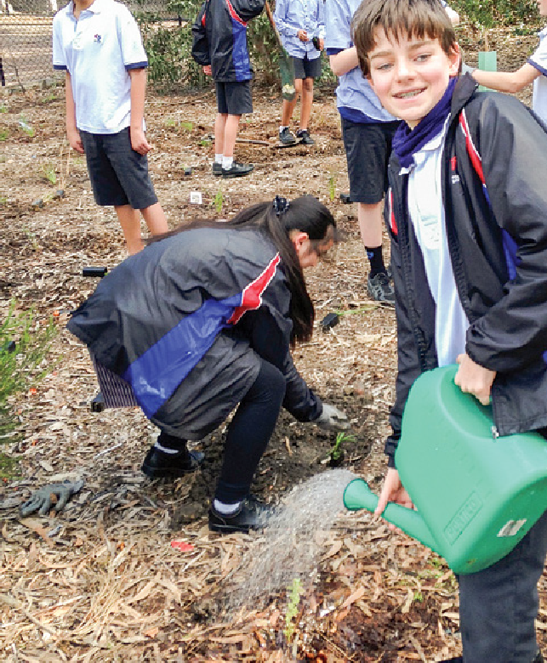
Students from Footscray City College, winners of the 2015 ResourceSmart Schools Biodiversity Secondary School of the year.
Improving the biodiversity in your school benefits your community by:
- Building resilient ecosystems now and for future generations.
The school will bring nature back into its grounds and nurture indigenous plants and wildlife outside the school gates, to provide safe spaces for species facing environmental challenges now and into the future.
- Creating smarter, happier and healthier students.
Research has shown that learning and playing in natural, outdoor spaces brings us better health and wellbeing.
- Building young leaders and providing learning opportunities.
Practices that improve the biodiversity in your school provide excellent leadership opportunities and practical learning activities for students, as well as professional development for you and your colleagues.
- Reducing your water, waste and energy costs.
Practices that improve biodiversity also encourage an efficient use of your school’s resources, meaning that you can you can do more with your current budget.
- Building a strong school culture based on good communication and shared goals.
Getting the whole school involved allows everyone to work together and share the success.
- Raising the school’s profile and building communities.
The school can connect with the broader community through partnerships and local networks. This is increasingly important for the reputation of schools as students, teachers and parents become more aware of climate change and other environmental issues facing our communities.
This guide takes a whole school approach to embed sustainable practices across the school. The whole school approach is a more successful approach because the whole school is working together and celebrating the achievement of shared goals.

This guide will give you key steps and actions, as well as tips, links to resources and policies and interesting case studies to help you apply the knowledge to your own school.

Assistance in developing this guide has been provided by the Department of Environment, Land, Water and Planning (DELWP), CERES, Greening Australia, Landcare Australia, Parks Victoria and Zoos Victoria.

Become a ResourceSmart School
ResourceSmart Schools is a Victorian Government initiative that helps schools reduce costs while giving students important and inspiring

opportunities to learn about sustainability in a practical environment.

A Victorian government program managed by Sustainability Victoria helping schools benefit from embedding sustainability into everything they do.

Schools seeking to improve the biodiversity of their grounds are encouraged to take a whole of school approach to sustainability.
A whole of school approach helps you build a constructive school culture and achieve greater environmental outcomes. In Victoria, this approach is available to all schools through ResourceSmart Schools.
Key features
ResourceSmart Schools provides a framework that helps schools embed sustainability across learning areas, assisting schools to address the cross-curriculum priority of sustainability outlined in the Victorian Curriculum. The program also provides practical support to schools through a network of sustainability experts to help schools reduce their use of energy, water and waste and improve biodiversity.
Since 2003, Victorian schools have planted over 5.5 million plants. As well as this, Victorian schools have won ResourceSmart Schools Awards and international awards and nurtured productive relationships with their local communities.

Support | Sustainability experts support the school on their sustainability journey and schools track and measure their progress using the online system.
Recognition | Sustainability Certification and the ResourceSmart Schools Awards recognise and reward school activity.
Savings | Save on energy, water and waste bills and greenhouse gas emissions.
Adaptability | Schools create a unique environmental management system and can work with any sustainability resources or organisation to progress through framework.
Learning | Students learn take-home lessons about sustainable actions as required by the Victorian Curriculum.
Environmental outcomes | Schools learn to operate more sustainably, reducing costs and minimising their impact on the environment through efficient resource use.
Community building | Practical support for schools and communities to live and work more sustainably and to support other schools and environmental partners along the way.

TABLE 1 – RESOURCESMART SCHOOLS OUTCOMES BETWEEN 2011 AND 2016*

Activity | Measured Result
Waste diverted from landfill | $1.08 million saved | 37,649 Cubic metres
Reduced electricity consumption | $1.71 million saved | 8,636 Tonnes CO2-e (GHG emissions) saved
Reduced water consumption | $474K saved | KL 143,783 saved
Planted trees | 52,117
Total dollars saved | $3,281,386.58

* As per data available in ResourceSmart Schools Online in June 2016

Step one: Understand your school’s biodiversity

Biodiversity is dynamic, as life continually adapts to changes in the environment.

You will need to understand your local area as well as your school to understand what can be improved and how to respond to change.
It is important to know the indigenous plants and animals from your area. Supporting these species will make the greatest contribution to strengthening your local biodiversity.
The following activities can help you understand your school’s biodiversity.

Find out what biodiversity looks like
See how other schools have improved the biodiversity of their schoolyards. Build relationships with other schools to help you develop your knowledge and skills.
See how community groups have worked together to improve the biodiversity of their local area, for example bushlands, creeks, coasts, wetlands and the grounds of local businesses.
Build relationships with ‘Friends of’ groups, Landcare groups
and local Indigenous groups to develop your knowledge and skills.
See how other organisations help to manage and protect biodiverse landscapes. Visit a Parks Victoria reserve or Zoos Victoria.

Understand your setting
There are many different types of ecosystems and you need to understand your school’s setting to know what ecosystem to support.
Look at the location, conditions and landscape of your school. What is the local climate? Are you in a metropolitan or regional setting? Are you on the coast or inland? Are you in the hills or on
the plains? Are you surrounded by parklands, residences or industry? What flora and fauna are endemic to your area? What are the threats to the biodiversity in your area? These threats may include introduced pests and weeds, pollution or habitat fragmentation through
land clearing.
You can learn a lot by looking back. Find out how your surrounding landscape has been used in the past. Research the previous uses of your school site. What was the land used for prior to it being a school? What has changed in the last 200 years? What has disappeared?
It’s also important to look forward because vegetation will naturally vary over time. Find other sites that are similar to your own to
see what is possible in your school. For example, if you want to plant an indigenous garden you might visit a local nearby bush reserve that has endemic vegetation in good condition. You could contact your local council or team up with a local Landcare group to identify species typical of your site. If there aren’t good reference sites nearby you can use historical regional information to develop an idea of what to plant.

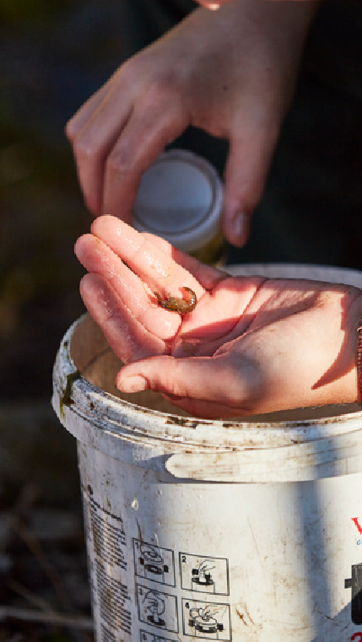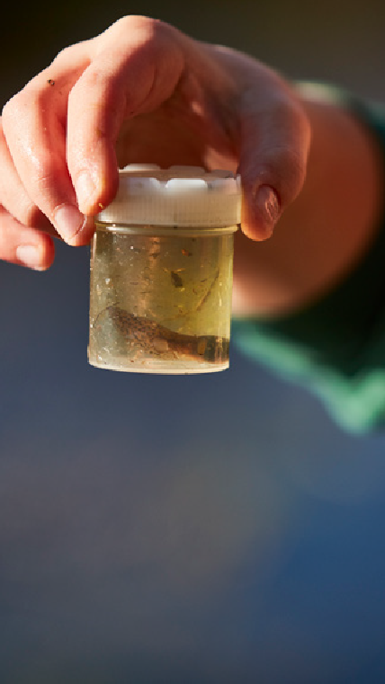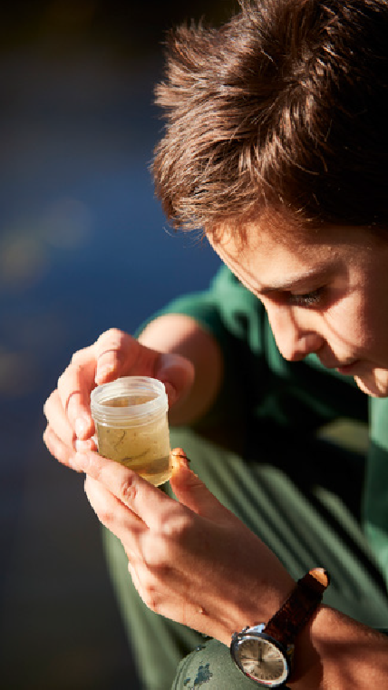

A student from Carrum Primary School, a 5Star school studying biodiversity from the school wetlands

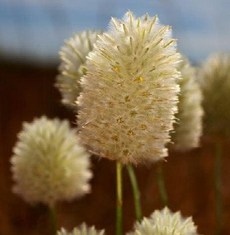Audit your school’s biodiversity
Fact – Protecting Victoria's unique grasslands
The grasslands endemic to Victoria’s volcanic plains are amongst the most critically endangered ecosystem in Australia. They used to cover 10%
of the state, around 21,000 square kilometres. There are now less than 4.5% of the original grasslands left, just a few thousand hectares.
BIODIVERSITY
FACT
#1
An audit will help you understand your challenges and how you can make structural improvements as well as change behaviour to improve your biodiversity. Use one of the existing biodiversity audit documents listed below to measure the biodiversity in your school grounds.
Get your students to help with the audit. Not only will this make the task easier, it will also develop their environmental literacy and give them practical and inspiring lessons. Getting many people involved in this process will help embed sustainability into the minds and actions of people across the school.
Staff professional development can help improve skills in identifying plant and animal species. There are short courses as well as information available online. Check out courses delivered by Greening Australia such as their Habitat Conversation Management course at www.greeningaustralia.org.au/events.
An audit will help identify your school’s:
- Geographical location
- Size and types of surfaces 3 Vegetation structure:
› Herbs and grasses
› Shrubs
› Trees
› Weeds
› Leaf litter
› Logs and rocks
› Soil management
› Habitats
- Local wildlife:
› Invertebrates
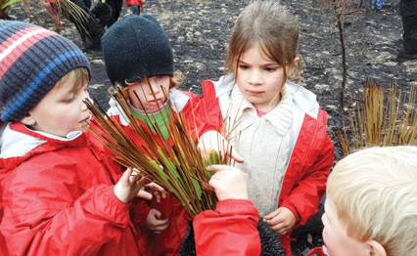› Vertebrates

The Westgarth and Dunkeld Kindergartens run innovative Bush Kinders that give pre-schoolers the opportunity to explore and connect to natural landscapes. The children and adults only use what nature provides and learn about the significance of the local land in aboriginal culture.
The children at the award winning Dunkeld Bush Kinder identify animals, learn about seed pods and bird calls and take photos to include in their own book of local plants and animals.
CASE STUDY:
Westgarth and Dunkeld Kindergartens
- Threats to biodiversity:
› Weeds and introduced pests and animals
› Pollution and rubbish
› Habitat fragmentation.

In February, 2015 SV delivered a ResourceSmart Schools workshop on the Pelican 1 catamaran to help teachers and educators understand how to improve marine and
terrestrial biodiversity. Short workshops and presentations were provided by Greening Australia, DELWP, Parks Victoria and the Department of Conservation and Environment in NZ.
CASE STUDY:
Teachers learning on a marine science education and research vessel

Useful resources

Choose an audit that best suits your needs:
› Biodiversity Up Close
www.landlearn.net.au/resources/bio_up_close.htm
› Cool Australia
www.resourcesmartschools.vic.gov.au/resources
› Greening Australia
www.greenhub.org.au/wp-content/uploads/2013/06/ Greening-Australia-Biodiversity-Audit-Pack.pdf
› SEEDS
www.seedsbushland.com.au/teacher-notes--resources.html
› Yarra Ranges HabitAT Schools Census
http://lfs.yarraranges.vic.gov.au/lfs/HabitAT_School_Census
› USA National Wildlife Federation www.nwf.org/~/media/PDFs/Eco-schools/Audits/ Biodiversity%20Audit_2012.ashx

Identify your school’s bioregion:
› EVC benchmarks (DELWP) www.depi.vic.gov.au/environment-and-wildlife/biodiversity/ evc-benchmarks
› Local councils directory
www.dtpli.vic.gov.au/local-government/find-your-local- council
› Catchment management authorities www.delwp.vic.gov.au/water/governing-water-resources/ catchment-management-authorities

Research your area:
› DELWP biodiversity resources
www.depi.vic.gov.au/environment-and-wildlife/biodiversity
› Port Philip eco centre
www.ecocentre.com
› Latrobe Wildlife Sanctuary
www.latrobe.edu.au/wildlife
› Sea search
http://parkweb.vic.gov.au/get-involved/volunteer/sea-search
› State of the Bay (DELWP)
http://delwp.vic.gov.au/ data/assets/pdf_ file/0005/302927/Victorian-Governments-Response-to-the- State-of-the-Environment-Report-2013.pdf

Learn more about indigenous species in your area:
› National Landcare Directory
https://landcareaustralia.org.au
› Indigenous plant nurseries
www.iffa.org.au/indig_nurseries
› ‘Friends of’ groups
http://parkweb.vic.gov.au/get-involved/friends-groups
› Plan an excursion to a Parks Victoria site http://parkweb.vic.gov.au/learn/teachers/planning-an- excursion

Subscribe to useful e-newsletters:
› ResourceSmart Schools
www.resourcesmartschools.vic.gov.au
› Ceresly Connected (CERES)
http://sustainability.ceres.org.au/program/cereslyconnected
› Junior Landcarer
https://landcareaustralia.org.au/junior-landcare
› Landcare Australia
https://landcareaustralia.org.au
› Zoos Victoria
www.zoo.org.au/education
› Greening Australia
www.greeningaustralia.org.au
› Trust for Nature
www.trustfornature.org.au
› Museums Victoria
https://museumvictoria.com.au/footer-links/e-news
› The Gould League
http://gould.org.au/stay-in-the-loop
› Bird Life Australia
https://support.birdlife.org.au/sign-up

Keep in touch with other schools:
› CERES Sustainability Hub
http://sustainability.ceres.org.au
› Sustainability in Schools
www.sustainabilityinschools.edu.au

Develop your plant and animal identification skills:
› An app to identify plants
https://gardentags.com
› Bower Bird
www.bowerbird.org.au
› Gould League
http://gould.org.au
› Birds in Backyards
www.birdsinbackyards.net
› Bird Life Australia workshops http://birdlife.org.au/education-publications/education/ workshop-and-bird-education-services
› Participate in Waterwatch’s community activities for staff professional development and student activities www.vic.waterwatch.org.au
› Zoos Victoria’s teacher resources
www.zoo.org.au/education/teacher-resources
› Museum Victoria’s Bioinformatics
https://museumvictoria.com.au/bioinformatics/wildlife
› Museum Victoria’s Field Guide to Victorian Fauna app https://museumvictoria.com.au/discoverycentre/museum- victoria-apps/mv-field-guide-to-victoria-app
› Victorian Biodiversity Atlas http://www.depi.vic.gov.au/environment-and-wildlife/ biodiversity/victorian-biodiversity-atlas
› Australian Museum
http://australianmuseum.net.au/animals

Step two: Make a plan

Vegetation structure

Herbs and grasses

Create a vision of your school that supports the local biodiversity.
Plant endemic grasses as part of your garden bed display.
Shrubs

Plant suitable shrubs to control weeds, attract local wildlife and
improve your school’s soil quality.

Now that you understand the level of biodiversity at your school, as well as the threats, it’s important to understand where you want to go. What have you learned from other sites and how can you apply it to your school?
Talk to students, parents and staff to find out what they want and what ideas they have. Create a multi year plan that you can review and improve along the way. In particular, create a plan that:
1 Supports plants and animals that are endemic to this area. 2 Provides habitats for indigenous animals.
3 Reduces the threats to the local plants and animals.

Identify your opportunities
What are the best opportunities to improve the biodiversity in your school grounds? Where can you have the most impact? What are the easy wins that you can first do easily and quickly? Consider simple and everyday things that can create significant change over time,
as well as the big, once off actions.
Identify who can help you in the school, including student committees, staff and parents groups. Also think about where you can develop partnerships outside of the school for advice and support
(for example, local councils, local nurseries, ‘Friends of’ groups, Landcare groups and indigenous groups).
There may be funding available that can help you achieve your plan. Check out Landcare, DELWP or local council grants.
Your school’s key opportunities are dependent on your local environment and bioregions. Here are just a few popular actions that you could consider:
Trees
Plant trees to have a long-term impact for future generations and to provide habitat for animals.
Leaf litter
Good soil is the start of a long food chain and a healthy ecosystem. Add organic litter and compost that recycle nutrients for plants and micro-organisms and keep the soil moist, weed-free and healthy.
Logs and rocks
Provide habitats for small creatures.
Soil management
Good soil management will control erosion, weeds and soil compaction.
Habitats
Provide nesting boxes for birds and mammals like possums and bats and create homes for reptiles, amphibians and insects.

Local wildlife
Invertebrates
Welcome native bees and butterflies to your school by providing fresh water and growing indigenous flowering plants.
Vertebrates
Provide fresh water and grow indigenous flowering plants in your grounds to attract native mammals and birds.

Myth
Kitchen gardens improve biodiversity
Kitchen gardens can be a popular way to learn about growing food, life cycles and connecting with nature, but they won’t necessarily improve the biodiversity of your school grounds. You could consider a kitchen garden
as part of your sustainable waste management plan. Check out the ResourceSmart Schools Waste module and great kitchen garden programs like the Stephanie Alexander Kitchen Garden Foundation at www. kitchengardenfoundation.org.au.
Contact your Local Council, Landcare or ‘Friends of’ group to learn more about your region’s biodiversity, indigenous plants and what activity is happening in your area.

Threats to biodiversity
Weeds
Use organic, chemical-free solutions to control pests and weeds.
This will support the health of both the school community and the soil.
Introduced pests and animals
Poor management of domestic animals can impact on native animals and the environment. With good management and public awareness of pet ownership we can protect the environment for generations to come.
Litter and stormwater
Litter that ends up in our school grounds or close to stormwater drains ends up in our waterways. Work with your students to prevent litter through activities such as nude food days.
Habitat fragmentation
When you grow endemic plants and create habitats you are providing natural, safe spaces to help native animals thrive, move between habitat areas and breed with other population groups.

Set and prioritise your goals
It’s important to know your school’s resources and limitations. From your audit you will understand where you are doing well and where you can improve. Your audit may have calculated your Habitat Assessment score. Each school will vary but a good target to aim for is a score of 75 or higher.
Use the ResourceSmart Schools School Environmental Management Plan template link below to build your plan. It’s best to work in partnership with staff and students when setting goals. Consider what you can stop or continue doing, as well as what you can improve and increase doing.
You may like to start off with one key project that will improve biodiversity and touch on as many of your identified opportunities as possible. Think back to your research in Step One and learn from the good things that other people are doing. Link your plan to the curriculum as you can improve your biodiversity while you’re delivering important learning outcomes.
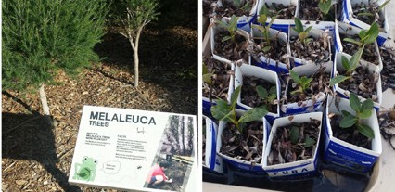Before you go much further, get your plan approved by your school’s key decision makers.
CASE STUDY:
St Joseph’s Primary School

St Joseph’s Primary School Crib Point outdoor learning includes a wetland complex with mangrove research centre. It includes the research of algal bloom, an indigenous produce garden, wicking garden beds, propagation of mangroves and habitat shelters with many bird species on site.

Fact – Most plants need help to pollinate
It is estimated that 65% of all flowering plants and some seed plants require insects for pollination. Australia has over 1,500 species of native bees that are great pollinators. There is even one with blue stripes!
FACT
BIODIVERSITY
#2

Set targets
Make sure the targets are SMART, which means that they are specific, measureable, attainable, relevant and time-bound. Don’t forget to include targets that address behaviour change.
To encourage contribution from the whole school you could link targets to school-wide celebrations. Working in partnership with your colleagues to assign tasks and timelines will give you a better chance at success. Don’t forget to make times to share each other’s progress.

Engage and educate your community
Getting the whole school involved will make the activity interesting, share the workload and mean it’s more likely that the school will achieve its goals.
You could create biodiversity champions to share the knowledge and build enthusiasm. Get the students involved with outside activities. Consider assigning separate activities to different classes and year levels.
When you’re identifying community partners who could help you achieve your goals, tell them how improving biodiversity can also help them.

TIP
ResourceSmart schools are models for biodiversity conservation
ResourceSmart schools protect and improve the land, local ecosystems and plant and animal habitats in their grounds, communities and homes. The program also encourages students to connect with natural systems and understand ecological processes by:
- Incorporating biodiversity conservation into their curriculum;
- Working with their communities to protect and improve biodiversity;
- Conducting a ‘Biodiversity Audit’ of their school grounds;
- Establishing a practical ‘Action Plan’ as part of a Schools Environment Management Plan (SEMP) to enhance their school grounds in terms of biodiversity conservation.
Download tools and templates via the Sustainability Victoria website www.sustainability.vic.gov.au/services- and-advice/schools/resources.

Useful resources

General biodiversity resources:
› ResourceSmart Schools resources
www.resourcesmartschools.vic.gov.au/resources
› Junior Landcare curriculum resources and teaching guides
https://landcareaustralia.org.au/junior-landcare/junior-landcare-resources/curriculum-resources
› CERES Sustainability Hub
http://sustainability.ceres.org.au
› iBook on habitats
https://itunes.apple.com/au/book/habitat/id982864283?mt=13
› Gardening tips
www.darebin.vic.gov.au/Darebin-Living/Caring-for-the-environment/Gardening
› Create your School Environmental Management Plan
www.resourcesmartschools.vic.gov.au/resources
› Ten things that we can all do to help nature adapt to a new climate
http://vicnature2050.org
› Talk to your local Landcare group to help design your approach
http://nld.landcareaustralia.com.au

Help identify dangerous weeds in your area:
› Weeds Australia
www.weeds.org.au/vicmap.htm
› Department of the Environment
www.environment.gov.au/cgi-bin/biodiversity/invasive/weeds/weedidtool.pl

Keep an eye out for grants:
› Landcare Australia
https://landcareaustralia.org.au/funding-opportunities
› CERES Sustainability Hub
http://sustainability.ceres.org.au/education-resources/grants

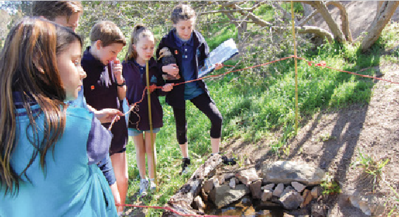

POLICY
Department of Education and Training Policy:
The Department of Education and Training has a Pesticide and Herbicide policy to help schools avoid using dangerous materials and practices.
http://www.education.vic.gov.au/school/principals/ spag/governance/Pages/pesticides.aspx

Winters Flat Primary School in Castlemaine is a 5Star school and the 2015 ResourceSmart School of the Year. Student leaders attend conferences, workshops and community meetings to improve their understanding of environmental impacts while developing their presentation skills. Students worked with local elders, Landcare and ‘friends of’ groups to create an indigenous garden to improve the wildlife habitat in the school. Students also work with Friends of Campbell’s Creek to contribute to community spaces.
CASE STUDY:
Winters Flat Primary School

Step three: Live your plan
Fact – Soils contain good bacteria
Did you know that one teaspoon of good garden soil contains one billion bacteria of between 20,000 and 30,000 species, several yards of fungal hyphae, several thousand protozoa and a few dozen nematodes? Mulching your gardens and adding compost to the soil are some ways to keep the soil healthy and alive.
Fact – Flowers need insects
Many flowers have lines in their pattern to guide the animals to the nectar. Some flowers are only designed to be attractive to one or two types of insect.
BIODIVERSITY
FACTS
# &
3 4

Now is the time to start making change.

You’ve done all your research and planning and you’ve created your School Environmental Management Plan. Now you can put that plan into action!
Biodiversity is dynamic as life adapts to changes in the environment. Therefore improving the biodiversity of your local area is an ongoing activity. Give yourself time to create momentum and have the confidence to adapt your plan as your physical landscape changes.
Being flexible is the best way to build resilience, improve biodiversity and respond to changes in the environment.

Do the work and measure it
Regularly review your school’s progress to see if it is meeting the goals of your plan. For example, are you getting more diverse birds visiting? Are your plants thriving? Do you see fewer pests and weeds on the school grounds?
If you’ve set up a student and teacher committee make sure that you meet regularly to share everyone’s progress. Build relationships with community partners to help you do your work, for example parents groups, ‘Friends of’ groups, Landcare groups, indigenous groups and local business sponsors.
If you are using the habitat assessment score, review it annually. You will start to see seasonal changes in biodiversity as animal species are more visible depending on the season and weather conditions when you are making the assessment. Annual reviews will pick up the changes in your school’s biodiversity and let you amend your plan if you need to. This is a natural cycle.

Talk about your successes
It’s going to be important to nurture the energy and enthusiasm in the school so that the good work can continue. One of the best
ways to do this is to reward the school’s great activity and progress. So celebrate loudly when you reach a target! You can offer prizes and highlight great activity in newsletters, at assemblies and at other shared events.
You could consider entering your school’s work into competitions, or joining with other local, state and nation-wide environmental activity, such as Kids Teaching Kids. This will help to build your school’s profile and potentially attract more partnerships.
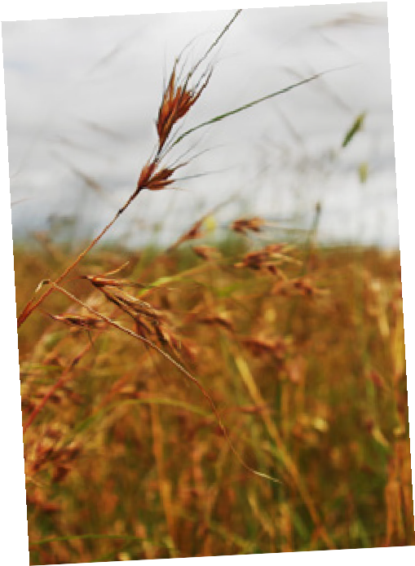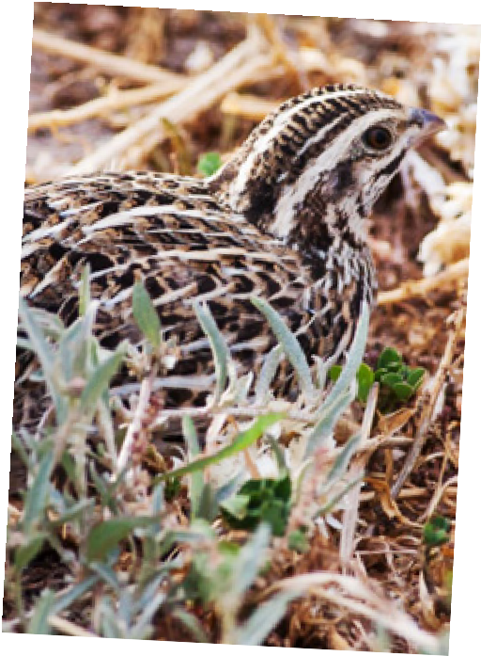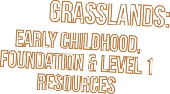Share your stories with the school council. Share your successes with your broader community and partners. And share your knowledge to help other schools achieve their biodiversity goals.

TIP
Love your Grasslands!
The remnant patches of Victorian Grasslands are amazing places. Did you know that they are the home to creatures such as the Eastern Barred Bandicoots and Fat Tailed Dunnarts? Unfortunately though, grasslands have a bit of a reputation issue. They have often been mistaken as disused paddocks or a pre-prepared location to build a house.
With this in mind, Environment Education Victoria (EEV) set out on a mission: to help the Grasslands by helping teachers and students to connect to this very beautiful and unique ecosystem in their own backyards. Blending knowledge and appreciation of the local environment with the arts, scientific principles and concepts, numeracy and literacy, EEV have created The Great Grasslands education resources.
To view The Great Grasslands education resources and range of resources EEV has to offer, visit their resources page at: http://eev.vic.edu.au/resources.

10

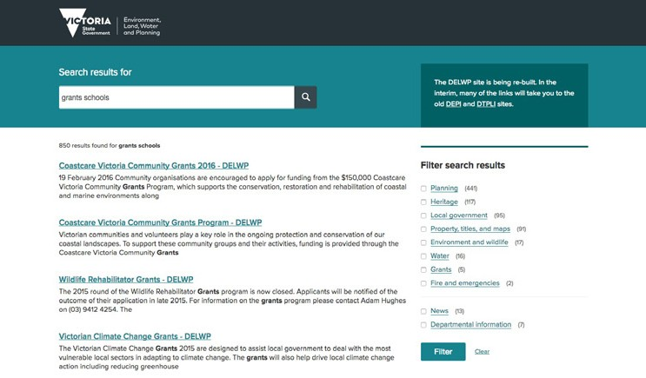
Check the Department of Environment, Land, Water and Planning website regularly to see
what grants are available to schools. www.delwp.vic.gov.au
11

Useful resources
Connect your activity to local, state and national events:
› Aussie Backyard Bird count
http://aussiebirdcount.org.au
› City of Melbourne BioBlitz
http://participate.melbourne.vic.gov.au/bioblitz
› Melbourne Water frog census
www.melbournewater.com.au/getinvolved/protecttheenvironment/Pages/Frog-Census.aspx
› Showcase your activity at national events like Enviroweek
www.enviroweek.org

Enter your star project into a state award:
› ResourceSmart Schools Awards
http://resourcesmart.e-award.com.au
› Premier’s Sustainability Awards
www.sustainabilityawards.vic.gov.au
› Department of Education and Training’s Garden Awards
www.schoolsgardenawards.org.au
› Junior Landcare Awards
https://landcareaustralia.org.au/news/landcare-awards
› Back to Earth Garden Awards
http://competitions.backtoearth.vic.gov.au
› Showcase your results on the international stage at the World Environment Day awards
www.unaavictoria.org.au/awards-programs/world-environment-day-awards
› Provide your students with great leadership opportunities at the Kids Teaching Kids conferences
www.kidsteachingkids.com.au

Glossary

Indigenous or native plants and animals naturally occur in a wide geographic range. They have occurred there naturally
without having been introduced by humans. For example, kangaroos are indigenous or native to Australia and can be found widely across Australia they don’t occur naturally anywhere else in the world.
Endemic plants or animals are native or indigenous to only a specific smaller region. The advantage of using plants that are endemic to your area are that they would grow best in your local conditions where a native species may not survive so easily. In Victoria there
are many endemic plant species that are only found in the Western Plains grasslands. These plants don’t occur naturally anywhere else in Australia or the world. Similarly, the Tasmanian Devil is only found naturally in Tasmania.
Introduced flora and fauna are plants and animals that not native and have been accidentally or deliberately been brought to Australia by humans. Introduced plants and animals might also be brought in by animals.
Knowing the provenance of your plants means you understand where they have come from. It is based on the idea that local plants are genetically adapted to local environmental conditions.
A habitat corridor, wildlife corridor or green corridor is an area of habitat connecting wildlife populations separated by human activities or structures (such as roads, houses or logging).
Victoria’s Grasslands are dominated by perennial, mostly tufted or tussock-forming grasses and occur on the vast, undulating western volcanic plains, the northern plains and in Gippsland.
A weed can be a species that is growing in the wrong place where it did not exist before. Many plants introduced into Australia in the last 200 years are now weeds.
Invertebrates are animals lacking a backbone. The most common invertebrates include the protozoa, annelids, echinoderms, mollusks and arthropods. Arthropods include insects, crustaceans and arachnids.
Vertebrates are animals that have a backbone or spinal column. They include mammals, birds, reptiles, amphibians and fishes.

12

Further information

Sustainability Victoria
www.sustainability.vic.gov.au
ResourceSmart Schools
www.resourcesmartschools.vic.gov.au
Department of Environment, Land, Water & Planning www.delwp.vic.gov.au
Department of Education and Training Tools and Resources
www.education.vic.gov.au/school/principals/ infrastructure/pages/sustainabilitytools.aspx
CERES
www.ceres.org.au
Environment Education Victoria
http://eev.vic.edu.au/
Junior Landcare
www.juniorlandcare.com.au
Greening Australia
www.greeningaustralia.org.au
Parks Victoria
www.parkweb.vic.gov.au
Zoos Victoria
www.zoo.org.au
Cool Australia
www.coolaustralia.org
Australian Association for Environmental Education
www.aaee.org.au/state-chapters/victoria/
The Nature Conservancy
www.nature.org
World Wildlife Fund
www.worldwildlife.org
Royal Society for the Protection of Birds
www.rspb.org.uk
Oceana
http://usa.oceana.org
Conservation International
www.conservation.org
Wildlife Conservation Society
www.wcs.org

Sustainability Victoria Level 28, Urban Workshop,
50 Lonsdale Street, Melbourne VIC 3000
Phone (03) 8626 8700
sustainability.vic.gov.au
Published by Sustainability Victoria. Biodiversity in schools
© Sustainability Victoria, July 2016 ENG063

