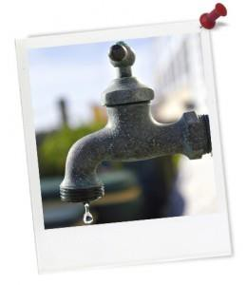
Ecological Footprint - Secondary

Note: For the most up-to-date digital version of this resource click here.

Activity Introduction
Quick summary: In this activity students learn about the concept of environmental/ecological footprints. They will learn how to measure their impact and take steps to reduce their personal footprint. Students make comparisons between the environmental footprint of a traditional indigenous lifestyle and a modern lifestyle.

This lesson supports schools working towards their ResourceSmart AuSSI Vic accreditation.

By completing this lesson students will gain a deeper understanding of the relationship between our daily activities and the health of our environment. In this way, this lesson will help provide students with a broader context for the audits required when completing the ResourceSmart AuSSI Vic accreditation.

Australian Curriculum content description:

Cross curriculum priorities | Sustainability  - OI.3 – Sustainable patterns of living rely on the interdependence of healthy social, economic and ecological systems.  - OI.6 – The sustainability of ecological, social and economic systems is achieved through informed individual and community action that values local and global equity and fairness across generations into the future.  - OI.9 – Sustainable futures result from actions designed to preserve and/or restore the quality and uniqueness of environments.
Aboriginal and Torres Strait Islander histories and cultures
- OI.2 – Aboriginal and Torres Strait Islander communities maintain a special connection to and responsibility for Country/Place throughout all of Australia.
- OI.5 – Aboriginal and Torres Strait Islander Peoples’ ways of life are uniquely expressed through ways of being, knowing, thinking and doing.
General capabilities | Numeracy, Critical and creative thinking, Intercultural understanding, Ethical understanding.
Explicit content description | Geography Year 7  - Reflect on their learning to propose individual and collective action in response to a contemporary geographical challenge, taking account of environmental, economic and social considerations, and predict the expected outcomes of their proposal (ACHGS054)
Civics and Citizenship Year 7
- Reflect on their role as a citizen in Australia’s democracy (ACHCS060)

Science Year 7
- Some of Earth’s resources are renewable, but others are non- renewable (ACSSU116)
Geography Year 8
- Reflect on their learning to propose individual and collective action in response to a contemporary geographical challenge, taking account of environmental, economic and social considerations, and predict the expected outcomes of their proposal (ACHGS062)
Science Year 8
- Science and technology contribute to finding solutions to a range of contemporary issues; these solutions may impact on other areas of society and involve ethical considerations (ACSHE135)
Geography Year 9
- The effects of the production and consumption of goods on places and environments throughout the world and including a country from North- East Asia (ACHGK068)
- The effects of people’s travel, recreational, cultural or leisure choices on places, and the implications for the future of these places (ACHGK069)
Geography Year 10
- The environmental worldviews of people and their implications for environmental management (ACHGK071)
- The Aboriginal and Torres Strait Islander Peoples’ approaches to custodial responsibility and environmental management in different regions of Australia (ACHGK072)
- Reflect on and evaluate the findings of the inquiry to propose individual and collective action in response to a contemporary geographical challenge, taking account of environmental, economic and social considerations; and explain the predicted outcomes and consequences of their proposal (ACHGS080)

Connecting lessons: All ResourceSmart AuSSI Vic audits.

Resources required: Magazines and newspapers, Student Worksheet.

Digital technology opportunities: Get your students to complete a digital
footprint: www.myfootprint.org, http://www.wwf.org.au/our_work/people_and_the_environment/h uman_footprint/footprint_calculator/

Keywords: Food, resources, energy, waste, water, footprint, environment, Indigenous, waste, litter.

Need some more support? Click on these leading organisations

CERES

Greening Australia

PlanetSavers

Teacher worksheet

Teacher preparation

Overarching learning goal:

- Students understand their impact on the Earth.
- Students take responsibility for their personal actions.
- Students compare the impact on our environment between the past resource use by Aboriginals and our current resource use.

Teacher content information: With a world population of 7 billion people and rising, we need to be concerned about the Earth’s ability to provide us all with the things we need to live, and to absorb all the waste we produce. Your environmental footprint is a measure of your personal impact on the environment. It can be defined as the amount of the Earth’s surface it takes to provide everything each person uses – food, water, energy, clothes, roads, buildings etc.

The larger the footprint, the more resources needed to support that lifestyle. The ecological footprints of most developed countries require more land than is available. People in Australia have a very large footprint. Based on one estimate, the average Australian has a footprint of 9.4 hectares (about the size of 14 average sports fields). If everyone on Earth lived like the average Australian, we could need at least three Earths to provide all the materials and energy we currently use and the waste we produce. To be sustainable we need to reduce our footprint to approximately 2.2 hectares.

The graph below shows a possible future scenario if we continue to consume the Earth's resources at the same rate.
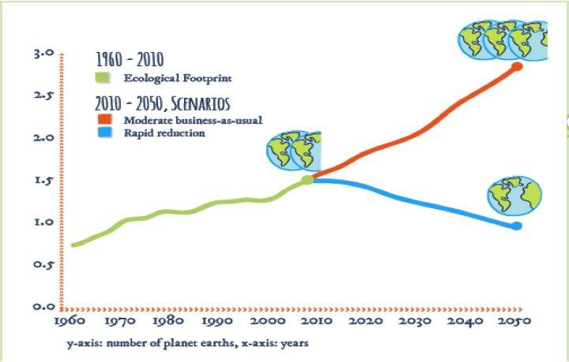

Hot tips: Talk to students about why scientists have different predictions and measurements of environmental footprints.

Student and classroom organisation

Step 1. Environmental/ecological Footprints Introduction

Introduce your students to the term ‘environmental or ecological footprint’. Explain to them what the term means - you can use the analogy of walking in sand and the depth of the foot imprint.
Discuss the difference between resources that we 'need' verses resources that we 'want'. Ask the question 'does Australia, as a country, have a large footprint?'
Draw a very large footprint on the board and put the title: ‘Areas that make up your footprint’. As a class brainstorm, what activities contribute to our environmental footprint? You may want to divide the footprint up into three main areas:

Energy | Using electrical or other powered devices including microwaves, lights, hair dryers, heaters, air-conditioners, travelling in a car, tractor, bus or train, lawn mowers, televisions, computers, radios, and refrigerators.
Water | Using water for drinking, growing food, cleaning. It could be cleaning your hands, teeth or flushing the toilet. Water is also used in washing machines and dishwashers, and to water the garden and sporting fields.
Waste | What you use and no longer need. This could be bottles, newspaper, packaging, old clothes and leftover food.

Get your students to record a definition of environmental footprint on their Student Worksheet.

Then get them to trace their own footprint. Then they can draw or cut out pictures from a magazine the activities that contribute to their footprint.

Step 2: Assessing Our Environmental Footprint

Ask the students to complete the Activity Measure Your Impact on their Student Worksheet. Get students to think about the activities they have completed in the last 24 hours and help them think about the resources that were used to undertake the activity.

Each student then rates each of their activities and associated resources out of one to three in terms of their environmental impact. Once students have finished rating each activity’s impact, they should add up their total score to assess what size their footprint was for that particular day.

Step 3: How could you improve your score?

What changes could they make to their daily activities at school and in the home to improve their score? Students use the table below to write down ways of using less energy, using less water and making less waste.

Step 4: Indigenous footprints - a historical perspective

Students are provided with sets of two photos to compare. One is related to traditional Aboriginal culture and the other with our current way of living. Using the photo students compare the energy, water and waste used in the photos. They then explain two or more contrasting situations between the way we currently live compared with Aboriginal traditional culture.

Students can then complete the reflection thinking tool.

Take action
Working in groups ask students to think up 5 things that your school can do to reduce its ecological footprint. Ask groups to create a poster, infographic, or article for the school website or newspaper describing these 5 things as well as what an ecological footprint is.

Ideas for saving energy and helping fight climate change

Project | Description | Resources
Start an energy team at your school | Start an energy team to monitor energy saving practices at your school, such as switch off regimes or the provision of energy saving interpretive signage. | How to start a green team
Take it home | Create home energy saving booklets or brochures for the school community. | Cool Australia Energy fact sheet Cool Australia Climate Change fact sheet
Nesting Boxes | Many birds and mammal species rely on hollows in trees for shelter and breeding. Natural hollows in trees take years to develop and nesting boxes can be a great alternative. | How to build a nesting box Nesting box construction guide.
Frog bog or butterfly garden | Help increase the biodiversity at your by building habitats for frogs | CERES hub  ActWild - Get Grubby
Planet Arks School Tree Day | Take part in the largest nature-care event in Australian schools, Planet Ark’s Schools Tree Day. You’ll be joining thousands of amazing teachers in making a difference, fostering a child’s love of nature and creating positive environmental change. | Schools Tree Day Tree Day Learning resources
Spread the word | Create interpretive signage for the school about cutting waste. | Cool Australia Waste factsheet
Engage an expert | Contact a local waste expert to arrange an incursion or an excursion. | Your local Council or waste management company.

For more ideas on how to reduce your ecological footprint, visit the Cool Australia Student Toolbox.

Extension/Homework:
- Into the Future - Ask students to imagine what the world would be like if we continue to use more resources than we have. Students can write a story of living in the next century – the year 3000. Have we managed to reduce the amount of resources we use?

- Digital versus manual footprint - Ask students to compare the results of the manual footprint that they completed in this activity with the results of a digital footprint calculator. Students could use this footprint calculator: http://www.wwf.org.au/our_work/people_and_the_environment/human_footprint/footprint_calcula tor/

Student worksheet

Thought Starter: Does everyone in the world have access to the same things you do?

Part 1: What is our Environmental Footprint?

1) a. Write a definition of the term environmental footprint:

b. What do you think are the lifestyle factors that contribute the most to environmental footprints?

2. Draw an outline of your footprint below. You then need to cut out pictures from magazines and newspapers or draw what things you think make up your footprint.

Part 2: Measure Your Impact Instructions
- You need to write down eight activities and record what resources are used. Activities may cover catching a bus, brushing teeth, getting dressed, eating lunch, and playing sport to name a few.

- You also need to record what resources were used to undertake the activity. The resources include water, energy or waste produced.

- You then need to estimate how much of the resource you used and write down the number 1, 2 or 3 in the usage boxes. Use the following guide:

Length of Activity | Usage | Score
Less than 10 minutes | Low | 1
11 minutes – 1 hour | Medium | 2
Over 1 hour | High | 3

For example if you only had the television on for 30 minutes the resource used would be medium however if you had the television on for three hours it would be high. We have included an example below to get you started!

Activity | Resources | Low Usage | Medium Usage | High Usage
Brush my teeth | water | 1
Subtotals (add up each column and write the subtotals in the boxes
TOTAL SCORE (add up all of the subtotals)

How do you rate?
10 -15 Friendly Flea | 16 -20 Careful Kangaroo | 21 -30 Dumping Dinosaur

I am a

Part 3: How could you improve your score?

What changes could you make to your daily activities at school and in the home to improve your score? Use the table below to write down ways of using less energy, using less water and making less waste.

Use Less Energy | Use Less Water | Use Less Waste

Part 4: Indigenous footprints - a historical perspective

Traditional Aboriginal cultural practices over at least 50,000 years has left a minimal environmental footprint other than where they managed country using fire. They had only a few belongings mostly consisting of tools, items of cultural importance, some clothing depending how cold it was and
woven bags and baskets. They owned few things that couldn’t be carried and consisted of items made from rocks, wood and from plant and animal materials. While they had few belongings they did have an extremely rich culture that had blossomed over the tens of thousands of years.
Thinking about environmental footprints, write down the three biggest contrasts between the photos. Think about the way we currently live compared with Aboriginal traditional culture.

Energy

Indigenous lifestyle | Modern lifestyle | Comparisons
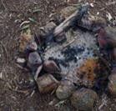 | 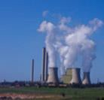

Waste

Indigenous lifestyle | Modern lifestyle | Comparison
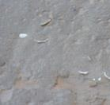 | 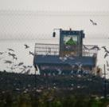

Water
Indigenous lifestyle | Modern lifestyle | Comparison
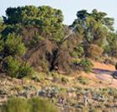 | 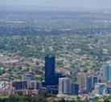

Reflection - what have you learnt?

- What are the social, economic and environmental consequences of having a large ecological footprint?

- Make a pledge to reduce your personal ecological footprint?

