
  - Circular Economy Matrix Background document
  - Measuring Circularity in projects
A resource developed by Buy Circular Council Champions in collaboration with Sustainability Victoria

Authorised and published by
Sustainability Victoria
Level 12, 321 Exhibition Street
Melbourne Victoria 3000 Australia
Matrix Background document
© Sustainability Victoria
December 2025
Accessibility
This document is available in PDF and Word format on the internet at sustainability.vic.gov.au
While reasonable efforts have been made to ensure that the contents of this publication
are factually correct, Sustainability Victoria gives no warranty regarding its accuracy, completeness, currency or suitability for any particular purpose and to the extent permitted by law, does not accept any liability for loss or damages incurred as a result of reliance placed upon the content of this publication.
This publication is provided on the basis that all persons accessing it undertake responsibility for assessing the relevance and accuracy of its content.
This report should be attributed to Sustainability Victoria.
This report is licensed under a Creative Commons Attribution 4.0 International licence.
In essence, you are free to copy, distribute and adapt the work, as long as you attribute the work and abide by the other licence terms. Go to http://creativecommons.org/licenses/by/4.0/ to view a copy of this licence.

Sustainability Victoria acknowledges Aboriginal and Torres Strait Islander people as the Traditional Custodians of the land and acknowledges and pays respect to their Elders, past and present.

Table of Contents
What is the purpose of the matrix 0
Matrix 2
How to read your score 3
Who should use this matrix 3
How to conduct an assessment 3
What is in and out of scope 4
In Scope 4
Out of Scope 4
How do you measure progress in the vertical axis 4
How do you measure your progress on the horizontal axis? 5
Considering Multiple Materials 6
How do you give yourself a point for designing material / waste out 6
Case Studies 9
Appendix 1: Circularity Deck Principles 11

What is the purpose of the matrix
This matrix has been prepared to help project managers who are not Circular Economy experts to assess the circularity of a project, purchase or programme of works. It provides a Circularity measurement that can be used to compare projects to each other or for options analysis.
The matrix does not attempt to measure the sustainability, carbon footprint or environmental impact of a project and should be used as part of a suite of tools, depending on the project needs.
The matrix provides a three dimensional measure of recycled content, end-of-life recyclability and material and/or waste minimisation.
A Circular Economy approach prioritises the minimisation of inputs (Use Less), the use of recycling (Use Again) and the efficient maintenance of assets (Use Longer) to create an economy that minimises the need for virgin materials and promotes best practice for end-of-life disposal.
A truly Circular Economy is regenerative for nature as well, providing ways to lessen our impact and repair ecosystems to preserve the earth’s capacity to support human life.
This matrix is designed to be used in the planning and implementation phases of a project including options analysis, design, specification, and construction. However, it can also be used to review existing or past projects to learn lessons and enhance future projects.
Once a project or programme has been scoped with a Circular Economy Lens, this matrix helps those who are implementing the project or programme to continue to apply Circular Economy principles throughout the design and delivery phase, as decisions are made.

Figure 1: What is a Circular Economy
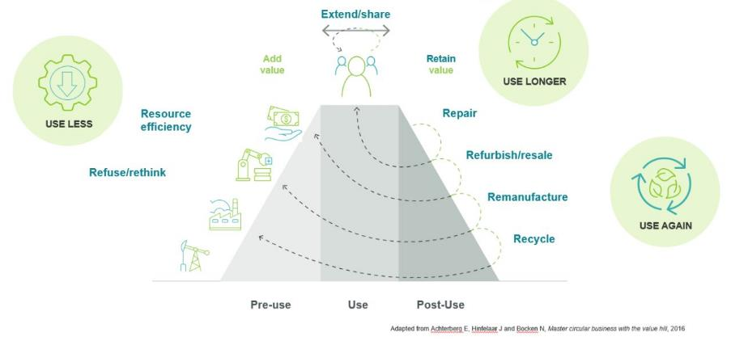
Credit: Value Hill (Achterberg, Hinfelaar and Bocken 2016) as adapted by Sustainability Victoria
A Circular Economy approach can be thought of on a sliding scale, with approaches ranging from extracting virgin materials and sending material to landfill (representing a traditional, linear economy), through to the more circular approaches that Use Less or Use Longer, including Refuse, Rethink, Reduce, Reuse, Repair and more. A representation of this sliding scale of Circularity is shown below.

Figure 2: Scale of Circular Economy approaches
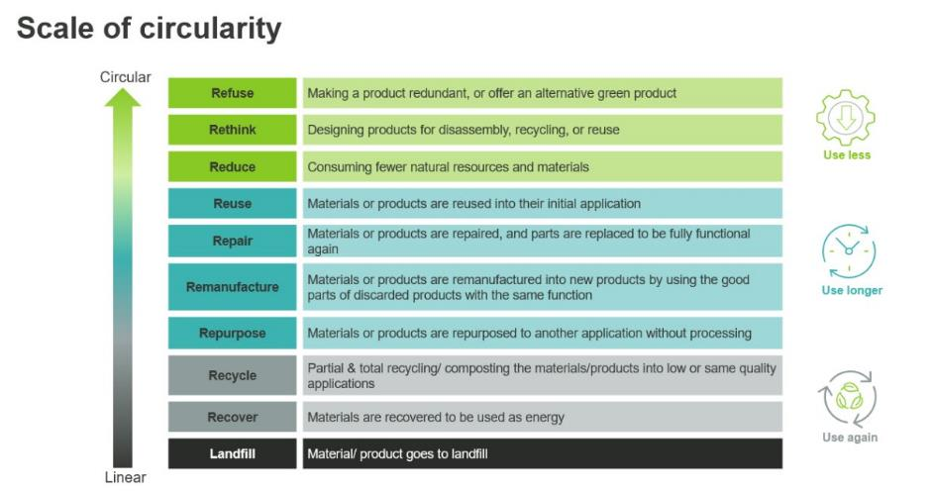
Credit: Sustainability Victoria
Sustainability Victoria has also developed a glossary of Circular Economy terms which may be useful in understanding the matrix and Circular Economy. This can be found at: https://directories.sustainability.vic.gov.au/buy-circular/glossary

Matrix
The scoring matrix is shown below. Scoring is initially completed on two axes.
The vertical axis (y-axis) identifies where material for the project is sourced from. This can range from the use of virgin materials through to a project where no new material is needed to carry it out.
The horizontal axis (x-axis) considers the end-of-life options for project materials, which range from becoming a persistent environmental pollutant, through to being intended for full and local reuse. This axis should be used to score the intended end-of-life outcome of the project materials, rather than the waste generated during construction or manufacturing activities.
The third dimension of the matrix rewards design decisions that reduce the amount of materials required for future projects, purchases or procurements. This could include selecting long-lasting materials (reducing maintenance and replacement needs) or by reducing the need for materials in the project.
For further explanation of how to assess your score on each axis, please see the sections below.
Figure 3: Circular Economy Matrix
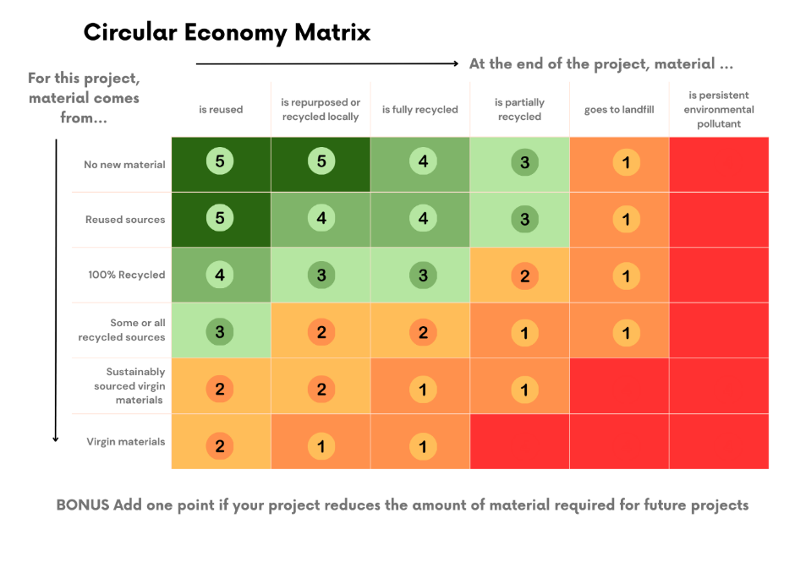

How to read your score
0–1 points → Mostly Linear (Business as Usual)
Projects in this range have little to no circular elements. Materials mostly come from virgin sources and are likely to mostly end up in landfill or persist in the environment.
2–3 points → Circular-ish
These projects include some circular economy elements — such as using recycled content or reusing materials — but still rely partly on virgin inputs or create waste at end-of-life.
4–5 points → Closing the loop
Projects in this range are designed with circularity at the core. Materials are reused, recycled locally, or kept in continuous loops, helping to minimise waste and reduce reliance on virgin resources.

Who should use this matrix
This matrix is intended for use by project managers to provide a simple method of estimating the circularity of a project or programme of works. Projects could be large complex projects such as major civil asset construction or small projects such as purchasing office furniture or running a community workshop.
The matrix is not intended as a scoping or strategy tool – assessments at this stage should be undertaken by Circular Economy professionals who can provide the context, tools and techniques that could apply. Once a project has been identified and scoped, the assigned project manager can apply this at any stage of project development.

How to conduct an assessment
The matrix operates like a risk matrix, and should be used in a similar way. It can be used individually but works best when completed by a team with a variety of perspectives.
The assessment can be completed at a detailed level, assessing the circularity of each element of the project. These assessments can be undertaken once a full design (preliminary or detailed) has been completed, allowing an assessment of each material or project input. This type of assessment can help with product or supplier selection, highlighting where less circular materials are being used and identifying opportunities to improve circularity of various elements of the project. These detailed assessments can result in a weighted average score, using cost or volume as a weighting tool.
The assessment can also be applied at a high level with estimations of circularity conducted across the whole project or on different aspects of the project. These assessments can be undertaken at any stage of project development, and could be used to inform options analysis or to identify techniques that could be applied to improve the project’s Circular Economy score.

What is in and out of scope

In Scope:
- Procurements, Projects or Programmes of work
- Preliminary Options Assessments
- Design-stage assessments
- Comparing options for Circularity
- Identifying opportunities to improve project Circularity
- High-level assessments for Board, Council, PCG or Executive-level information

Out of Scope:
- Strategy or scoping stage assessments
- Economy-wide assessments
Strategy or Scoping stage assessments should utilise other tools and approaches, such as the Scale of Circularity shown in Figure 2 above.
Economy-wide assessments can be undertaken using different metrics. Australia has a national Circular Economy measurement that captures the percentage of recycled material being used in the economy. At a State level, Recycling Victoria has developed a Circular Economy Market Report that provides state-level Circular Economy metrics, including Circularity Rate (measured as above), Material Footprint (raw material extraction per capita) and Material Productivity (ratio of economic output to material consumed).

How do you measure progress in the vertical axis
At this stage, you should assess where the material for your project is coming from. Are the chosen materials new (virgin), recycled, reused, or is the project designed to need little or no new material?
For this project, material comes from…
 | Description | Example
Virgin materials | Materials produced from raw, untouched resources such as newly mined minerals, harvested timber, or newly manufactured plastics. | Using office paper made entirely from new trees (no recycled content).
Sustainably sourced virgin materials | Materials produced from raw resources that have been sourced using best practice sustainable methods. | Sustainably sourced timber (e.g. FSC certified).
Some recycled sources | Materials include a blend of both virgin and recycled content, reducing pressure on raw resources but still relying on new inputs. | Concrete that includes a portion of recycled crushed glass alongside virgin aggregates.
100% recycled | Materials fully made from recycled materials, with only small or nominal components not recycled (such as rubber gaskets or cork stoppers). | Parking bollards made from 100% recycled plastic.
Reused sources | Materials recovered and used again in their existing form, with little or no reprocessing. | Second-hand bricks salvaged from demolition and used directly in a new wall.
No new material | The project avoids the need for new inputs altogether by repairing or designing around existing assets or infrastructure. | Repairing existing park garden beds rather than replacing them with new ones, or reusing materials already within the project (e.g., seating relocated on-site).

How do you measure your progress on the horizontal axis?
At this stage, you should look ahead and imagine what will happen to the material at the end of the project. Are the chosen materials designed to go back into the project, reused locally, fully recycled, partly recycled, sent to landfill, or will they remain in the environment long-term?
At the end of the project, material…
 | Description | Example
Is reused | Materials are reused directly in the same project or another Council project, with little or no extra processing. | Pavers lifted during roadworks are stored and laid again in the same project.
Repurposed or recycled locally | Materials are collected and processed through existing local facilities and markets, supporting nearby reuse and recycling. | Timber formwork sent to a local reclaimed timber centre.
Is fully recycled | Materials are recovered and recycled into new products so they can be used again and again. | Aluminium components collected and smelted into new aluminium products.
Is partly recycled | Only some of the material is recycled, or it is “downcycled” into a lower-value product that may eventually end up as waste. | E-waste (electronic waste) where metals and circuit boards are recovered, but plastics and mixed components are discarded.
Goes to landfill | Materials cannot be reused or recycled, and are disposed of in landfill. | Contaminated soil with no recovery option being sent to landfill.
Is a persistent environmental pollutant | Materials persist in the environment, could be a pollutant, and there is no plan for them to ever be collected or processed. | Synthetic turf left in place without an end-of-life plan, allowing microplastic shedding.

Considering Multiple Materials
Most projects will include many different materials, not just one. You can use the matrix by assessing each material individually, however, you can also consider multiple materials at once. To use the matrix this way, think about where the largest share of materials (by volume) will most likely fall on the axis.
For example, a new playground might include recycled plastic seating, steel play equipment, and soft-fall rubber. While some components may be fully recycled at the end of the project, if the bulk of the project materials (like the soft-fall surface) is destined for landfill, the project would be scored at the landfill level.
You can often shift a project like this along the axis to achieve a better score by including an end-of-life plan for the majority of the materials used. By considering disposal and reprocessing options early in design, a project can move from a linear outcome to a “Circular-ish” or even a closed-loop project.

How do you give yourself a point for designing material / waste out
There are a range of techniques and approaches that can be applied to create Circular outcomes. One way of understanding these is the Circularity Deck, developed by Jan Konietzko. These are framed as either Narrowing, Slowing or Closing material flows, along with Regenerating nature and using a data-informed approach.

Figure 4: Circular Economy approaches
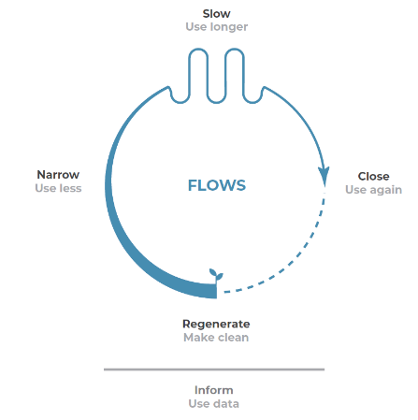
Credit: Jan Konietzko – Circularity Deck
To award a bonus point, approaches that “Narrow” or “Slow” material flows should be used.

Figure 5: Circularity Deck – Narrow and Slow
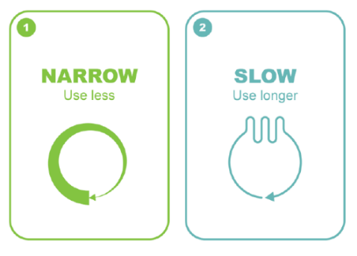
Credit: Jan Konietzko – Circularity Deck
In the circular economy, the "narrow" principle, also known as "narrow loops", refers to reducing the overall volume of materials and energy used in product design and manufacturing to minimise resource consumption and waste. This involves strategies such as designing products to use fewer components, selecting efficient and low-impact materials, reducing energy use, and minimising the number of steps in a product's supply chain.
For example, when selecting a seat, think about any plastic parts that are not easily taken apart and/or reused/recycled at its end of life.
The "slow" principle of circular economy emphasises extending the lifespan of products and materials to keep them in use for longer, thereby reducing the need for constant replacement and minimising resource depletion and waste. This principle involves designing out waste by creating high-quality, durable, and repairable products, promoting a culture of slowing consumption patterns.
For example, when selecting a seat, replacing plastic parts with high-quality metal supports will improve its longevity as they are stronger. The upfront cost of the material often is justifiable when maintenance and asset life are considered.
A full description of the Circularity approaches can be found at www.circularitydeck.com

Case Studies
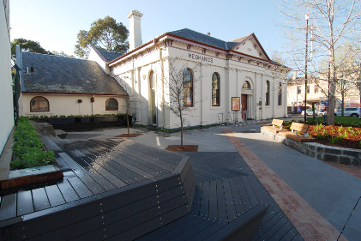 | Project: Brunswick Mechanics Institute Forecourt Upgrade  CE Strategy: The construction upgrade of the small forecourt reuses materials on site and uses high-quality materials that will last long for the public space.  List of materials: Bluestone, asphalt footpath, crushed rock base, brick footpath, custom seats from timber, steel drinking fountain, timber decking, metal planters, Corten steel tree pit grate, imported bluestone paving, retained monument, old seat reuse.

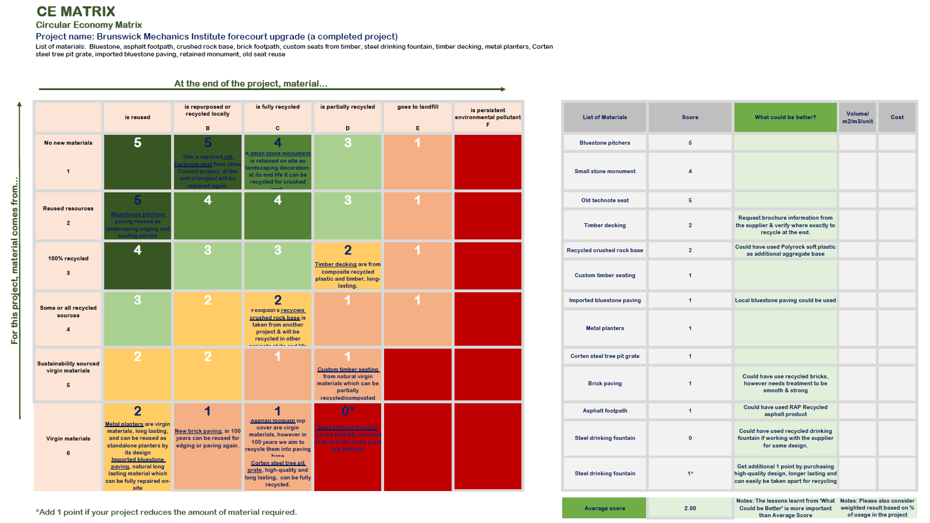

Appendix 1: Circularity Deck Principles
A full description of the Circularity approaches can be found at www.circularitydeck.com

Circular Strategy | Circular Principle | Required Innovation Perspective | Description and Example
Narrow | Design with low-impact inputs | Product | Design products with ‘ingredients’ and materials that require less land, energy, water and/or materials to produce.  The company Impossible Foods has designed a ‘meaty’ plant-based burger. Compared to the beef version, it requires ca. 7 m² less land, 300 L less water and 5 kg less CO₂ than the meat-based alternative.
Narrow | Design light-weight products | Product | Design products that are lighter than comparable products on the market. Lighter products usually require less materials and need less energy to transport.  Adaptive City Mobility has designed a car that weighs 650 kg incl. battery. This is around 1/3 of an average car (in 2019), leading to ca. 50% less battery to operate.
Narrow | Design for multiple functions | Product | Design products with multiple functions. Multi-functional products can reduce the overall number of products and may be usable by different user groups.  Studio Davero has designed Puzzle Peace: a modular furniture kit that can be turned into multiple types of furniture; e.g., a bench, table, armchair, chair, bar or display.
Narrow | Eliminate production waste | Business Model | Eliminate any type of waste from production processes, for example material scraps, food left-overs or excess heat and electricity.  The company Winnow helps professional kitchens to reduce food waste and save cost through a bin with a scale, Artificial intelligence enabled image recognition software and training based on gathered waste data.
Narrow | Enable and incentivize users to consume less | Business Model | Incentivize users to use less energy or material during the use of energy or material-using goods like washing machines or cars.  The firm HOMIE offers washing machines through a pay-per-wash model. By monitoring user behaviour, the company increases the resource efficiency of doing laundry.
Narrow | Organize light-weight urban transport | Business Model | Organize lighter forms of transportation, for example using electric tricycles. The lighter the vehicles, the lower the amount of energy and materials required to transport people and goods.  The firm RYTLE provides a cargo solution that consists of a light-weight vehicle, an easily exchangeable box, storage hubs and software that connects all entities.
Narrow | Localize supply where appropriate | Business Model | Find more local suppliers, where appropriate. More local suppliers decrease the amount of energy needed to transport goods.  The restaurant chain ‘Dig Inn’ has developed a supply system of local farmers in every region it operates in to provide a scalable, locally adapted and seasonal restaurant model, reducing travel distances for food ingredients and stimulating the regional economy.
Narrow | Maximize capacity use of products | Ecosystem | Maximize the degree to which the capacity of a product is used. This is sometimes referred to as ‘sharing’, where multiple user groups have access to the same product. This can decrease the overall number of products in an ecosystem.  The online platform Peerby enables people to share everyday goods like drills or bicycles, which can increase their usage and reduce the overall number of personally owned goods in homes over time.
Slow | Design for physical durability | Product | Design products that degrade more slowly than comparable products on the market.  A cast-iron pan can last much longer than comparable pan types.
Slow | Design for emotional durability | Product | Design products that users will love and trust over a long period of time.  The ‘Leatherman’, a pocket-knife sized toolkit, has a 25 year warranty and many uses. It lets people collect and experience personal stories and creates an emotional bond between the user and the product.
Slow | Design for ease of maintenance and repair | Product | Design products that can be easily maintained or repaired. Maintaining means inspecting the product to retain its functional capabilities. Repairing is about restoring a product to a sound/good condition after decay or damage.  Fairphone has designed a modular phone that can be easily disassembled to repair and exchange components.
Slow | Design for easy dis - and reassembly | Product | Design products that can be easily separated and reassembled.  Gerrard Street has designed a pair of headphones that can be easily separated and reassembled.
Slow | Design for upgradability | Product | A product is upgradable if its functionality or performance can be improved during or after use.  An example is a bicycle with exchangeable and upgradable components.
Slow | Design for standardization and compatibility | Product | Create products, components or interfaces that also fit other products, components or interfaces.  A common example of a standardized component is the Mini-USB slot for charging.
Slow | Enable users to maintain and repair their products | Business Model | Create services that enable users to care for their product.  Fairphone supports users to care for their phones through discussion forums on how to maintain and repair, and an inventory of spare parts.
Slow | Remanufacture existing products and components | Business Model | Recover value from collected end-of-use products by reusing their components for the manufacturing of products with the same functionality.  The Chinese company Guangzhou Huadu collects used vehicle parts and remanufactures them into as-new certified spare parts.
Slow | Repurpose existing products and components | Business Model | Take existing products and components and take them out of their context to create new value with them.  Ubitricity turns lamp lanterns in cities into charging stations for electric vehicles.
Slow | Provide an unconditional lifetime warranty | Business Model | Offer your customers a life-time warranty, adding a promise to products that are made to last.  The company Darn Tough Vermont produces socks with an unconditional lifetime guarantee. They say: “If our socks are not the most comfortable, durable and best fitting socks you have ever owned, return them for another pair.”
Slow | Encourage sufficiency | Business Model | Encourage your customers to moderate the consumption of your products.  In 2011, the clothing company Patagonia advocated: “Don’t buy this jacket.” With Worn Wear, it opened an online store for used Patagonia clothing, encouraging users to maintain their gear and trade it back once they don’t use it anymore.
Slow | Provide the product as a service | Business Model | Offering the product as a service keeps the ownership with the firm and creates incentives to increase their lifetimes. You can offer product-, use-, or results-oriented models.  The company Kaer offers a result: cool and fresh air as a service, rather than air conditioners as products.
Slow | Organize maintenance and repair services | Business Model | Make sure that your products can last longer through maintenance and repair services. They can be offered by the manufacturer of a product or by third-party providers.  The company Nudie Jeans, at its point of sale, has started to offer a free repair service for their Jeans. This has changed the shop appearance into a craftsmanship atmosphere.
Slow | Upgrade and adapt existing products | Business Model | A product is upgradable if its functionality or performance can be improved during or after use. Try and integrate upgrading services into your offering.  Gispen offers REMADE, a service to repurpose old furniture to fit new trends and workspace requirements.
Slow | Turn disposables into a reusable service | Ecosystem | Make use of or provide services that replace disposable with durable products.  TerraCycle has designed ‘Loop’, which delivers products like shampoo or ice cream in reusable packaging. The packaging gets picked up, cleaned and used again. Involved actors include retail brands, service providers (e.g., cleaning and transport service) and end users.
Close | Design with recycled inputs | Product | Design with materials that have been recycled from other products and components.  The ‘Design for Recycled Content Guide’ supports firms in opting for more recycled content in their products.
Close | Design components, where appropriate, with one material | Product | Composite materials are often hard to recycle because they cannot be separated. Design components, therefore, where appropriate, with only one material to increase recyclability.  Adidas has launched Futurecraft.Loop, a shoe made from one recyclable material and no glue. It can be recycled into pellets that can be turned into a new shoe.
Close | Design with materials suitable for primary recycling | Product | Try and design for primary recycling, that is: recycling that can turn materials into materials with equivalent properties.  Aquafil has designed the Econyl system, which enables Polyamide 6 or Nylon 6 waste to be manufactured into new Nylon 6, with no loss of quality.
Close | Design for easy disassembly at the end of the product lives | Product | Easy disassembly allows product components to be more easily recycled.  Magnomer uses magnetizable ink on packaging labels to allow for easier separation during the recycling process.
Close | Reuse and sell components and materials from discarded products | Business Model | Create new value from wasted products and components.  Roetz recovers bicycle components that were thrown away and uses them to let customers assemble their own bikes.
Close | Enable and incentivize product returns | Business Model | Make sure that you can get the products back that you put on the market.  The clothing company Teemill makes users send back old and worn out products. Users can scan a QR code in the wash-care label to generate a free post label, which can be used to send the garment back to Teemill. Sending back products earns users credit for their next purchase.
Close | Recycle products in proper facilities | Business Model | Make sure that the products you put on the market get recycled in proper facilities.  The initiative ‘Closing the Loop’ supports users and sellers of phones to be material-neutral and waste free. It collects scrap phones on behalf of customers and recycles them.
Close | Build local waste-to-product loops | Ecosystem | Create local resource loops by turning the waste of a given facility into new products that can be sold back to the facility.  The firm SOOP has designed an ecosystem that collects waste (coffee grounds and orange peels) from offices, processes it, and re-delivers products to the offices that are made from to the waste.
Close | Engage in industrial symbiosis | Ecosystem | Share or exchange by-products, materials, energy, or waste among nearby firms.  The Kalundborg Eco-industrial park is an example where firms collaborate to share by-products from their factories.
Regenerate | Design with renewable materials | Product | Design products with renewable and low-carbon materials. Timber wood, for example, can replace non-renewable building materials. Renewable materials should only be chosen when its extraction rate is equal to or lower than its recovery rate. Further, next to its properties, materials need to be selected based on their expected end-of-life treatment to avoid unintended consequences.
Regenerate | Design self-charging products | Product | Design products that can charge themselves with renewable energy. This is especially relevant for mobility assets.  The company Sono Motors has designed a car with solar cells integrated into its body, allowing it to charge itself throughout the day.
Regenerate | Design with living materials | Product | Living materials leverages the properties of natural materials.  Ecovative, for example, produces mycelium-based fibers and materials with natural glue properties. Used for packaging, apparel and in the medical industries.
Regenerate | Design with non-toxic materials | Product | Avoid using toxic materials and substances in any of your products or operations. Toxic substances tend to accumulate in the biosphere and cause negative health effects for humans and other species.  Vestaron substitutes synthetic pesticides with biological ones that are safe for humans, birds, fish and pollinators.
Regenerate | Produce and process with renewable energy | Business Model | Build up your capacity as a company to produce and process with renewable energy.  In 2019, Apple has been the company with the biggest installed capacity for solar energy, 400 MW.
Regenerate | Power transportation with renewable energy | Business Model | Find ways to power your transportation needs with renewable energy.  The company Foodlogica links local food, consumers and businesses in Amsterdam’s city center through a light-weight mobility system, powered by renewable energy.
Regenerate | Power the use of the product with renewable energy | Business Model | Find ways of powering your product with renewable energy, through creative partnerships or product and service design.  Waka Waka provides portable devices with photovoltaic panels that can power every-day electronics.
Regenerate | Embed renewable energy production in the existing infrastructure | Ecosystem | Find ways of making renewable energy production part of the existing infrastructure.  ‘Solar Roadways’ has developed a modular system of solar panels that can be walked and driven upon.
Regenerate | Recover nutrients from urban areas | Ecosystem | Find ways of recovering valuable nutrients from urban areas that are usually lost.  Lystec Inc. helps the city of Guelph to turn biosolids from wasterwater treatment into organic nutrients for surrounding agriculture.
Regenerate | Regenerate polluted ecosystems | Ecosystem | Contribute to regenerating polluted ecosystems that affect your business.  The Ocean Cleanup Project develops technology to clean oceans from plastic pollution.
Regenerate | Manage and sustain critical ecosystem services | Ecosystem | Engage in projects that manage and sustain the natural ecosystems that surround and/or affect your business operations.  Nestle’s Häagen-Dazs has partnered with the nonprofit Xerces Society to plant the largest pollinator habitat in the United States. Without pollination services from bees, many critical ingredients for the ice-cream would not exist anymore.
Inform | Use artificial intelligence to develop new materials with circular properties | Product | Developing a new material requires data about the structure and properties of materials. AI can help analyze the required and available data quickly to inform design decisions based on circular requirements.  The ‘Accelerated Metallurgy project’, run by the European Space Agency, has used AI to produce and test new metal alloys. AI enabled the project to speed up the process of finding new materials.
Inform | Virtualize | Product | Deliver utility virtually. Virtualizing reduces the need for materials to deliver the same utility.  reMarkable has designed a digital device that “feels like paper”. A tool for note-taking, reading and reviewing documents.
Inform | Design connected products | Product | Design products with sensors that can send and receive different types of data.  Delta Development, as part of its ‘product-as-a-service’ model, has sensors in some of their elevators to inform maintenance needs.
Inform | Use product-in-use data for circular design | Business Model | Data on how a product is used can be valuable to make better design decisions for future products and services.  Rolls-Royce aggregates product-in-use data to make their engines more efficient, durable and long-lasting.
Inform | Track the resource intensity of the product-in-use | Business Model | Tracking the resource use of products while they are used can, for example, help to influence user behavior to decrease the resource intensity of product use.  Philips uses sensors to track data on how their lights are used within their lighting-as-a-service model to save electricity.
Inform | Track the condition, location, and/or availability of the product | Business Model | Tracking the condition of the products can help to predict when it will be necessary to service (e.g., repair, maintain) them. Tracking the location and availability can, for example, enable the maximizing of their use capacity.  Zipcar uses the data to optimize their car sharing service.
Inform | Market circular products, components and materials through online platforms | Ecosystem | Online platforms can serve to market circular products, components and materials.  Stuffstr buys and collects used products from consumers and sells them in secondhand markets. An AI algorithm helps Stuffstr to set competitive prices for the seller, while offering Stuffstr a good margin on the secondhand market.
Inform | Build material database ecosystems | Ecosystem | Create or leverage material databases. They describe the characteristics of materials and components in products so that products can be more easily reused and their materials recovered.  The project ‘Buildings as Material Banks’ has brought together different stakeholders to develop a material database ecosystem for buildings.
Inform | Co-create products, components, materials and information via online platforms | Ecosystem | Online platforms can be used to ‘crowdsource’ design projects for circular products, components and materials.  The online platform launchforth.io connects designers and engineers with firms to co-create new products.
Inform | Use artificial intelligence to optimize circular infrastructure | Ecosystem | The circular economy requires the collecting, sorting, separating, treating, and redistributing of products, components and materials. Often, products, components and materials are diverse and difficult to handle. Artificial intelligence can help to optimize the infrastructure required for a circular economy.  ZenRobotics uses robots with cameras and sensors to automatically sort all kinds of waste streams with an accuracy level of 98%.
Inform | Operate service ecosystems via online platforms | Ecosystem | Online platforms can serve to operate service ecosystems that require several actors who need to coordinate their interactions and economic exchange.  The online platform Whim operates mobility-as-a-service ecosystems in cities combining different private and public transportation options for a seamless mobility experience.

