Campaign overview
This document outlines how you can use the resources provided by Sustainability Victoria (SV) to promote Detox your Home events to householders in your municipality or in a neighbouring municipality.
All resources mentioned in this document such as written materials and flyers can be found on the Sustainability Victoria website under Detox your Home asset library.
These resources have been designed to make it as easy as possible for you to promote your events – and you can tailor them to your needs.
Get organised
We have provided you with a communications plan to help you design, deliver and evaluate the impact of your Detox your Home communications activities. It can be downloaded from the campaign asset library.
The activities included are suggestions only – work with your communications team to determine the best mix based on your:
- audience
- budget
- staff availability and skills.

Planning ahead will help you to:
- raise community awareness of the Detox your Home service
- highlight the safe, contactless, drive-through service
- attract as many householders as possible
- educate householders about the importance of correct storage of materials until they can get to an event
- measure the impact of communications activities in your area to inform future communications plans for the service (such as, what’s working and what isn’t).

Working with Customer Service
We recommend you provide your customer service staff with full details about your upcoming Detox your Home event so that they can respond to queries with accurate information.
Highlight that registration is essential and that the service is drive-through and contactless (walks-ins cannot be accepted) and that these measures are part of Sustainability Victoria’s COVIDSafe plan.

Campaign materials
We have provided you with campaign materials that can be downloaded from our campaign asset library.
Whether you’re running an event and want to drive registrations or can’t host an event at this time and want to encourage safe storage, there is content included in this kit to support you.

Please note that in special circumstances, such as the cancellation of a scheduled event, SV will provide additional key messaging to support communication of changed arrangements.

Campaign materials | How materials can be used
Written materials (copy) | We have provided a variety of written templates that can be used in:  - newsletters – print and digital  - websites  - social media  - media releases  Note that media releases can be particularly effective in regional and rural areas and with suburban newspapers and community radio stations. Use the templates we’ve provided as well as the key messages document to tailor your story to your local community.  If pitching your story to a newspaper, you may want to also set up a pre-event photo opportunity with the mayor or a local householder. The householder could be clearing chemicals from their house, ready to attend an event. Your communications team can help you craft a media release and a media alert (for a photo opportunity).
Posters and flyers | These print-quality items can be used at Council buildings and other appropriate places within your municipality.  On request, we can customise posters and flyers with your event details. Please contact us via email at least 4 to 6 weeks prior to your event.  Consider providing the artwork to relevant organisations in your area for inclusion in their newsletters or print publications.
Social media tiles | We have provided a variety of tiles, such as, designed images that can be used on social media.  The suggested copy to accompany these materials is included under Written materials inside the asset library.
Banner artwork | The banner artwork we provide can be used in several ways:  - Email marketing:  - Email marketing is a quick and easy way to advertise an event in your area direct to householders. Chat to your marketing or web team to see if there may be an opportunity to include a tile in an email newsletter. The tiles in this kit can be hyperlinked direct to the Detox your Home registration page for the event in your area.  - You could also consider providing the artwork to relevant community organisations in your area for inclusion in their email newsletters.  - Website promotion:  - The artwork tiles and banners provided also work perfectly as web graphics or banners.  - You can use these tiles to help illustrate Detox-related information, or as advertisements across your site to link back to Detox-related content.

Campaign materials examples
Here are some examples of the above communication materials in action. These combine written materials and visual assets available in the asset library online.
- Example Facebook post
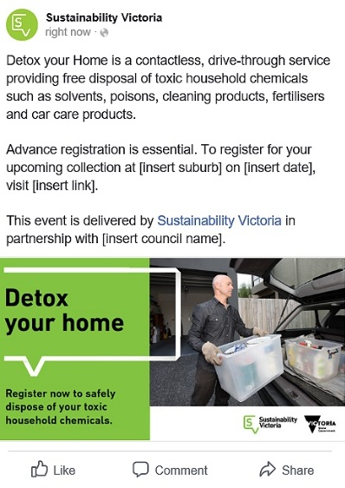

- Example of a hyperlinked image in an email newsletter
You can use these tiles within an email newsletter to link back to Detox-related content. This first type of tile can work well if you have an upcoming event you’d like to promote:

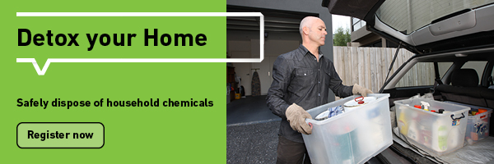
This second tile works well if you’re wanting to send people to general information on the program:
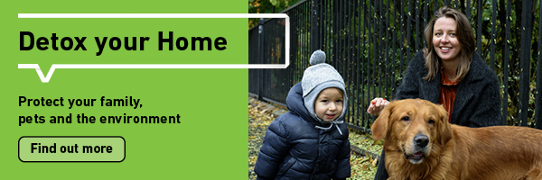
Other promotional opportunities
In addition to the tactics laid out in the previous sections of this document, you may wish to consider the following additional ways to promote your event or safe storage of household chemicals.
The key messages document can be used as a basis for additional content to create the following: [need to define location/format for key messages]
- Mayor column or editorial
- News articles in newsletters, publications or on your website
- Internal communications channels (for example, staff intranet)
- On-hold message for phone services
- Posters or flyers if you have a physical customer space operating
- Promotion through local partner organisations (for example, maternal health, schools, fire authorities)
- Print advertising – if you choose to pursue print advertising, be sure to use the artwork with the web URL so people know where to go for more information.
It can also be worthwhile liaising with real estate agents and property managers. These people have relationships with renters and landlords who may need to dispose of toxic waste.

Contact Us
For support or advice, feel free to contact us using the following: Detox@sustainability.vic.gov.au
Please use ‘communications support’ in the subject line.

