Recycling Victoria

Kerbside contamination campaign: Not in Bags – Campaign Kit
October 2021

Table of contents
How to use this kit 2
About the campaign 2
Campaign approach and development 3
Campaign delivery 3
Campaign research 4
Campaign materials 4
Key contact 8

How to use this kit
This kit provides background information and campaign tools for councils to use in their own communication channels with the community for ‘Not in Bags’ activity. It includes all the information you need to learn about:
- the advertising campaign
- the problem with recycling in bags
- the research that informs the campaign
- the campaign materials available to you

About the campaign

Overview and purpose
To reduce contamination in kerbside recycling bins across the state, Sustainability Victoria (SV) is running an 8-week campaign from 31 October to 31 December targeting the problem of people placing recycling in plastic bags.
The campaign will help the community to recycle correctly by encouraging Victorians to put their recycling in the bin loose and not in a plastic bag. Items in a plastic bag don’t get recycled because the bag can cause jamming of machinery at the sorting facilities. They also pose a risk to workers sorting items at the facility as they cannot see what items may be contained in the bags, which could include sharps and other hazardous materials.
Statewide campaign activities will include advertising, multicultural community engagement and social media influencer activities. Activities will target the groups which have been identified to be more likely to put recycling in plastic bags – people aged 36-55 and culturally and linguistically diverse (CALD) communities.
This campaign will help us to achieve Recycling Victoria (RV) policy outcomes including a 15% reduction in waste generation per capita and increase waste recovery to 80%.
It is one of a series of planned campaigns that Sustainability Victoria will deliver as part of the Victorian Government’s $380 million investment in Recycling Victoria: A new economy, a plan to build a circular economy by reducing waste and making more productive use of our resources.

Key messages
- Primary: Put your recycling in the bin loose, not in bags.
- Secondary: Items in plastic bags don't get recycled because they can't be sorted.
- Call-to-action: Learn more at sustainability.vic.gov.au/not-in-bags

Key dates
The campaign will run from 31 Oct 2021 to 31 Dec 2021.

Campaign approach and development
This campaign has been developed using an insight-led approach.

The issue
- Reported increase in contamination since COVID-19
- Need to address recycling contamination issue
- Recycling knowledge levels are low and incorrect recycling behaviours are common
- Bagged recycling can jam machines at material recovery facilities and prevent items from being recycled into new products.
- In addition to causing damage to machinery, recycling in bags poses a safety risk to staff who manually sort recycling.

The solution
- Address key contaminant
- Educate Victorians to put their recycling in the bin loose and not in bags
- Insight-led, statewide behaviour change campaign
- Tailored approach for specific audience groups
- Utilise impactful campaign materials

Creative development
The campaign creative builds on SV’s successful Know Your Recycling (KYR) campaign by repurposing hero imagery from the KYR campaign that clearly demonstrates how to recycle correctly. The design has updated branding which will continue into the future RV campaigns and materials provided to councils. This will provide an ongoing consistency in campaign look and feel.
Campaign materials focus on the key behavioural message encouraging Victorians to correctly put their recyclables into their recycling bin loose and not in bags.

Campaign delivery

Statewide level (delivered by SV)
- Advertising:
  - Campaign advertising will run from 31 October to 31 December 2021.
  - Advertising will run across television broadcaster streaming services, YouTube, radio and audio, press (regional only), out of home (digital shopping centre panels), social media (Facebook and Instagram) and display (desktop and mobile).
- CALD engagement
  - CALD engagement activities will run alongside advertising and will be delivered by a specialist multicultural agency.
  - Outreach activities include social media public relations (PR), community member PR, peak body liaison, and traditional ethnic media PR.
- PR micro-influencer campaign
.

Local level (delivered by councils)
Councils can use the campaign materials provided to communicate the ‘recycle items loose, not in bags’ messaging to their communities. Materials have been adapted from statewide materials to suit local campaign activities and include social media posts and print assets.

Campaign research
Comprehensive research was undertaken to inform the development of the RV campaign.

Key findings
Recycling in plastic bags:
- 17% of Victorians currently bag their recycling
- 22% of Victorians would put bagged recycling in a commingled bin in a 4-bin system
- 27% of multicultural communities bag their recycling often or every time
- Industry has consistently reported bagged recycling to be an issue
(Source: Sustainability Victoria / Fiftyfive5 Recycling Victoria Campaign Baseline Research – July 2021)
Recycling in Victoria:
- 54,000 tonnes of recycling were sent to landfill as a result of contamination in 2020-21, an increase from 35,000 tonnes in 2019-20.
(Source: Sustainability Victoria / Waste Management and Resource Recovery Association of Australia / Envisage Works Recovered Resources Market Bulletin – July 2021).
- There is a gap between good intentions and good practice in Victorians’ recycling. 88% of Victorians believe recycling is important to protect the environment while more than three quarters (76%) of Victorians have incorrectly recycled an item over the past month.
(Source: Sustainability Victoria / Kantar Recycling Victoria Kerbside Education and Behaviour Change Research – March 2021).
- Although underlying attitudes towards recycling and its environmental benefits are positive, knowledge levels are low and incorrect recycling behaviours are common.

Campaign materials
We have provided you with campaign materials and artwork to use that can be downloaded from our campaign asset library. The campaign materials include various campaign resources and advertising.

Campaign resources
Campaign materials that will be available | How materials can be used
Article copy | Written content that can be used in newsletters and on websites.
Posters and print assets | Print assets and posters which can be used in advertising or in newsletters.
Videos 15s and 6s | Short videos which can be posted on social media or on your website.
Social media static tiles and gifs | Tiles and gifs which can be used on social media. Suggested copy to accompany these materials is included in this kit.
Audio 30s | A short audio recording which can be used in council offices or as on-hold audio.
Frequently Asked Questions | FAQs to assist council in responding to queries about recycling in plastic bags.
Translated materials | Video, audio and static social tiles will be translated into eight languages: Arabic, Cantonese, Mandarin, Hindi, Punjabi, Vietnamese, Dari, Khmer.  The campaign webpage (sustainability.vic.gov.au/not-in-bags) will also be translated into these languages to support CALD communities.

When you will receive the campaign materials
English materials are available from early November. Translated materials will be added to the campaign library from mid-November.

Suggested social media copy and calendar (please adapt using locally relevant information and examples)
Date | Proposed copy | Proposed asset | Channel
W/c 8th Nov | Currently, 17% of Victorians are making the simple mistake of putting their recycling in the bin in a plastic bag. Unfortunately, items in bags can’t be recycled as the bags can jam machines at the sorting facilities.  That’s why a new campaign is encouraging you to put your recycling in the bin loose and not in bags, so that more of it can be turned into new products like [roads, glass jars and park benches Or use local examples].  This campaign forms a part of the Victorian Government’s investment in Recycling Victoria to build a circular economy.  Learn more at www.sustainability.vic.gov.au/not-in-bags [Or insert your own relevant URL] | 15s video | Facebook
W/c 15th Nov | Recycling in plastic bags can’t be recycled because it can't be safely sorted by workers at recycling facilities.  Remember to put your recycling in the bin loose and not in a plastic bag so that more of it can be turned into new products like [roads, glass jars and park benches Or use local examples].  Learn more at www.sustainability.vic.gov.au/not-in-bags [Or insert your own relevant URL] | Gif | Facebook
W/c 22nd Nov | When recycling is put in a plastic bag it can’t be sorted as it can jam the sorting machines, and puts workers at risk.  Instead of collecting your recycling in a plastic bag, use a basket, cardboard box or container. Then, once it’s full, simply tip the contents into your recycling bin so the items go into the bin separately.  By putting your recycling in the bin loose and not in a bag, more of it can be recycled into things like [planter boxes, park benches and even roads Or use local examples].  Learn more at www.sustainability.vic.gov.au/not-in-bags [Or insert your own relevant URL] | Static tile | Facebook
W/c 29th Nov | Putting recyclables in the bin loose and not in a bag is a simple step we can all take to make the most of our recycling and help create a more sustainable future.  Learn more at www.sustainability.vic.gov.au/not-in-bags [Or insert your own relevant URL] | 15s video | Facebook/Twitter
W/c 6th Dec | Recycling in a plastic bag can jam sorting machines and pose a safety risk to staff at the recycling facilities.  By putting your recycling in the bin loose and not in a bag, more of it can be turned into new products like [footpaths, park benches and even roads Or use local examples].  Learn more at www.sustainability.vic.gov.au/not-in-bags [Or insert your own relevant URL] | Gif | Facebook
W/c 13th Dec | Putting recycling in a plastic bag prevents it from getting turned into new products such as new [jars, roads and planter boxes Or use local examples]. Always put your recycling in the bin loose.  Learn more at www.sustainability.vic.gov.au/not-in-bags [Or insert your own relevant URL] | Static tile | Facebook/Twitter
W/c 20th Dec | Two simple tips that can help us turn more of your recycling into new products:  1. Check our website if you’re not sure if an item belongs in the recycling bin.  2. Always put your recycling in the bin loose and not in plastic bags.  Learn more at [Insert your own relevant URL] | 15s video | Facebook

Campaign material examples
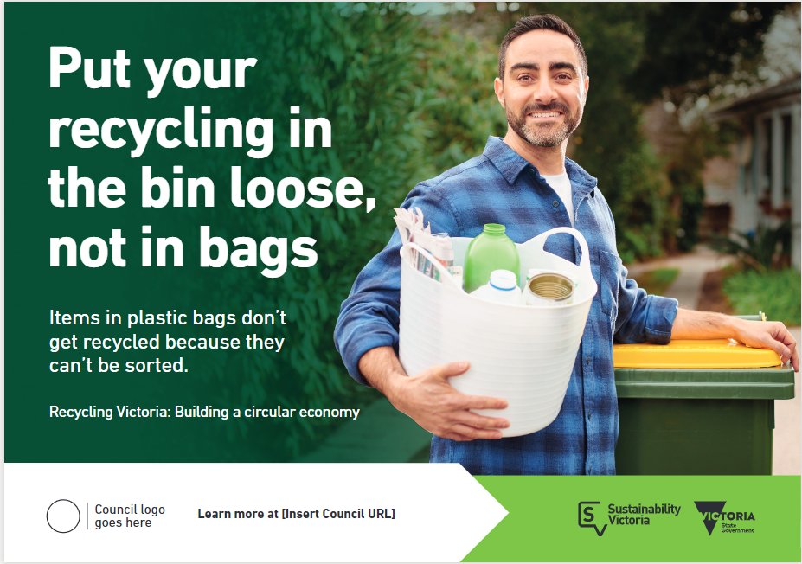
Figure 1 Half page press ad

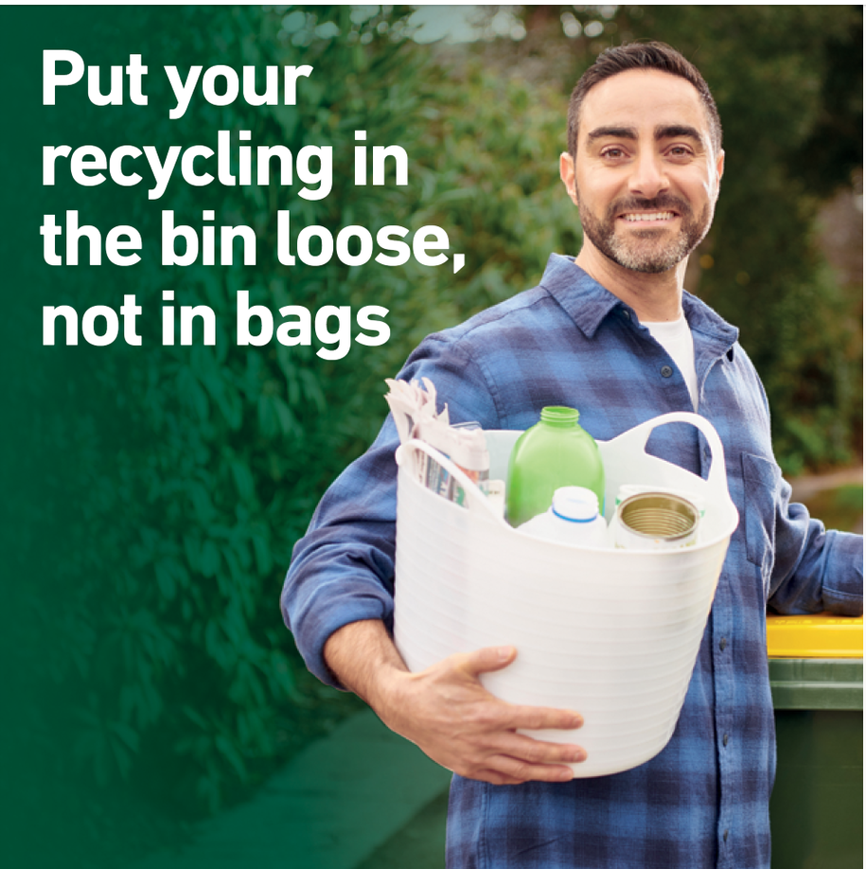
Figure 2 Static social media tile

Key contact
For support and advice on promoting / communication of this campaign, please contact us at:
Campaigns@sustainability.vic.gov.au

