Bree,

Here is the new linSWRRIP – Snapshot
STATEWIDE WASTE AND RESOURCE RECOVERY INFRASTRUCTURE PLAN
at a glance

The role of the SWRRIP
VISION
Victoria has an integrated statewide waste and resource recovery system that provides an essential community service to:
- Protect the community environment and public health
- Recover valuable materials from our waste
- Minimise long term costs to households, industry and governments
The Statewide Waste and Resource Recovery Infrastructure Plan (SWRRIP) provides strategic direction for the development and management of waste and resource recovery infrastructure to achieve an integrated system that:
- Effectively manages the expected mix and volumes of waste
- Reflects the principles of environmental justice to ensure that impacts on the community, environment and public health are not disproportionately felt
- Supports a viable resource recovery industry
- Reduces the amount of valuable materials going to landfill.
Prepared by Sustainability Victoria (SV), the SWRRIP provides Victoria with a roadmap to guide planning and investment in waste and resource recovery infrastructure over the next 30 years.

Why we need the SWRRIP
The Victorian Waste and Resource Recovery System is a complex mix of infrastructure, transportation networks, services and stakeholders that manage these wastes and materials
As Victoria’s population grows, so too will the amount of materials we generate. In 2015–16, approximately 12.7 million tonnes of materials (non-hazardous solid waste) entered Victoria’s waste and resource recovery system. By 2046 it is projected to approach 20 million tonnes – an increase of 57 per cent. Figure 1 indicates the projected growth from the three waste generation sectors – noting a significant increase in the proportion from construction and demolition (C&D) activities.
By 2046 the system may need to manage close to 20 million tonnes of waste a year
FIGURE 1: Projected waste and materials recovered and landfilled (tonnes) Business as usual scenario (2005-06 to 2045-46)
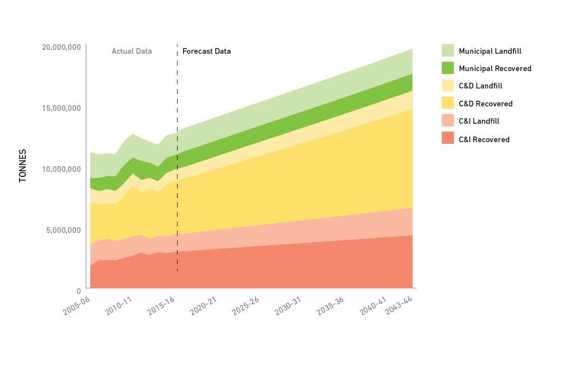

FIGURE 2 SWRRIP vision, purpose and long term strategic directions
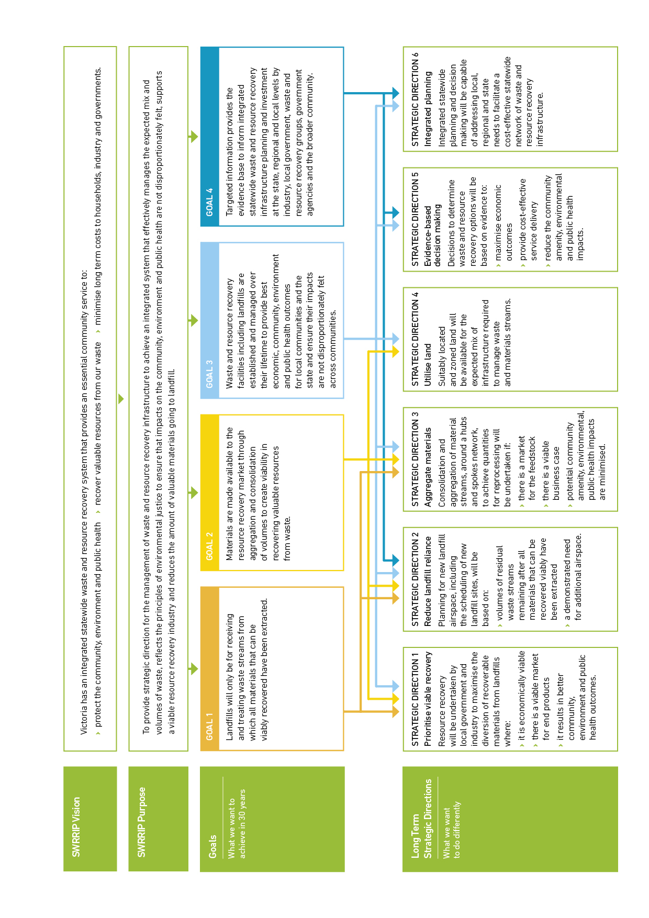

What’s in the SWRRIP
The SWRRIP sets out the vision, goals and strategic directions for the next 30 years required to ensure we have the right infrastructure in the right place to manage the waste we generate in a manner that maximises recovery and minimises adverse impacts on the community, environment and public health. It includes:
- A description and analysis of the sources of waste and materials streams (updated)
- Forecasts future projections and identifies trends (updated)
- An analysis of the materials and wastes being managed by the system
- An outline of Victoria’s waste and resource recovery infrastructure and potential future needs reflecting the Regional Waste and Resource Recovery Implementation plans (Regional Plans) (new)
- An assessment of the economic benefits of options to meet needs and identification of transport impacts and opportunities (updated)

A circular economy
The concept of a circular economy underpins the SWRRIP. In a circular economy, resources flow through a system to be productively reused. The SWRRIP seeks to ensure that Victoria’s waste and resource recovery system, particularly its infrastructure, not only manages this increasing amount of materials, but maximises circular flows whilst minimising impacts on the community and the environment. The SWRRIP focuses on the resource recovery aspect of the circular economy (see Figure 3).
The SWRRIP seeks to increase the diversion of waste from landfill beyond our current rate of 67 per cent. By 2020, we expect to see up to 72 per cent of materials being recovered for recycling or energy. This represents a reduction of over 500,000 tonnes of valuable materials going to landfill.
Over time, the SWRRIP seeks to support more strategically located and sophisticated collection and sorting facilities, along with and the introduction of innovative technologies to process materials into new products. The SWRRIP also supports converting organic and residual wastes to energy where higher order recovery is not viable.
Investing in new or expanded infrastructure to both manage the increasing volume of material and to increase recovery will cost money. However, as well as creating jobs in an industry already employing around 12,000 Victorians, there is a net economic benefit to Victoria of over $4 billion.

We can be proud that, in Victoria, we recover 67 per cent of materials, but we can do more.

FIGURE 3: Resource flows in Victoria's circular economy
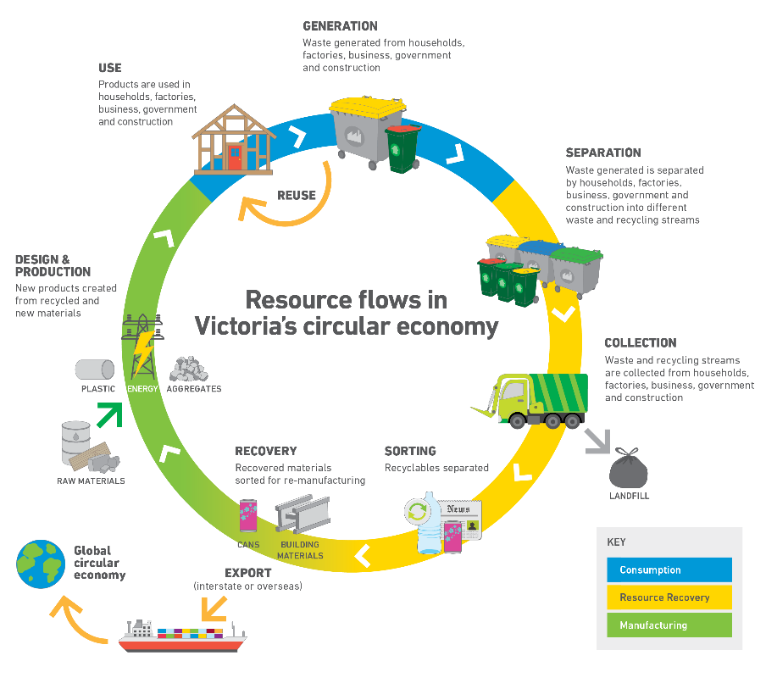

Victoria’s Waste and Resource Recovery Infrastructure Planning Framework
The Environment Protection Act 1970 (EP Act) establishes the Victorian Waste and Resource Recovery Infrastructure Planning Framework (Framework); its aim being to achieve long-term, integrated planning for waste and resource recovery infrastructure at state and regional levels, integrated with land use and transport planning systems.
Collectively, the SWRRIP and the seven Waste and Resource Recovery Implementation Plans (Regional Plans) seek to establish an integrated statewide waste and resource recovery system.
Initially published in June 2015, the amended SWRRIP reflects the priorities of Victoria’s seven Regional Plans and policy settings, includes the latest data and information and more clearly informs decision-makers.

SWRRIP Goals
GOAL 1 Reduce our reliance on landfills
Landfills will only be for receiving and treating waste streams from which all materials that can be viably recovered have been extracted.
To reduce our reliance on landfill in the context of increasing amounts of waste will require increased recovery of resources. Victoria currently diverts 67 per cent of the waste it generates from landfill – these recovered materials are mostly recycled – whether locally or overseas. Just to maintain this diversion rate will require investment in new or expanded infrastructure. To increase this rate, Victoria will also need to innovate.
GOAL 2 Encourage resource recovery and recycling
Materials are made available to the resource recovery market through aggregation and consolidation of volumes to create viability in recovering valuable resources form waste.
Key to improving the viability of reprocessing is sufficient, reliable feedstocks – materials need to be aggregated at least to the point where processing is viable – small scale local solutions may often be suitable.
GOAL 3 Raise the standard of waste and resource facilities
Waste and resource recovery facilities including landfills are established and managed over their lifetimes to provide best economic, community, environment and public health outcomes for local communities and the state and ensure their impacts are not disproportionality felt across communities.
Victorians can and should expect all facilities to be established and operated to a high standard and be fully compliant with regulations.
GOAL 4 Improve the evidence base for decision making
Targeted information provides the evidence base to inform integrated statewide waste and resource recovery infrastructure planning and investment at the state, regional and local levels by industry, local government, waste and resource recovery groups, government agencies and the broader community.
Robust information and analysis enables decision-makers to make strategic decisions about investments and operations of infrastructure to achieve the SWRRIP vision and address local priorities. The SWRRIP provides key information, and is complemented by the regular publication of up-to-date information on waste materials. As the SWRRIP and Regional Plans are actioned by the Victorian Government, the best available evidence is used. Information on global trends, economic analysis and evidence-based guidance will be available to inform decisions about investments and operation of Victoria’s waste and resource recovery system.

Strategic directions
The goals of the SWRRIP will only be achieved with involvement and action from all stakeholders – waste and resource recovery facilities owners and operators, local governments, waste generators – households, business and industry, investors and the Victorian Government.
The six strategic directions of the SWRRIP guide action at the state, regional and local level.

Strategic Direction 1 – Prioritise viable recovery
Victoria’s 67 per cent diversion rate has increased from 55 per cent ten years ago. Victoria’s system performs well by global standards, but we can do better. Analysis of the recoverable materials that are still being landfilled indicates the extent of the opportunity for improvement. However, the SWRRIP recognises that materials need to be considered separately, they - vary in value and the demand for end products, are impacted differently by contamination, come from different sources and require different sorting and processing infrastructure.
Priority materials for recovery
- Organics (including timber)
- E-waste
- Plastics
- Tyres
- Glass fines
- Concrete and aggregates

FIGURE 4 Recovery of main material streams 2015-16, (tonnes and percentage)
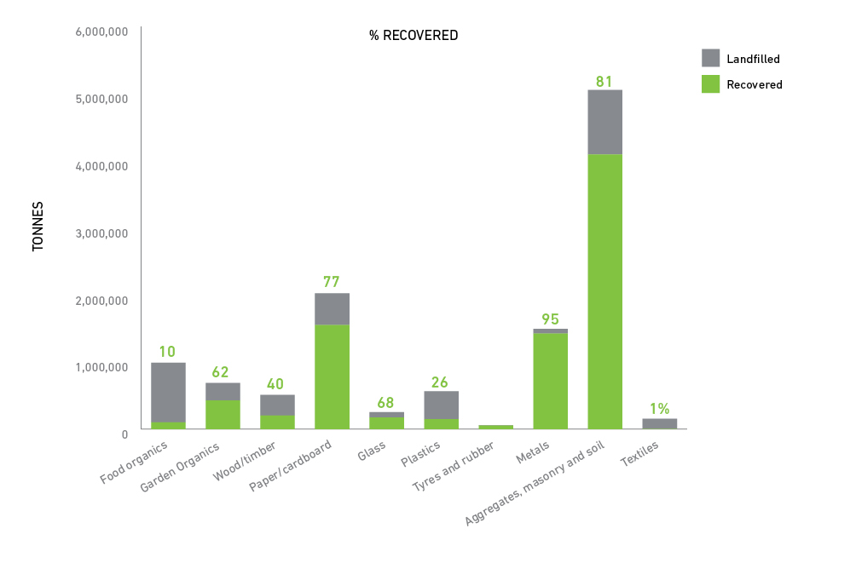
The total amount of each material is not the only consideration when identifying priorities – others include:
- risk to the community and environment posed by the waste material – e.g. putrescible organic waste generates odorous methane when breaking down, and is a potent greenhouse gas
- environmental impact of the material through its lifecycle – e.g. producing aluminium from virgin material uses around 20 times more energy than recycling
- economic value
- generation trends – e.g. flexible plastics and e-waste are increasing significantly.
Key priority – Increasing the recovery of food organics.
Unrecovered organic materials is the largest material type going to landfill, with an estimated 35% of organics making up all landfill deposits in 2015-16. Increasing its recovery will be critical to diverting waste from landfill. Not only will this reduce reliance on landfill, but will also reduce their impact, as decomposing organics materials generate odorous methane, which is also a greenhouse gas 25 times more powerful than CO₂.
Increasing the recovery of organics, particularly food organics from household collection services, is a priority in all seven Regional Plans and the Victorian Organics Resource Recovery Strategy (VORRS) – also produced by SV - provides a statewide approach, including developing and strengthening markets for end products – materials and energy.

How waste service contracts are designed impacts on what happens to the recoverable materials. Local governments collectively manage nearly three million tonnes of Municipal Solid Waste (MSW), mostly from households. When Councils, either alone or in collective procurements, require recovery as part of waste service contracts, the result is a consistent feedstock of material which can underpin investment in infrastructure. SV’s Optimising Kerbside Collection Systems provides guidance for local governments. Private collectors manage the remainder – improving the recovery from business and industry will require a range of approaches – often specific to the material being recovered.
Critical to a robust system and viable recovery is sustainable markets for end products. The Victorian Market Development Strategy for Recovered Resources guides the government’s work, in partnership with industry, to develop and strengthen markets, particularly through establishing fit for purpose standards and specifications that meet regulatory requirements. Government also plays a role as a procurer – stimulating the use of products incorporating recycled materials.
In 2015-16 around 14 per cent or recovered resources were exported overseas. The SWRRIP seeks to sustain a local robust recovery and recycling sector – but recognises that there is also a place for exporting materials to other states or overseas.

TABLE 1: Potential opportunities to increase the recovery of individual material streams
Material stream | Opportunities
Organics
Food | - Increase local government food and garden organics collection services to increase feedstock for reprocessing through collaborative and joint procurements between local governments  - Distribute energy solutions using food materials from manufacturing processes and wastewater treatment plants  - Build markets for products made from recovered food organics
Garden | - Facilitate collaborative procurements between local governments in regional Victoria  - Build markets for products made from recovered organics in broadacre farming  - Encourage small-scale, well managed, on-farm composting using low contaminated feedstocks and meeting regulatory requirements
Wood and timber | - Improve source separation at construction and demolition sites  - Increase viability of collecting timber from resource recovery centres/transfer stations  - Shred and process recovered untreated timber into briquettes, pellets or a dry woodchip  - Use treated and untreated timber for WtE processes
Paper/cardboard
- Improve separation of materials at materials recovery facilities (MRFs) from municipal sources and accept clean materials from commercial and industrial sources
- Improve source separation at the point of generation
- Investigate recovering paper and cardboard from residual waste
Glass
- Improve colour sorting technologies at MRFs
- Investigate viability of mobile glass crushers to produce sand replacement products
- Investigate uses for recovered glass fines
- Build end markets for recycled glass products
Plastics
Plastics – all | - Improve source separation and reduce contamination at the point of generation  - Investigate use of plastics for feedstock for refuse derived fuels or WtE  - Build end markets for recycled plastics products by developing specifications for products made from recovered plastics
Rigid plastics | - Improve collection and sorting of recovered rigid plastics from renovations, refurbishment and demolition of residential and commercial buildings
Flexible plastics | - Build capacity to collect flexible plastics through kerbside commingled systems  - Set up viable collection systems for flexible plastics from agricultural activities  - Investigate using materials and products made from recovered flexible plastics
Shredder floc | - Investigate alternative uses for shredder floc available internationally for viability in the Victorian context  - Investigate WtE options for shredder floc pre-sorted to remove materials that can be viably recovered including metals
Tyres and rubber
Investigate use of recovered tyre and rubber materials in line with the National Market Development Strategy for used tyres
- Build end markets by developing product specifications
- Investigate local WtE opportunities using tyre derived fuels
Concrete, aggregates and soil
Increase point source separation of materials on building and construction sites
- Build end markets for recovered materials by developing product specifications
- Increase local availability of recovered materials
E-waste
Strategic upgrade of the existing resource recovery centre/transfer station network to enable collection of e-waste materials
- Support for industry to develop the capacity to improve separation and sorting of component materials
- Develop a market for the recovered materials to ensure stockpiling does not occur
Residual waste
Increase pre-sorting of the residual waste stream at landfills or residual waste consolidation centres
- Establish MRFs that can sort residual waste
- Treat residual waste to produce products such as energy, heat, biogas, biofuels and soil conditioners

What will be different?
- Material streams for recovery will be diverted from landfills if it is economically viable and can improve community, environment and public health impacts.
- Resource recovery will be prioritised in procurements for waste and resource recovery services.

Strategic Direction 2 – Reduce landfill reliance
Landfills are an important part of our system – safely disposing of over four million tonnes of residual waste. However, the SWRRIP and the Regional Plans seek to minimise the use and development of landfill.
With increasing recovery, we reduce our reliance on landfill and consequently Victoria may not require additional landfills over the life of the SWRRIP. Our remaining landfills will also be less odorous as we remove organic material.
Over the last 15 years, the number of operating landfills in Victoria has reduced from 16 to 72, with fewer, larger landfills. This number is expected to further decline over the 10-year life of the Regional Plans to 38. Closed landfills need to be actively monitored and managed for a considerable time and many have a detailed rehabilitation and aftercare plan. A risk based approach is being developed for smaller older landfills which were not covered by the more rigorous modern standards.
Landfills need to be well-operated in accordance with regulations and we need enough landfills in the right place to provide for contingencies. Taking into account the expected amounts of materials to be managed and a range of considerations, such as emergency events, none of the seven Regional Plans identified the need for any new landfills in the next 10 years, subject to approval of planned expansions as required. The Regional Plans’ Infrastructure Schedules will be reviewed by 2020 to ensure that we have sufficient landfill airspace across Victoria.
Waste to energy facilities also produce a small amount of residual ash, which will need to be managed should these be introduced.
Key priority – recovery from residual waste
Some materials are easily recovered by sorting at the point of generation or at a recovery facility - the SWRRIP proposes that we can do better at efficiently recovering and maximising the value of these materials. However, some materials are not so easily sorted, are readily contaminated or are in products made from a mix of materials. Examples include food contaminated paper, nappies, unrecyclable plastics and composite building materials. Collectively these comprise residual waste.
The SWRRIP identifies that we need to consider new technologies to both safely sort contaminated residual material to maximise material recovery and to provide alternatives to landfill disposal, such as energy capture. Incineration without recovery is not consistent with the SWRRIP as there is no recovery of resources.
What will be different?
A consistent statewide process is used to assess the need for, and scheduling of, landfill airspace that includes:
- a robust analysis of viable opportunities to maximise resource recovery and minimise volumes of residual waste requiring landfill
- identification of any remaining airspace needed, including allowance for contingencies and identification of alternatives
- mechanisms to preserve against encroachment, resulting in amenity impacts on the surrounding communities.

Strategic Direction 3 – Aggregate materials
Aggregating materials to reach economies of scale is critical to an efficient system. This will vary for different materials – often materials need only be aggregated to enable viable local solutions – providing local jobs and reducing transport requirements. A distributed system of smaller scale resource recovery infrastructure also reduces risk by ensuring that we are not overly reliant on too few sites.
The collection and transport systems need to be in place to enable efficient and safe aggregation. Whilst local government kerbside collection contracts are important, companies collecting from Victoria’s businesses in industry also play a key role – managing 76 per cent of waste. Victoria has 401 resource recovery facilities all play a role in aggregating materials. These facilities must manage materials safely and in accord with regulations and will need to continue to be improved to enable the system to manage new materials, such as flexible plastics.
Key priority – strategic network of Resource Recovery Centres
Victoria has 282 Resource Recovery Centres (Transfer Stations), most of which are owned and operated by local government. They provide a service to households and businesses and, in some regions, manage up to 15 per cent of household waste.
This extensive network comprises facilities of various sizes, accepting different materials and products, at a range of standards. All Regional Plans have identified the need for a more strategic approach to RRCs to both provide an effective service for Victorians which maximises recovery and is economically viable.
SV’s Guide to Better Practice at Resource Recovery Centres provides guidance to planners and operators.
What will be different?
- Local governments and/or industry will develop collective procurements for waste and resource recovery services.
- Local governments will be supported to develop waste management plans that maximise local recovery opportunities.
- Industry will be proactively engaged and identify waste and resource recovery management options that are economically viable and minimise community, environment and public health impacts.
- The Victorian Government will take a strategic approach to determine where to intervene to stimulate markets for recovered resources.

Strategic Direction 4 – Utilise land
Victoria needs infrastructure in the right place – to maximise recovery, use transport efficiently, provide certainty to operators and protect communities and the environment.

Land use planning
Victoria’s legislative framework for planning the use, development and protection of land in the present and long term interest of all Victorians establishes our land use planning system, including the Victoria Planning Provisions. These provisions underpin land use planning decisions and reference the SWRRIP and the Regional Plans. The SWRRIP recognises that planning for waste and resource recovery infrastructure must be integrated with land use planning at state, regional and local levels.
Bringing this to life will ensure that land use planning activities considers existing waste and resource recovery infrastructure and the need for future infrastructure will be key to the success of the SWRRIP. This is particularly important at the early stages of planning. At a local level, many facilities require buffers to ensure that communities are not impacted – i.e. areas in which “sensitive uses” are not located. Establishing and retaining buffers, and having them recognised appropriately in strategic plans and local planning schemes will be a focus.
Another area of integration is waste and buildings. Not only can our built environment incorporate recycled materials, we can use design to make it easy for households and businesses to recycle. SV’s Guide to Best Practice for Waste Management in Multi-unit Developments provides guidance for designers and planners.

Hubs
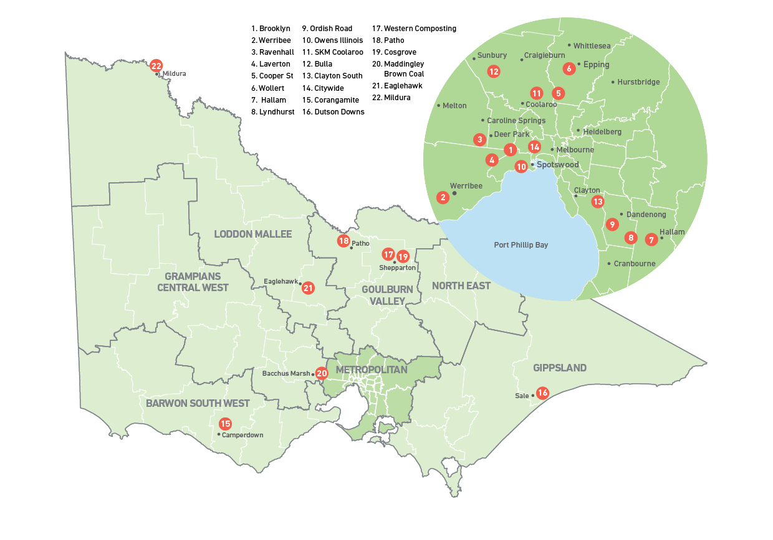
Waste and resource recovery hubs play a key role in managing materials at a state, regional and local level. The hub network will be a key mechanism to identify existing activities that may need to be considered in the land use planning system, and may help identify suitable sites for new infrastructure. Hubs of state importance play a significant role in our waste and resource recovery system. Figure 4 indicates their locations. These sites evolved as our system grew – they are all different, managing different materials and in very different settings. However, retaining the functions that they currently play is critical to Victoria.
FIGURE 5: Hubs of state importance
Key priority – strategically planning for hubs of state importance
The SWRRIP and Regional Plans identify 22 hubs of state importance
Waste and Resource Recovery Groups and SV will work with local governments, state government agencies and facility owners to strategically plan for hubs and to integrate them with local planning schemes.
Transport
Efficient use of transport is an important consideration when planning for the management of waste as it can increase the viability of recovery. Greater efficiencies will be sought to improve the system, as will reducing transport needs by facilitating local solutions.
While the impact of the waste and resource recovery system on Victoria’s transport and freight system is not significant at a state level, transport impacts will be appropriately considered when planning for sites, including hubs.
What will be different?
- Suitable sites and buffers will be progressively protected through local planning schemes or other land use planning tools.
- Planning will ensure unsuitable land uses are not established with, or near waste and resource recovery facilities.
- Compatible activities that can support the waste and resource recovery industry by generating or using feedstock, or creating markets for products, will be encouraged.
- Closing or closed landfill sites will be used for alternative resource recovery activities where appropriate, when a viable business case and improved community, environment and public health impacts can be demonstrated.

Strategic Direction 5 – Evidence-based decision-making
Evidence is critical to making informed decisions. The SWRRIP is based on best available data and includes a comprehensive outline of information, complemented by more detailed information in the Regional Plans. Whilst these documents will support decision-makers, additional information and appropriate analysis will often be required. The Waste Data Portal, available on the SV website, provides up-to-date information on materials at a range of scales.
Research, guidance and case studies can guide how facilities might best be established and operated. SV updates and publishes statewide guidance and research, for example on resource recovery technologies, kerbside collection systems, resource recovery centres etc. Victoria’s seven Waste and Resource Recovery Groups are a source of support and information about the regional context and opportunities.
An economic assessment of the SWRRIP found that improving the recovery of resources provides a net economic benefit to the state. Whilst the establishment of new infrastructure to increase recovery incurs costs – for every dollar spent, the benefit to Victoria is at least $1.80. This analysis gives confidence to decision-makers that seeking to achieve the goals of the SWRRIP will have benefits for the Victorian community.
Regulators, including the Environment Protection Authority (EPA) and local governments are required to make decisions about the suitability of proposed infrastructure. The SWRRIP provides decision-making guidance to how to determine what is consistent with the SWRRIP.
What will be different?
- Identifying and analysing opportunities will include assessing:
  - community service needs
  - economic, community, environment and public health costs
  - benefits, risks and costs associated with rehabilitation.
- Assessing alternatives to local management of residual waste will consider:
  - transitioning small landfills to resource recovery and consolidation activities
  - transporting residual waste to appropriate facilities, including regional landfills

Strategic Direction 6 – Integrated Planning
Integrated planning and decisions across government will help achieve the goals of the SWRRRIP.
The Framework enables the SWRRIP’s statewide goals and directions to be achieved at the regional and local level. The seven Regional Plans identify local priorities, developed in consultation with community and industry, and establish critical connections between stakeholders within each region. Each of these 10 year plans includes a schedule of existing and required infrastructure – which will be used to inform government decision-making - and outlines a course of action involving all local governments, local waste industry and ultimately the community. The community will also be involved in the development of local government waste management plans, which will align with the regional approach.
Many state government departments and agencies have a role to play in the SWRRIP. In addition to SV and the seven Regional Waste and Resource Recovery Groups, the EPA plays a significant regulatory role, with the Department of Environment, Land Water and Planning (DELWP) responsible for policy. As outlined previously, integration with land use planning bodies such as DELWP (Planning Division) and the Victorian Planning Authority is critical. Other areas which play a role include the Department of Economic Development, Jobs, Transport and Resources and its agencies and the Department of Health and Human Services.
What will be different?
- Planning by government departments, agencies and local government will be aligned with the SWRRIP’s long-term strategic directions and the relevant Regional Plans.
- Government departments, agencies and local government will actively engage the community when planning for waste and resource recovery infrastructure.

Victoria’s infrastructure

The role of infrastructure
Victoria’s waste and resource recovery system provides an essential service by managing these materials through a network of infrastructure. One of the most vital components of this system is the network of more than 630 pieces of infrastructure across Victoria, run by over 590 businesses and local governments.
The materials that the system will need to manage are changing as our industries and consumption patterns change.
The industry is estimated to employ over 12,000 people and contributes over $4 billion to the Victorian economy²

TABLE 2: The four major groups of waste and resource recovery infrastructure
Infrastructure group | Function
Collection infrastructure | - Facilitates recovery of materials at the point of generation by collecting and transporting to facilities for sorting, consolidation or disposal
Recovery facilities | - Facilitates recovery of resources primarily through segregating, sorting, consolidating and aggregating before transporting for reuse, reprocessing or disposal
Reprocessing facilities | - Facilitates recovery of resources primarily by converting materials into products that can be used again or energy
Disposal infrastructure* | - Final repository of waste after the extraction of all materials that can be viably recovered

Future infrastructure needs
As the system expands to increase to both manage increasing amounts and to increase recovery – the infrastructure requirements will change. Specific gaps have been identified across the system in Victoria’s regions over the next 10 years – for sorting and processing infrastructure for specific materials.

TABLE 3: Existing facilities in June 2017 and anticipated gaps in the resource recovery infrastructure network
 | Waste and resource recovery region
 | Barwon South West | Gippsland | Goulburn Valley | Grampians Central West | Loddon Mallee | Metropolitan Melbourne | North East
RECOVERY FACILITIES
Existing recovery facilities (TOTAL 401) | 52 | 97 | 41 | 74 | 47 | 69 | 21
Gaps
Resource Recovery Centres (Transfer Stations)
Strategic efficient networks to:
- respond to population change & trends in discarded materials
- enable e-waste collection
- increase compaction
- increase recovery from residual waste
Large-scale sorting facility for multiple material streams from all sectors
Bulk haul consolidation centre
Materials Recycling Facilities (MRFs)
- Improved sorting capacity for commingled recyclables
- Infrastructure to accept non-kerbside collected materials
Pre-sorting infrastructure for residual waste (not at landfill)
- at RRCs, specialised MRFs or other locations
Pre-sorting infrastructure for residual waste (at landfills)
- Increased capacity to sort residual waste
REPROCESSING FACILTIES
Existing reprocessing facilities (TOTAL 164) | 21 | 21 | 22 | 13 | 8 | 69 | 10
Gaps
Food Organics |  |  | *
Garden Organics
Combined Organics |  |  |  | * | * |  | *
Wood / timber
Paper and cardboard
Glass
Plastics
Tyres and rubber
Metals
Aggregates, masonry and soil
Textiles
Residual
LANDFILLS
Existing landfills (TOTAL 72) | 6 | 10 | 5 | 16 | 13 | 18 | 4
*Planning for facilities is significantly progressed

Implementing the SWRRIP
Many stakeholders will be involved in implementing the SWRRIP. The SWRRIP identifies actions for the Victorian Government agencies with direct responsibility for its statewide and regional delivery, including complementary activities which support the SWRRIP and the other elements of the circular economy. The key elements are outlined in Figure 6.
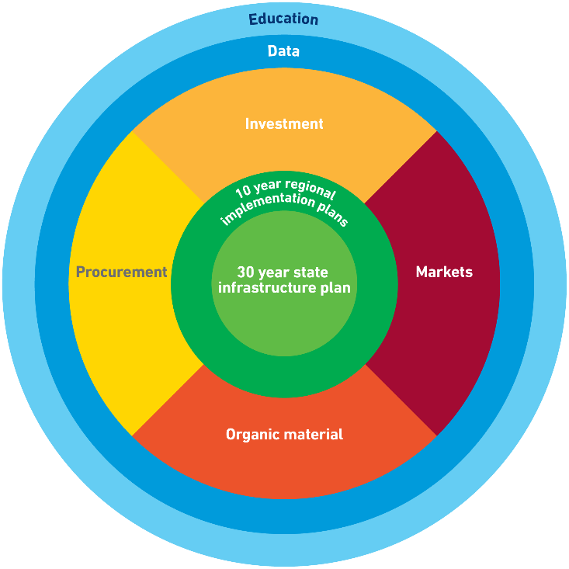
FIGURE 6: Initiatives to achieve the SWRRIP

The Regional Plans are 10-year action plans, which deliver the statewide directions in the context of regional priorities.
Critical to our infrastructure system is strong markets for the end products made from recovered materials. Complementing the SWRRIP, activities to develop markets for organic materials and other priority materials will focus on priority materials, addressing barriers and managing risks. The Victorian Government’s sustainable procurement policies can also create demand.
Education will be critical to success – keeping Victorians informed about the role of the system, involved in decisions and enabling us all to play our role in recycling. A coordinated approach at state, regional and local levels is established.
The SWRRIP will inform decisions by Victorian Government agencies, local government and industry. Guidance on what is considered to be consistent with the SWRRIP is included, for example incineration without recovery is inconsistent with the SWRRIP in most instances.

Measuring success
A robust Monitoring and Evaluation Plan is in place. This involves monitoring progress of actions, regularly measuring the impact of the SWRRIP, Regional Plans and complementary activities via a stakeholder survey, and evaluative reviews.
Headline performance indicators are outlined in the SWRRIP. Three of these can be used to measure how effectively Victoria’s system is working to achieve a circular economy, whilst protecting the environment and human health:
- Overall diversion rate from landfill has improved (tonnes recovered over total waste generation) for all wastes and organic materials
- Industry report increasing market demand for end products made from priority materials
- Environmental, public health and/or amenity performance of waste management and resource recovery facilities has improved
The SWRRIP will be reviewed within five years and the next iteration will include consideration of infrastructure for the management of hazardous waste.

How to keep informed
SV’s webpage provides links to the SWRRIP, Regional Plans and relevant strategies, along with a wide range of relevant information and materials and regular updates on progress.

Authorised and published by
Sustainability Victoria
Level 28, Urban Workshop
50 Lonsdale Street, Melbourne
Victoria 3000 Australia

Statewide waste and resource recovery infrastructure plan at a glance
© Sustainability Victoria 2018
While reasonable efforts have been made to ensure that the contents of this publication are factually correct, Sustainability Victoria gives no warranty regarding its accuracy, completeness, current or suitability for any particular purpose and to the extent permitted by law, dopes no accept any liability for loss or damages incurred as a result of reliance places upon the content of this publication. This publication is provided on the basis that all persons accessing it undertake responsibility for assessing the relevance and accuracy of its content.
Statewide waste and resource recovery infrastructure plan at a glance is licenses under a Creative Commons Attribution 4.0 Australia. In essence, you are free to copy, distribute and adapt the work, as long as you attribute the work and abide by the other license terms. To view a copy of this license, visit: http://creativecommons.org/licnesez/by/4.0/

Department of the Environment and Energy, Centre for International Economics, Headline economics value for waste and material efficiency in Australia. October 2017
Department of the Environment and Energy, Centre for International Economics, Headline economics value for waste and materials efficiency in Australia. October 2017

